Blaenavon, a learning report

Regeneration and Distinctiveness

TUTOR Anthony Burns

Samantha Connelly 1905798

Blaenavon Iron works
Giant of the monetary age nevertheless stands tall at the shoulders of its workers Blaenavon changed the arena. These hills getting ready to the Brecon Beacons were wealthy with coal, limestone and iron ore – the gasoline of the Industrial Revolution. From right here Wales heaved and belched and blasted itself onto the global degree. Welsh iron unique trailblazing engines, tools and machines. It constructed bridges, ships and railway strains. In quick it made the modern global. (Cadw.gov.wales, 2020)
In 1789 Blaenavon Ironworks first harnessed the electricity of steam to blow air into its large blast furnaces. A century later it modified into here that Sidney Gilchrist Thomas transformed the area’s metallic industry thru inventing a manner to cast off phosphorus from iron ore. (Cadw.gov.wales, 2020)
The ruined furnaces are although visible these days along the unexpected stays of the foundry, cast residence and water balance tower that raised wagons eighty feet into the air.
Blaenavon became run via tremendous, and regularly ruthless, industrialists. But it would be now not something without its people. Explore their authentically supplied cottages and the recreated ‘truck maintain’ wherein they spent their meagre wages. Their tale, knowledgeable via cutting-edge interpretation, lies at the coronary heart of a commercial enterprise landscape so particular it’s been made a World Heritage Site. (Cadw.gov.wales, 2020)
Keeping the ever-hungry furnaces of Blaenavon burning wasn’t only a task. It became more like hard labour.(Cadw.gov.wales, 2020)
Twelve hours per day, seven days every week. In ordinary peril from chimney or liquid metal, poisonous vapor and overwhelming hardware. Never high-caliber if a tumble inside the charge of iron could see you turfed out of your private home. It wasn't genuinely the grown-ups who endured. Youngsters as youthful as five had been set to fine art. In 1842 Government examiners chose 185 kids younger than 13 walking around the ironworks and its encompassing mines. A segment of them were young ladies – many breaking separated iron mineral with the guide of method for hand on the grim slopes over the yard. Author AJ Munby said enthusiastically that folks would address the bigger protuberances: 'At that point the ladies hurt them up… lifting the mallet over their heads and bringing it down with masculine capacity and pressure'. There are numerous other deplorable stories. Margaret Thomas, matured 15, sprinkled round shoeless pushing cable cars underground. Eight-yr-vintage Lucretia Jones went through the entire day getting out orders to the individual at the waterwheel. In any case, heater chief William Lloyd wasn't actually thoughtful. After all he'd been situated to works of art in a Staffordshire ironworks himself on the age of 8. (Cadw.gov.wales, 2020)
'The processing plant young men fine art in some glow inside the mid year season and every so often get scorched, yet now not truly ghastly,' he expressed. 'I worked a deal more troublesome than the folks do here.'(Cadw.gov.wales, 2020)
Blaenavon contains two broadly significant destinations saved as instances of the territory's rich mechanical inheritance: the Blaenavon Ironworks and the Big Pit Mining Museum, both significant authentic and innovative parts in the modern and social scene of Blaenavon. (Ggat.org.uk, 2020)
A water soundness raise is a totally predominant shape. Manufactured some time after 1839, it's far a brilliant water powered convey which become used to convey cable car many iron from one phase to each other with the goal that they could be moved by means of tramroad to the close by Garn Ddyrys Forge, and also to the Brecon and Abergavenny Canal which administration a correspondingly far reaching component on this enormous interconnecting business scene. Furthermore, there's a significant enduring workforce cabin at Stack Square. (Ggat.org.uk, 2020)
The previous Big Pit Colliery was sited at the easternmost part of the South Wales coalfield. In 1980, it shut as a working mine and is presently run by methods for an altruistic concur with offering guest get section to slip 90m underground. The colliery changed into sunk to its present stage in 1880, despite the fact that its underground activities contain parcels ahead of time shafts and passages, one model being Forge Level, which become pushed in 1812 to convey coal particularly for the Blaenavon Ironworks. Subterranean, motor homes and stables in any case remain. On the floor, the metal headgear dated to 1921 and the related levels of structures show the amount of the previous colliery. These homes comprise of the pithead showers, metal forgers' keep, light room, winding motor habitation and cable car circuit. This site stays as a well-deciphered, yet remarkable, occurrence of a colliery which added to the norm of particular Welsh people group set inside the scenes they made. (Ggat.org.uk, 2020)
Related with the mechanical misuse of the territory are the stays of the vehicle network, required to carry the uncooked materials to the ironworks and fare the finished item. The region contains a development of conveyance highlights, beginning from little tramroads through to head landmarks including the passage and the dyne metal willing airplane at Pwll Du. The passage become opened in 1815 to ship limestone to the ironworks from the quarries toward the north. It likewise took pig iron from the ironworks to the manufacture at Garnddyrys, anyway it was at some point or another supplanted by methods for the dyne steel willing airplane in around 1850. (Ggat.org.uk, 2020)

million years back
The center of the Devonian time frame, the previous Welsh Basin had in this manner become some portion of a scope of mountains. The atmosphere was bone-dry, with infrequent precipitation disintegrating the mountains away and creating new dregs simultaneously. Streams diverted flotsam and jetsam towards the Midlands and South Wales, saving sands over the fields. The sands in the end combined, to frame what is today called the Old Red Sandstone. These strata give the trademark red shading to the dirts of parts of South and East Wales. (Moodle.uwtsd.ac.uk, 2020)
The Devonian time frame has been known as the "time of fishes". It denoted the major developmental burst that built up these animals in their full assorted variety - hard fish, sharks, lungfish - in oceans, lakes and streams around the world. Also, from the lungfish there developed the main creatures of land and water to slither onto the land, where the colonization by plants was at that point well in progress.
With the beginning of the Carboniferous time frame, shallow warm oceans attacked zones of NE and South Wales, by and by permitting coral reefs to thrive and set out the limestones in which Wale's caverns were later shaped. (Moodle.uwtsd.ac.uk, 2020)

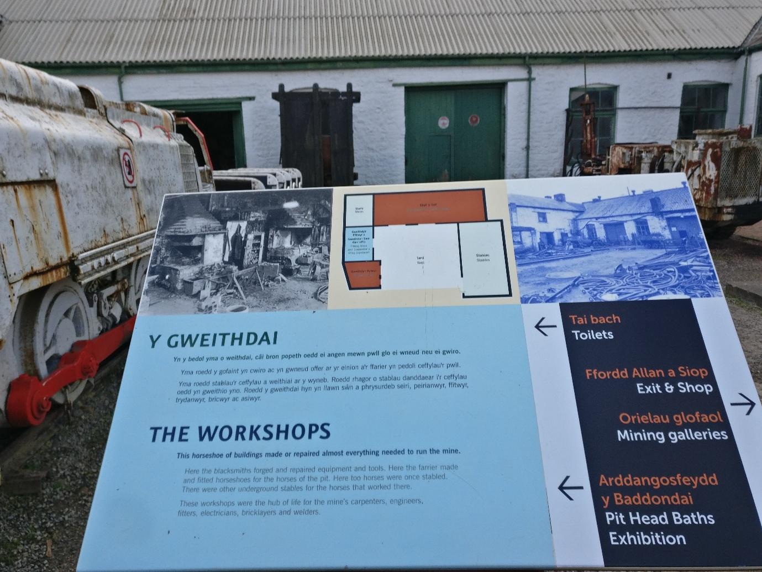

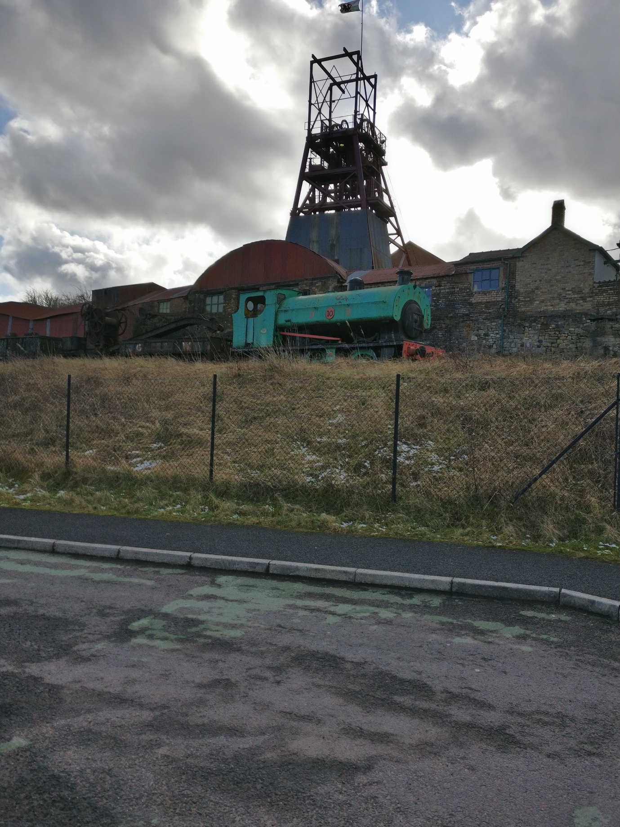

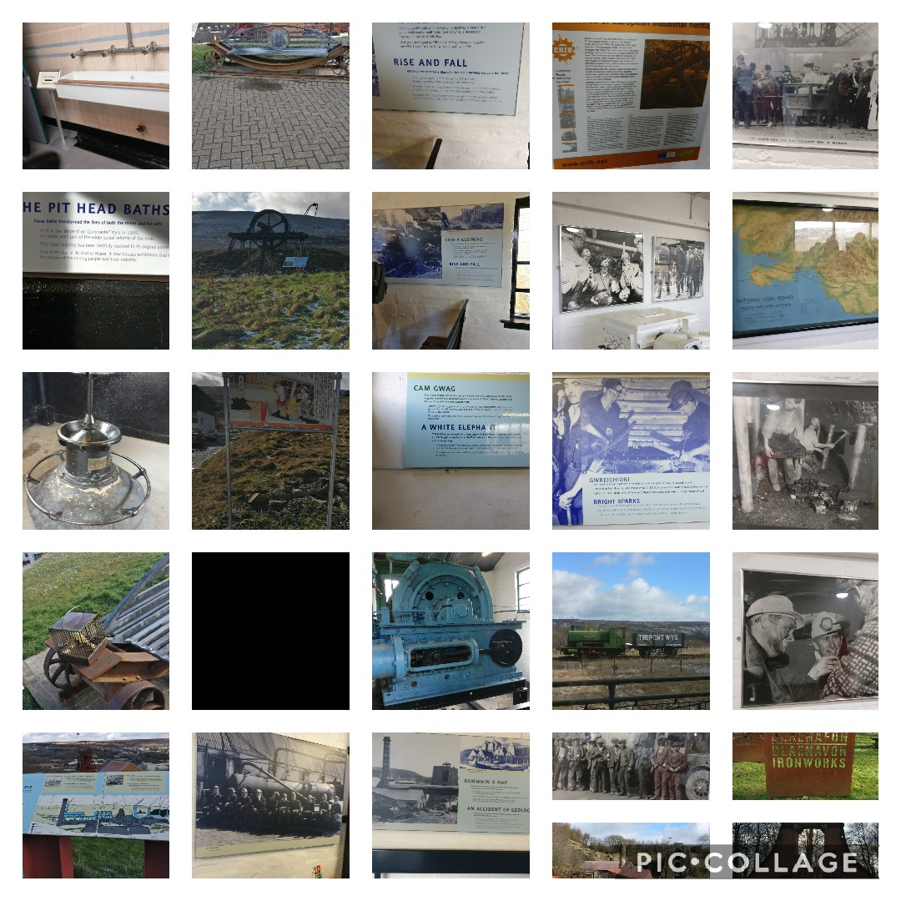


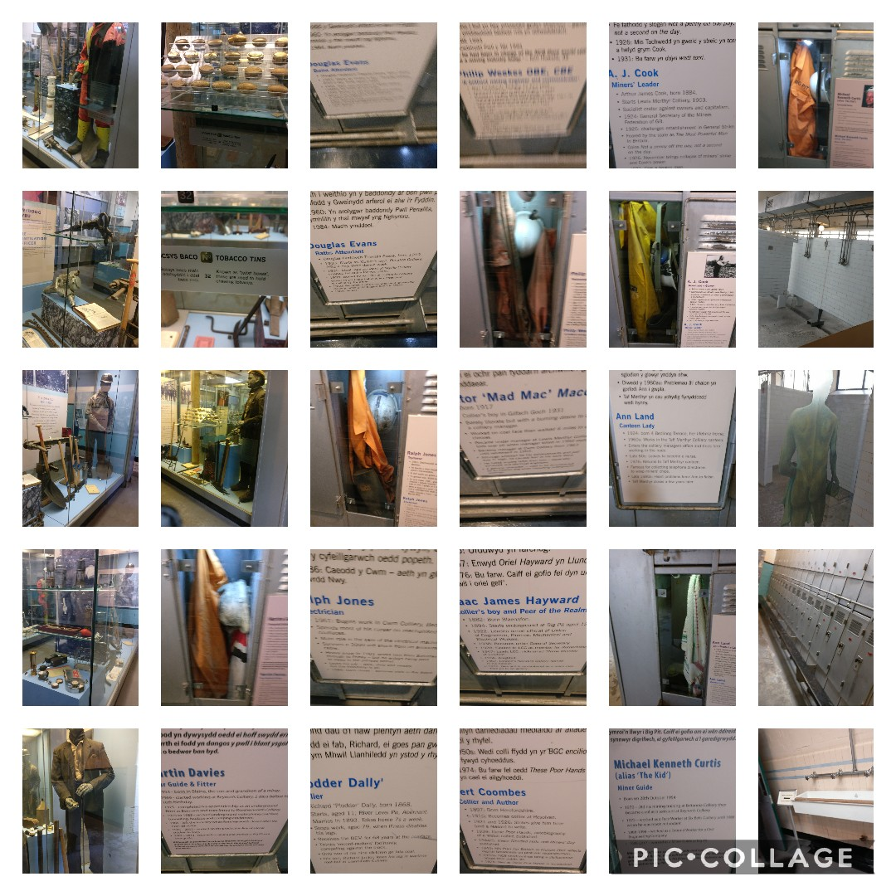
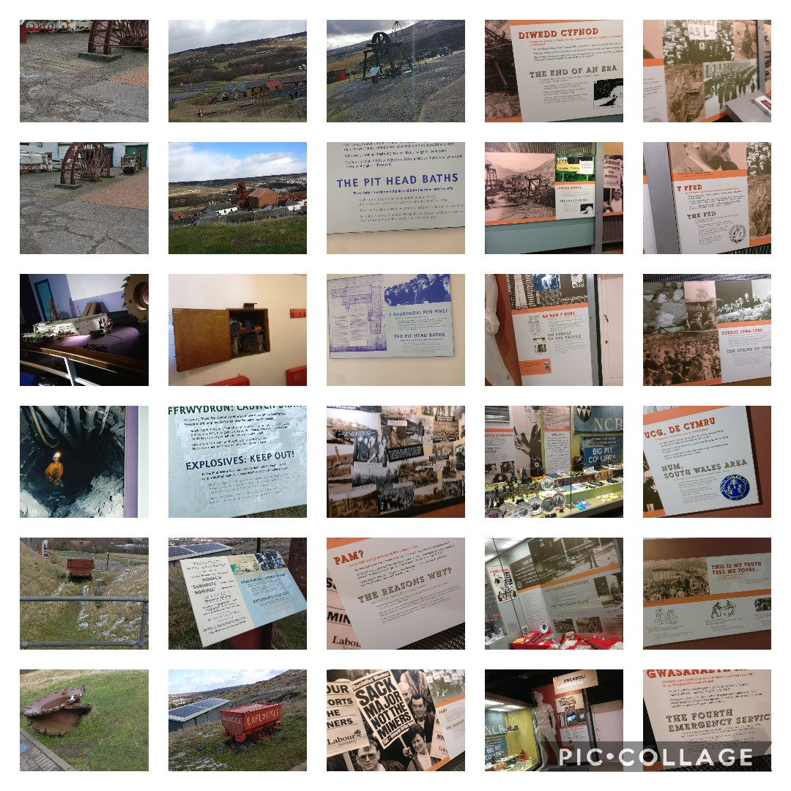
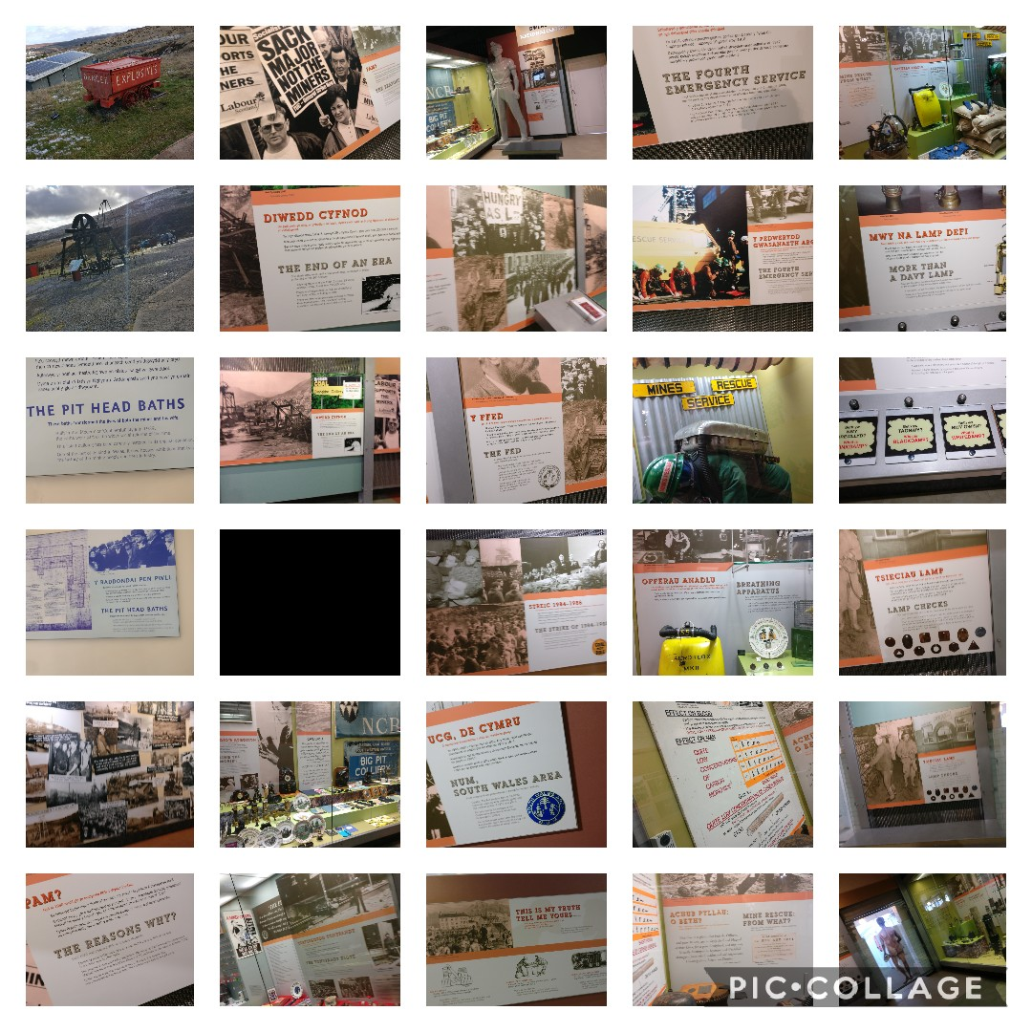

References
Cadw.gov.wales. (2020). More about Blaenavon Ironworks | Cadw. [online] Available at: https://cadw.gov.wales/more-about-blaenavon-ironworks [Accessed 6 Mar. 2020].
Cadw.gov.wales. (2020). Blaenavon Ironworks | Cadw. [online] Available at: https://cadw.gov.wales/visit/places-to-visit/blaenavon-ironworks [Accessed 6 Mar. 2020].
Ggat.org.uk. (2020). Blaenavon HLCA010. [online] Available at: http://www.ggat.org.uk/cadw/historic_landscape/blaenavon/english/Blaenavon_Main.htm [Accessed 6 Mar. 2020].
Moodle.uwtsd.ac.uk. (2020). UWTSD Moodle 2019/20: Log in to the site. [online] Available at: https://moodle.uwtsd.ac.uk/pluginfile.php/346841/mod_resource/content/2/Limestone%20lecture_no%20narrative.pptx [Accessed 6 Mar. 2020].
Moodle.uwtsd.ac.uk. (2020). UWTSD Moodle 2019/20: Log in to the site. [online] Available at: https://moodle.uwtsd.ac.uk/pluginfile.php/346841/mod_resource/content/2/Limestone%20lecture_no%20narrative.pptx [Accessed 6 Mar. 2020].

