SUSTAINABLE BUSINESS REVENUE GENERATION PLAN FOR HILTON HOTEL

SHAHEDA AHMED

2109892

BMIH5007 /BMIH5002

FINANCIAL MANAGEMENT FOR THE HOTEL INDUSTRY

LECTURER DALE CLARKE

CONTENTS PAGE

EXECUTIVE SUMMARY PAGE 3

INTRODUCTION PAGE 3

DISCUSSION PAGE 4 - 5

PROS AND CONS OF OUTSOURCING PAGE 5 – 7

EVALUATION PAGE 8

CONCLUSION AND RECOMMENDATION PAGE 8 – 9

BIBLIOGRAPHY PAGE 10 - 13

EXECUTIVE SUMMARY
This is a report to find a sustainable business revenue generation plan for Hilton hotel making a comparison of insourced housekeeping team versus outsourcing housekeeping in terms of the abilities of those employed as well as a look at the cost implications of each approach. We will try and find out which is more feasible in the hotel industry.

INTRODUCTION
In this report we will research a sustainable business revenue generation programme plan for Hilton hotel. Considering the housekeeping department, comparing of insourced housekeeping teams versus the outsourcing housekeeping how it affects those employed as well as the cost implications.
Outsourcing is a strategy used in the hotel industry as managers try to cut operating costs to a minimum in a high profile business environment (Lam and Han, 2005).
The Outsourcing trend started in the 1980s, when it developed huge success, all businesses followed by outsourcing and looked at the core and profit making department, hotels followed suit with having contracted caterers and cleaners in, this took pressure off the housekeeping team, and they could concentrate more on keeping a well kept house and room, maintaining it to the level of the hotels standard (Panchal, 2021).
In house is an operation performed within the hotel, it assigns a person to a department instead of hiring an outside company. Insourcing can be expensive as it often requires implementing new processes for an existing one (Beers, 2022).
Hotel housekeeping has direct impact on the hotels reputation and its revenue therefore staff training is essential to maintain standards, so when outsourcing the provider must ensure that the hotels value and culture is intact (Dixit, n.d.).

DISCUSSION
Outsourcing is a global industry, for large company’s outsourcing lets them tick off those boxes by off loading specific jobs to outside company’s, this also frees up staff to concentrate on core functions. Global outsourcing spend could hit the $731 billion in 2023 (Howarth, 2023).
Many hotels who have outsourced can see the benefits.
Hotels have seen labour costs drop by 25%
Hotels have found outsourcing company’s providing top quality services.
Hotels have found their guests are happy and satisfied after each visit (Goswami, 2022).
The use of outsourced housekeeping is popular among hotels, this means hotels don’t need to go through a recruitment process which is long and costly. Therefore, improve revenue and bring better efficiency to the job (Dixit, n.d.).

Omni facilities management is an outsourced service used by Hilton Hotels. Omni employees over 4000 employees and provides housekeeping, recruitment property and software services (Omni facilities management, 2023). Laundry is one of the things most hotels including Hilton outsource. Mark Allaf, general manager of Hilton Garden Inn Al Mina, says he works closely with the hotels laundry supply to ensure the outsourcing model remains successful (Admin, 2016).
Hilton uses a few outsourcing company’s in their hotels, Compaq services is an operational management for Hiltons Oracle Financials solution, which deals with applications, database, and systems support. One key requirement Hilton wanted was a company who was willing to work with third parties to ensure quality of service, which helps hotel managers work effectively freeing up valuable time to focus on guests satisfaction and housekeeping duties (Hilton international,1999).
Accenture is a technology services to strengthen Hiltons technological service, this outsourced company looks at IT and back office help which will help run that area smoothly without having to intervene therefore this also frees up valuable employee’s time to concentrate on the much needed areas of housekeeping and guest satisfaction areas (Accenture, 2010).
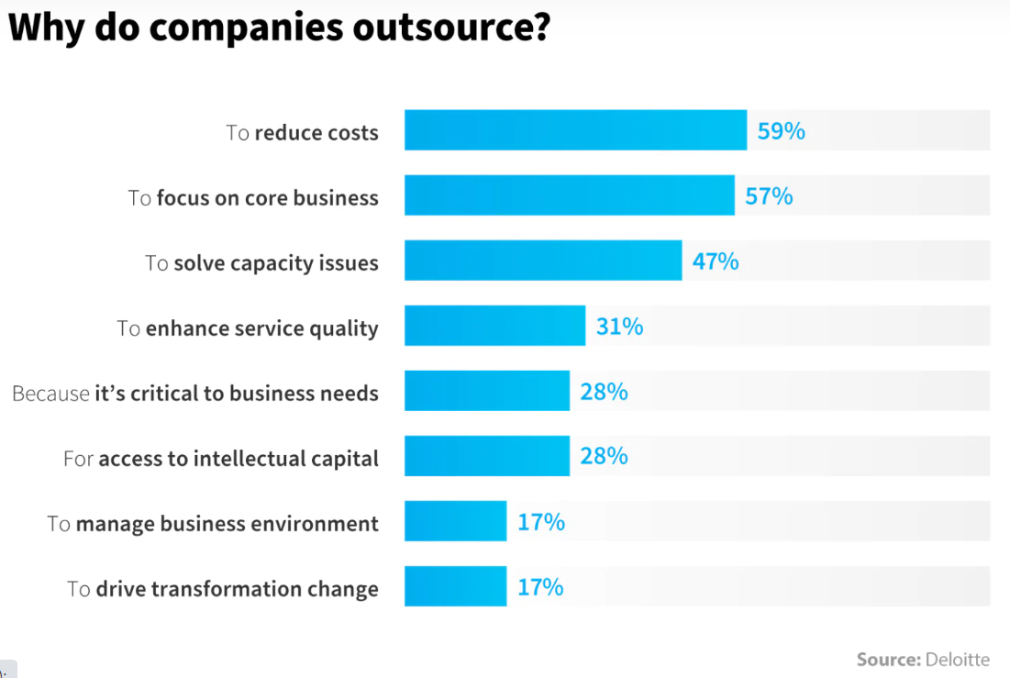
Here is a graph from Deloitte to show why company’s outsource:
(Nix United, 2020).

PROS AND CONS OF OUTSOURCING
According to a Deloitte study most company’s outsource to reduce cost, elevate the way they do business and improve and be flexible in the way they deliver to the market and with the recent pandemic, this makes sense (Prater, 2022).
Here we will look at the advantages of outsourcing.
1. SAVE MONEY
It is less expensive to hire a professional outsourced team than hiring in house employees for example an in house employee would need extra training to do their assigned job therefore needing extra revenue from the company to help them and time consuming, In average it would cost the hotel on average around $4,129, to train, in house employees (Cohen, 2021).
2. REDUCE WORKLOAD AND SAVE TIME
Outsourcing saves time for you and the employee which reduces the workload off you and the in house employee this helps reduce the risk of employee burnout which is a major challenge that is affecting employee retention in the hospitality sector, and increases employee satisfaction (GrowthForce, n.d.).
3. ACCESS INDUSTRY EXPERTS
Accessing professional experts in the departments needed and have top talent services, rather than minimising your service to the bare minimum of what your in house employee knows (Growthforce, n.d.).
4. TECHNOLOGY
Technology is an important part of the hotel business and getting an expert in to do all the websites, check in facilities and keyless entries and upgrades is worth it as todays consumer trends and customers are exposed to it due to the pandemic for one thing and other hotels are doing it, so makes sense to level up to competition (OpenKey, 2018).
Here we look at the disadvantages of outsourcing
1. SECURITY AND CONFIDENTIALITY RISKS
Choosing a good provider to deal with all your financial and security policies is vital as confidentiality is key. Falling in to the wrong company could be disastrous for your company in terms of confidential information leaking out (GrowthForce, n.d.).
2. LOSS OF CONTROL
Outsourcing usual means leaving it up to the experts, but sometimes its best to check in and liaise with a company to see they are following your company culture and following the task they are hired to perform (Growthforce, n.d.).
3. QUALITY CONCERNS
Hotels outsource to get the job in hand done better than could be done in house but sometimes you might experience quality issues from guests or from the in house employee’s. For example, on Hilton’s trip advisor a guest had left a comment stating that the outsourced F&B was not there usual and not up to scratch as they had been coming to the same hotel for 14 years and outsourcing has ruined the hotels reputation (SooHeeT1, 2019).
4. SLOW RESPONSE TIME
As a hotelier outsourcing you might not always be a priority for the company depending on how many contracts they have taken on so response time might be slow and not to your liking, or time frame. So work that needs carrying out can take longer or be rushed (Prater, 2022).

The housekeeping department has the highest turnover in the industry, outsourcing in this department helps with wages and benefits as staff are usually on a fixed contract.so no hidden extras (Staff, 2010).
In a global survey it found an increase in revenue and strong growth within the industry using outsourcing, over the past two years,75% managers reported an increase in terms of revenue growth, and one in four reported a growth greater than 10% (Deloitte, n.d.).
Hilton hotels are not showing much evidence of outsourcing housekeeping, but during the pandemic they teamed up with RB makers of Lysol and Dettol a new programme to deliver cleanliness and disinfection. Hilton clean stay with Lysol protection. The goal is to provide guests with peace of mind with a focus on cleanliness, as research had indicated that guests were concerned during covid and needed reassurance in the hotel’s cleanliness, if they were to resume back after travel restrictions were lifted (Simon, 2020).
Also, during the pandemic Hilton eliminated daily housekeeping as guidelines were given by government, Hilton is sticking to this and will only clean your room on day 5 of your stay or otherwise told to by the customer. This eliminates the need for extra staff or helps housekeeping staff to carry out other jobs and is money and time saving (Schlappig, 2021). Although there are mixed reactions to this, from Hilton customers who regularly stay, some say they are not bothered others say Hilton is cutting corners and trying to save money and all rooms should be cleaned not as and when or asked by a customer.

EVALUATION
What we need to consider in this report is how effective is outsourcing to in house and which is more effective and proven to work. As we can see for Hilton, they have used a variety of outsourced company’s to tackle mostly there IT demands and are currently invested in a long term program with these company’s this shows that they have cut overhead and are most likely in profit, generating good revenue and sticking to their proposed budget plan. Hence the long term contract.
With most outsourcing, the cost benefits need to outweigh in house production to be feasible, each hotel will find their own way of what works for them in terms of cost and guest satisfaction. Finding ways to eliminate jobs in hotels is an effective tool to saving money. Having everything under one roof is a concept that in todays market will not work effectively as with new technology and the mind set of the next generation hotels need to follow trends and be accessible as possible. This involves outsourcing your IT resources and getting help from professional’s.
For the hotel industry outsourcing non core functions helps you focus better on what your hotel is intended to do give the guests the experience they came for.

CONCLUSION AND RECOMMENDATION
In conclusion this report has showed us the pros and cons of outsourcing, it is up to an individual hotel to find the right balance between making a revenue and over head costs and weighing it up, finding out what your requirements are and knowing what your company is lacking in, will help you whilst outsourcing (Nix United, 2020). This is a common practice in the hotel industry, but functions that have direct impact with guests are less likely outsourced for example concierge, these need staff training. So, an in house approach. As a recent study found that 57% of people cited that they had a bad experience at a hotel due to employees (OpenKey, 2018).
Looking at outsourcing it outweighs the cons, and to be fair most hotels do need that help from outsourcing and the experts, to rebound faster in the market place than the hotels around them (Landman, n.d.).
Compared to in house managers witch outsourced, outsourced has the most advantage, because the average revenue for in house varies depending on your expertise, whilst outsourced management has a fixed revenue irrespective of their expertise in that field (Sarmah, 2021).
Outsourcing success is based on finding the right company for your hotel they should be engaged and share the same vision as you and follow the company mission and values as the hotels reputation is still important (Weiss, 2021).
Outsourcing is recommended for most hotels to keep up with competition save time and money tackle employee burnout, reduce unemployment, improve in areas that need expert help generate revenue and keep customers, employees happy and engaged.
The important thing about outsourcing is it becomes a powerful tool to leverage talent improve productivity and reduce work cycles, and in the long run improve the core ability to change and grow (Dalleva, 2019).
When business owners, have time to invest more time in their growth opportunities and not worry about tasks that there not suited to, that’s when you know outsourcing has achieved its goals, and revenue and company reputation is on point (Larase, 2021).

Bibliography
Accenture (2010) Hilton Worldwide and Accenture Announce Multi-Year Technology Services Agreement. Available at: https://newsroom.accenture.com/news/hilton-worldwide-and-accenture-announce-multi-year-technology-services-agreement.htm (Accessed: 03 March 2023).
Admin. (2016) ‘The outsourcing dilemma’, Hotel & Catering News Middle East, 1st March. Available at: https://www.hotelnewsme.com/interviews-features/the-outsourcing-dilemma/ (Accessed: 01 March 2023).
Beers, B. (2022) ‘Outsourcing vs. Insourcing: What's the Difference?’, Investopedia, 26th December. Available at: https://www.investopedia.com/ask/answers/032715/whats-difference-between-outsourcing-and-insourcing.asp (Accessed: 01 March 2023).
Cohen, D.B. (2021) ‘Pros and cons and the impact of outsourcing on employees’, Atera [blog], 31st January. Available at: https://www.atera.com/blog/understanding-the-impacts-of-outsourcing-your-business/ (Accessed: 03 March 2023).
Dalleva, N. (2019) ‘12 Of The Best Quotes about Outsourcing’, SAS Call Center [blog], 12th July. Available at: https://www.sascallcenter.com/12-of-the-best-quotes-about-outsourcing/ (Accessed: 07 March 2023).
Deloitte. (n.d.) Global outsourcing survey 2022. Available at: https://www2.deloitte.com/us/en/pages/operations/articles/global-outsourcing-survey.html (Accessed: 05 March 2017).
Dixit, S. (n.d.) ‘What are Benefits Of Outsourcing Housekeeping Services In The Hotel And Hospitality Industries’, Rare Hospitality [blog]. Available at: https://www.raregrp.com/what-are-benefits-of-outsourcing-housekeeping-services-in-the-hotel-and-hospitality-industries/ (Accessed: 01 March 2023).
Goswami, S. (2022) ‘Outsourcing Your Hotel Housekeeping: The Ultimate Guide for Hoteliers’, eZee Absolute [blog], 19th December. Available at: https://www.ezeeabsolute.com/blog/outsourcing-hotel-housekeeping/ (Accessed: 01 March 2023).
GrowthForce. (n.d.) ‘Pros and cons and the impact of outsourcing on employee The Pros and Cons of Outsourcing in 2023’, GrowthForce [blog]. Available at: https://www.growthforce.com/blog/the-pros-and-cons-of-outsourcing-in-2023 (Accessed: 04 March 2023).
Hilton International. (1999) ‘Compaq signs outsourcing deal with Hilton International’, Hospitality Net, 15th February. Available at: https://www.hospitalitynet.org/news/4001646.html (Accessed: 01 March 2023).
Howarth, J. (2023) ‘47 New Outsourcing Statistics (2023-2026)’, Exploding Topics, 19th January. Available at: https://explodingtopics.com/blog/outsourcing-stats (Accessed: 01 March 2023).
Lam, T. and Han, M.X.J. (2005). A study of outsourcing strategy: a case involving the hotel industry in Shanghai, China. International journal of hospitality management, 24(1), pp. 41–56. Available at: https://doi.org/10.1016/j.ijhm.2004.04.002
Landman, P. (n.d.) ‘Now is the time for Hotels to Outsource!’, Xotels. Available at: https://www.xotels.com/en/revenue-management/now-is-the-time-for-outsourcing (Accessed: 06 March 2023).
Larase, J. (2021) ‘Benefits of outsourcing: Why companies outsource (10 key benefits)’, MYOB [blog], 14th March. Available at: https://www.myob.com/au/blog/outsourcing-key-benefits-small-business/ (Accessed: 07 March 2023).
Nix United. (2020) ‘Why Do Companies Outsource? Lessons Learned and Outsourcing Examples’, Nix United [blog], 24th August. Available at: https://nix-united.com/blog/outsourcing-who-does-it-and-why/ (Accessed: 03 March 2023).
Omni Facilities Management (2023) Housekeeping Supervisor at Hilton London Metropole. Available at: https://careers.omnifm.com/housekeeping-supervisor-at-hilton-london-metropole-145063.htm (Accessed: 01 March 2023)
OpenKey. (2018) ‘Outsourcing Hotel Operations: Advantages and Disadvantages’, OpenKey [blog], 22nd February. Available at: https://www.openkey.co/2018/02/22/outsourcing-hotel-operations-advantages-and-disadvantages/ (Accessed: 04 March 2023).
Panchal, M. (2021) ‘Outsourcing in the hospitality Industry.’, Linkedin, 24th February. Available at: https://www.linkedin.com/pulse/outsourcing-hospitality-industry-milind-panchal?utm_source=share&utm_medium=guest_desktop&utm_campaign=copy (Accessed: 01 March 2023).
Prater, M. (2022) ‘Outsourcing: Pros, Cons, & Projects to Consider When Hiring a Third Party’, Hubspot [blog], 28th January. Available at: https://blog.hubspot.com/sales/outsourcing (Accessed: 03 March 2023).
Sarmah, H. (2021) ‘In-house vs Outsourced Hotel Revenue Management: Which is Best?’, eZee Absolute [blog], 24th December. Available at: https://www.ezeeabsolute.com/blog/inhouse-vs-outsourced-hotel-revenue-management/ (Accessed: 06 March 2023).
Schlappig, B. (2021) ‘Hilton Housekeeping Is Now On-Demand’, One Mile At A Time, 1st July. Available at: https://onemileatatime.com/news/hilton-housekeeping-on-demand/ (Accessed: 06 March 2023).
Simon, E. (2020) ‘Hilton, AHLA roll out hotel cleaning initiatives’, Hotel Management, 28th April. Available at: https://www.hotelmanagement.net/housekeeping/hilton-ahla-roll-out-hotel-cleaning-initiatives (Accessed: 05 March 2023).
SooHeeT1. (2019) ‘Remodelled and outsourcing destroying the Hilton standard’, Tripadvisor, 13th September. Available at: https://www.tripadvisor.co.uk/ShowUserReviews-g187309-d199638-r709289050-Hilton_Munich_City-Munich_Upper_Bavaria_Bavaria.html (Accessed: 04 March 2023).
Staff, H.M. (2010) ‘Pros, cons of outsourcing housekeeping’, Hotel Management, 7th October. Available at: https://www.hotelmanagement.net/housekeeping/pros-cons-outsourcing-housekeeping (Accessed: 05 March 2023).
Weiss, S. (2021) ‘Outsourced housekeeping - the panacea to all our housekeeping woes?’, Hospitality Net, 25th April. Available at: https://www.hospitalitynet.org/viewpoint/125000100.html (Accessed: 06 March 2023).

