21/11/2025
University of Wales Trinity Saint David
London Campus
E-Portfolio Link: https://25104038.wixsite.com/djassic

Assessment 1
Learning in the Digital Era
Module Name: Learning in the Digital Era
Module Code: ACCA4025
Student Name: Djassic Correia
Student ID: 2510403
Croup No: 2
Lecture’s Name: Koushik Modak
Submission Deadline: 21st November 2025

Table of Contents
Introduction 2
Main Body 2
Task 1: Summary Report and IEEE Referencing 2
Task 1 (a): Report on Essential Academic and Employment Skill 2
Task 1 (b) Similarity Report Analysis 4
Task 2: Collaborative Teamwork and Professional Academic poster and Team Activity: ‘Life is a Team Sport’ introductory activity (mind-map) 5
Mind Map (Collaborative) 5
Individual Academic poster 6
Task 3: Automatic Referencing tool 7
Virtual Collaboration 7
Step by step guide on how to use RefWorks for IEEE referencing 8
Task 4: E-Portfolio creation and review 16
Task 4 (a) E-Portfolio Pages 16
Task 4 (b): Illustrative Review 16
Conclusion 17
References 17
Task 1 References 17
Task 3 References 18

Introduction
In this assessment, I will create an e-portfolio, where I have four tasks: the first is about Essential Academic and Professional Skills, then use the Turnitin link; the second is to create a Mind Map and an Academic Poster; the third is an Automatic Referencing Tool, and choose a topic in Unit 4 to create reference, bibliography and citation , and finally create an e-portfolio.

Main Body

Task 1: Summary Report and IEEE Referencing

Task 1 (a): Report on Essential Academic and Employment Skill
There has been a significant change in how we work and in the work environment. Technological advances have profoundly impacted companies, and to improve this rapidly evolving scenario, companies must have employees dedicated to excelling in technical and professional skills, adopting new technologies, demonstrating self-motivation, and engaging in their work [1].
Companies need responsible workers who can solve problems and who possess the skills and attitude necessary to work in teams. Creativity, once a trait avoided by employers who used a standardized system, is now valued by those seeking to create a skilled and high-performing workforce, essential for competitiveness in today's market. Employees with these skills are highly sought after and considered valuable assets to companies [2].
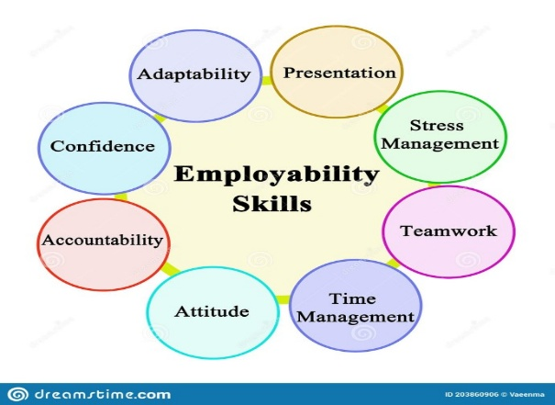
Figure 1: Employability Skills [3].
Students need to be able to communicate effectively both verbally and in writing, able to analyse complex information, evaluate evidence, and develop logical and well-reasoned arguments, to work effectively in teams, respecting diverse viewpoints and contributing their own unique skills [3].
To deal with this challenge, a detailed and data-driven understanding of future skills demand is needed, which will be required in the future labour market as well as the supply of skills that are expected to be available, to meet these challenges of seeking the future skills needed in the labour market, which, according to some research, are currently scarce, it is necessary to avoid side effects in our society [4].

Task 1 (b) Similarity Report Analysis

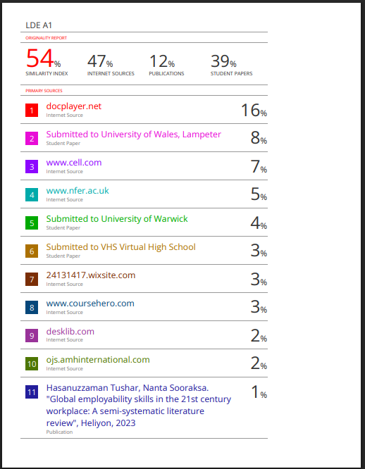
Figure 2: Similarity Check

I have this similarity score because it's the first time I'm doing a project and using Similarity Check, and I found some difficulties finding better sources, reference and some difficulties paraphrasing, and next time I will try my best to lower this score.
I expect a mark of 49. As it is the first time I am doing an assessment of this type, and I completed all tasks included in the description, and I have improved considerably in how to conduct research on Google Scholar and the university's online library, I faced my challenge of doing research in English, which is not my first language, and I managed to overcome it although I used a translator for help, and I hope that with time I can improve even more and use the translator less in the next assessment.

Task 2: Collaborative Teamwork and Professional Academic poster and Team Activity: ‘Life is a Team Sport’ introductory activity (mind-map)

Mind Map (Collaborative)
Mind Map Link: https://mm.tt/map/3845110050?t=qqW00gEgwH

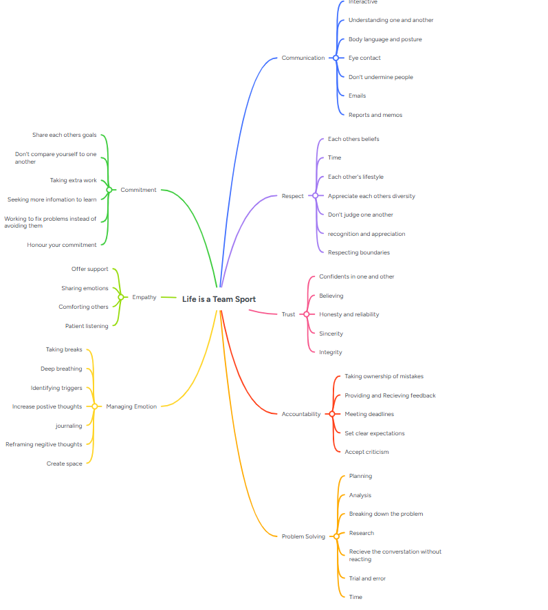
Figure 3: Mind Map “Created with Mind Meister”

Individual Academic poster
Poster Link: https://www.canva.com/design/DAG32Nl8KWU/1j58H2XqI_K23J64t2pkQQ/edit?utm_content=DAG32Nl8KWU&utm_campaign=designshare&utm_medium=link2&utm_source=sharebutton

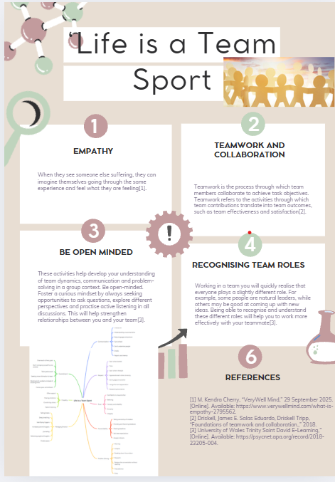
Figure 4: Poster “Created with Canva”

Task 3: Automatic Referencing tool

Virtual Collaboration
Topic 4: Lights Camera, Action
While the demand for online courses has increased, many students also still want to be educated in a traditional face-to-face environment. Lecture capture offers a way for faculty to teach a class both face-to-face and online simultaneously, making the course accessible to both types of students. By using a camera to record the instructor and the whiteboard along with a screen capture and video editing program such as Camtasia 2000 or OBS Studio, instructors can record their in-person lectures and create high-quality videos that can be posted online. These videos can be used by students who are taking the course in an online format or who were unable to attend class as well as by students who attended the in-person lecture and would like to use the lecture video as a study aid[1].
When considering the use of videos in the English as a Foreign Language (EFL) classroom, one might imagine teachers using films for listening or viewing activities, such as asking students to watch a scene from a film and then answer a set of comprehension questions or even complete some type of gap-fill exercise. The example given above is just one example of activities for using videos in the classroom, as they are relatively easy to implement and convenient to integrate into a curriculum plan[2].
The DVD/video format offers an educational program that is convenient, consistent, and interactive for the viewer. Faculty members are essential and instrumental in creating storyboards from a script, which is an initial step in the production of DVD/videos. The authors discuss how faculty can participate in the process of developing an educational DVD/video program[3].
Network managers should start preparing for streaming video technology, which is rapidly improving and will soon find applications on the internet. Streaming media has the potential to provide web-based distance learning directly to desktop computers, and the technology is likely to have a particularly significant impact on corporate training. Another area of application involves placing product brochures on websites. Brochures have a greater impact when presented as videos, and as streaming technology evolves, it will become possible to incorporate hyperlinks into data streams. This means that users will be able to jump from one video presentation to another[4].
The most frequently promoted benefit of these systems is that they are student-centred. It provides students with a resource that enhances learning outcomes, lecture capture has changed the way teachers teach and improved the quality of their teaching[5].

Step by step guide on how to use RefWorks for IEEE referencing

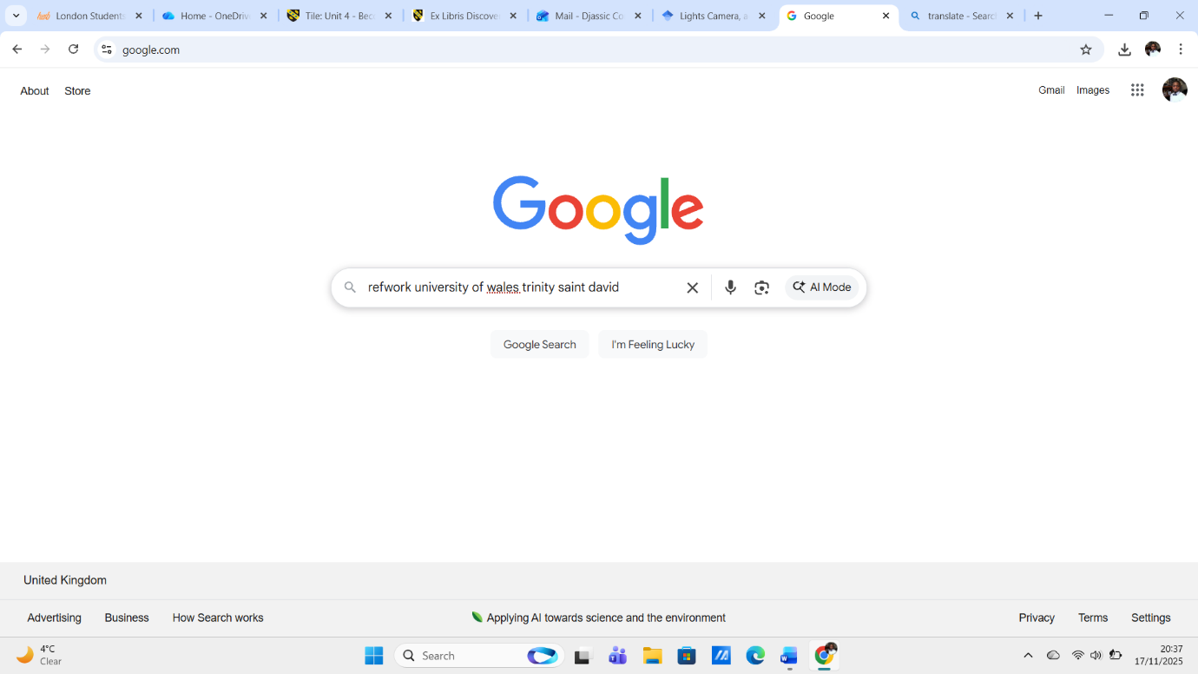
Figure 5: Search RefWorks on Google to confirm if it is available for UWTSD.
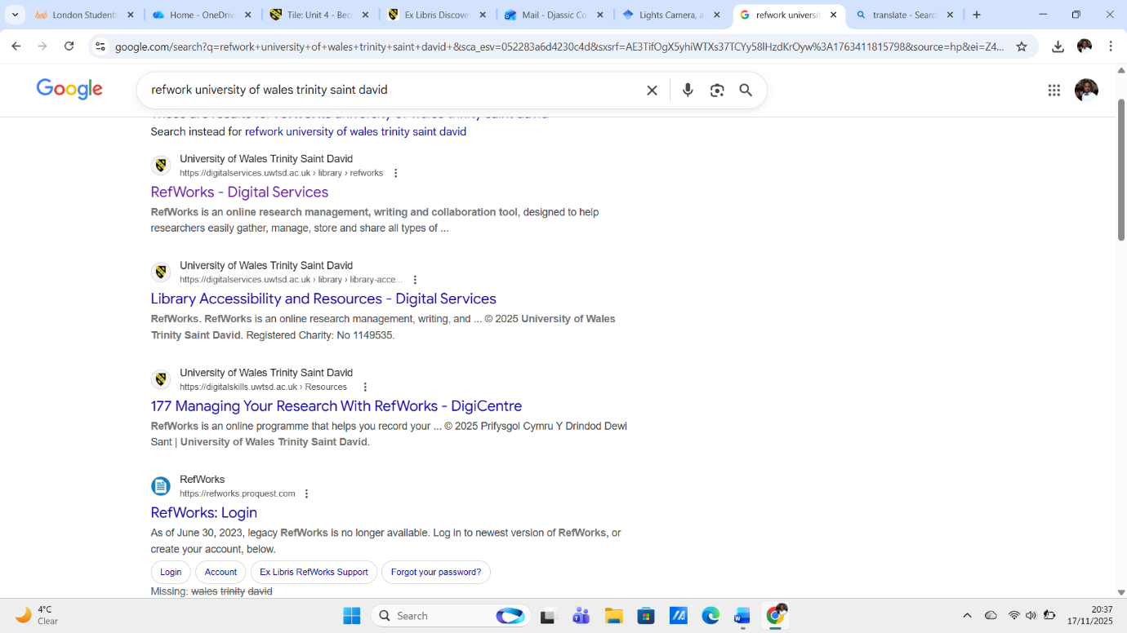 Figure 6: Research result.
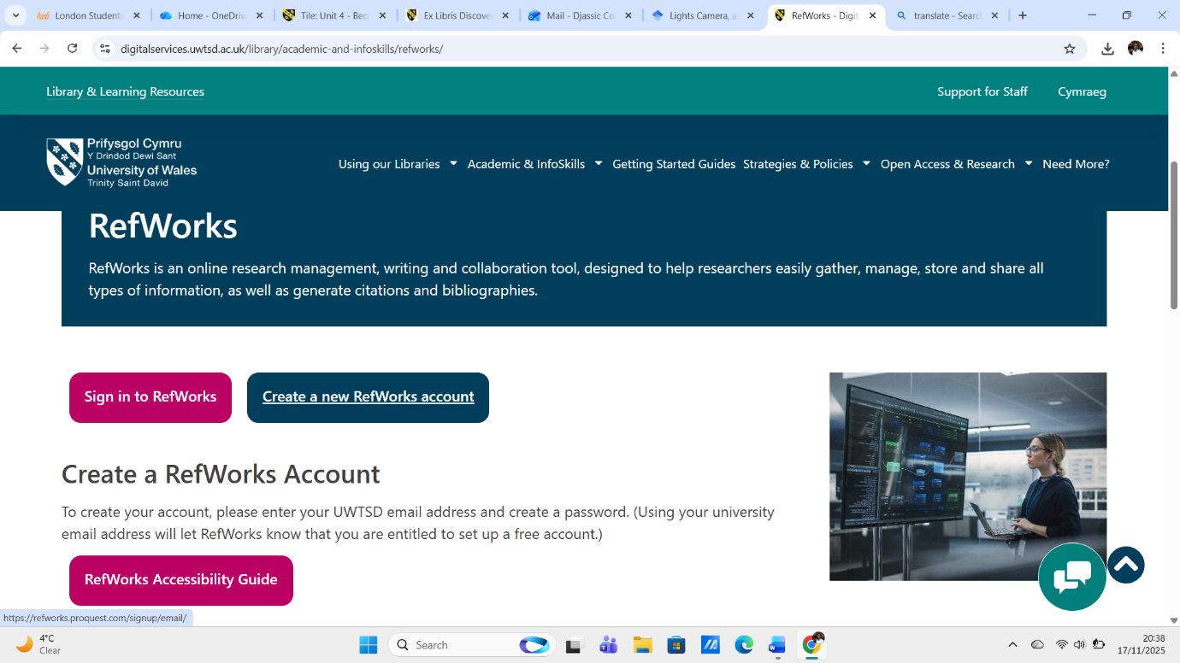
Figure 7: I start creating the account to see if it is available for students.

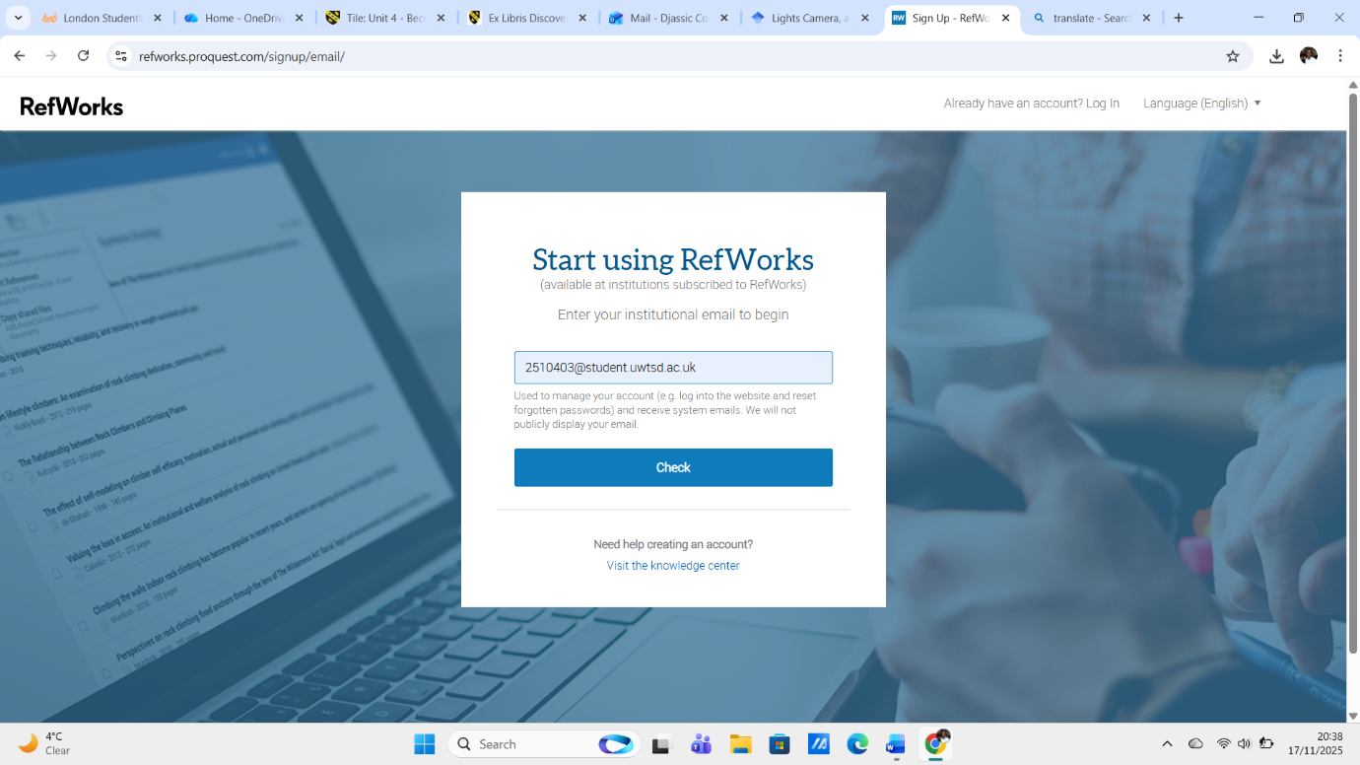
Figure 8: Enter my student email to check.

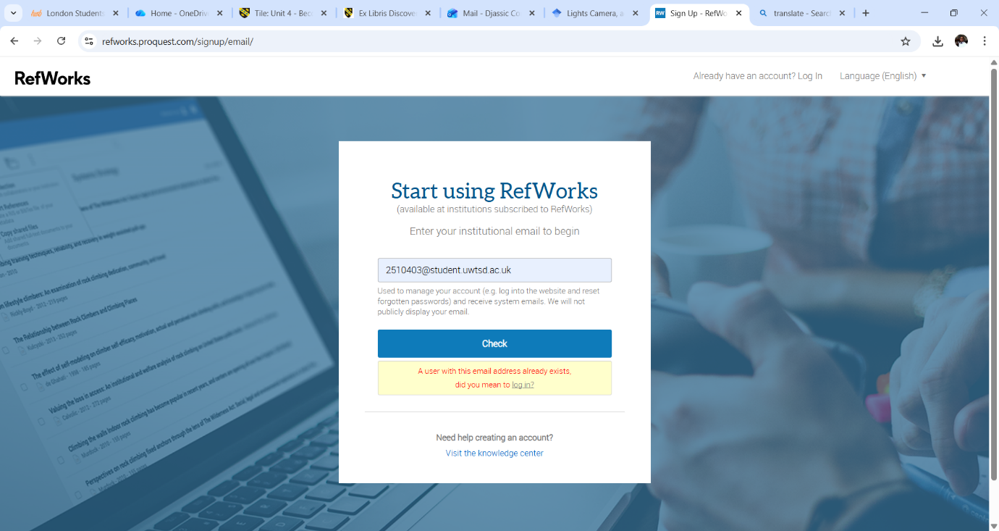
Figure 9: At this step, it was supposed to verify that it was available, but since I had already created the account it was not possible, because there is already an account with the same email.

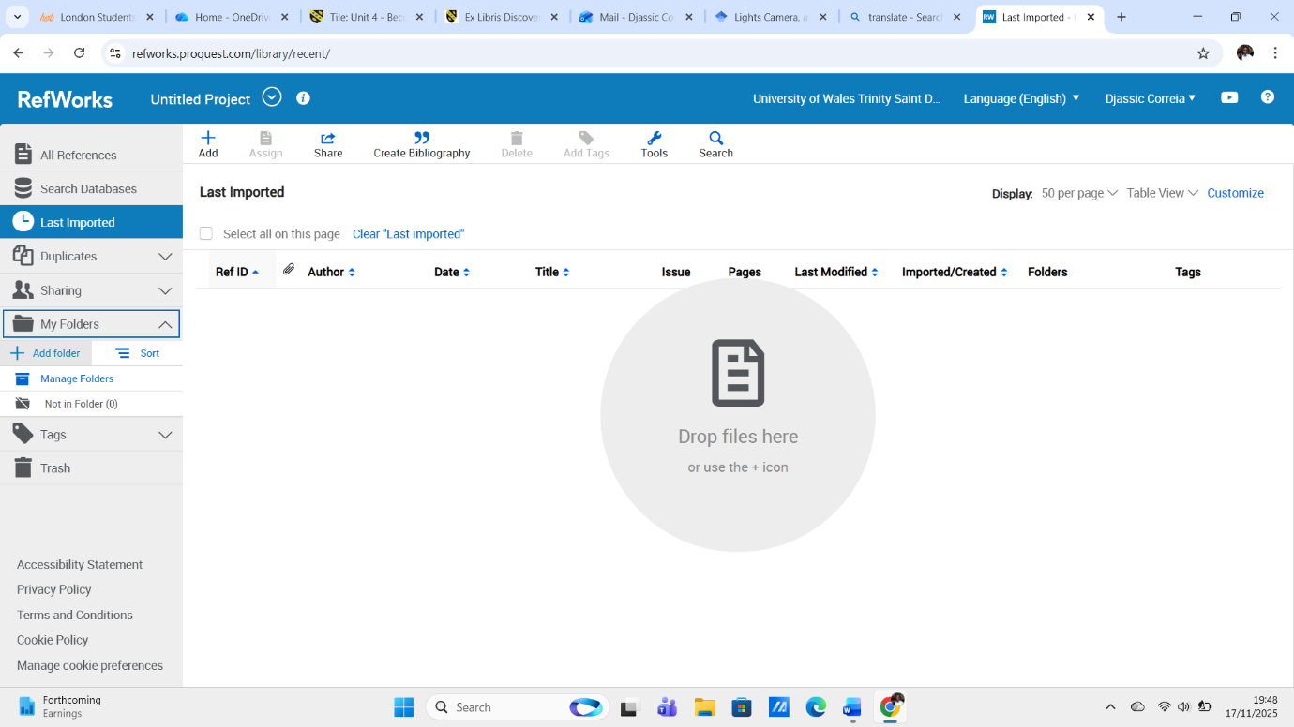
Figure 10: Home Page after logging in.
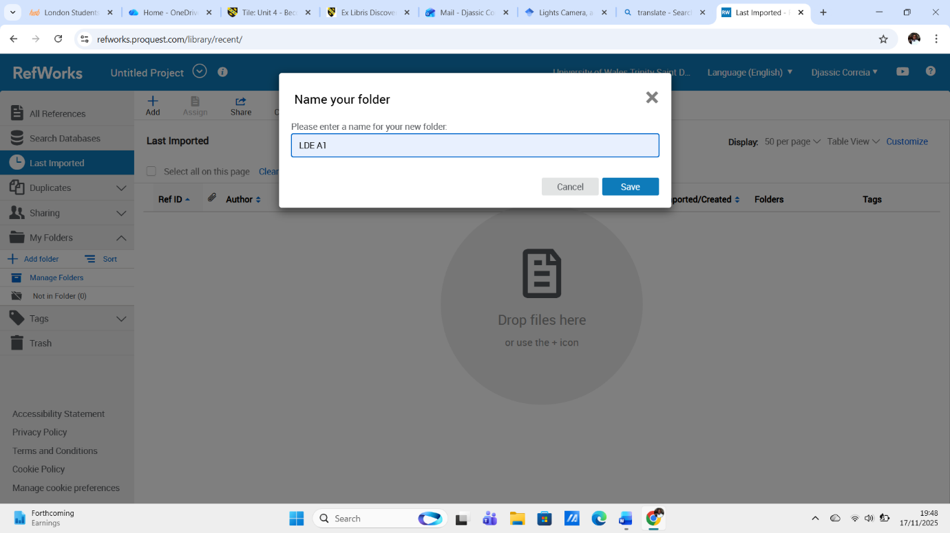
Figure 11: Create a folder to store references.

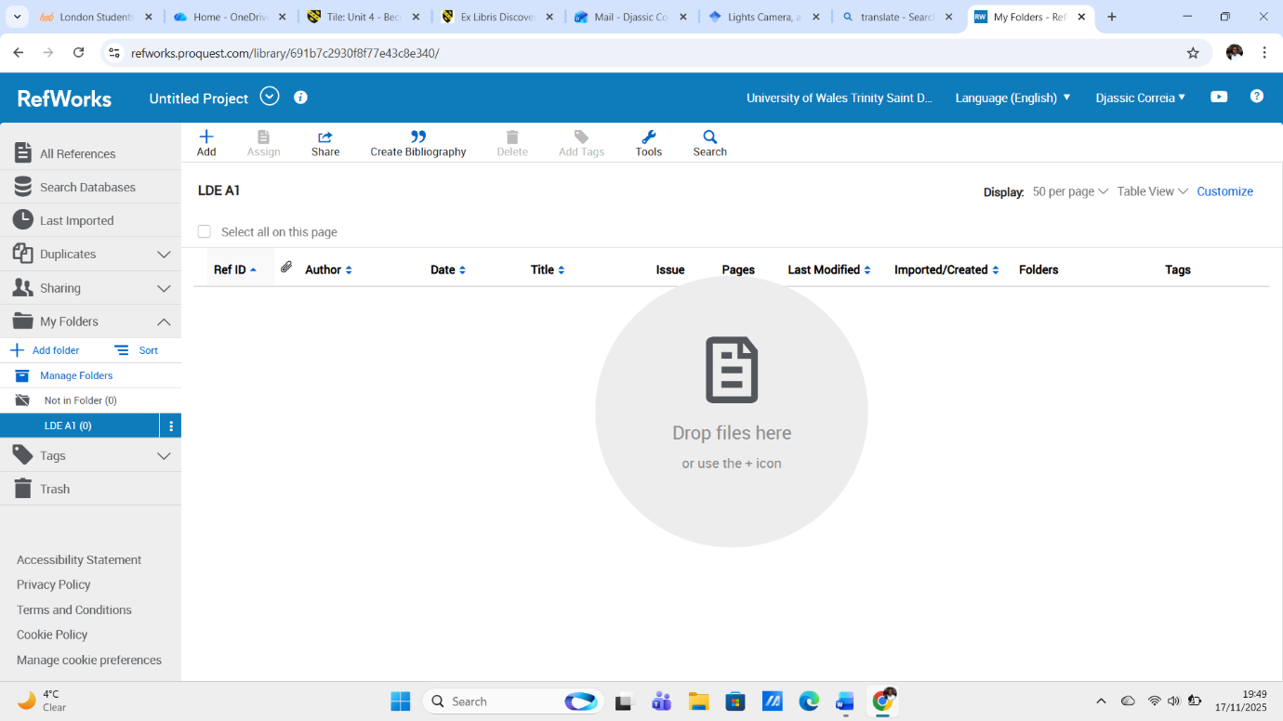
Figure 12: My folder after being created.

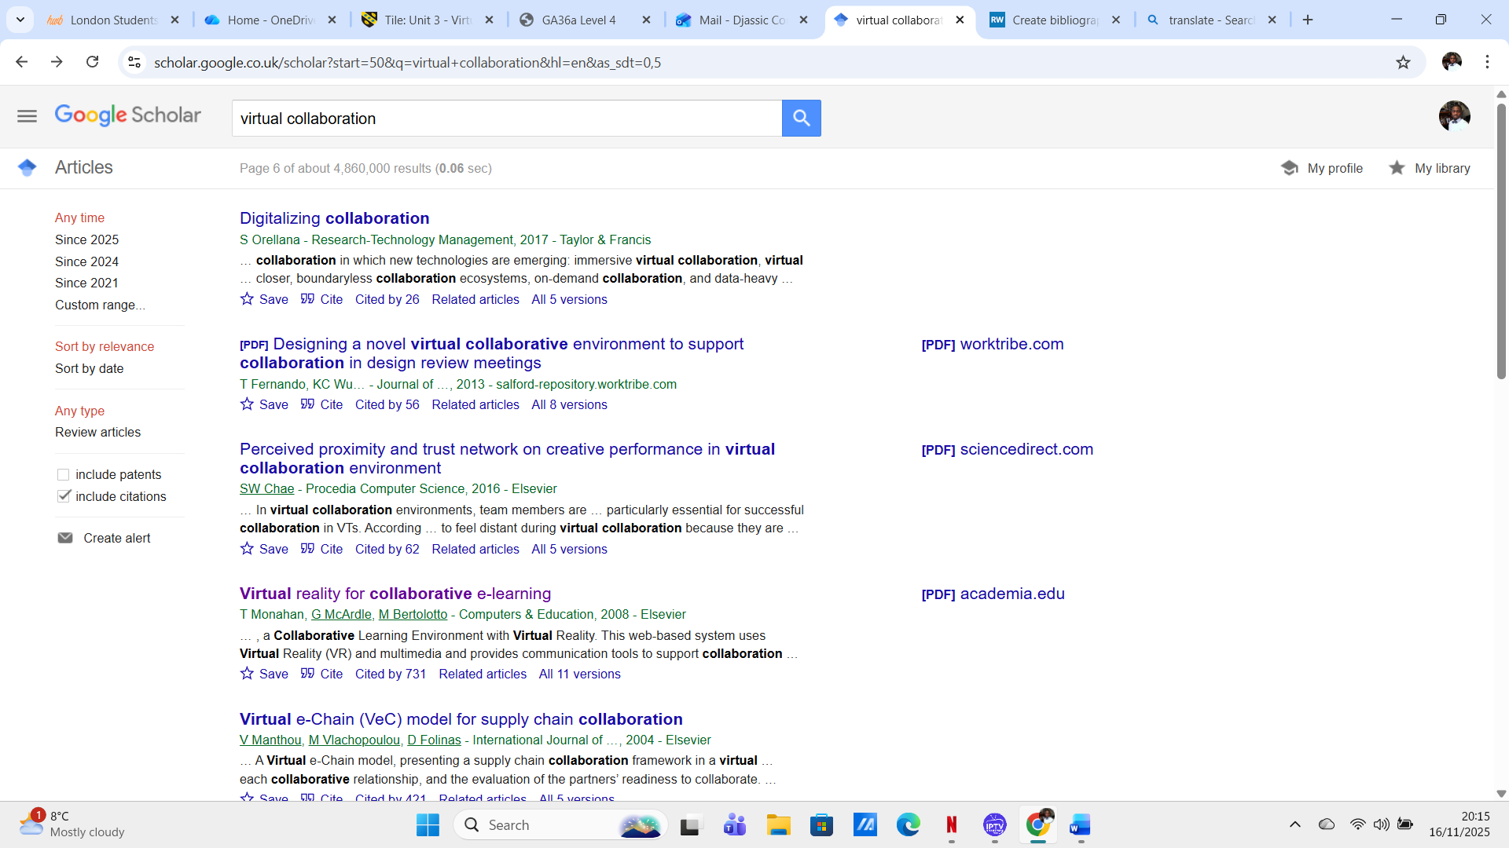
Figure 13: Search sources on Google Scholar.

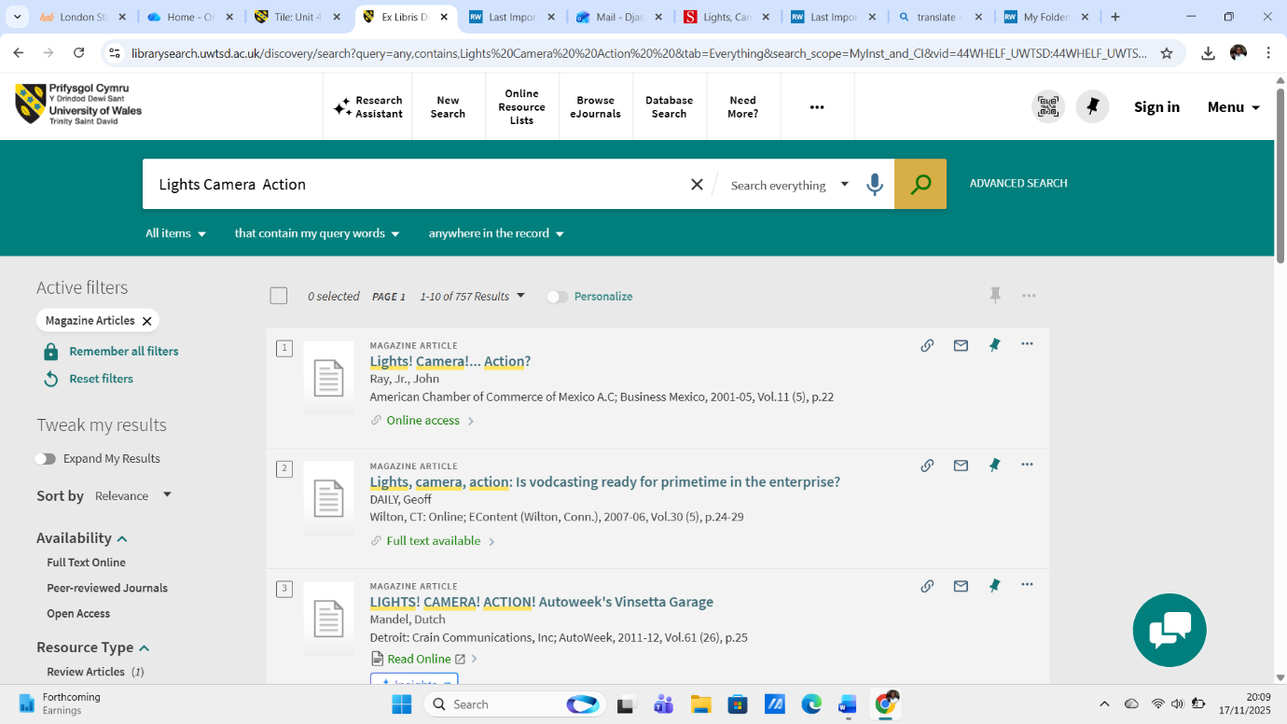
Figure 14: Search for sources in the University's online library.
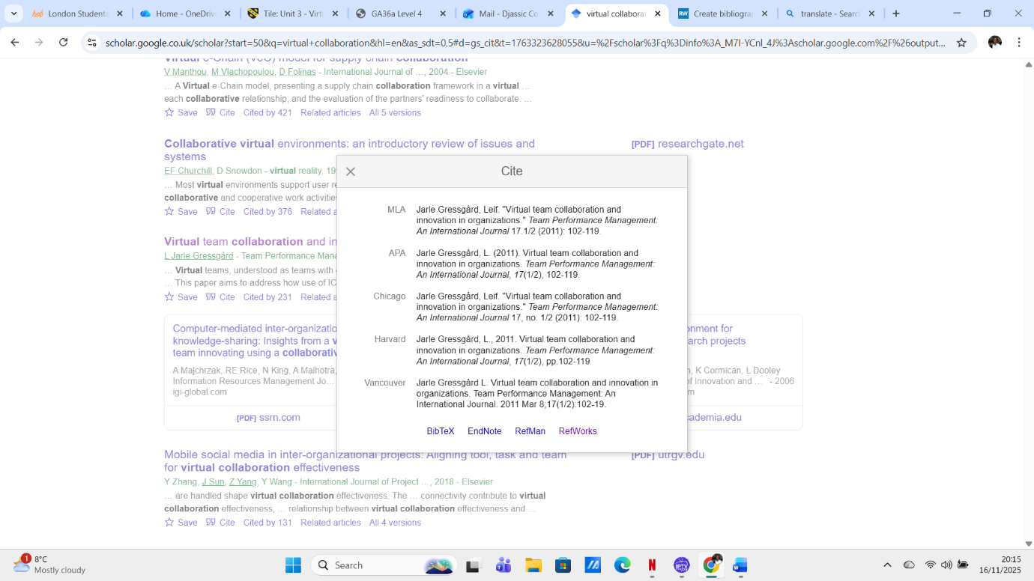
Figure 15: Import reference through Google Scholar, after finding what you are looking for just click on "Cite" below the result, it will give you the option for RefWorks.

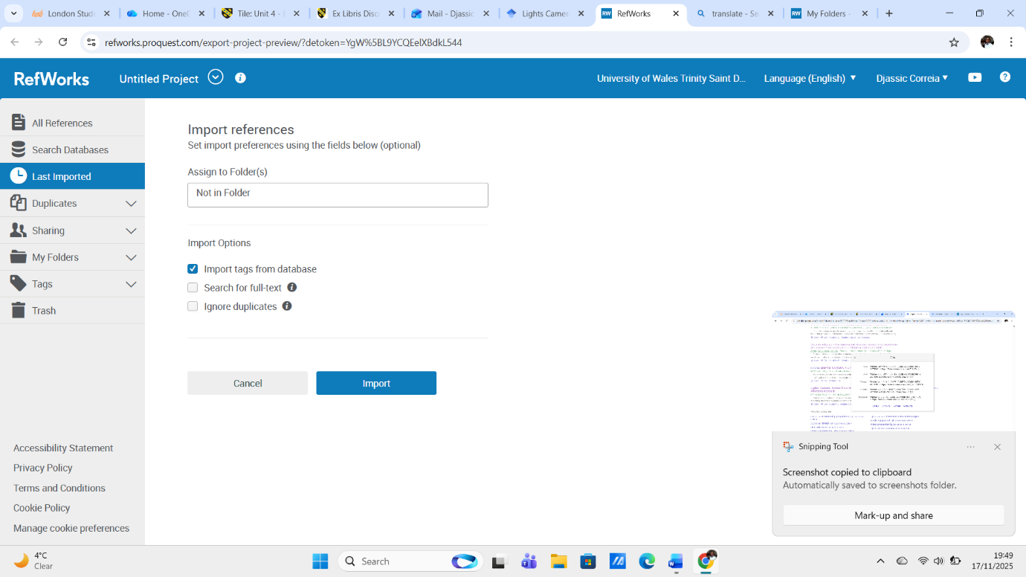
Figure 16: After importing Reference, it will ask you which folder you want to save it.
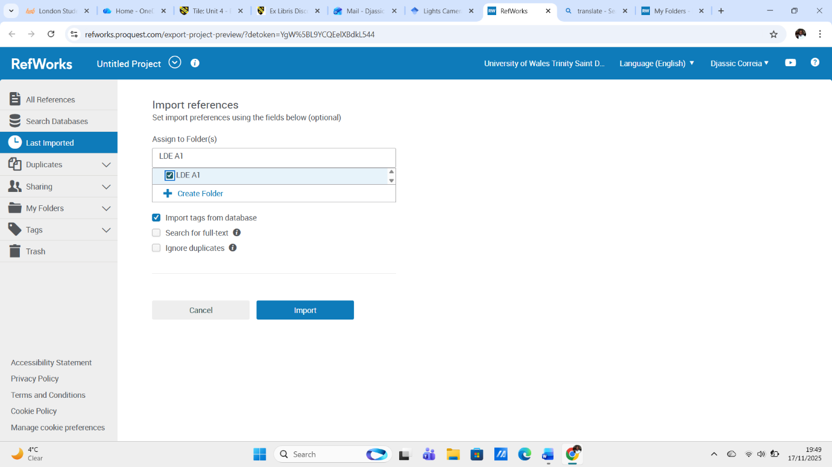
Figure 17: In this step I decided to save it in a folder I had already created.

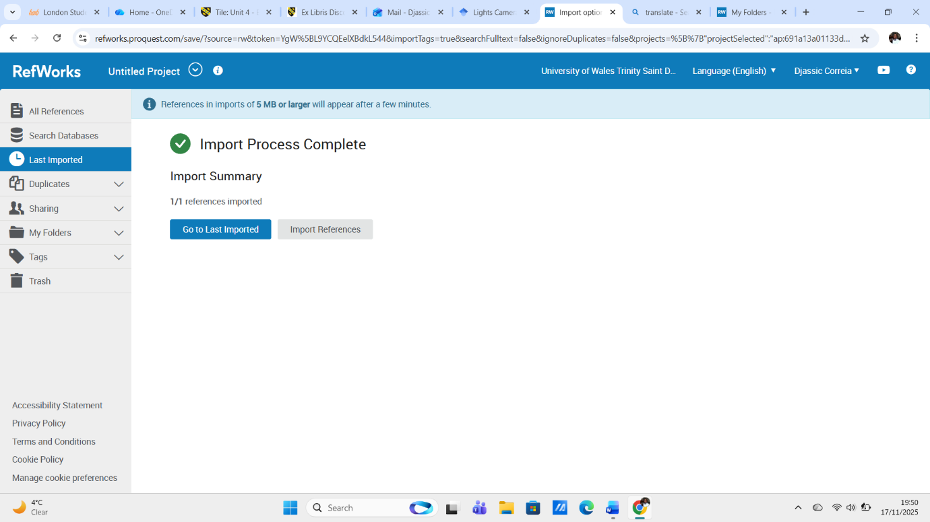
Figure 18: After saving you will receive a notice saying that the import Reference is already complete, you can go back to see the last imported.
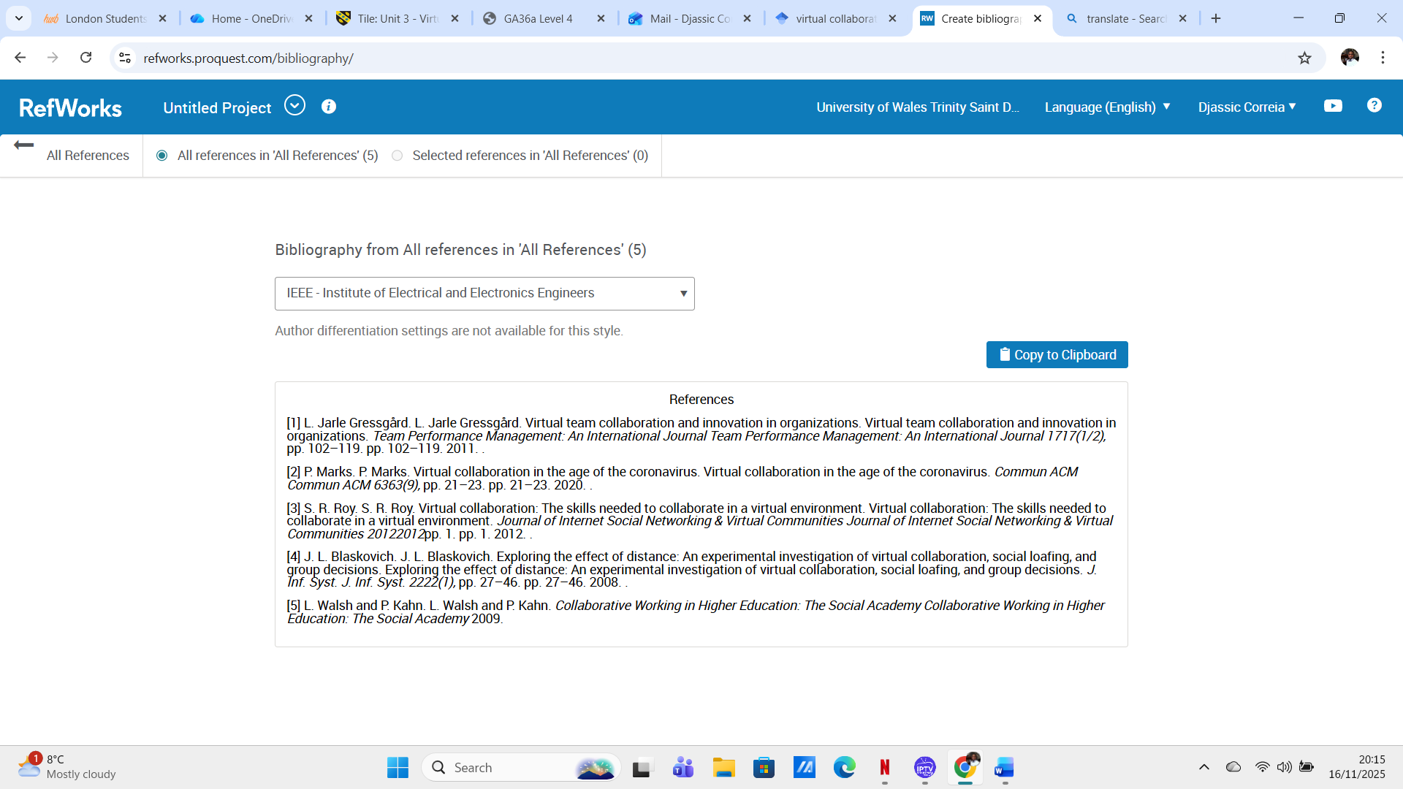
Figure 19: These are the last imported references, where a bibliography was created.

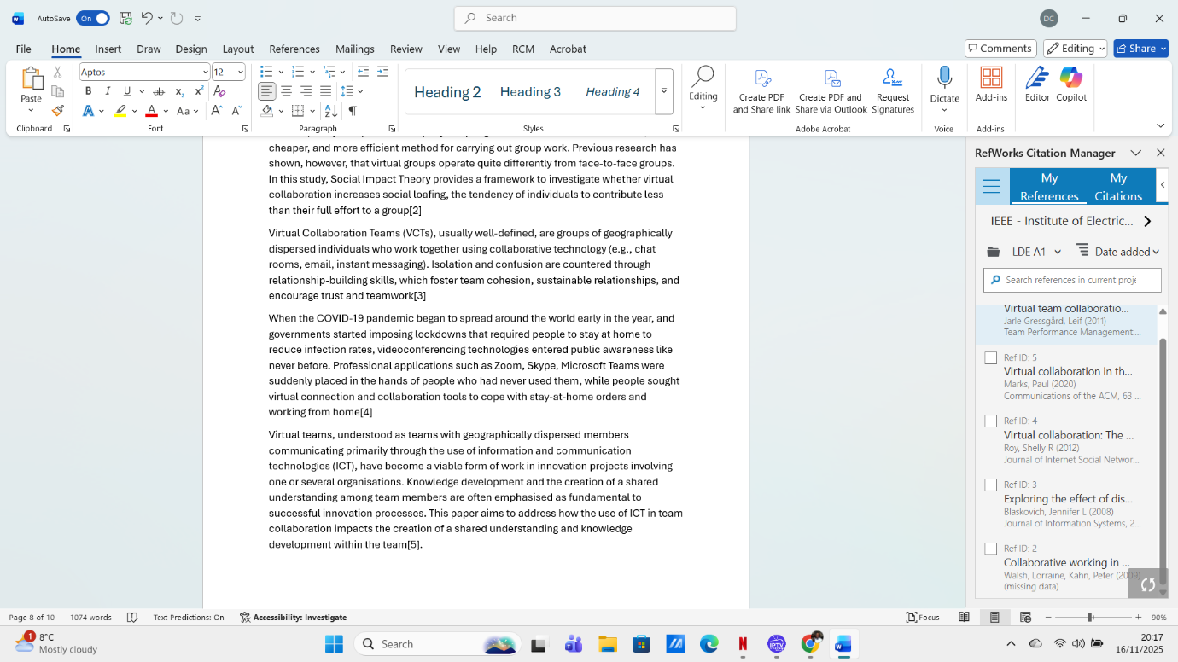
Figure 20: This last picture is where Citation was created in Word.

RefWorks is a citation manager that can help you organize your research b y storing citations from articles you find. You can use these citations to automatically generate your bibliography, formatted according to your chosen citation style.
You can even sync your RefWorks account with Microsoft Word to insert citations into your document text. It's even possible to include it as a browser add-on to create citations from websites. RefWorks isn't very difficult to use, but it does require some practice to become familiar with it.
With RefWorks, you can store, manage, and share references or citations, as well as generate bibliographies in various citation formats such as APA, MLA, etc.
Store your references online and access them from anywhere with internet access.

Task 4: E-Portfolio creation and review

Task 4 (a) E-Portfolio Pages

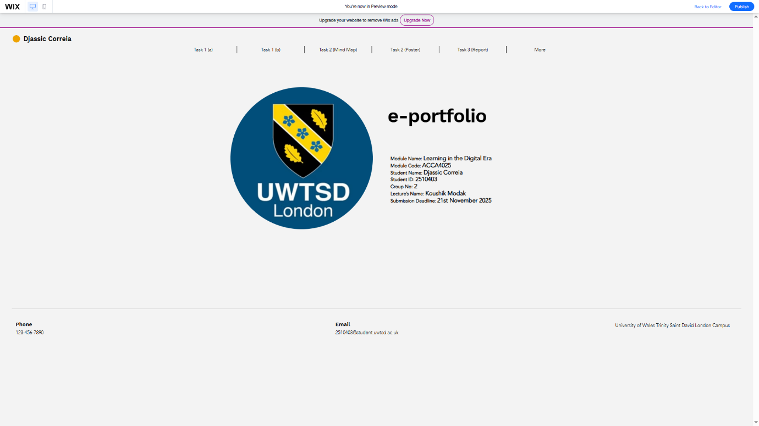
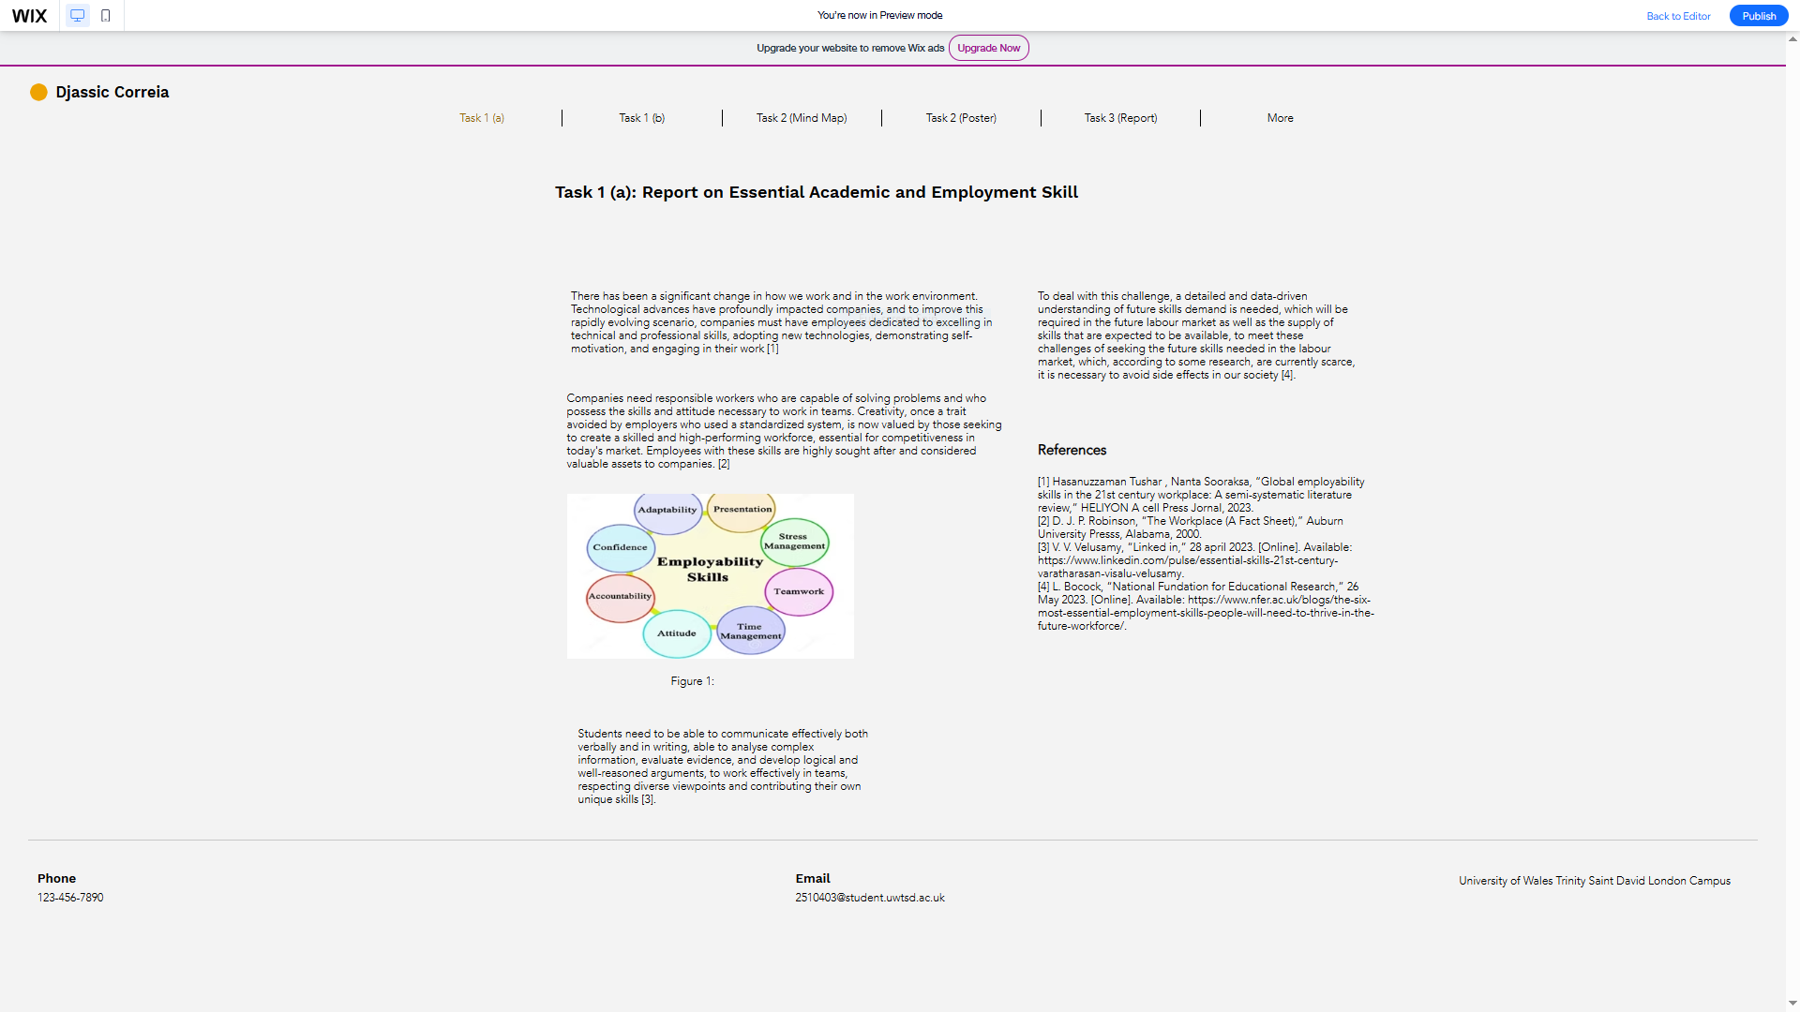

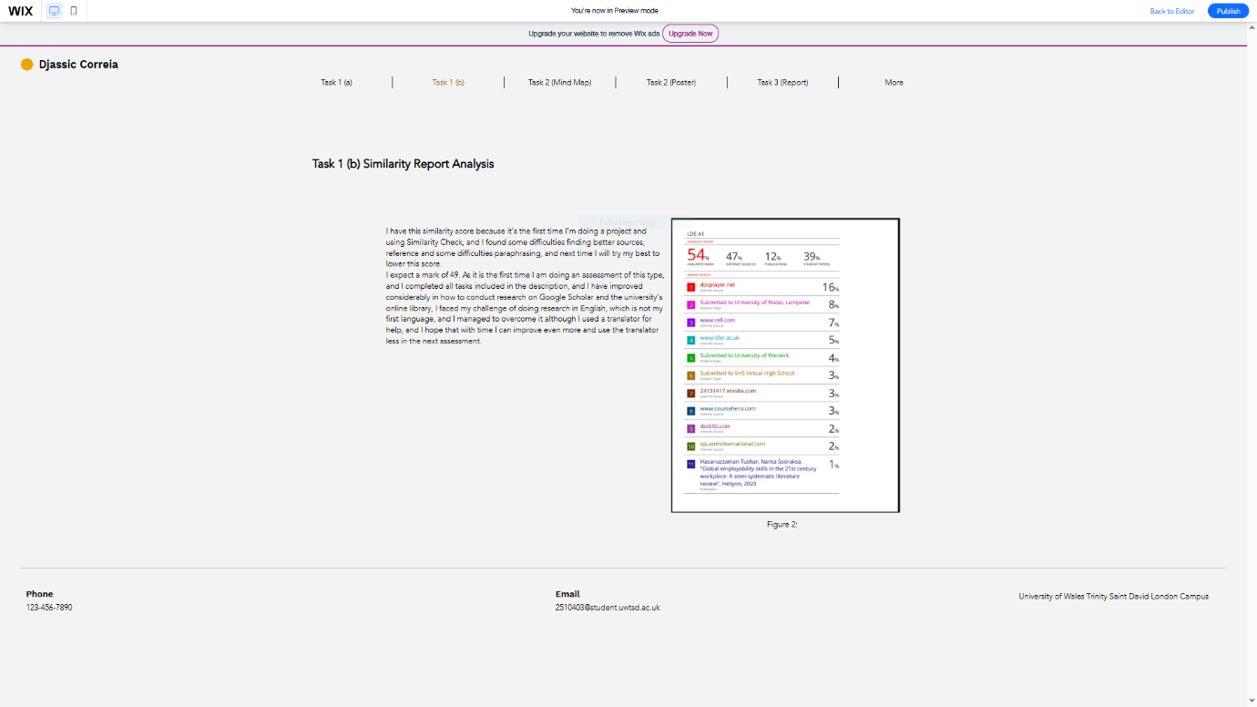
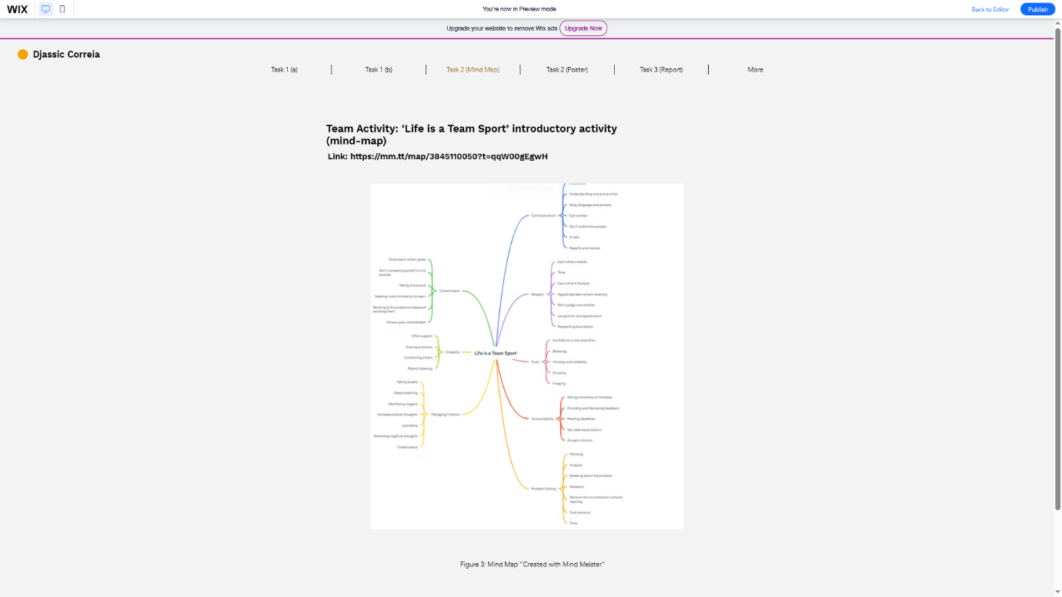

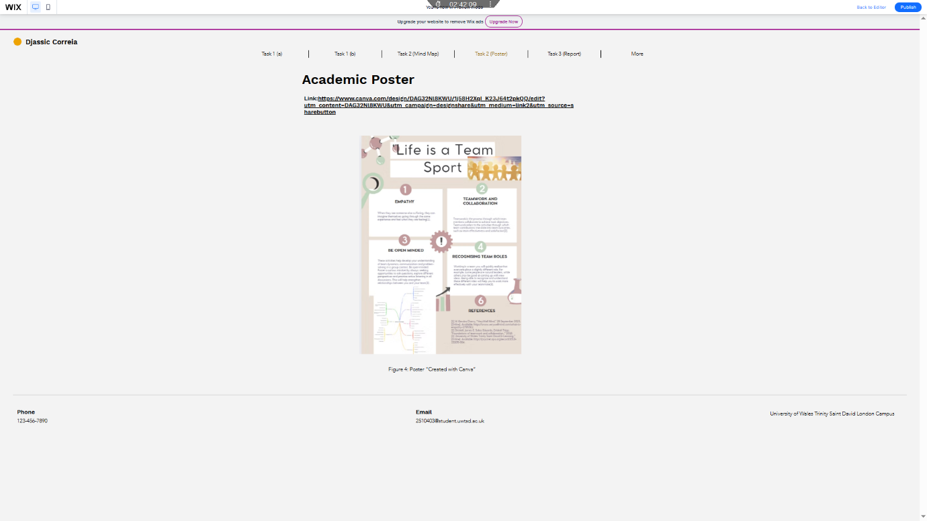
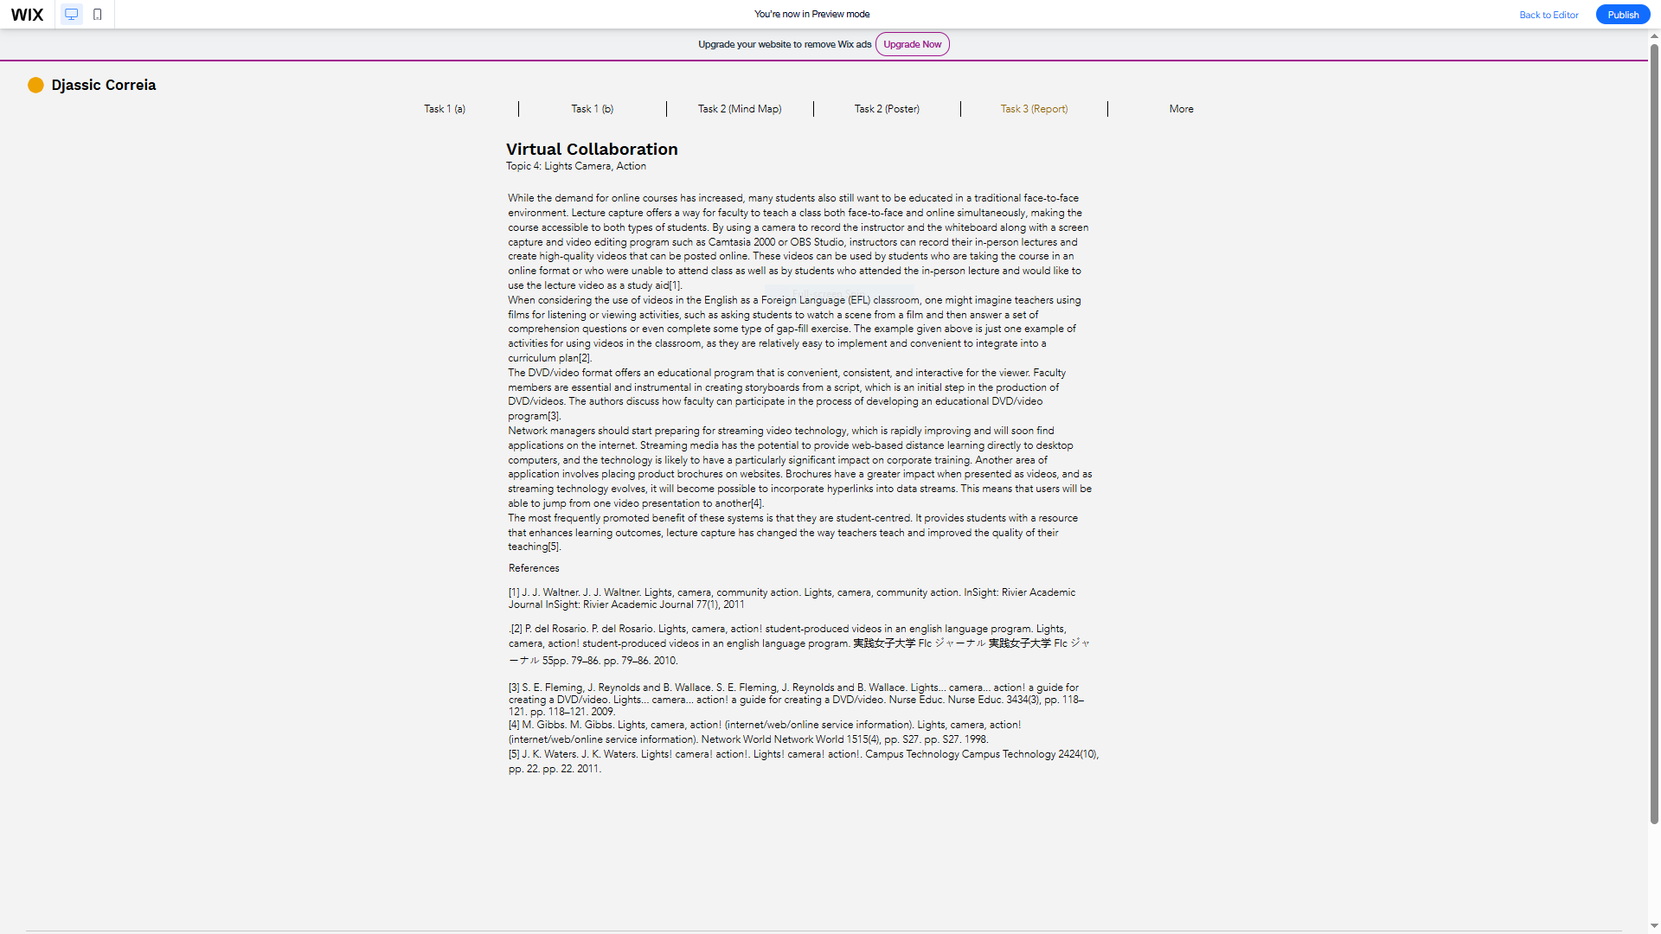

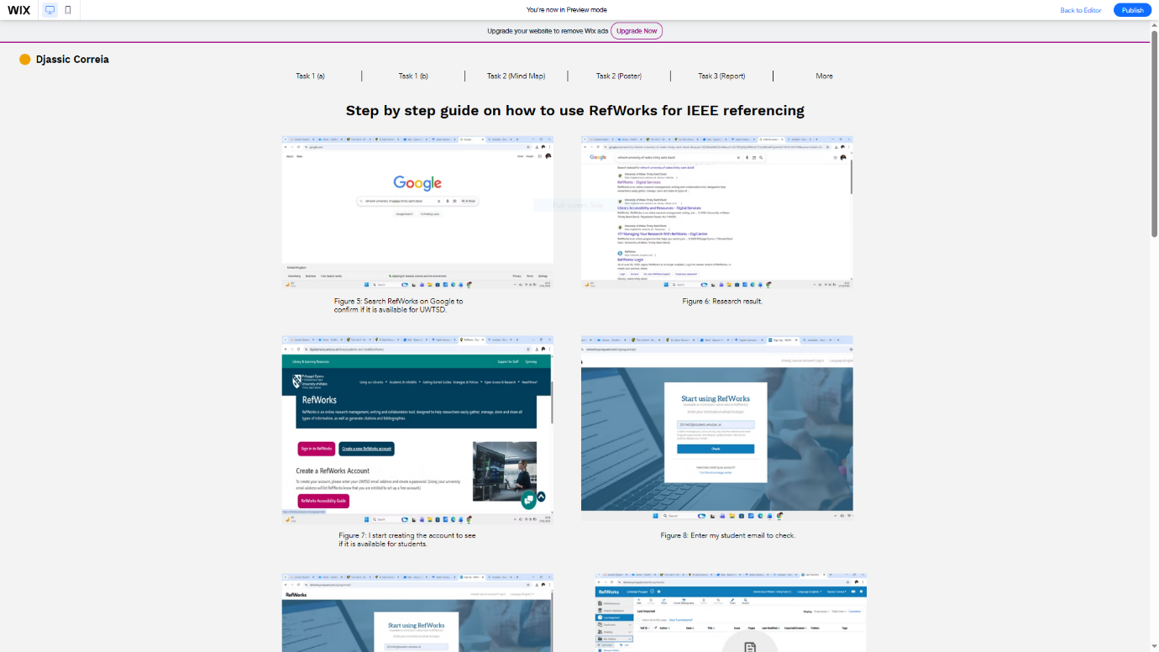
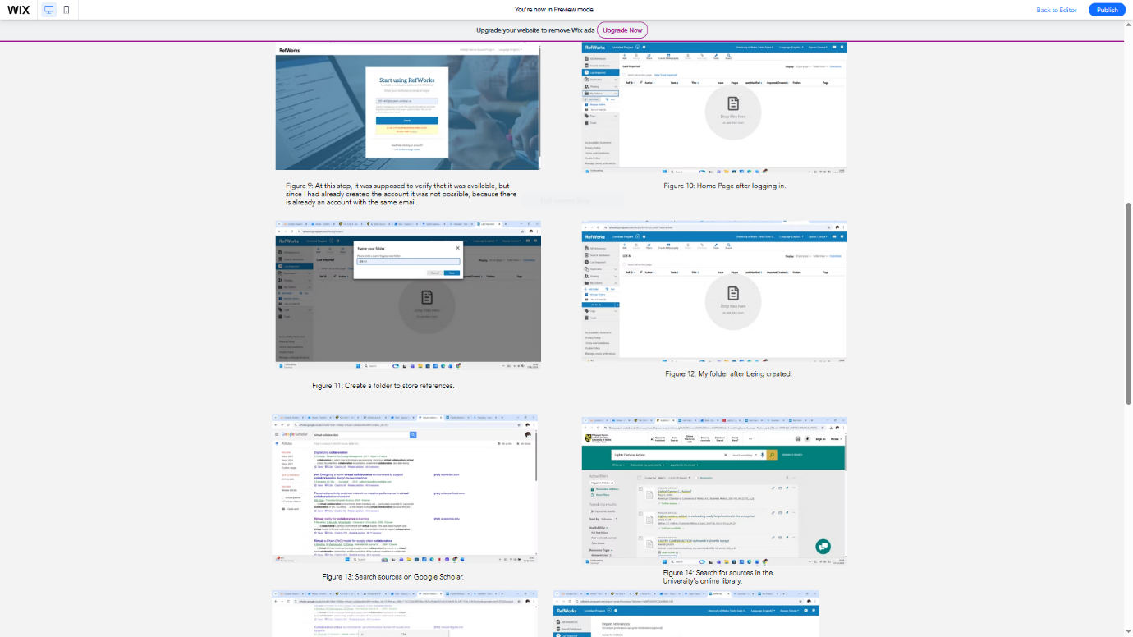

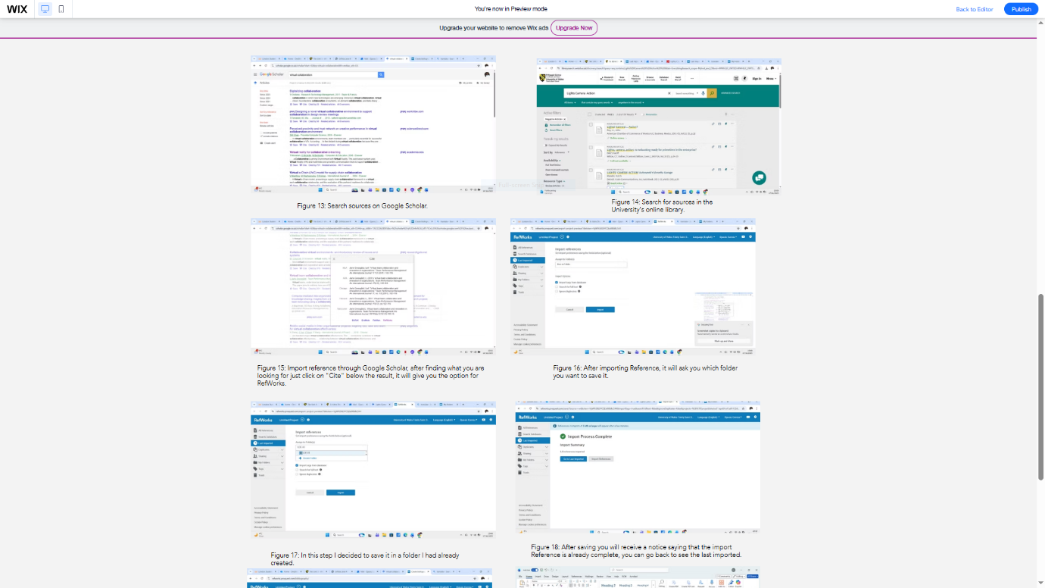
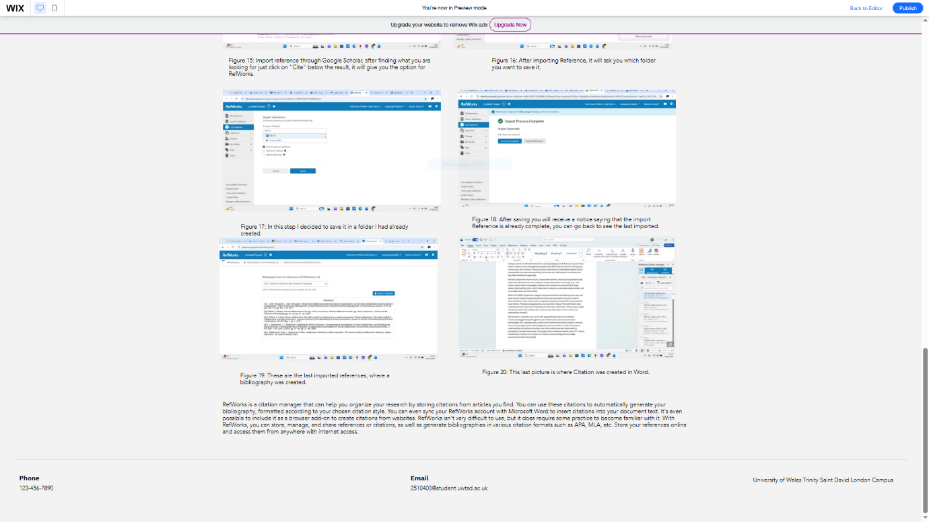
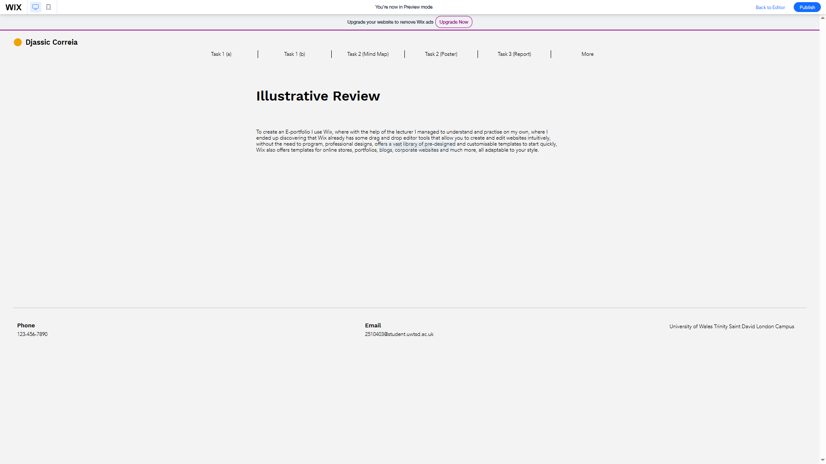

E-Portfolio Link: https://25104038.wixsite.com/djassic

Task 4 (b): Illustrative Review
To create an E-portfolio I use Wix, where with the help of the lecturer I managed to understand and practise on my own, where I ended up discovering that Wix already has some drag and drop editor tools that allow you to create and edit websites intuitively, without the need to program, professional designs, offers a vast library of pre-designed and customisable templates to start quickly, Wix also offers templates for online stores, portfolios, blogs, corporate websites and much more, all adaptable to your style.

Conclusion
I found this assessment very interesting, the main aim of which is to create an online e-portfolio with four tasks, along with some research done for the first one, Essential Academic and Employment Skills, where I was able to discover important skills, and also had the opportunity to learn how to create a Mind Map using Mind Meister tools, create an academic Poster with Canva tools, and create an e-portfolio with Wix tools, which is the main focus of the assessment, where I ended up learning a lot by using these tools mentioned above. I had some difficulties, but with the lecturer's help, I managed to overcome them. Now, the idea for the next assessment is to overcome as many of the difficulties faced in this assessment as possible.

References

Task 1 References

[1] | D. J. P. Robinson, “The Workplace (A Fact Sheet),” Auburn University Presss, Alabama, 2000.
[2] | V. V. Velusamy, “Linked in,” 28 april 2023. [Online]. Available: https://www.linkedin.com/pulse/essential-skills-21st-century-varatharasan-visalu-velusamy.
[3] | Hasanuzzaman Tushar , Nanta Sooraksa, “Global employability skills in the 21st century workplace: A semi-systematic literature review,” HELIYON A cell Press Jornal, 2023.
[4] | L. Bocock, “National Fundation for Educational Research,” 26 May 2023. [Online]. Available: https://www.nfer.ac.uk/blogs/the-six-most-essential-employment-skills-people-will-need-to-thrive-in-the-future-workforce/.

Task 3 References
[1] J. J. Waltner. J. J. Waltner. Lights, camera, community action. Lights, camera, community action. InSight: Rivier Academic Journal InSight: Rivier Academic Journal 77(1), 2011.
[2] P. del Rosario. P. del Rosario. Lights, camera, action! student-produced videos in an English language program. Lights, camera, action! student-produced videos in an English language program. 実践女子大学 Flc ジャーナル 実践女子大学 Flc ジャーナル 55pp. 79–86. pp. 79–86. 2010.
[3] S. E. Fleming, J. Reynolds and B. Wallace. S. E. Fleming, J. Reynolds and B. Wallace. Lights... camera... action! a guide for creating a DVD/video. Lights... camera... action! a guide for creating a DVD/video. Nurse Educ. Nurse Educ. 3434(3), pp. 118–121. pp. 118–121. 2009.
[4] M. Gibbs. M. Gibbs. Lights, camera, action! (internet/web/online service information). Lights, camera, action! (internet/web/online service information). Network World Network World 1515(4), pp. S27. pp. S27. 1998.
[5] J. K. Waters. J. K. Waters. Lights! camera! action!. Lights! camera! action!. Campus Technology Campus Technology 2424(10), pp. 22. pp. 22. 2011.

