A critical analysis of how past major sporting events have impacted the perception and awareness towards disability sport


Dissertation submitted as part of the requirements for the award BA (Hons) Events Management.

Polly Thomas

UWTSD Swansea 2020

Declaration

This work has not previously been accepted in substance for any degree and is not being concurrently submitted in candidature for any degree.
Signed ……………….
Date ………………….

Statement 1
This dissertation is being submitted in partial fulfilment of the requirements for the degree of BA.
Signed ……………
Date ……………..

Statement 2
This dissertation is a result of my own independent work/investigation, except where otherwise stated.
Other sources are acknowledged by footnotes giving explicit references. A bibliography is appended.
Signed ………….
Date ……………

Statement 3
I hereby give consent for my dissertation, if accepted, to be available for photocopying and for interlibrary loan, and for the title and summary to be made available to outside organisations.
Signed …………..
Date ……………

Statement 4
I hereby give consent for my dissertation, if accepted, to be available on the university’s IT system to those who have consent to use the system.
Signed ……………
Date ………………

Acknowledgements

I would like to acknowledge and thank those athletes and disability sport coaches, along with my fellow classmates who all contributed to my research for this dissertation. However, I would like to give a huge thank you to Jayne Thomas, a very special lady who took the time to support me with my work during some trying times, I will never be able to thank you enough!

Also, a very special thank you to my auntie, Alison Prince, she’s an absolute inspiration. She has been amazing. Thank you so much for everything.

I would also like to give a massive thank you to my family for the constant support and guidance. Although it’s been a tough journey, I’ve enjoyed studying this topic and sharing the experience with all of you. Especially my mum who although has been through a difficult time herself, still selflessly supports me with everything I do, and I cannot express enough how lucky I am to have someone as incredible as you in my life. Without you, I would not have been able to do this. I am truly grateful.

Abstract

The aim of this dissertation is to critically analyse whether past major sporting events have impacted society’s perception of individuals with disabilities. This study covers past major sporting events, with the prime focus on the London 2012 Paralympic Games. It also conducts research into society’s perception of disability sport, and whether major sporting events, such as the Paralympic Games, have had any impact on the way society views disability.

The researcher conducted an in-depth review of past and present academic literature on perceptions towards disability overall, as well as disability sport, including discrimination and prejudice, the Paralympic movement, and historic and current legislation.

An online survey was created through the professional platform Google Forms, distributed on the social platform Facebook for a sub-group of university students, to gauge a non-bias societal view of disability sport. There were 110 respondents. However, after the researcher had cleansed the data, there were 107 respondents left. Interviews were also conducted with 6 participants, 5 of whom were disabled athletes, competing at elite level, along with 1 coach, who coaches at a professional level for Great Britain.

The main findings of the study demonstrate that the overall awareness of disability sport in society has increased, through advertisement and promotion. However, athletes interviewed felt that awareness had not in fact increased, but that any understanding would detract from what a disabled athlete could achieve.

Table of Contents

Acknowledgements 1
Abstract 2
Table of Contents 3
Chapter 1 - Introduction 6
1.1 Background 6
1.2 Rationale 7
1.3 Research Aim 8
1.4 Objectives 9
1.5 Structure 9
1.6 Conclusion 10
Chapter 2 - Literature Review 11
2.1 Introduction 11
2.2 What is Disability? 11
2.3 Past Major Disability Sporting Events 12
2.4 Perceived Attitudes Towards Disability in the 20th Century 14
Figure 2.1 – Chronological timeline regarding social awareness of disability. 15
2.5 Existing Present Research on Disability Awareness 15
2.6 Disability Discrimination and Prejudice 17
2.8 Historic and Current Legislation 18
2.9 Paralympic 2012 Legacy 19
2.10 Disability Sports Development 21
2.11 Conclusion 24
Chapter 3 – Methodology 25
3.1 Introduction 25
3.2 The Research Onion 26
Figure 3.1 – An image of Saunders research onion. 26
3.3 Data and Methods 27
3.4 Resources and Planning 28
3.5 Research Strategy 28
3.6 Philosophy and Positivism 30
3.7 Research Methods 30
Surveys 31
Interviews 32
Table 3.1 – Interview Design Approach 33
Table 3.2 - Interview Question and Literature Review Matrix 34
3.8 Pilot Study 36
3.9 Ethical Considerations 36
3.10 Confidentiality and Privacy 37
3.11 Reliability and Validity 37
3.12 Conclusion 38
Chapter 4 - Data Analysis 39
4.1 Introduction 39
4.2 Background 40
4.3 Quantitative Analysis 40
4.4 Main Findings 40
4.5 Descriptive Statistics 41
Figure 4.1 – Displaying how participants became aware of Disability Sport. 41
Figure 4.2 – Displaying British Paralympians. 42
4.6 Chi-square Hypothesis 42
Figure 4.3: Displaying the mean rank for both genders. 46
4.7 Qualitative Analysis 47
4.8 Main Findings 48
4.9 Common Threads 48
4.10 Themes 49
49
Figure 4.4: Word Cloud graphic displaying most commonly used words during interview. 49
Figure 4.5: Commonly used words describing awareness. 50
4.11 Conclusion 51
Chapter 5 – Conclusion and Recommendations 52
5.1 Introduction 52
5.2 Achieving Objectives 52
5.3 Main Findings 53
5.4 Conclusion 54
5.5 Limitations 55
5.6 Recommendations 55
5.7 Further Research 56
5.8 Self- reflection 57
5.9 Final Summary 57
References 58
Appendices 65
7.1 Ethics Approval Form 65
Outline any anticipated risks that may adversely affect any of the participants, the researchers and/or the University, and the steps that will be taken to address them. 73
Full risk assessment completed and appended? 73
7.2 Interview Participant A (Coach) 84
7.3 Interview Participant B (Athlete) 88
7.4 Interview Participant C (Athlete) 89
7.5 Interview Participant D (Athlete) 94
7.6 Interview Participant E (Athlete) 96
7.7 Interview Participant F (Athlete) 98
7.7 Survey Questions 100

Chapter 1 - Introduction
The purpose of this dissertation is to analyse whether past major sporting events impact the way society views individuals with disabilities and evaluates whether disabilities may be looked upon differently in society today. This chapter summarises the aim and objectives, along with discussing the background and rationale to further investigate.

1.1 Background

“Disability is culturally produced through the relationship between the mode of production and the central values of the society concerned” (Oliver, 1990). Sport has such a powerful impact on people, whether as a spectator, or as a participant, sport can be as important to anyone. “Sport is so persuasive in society and has been perceived by society as an equalizer as a means of gaining acceptance” (DePauw, Gavron, 1995, page 4). Consequently, sport is something to feel a part of, as a means of acceptance. “It is estimated that there are 650 million disabled people in the world, approximately 10 per cent of the population” (Fitzgerald, 2009, page 1). This figure demonstrates the vast number of people with disabilities in the world, however having a disability does not define a person. Professor Stephen Hawking (Viewed on 2nd December 2019) is a prime example for this as he states, “Disability need not be an obstacle to success. I have had motor neurone disease for practically all my adult life. Yet it has not prevented me from having a prominent career and a happy life”. (Disability and Vulnerability). There has been extensive research conducted as those with disabilities, may be looked upon differently, but what needs to be asked is whether those with a disability are realising an attitude change in society and consequently a positive impact on these lives. This research demonstrates some individuals with disabilities face limitations each day, socially excluding few from society and making their little participation feel inadequate. Following this, research also indicates an exclusion and disenfranchisement for those with disabilities in the sporting world. Sport has a major role in society, therefore for those disabled individuals not being able to fully participate in these roles, displays a form of exclusion demonstrated on these individuals (DePauw, Gavron, 1995, page 10).

1.2 Rationale

Historically, having a disability was seen as a barrier to success and achievement. The Paralympics has shown the public what can be achieved by athletes with disabilities at the very highest level, highlighting their courage, ability, and determination, inspiring so many others. Although progress has been made, there are still strides to be made in changing people’s perception and attitudes. Traditional societal views have been that a disability is a barrier, we in the future must look upon these competitors as elite athletes and not disabled athletes.

This dissertation reviewed events including the development of Stoke Mandeville. Stoke Mandeville is a hospital in Buckinghamshire, with an internationally acclaimed spinal injuries unit, and part of its rehabilitation process created the first ever competitive games that later into the Paralympic movement (NHS, 2008) which will be discussed later in this study. These events showcase the best athletes from disability sport.

Furthermore, sport has naturally evolved over time, and disabled athletes are beginning to feel more accepted, however, there are still numerous limitations that these athletes are being exposed to. The researcher aims to analyse this further and in more detail in chapter 2, from a range of literature.

This study has produced comprehensive research, in order to establish these findings and to critically analyse historic events in the disabled sporting world. Following this, conclusions are made, considering past sporting events and therefore analysing whether perceptions and attitudes towards athletes with disabilities have altered. With intent to thoroughly research existing theories and build on arguments to critically analyse how effective previous events have been and how they have shaped today’s sporting industry. A critical conclusion has been formed covering all findings on impacts on perception and awareness within disability sport.

1.3 Research Aim
The overall aim of this study is to critically analyse whether past major sporting events have impacted society’s perception of individuals with disabilities.

1.4 Objectives
In order to achieve this aim, the following objectives were formulated using SMART objective setting principles:

- To critically analyse previous academic literature to evaluate how perceptions have been impacted since major sporting events.

- To analyse the degree of awareness of disability sport through conducting qualitative and quantitative research on a sub-group of university students, along with conducting interviews with athletes and a coach in the sport today.

- To provide recommendations to continue the transformation on perception towards disability.

1.5 Structure
In order to successfully achieve the objectives for this study, chapter two has achieved the first objective, to analyse previous academic literature on past and present perceptions of disability sport, and to identify gaps within current literature which could be explored further.

Chapter three identifies the methods used for this study, using both qualitative and quantitative approaches to conduct the necessary research.

Chapter four has analysed the data collected through a quantitative method, being the online administered survey, along with a qualitative method by conducting interviews. This chapter determines the second objective, to analyse the degree of awareness of disability sport through conducting qualitative and quantitative research on a sub-group of university students, along with conducting interviews with athletes and a coach in the sport today.

Chapter five has concluded findings throughout the study, and determines the final objective, to provide recommendations to continue the transformation on perception towards disability. A discussion on the key findings along with limitations throughout the study. Recommendations for further research are also included.

1.6 Conclusion

This chapter summarises the aim and objectives for the study and discusses the background and rationale to further investigate the subject matter throughout this dissertation. Chapter two will critically analyse previous academic literature in order to evaluate how perceptions have been impacted since major sporting events.

Chapter 2 - Literature Review

2.1 Introduction
This chapter will examine how past major sporting events have impacted the perception towards disability sport through analysis of key and current academic literature. This chapter also aims to investigate whether attitudes towards disability sport have altered, and whether this is a positive or a negative chance. To begin, a basic understanding of disability sport will be reviewed, considering major sporting events such as the London 2012 Paralympic Games. Following this, the perception towards disabilities in sport will be focused on in depth, with regards to how those with disabilities are viewed and treated within the sporting world. Therefore, through summarising these specific topic areas, it will dictate further knowledge of this topic. The researcher aims to determine the first smart objective to critically research and analyse past events in disability sport. This objective will be focused on through conducting a substantial literature review on current and formative research undertaken, that covers the subject matter.

2.2 What is Disability?
A disability is defined as an impairment of the body or mind, affecting everyday life and limiting chances of being interactive and involved in activities, whether those are major or minor activities, problems could still arise (Centers for Disease Control and Prevention, 2019). The World Health Organization (2020) describes it as a “complex phenomenon” as those with disabilities face daily challenges, such as social exclusion and discrimination. Society’s attitudes have drastically altered since the term ‘handicapped’ emerged, portraying someone begging in the street with a ‘cap in hand’. This perception demeans disability, allowing society to stereotype disability shamefully (Hyatt, 2016).
The UK government’s description of disability under the Equality Act (2010, no page) defines disability as a “Physical or mental impairment that has a substantial and long-term negative effect on your ability to do normal daily activities”. Whilst the United Nations promote positive principles of the correct treatment that those with disabilities should receive, such as individual autonomy, inclusion in society and acceptance and respect of diversity. Therefore, diverse terms are continuously used to describe disability, attempting over the years to be more considerate when discussing it today.

2.3 Past Major Disability Sporting Events
To critically analyse disability sport, one needs to know the background of how disability sports began. Stoke Mandeville developed a Paralympic movement in July 1948, when Dr Guttman arranged a competition for injured servicemen and women in wheelchairs to performs as athletes. This was viewed as a milestone in Paralympic history and opened up a new world for disability. Four years on, ex-servicemen began to join this development and the International Stoke Mandeville Games were founded. This movement created such a legacy for disability sport, with only the participation of servicemen. However, these Games later developed into the Paralympic Games in 1960 with the first Games being held in Rome, Italy, taking place every four years since and has continued to develop into a Paralympic legacy. Over the years, the International Sport Organisation for the Disabled worked to involve other disabilities in the Paralympic Games, however it wasn’t until later years that those individuals with disabilities such as Cerebral Palsy, visual impairments, amputees, along with those with paraplegics were given the opportunity to take part in the Paralympic Games. (IPC, 2020).

Following on from this historic movement in disability sports, a report was produced by the All for Sport for All (2011), based on data from questionnaires, answered in 19 countries, as to the awareness of issues related to sporting events and competitions for people with disabilities. These included, France including sports such as tennis, cycling and football, as well as Italy, organising events and competitions inside and outside the Paralympic movement. It concluded that, even taking into consideration, the number of countries in which data was collected there was still a general lack of information as to these issues. Also, it noted that the data collected was from elite competitions, and not from events at regional or grassroot level. Despite the shortcomings, overall, it concluded that awareness of such issues with all countries that took part in the report were high. It recommended that the disability sport movement continued to promote the benefits connected with participation in sports, which will support further development across all disability sports.

2.4 Perceived Attitudes Towards Disability in the 20th Century
Literature research conducted into attitudes to disability during the 20th Century emphasise and reflect the changes in definition globally. However, they also highlight the problems in society holding on to previous ideas and consequently impacting negatively on attitudes. Du Brow (1965) and Wright (1973) suggested that although there had been significant changes worldwide, with regards to how individuals with disabilities were treated, the previous views and beliefs of disability had impacted on their current attitudes (Disability Studies, 2012).

Whilst Hanks and Hanks (1948) stated that individuals with disabilities were completely mistreated in some cultures, being excluded and even beaten for their disabilities. They compared this to others where in contrast disabilities were widely respected and treated with dignity, allowing opportunities to participate in normal activity. Lukeoff and Cohen (1972) highlighted that various communities would mistreat the blind and would entirely banish them. In contrast, Lippman (1972) discovered that individuals with disabilities were seen to be more respected in the United States, in comparison to countries such as Denmark and Sweden as they offered services more beneficial to disabilities, such as rehabilitation programmes in order to encourage a healthier lifestyle (Disability Studies, 2012).

Furthermore, Hobbs (1973) stated that the supporters of Darwinism were against helping individuals with disabilities, as they would have a negative impact on the process of natural selection. They believed in limiting their chances of offspring.

To transform views of disability to form positive perceptions it is important that ‘stigma extension’ is neutralised. Wright (1960) said that the phenomenon of stigma extension was an overarching view in that every area of the disabled person including personality, characteristics, skills, abilities, values, achievement potential was unfairly devalued as well. Focusing on the ability of the person, rather than the disability, sport can be a positive catalyst (Disability Studies, 2012).

Figure 2.1 – Chronological timeline regarding social awareness of disability.
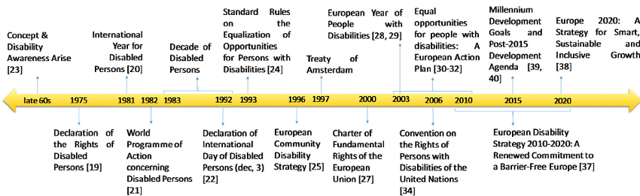

The researcher considers this timeline useful context in illustrating the progression towards social awareness of disability in the 20th Century.

2.5 Existing Present Research on Disability Awareness
During the latter part of the 20th Century, attitudes towards disability become more focused on how the disabled could benefit from inclusion fully in society. Oliver (1990) suggested that the disabled freedoms and rights should be based on a social model rather than because of society’s charity viewing them as victims. This means that the disadvantages and problems that disabled people encountered come more from society placing barriers rather than from any infliction itself. This included participation in sport and leisure activities endorsed by the Convention on the Rights of Persons with Disabilities in Article 30 (United Nations Department of Economics and Social Affairs Disability, 2008). To be a fully inclusive society, it requires more than paying lip service to these principles in so much that those disabled, who inspire to perform at the highest level in sport should be encouraged and enjoy the same funding and infrastructure as the able-bodied individuals. However, problems arise with this through a social model. Freedom and rights of individuals fall within three categories; civil, political and social. Whilst civil rights contain freedom from discrimination, it is social rights that society may have problems fulfilling. As Marshall (1950) classically pointed out to include those with disabilities fully in society, it requires greater commitment financially.

Research undertaken for the charity Scope by Dixon et al. (2018) reported that finances had to continue to be made available to ensure the continuation of the use of media platforms, to endorse and support disabled talent. Showing greater diversity would enable positive attitudes in society. The need for this was shown in the research where there was a difference in perception of disability. Whilst one in three disabled people felt that society was still prejudiced towards them, only one in five able bodied agreed with this. The able bodied felt that British Society had become more tolerant and aware, whereas disabled individuals still felt that discrimination affected them greatly.

Macgillivray et al (2018) argues that although major events are governed by strict guidelines by the International Paralympic Committee to ensure equality of access and greater positive social outcomes, problems arise when these are not sustainable. This means that although during events those with disabilities can benefit from infrastructure, transportation and general access to public amenities, as easy for anyone, these benefits are diluted or even removed following the event. This temporary situation then creates an even greater negative social marginalisation, having enjoyed parity and then to have it removed.

Major sporting events, where able bodied athletes compete and co-exist alongside those with disabilities, generally aspire to promote positive perspectives and attitudes in society. By seeing the ability of a disabled person and not merely the inability. However, in leveraging it is critical that these positive attitudes are nurtured and continue to grow through specific monitoring and programmes following the event. Without continued monitoring and research the full impact in the continued attitude of society to disabilities will remain solely subjective assumptions and not realistic objective outcomes. Asking merely the question if change in attitude has occurred rather than why. Finding the answer to why this will help to retain improvements and set new goals for future events. Leveraging is not a short-term temporary change, but a sustainable transformation. By placing attitudes under a microscope, the impact of failing to retain accessibility and equality can be measured (Misener ​et al. 2​015. Macgillivray ​et al 2​018. Smith. A ,2010).

2.6 Disability Discrimination and Prejudice
Although evident forms of discrimination towards individuals with disabilities may be declining, such as bullying and violence, indirect prejudice continues to occur in everyday life, with these individuals being excluded from society. Miller, Parker and Gillianson describe this prejudice as ‘discriminatory, oppressive or abusive behaviour arising from the belief that disabled people are inferior to others (Disability & Society, 2007).

It is difficult to gauge the most deep-rooted beliefs and views held by the able-bodied spectators of Disability Sports. As Morris (1991, no page) calls the remarks and platitudes foisted at the disabled by the non-disabled as being ‘patronising nonsense’ and ‘undermining’. She feels that at the heart of these so called praising and positive comments was that non-disabled people thought that it must be awful to be that abnormal disabled person. This type of prejudice may be deeply hidden within the able bodied so that they do not recognise their comments in this way. When someone watches a disability sporting event, is it difficult to know whether they just see the disability or whether part of the competitor lessens as they become more aware of the person’s ability and capability. If this is so, then disability sport can be a catalyst in the fight against deep-rooted unrecognised prejudice.

2.8 Historic and Current Legislation
Historically, the Human Rights Act 1998 states that those individuals with disabilities should have the right to ‘freedom from torture and inhuman or degrading treatment’, ‘freedom from slavery and forced labour’, and ‘protection from discrimination in respect of these rights and freedoms’. This act came into force in 1998, however those with disabilities continue to receive neglect and unfair treatment today. Better Health (2020) claim that those with disabilities are some of the most vulnerable individuals, putting them at high risk of receiving abuse or exclusion amongst society. A statement reveals that individuals with a disability are twice as likely as women to experience violence. Journalist, Robert Booth, stated in The Guardian (2018) that in 2018 the Equality and Human Rights Commission reported to the UN that one in five disabled people living in Britain, have their rights violated, including inclusion in participating in everyday activities. The article also states that 40% of those with disabilities do not feel included or valued by society, and 42% do not feel that the United Kingdom is a secure enough place to live if you have a disability. Although acceptance towards disability has improved since historic years, this current evidence displays this unfair treatment still occurring today.

Following this, the United Nations principles on the Convention on the Rights of Persons with Disabilities (2020) state ‘non-discrimination’, ‘equality of opportunity’, along with ‘respect for the evolving capacities’. Although the UN has stated that principle, it is always up to an individual government to ensure that it is adhered to and put into practice. However, a report stated, previous to the 2012 Games, in 2009. whilst adhering to the UN guidelines, they wanted to show real progress in Britain, and use the 2012 Paralympics as a springboard for a more positive perception of disability sport (BMC Public Health, 2016).

2.9 Paralympic 2012 Legacy
As discussed earlier, historic views on disability have been perpetually negative, with disability being looked upon as inferior compared to those able-bodied athletes. These attitudes influenced society into a sense of fear for disability, excluding them completely from society’s ways. However, perspectives have been seen to improve since the Paralympic 2012 Games, in London, broadcasting what those with disabilities can truly achieve (The Conversation, 2016). The Chairman of BT plc, Sir Michael Rake, stated “We believe London 2012 was a watershed moment, making people change the way they looked at disabled people”. The Chairman also stated, “Together we aim for nothing less than transforming the way the world views Paralympic sport” (Paralympics GB, 2012, page 10). This statement emphasises the negative portrayal society deems disability sport; however, the 2012 Games have made a positive impact with Paralympians being viewed as ‘heroic’, creating a new perception on disability (The Conversation, 2016).

In addition, Channel 4 produced an advertisement campaign “Meet the Superhumans”, promoting the build-up to the 2012 Paralympic Games, by introducing the para athletes as ‘superhuman’. Alice Tonge, the creative director the company who created the advertisement, ‘4creative’ stated that “there’s a poor representation of disability on screen and this was a chance to change that”. This campaign aimed to promote the Games and acted as a ‘pivotal moment’ in disability sport. This campaign was perceived to be a great success as Channel 4 planned to create another advertisement for Rio in 2016 (The Drum, 2016).

The 2012 Summer annual report on both the Olympic and Paralympic Games promotes this positive impact with Theresa May, former Prime Minister, stating that the Games promoted disabled artists with cultural initiatives. The report also mentions Paralympic Boccia player, David Smith, stating that he has won 125 medals during his Paralympic years. This publicity demonstrates the positive influence since the 2012 Games. It also encourages society overall, as if the Paralympics have been praised in such a way, society may begin to alter their opinions too.

The researcher found when researching Paralympic legacies, there was little to be found on the 2016 Rio Games held in Brazil. There was an abundance of material to be found relating to the London 2012 Games, as this was seen to bring into the light, the Para athletes and a shift in perception.

2.10 Disability Sports Development
Following on from these major sporting events, BBC News (2015) reports a 30% increase in people taking part in disability sports activities, over the past year, proving to be a triumph for disability sport. Disability Sport Wales partnership manager, Michelle Daltry, stated that figures were encouraging, however there could still be improvements. In 2013, Corby Disability Sports Club (BBC News) reopened following a Paralympic boost. This demonstrates the success of the 2012 Games, and how this success has impacted even the smaller communities.

However, in contrast to this, BBC News (2018) reported that 21-year-old student, Josh Reeves, has found that there is a lack of basic equipment and facilities in his lack gym for disabled users. He quotes that “society only focuses on the able-bodied people”. Disability Sport Wales’ CEO Fiona Reid stated that 62% of funding went into grassroots participation and development, however the report suggests that the focus lies more so on finding future Paralympians, rather than providing grassroot support. Along with this, journalist Ben Coles, stated in The Telegraph (2018), that the participation numbers for individuals with disabilities has decreased by 10 per cent since the 2012 Paralympic Games. The report also displays figures demonstrating a 168,700 decrease between 2012 and 2016, equating to an average of 56,567 people per year. In contradiction to previous findings stating a participation boost for disability sport, these figures suggest otherwise, indicating the 2012 Paralympic Games created a negative impact.

BBC News (2018) also stated that Sport Wales had published feedback earlier in the year, from around 600 people which will inform its next vision for sport. It displayed ‘access to sport by disabled children and adults is perceived to be very patchy in many areas and across many sports…with accessible changing rooms and direct access to the sporting facility often lacking” (2018, no page). These results show that there is a lack in participation and development, with funding possibly being an issue. During the Disability History Month’s launch in London in November (2019), co-chair of Shaping Our Lives and Professor Peter Beresford and Richard Rieser, founder a coordinator of Disability History Month, spoke out regarding their feelings of austerity for disabled individuals. Professor Beresford stated that this discriminatory treatment has led individuals to taking their own lives due to mental health problems. Rieser added that there is a “wall between disabled people and the rest of society”. Earlier that year, United Nations special rapporteur, Professor Philip Alston, suggests discriminatory behaviour from the government as they breach the “principle of non-discrimination enshrined in international law”, due to refusing to asses austerity cuts (Disability News Service, 2019). Journalist Yvonne Roberts at The Guardian (2019) reported that The Centre for Welfare Reform calculated in 2013 that disabled individuals have experienced nine times the average burden of austerity cuts. These findings demonstrate the ongoing financial struggle for disabled individuals, having such a negative impact on lives.

A final evaluation report (Scottish Government, 2018) discusses that witnessing an athlete excel in their sport, could be thought to provide inspiration, resulting in those involved in sport, continuing with a renewed enthusiasm. As well as those individuals who were once involved in sport, but had given up, were enthused to retry a sport with restored motivation. Along with this, there are those who may have had no involvement in sporting activity, found themselves excited by the prospect of belonging to the sporting world portrayed. Very careful planning in the infrastructure of a major sporting event will mean constructive usage is able to take place following the event, so that this country is able to continue providing high quality venues for the sport at later dates. This then can have a positive impact on the legacy of that sporting event. Initially, following London 2012, it was thought that there was an increase in participation due to both the positive effects of the Games, and the legacy programmed put in place. Sport Wales (2019) produced a statistical nation report for 2018-2019, demonstrating that the number of people participating in sporting activity had increased from 29% in 2016-2017 to 32%, with 787,000 people in 2017-2018. In 2018-2019, 59% of adults aged 16 and above stated that they had taken part in some kind of sporting activity in the last four weeks. Both 2018-2019 figures remain the same, however this increase displays a positive growth from the recent years of participation.

2.11 Conclusion
The study’s overall aim is to critically analyse how past major sporting events have impacted the perception and awareness towards disability sport. However, by conducting in depth research, the literature review has determined the first objective, being to critically analyse previous academic literature in order to evaluate how perceptions have been impacted since major sporting events. These arguments and ideas in this chapter, demonstrate that attitudes towards disability have been varied and contentious, often portraying the disabled in society as inferior to those who were able bodied, and a general burden on society. Additionally, although the Paralympics and other major sporting events have had a positive influence, and raised general awareness of disability sports, it is apparent that there needs to be an increase in facilities and resources for disability sports. However, there seems to be a lack of research and evidence of the progress being made to integrate disability sports to mainstream sports.

Chapter 3 – Methodology

3.1 Introduction
Saunders, et al, (2007, no page), defines research as ‘a process by which individuals attempt to learn things in a systemic way in order to increase their knowledge’.

This chapter considers the methodology used within this research to achieve the aims and objectives set at the beginning of this project. The data collected and research techniques are discussed, along with the philosophies, research methods and the data collection methods that have been utilised will be evaluated. Sampling techniques used to select a sub-group of participants will then be explained, and ethical procedures considered during this research will be identified. Finally, the limitations of the research methodology will be detailed.

The overall aim of this research is analysing past major sporting events and whether they have had an impact on the perception and awareness towards disability sport. The dissertation studies how society’s regard towards disability may have altered since past disability sporting events and for what reason.

3.2 The Research Onion

Saunders, et al (Research Gate, 2016) produced the research onion, an effective research approach symbolising the stages to examine when conducting research.

Figure 3.1 – An image of Saunders research onion.



Saunders, et al (Research Gate, 2016), theory of the research onion illustrates that each layer reveals an efficient stage in conducting and carrying out research. Beginning with the outward layer of the onion, and following through to the centre area, the onion is divided into the inductive approach and the deductive approach. This research study will use the deductive approach to utilise the plethora of outcomes from past events to evaluate the change in society’s perception today. It is intended to analyse the findings from the data collected to formulate an interpretive summary.

Saunders, et al believes that following this format gives the researcher the best analytical data to achieve the research aim and will result in an effective research strategy, thus giving a clear and successful outcome.

3.3 Data and Methods
Mixed methods have been used during this study in order to gather the necessary analytical data and statistical evidence to confirm findings. Methods have included quantitative research, conducted through the form of an online survey on the social media platform, Facebook, gathering a total of 110 responses from a sub-group of UWTSD students. Questions asked in the survey aim to evaluate awareness of disability sport, asking participants to describe their awareness in a sentence, along with asking participants to state what Paralympic sports they are aware of. The researcher hopes to gather the impact that disability sport influenced on society.

A quantitative method was also used during the study, by conducting interviews with former and current athletes and coaches involved in disability sport today. The questions for athletes aimed to distinguish their views on whether perception has changed since being involved in major sporting events. Along with questions for disability sport coaches aiming to not only distinguish alterations in perception, however, also consider greater opportunities since the occurrence of major sporting events, such as the Paralympics. Voice recordings were utilised on participants involved in this form of research, along with a pre-formatted interview schedule whilst conducing the one to one interview.

These research methods were put into practice to gain some substantial evidence and analysis from an outsider’s perspective, being a non-bias group of students, in comparison to gaining first-hand knowledge and information from those who are living and experiencing this sporting world, as well as those close to them.

3.4 Resources and Planning
Resources used throughout this study include the use of reports and journal articles, found through google scholar, books acquired from The University of Wales Trinity Saint David’s online and on-site library. Along with the use of government legislation and credible websites. IT based platform, Nvivo has been utilised to analyse qualitative and quantitative research used during the study. Literature researched and used during this study must be pertinent to the chosen subject in order to provide relevant resources. Theories used in the study will explain and critically evaluate the subject matter and aim to analyse whether major sporting events such as the London 2012 Paralympics have altered society’s view on disability.

3.5 Research Strategy
The researcher followed a mixed methods approach, through conducting interviews and an online survey, through which qualitative and quantitative data was collected. An interview technique was used as a quantitative approach, presupposing that the evidence provided will be gained from a phenomena based on facts that could be measured. In contrast, a survey questionnaire was used as a qualitative approach, based on the sample continually using their observations and beliefs to place meaning and understanding to a social construct (Topping, 2006).

Qualitative research methods as Mason (1996) found are based on an array of difficulties mostly reflecting a lack of perspectives, meaning there is not a specific set of truths or facts which can be empirically researched upon. Whilst classically, Goffman (1964) while researching mental illness and stigma, placed importance into interpretive research to understand how humans make meaning in their beliefs. Stigma and discrimination are crucial elements to this research. Therefore, using both an objective, positivism, empirical approach of quantitative data and the subjective, interpretivism qualitative collection methods, strengthens the research design validity.

In-depth interviews were carried out with five disability sport athletes in the sport today, to determine their opinion of perception and awareness towards disability sport, and whether they feel they are treated as inferiors compared to able-bodied athletes. The interview questions conducted on these athletes will also evaluate whether they feel their treatment has altered since major sporting events, such as their participation in the London 2012 Paralympic Games. An interview has also been conducted with one disability sports coach to discover their opinion on perception and if they feel there are enough opportunities to get involved for those with a disability.

Following this, primary data has also been conducted through the form of an online administered questionnaire on social media platform, Facebook. This anonymous questionnaire is aimed at a sub-group of students studying at The University of Wales Trinity Saint David, to analyse their judgement and awareness of disability sport.

The questions asked during both forms of qualitative and quantitative data will be non-threatening and non-obtrusive and will be completely confidential in the study.

3.6 Philosophy and Positivism
Martin, J.J (2018) discovered philosophical approaches to disability sport, stating that through conducting quantitative or qualitative data on sporting athletes, you must also be realistic, as the observation of the athletes may have had an impact on their behaviour. Therefore, although successful data has been collected, the statistics or information collected may have been greater than it would have if the athletes were not being observed, so being a positivism approach. Positivism theoretical position derived from philosophy believing that scientific truth can only be derived from human senses and observable. Apply this method of scientific enquiry to the study of human behaviour.

3.7 Research Methods

Surveys
The first chosen method of data collection was a self-administered online questionnaire survey through the social media platform of Facebook. When considering this form of research, it was significant to analyse the advantages and disadvantages of using a social platform such as Facebook, as this might have been an inadequate way to collect the necessary data. Facebook was chosen to collect the necessary data, as it’s able to reach an array of audiences, along with capturing users during their free time, therefore knowing that you will have their full attention (Drive Research, 2017). However, research indicates that there are subsequently more benefits than negatives to collecting data through an online survey. Benefits include having a global reach, speed, convenience and questioning diversity (Evans, J.R and Mathur, A, 2005). Scholl et al. (2002) states that society deems this use of internet access essential to gathering the information needed. The thought process behind conducting an online survey on a subgroup of university students, was to evaluate how aware they were of disability sport overall, and whether this opinion had altered since the occurrence of major sporting events such as the London 2012 Paralympic Games.

The online administered survey began with simple questions asking participants their gender, age, along with questioning whether they themselves, have a disability, or whether they know anyone who does. The questions then become more specific, questioning how participants would describe their awareness of disability sport, and how they became aware of disability sport. The questions asked aimed to gather an indication of how disability sport is perceived in society. However, the researcher cleansed the data and withdrew three responses, leaving 107 responses. This was due to some insignificant data however; the researcher made the decision to do this to improve the overall quality of the data.

Interviews
As part of collecting primary data, interviews have been conducted with five international disability sport athletes, as well as an international disability sport coach, coaching at a professional level for Great Britain in the Paralympic sport, Boccia. For the interviews to be rigorous, a collection tool was designed. Data was collected in a method that dealt with researcher bias and Hawthorne effect (Nelson et al. 2007) by participants.

Interviews allow the capture of information formed through personal and unique experience in a balance of direction but also participant flexibility (Saul McLeod, 2014). An interview method was adopted closer to a non-structured rather than a structured approach. Therefore, the participant held control of direction in responses being led by a set of topics rather than the constraint of questions. However, the researcher was aware of the fact that data obtained through a more unstructured approach may be less reliable. It was therefore important that interviews were conducted in a consistent way so that data was rigorous. For example, allowing participants flexibility in responses ensured that the interviewee could adequately give their point of view. This also helped to reduce any problem with the interviewer influencing the response to suit the research question.

The researcher sent a copy of the interview questions, prior to personal contact with the interviewee. The confirmed interview was undertaken using the social media site Skype, and recorded through a voice recorder, which was deleted once a transcript was completed, to follow the General Data Protection Regulation (GDPR). This regulation allows participants the ask the researcher to delete the data used for research (Taylor, B.E, 2018). A transcript of the interview was sent to the interviewees following the interview, in order to check that they were happy with the content used for this study.

Table 3.1 – Interview Design Approach

Introduction | Introduction of researcher and establishing a rapport. Explain purpose of interview. Check understanding and obtain consent to continue. Reassure interviewees that they can withdraw at any time if requested. Explain how their responses will be recorded and that they will be confidential.
Warm Up | Ask neutral, non-threatening questions such as age etc. Obtain any factual background. Again, reassure them of anonymity and confidentiality.
Main topic areas. Leave any emotionally challenging, complex or sensitive topics towards the end with reassurance regarding beforehand. Such topics may include beliefs and feelings. | Introduce the first topic area.  Second,  Third,  Fourth,  Fifth,  Finally, to bring the interview to the end.
Concluding | Ask if there is anything else the interviewee would like to add.
Closure | Check that the interviewee understands what will happen to the data. Thank them for taking part in the interview.

Table 3.2 - Interview Question and Literature Review Matrix

Questions in Interviews | Relation to Chapter Two
Q1. At what age do you feel you were interested in sport?  Q2. Was there something specific that prompted you to become involved in sport?  Q3. What made you choose Boccia as your sport?  Q5. What opportunities has been being involved in sport brought to your life? | The questions were asked to gauge a profile of the interviewee, not specifically based on any current academic literature.
Q4. Has being involved in this sport, opened your eyes to what can be achieved? | The Drum. (2016). Anatomy of an Ad: How Channel 4 told the story of the humans behind the Superhumans.
Q6. Have you noticed a change in perception for Disability Sport since the 2012 Paralympic Games? | The Conversation. (2016). The Paralympics is changing the way people perceive disabilities.
Q7. Do you feel that there are now greater opportunities for individuals to become involved in a Disability Sport, since major sporting events such as the Paralympics and the World Para Athletics Championships? | BBC News. (2015). Disability sports participation in Wales up 30%.
Q8. Do you feel that the public are aware of the challenges that having a disability brings? | Macgillivray,D.,Mcpherson,G.,and Misener,L (2018). M​ajor Sporting Events and geographies of disability. ​Journal Urban Geography.
Q9. Have you ever experienced any prejudice or discrimination during your involvement in sport? | Miller, Parker and Gillianson. (2007). Aversive disablism: subtle prejudice toward disabled people. Disability & Society. Vol 22. Issue 1.
Q10. How has being involved in sports and attending major sporting events impacted your life? | Scottish Government. (2018). Glasgow 2014 Commonwealth Games legacy: final evaluation report April 2018.

3.8 Pilot Study
A pilot study was carried out on a chosen participant, prior to conducting the official research. This is the process of obtaining a sample for research. This sampling method is to ensure robustness and reliability of the research, and that the questions asked, gather the correct data, allowing the results of the research to be effective (Murphy-Black.T, 2006). This method will be sampled to determine and assess the feasibility steps to be taken in order for the research to be successful.

3.9 Ethical Considerations
When conducting any form of research, it is important that participants feel at ease and have confidence in the researcher as they are in an unfamiliar situation. This feeling of confidence allows the researcher to gain the best responses possible from each participant taking part in the study. The participant was presented with an informed consent form and a participant information sheet prior to beginning the research. For the duration of the research, the British Education Research Association (BERA) guidelines (2011), were closely abided by to ensure rich ethical conduct and professional practice throughout. Following this, the researcher also gave the participants the chance to withdraw from the research at any given time. This will be explained prior to when the research begins. If the participant decides to withdraw, the data collected will not be included in the study. (Cohen, L, Manion, L and Morrison, K, 2011). Lastly, the University of Wales Trinity Saint David’s ethical approval was gained through completion of an ethical content form, approved by the researcher’s study supervisor.

3.10 Confidentiality and Privacy
To ensure confidentiality and to respect the privacy of all participants, none of their names will be included in the study, nor any of their personal information. “Researchers must recognise the participants’ entitlement to privacy and must accord them their rights to confidentiality and anonymity, unless they or their guardians or responsible others, specifically and willingly waive that right” (BERA, 2011, page 7).

3.11 Reliability and Validity

Topping (2006) states that quantitative research data needs internal validity, meaning is what is being observed a true reflection of current position. Whereas external validity means how trustworthy is the data if transferred to other contexts. Reliability refers to how consistent and accurate has the data process been. Qualitative data consists of trustworthy elements such as credibility, that the researcher represents the participants views truthfully, transferability that findings can be transferred to similar contexts, dependability, meaning that the process is unambiguous and confirmability that data findings and analysis can be clearly linked to each other. Mixing quantitative and qualitative approaches to research ensures the mitigation of weaknesses in one research method. The researcher carefully selected both forms of primary data to produce reliable and credible findings.

3.12 Conclusion
This chapter focuses on the use of both qualitative and quantitative data methods, allowing the researcher to gather information regarding the awareness and perception of society, and those in the sport today. By utilising the responses from both the online survey questionnaire and the interviews conducted, this enables a more diverse understanding and awareness of disability sport.

Chapter 4 - Data Analysis

4.1 Introduction
This chapter analyses in detail the primary data gathered through the use of a qualitative method by conducting interviews with those involved in disability sport. The software, Nvivo, was used to analyse this qualitative data to determine the most common threads of responses from the interviewees, allowing comparisons to be made. Another form of primary data was analysed using the Statistical Package for Social Sciences (SPSS). The hypothesis will be tested using SPSS’s Chi-square test function to determine the statistical association between variables. SPSS also determines the asymptotic significance through the P value. The researcher felt that triangulation of data would produce a broader range of data, therefore allowing more substantial findings.

The results from both forms of qualitative and quantitative research will be analysed to be able to meet the second objective of the study;

- To analyse the degree of awareness of disability sport through conducting qualitative and quantitative research on a sub-group of university students, along with conducting interviews with athletes and a coach in the sport today.

This chapter will analyse and display findings from the data researched from both the questionnaire administered and interviews conducted.

4.2 Background
Chapter 2 demonstrates a range of published literature researched, underpinning society’s perception and awareness towards individuals with disabilities, since the occurrence of major sporting events. The conclusion of chapter 2 displays that disability is deemed as a burden to society and proves difficult to be included in everyday participation. Nevertheless, it is argued that past major sporting events, such as Stoke Mandeville developing into a Paralympic movement, has proved to gain a positive impact and raised general awareness of disability sport. However, there needs to be an increase in resources at grass root level for disabilities. The researcher wanted to emphasise the previous findings, before introducing chapter 4. This chapter aims to analyse the key findings from the qualitative and quantitative research undertaken to determine whether perceptions have altered in society.

4.3 Quantitative Analysis
Quantitative data was produced through an online survey questionnaire to a sub-group of University of Wales Trinity Saint David students, and therefore analysed manually on an excel spreadsheet and processed by SPSS software.

4.4 Main Findings

The researcher found from analysing the quantitative data, that the vast majority, being 88.8%, stated that they were aware of disability sport. A high proportion of participants are aware of major sporting events, and 66.3% developed this awareness of disability sport through the medium of television. Therefore, it is suggested that the main finding from this data, is that major sporting events do have an impact on people’s perception of disability.

4.5 Descriptive Statistics
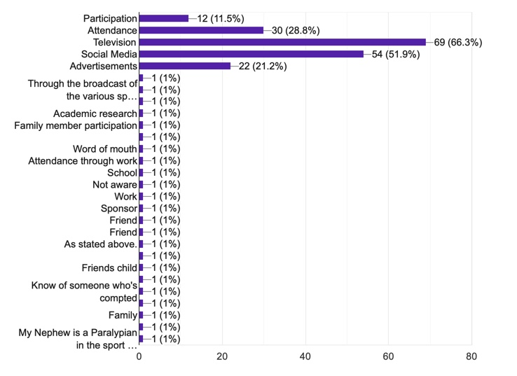

Figure 4.1 – Displaying how participants became aware of Disability Sport.

A greater proportion, 66.3%, had their awareness of disability sport through the medium of television. This reflects the figure 97.2%, felt that they had a positive perception of the 2012 Paralympics, and the same figure demonstrated the positive impact that the Paralympic Games had on people’s perception of disability. The 2012 Paralympics were a home Games, in Great Britain, therefore media coverage and advertising was magnified, and particular Paralympians became household names.

This was reflected through the question asking participants to tick which British Paralympic names they were aware of.
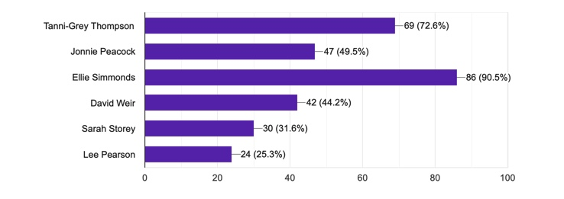

Figure 4.2 – Displaying British Paralympians.

The above diagram illustrates that Paralympian Ellie Simmonds came out as being very well known, this can be linked to the face that Simmonds was one of the faces for of Channel 4’s Superhuman campaign “Meet the Superhumans” prior to the 2012 Paralympic Games.

4.6 Chi-square Hypothesis

The researcher firstly began the analysis by creating a crosstabulation of gender and if the participant themselves had a disability, or if they knew anyone with a disability.
H₁: There is no difference between genders in disability.
The result (X = .688, df = 1, p = .407) indicate that there is no difference between genders and the null hypothesis is retained. 54.2% of males and 44.6% of females stated they were themselves disabled, or they knew someone with a disability. In comparison, 45.8% of males and 55.4% of females stated that they did not have a disability, neither knew anyone with a disability.

Crosstabulation between awareness of disability and awareness of issues surrounding disability.
H₂: There is no difference between awareness of disability and awareness of issues surrounding disability.
The result (X = 3.036, df = 1, p = .081) indicate that there is no difference between the awareness of disability and the awareness of issues surrounding disability and the null hypothesis is retained.
In total, there were 94 respondents, who stated that they were aware of disability, of this 94, 30.9% were shown to also be aware of issues surrounding disability. Therefore, making a total of 69.1% of these respondents, who were aware of disability, were not aware of any issues. The remaining 13 respondents, who stated that they were not aware of disability, 7.7% stated that they were aware of issues, and the majority, 92.3% stated that they were not aware of issues.

Crosstabulation of gender and participation in any organised sporting event:
H₃: There is no difference between genders in participation in a sporting event.
The result (X = 2.412, df = 1, p = .120) indicate that there is no difference between genders and the null hypothesis is retained. 70.8% if males and 53.0% of females stated that they had participation in an organised sporting event, whereas 29.2% of males and 47.0% of females stated that they had not.

Crosstabulation of gender and awareness of major sporting events:
H₄: There is no difference between genders in awareness of major sporting events.
The result (X = 2.184, df = 1, p = .139) indicate that there is no difference between genders and the null hypothesis is retained. 91.7% of males and 78.3% of females stated that they were aware of major sporting events, whereas 8.3% of males and 21.7% of females stated that they were not aware.

Crosstabulation of age and whether participants had a positive perception of the Paralympic Games:
H₅: There is no difference between age and whether participants had a positive perception of the Paralympics.
The result (X = 7.269, df = 1, p = .201) indicate that there is no difference between age of participants and their perception of the Paralympics, therefore the null hypothesis is retained. Results display that 94.1% of 18-24 years, 95.7% of 25-35-year olds, 100% of 36-45, 46-55 and 56-65 year olds and 75% of 65+ participants responded that they had a positive perception of the Paralympic Games. In contrast, 5.9% of 18-24 year olds, 4.3% of 25-35 year olds, and 25% of 65+ participants stated that they did not feel the Paralympics had a positive impact on perception. These results indicate that the older participants, felt more negatively towards the perception with 25% stating no, in comparison to 5.9% of the younger generation, being 18-24 year olds, therefore displaying a more positive outlook.

Crosstabulation of gender was also conducted between whether participants had a positive perception of the Paralympic Games:
H₆: There is no difference between age and whether participants had a positive perception of the Paralympics.
The result (X = 1.129, df = 1, p = .288) indicate that there is no difference between gender of participants and their perception of the Paralympic Games, therefore the null hypothesis is retained. The percentages of genders is relatively close with 87.5% of males, and 94% of females, stating that they have a positive perception. This is an extremely positive correlation between the genders with only a 6.5% difference, and displays these participants have an overall positive perception with only 12.5% of males, and 6% of females stating they do not feel positively towards the Paralympic Games.

A crosstabulation was also conducted between age and whether participants had ever watched a disability sporting event, either through attendance or through a media service.
H₇: There is no difference between age and participants watching a disability sporting event.
The result (X = 6.421, df = 1, p = .267) indicate that there is no difference between age and attending an organised sporting event and the null hypothesis is retained. 85.3% of 18-24 year olds, 69.6% of 25-35 year olds, 50% of 35-45 year olds, 76.9% of 46-55 year olds, 87.5% of 56-65 year olds, and 50% of 65+ stated that they had attended a sporting event. Whereas, 14.7% of 18-24 year olds, 30.4% of 25-35 year olds, 50% of 36-45 year olds, 23.1% of 46-55 year olds, 12.5% of 56-65 year olds, and lastly 50% of 65+ stated they had not attended a sporting event. Both the percentages for 18-24 year olds and the 56-65 year olds, are high figures displaying a positive correlation between those that had attended a disability sporting event, and those that were aware of disability.

A Mann-Whitney U test was conducted to test the hypothesis of how interested participants were in sport across gender. The below table displays the mean rank calculation for both male and female participants based on their interest.

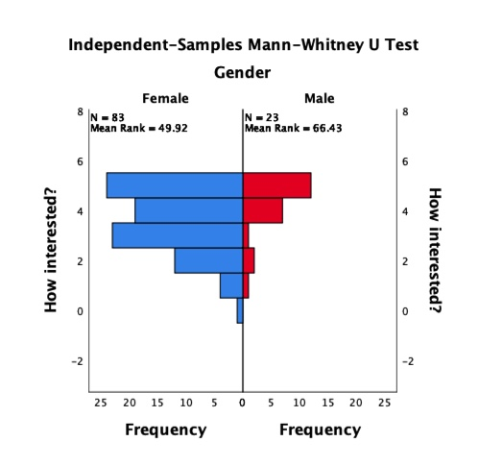

Figure 4.3: Displaying the mean rank for both genders.

This independent samples Mann-Whitney U test demonstrates a .018 significance, and therefore the null hypothesis is rejected.

However, along with the Mann-Whitney U test, a crosstabulation was also conducted between gender and how interested participants are in sporting activity.
H_{8a}: There is a high significance between gender and interest in sport.
The result (X = 0.33, df = 1, p = .856) indicates that there is a significant difference between gender and interest in sporting activity as this figure is lower than 0.5.
The results also display 91.7% of males and 92.8% of females have stated that they are interested in sport, with only a minor 8.3% of males and 7.2% of females who are not interested.

In summary of these findings, 88.8% were aware of disability sports and over half of this figure had this awareness through watching television. The Chi-squared hypothesis showed the researcher that there was little difference in gender of those who took part in the survey, and those who had a disability themselves, or knew someone who had a disability. An astounding 97.2% felt they had a positive perception of the London 2012 Games.

4.7 Qualitative Analysis
Qualitative data was gathered in this study through conducting interviews with disabled athletes in the sport today, as well as a sporting coach. The findings have been analysed through the software Nvivo.

4.8 Main Findings
Since disability sports have taken a more prominent role in sport in general, there was positive correlation between all interviewees agreeing that the 2012 Paralympic Games was the defining moment after which disability sport became more mainstream.

This finding is supported through not only the athlete’s perceptions of the new opportunities open to them, but a coach’s perception of a shift in public opinion and a greater social acceptance of people with disabilities.

4.9 Common Threads

The researcher found common threads linking all interviewees namely, an early interest in disability sport, promoted by either their own disability, or knowledge of someone with a disability. In addition, early exposure to sport on television led them to explore the options open to those individuals with disabilities.

Although three out of five athletes stated that they feel there is increased awareness of disability since major sporting events, it was also highlighted by two of the athlete’s responses, as well as the coach’s response, that there is limited awareness surrounding disability sport and the time, dedication and effort taken to achieve their success. It was reported that there is a downside to making people aware of an athlete’s disability because it shifts focus from them achieving as an athlete, to them achieving with a disability. The coach also responded with a statement believing that society may have good intentions, however, end up with patronising the athlete seeing only the disability and not their achievement as a sports person.

4.10 Themes

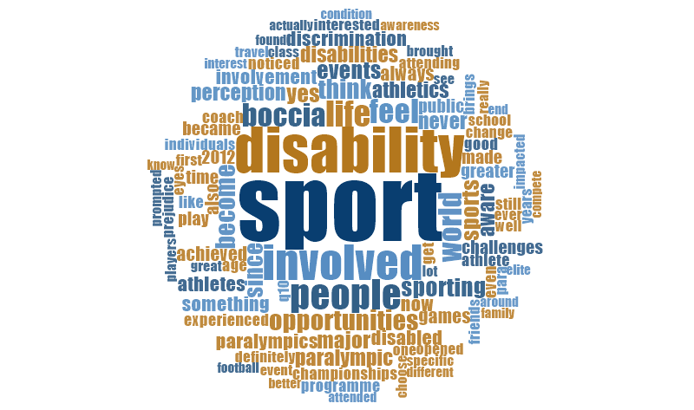

Figure 4.4: Word Cloud graphic displaying most commonly used words during interview.

Each interviewee, being all disabled athletes, are ideally placed to have an honest opinion on how they find discrimination and have lived through experiences of ignorance. This was stated in chapter 2 with Miller, Parker and Gillianson (2007) discussing discrimination and prejudice. However, all interviewees agreed that society has become more aware of disability sport and has a greater social acceptance since major sporting events. Although, a common theme between the participants is that there is a limited understanding of the challenges that having a disability brings. It was illustrated by participants that the majority of people would not even consider that what is seen to be as an easy daily task, would create great difficulty for individuals with disabilities. Examples were used during the interview, such as feeding, toileting and even breathing. This was brought to attention in chapter 2, as Wright (1960) stating that this phenomenon of stigma extension was a view that all areas of a disabled persons life was seen to be devalued.

The advertising campaign building up to the London 2012 Paralympic Games, portrayed the athletes as ‘superhumans’, and promoting what a disabled athlete can achieve. This advertisement was mentioned during the interviews by the coach, that programmes such as this one has supported greater social acceptance of people with disabilities. Research on this advertisement campaign “Meet the Superhumans” was carried out in chapter 2, where the researcher focused on the positive impact it had towards disability.


Figure 4.5: Commonly used words describing awareness.

The majority of respondents have agreed that there is now a greater social acceptance towards disability sport, since increased media coverage of the home 2012 Paralympic Games and since that time the World Para Athletics Championships.

4.11 Conclusion

Chapter 4 analyses the qualitative and quantitative data gathered through both the conduction of interviews and an online survey questionnaire. This chapter has determined the second objective, to analyse the degree of awareness of disability sport through conducting qualitative and quantitative research on a sub-group of university students, along with conducting interviews with athletes and a coach in the sport today. This chapter displays quantitative findings that a high percentage of 88.8% of interviewees were aware of disability sports. Of these interviewees, there was little difference in gender and between those who had a disability themselves, or knew somebody with a disability, and those who were able bodied. Finally, 97.2% felt that they had a positive perception of the 2012 Paralympic Games. The qualitative findings show a positive correlation between all interviewees agreeing that the London 2012 Paralympic Games was a pivotal moment in disability sport, displaying a degree of social acceptance. However, there is shown to be a limited understanding surrounding what having a disability means. Chapter 5 concludes these findings and discusses the implications.

Chapter 5 – Conclusion and Recommendations

5.1 Introduction
Chapter 4 achieved the second objective, to analyse the degree of awareness of disability sport through conducting qualitative and quantitative research. Therefore, chapter 5 aims to determine the final objective of this study;

- To provide recommendations to continue the transformation on perception towards disability.

This chapter will discuss the main findings of the study, along with limitations along the way. Recommendations will also be produced in order to reference for future academic study.

5.2 Achieving Objectives

- To critically analyse previous academic literature to evaluate how perceptions have been impacted since major sporting events.

An extensive amount of research was produced in chapter 2 to analyse academic research.

- To analyse the degree of awareness of disability sport through conducting qualitative and quantitative research on a sub-group of university students, along with conducting interviews with athletes and a coach in the sport today,

This objective was achieved in chapter 4’s data analysis, as this chapter measured both the qualitative and quantitative data and evaluated it through the use of SPSS and Nvivo.

- To provide recommendations to continue the transformation on perception towards disability.

This chapter will provide recommendations in order to continue the transformation on perception towards disability.

5.3 Main Findings

The main findings of the study are firstly, that awareness of disability has increased within society, through the advertisement and promotion of such a worldwide sporting event such as the Paralympic Games. Athletes however, felt that the awareness that people had of what it’s like to live with a disability had not increased but in fact this was felt that any understanding of this would detract from what an athlete had or could achieve. Although findings show that 69.1% of people are not aware of issues surrounding disability, interviewees stated that they would rather society not be completely aware of daily struggles that they experience with their disability. However, implications could include that the positive strides achieved to date, do not continue, therefore undoing the positive progress seen so far.

5.4 Conclusion

Chapter 2 demonstrates a range of current academic literature and displays findings that attitudes towards disability are very varied, and there are often misconceptions about what a disabled person can achieve. The attitude towards major sporting events, such as the Paralympics is thought to have had a positive influence, towards the perception of disability and generally raised the profile of disability sports. This positivity, however, only goes so far, and those interviewed felt that more resources and better facilities were needed to be put into disability sports at grassroots level and promoting the possibilities of what can be achieved to the disabled community.

From the evaluation of the athlete’s views, there has been a shift in people’s perception of what a person with a disability can achieve. The London 2012 Paralympic Games has played a very important role in this shift of perception and can be deemed as ‘The Games’ that actually brought Paralympic sport into people’s lives. The build-up to the Games was greatly promoted with the advertising campaign, the ‘Superhumans’. Promoting the athletes with a very positive perception, and many athletes becoming household names. All interviewees agreed that society has become more accepting, however, although this shift is positive, there is still a long way to go for complete integration into society. It was pointed out that these athletes would rather avoid the potential for people to become more aware of disability, as this gives society the opportunity to feel pity on those athletes and their day to day struggles, rather than focus on their sporting achievements. However, in analysis of the survey responses, the majority, 69.1% of those asked whether they were aware of a disability, and answered ‘yes’, were not aware of any issues relating to disability.

5.5 Limitations

Throughout the study, a limitation that the researcher experienced, was that the focus was mainly on the impact that the London 2012 Paralympic Games had on perceptions. The researcher originally researched major sporting events worldwide, as a whole, however this proved difficult, as the majority of information available, focused on the London 2012 Games. This reiterates the researcher’s findings, that these Games were actually a pivotal moment in positive awareness and perception of disability.

5.6 Recommendations

Many of the athletes interviewed stated that they became interested in sports at school or at a young age. Therefore, the first recommendation would be that there should be an opportunity for disability sport to be introduced at primary and secondary school. This is a crucial time to get young children interested in sport in general and make them aware that if you have a disability, it does not mean exclusion.

As shown by the major success of the 2012 Paralympic Games in London, the second recommendation is that mainstream television channels must give equal prominence to disability sports, such as wheelchair tennis during Wimbledon fortnight.

Thirdly, fight prejudice and skewed perceptions of athletes with disabilities; avoiding a patronising tone, lowering expectations, remembering that they are elite athletes rather than disabled athletes.

5.7 Further Research

Further research on this topic, could include following one particular athlete during a high-level sporting event such as a World Championships, providing insight into their personal experience both as a competitor, and a person with a disability. This would shine a light on their achievements and failures, as well as their day to day struggles, giving the researcher first-hand insight which could essentially change perceptions and improving the lives of athletes with disabilities.

Further research could also take place before and after another major disability sporting event to assess public knowledge and perception of the event.

Lastly, to measure how any improvements in perceptions are maintained. Also to research the longer term benefits to the disability community following major sporting events, social awareness, inclusion and improved infrastructure for example.

5.8 Self- reflection

The researcher found the past university year a massive struggle, with issues at home which had impacted her university work. However, the researcher wanted to push herself to achieve something that she thought she was capable of. Despite the difficult process, the researcher found it very rewarding to have completed this study and has developed self-learning skills, such as using software SPSS and Nvivo. Along with this, the researcher found that it is important to be patient and has learned a significant amount about disability sport as a whole, as well as the implications that come with it. This was reflected through the researcher’s awareness that she had to give the athletes time to respond to her questions. It has taught her how important it is to show kindness and be understanding of other people.

5.9 Final Summary

In final summary, the researcher’s overall aim, to critically analyse whether major sporting events have impacted society’s perception of individuals with disabilities, has been achieved. Findings show that a positive impact has been made on society and their recognition of what these para athletes can achieve, and this can be translated to others with disabilities.

References

- All for Sport for All. (2011). Perspectives of sport for people with a disability in Europe. Page 21.
- BBC News. (2013). Corby disability sports club reopens after Paralympic boost. (WWW). https://www.bbc.co.uk/news/uk-england-northamptonshire-22690139. (Accessed 23/02/20).
- BBC News. (2015). Disability sports participation in Wales up 30%. (WWW). https://www.bbc.co.uk/news/av/uk-wales-34226793/disability-sports-participation-in-wales-up-30. (Accessed 23/02/20).
- BBC News. (2018). Disability Sport: ‘Lack of basics’ stops people taking part. (WWW). https://www.bbc.co.uk/news/uk-wales-44795155. (Accessed 23/02/20).
- BERA. (2011). Ethical guidelines for educational research. (WWW). https://www.bera.ac.uk/wp-content/uploads/2014/02/BERA-Ethical-Guidelines-2011.pdf. (Accessed 10/04/20).
- Better Health. (2020). People with a disability who experience violence, abuse or neglect. (WWW). https://www.betterhealth.vic.gov.au/health/servicesandsupport/people-with-a-disability-who-experience-violence-abuse-or-neglect. (Accessed 21/02/20).
- BMC Public Health. (2016). Comparison of attitudes toward disability and people with disability among caregivers, the public and people with disability: findings from a cross-sectional survey. (WWW). https://www.ncbi.nlm.nih.gov/pmc/articles/PMC5043610/. (Accessed 21/02/20).
- Centers for Disease Control and Prevention. (2019). Impairments, Activity Limitations, and Participation Restrictions. (WWW). https://www.cdc.gov/ncbddd/disabilityandhealth/disability.html. (Accessed 21/02/20).
- Cohen, L, Manion, L and Morrison, K. (2011). Research Methods in Education; seventh edition. Oxon, Routledge.
- DePauw, K; Gavron, S; (2005), Disability Sport, Second Edition
- Disability News Service. (2019). Disability History Month’s stark messages after Tory austerity decade. (WWW). https://www.disabilitynewsservice.com/disability-history-months-stark-messages-after-tory-austerity-decade/. (Accessed 18/05/20).
- Disability News Service. (2019). Disabled people ‘driven to breaking point’ by cuts, says UN expert. (WWW). https://www.disabilitynewsservice.com/disabled-people-driven-to-breaking-point-by-cuts-says-un-expert/. (Accessed 18/05/20).
- Disability Rights UK. (1998). The Human Rights Act 1998 (HRA). (WWW). https://www.disabilityrightsuk.org/human-rights-act-1998-hra.(Accessed 21/02/20).
- Disability Studies. (2012). Past and Present Perceptions Towards Disability: A Historical Perspective. (WWW). https://dsq-sds.org/%20article/view/3197/3068. (Accessed 21/02/20).
- Drive Research. (2017). 5 Reasons to consider Facebook for online surveys. (WWW). https://www.driveresearch.com/market-research-company-blog/5-reasons-to-consider-facebook-for-online-surveys/. (Accessed 10/04/20).
- Evans, J. R and Mathur, A. (2005). The value of online surveys. Page 197.
- Fitzgerald, H, (2009), Disability and Youth Sport
- Gerrish,K and Lacey,A. Eds 2006 The Research Process in Nursing. 5th Edn. Oxford: Blackwell Publishing.
- Goffman, A. (1964) Stigma notes on the management of a spoiled identity. Harmondsworth: Penguin. Cited in Topping, A. (2006) Chapter 11. The Quantitative – Qualitative Continuum. Page 157-172 in Gerrish, K and Lacey, A. Eds 2006. The Research Process in Nursing. 5th Edn. Oxford: Blackwell Publishing.
- Hawking, S; (2014), Disability and Vulnerability, http://hdr.undp.org/en/content/disability-and-vulnerability-0. (WWW). (Accessed 02/12/19).
- HM Government. (2016). Olympic and Paralympic Legacy: Inspired by 2012 – fourth annual report. Department for Digital, Culture, Media & Sport.
- Hyatt, G. W. (2005). What is in a word? The evolution of disability language. Page 12. (WWW). https://www.amssa.org/wp-content/uploads/2016/01/watson-hyatt-what-is-in-a-word.pdf. (Accessed 21/02/20).
- International Paralympic Committee. (2020). History of the Paralympic Movement. (WWW). https://www.paralympic.org/ipc/history?gclid=EAIaIQobChMI9_yB7YHK5wIVC9HeCh1T1wUFEAAYASAAEgKyrfD_BwE. (Accessed 23/02/20).
- Johnson, B; Gray, R (2010), ‘A history of philosophical and theoretical for mixed methods research. Leadership and its Outcomes’
- Macgillivray,D.,Mcpherson,G.,and Misener,L (2018). M​ajor Sporting Events and geographies of disability. ​Journal Urban Geography.
- Marshall. T.H., 1950 Citizenship and Social Class and other essays. Cambridge: Cambridge University Press cited in
Blakemore, K and Griggs, E. 2007. Chapter 2 Ideas and concepts in Social Policy in Social Policy an introduction. ​3rd edn. Maidenhead: Open University Press.
- Martens, D. M and Wilson, A, (2012), Program evaluation theory and practice. New York, NY: Guildford Press
- Martin, J,J. (2018). Disability Sport & Exercise Psychology. Oxford University Press, New York.
- Mason, J. (1996). Qualitative Researching. London: Sage. Cited in Topping, A. 2006. Chapter 11. The Quantitative – Qualitative Continuum. Page 157-172 in Gerrish, K and Lacey, A. Eds 2006. The Research Process in Nursing. 5th Edn. Oxford: Blackwell Publishing.
- Miller, Parker and Gillianson. (2007). Aversive disablism: subtle prejudice toward disabled people. Disability & Society. Vol 22. Issue 1.
- Murphy-Black.T. 2006 Chapter 24 Using Questionnaires. in
NCBI. (2006). Doing a pilot study: Why is it essential? (WWW). https://www.ncbi.nlm.nih.gov/pmc/articles/PMC4453116/. (Accessed 10/04/20).
- Nelson, A, Durnville, J and Torgerson, D. (2007). Chapter 16. Experimental Research in Gerrish, K and Lacey, A. (2007). The Research Process in Nursing. 5th Edn. Blackwell Publishing, Oxford.
- Oliver M., 1990. Politics of Disablement. Cited in
Blakemore, K and Griggs, E. 2007. Chapter 2 Ideas and concepts in Social Policy in S​ocial Policy an introduction. ​3rd edn. Maidenhead: Open University Press.
- Oliver, (1990), ‘Sport and Disability’, Sport and Society: A student Introduction
Saul McLeod. (2014). The Interview Research Method. (WWW). https://www.simplypsychology.org/interviews.html. (Accessed 10/04/20).
- NHS. (2008). Paralympic ‘truly coming home’. (WWW). https://www.buckshealthcare.nhs.uk/NSIC%20Home/About%20us/Paralympics-truly-coming-home.htm. (Accessed 30/05/20).
- Research Gate. (2016). Peeling Saunders’s Research Onion. https://www.researchgate.net/publication/309488459_Peeling_Saunder%27s_Research_Onion. (WWW). (Accessed 21/02/20).
- Research Gate. (2020). Chronological timeline regarding the social awareness of disability. (WWW). https://www.researchgate.net/figure/Chronological-timeline-regarding-the-social-awareness-of-disability_fig1_283840675. (Accessed 30/05/20).
- Saunders et al, (2015), ‘Methodological Considerations in Studying Transformational'
- Scholl et al. (2002). In The Value of Online Surveys. Evans, J. R and Mathur, A. (2005). (WWW). https://www.researchgate.net/profile/Joel_Evans4/publication/220146842_The_Value_of_Online_Surveys/links/5519365c0cf273292e70e1c5.pdf. (Accessed 10/04/20).
- Scottish Government. (2018). Glasgow 2014 Commonwealth Games legacy: final evaluation report April 2018. (WWW). https://www.gov.scot/publications/glasgow-2014-commonwealth-games-legacy-final-evaluation-report-april-2018/pages/6/. (Accessed 24/02/20).
- Sport Wales. (2019). The National Survey for Wales. (WWW). https://www.sport.wales/content-vault/statistics/. (Accessed 10/05/20).
- Talent. Pride. Determination. Paralympics GB. (2012). Official Report of the London 2012 Paralympic Games.
- Taylor, B.E. (2018). GDPR for qualitative researchers. (WWW). https://erinbtaylor.com/entry/gdpr-for-qualitative-researchers. (Accessed 10/04/20).
- The Conversation. (2016). The Paralympics is changing the way people perceive disabilities. (WWW). https://theconversation.com/the-paralympics-is-changing-the-way-people-perceive-disabilities-65407. (Accessed 21/02/20).
- The Drum. (2016). Anatomy of an Ad: How Channel 4 told the story of the humans behind the Superhumans. (WWW). https://www.thedrum.com/news/2016/08/17/anatomy-ad-how-channel-4-told-story-humans-behind-superhumans. (Accessed 23/04/20).
- The Guardian. (2018). One in five Britons with disabilities have their rights violated, UN told. (WWW). https://www.theguardian.com/society/2018/oct/07/one-in-five-britons-with-disabilities-have-their-rights-violated-un-told. (Accessed 21/02/20).
- The Guardian. (2019). Crippled: Austerity and the Demonization of Disabled People by Frances Ryan – review. (WWW). https://www.theguardian.com/books/2019/jun/18/crippled-austerity-demonisation-disabled-people-frances-ryan-review. (Accessed 18/05/20).
- The Telegraph. (2018). Exclusive: Disabled sport in crisis as numbers of participants drop by ten per cent since London 2012. (WWW). https://www.telegraph.co.uk/paralympic-sport/2018/08/15/disabled-sport-crisis-numbers-participants-drop-ten-per-cent/. (Accessed 18/05/20).
- Tod, A. (2007). Chapter 22. Collecting Data in Gerish, K and Lacey, A. (2007). The Research Process in Nursing. 5th Edition. Blackwell Publishing, Oxford.
- Topping, A. (2006). Chapter 11. The Quantitative – Qualitative Continuum. Page 157-172 in Gerrish, K and Lacey, A. Eds 2006. The Research Process in Nursing. 5th Edn. Oxford: Blackwell Publishing.
- United Kingdom Government (2010). Definition of disability under the Equality Act 2010. (WWW). https://www.gov.uk/definition-of-disability-under-equality-act-2010. (Accessed 21/02/2020).
- United Nations. (2020). Convention on the Rights of Persons with Disabilities. Article 3 – General Principles. (WWW). https://www.un.org/development/desa/disabilities/convention-on-the-rights-of-persons-with-disabilities/article-3-general-principles.html. (Accessed 21/02/20).
- World Health Organisation. (2020). Disabilities. (WWW). https://www.who.int/topics/disabilities/en/. (Accessed 23/02/20).

Appendices

7.1 Ethics Approval Form

APPLICATION FOR ETHICAL APPROVAL

In order for research to result in benefit and minimise risk of harm, it must be conducted ethically. A researcher may not be covered by the University’s insurance if ethical approval has not been obtained prior to commencement.

The University follows the OECD Frascati manual definition of research activity: “creative work undertaken on a systematic basis in order to increase the stock of knowledge, including knowledge of man, culture and society, and the use of this stock of knowledge to devise new applications”. As such this covers activities undertaken by members of staff, postgraduate research students, and both taught postgraduate and undergraduate students working on dissertations/projects.

The individual undertaking the research activity is known as the “principal researcher”.

Ethical approval is not required for routine audits, performance reviews, quality assurance studies, testing within normal educational requirements, and literary or artistic criticism.

Please read the notes for guidance before completing ALL sections of the form.

This form must be completed and approved prior to undertaking any research activity. Please see Checklist for details of process for different categories of application.

SECTION A: About You (Principal Researcher)

Full Name: |  |  | Polly Elinor Thomas
Tick all boxes which apply:
Member of staff: | ☐ | Student: |  | ☒ | Honorary research fellow: | ☐

Faculty/School/Centre: | University of Wales Trinity Saint David
Campus: | Business Campus
E-mail address: | 1800171@student.uwtsd.ac.uk
Contact Telephone Number: | 07557384891
For students:
Student Number: | 1800171 | Undergraduate | ☒
Programme of Study: | BA Events Management | Taught Postgraduate | ☐
Director of Studies/Supervisor: | Matthew James | Research | ☐

SECTION B: Approval for Research Activity

Has the research activity received approval in principle?  (please check the Guidance Notes as to the appropriate approval process for different levels of research by different categories of individual) |  | YES | ☒ | NO | ☐
 |  |  |  | Date
If Yes, please indicate source of approval (and date where known): | Research Degrees Committee |  | ☐
 | Faculty Research Committee |  | ☐
 | Other (write in) |  | ☒ | Lecturer/Supervisor
Approval in principle must be obtained from the relevant source prior to seeking ethical approval.

SECTION C: External Ethical Guidance Materials

Please list the core ethical guidance documents that have been referred to during the completion of this form (including any discipline-specific codes of research ethics, and also any specific ethical guidance relating to the proposed methodology). Please tick to confirm that your research proposal adheres to these codes and guidelines.
Dissertation Handbook | ☒
Advice from Supervisor | ☒
 | ☐

SECTION D: External Collaborative Research Activity

Does the research activity involve collaborators outside of the University? |  | YES | ☐ | NO | ☒
If Yes, please provide the name of the external organisation and name and contact details for the main contact person:
Institution
Contact person name
Contact person e-mail address

Where research activity is carried out in collaboration with an external organisation
Does this organisation have its own ethics approval system? | YES | ☐ | NO | ☒
If Yes, please attach a copy of any final approval (or interim approval) from the organisation

SECTION E: Details of Research Activity

Indicative title: | A critical analysis of how past major sporting events have impacted the perception and awareness towards disability sport
Proposed start date: | February 2020 | Proposed end date: | May 2020
Purpose of research activity (including aims and objectives)
Outline the purpose, aims and objectives of the research activity, including key research questions. Show briefly how existing research has informed the proposed activity and explain what the research activity will add and how it addresses an area of importance. (Maximum 300 words)
The purpose and overall aim of this study is to critically analyse whether past major sporting events have changed public perception and awareness towards disability sport. SMART objectives of this study would include
- To critically research and analyse past events in disability sport
- To gain first-hand opinions on how perception has changed for those in the sport today
- To identify the degree of awareness of disability sport
- To reflect and evaluate whether perceptions have transformed attitudes towards disability

This dissertation will analyse whether past major sporting events have impacted the way society view individuals with disabilities and evaluate whether disabilities may be looked upon differently, along with whether change has been made to regard them differently in society.

(this box should expand as you type)
Proposed methods
Provide a brief summary of all the methods that may be used in the research activity, making it clear what specific techniques may be used. If methods other than those listed in this section are deemed appropriate later, additional ethical approval for those methods will be needed. (Maximum 600 words)
Interview
Online survey

(this box should expand as you type)

Location of research activity
Identify all locations where research activity will take place.
UWTSD
Swansea
(this box should expand as you type)
Research activity outside of the UK
If research activity will take place overseas, you are responsible for ensuring that local ethical considerations are complied with and that the relevant permissions are sought. Specify any local guidelines (e.g. from local professional associations/learned societies/universities) that exist and whether these involve any ethical stipulations beyond those usual in the UK (provide details of any licenses or permissions required). Also specify whether there are any specific ethical issues raised by the local context in which the research activity is taking place, for example, particular cultural sensitivities or vulnerabilities of participants.
(this box should expand as you type)

SECTION F: Scope of Research Activity

Will the research activity include: | YES | NO
Use of a questionnaire or similar research instrument? | ☒ | ☐
Use of interviews? | ☒ | ☐
Use of diaries? | ☒ | ☐
Participant observation with their knowledge? | ☒ | ☐
Participant observation without their knowledge? | ☐ | ☒
Use of video or audio recording? | ☒ | ☐
Access to personal or confidential information without the participants’ specific consent? | ☒ | ☐
Administration of any questions, test stimuli, presentation that may be experienced as physically, mentally or emotionally harmful / offensive? | ☐ | ☒
Performance of any acts which may cause embarrassment or affect self-esteem? | ☐ | ☒
Investigation of participants involved in illegal activities? | ☐ | ☒
Use of procedures that involve deception? | ☐ | ☒
Administration of any substance, agent or placebo? | ☐ | ☒
Working with live vertebrate animals? | ☐ | ☒
Other primary data collection methods, please explain in this box | ☐ | ☒

If NO to every question, then the research activity is (ethically) low risk and may be exempt from some of the following sections (please refer to Guidance Notes).

If YES to any question, then no research activity should be undertaken until full ethical approval has been obtained.

SECTION G: Intended Participants

Who are the intended participants: | YES | NO
Students or staff at the University? | ☒ | ☐
Adults (over the age of 18 and competent to give consent)? | ☒ | ☐
Vulnerable adults? | ☐ | ☒
Children under 18? | ☐ | ☒
Prisoners? | ☐ | ☒
Young offenders? | ☐ | ☒
Those who could be considered to have a particularly dependent relationship with the investigator or a gatekeeper? | ☐ | ☒
People engaged in illegal activities? | ☐ | ☒
Others (please identify): | ☐ | ☒

Participant numbers and source
Provide an estimate of the expected number of participants. How will you identify participants and how will they be recruited?
40 students to complete a survey

this box should expand as you type)

Information for participants: | YES | NO | N/A
Will you describe the main research procedures to participants in advance, so that they are informed about what to expect? | ☒ | ☐ | ☐
Will you tell participants that their participation is voluntary? | ☒ | ☐ | ☐
Will you obtain written consent for participation? | ☒ | ☐ | ☐
Will you explain to participants that refusal to participate in the research will not affect their treatment or education (if relevant)? | ☒ | ☐ | ☐
If the research is observational, will you ask participants for their consent to being observed? | ☒ | ☐ | ☐
Will you tell participants that they may withdraw from the research at any time and for any reason? | ☒ | ☐ | ☐
With questionnaires, will you give participants the option of omitting questions they do not want to answer? | ☒ | ☐ | ☐
Will you tell participants that their data will be treated with full confidentiality and that, if published, it will not be identifiable as theirs? | ☒ | ☐ | ☐
Will you debrief participants at the end of their participation, in a way appropriate to the type of research undertaken? | ☒ | ☐ | ☐
If NO to any of above questions, please give an explanation
(this box should expand as you type)

Information for participants: | YES | NO | N/A
Will participants be paid? | ☐ | ☒ | ☐
Is specialist electrical or other equipment to be used with participants? | ☐ | ☒ | ☐
Are there any financial or other interests to the investigator or University arising from this study? | ☐ | ☒ | ☐
Will the research activity involve deliberately misleading participants in any way, or the partial or full concealment of the specific study aims? | ☐ | ☒ | ☐
If YES to any question, please provide full details
(this box should expand as you type)

SECTION H: Anticipated Risks

Outline any anticipated risks that may adversely affect any of the participants, the researchers and/or the University, and the steps that will be taken to address them.

If you have completed a full risk assessment (for example as required by a laboratory, or external research collaborator) you may append that to this form.

Full risk assessment completed and appended?

Yes ☒
No ☐

Risks to participants
For example: emotional distress, financial disclosure, physical harm, transfer of personal data, sensitive organisational information
Sensitive information

(this box should expand as you type)
If research activity may include sensitive, embarrassing or upsetting topics (e.g. sexual activity, drug use) or issues likely to disclose information requiring further action (e.g. criminal activity), give details of the procedures to deal with these issues, including any support/advice (e.g. helpline numbers) to be offered to participants. Note that where applicable, consent procedures should make it clear that if something potentially or actually illegal is discovered in the course of a project, it may need to be disclosed to the proper authorities
Non-disclosure agreement
(this box should expand as you type)
Risks to investigator
For example: personal safety, physical harm, emotional distress, risk of accusation of harm/impropriety, conflict of interest.
All participants including the researcher will be treated with treated with respect and consideration
(this box should expand as you type)
University/institutional risks
For example: adverse publicity, financial loss, data protection
Good standing of UWTSD considered at all times

(this box should expand as you type)
Adverse outcomes
List measures put in place to limit any adverse effects or outcomes of research activity where appropriate. Include any emergency protocols.
All information will be sorted securely and confidentially, and stored securely

(this box should expand as you type)

Disclosure and Barring Service
If the research activity involves children or vulnerable adults, a Disclosure and Barring Service (DBS) certificate must be obtained before any contact with such participants. | YES | NO | N/A
Has a DBS certificate been obtained? | ☐ | ☐ | ☒

SECTION I: Feedback, Consent and Confidentiality

Feedback
What feedback will be provided to participants, how will this be done and when?
This dissertation will be available to all participants by email request
(this box should expand as you type)
Informed consent
Describe the arrangements to inform potential participants, before providing consent, of what is involved in participating. Describe the arrangements for participants to provide full consent before data collection begins. If gaining consent in this way is inappropriate, explain how consent will be obtained and recorded.
Interviewees will sign a form for content, participants will tick boxes for their agreement

(this box should expand as you type)
Confidentiality / Anonymity
Set out how anonymity of participants and confidentiality will be ensured in any outputs. If anonymity is not being offered, explain why this is the case.
All participants will remain anonymous. Confidentiality will be guaranteed. No participant will be identifiable

(this box should expand as you type)

SECTION J: Data Protection and Storage

In completing this section refer to the University’s Research Data Management Policy and the extensive resources on the University’s Research Data Management web pages (http://uwtsd.ac.uk/library/research-data-management/).
 | YES | NO
Does the research activity involve personal data (as defined by the Data Protection Act)?  “personal data” means data which relate to a living individual who can be identified—  (a) from those data, or  (b) from those data and other information which is in the possession of, or is likely to come into the possession of, the data controller, and includes any expression of opinion about the individual and any indication of the intentions of the data controller or any other person in respect of the individual. | ☐ | ☒
If YES, provide a description of the data and explain why this data needs to be collected:
(this box should expand as you type)
Does it involve sensitive personal data (as defined by the Data Protection Act)?  “Sensitive personal data” means personal data consisting of information as to –  (a) the racial or ethnic origin of the data subject,  (b) his political opinions,  (c ) his religious beliefs or other beliefs of a similar nature,  (d) whether he is a member of a trade union (within the meaning of the Trade Union and Labour Relations (Consolidation) Act 1992),  (e) his physical or mental health or condition,  (f) his sexual life,  (g) the commission or alleged commission by him of any offence, or  (h) any proceedings for any offence committed or alleged to have been committed by him, the disposal of such proceedings or the sentence of any court in such proceedings. | ☐ | ☒
If YES, provide a description of the data and explain why this data needs to be collected:
(this box should expand as you type)

Will the research activity involve storing personal data on one of the following: | YES | NO
Manual files (i.e. in paper form)? | ☒ | ☐
University computers? | ☐ | ☒
Private company computers? | ☐ | ☒
Home or other personal computers? | ☒ | ☐
Laptop computers/ CDs/ Portable disk-drives/ memory sticks? | ☒ | ☐
“Cloud” storage or websites? | ☐ | ☒
Other – specify: | ☐ | ☐
For all stored data, explain the measures in place to ensure data confidentiality, including details of password protection, encryption and anonymisation:
The data used will be kept confidentially

(this box should expand as you type)

Will the research activity involve any of the following activities: | YES | NO
Electronic transfer of data in any form? | ☐ | ☒
Sharing of data with others at the University? | ☐ | ☒
Sharing of data with other organisations? | ☐ | ☒
Export of data outside the European Union or importing of data from outside the UK? | ☐ | ☒
Use of personal addresses, postcodes, faxes, emails or telephone numbers? | ☐ | ☒
Publication of data that might allow identification of individuals? | ☐ | ☒
Use of data management system? | ☐ | ☒
Data archiving? | ☐ | ☒
If YES to any question, please provide full details, explaining how this will be conducted in accordance with the Data Protection Act (and/or any international equivalent):
(this box should expand as you type)

List all who will have access to the data generated by the research activity:
Researcher

(this box should expand as you type)
List who will have control of, and act as custodian(s) for, data generated by the research activity:
Researcher

(this box should expand as you type)
Give details of data storage arrangements, including where data will be stored, how long for, and in what form. Will data be archived – if so how and if not why not.
All data will be stored on the researcher’s personal laptop and not shared with anyone. Irrelevant data will be deleted and inaccessible to anyone – all data being used in the dissertation will be available upon email request

(this box should expand as you type)

SECTION K: Declaration

The information which I have provided is correct and complete to the best of my knowledge. I have attempted to identify any risks and issues related to the research activity and acknowledge my obligations and the rights of the participants.

In submitting this application I hereby confirm that I undertake to ensure that the above named research activity will meet the University’s Research Ethics and Integrity Code of Practice
Signature of applicant: | Polly Thomas | Date: | 12/12/19

For students:
Director of Studies/Supervisor:
Signature:
Date:

For staff:
Head of School/Assistant Dean:
Signature:
Date:

Checklist: Please complete the checklist below to ensure that you have completed the form according to the guidelines and attached any required documentation:
☒ | I have read the guidance notes supplied before completing the form.
☒ | I have completed ALL RELEVANT sections of the form in full.
☒ | I confirm that the research activity has received approval in principle
☒ | I have attached a copy of final/interim approval from external organisation (where appropriate)
☒ | I have attached a full risk assessment (and have NOT completed Section H of this form) (where appropriate)
☒ | I understand that it is my responsibility to ensure that the above named research activity will meet the University’s Research Ethics and Integrity Code of Practice.
☒ | I understand that before commencing data collection all documents aimed at respondents (including information sheets, consent forms, questionnaires, interview schedules etc.) must be confirmed by the DoS/Supervisor, module tutor or Head of School.

RESEARCH STUDENTS AND STAFF ONLY
All communications relating to this application during its processing must be in writing and emailed to pgresearch@uwtsd.ac.uk , with the title ‘Ethical Approval’ followed by your name.
You will be informed of the outcome of your claim by email; therefore it is important that you check your University and personal email accounts regularly.

STUDENTS ON UNDERGRADUATE OR TAUGHT MASTERS PROGRAMMES should submit this form (and receive the outcome) via systems explained to you by the supervisor/module leader.

This form is available electronically from the Academic Office web pages: http://www.uwtsd.ac.uk/academic-office/

Application Process

All staff research projects and all research students must submit the Ethical Approval Form to the University Ethics Committee via the Academic Office (pgresearch@uwtsd.ac.uk). Staff research directly in relation to personal study for taught undergraduate or Masters programmes should be submitted via the Faculty procedures explained below.

Taught masters and taught undergraduate research Ethical Approval Forms are considered within Faculties. Faculties will provide details of the specific processes for this. Where the Ethical issues within any single ethical application are of particular concern the Faculty will refer these to the University Ethics Committee. Any student activity that involves the collection of primary data needs to undergo Ethical approval, this includes assignment work as well as dissertations.

Notes for guidance in completion of this form

Section A: About You
Please complete all relevant sections

Section B: Approval for research activity
Research proposals must be approved in principle before applying for Ethical Approval. The proposal approval only becomes final when the ethical approval is received.

The process for proposal approval varies according the individual and programme of study:
- Research students, by application on form PG1 to the Research Degrees Committee
- Taught students by review of research proposal within Faculties (Faculties provide specific details of these processes)
- Staff, by agreement by the Head of School/Assistant Dean

Section C: External Ethical Guidance materials
Many discipline areas are required to operate with the discipline specific codes of research ethics (for example health, psychology, education etc.), any such codes must be listed and you must tick to confirm that you have consulted with these.

Section D: External Collaborative Research Activity
Provide details of the external collaborative partners, where appropriate you might want to submit a copy of the external collaboration agreement with the Ethical Approval Form. If the partner requires the research to be subject to its own internal Ethical approval process then please provide details of that process and a copy of any final (or interim) approvals received from the organisation.

Section E: Details of Research Activity
Remember that the individuals reviewing this Ethical Approval Form may not have seen your research proposal, and also may not be experts in the specific area of your research. The information provided should therefore be jargon free and clearly stated.
Indicative Title: please use the same title as used on the research proposal.
Purpose: the Ethical approval process will want to ensure that the methods you propose are adequate and appropriate to address the research aims and objectives. Excessive additional data collection can be seen as unethical.
Proposed Methods: the Ethical approval process seeks to ensure that you understand the methods that are intended, and that the implementation of those methods will be appropriate and without unnecessary impact on respondents. Please be specific.
Location: this needs to mention geographical location and also local situation (for example, within Local Authority Offices in Cardiff, using a private room but close to other individuals). If you are collecting data within an organisational setting then you need to explain the permissions that you have obtained to do this.
Research Activity outside of the UK: please complete this section in detail, and note any guidance you have received. Also describe your own familiarity (or not) with the location that you will be utilising.

Section F: Scope of Research Activity
Please tick ALL of the research activities that might be undertaken. If any additional types of activity are intended then please add an extra box and describe these.
If you have answered no to all questions in F then sections G and J do not need to be completed. Section H should be considered, and may be completed. Signatures are still required in section K.

Section G: Intended Participants
Please tick all categories that might apply.
Numbers & Source: if you are using a series of different methods or research activities please list numbers for each stage/phase. Be clear about how you will find respondents. Will you use intermediaries, and if so how? How will you ensure compliance with your sampling strategy?
Information for participants: all participants should be appropriately informed about the research, what is expected of them and what will happen to the information that they provide. The Ethical review process does not ask to see this documentation, but requires this to be reviewed and approved by the Director of Studies in the case of research students, the supervisor/module tutor in relation to students on taught programmes and the Head of School/Assistant Dean in relation to staff research.

Section H: Anticipate Risks
All research carries some level of risk. The answers you provide to questions in this section will be reviewed to ensure that you have an appropriate understanding of the type of risks involved and how you can mitigate against these risks. If you have completed a full risk assessment, as required for example for laboratory work, field work, clinical tests, diving operations, or by a collaborative partner, you may append that to this form. In that case, please tick the box indicating this has been provided. You will not then be required to complete Section H.
Risk to participants Think very carefully about how your actions/questions/discussions might affect the people you are involving as participants. You might identify the risk as small but it would still be a risk. Many types of question have the potential to make respondents less content with their life / job; you need to recognise and try to ameliorate any such effects
If these are business owners, time with you may reduce profit.
In some locations physical risk is very real to both participants and yourself, please consider this.
Risk to you, the researcher Think about where you will meet people, if there are any dangers involved in the location. If you are meeting people as individuals think about using a public place. In general do not visit people in their own homes or remote locations. If you are talking to individuals about certain issues think about how their responses might affect you emotionally. What about the risk of collecting insufficient data?
Risk to the University When undertaking your research, you are acting as a member of the University (student or staff). Professionalism is important, so it is important to be well organised and well prepared. Punctuality, clarity etc. are all part of this. What will you do to ensure this? You must ensure you do not harm the good name of the University in any way and do nothing to undermine the reputation of the research it conducts and sponsors. Upholding high standards of conduct and integrity are vital in this regard. You must also conduct the research in such a way to minimise the potential for claims of negligence made against the University, its researchers and any collaborating individual or organisation. In this respect you should always comply with ethical, legal and professional frameworks, obligations and standards as required by statutory and regulatory authorities, as well as the university’s Research Integrity and Ethics Code of Practice. Research misconduct in this respect can take many forms, including:
- fabrication: making up results or other outputs (eg, artefacts) and presenting them as if they were real
- falsification: manipulating research processes or changing or omitting data without good cause
- plagiarism: using other people’s material without giving proper credit
- failure to meet ethical, legal and professional obligations: for example failure to declare competing interests; misrepresentation of involvement or authorship; misrepresentation of interests; breach of confidentiality; lack of informed consent; misuse of personal data; and abuse of research subjects or material
- improper dealing with allegations of misconduct: failing to address possible infringements such as attempts to cover up misconduct and reprisals against whistle-blowers

Adverse Outcomes. Think carefully about the possibilities, and cover here

Section I: Feedback, Consent and Confidentiality
Feedback to participants: outline your approach. Will interview transcripts be shared with respondents to check accuracy? Will summaries of questionnaire analysis be made available to respondents in some way? Will an overview report be provided? How and when?
Informed consent: Draft letter / e-mail / or heading (or footer) section of questionnaire must be approved by DoS/supervisor (if research student), supervisor/module tutor if taught student, or Head of School / Assistant Dean if a member of staff.
Confidentiality/Anonymity. Explain clearly how you will ensure confidentiality and anonymity.

Section J: Data Protection and Storage
Before completing this section it is necessary to read the University’s Research Data Management information. The questions that follow are designed to ensure compliance with the Data Protection Act as well as established research protocols.

Many research activities will involve electronic transfer of data and use of data management systems in the summarisation and analysis of data. You will need to explain these in relation to compliance with the Data Protection Act.
Think carefully about who will have access to your data, this will include supervisors and examiners. Also that a thesis will be made available via the University library and the British Library system. If you are seeking an access bar for a period of time after completion then mention it here. If you will provide a copy of your findings, or intend to give a presentation, to a facilitating/ supporting/accessing organisation then explain that in this section. But also think about the general principle of data sharing, as explained in the Research Data Management information.
In terms of storage of data please ensure security, and also mitigate against loss of data.

Section K: Declaration
Ensure the appropriate countersignatures have been provided
Look carefully at the checklist and ensure that you comply with and tick all that are relevant to your research.

7.2 Interview Participant A (Coach)

Q1. How would you describe your interest in sport?
A1. It is life-consuming and dominates most of my life outside (and even within) family. I have been involved in sport my entire life and I love it. I have been an athlete, manager and coach; and would say my interest in sport is both professional and passionate.

Q2. When did you become interested in Disability Sport?
A1. When I was a competing athlete, there was an athlete with cerebral palsy who trained at the same time as me and we used to talk about his progress.
Also, there was a very good runner locally who was blind. His name was Bob Mathews and he was a multiple Paralympic Champion, so I had an awareness of the existence of sport for people with disabilities long before I was actively involved.
Twenty years ago, I was a Development Officer, and became involved in something called The Youth Games. I saw an opportunity to include events for athletes with disabilities alongside the established athletics programme. I believe I was the first person in the country to do this.
This involvement and some subsequent contacts led to my appointment for British Athletics as the Assistant Head of the first World Class Potentials Programme for athletes with disabilities.

Q3. When did your involvement in Disability Sport begin?
As described above. The role with British Athletics as Assistant Head of the World Class Potentials Programme for athletes with disabilities was 2002.
A3. In 2006, I became Performance Manager for Athletes with Disabilities and began to lead the World Class Programme. These two roles saw involvement with both the Athens and Beijing Paralympic Games.
I also worked on the Olympic Programme heading World Class Talent for UK Athletics, before switching across to Boccia at the end of 2009. I was the first professional coach in Boccia from 2013 (Previously I was Talent manager and BC3 Performance Manager) and I remain the Performance Coach for UK Boccia.

Q4. Being involved in Disability Sports, has this opened your eyes to what can be achieved?
A4. Yes. My approach was always to look beyond the disability and consider the sport first. It was always about what can be achieved and removing the limits. This has been my approach to coaching whether it involves disability or not. My job as coach is to stretch the boundaries and ask for more and better.

Q5. Do you feel that with each Disability Sporting event you attend, it changes your perception further?
A5. Learning never stops. I’m not sure if my perception changes but I always look and learn and reflect. The older I get, the less I know, and the better I get at learning. There is never a single answer to a coaching problem, just a perception on how a solution might be found. I never cease to be amazed and impressed but my wish to challenge and improve those that I work with never shifts.

Q6. Have you noticed a change in perception for Disability Sport since the 2012 Paralympic Games?
Yes. In the UK particularly, there has been greater social acceptance of people with disabilities. Campaigns like the ‘superhumans’ and ‘yes, we can’ for London 2012 and Rio 2016 help as do programmes like the Last Leg. I function in a world where disability is accepted as the normal part of living and we look at people, not disabilities. This happens more and more outside that world but there are still some who are impressed not because of the sporting achievement but because of the achievement plus the disability. The task is to look beyond the disability completely.
A6. I think the perception is shifting from ‘isn’t it nice that they have something to do’ to ‘wow, did you see that’. This is the direction of travel.

Q7. Do you feel that there are now greater opportunities for individuals to become involved in a Disability Sport, since major sporting events such as the Paralympics and the World Para Athletics Championships?
A7. I don’t know. I hope so. Accessibility remains an issue. I hope that if somebody wants to take part in sport, they can find a sport and find a place to do this, regardless of their disability.
The athletics club that I was a part of for most of my life as an athlete and then as a coach once had one cp runner and one blind runner. Now there is a whole wheelchair racing section of the club and opportunities for athletes with disabilities, so the greater awareness and more positive perceptions opens doors and creates opportunities.

Q8. Do you feel that the public are fully aware of the challenges that having a Disability brings?
A8. No. I think without direct involvement through family and friends, most people do not have a clue about the myriad of challenges.
Obviously, this depends on the disability but at the extreme end of physical disabilities such as boccia, the challenges of simply getting through the night, getting up, feeding, toileting, even breathing etc would not really be considered by most people.

Q9. Have you noticed any prejudice or discrimination during your involvement as a Disability Sport coach?
A9. Nothing significant but yes, I have. This could be from one disability to another more than from non-disabled to disabled.
If I ever see discrimination, I would tackle it.
I would say I see more ignorance and lack of understanding than discrimination.
And people who behave with good intentions but end up being patronising. Like patting someone in a wheelchair on the head and saying well done; or talking to an assistant/carer rather than the athlete…

Q10. How would you describe your own perception of Disability Sport?
A10. Positively. I treat the participants as if the ‘disability’ part of your question doesn’t exist but make the adaptations where I need to.
I work at the highest elite end of Paralympic sport as a high-performance coach on a world class programme. My job is to create an environment that enables players and athletes to become better at what they do, and then to celebrate their success.
I work in elite sport rather than disability sport.

7.3 Interview Participant B (Athlete)

Q1. At what age do you feel you became interested in sport?
A2. 6

Q2. Was there something specific that prompted you to become involved in sport?
A2. Seeing it on television

Q3. What made you choose Boccia as your sport?
A2. I attended a come and try disabled sports event with my school and realised I could physically play it to a good standard.

Q4. Has being involved in this sport, opened your eyes to what can be achieved?
A2. Absolutely, I have seen many different disabilities and people from different back grounds achieve great things in this sport.

Q5. What opportunities has being involved in a sport brought to your life?
A2. It has giving me the opportunity to channel my competitiveness at a high level, I have been fortunate enough to travel around the world through sport and physically I have been able to maintain my strength through sport.

Q6. Have you noticed a change in perception for Disability Sport since the 2012 Paralympic Games?
A2. Yes. I think more people since London have heard of Paralympic sport and now support it and treat us equally to Olympic athletes.

Q7. Do you feel that there are now greater opportunities for individuals to become involved in a Disability Sport, since major sporting events such as the Paralympics and the World Para Athletics Championships?
A2. Yes. I think the number of come and try events have increased and the pathway up form that is advertised a lot.

Q8. Do you feel that the public are aware of the challenges that having a disability brings?
A2. I think the majority do and in Britain we are one of the best at this awareness.

Q9. Have you ever experienced any prejudice or discrimination during your involvement in sport?
A2. No.

Q10. How has being involved in sports and attending major sporting events impacted your life?
A2. I have more self-confidence and feel I have achieved a lot in life despite my severe disability. I also think physically I have kept very healthy due to my sport.

7.4 Interview Participant C (Athlete)

Q1. At what age do you feel you became interested in sport?
A1. I suppose from as early as I can remember which would be around 5 years old, I enjoyed playing football. The nature of my disability meant that at that age I could participate pretty well although I had no real interest in watching it. It wasn’t until a few years later that I began to watch sport which gradually replaced participating in it as my disability developed although I still tried to get involved even when using a powerchair.

Q2. Was there something specific that prompted you to become involved in sport?
A2. My family were all football fans so it was passed on. One of my best friends at school was a big football fan at school also. Then after I transitioned to a powerchair, my parents took me to a group for parents of a child with my condition where the kids could play wheelchair hockey and this was a watershed moment as I had never experienced it before and I loved it! I saw quite early that I had a talent for it and it was great to get to play a sport properly which was similar to football in some regard.

Q3. What made you choose Boccia as your sport?
A3. To be honest, it was a game I played at a multi-sports event for disabled school children and I was only there to play hockey. At that time I could throw the Boccia balls but the game wasn’t shown in it’s proper form and was more just target practice which I found dull. It was only after a couple of years of attending the event yearly and one of the Scotland coaches hassling me to try it that I finally attended a Scotland training session. At that time I was struggling to throw far and didn’t even know there was an assistive devices category but when I realised there was an opportunity to compete nationally, I was in and when I attended my first Championships I was hooked! I still enjoyed Hockey more but there was no way of actually competing which I had always wanted to do. My love for Boccia developed through time and my focus gradually switched to Boccia but the reality is it’s the only sport I can actually compete in.

Q4. Has being involved in this sport, opened your eyes to what can be achieved?
A4. Oh absolutely! Meeting people within my sport who have even more or different physical limitations than myself but are still able to compete has been remarkable and this was made even more apparent at the two Paralympic Games I’ve been lucky enough to compete in, which is the only real time we as Boccia players experience a multi-sports event, where you are living alongside thousands of people from all over the world with all kinds of disabilities which makes you realise that the limits of what can be achieved are even less than you realised.

Q5. What opportunities has being involved in a sport brought to your life?
A5. Well fundamentally it’s allowed me to have the competition which I’ve always been looking for but it has also been very good for my quality of life due to the physical benefits it provides. My condition is a progressive, muscle wasting condition which means if you don’t use the muscles regularly, then they will get weaker so training at least 3 times a week for the last 10 years as well as my physical conditioning programme and regular access to physio that I wouldn’t be able to get otherwise has meant I’m in a lot better shape than I otherwise might have been without doubt. As well as that it has proved a good social interest also because I have made friends from all over Britain as well as the wider world which social media allows me to keep in contact with. It has also allowed me to have a platform to encourage people with conditions like mine that there is a world of possibilities out there and that they can live full and enjoyable lives regardless of their disability which I think is really important because still a lot of the messaging around the disability is very negative and hopeless and it doesn’t have to be that way.

Q6. Have you noticed a change in perception for Disability Sport since the 2012 Paralympic Games?
A6. Yes I think there definitely has been. I think London made the general public aware of disability sport probably for the first time and the great coverage by Channel 4 got the athletes into the public consciousness like never before to the point where some of the athletes became household names. I think people now see disability sport on a par with their disabled counterparts.

Q7. Do you feel that there are now greater opportunities for individuals to become involved in a Disability Sport, since major sporting events such as the Paralympics and the World Para Athletics Championships?
A7. I have definitely seen a lot more coverage of where people can access disability sports on television, news and social media but I’m not sure if there are more opportunities across the disability sport spectrum than before. What I can say is that in my sport of Boccia the opportunities available to players starting out now are night and day compared to when I was starting out. Although I wouldn’t say I have seen the rise in potential elite players coming through that I expected after London which has been disappointing.

Q8. Do you feel that the public are aware of the challenges that having a disability brings?
A8. I would say that they are more aware than before I think but I think it’s very difficult to truly understand unless you know someone with a disability. However, in my opinion, I would say that it’s not necessarily a good thing to make people aware because I reckon most disabled athletes would rather avoid the potential for people talking more about the day to day struggles of having a disability instead of their sporting prowess or achievements.

Q9. Have you ever experienced any prejudice or discrimination during your involvement in sport?
A9. No I haven’t but I would say that recent rule changes in my sport which has seen the introduction of a female quota has led to the potential for reverse discrimination despite the opposite intentions. In my opinion there is no significant disadvantage to being a female in Boccia and the reasons for reduced representation are multi-faceted. Despite this, countries having to select and play a stipulated amount of female players means that females have more opportunities for selection than males.

Q10. How has being involved in sports and attending major sporting events impacted your life?
A10. It has had a major impact on my life. As previously mentioned, my health and quality of life have been significantly improved by my participation in sport. It was the motivation I needed to do long-haul travel again which meant I visited countries that I would never have visited otherwise such as China, Brazil and Colombia which definitely broadened my horizons! I have met people from all over the world and have some really good friends. Most importantly though it has given me something to strive for everyday which too often many disabled people don’t have.

7.5 Interview Participant D (Athlete)

Q1. At what age do you feel you became interested in sport?
A1. At a young age, probably about 9

Q2. Was there something specific that prompted you to become involved in sport?
A2. We always used to watch the Paralympics on in the house, and I always remember thinking how great it would be to be involved in something like that.

Q3. What made you choose Boccia as your sport?
A3. A friend of the family had attended the 2012 Paralympics and actually saw Boccia. He told me about it and my parents found a local club.

Q4. Has being involved in this sport, opened your eyes to what can be achieved?
A4. Yes definitely.

Q5. What opportunities has being involved in a sport brought to your life?
A5. Making friends and becoming for sociable.

Q6. Have you noticed a change in perception for Disability Sport since the 2012 Paralympic Games?
A6. I have, I do believe people have become more aware that disabled people can actually play sport and they’ve had a taste of what sports they can play.

Q7. Do you feel that there are now greater opportunities for individuals to become involved in a Disability Sport, since major sporting events such as the Paralympics and the World Para Athletics Championships?
A7. Yes, I think it’s helped disabled people see what’s out there and give them the confidence to try something they thought they could never do.

Q8. Do you feel that the public are aware of the challenges that having a disability brings?
A8. No, society thinks they are understanding but they have no idea that simple tasks they take for granted, are a great effort.

Q9. Have you ever experienced any prejudice or discrimination during your involvement in sport?
A9. Not discrimination exactly but received some funny looks.

Q10. How has being involved in sports and attending major sporting events impacted your life?
A10. Definitely given me more confidence and allowed me to do things I never thought I would, such as travel and meet amazing people.

7.6 Interview Participant E (Athlete)

Q1. At what age do you feel you became interested in sport?
A1. From 8 years old.

Q2. Was there something specific that prompted you to become involved in sport?
A2. My LSA encouraged me in Primary school to become involved in sport, but as my muscle wasting condition progressed, this was difficult.

Q3. What made you choose Boccia as your sport?
A3. This was when my LSA found out about Boccia, and the local school provided a set, which meant my friends could play this sport with me.

Q4. Has being involved in this sport, opened your eyes to what can be achieved?
A4. I never really thought about it like that, but yes it definitely has.

Q5. What opportunities has being involved in a sport brought to your life?
A5. It completely changed my life, I’ve travelled the world, met so many people, who I have so much in common with and have created a real bond. It’s been amazing.

Q6. Have you noticed a change in perception for Disability Sport since the 2012 Paralympic Games?
A6. Yes I feel that people are more aware.

Q7. Do you feel that there are now greater opportunities for individuals to become involved in a Disability Sport, since major sporting events such as the Paralympics and the World Para Athletics Championships?
A7. I think it’s slightly improved, but more still needs to be done to encourage people.

Q8. Do you feel that the public are aware of the challenges that having a disability brings?
A8. Not at all.

Q9. Have you ever experienced any prejudice or discrimination during your involvement in sport?
A9. People staring.

Q10. How has being involved in sports and attending major sporting events impacted your life?
A10. Time wise it’s taken up a huge amount of my time with training and competitions. It completely changed my life.

7.7 Interview Participant F (Athlete)

Q1. At what age do you feel you became interested in sport?
A1. Probably since I was 5

Q2. Was there something specific that prompted you to become involved in sport?
A2. I enjoyed it. I’m competitive.

Q3. What made you choose Boccia as your sport?
A3. It chose me due to my disability preventing me being competitive in other sports.

Q4. Has being involved in this sport, opened your eyes to what can be achieved?
A4. Yes. I would never be a fully funded athlete without it and I wouldn’t have experienced Paralympics.

Q5. What opportunities has being involved in a sport brought to your life?
A5. The sport has giving me independence, travel, life experience and optimised my limited ability.

Q6. Have you noticed a change in perception for Disability Sport since the 2012 Paralympic Games?
A6. Yes a little. Sadly Boccia doesn’t always get same recognition as other sports but in general Paralympics is more accepted as elite sport.

Q7. Do you feel that there are now greater opportunities for individuals to become involved in a Disability Sport, since major sporting events such as the Paralympics and the World Para Athletics Championships?
A7. Not necessarily in Boccia. The same barriers still exist around funding and awareness.

Q8. Do you feel that the public are aware of the challenges that having a disability brings?
A8. Not really. I think there is a limited understanding. However, there is an appreciation of the extra effort.

Q9. Have you ever experienced any prejudice or discrimination during your involvement in sport?
A9. I’ve been told I’m too disabled to be an athlete. And people don’t always take my achievements seriously.

Q10. How has being involved in sports and attending major sporting events impacted your life?
A10. It’s let me meet lots of new people, experts in different fields. It’s also given me an income that has taken pressure off my private life.

7.7 Survey Questions

Question 1:

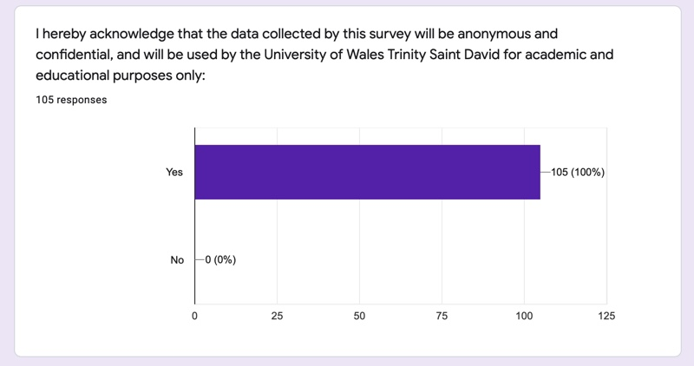

Question 2:

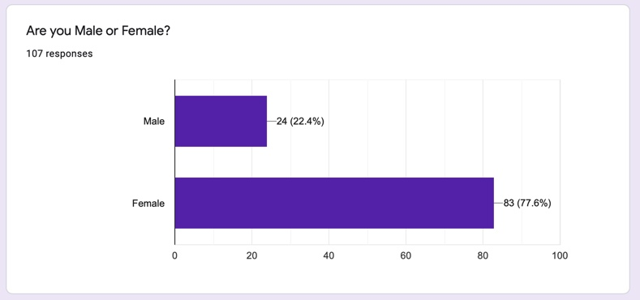

Question 3:

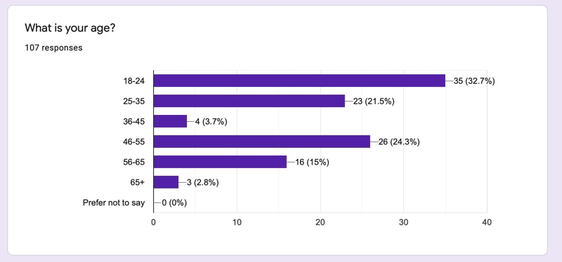

Question 4:

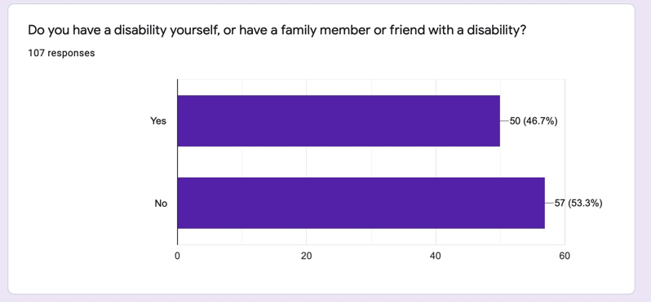

Question 5:

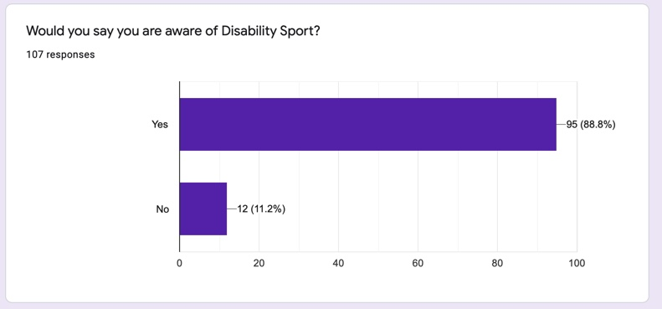

Question 6:

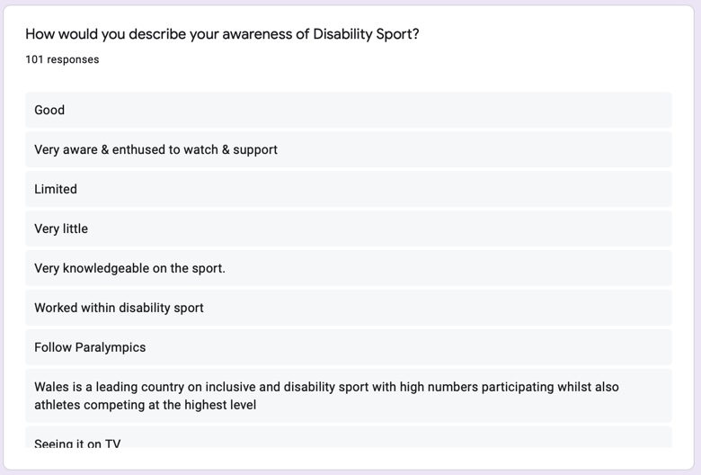

Question 7:

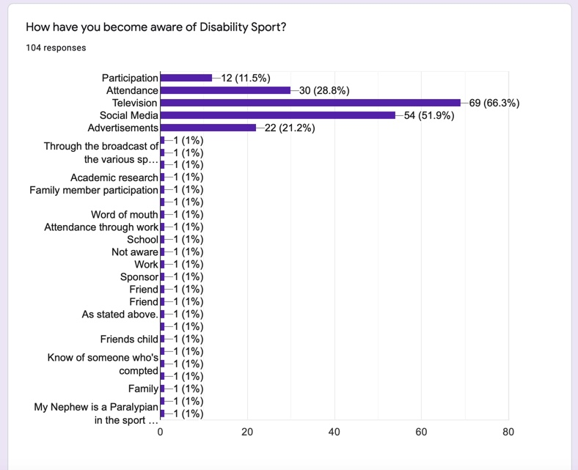

Question 8:

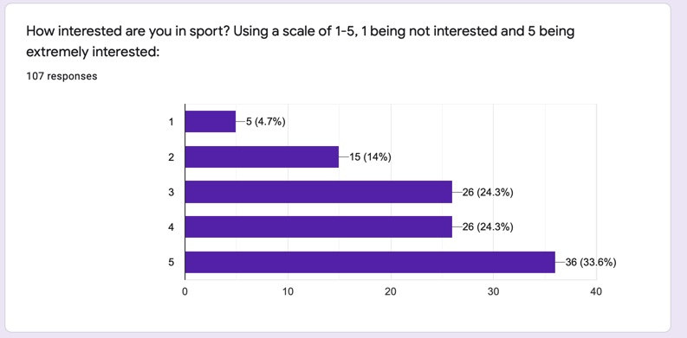

Question 9:

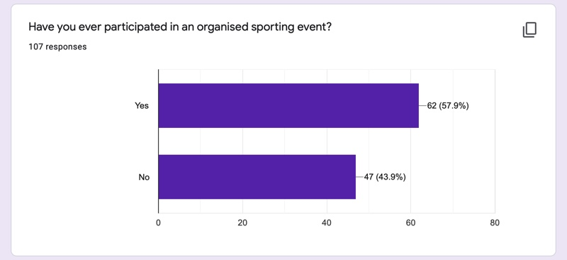

Question 10:

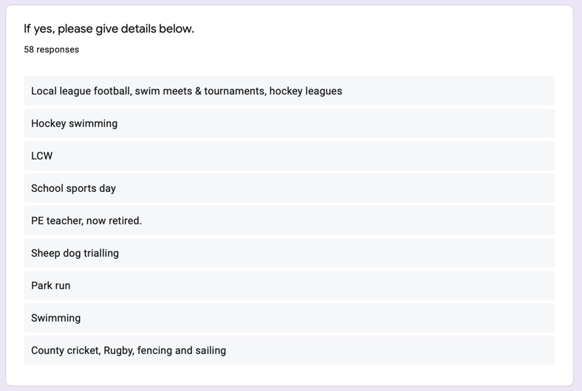

Question 11:

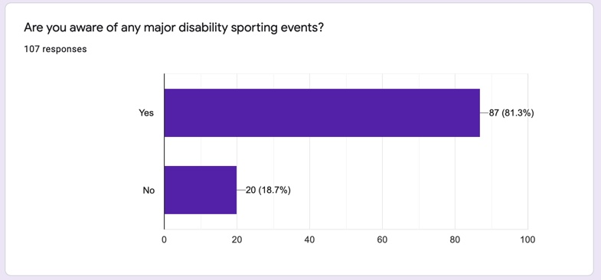

Question 12:

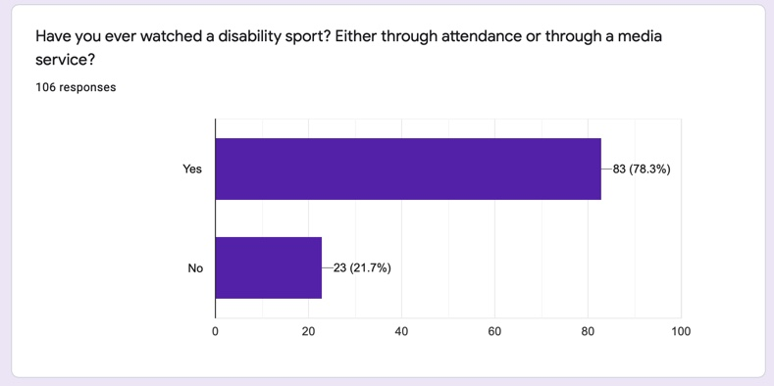

Question 13:

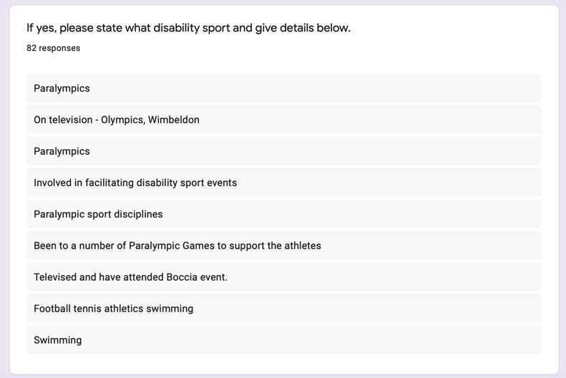

Question 14:

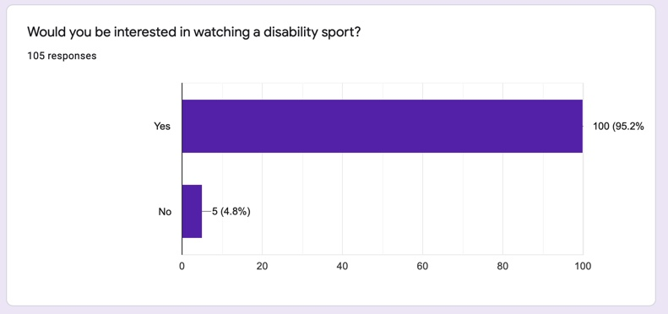

Question 15:

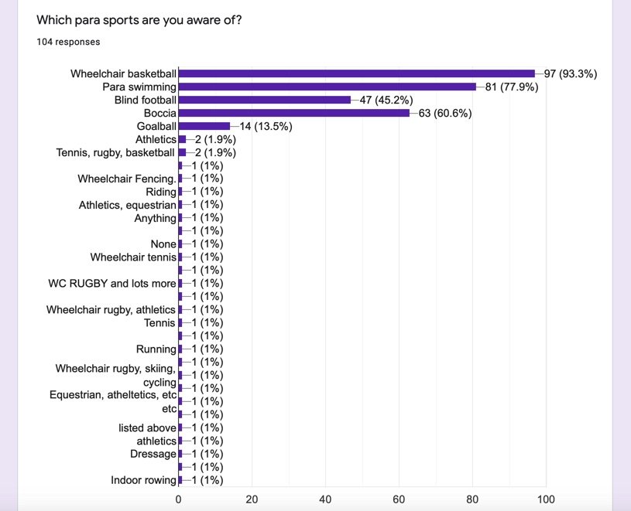

Question 16:

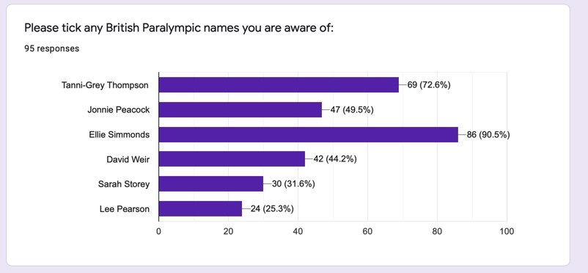

Question 17:

Question 18:

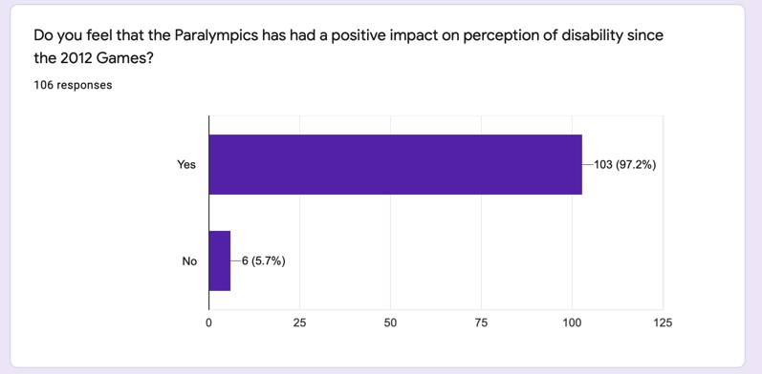

Question 19:

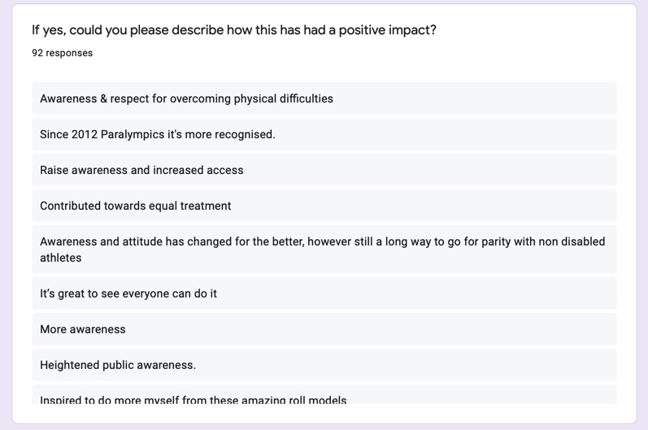

Question 20:

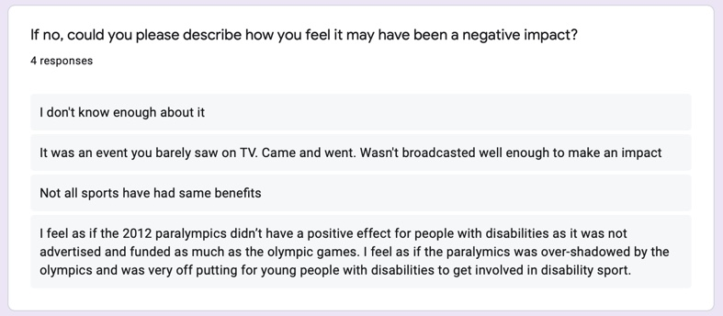

Question 21:

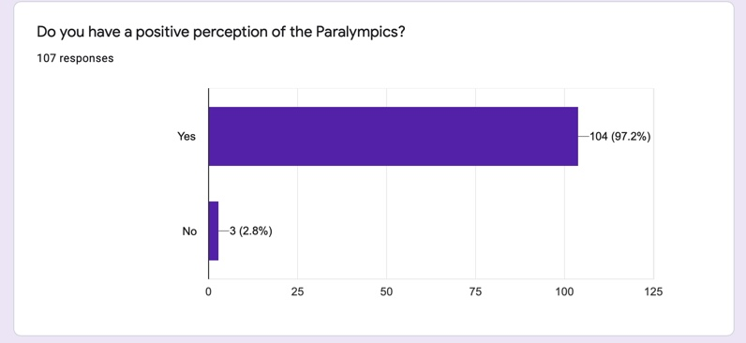

Question 22:

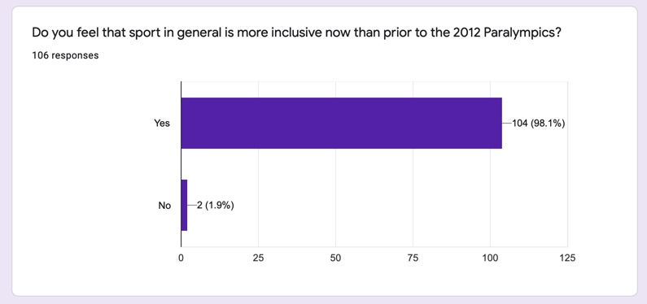

Question 23:

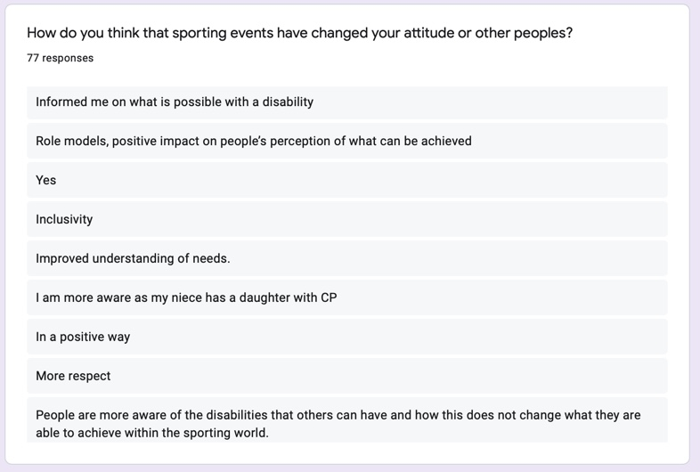

Question 24:

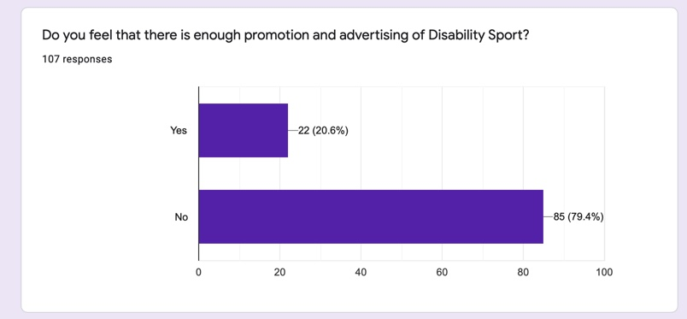

Question 25:

Question 26:

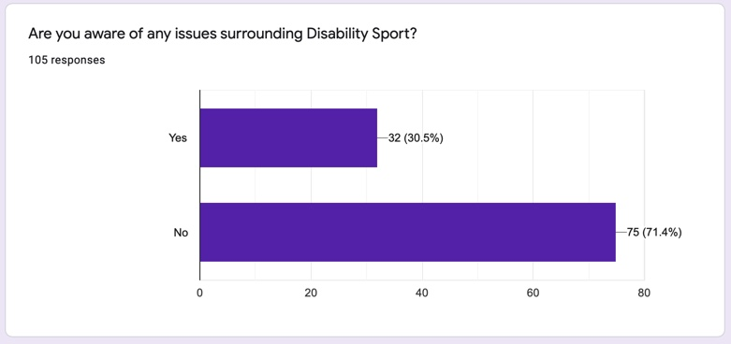

Question 27:

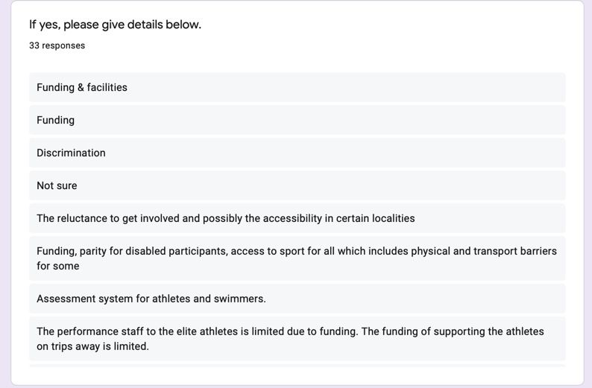

The below link allows access to responses on Google Forms:

https://docs.google.com/forms/d/17qUguyH6VuZsmWBkcGmr4ksAYlcS0Skl887-IRv9gU0/edit#responses

