Network and Cybersecurity Essentials Component 1
Author: Kes Sumner (2015409)
L4 - Network and Cybersecurity Essentials (ACCA4024)
School of Applied Computing
Wales Institute of Science and Art
Date and Time of submission: 18/03/2021 1200 (due to agreed EC)
Contents
1 Introduction 3
2 Networks, devices and threats 4
2.1 Networks and Devices 4
2.2 Threats and vulnerabilities 4
2.3 Mitigations 5
3 Demonstration Design and Implementation 6
4 Mitigation Strategies and Recommendations 9
4.1 Digital Signatures and Data Encryption 9
4.2 Conclusion 10
5 References 11
6 Appendices 12
6.1 Security Policy Amendments 12

Introduction

What is a network? At a high level, in computing terms a network is used by endpoint technology devices or systems for communicating or transferring information or data between them. Generally, there are both physically cabled networks and wireless networks used for this purpose usually connected together by network switches and routers.
Security is key in networks in order for businesses and individuals to prevent unauthorised parties gaining access to systems or information that they are not allowed or permitted to. This type of activity is generally known as a cyberattack or ‘hacking’ and can vary in scale from individuals to gangs to countries with intent to breach security of other individuals, organisations or countries. The top five consequences to the business of a breach are financial loss, legal proceedings, critical system downtime, data loss and reputational loss [1].
This report intends to inform in the context of the Che-Si organisation how networks are used within the business, to review potentials threats and attacks that could take place given the current security posture of the organisation and how these threats could potentially be mitigated against.
The paper also demonstrates in some detail how one of the threats could be exploited and the potential impact/outcome of that specific breach taking place.
The final section of the report seeks to explain security breach mitigation strategies and make recommendations to strengthen Che-Si’s existing security posture through network hardening/improvements and updates to the existing security policy.

Networks, devices and threats

Networks and Devices
The Che-Si business is a global company and as per the existing security policy, the company allows its staff, clients and third party vendors access to the company’s network from any location and from any device, including non-company unmanaged mobile devices. The network (wired and wireless) is the communication layer that allows people and services to access Che-Si corporate data. Many devices are capable of accessing network resources including:
- Unmanaged devices via public access points that the Che-Si IT department has no control or management of. This permitted ability to access the corporate network from any location using any unmanaged device presents an extremely high risk to the business.
- Corporate mobile devices such as tablets and mobile phones. Similar to PCs and laptops some form of Mobile Device Management (MDM) is applied to the devices such as Microsoft Intune to maintain security through policies and patching. [2]
- Bring Your Own Device (BYOD). This is a type of hybrid of unmanaged and corporate devices where the device owner consents to having the corporate MDM software applied.
- PCs and laptops – these are generally managed devices with a high degree of central control administered by the corporate IT department to restrict access to unsecure sources and networks and maintain up to date patching capability.
- Internet of Things (IoT) devices. This category would include things like centrally managed door locks, lighting or cooling/heating facilities.

Threats and vulnerabilities
There are many risks and vulnerabilities present in using such an uncontrolled access model and any/all of the company’s data is at risk of loss and/or theft which, as per the previous section of this document, could have significant financial, legal and long term business implications. A few of the most impacting vulnerabilities and threats that the company are exposed to relative to mobile devices are detailed in the below section. Although this is not a fully comprehensive list of all potential risks, it does highlight some of the worst case scenarios that the Che-Si business could potentially fall victim to under the current security policy.
Some of the key current vulnerabilities regarding mobile devices include the below: [3]
- Malware, ransomware and high risk applications on unmanaged devices can easily spread to the corporate network though file shares, email etc. This type of vulnerability could not only compromise the Che-Si network and systems but spread to other companies and businesses that Che-Si engage with. This would leave the business exposed to compensatory claims from other infected businesses and individuals.
- Phishing/spear phishing. Phishing is a way of distributing malware/ransomware to intended targets, both through personal and corporate devices. This is where threat actors spoof emails or websites to lure individuals to click on some form of trigger to download the payload. The email or website is made to look as if it is a known sender or site (e.g. from someone within the company, or a web site that the individual has used before). [4]
- Theft or loss of devices is one of the key vulnerabilities with mobile devices as they are relatively small and easy to conceal if stolen. Once a threat actor has a device it could potentially be used to connect to network resources and steal/capture corporate data, particularly if there is little security protection on the device.
- Poor password/PIN choices on personal mobile devices are a common method for bad actors to gain access to network systems and applications
- Sniffer/Man in the Middle attacks. There are many unsecure legacy network protocols that are still in use today that transfer credentials and traffic between devices in plain text. This makes them highly susceptible to sniffer attacks. A sniffer is a tool (such as Wireshark or Solarwinds), that can capture network traffic between devices on a network. If that information is not encrypted, then data and/or credentials can be captured and potentially be used as part of a cyber-attack. [5]

Mitigations
The above vulnerabilities and threats pose a considerable risk to the Che-Si network and business. Below are multiple some specific risk mitigations that could implements to improve the security posture of the business and our partners, clients and employees. There are wider mitigations which should be included in the security policy which will be discussed in the next section.
- Password security: Passwords have long been a weakness in authentication, mainly due to people not being able to retain many different complex passwords and succumbing to the temptation of using the same password across multiple systems or really simple passwords. A common mitigation is to stipulate Multi Factor Authentication (MFA) within the security policy. “MFA, sometimes referred to as two-factor authentication or 2FA, is a security enhancement that allows you to present two pieces of evidence – your credentials – when logging in to an account. Your credentials fall into any of these three categories: something you know (like a password or PIN), something you have (like a smart card), or something you are (like your fingerprint). Your credentials must come from two different categories to enhance security – so entering two different passwords would not be considered multi-factor” [6]
- User training: help all users of a network to identify potential malware, ransomware and phishing type attacks. This could be in the form of an online training exercise that all remote users should complete prior to accessing Che-Si’s network. Not all users will be familiar with the concepts of and the damage these types of exploits can carry. Spending some time educating users of the network on the dangers and typical indicators of the above type of exploits is key.
- For ransomware/malware being spread from personal devices, a good anti-virus or end point security solution that provides regular updates should be used for all devices. Devices should be regularly patched to maintain optimum security. Within the business, regularly verified backups should be taken to ensure that the data is recoverable in case of an infection. This includes that standard daily/weekly/monthly and offsite copies of backup data in order to minimise any loss of data in case of infection from remote devices. [7]
- The risk of lost or stolen devices can be mitigated in multiple ways in order to minimise the risk of data theft or network compromise. Some form of mobile device management tool should be used with any BYOD devices that need to connect to the corporate network could be registered with the management system, with the owner’s consent. These types of tools can remotely erase devices if they become lost or stolen.
- The practice of intercepting network traffic and gaining information from that traffic can be mitigated by ensuring that legacy unsecure protocols identified in the previous section are not permitted on the corporate network.

Demonstration Design and Implementation
This section of the document presents a simulated attack based on the possible weak points in the existing architecture and policies. The current security policy allows staff, clients and vendors to access the network from any location using personal devices. The following scenario created in Cisco Packet Tracer is based on a staff member connecting to a public Wi-Fi in a coffee shop to access some files via a tablet mobile device.
Below is a screenshot of network layout from the coffee shop to the Che-Si server. Devices connect to the coffee shop Wi-Fi, behind the Wi-Fi router is a sniffer device. All traffic passes through the sniffer device to get out on to the internet and specific protocols can be captured as required. (such as ARP and FTP in this demonstration).
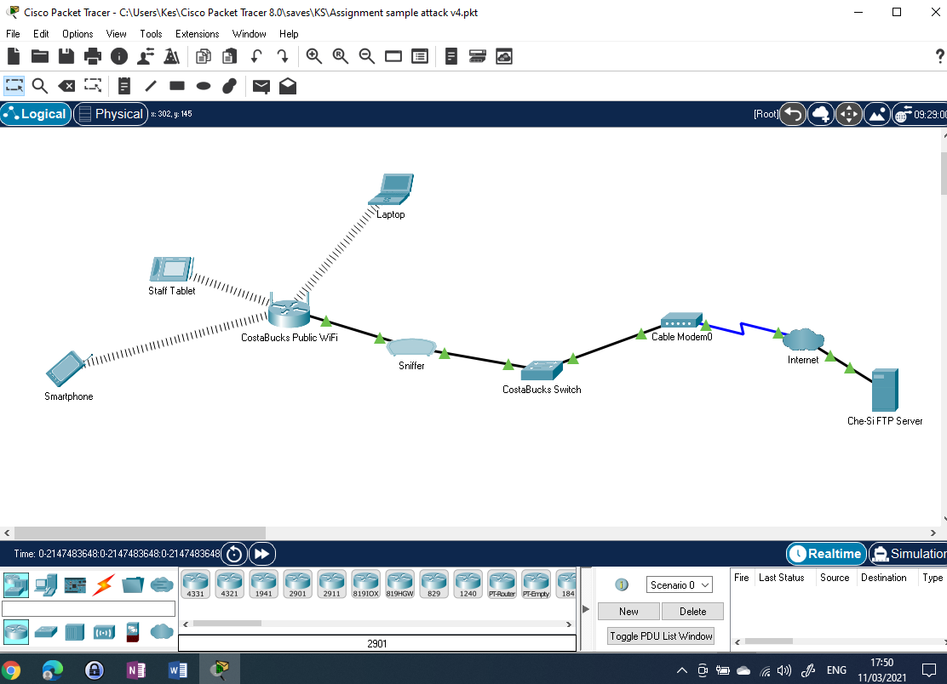
Figure 1: Demonstration Scenario Network Structure

The steps taken during the security breach are as follows:
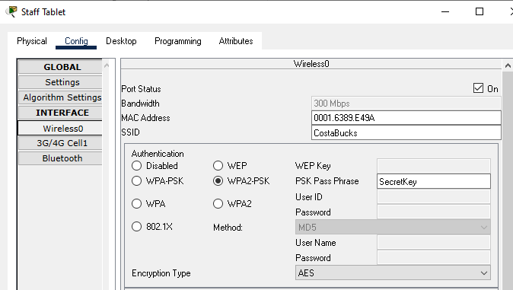
Figure 2: Che-Si staff member connects to the coffee shop Wi-Fi

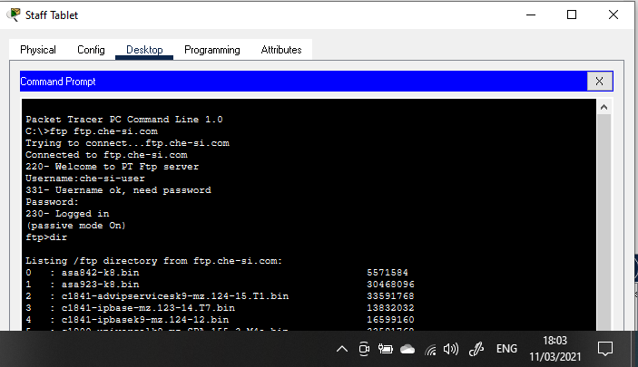
Figure 3: The staff member uses a command prompt on their tablet to access the Che-Si FTP server and log on using the credentials “che-si-user” and password “ftp-pass1”. They successfully connect and upload/download client data files as required.
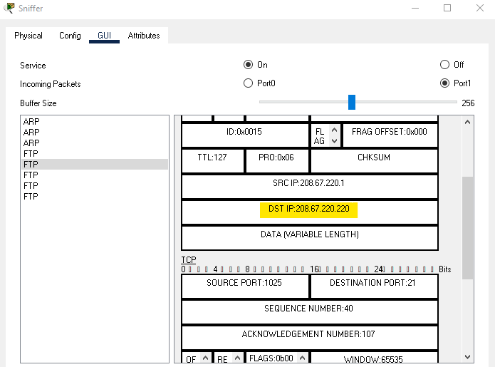
Figure 4: The destination IP address is captured on the sniffer for the Che-Si FTP server.
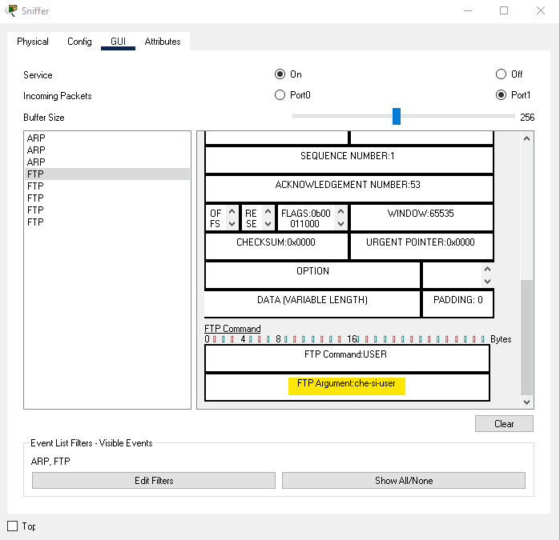
Figure 5: The ftp username is captured on the sniffer in plain text.
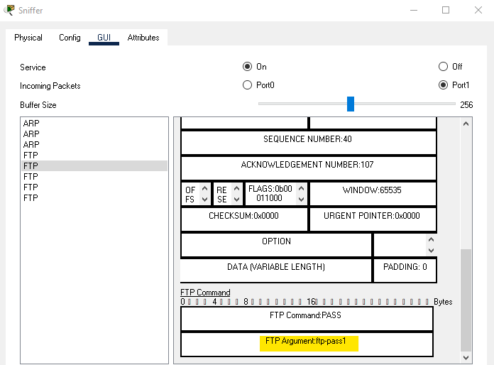
Figure 6: the FTP user’s password is also captured in plain text.

Now that the credentials to log on to the remote FTP server have been captured, the threat actor can retrieve the Che-Si user logon details and server IP address from the sniffer. They can then access the FTP server remotely themselves using the same credentials to logon to download, change files and upload them back with false information or inject malware/ransomware in to files on the server, infecting the corporate network.
In order to mitigate against this type of attack, unsecure protocols such as FTP, HTTP, TELNET etc. should not be used on the network. Secure protocols should be used instead such as SFTP, SSH, and HTTPS should be enforced for any access from remote personal devices. Digital signatures and encryption can also mitigate against sniffer type attacks. This would prevent the attacker from interfering with any documents that they could gain access to as part of an attack.

Mitigation Strategies and Recommendations

Digital Signatures and Data Encryption
Digital signatures are a widely used way of verifying the authenticity and integrity of an electronic object, such as an email or digital document, for example. They use a virtual fingerprint, generated using keys, which will be unique to the entity that creates the signature. Digital signatures guarantee that the signatory (source person) has sent the email, e.g. that it is not a spear phishing email and also that an email/document has not been tampered with since it was signed. Digital signatures have the same legal rights as physical signatures in many countries. [8]
Digital encryption is a mechanism of ensuring confidentiality that uses pre-shared keys to allow a sender to encrypt an entire document or email. Only the intended recipient who owns the corresponding private key can decrypt the document or email. It is particularly important if the information being transferred is sensitive and should not be possible for it to be intercepted and read by unintended parties. It differs from a digital signature in that once a message or document is encrypted, it can only be unencrypted and read or modified by the recipient with the appropriate private key. Whereas a digital signature does not stop the email or document from be read if intercepted. [9]

Conclusion
In conclusion, it can be seen that there are multiple security flaws in the existing security policy permitting staff, clients, and even vendors to access the Che-Si network from any device (managed or unmanaged) and any external location. while it facilitates easier and more efficient ways of working with clients and third party vendors, presents a huge security risk and seriously compromises Che-Si’s cybersecurity posture. Such devices will be in an unknown security state and some mitigation measures should be put in place to help reduce the risks of a serious security breach and the subsequent catastrophic business impact on Che-Si from legal, financial and reputational perspectives.
See Appendix 6.1 for details on recommended updates to the company’s existing security policy.

References

[1] G. Strawbridge, “5 Damaging Consequences Of A Data Breach,” MetaCompliance, Feb. 25, 2020. [Online]. Available: https://www.metacompliance.com/blog/5-damaging-consequences-of-a-data-breach/ [Accessed Mar. 02, 2021]
[2] Centre for Internet Security, “CIS Controls Mobile Companion Guide,” CIS, [Online]. Available: https://www.cisecurity.org/blog/new-release-cis-controls-mobile-companion-guide/ [Accessed Mar. 04, 2021]
[3] National Crime Agency, “The threat from cyber-crime,” NCA, 2018. [Online]. Available: https://www.nationalcrimeagency.gov.uk/what-we-do/crime-threats/cyber-crime [Accessed Mar. 04, 2021]
[4] L. R. Hegwer, “Managing Cybersecurity Threats,” Healthcare Financial Management, vol. 71, no. 2, pp.32-39, Feb. 2017. [Online]. Available: ProQuest, https://search-proquest-com.ezproxy.uwtsd.ac.uk/docview/1869006241?pq-origsite=primo&accountid=130472. [Accessed Mar. 04, 2021]
[5] D. Glavan, “Sniffing Attacks on Computer Networks,” Naval Academy Scientific Bulletin, vol. 23, no. 1, pp.202-207, June 2020. [Online]. Available: Proquest, https://www-proquest-com.ezproxy.uwtsd.ac.uk/docview/2429826362/92A7FA08E89C4B52PQ/2?accountid=130472. [Accessed Mar. 05, 2021]
[6] National Institute of Standards and Technology, “Back to basics: Multi-factor authentication (MFA),” NIST, Dec. 2019. [Online] Available: https://www.nist.gov/itl/applied-cybersecurity/tig/back-basics-multi-factor-authentication [Accessed Mar. 06, 2021]
[7] F. Malecki, “ Best practices for preventing and recovering from a ransomware attack,” Computer Fraud and Security, vol. 2019, no. 3, pp. 8-10, Mar. 2019. [Online]. Available: Elsevier ScienceDirect, https://www-sciencedirect-com.ezproxy.uwtsd.ac.uk/science/article/pii/S1361372319300284. [Accessed Mar. 05, 2021]
[8] Cybersecurity & Infrastructure Security Agency, “Understanding Digital Signatures,” CISA, Aug. 2020. [Online] Available: https://us-cert.cisa.gov/ncas/tips/ST04-018#:~:text=Digital%20signatures%20work%20by%20proving,using%20the%20sender%27s%20private%20key [Accessed Mar. 07, 2021]
[9] Cybersecurity & Infrastructure Security Agency, “Understanding Encryption,” CISA, Sept. 2019. [Online] Available: https://us-cert.cisa.gov/ncas/tips/ST04-019 [Accessed Mar. 08, 2021]
[10] National Cyber Security Centre, “NCSC Cyber Assessment Framework Guidance,” NCSC, No date, [Online] Available: https://www.ncsc.gov.uk/collection/caf/caf-principles-and-guidance/b-3-data-security [Accessed Mar. 11, 2021]

Appendices

Security Policy Amendments
This appendix contains a number of potential amendments to the existing Che-Si security policy to mitigate against so of the key vulnerabilities identified within this document and by the demonstration exercise detailing a man it the middle or sniffer attack.
- A clear difference needs to be made between clients, vendors and especially staff using personal devices and Bring Your Own Device (BYOD). Where possible all mobile devices should be enrolled as part of the Che-Si corporate Enterprise Mobility Management (EMM) solution introducing some control over patching/updates, device encryption, application management, backup and erasure in case of loss or theft.

- Only secure network protocols should be permitted when connecting to the corporate network for any purpose. These should include, but not be limited to HTTPS, SFTP and SSH in place of legacy unsecure, plain text protocols such as HTTP, FTP and Telnet.

- Both digital signatures and digital encryption should be implemented (if not already in place) and utilised where appropriate. Digital signatures would provide reassurance that emails and documents sent from remote locations and mobile devices are valid (i.e. not phishing emails). Digital encryption capability would ensure that an email or document could not be read other than by the intended recipient.

- Strong password policies should be enforced through both security policy and technical mechanisms to reduce the risk of password cracking. For standard user accounts, passwords should be a minimum of 10 characters and include upper case, lower case, numeric and other non-alphanumeric characters. Accounts with elevated privileges (admin accounts) should have a minimum of 15 characters with the same character restrictions.

- There should be some form of user education for all people connecting to the corporate network or applications to inform them of the dangers of phishing/malware/ransomware, social engineering techniques employed by threat actors such as tail gating and shoulder surfing to gain access to accounts, information and facilities etc. This would probably best be delivered via an external web based facility prior to access being granted to Che-Si networks/applications being permitted.

- Every person that connects to the Che-Si environment should have clear visibility of the full security policy to ensure that they adhere to the required security practices and know what is acceptable to the business and what is not. This could be part of the user training requirement above.

- All clients and vendors should have some form of vetting of their own security policies and security history to ensure that they maintain a comparable level of cybersecurity as Che-Si. “It may be possible to gain sufficient assurance that a partner or supplier applies security controls to the same rigour (or better).” [10]

