AHHI5017 Contesting Conflict: Representations of War, 1789–Present
Week 1: The French Revolution and the Napoleonic Wars (plus introduction to module)
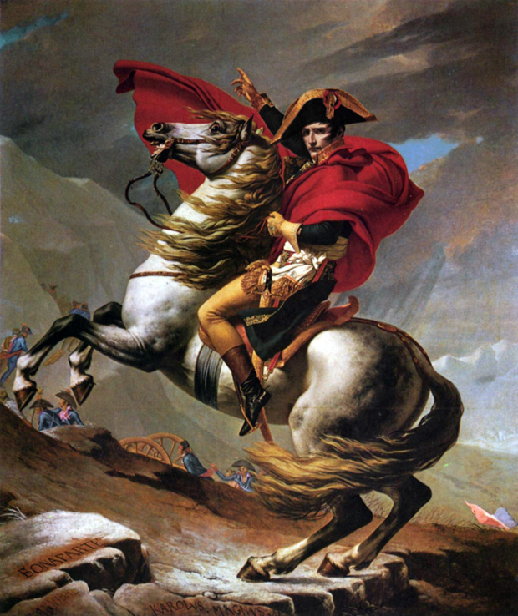
Jacques-Louis David, Bonaparte Crossing the Alps (1801)
Lectures summary:
This week concentrates on the cultural impact of the French Revolution and the subsequent Napoleonic Wars. We shall examine, in the first instance, how the Revolution and the French conquest of territories in Europe and North Africa were propagandised in art and museums, before shifting attention to British reactions to the Napoleonic era. Particular emphasis is placed on the depiction of Bonaparte in French art, but also British cartoons.

Required reading:
- Philip G Dwyer, ‘Napoleon Bonaparte as Hero and Saviour: Image, Rhetoric and Behaviour in the Construction of a Legend,’ French History, Vol. 18, No. 1 (2004), pp. 379–403.
Background reading:
- Andrew McClennan, ‘Introduction’ and ‘The Revolutionary Louvre’ in Inventing the Louvre: Art, Politics, and the Origins of the Modern Museum in Eighteenth-Century Paris (Los Angeles: University of California, 1999), pp. 1–12, 91–123.

- Background document available on Moodle
- British Library, ‘The Impact of the Napoleonic Wars in Britain’ and ‘The Impact of the French Revolution in Britain’ (http://www.bl.uk/romantics-and-victorians/articles/the-impact-of-the-napoleonic-wars-in-britain; http://www.bl.uk/romantics-and-victorians/articles/the-impact-of-the-french-revolution-in-britain). Pay particular attention to the collections of Revolution-era visual culture which accompany each of these articles.
- Open University, French Revolution (http://www.open.edu/openlearn/history-the-arts/history/history-art/french-revolution/content-section-0)
- David Gates, ‘Napoleonic Wars,’ The Oxford Companion to Military History (Oxford: Oxford University, 2004). Online: http://www.oxfordreference.com/view/10.1093/acref/9780198606963.001.0001/acref-9780198606963-e-891.

Preparing for the lectures:
The way students organise their preparation for the lectures will to an extent depend on their familiarity with the era under discussion. Those who are not especially conversant or knowledgeable about the key themes of the French Revolution may wish to avoid diving straight into the required readings, and instead begin with the (very) basic introduction that is available on the Moodle page. A useful, comprehensive overview by the Open University too is available here: http://www.open.edu/openlearn/history-the-arts/history/history-art/french-revolution/content-section-0.
A set of questions to consider when completing the reading is listed below. Some additionally useful background materials are also noted at the end of this document.

Questions to consider:
Dwyer, ‘Napoleon Bonaparte’
- Dwyer begins his article by stating that Napoleon’s campaigns in Italy can be conceived as having been “a war of representations.”
- How do you interpret this phrase, and what significance might it have?
- What were the features of this so-called “war of representations” involving France and the Italian states?

- What are some of the key features of the image of Napoleon as cultivated by himself and his supporters?
- Are these identical?
- Were responses to Napoleonic propaganda uniform amongst the French general public?

The below questions relate to materials assigned as background reading. The questions on Napoleon’s depiction in Britain will be relevant for the Monday lecture in Week 2.

McClennan, Inventing the Louvre
- Why does McClennan think ‘The Revolutionary Louvre’ was distinguishable from its precursors?
- How did the Louvre collection originate?
- To whom did the collection belong prior to the French Revolution?
- How did ownership change as a consequence of the revolution?

- How was ‘The Revolutionary Louvre’ affected during:
- the period immediately after the abolition of the monarchy;
- the Reign of Terror;
- the era of continental expansion under the military leadership of Napoleon Bonaparte?
- What types of things went on display during these different periods, and what ideas did curators visitors wish to take from observing the collection
- What changes occurred as regards how the museum and its collections were managed during these periods?
- What changes occurred as regards the manner in which collections were displayed and interpreted?

British Library, ‘The Impact of the Napoleonic Wars in Britain’ and ‘The Impact of the French Revolution in Britain’
- How would you characterise the British response to a) the Revolution and b) the Napoleonic Wars?
- What attitudes were expressed for or against the Revolution?
- What attitudes were expressed for or against French military expansion in Europe?
- What attitudes were expressed for or against Napoleon Bonaparte?

- How was Napoleon depicted by British artists, writers and cartoonists?
- What different sorts of images of Napoleon circulated in Britain?

- Which images of Napoleon do you find most interesting and/or effective? (Please make a note of these ready for in-class discussion.)

Recommended additional background materials:
- BBC Radio 3, ‘British Romanticism and Napoleon,’ December 16 2012 (part of On Napoleon series; available on BBC iPlayer: http://www.bbc.co.uk/programmes/b01p9d6x)
- BBC Radio 4, Napoleon: The Man and the Myths, June 15–19 2015 (series of fifteen-minute episodes by historian Andrew Roberts; available on the BBC Player and as podcast: http://www.bbc.co.uk/programmes/b05zzlb4)
- BBC Radio 4, In Our Time (long-running series which has featured episodes entitled ‘The Legacy of the French Revolution [June 14 2001]; ‘Napoleon and Wellington [October 25 2001]; ‘The French Revolution’s Reign of Terror’ [May 26 2005]; and ‘Delacroix's Liberty Leading the People’ [October 20 2011. The complete episode archive is available on the programme’s website: http://www.bbc.co.uk/programmes/articles/2Dw1c7rxs6DmyK0pMRwpMq1/in-our-time-archive.)
- British Museum, ‘Napoleon and the British’ (exhibition held earlier this year; see: http://www.britishmuseum.org/whats_on/past_exhibitions/2015/bonaparte_and_the_british.aspx; The Daily Telegraph website published an array of images from it: http://www.telegraph.co.uk/news/picturegalleries/11358740/Propaganda-wars-how-British-cartoonists-skewered-Napoleon.html?frame=3171251). These images can be viewed as a complement to the British Library collection.

