Software Development Assignment One
ACCB4017

Crina Elena Iordache (2112903)
Suneth Fernando
Table of Contents

Introduction 2
Part A 2
A1.Variables 2
a2.If/Else Statements 3
A3.Loops 4
part b 5
Exercise one 5
Exercise two 8
exercise three 12
Exercise four 18
conclusion 26
References 26

Introduction

This practical report will focus on the description and analysation of different types of variables, statements, and loops in the phyton programming language, as well as providing a variety of examples and practical proof of the successful outcomes of the given exercises.

Part A

A1.Variables

Variables can be used to store different types of values such as numbers or integers, letters, and sentences such as strings, floats, booleans and so on...,in the phyton programming language, they can be changed consecutively and are very flexible in that aspect, variables are the main starting points of the code as they are constantly used throughout the code and are a crucial part of the code. The data type of a variable can be determined in different ways based on the type the user wishes to utilize, another method of defining the data type of a variable can be casting which is very useful for redefining the variable.[1]
Variables are of two different types, they can be global variables and local variables, the global type is preferred when the user does not plan to change the data type of the variable or redefine it, while the local type of variables is redefined multiple times and can be used in many different operations and functions that require a data type change of a variable, as a result variables are an important means of communication between a user and the programming language.[1][2]
Also, as phyton is a programming language that uses dynamic typing and strong typing the variables are verified when the user runs the code in comparison to the static typing that verifies if you have defined the variables before running the code which can slow down the whole process.[1][2]
Although the strong type means that phyton does have its very own data types that can be defined with the help of a variable because it is also a dynamic type it doesn’t determine the variable until the code is run compared to the static type which determines the variables at the compile time.[1][2]
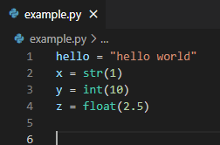

a2.If/Else Statements

An if/else statement is a conditional statement which means that the user can apply different boundaries and conditions to his code in order to obtain a more specific result, it can also be referred to as a multipath choice statement as it gives the user multiple choices with different outcomes. [3]
The if/else statement brings complexity and flexibility to a program as it can be used by itself multiple time to create a complex and conditioned path or within a while loop that creates even more of an opportunity for the choices of the user and also simplifies the writing and length of the code making it look clearer and much more organised rather than continuously using chains of if/else statements or nested ones.[3][4]
In the phyton programming language the if/else statement must be placed at the same indent for it to function otherwise phyton will not allow you to use or run it. The above-mentioned statement functions by checking both the if and else conditions and providing the output based on which condition of the code is met, for instance if the code meets the condition that is determined through the if it will give the output that if generates otherwise it will give the output that else generates.[3][4]
If/else statements are very effective because they contribute greatly to the program’s outcome as they are meant to verify and filter the code based on various conditions that the user wants to be met. Depending on how much the user plans on writing or how complex he wants the code to be the if/else statement can be written both in a row with multiple lines and outcomes or in the shorthand version which is useful for only having one statement or condition to verify.[4]

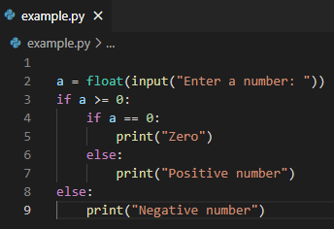

A3.Loops

The While loop is a control statement that allows the code to be repeated multiple times until a boolean condition is met, a boolean verifies if the code is true or false and based on the code it repeats until the condition is met and if it not used properly can repeat infinitely in the output as it has not been given the option to meet the chosen condition.[3]
A while loop is very similar to an if statement that keeps on repeating and an if statement, or elif or if/else statement can all be used inside of a while loop to determine the outcome of the code for a certain number of times until the desired ouput is given. To use another statement with the while loop in the phyton programming language the user has to verify the indentation as if the if statement for instance is not written or inserted inside the while loop code it will not function.[3]
The for loop is another control statement that can be used in order to repeat the block of code for multiple times based on the desire of the user but the main difference between the two is that a for loop has a specified number of times when the code is repeated unlike the while loop that repeats the code until a condition is met and otherwise does not stop repeating.[3][4][5]
Loops such as for and while are extremely important and efficient when used correctly as they highly change the workflow by minimizing the amount of code that must be written if the user would want to repeat a piece of code for a number of times it is much clearer and less redundant to use a loop that will do the same thing based on the conditions.[5]

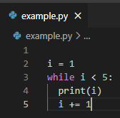

part b

Exercise one

- Variables with different types of values:

  - Logical stages:
- Require the user to enter the name.
- Check that the name variable is made up of letters and does not stop the code at the value error.
- Require the user to enter the age.
- Check that the age variable has boundaries between 0 and 100 and does not stop at value error.
- Require user to enter the height.
- Check that the height variable has boundaries between 0 and 3 and does not stop at the value error.
- Print the input of the variables when conditions are met.
  - Code with annotations:
import re
# input name with while and if conditions
while True:
try:
name = str(input("Enter name: "))
if name.isalpha():
print("Name entered successfully...")
break;
else:
print("The name is made up of letters...")
except ValueError:
print("The name is made up of letters...")

# input age with while and if conditions
while True:
try:
age = int(input("Enter age: "))
if age>0 and age<100:
print("Age entered successfully...")
break;
else:
print("Age should be >0 and <100...")
except ValueError:
print("The age is made up of numbers...")
continue

# input height with while and if conditions
while True:
try:
height = float(input("Enter height: "))
if height>0 and height<3 :
print("Height entered successfully...")
break;
else:
print ( "The height is incorrect, please try again!")
except ValueError:
print ( "The height is incorrect, please try again!")
continue

# print name, age and height
print("Name is:", name)
print("Age is:", age)
print("Height is:", height)
c) Testing: normal “Happy Path”/Boundary Conditions/Impossible-Out of range
- Normal values, within range
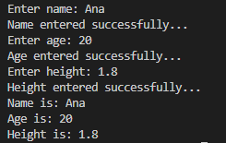
Conclusion: Program performed as expected, correct output is printed
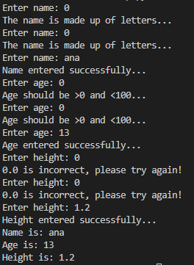
- Boundary: test variables for valid input
Conclusion: User was not granted to enter 0, program performed correctly

- Boundary: test variables for out-of-range input
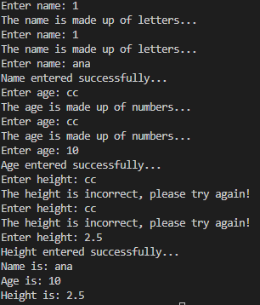
Conclusion: User was not granted to enter cc, Program performed correctly

- Boundary: test variables for out-of-range input
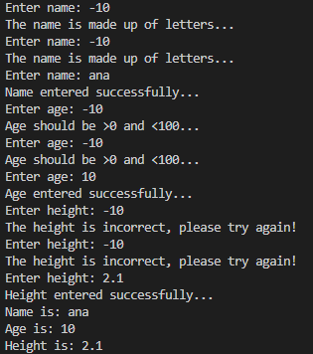
Conclusion: User was not granted to enter -10, Program performed correctly

Exercise two

- Require user to input multiple variables and calculate the area of the blue shaded part:

- Logical stages:
  - Require the user to enter the radius of the circle.
  - Check that the input has boundaries between 4 and 15 and does not stop the code at the value error.
  - Require the user to enter the side of the square.
  - Check that the input has boundaries between 0 and 11 and does not stop at value error.
  - Require user to enter the width of the rectangle.
  - Check that the input has boundaries between 0 and 11 and does not stop at the value error.
  - Require user to enter the length of the rectangle.
  - Check that the input has boundaries between 0 and 11 and does not stop at the value error.
  - Calculate area of circle.
  - Calculate area of square.
  - Calculate area of rectangle.
  - Calculate area of shaded part.
  - Print the result.
- Code with annotations:
from cmath import pi
import math
# input radius of circle
while True:
try:
print("Hint:it should be between 5 and 15.")
r_circle = int(input( "What is the radius of the circle?:"))
if r_circle>4 and r_circle<15 :
print("Radius entered successfully...")
break;
else:
print ("Please try again!")
except ValueError:
print ("Please try again!")
continue
# input side of square
while True:
try:
print("Hint:it should be between 1 and 10.")
s_square = int(input( "What is the side of the square?: "))
if s_square>0 and s_square<11 :
print("Side entered successfully...")
break;
else:
print ("Please try again!")
except ValueError:
print ("Please try again!")
continue
# input width of rectangle
while True:
try:
print("Hint:it should be between 1 and 10.")
w_rectangle = int(input( "What is the width of the rectangle?: "))
if w_rectangle>0 and w_rectangle<11 :
print("Width entered successfully...")
break;
else:
print ("Please try again!")
except ValueError:
print ("Please try again!")
continue
# input length of rectangle
while True:
try:
print("Hint:it should be between 1 and 10.")
l_rectangle = int(input( "What is the length of the rectangle?: "))
if l_rectangle>0 and l_rectangle<11 :
print("Length entered successfully...")
break;
else:
print ("Please try again!")
except ValueError:
print ("Please try again!")
continue
# define pi
math.pi
# calculate area of cirlcle
area_circle = math.pi*r_circle*r_circle

# calculate area of square
area_square = s_square*s_square

# calculate area of rectangle
area_rectangle = w_rectangle*l_rectangle

# calculate area of shaded part
shaded_area = area_circle - area_square - area_rectangle

# print area of shaded part
print ("The area of the blue shaded part is " + str(round(shaded_area,1)))

- Testing: normal “Happy Path”/Boundary Conditions/Impossible-Out of range

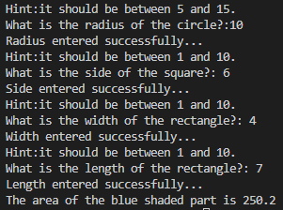
- Normal values, within range
Conclusion: program performed as expected, correct output is printed.

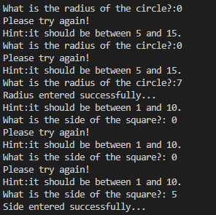
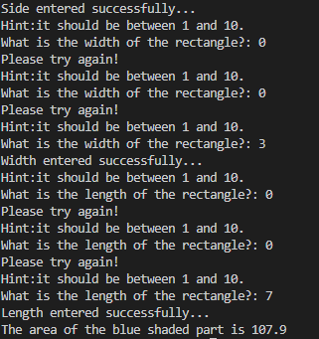
- Boundary: test variables for valid input
Conclusion: user was not granted to input 0, program performed correctly.
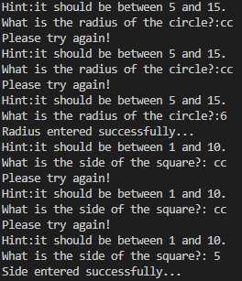
- Boundary: test variables for out-of-range input
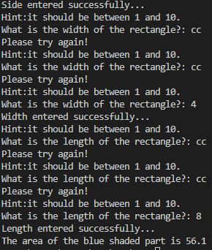
Conclusion: user was not granted to input cc, program performed correctly.

- Boundary: test variables for out-of-range input
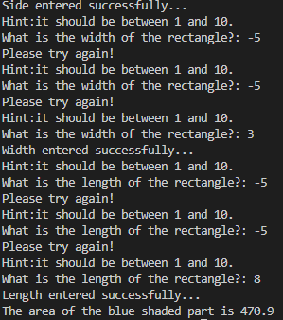
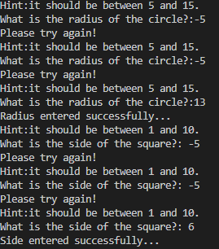
Conclusion: user was not granted to input -5, program performed correctly

exercise three

  - Write a program to calculate the total cost of petrol per week:

  - Logical stages:

- Define list.
- Define i variable.
- Require the user to enter the miles for Monday.
- Check that Monday has boundaries between 0 and 500 and does not stop at the value error and append Monday to list.
- Require the user to enter the miles for Tuesday.
- Check that Tuesday has boundaries between 0 and 500 and does not stop at value error and append Tuesday to the list.
- Require user to enter the miles for Wednesday.
- Check that Wednesday has boundaries between 0 and 500 and does not stop at the value error and append Wednesday to the list.
- Require user to enter the miles for Thursday.
- Check that Thursday has boundaries between 0 and 500 and does not stop at the value error and append Thursday to the list.
- Require user to enter the miles for Friday.
- Check that Friday has boundaries between 0 and 500 and does not stop at the value error and append Friday to the list.
- Require user to enter the miles for Saturday.
- Check that Saturday has boundaries between 0 and 500 and does not stop at the value error and append Saturday to the list.
- Require user to enter the miles for Sunday.
- Check that Sunday has boundaries between 0 and 500 and does not stop at the value error and append Sunday to the list.
- Redefine i and print list.
- Calculate total mileage.
- Define total.
- Calculate cost of petrol.
- Print the total price of the petrol.
  - Code with annotations:

from calendar import MONDAY

# define input list
list = []

# define i
i = 6
while i <7:

# input miles for monday
while True:
try:
monday= int(input("Enter miles for Monday: "))
if monday>0 and monday<500:
print("Miles entered successfully...")
break;
else:
print("Miles should be >0 and <500...")
except ValueError:
print("The miles should be numbers...")
continue
# add to list
list.append(monday)
# input miles for tuesday
while True:
try:
tuesday= int(input("Enter miles for Tuesday: "))
if tuesday>0 and tuesday<500:
print("Miles entered successfully...")
break;
else:
print("Miles should be >0 and <500...")
except ValueError:
print("The miles should be numbers...")
continue
# add to list
list.append(tuesday)
# input miles for wednesday
while True:
try:
wednesday= int(input("Enter miles for Wednesday: "))
if wednesday>0 and wednesday<500:
print("Miles entered successfully...")
break;
else:
print("Miles should be >0 and <500...")
except ValueError:
print("The miles should be numbers...")
continue
# add to list
list.append(wednesday)
# input miles for thursday
while True:
try:
thursday= int(input("Enter miles for Thursday: "))
if thursday>0 and thursday<500:
print("Miles entered successfully...")
break;
else:
print("Miles should be >0 and <500...")
except ValueError:
print("The miles should be numbers...")
continue
# add to list
list.append(thursday)
# input miles for friday
while True:
try:
friday= int(input("Enter miles for Friday: "))
if friday>0 and friday<500:
print("Miles entered successfully...")
break;
else:
print("Miles should be >0 and <500...")
except ValueError:
print("The miles should be numbers...")
continue
# add to list
list.append(friday)
# input miles for saturday
while True:
try:
saturday= int(input("Enter miles for Saturday: "))
if saturday>0 and saturday<500:
print("Miles entered successfully...")
break;
else:
print("Miles should be >0 and <500...")
except ValueError:
print("The miles should be numbers...")
continue
# add to list
list.append(saturday)
# input miles for sunday
while True:
try:
sunday= int(input("Enter miles for Sunday: "))
if sunday>0 and sunday<500:
print("Miles entered successfully...")
break;
else:
print("Miles should be >0 and <500...")
except ValueError:
print("The miles should be numbers...")
continue
# add to list
list.append(sunday)
# redefine i
i=8
print(list)

# calculate total mileage
print ("The total mileage is", sum(list))
# define total
total=sum(list)
# calculate cost of petrol
cost_of_petrol = 1.35 * total/11.2
print("The price of the petrol is " + str(round(cost_of_petrol, 2)))

  - Testing: normal “Happy Path”/Boundary Conditions/Impossible-Out of range
  - Normal values, within range
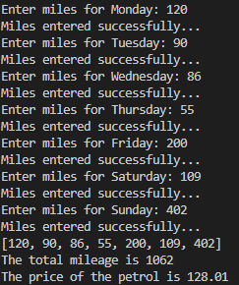
Conclusion: program performed correctly; output is printed as expected.
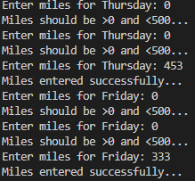
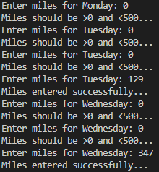
  - Boundary: variables for valid input
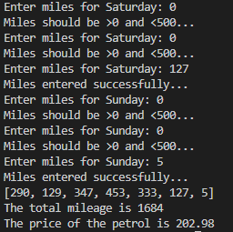
Conclusion: user was not granted to enter 0, program performed correctly.
  - Boundary: test variables for out-of-range input
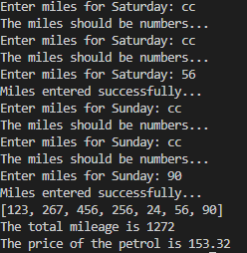
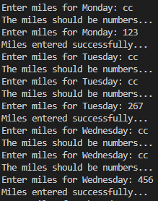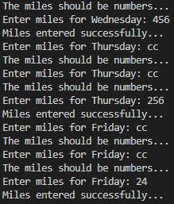
Conclusion: user was not granted to enter cc, program performed correctly.

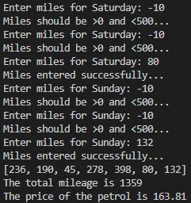
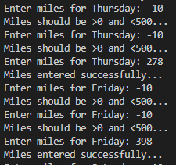
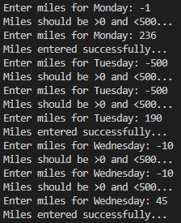
Conclusion: the user was not granted to enter negative values, the program performed correctly.

Exercise four

    - Write a program to play a pair matching game:

    - Logical stages:
      - Define matches lists.
      - Print game description and instructions.
      - Define input list.
      - Define the i variable.
      - Define the congrats variable.
      - Define main while loop to play multiple rounds
      - Input first guess with multiple conditions and boundaries.
      - Add first guess to list if conditions are met.
      - Verify first guess.
      - Input second guess with multiple conditions and boundaries.
      - Add second guess to list if conditions are met.
      - Verify second guess.
      - Check if any pairs are found in the first round
      - Verify number of turns to end loop.
      - Count and print final number of pairs matched.

    - Code with annotations:
from itertools import count
# define matches lists
matches_1= [10, 20, 30, 40, 50, 60, 70, 80, 90, 100, 110, 120]
matches_2= [120, 110, 100, 90, 80, 70, 60, 50, 40, 30, 20, 10]

# print game instructions
print("Let's play a gussing game!")
print("You can guess from 6 pairs.")
print(" ")
print("This is the board!")
print("? ? ? ? ? ? ? ? ? ? ? ?")
print("10 20 30 40 50 60 70 80 90 100 110 120")
print("As you can see values start from 10-120, best of fortune!")
print(" ")

# define input list
list = []

# define i
i = 0

# define congrats
congrats= 0

# define main while loop with i to play multiple rounds
while i <12:

# input first guess with while loop and conditions

while True:
try:
guess= abs(int(input("Make your first guess: ")))
if guess>0 and guess <121:
guess == matches_1.index(guess)
print("Accepted guess.")
else:
print("Your guess should be between 10 and 120...")
except ValueError:
print("Your guess should be between 10 and 120...cc")

continue
break;
# add to list
list.append(matches_1.index(guess))
#verify first guess
if guess in matches_1:
print("You found", guess, "in place:", matches_1.index(guess))
print( )
else: print("Not found.")
print( )

# input second guess with while loop and conditions

while True:
try:
guess1= abs(int(input("Make your next guess: ")))
if guess1>0 and guess1 <121:
guess1 == matches_2.index(guess1)
print("Accepted guess.")

else:
print("Your guess should be between 10 and 120...")
except ValueError:
print("Your guess should be between 10 and 120...")
continue
break;

# add to list
list.append(matches_2.index(guess1))
#verify second guess
if guess1 in matches_1:
print("You found", guess1, "in place:", matches_2.index(guess1))
print( )
else:
print("Not found.")
print( )

# verify if first round is a pair
if matches_1.index(guess)==matches_2.index(guess1):
print("Congratulations, you found a pair!")
congrats= congrats+1
i=i+1

else: print("Better luck next time.")
i=i+1
print("This was turn nr:"+str(i))
# verify number of turns to end game.
if i>=12:
print(list)
print(congrats)
break;
# count congrats to conclude how many pairs were matched

if congrats==1:
print("You found a pair out of six.")
if congrats==2:
print("You found two pairs out of six.")
if congrats==3:
print("You found three pairs out of six.")
if congrats==4:
print("You found four pairs out of six.")
if congrats==5:
print("You found five pairs out of six.")
if congrats==6:
print("You found six pairs out of six.")
elif congrats ==0:
print("You didn't find any pairs, thank you for playing.")

    - Testing: normal “Happy Path”/Boundary Conditions/Impossible-Out of range

- Normal values, within range
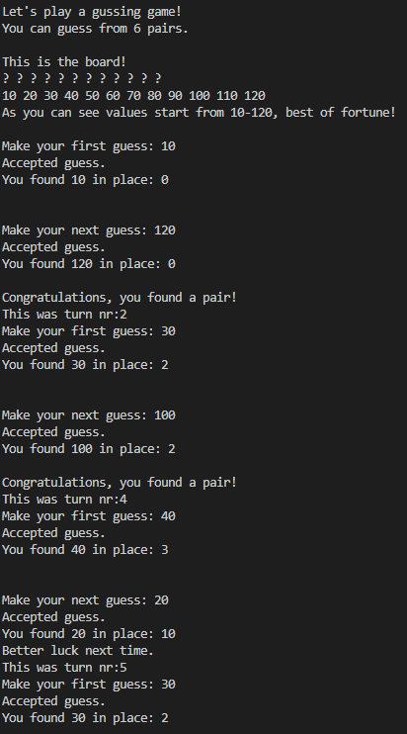

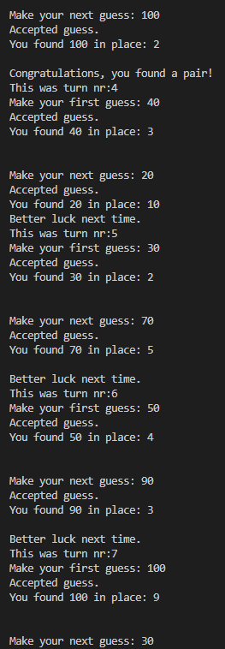

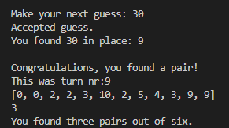

Conclusion: program performed correctly; output is printed as expected

ii) Boundaries: test variables for valid input

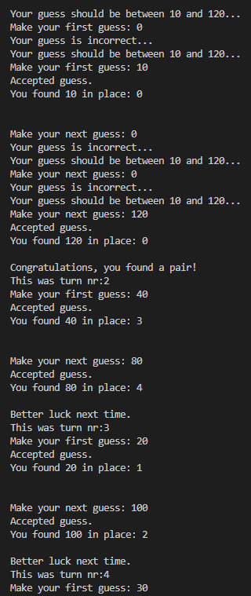
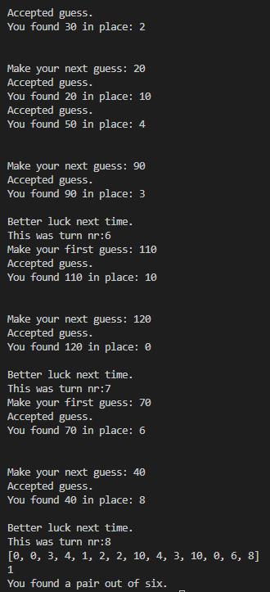

Conclusion: user was not allowed to enter 0, program performed correctly
        - Boundaries: test variables for out-of-range input:

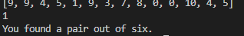
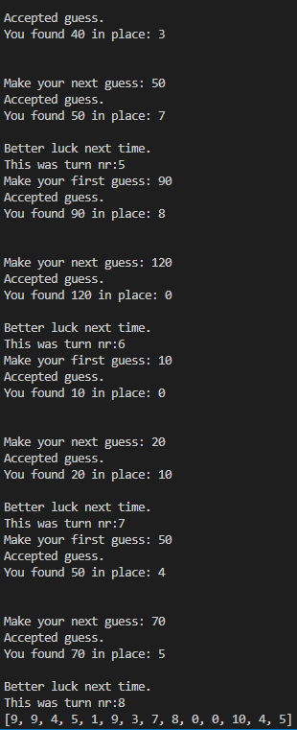
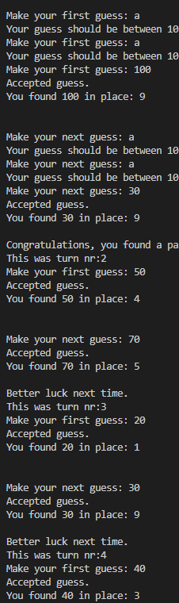

Conclusion: user was not allowed to enter a, program performed correctly

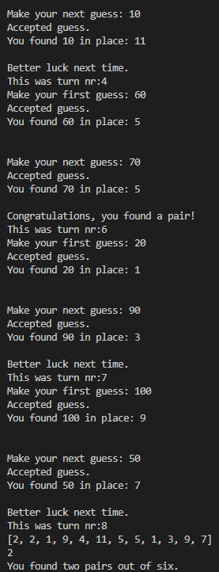
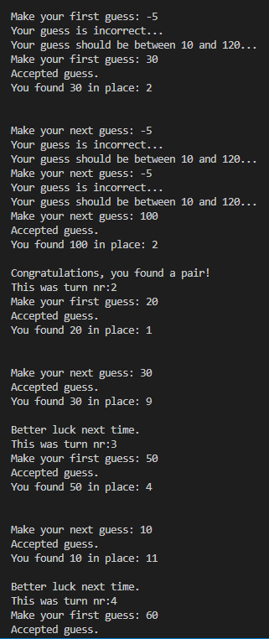

Conclusion: user was not allowed to enter -5, program performed correctly.

conclusion

All in all , I believe that the given paper has provided and shown multiple types of variables, if/else statements and while and for loop as well as practical examples with successful outputs for all four of the exercises and all the requirements of the exercises and question have been met, although they can use improvement, they functionality was proved.

References

[1]H. Y. Durak, “Modeling Different Variables in Learning Basic Concepts of Programming in Flipped Classrooms,” Journal of Educational Computing Research, vol. 58, no. 1, p. 073563311982795, Mar. 2019, doi: 10.1177/0735633119827956.
[2]U. Nikula, J. Sajaniemi, M. Tedre, and S. Wray, “Python and Roles of Variables in Introductory Programming: Experiences from Three Educational Institutions,” Journal of Information Technology Education: Research, vol. 6, no. 1, pp. 199–214, Jan. 2007, Accessed: Apr. 19, 2022. [Online]. Available: https://www.learntechlib.org/p/111416/
[3]T. Kohn, “ETH Library Teaching Python Programming to Novices: Addressing Misconceptions and Creating a Development Environment,” Doctoral Thesis, ETH ZURICH, 2017. doi: 10.3929/ethz-a-010871088.
[4]J. Hunt, “Flow of Control Using If Statements,” in Undergraduate Topics in Computer Science, Springer, Cham, 2019, pp. 65–73. doi: 10.1007/978-3-030-20290-3_6.
[5]K. Erciyes, “A Short Review of Python,” in Undergraduate Topics in Computer Science, Springer, Cham, 2021, pp. 11–26. doi: 10.1007/978-3-030-87886-3_2.

