Vehicle Technology 2- Vehicle Structure and Aerodynamics
Sean Deacon
Question 1: Choose two of the following body/chassis structure types and discuss the pros and cons:
Bonded aluminium chassis tub with fibre glass body
Steel monocoque
Generative design
Bonded aluminium chassis tub essentially describes the three main segments of the car conjoined to form the structure and chassis for the vehicle, usually consisting of the front subframe and the central tub with the rear subframe located directly behind. The frontal subframe houses the front suspension, steering rack, brakes and cooling system. The central tub contains the driver’s cockpit, interior and safety cell. Lastly, the rear subframe holds the rear brakes and suspension, exhaust system and transmission and, most importantly, the engine.
This type of chassis, much like the steel monocoque, is featured in some race cars and road going performance cars, such as the Lotus Evora. Lotus have consistently promoted the ability of their chassis to retain a high stiffness and strength, despite not using a monocoque, as a key selling point. However, the main weakness of this type of chassis is caused by its construction, as bonded aluminium chassis tubs are divided into segments which are joined together using a variety of techniques, such as welding or rivets. Weak points therefore inevitably occur throughout the structure at the joins. The alternative steel monocoque design does not suffer from such problems. Lotus have created a type of hybrid chassis for their Elise small sports car. At first glance the Elise appears to feature, like the Evora, a bonded aluminium chassis tub, however, as the Elsie is so small, the high volume of mountings and rivets going into the tub around the engine affected the strength of that area negatively. To resolve the problem, Lotus developed a steel space frame to cradle the engine, integrated to the Elise’s original bonded aluminium chassis tub. In this example, although a solution has been developed, the potential weakness of this design is highlighted, namely a lot of supports being required around any area of the car, usually the engine and the fix compromises cost, an advantage of this type of chassis. Most cars with this chassis are combined with a Fibre Glass body. This material consists of fibre-reinforced plastic, using glass fibres that are flattened into a sheet or woven into fabrics. In the car industry, it serves as a cheap and flexible substitute for the more costly carbon fibre body. It easily bends and flexes, meaning it’s suitable for many applications as it can be moulded into complex forms. Fibre glass is stronger than many metals, especially when compared by weight.
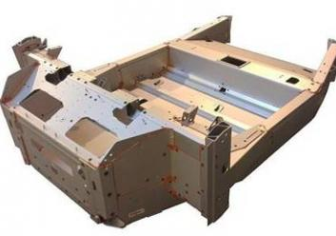 (Above: The Lotus Evora’s Chassis)
When compared to the monocoque chassis, a major advantage of the bonded aluminium chassis tub design is that it offers a much more affordable alternative that still delivers a level of competitive stiffness, although it is not class leading. Even when the chassis is mostly constructed from aluminium, it still isn’t nearly light enough to realistically compete against a carbon fibre monocoque, however this is counteracted by the significantly reduced cost.
Turning to the monocoque chassis, this has the benefit of being a single form moulded from a composite, most popularly from steel. There are many arguments over the terminology of the monocoque chassis, often being confused with unibody systems that can be found in mass production vehicles. Commercial models are almost never truly monocoque, but instead consist of box sections, bulkheads and tubes which provide most of the strength, whereas monocoque is a single component, with no need for any welds or rivets to hold each segment together, resulting in a lower weight which is the first main feature in favour of the monocoque chassis.
As previously explained, elimination of the need for joining techniques means less components that are required individually to be as rigid and strong as the chassis is one unit naturally giving it improved strength and stiffness. Joints and seams are usually the weakest part of a frame. Monocoque chassis present such an overall good package that many race car designers in the past have used them for their complex high performance design, as well as in some of the sports cars (Alfa Romeo 4C), super cars (McLaren 720S) and hyper cars (Aston Martin Valkyrie) on the road today. The use of the steel monocoque chassis is well proven in the industry, and there is now an array of materials and composites being used to create the spines for these cars. Three of the most used and successful materials are steel, aluminium and carbon fibre.
Steel is the most basic, and cheapest option, and it supplies good strength and rigidity with little flexibility, but is the heaviest of the three materials, although still lighter in comparison to other types of chassis. A second major disadvantage of steel against aluminium and carbon fibre, is its susceptibility to rust. This weakness significantly effects long term value, life span and reliability of a car.
Aluminium isn’t threatened by rust, but it can can corrode. However, due to the contradictory nature of the metal as being both highly reactive and passive, its initial corrosion produces a protective oxide layer which preserves it from further deterioration. Aluminium is a soft composite and much lighter material than steel, although this does mean its strength is compromised. A further disadvantage of aluminium is cost as it is more expensive than steel, but when compared to carbon fibre could be seen as a more affordable compromise.
Carbon fibre monocoque chassis have featured in more performance focused cars, the first being under the Jaguar XJR-15. These chassis have the advantages of being light, and therefore contributing to the car’s greater speed, and being both very strong and rigid, unlike aluminium. Carbon fibre is both rust and corrosion resistant leading to to a longer lifetime for the vehicle. The material results from a complex process binding microscopic fibres and the meat of the composite carbon atoms by weaving them into each other creating a balanced blend of both materials over the single composite. Unsurprisingly, this highly detailed and lengthy process, in addition to the higher quality of materials being used, translates to a steep cost. However, in return for the higher price other qualities are gained that the other two options cannot supply - high thermal tolerance, low thermal expansion and high chemical resistance.

(Above: Jaguar XJR-15’s competing in a Motorsport Event)

Question 2: An understanding of aerodynamics as it relates to automobiles is considered to be important in order to improve which major areas of performance and explain the criteria that effects drag/wind resistance of a vehicle:
One of the key aspects of car design today, originally made a major impact in the industry back in the 1960s when the design of racing cars of that era included developing large wings, fins, canards and ducts. These were all added in an effort to aid the performance of the car by exploiting advantages from the air flow and resistance the vehicle encounters while out on track. Essentially, the designers were applying the relatively basic physics of air resistance. As a car is moving along, it encounters air resistance as long as it’s in motion. In some situations, the car will encounter less air resistance due to a number of possible factors, such as the effect of a slip stream. This occurs where there is another vehicle a short distance in front of the car in question, punching a hole in the air and creating a semi vacuum, ultimately resulting in less air resistance. This allows the following car to use the vacuum to improve its performance in a number of ways, namely fuel consumption, tyre wear and straight line speed. There is also a technique used in NASCAR that increases stability and speed while the car is cornering, known as side drafting, where cars will corner side by side and the same effect as slipstreaming is created, but to the side rather than rear.
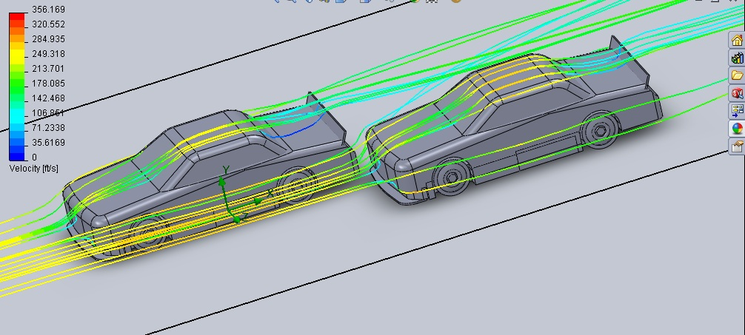(Above: Side Drafting Diagram Of Air Flow.)
Key areas of a cars performance that improve when aerodynamic parts are applied to it are: acceleration and launch; cornering speed and stability; handling and agility; grip and traction; amount of G force possible, tyre wear; and fuel consumption. These factors interact with each other to provide the maximum performance possible and overall optimum car control.
In the cases of acceleration and launch, many performance and race cars feature a spoiler, which is a large rectangular shaped fin positioned width ways horizontally above the rear of the car, with end plates at either end being held by a configuration of struts. This basic shape when developed to have a series of slits applied, moulded in a more complex shape and turned to an angle will result in increased rear downforce. Air rapidly flows over this structure resulting in more pressure on the tyres, in turn pushing them downwards onto the tarmac leading to improved traction which means better launch and acceleration.
Cornering speed and stability are significantly improved by the presence of aerodynamic features. They enable a car to be driven round a corner at a higher speed as the enhanced stability gives the driver a better level of car control during cornering, reducing the risk of over and under steer or the rear end slipping out of shape as well as keeping the vehicle well planted at high speeds. This is accomplished via the appliances of splitters, canards, side skirts, ducts, spoilers and diffusers, all of which produce increased downforce when encountering air resistance. The higher cornering speeds and the ability to take sharper corners at speed also increase the amount of G force the driver and any passengers will experience.
A car that features aerodynamic aids will enjoy improved handling and agility as a result. The advantage of canards and splitters is a faster response to any change in direction, particularly at the front end where the steering is located, giving the car better handling. Additionally, as already explained above, stability while cornering is enhanced through these design features.
Contributing to the superior handling and agility is the increased grip that aerodynamic features enable the car to achieve, contributing in the corners, braking and acceleration, as it’s a key aspect in the acceleration process which also includes traction.
Tyre wear and fuel consumption have balanced pros and cons when considering to the effects of aerodynamics. For the tyres, the main advantage of having parts such as a spoiler is that it gives the car increased traction, therefore resisting the urge of wheel spin saving many miles of rubber. Contra to this, more downforce means more pressure being put on to the tyre, thus increasing tread being laid on to the tarmac and overall wear. Fuel economy is affected similarly, with the most significant advantage being that braking when entering a corner does not need to be as heavy, as the improved downforce enables the car to be driven through a turn at a greater speed. This results in less throttle being required when coming out of the corner to get back up to speed, consequently less fuel is used as acceleration is the most fuel demanding process the car will endure. However, an aspect of aerodynamic features that hinders the fuel economy of a vehicle is the weight that is added in both a physical sense and in the terms of when air travels over such part and creates downwards pressure on the car. This means the engine has to work harder to achieve a competitive speed, using more fuel.
In summary, I want to demonstrate the simple example of the Chevrolet Camaro, the latest developed version of which possesses an array of splitters, canards and spoilers. Typically a car such as a Camaro, an American muscle car, is known to have high horse power, powerful engine, but by design is relatively boxy and large featuring no such aerodynamic features. This results in the Camaro, and similar type muscle cars, gaining a reputation for suffering performance in corners. Developments and improvements on the latest design of the Camaro by aerodynamicists, have quashed this reputation and provided this generation of muscle cars with an ability no previous versions could do - to go round corners at a competitive speed while remaining well planted and stable. This all contributes to quicker track times, race pace, endurance and a more pleasing and aggressive race car appearance.
(Above: A Chevrolet Camaro ZL1)

Bibliography:

Lotus Evora Case Study and picture:
https://www.lotuscars.com/sites/default/files/image_store/91969_Evora-chassis_353x248.jpg
McLaren’s introduction of carbon fibre monocoque chassises to F1:
https://cars.mclaren.com/featured-articles/barnard-first-carbon-chassis.html
McLaren Case Study:
https://www.mclaren.com/group/case-studies/case-study-carbon-fibre/
Jaguar XJR-15 Info:
https://www.supercars.net/blog/jaguar-xjr-15/
Side Drafting Discussion:
https://ecomodder.com/forum/showthread.php/help-get-rid-side-drafting-ideas-28530.html
Chevrolet Camaro ZL1:
https://media.chevrolet.com/media/us/en/chevrolet/vehicles/camaro-zl1/2019.html

