

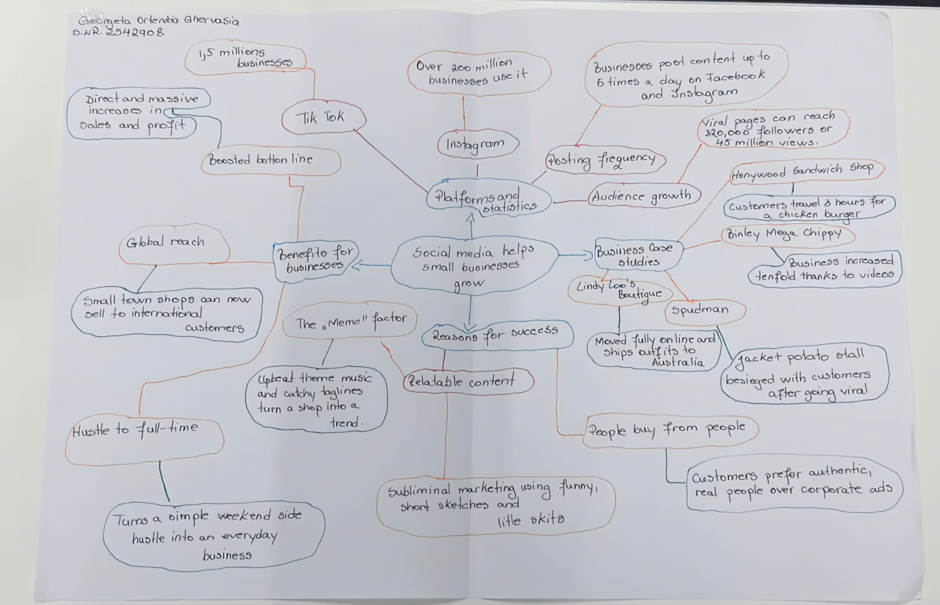

The main idea is that social media platforms like TikTok and Instagram for small businesses to be noticed by the world, helping them turn viral
One key point is platforms like TikTok and Instagram allow small shops to get famous quickly and attract customers from very far away.
Another key point is being real is better than advertising
The most important part is: Is explains exactly why social media works so well for small businesses today.
I was not sure about how small businesses can handle hight amount of customers.
My group helped me to understand better the text and extract the best informations.
I fund difficult to organize my mind map.

