Sultana Islam 1709614 uwtsd

PRESENTATION OF JOHN LEWIS
TASK 3/4

CRM SYSTEM AT JOHN LEWIS
John Lewis and Waitrose, UK’s largest best known retail brand. Their success is built on high quality products, their extraordinary service delivered by their Partners and their great relationship with their customers. It’s been centuries since each Partners has their say in how it is run through a democratic system. Through annual Partnership Bonus each Partners receive a share in the company’s profits.
John Lewis have decided to make number of changes, because of retail changes, economic, societal, and political hesitation. They have started to work hard today, and focusing on tomorrow for their Partnership’s future.
John Lewis doesn’t look at its customers as targets for their campaigns, the company will use data to identify what campaigns it should be developing for individual customers. Most importantly, this is the key to new approach of John Lewis. They are identifying their deeper understanding of motivations, for instance security or independence. These are the most powerful drivers of behaviour that opens up the new possibilities for their communications.
WHY JOHN LEWIS DECIDED TO HAVE CRM SYSTEM?
John Lewis investment in CRM enables to segment customers to create best user journeys on the floor. John Lewis understands that every unique visit costs money and they want to ensure their cost per visit, cost per customer and members are as active as possible.
John Lewis customers trust their products and services that demonstrate the value for money, quality and style. Their aim is to deliver products and services to their customer’s needs, whenever and however they wish to shop. This is done by modern Technology which gives the opportunity to differentiate further, by knowing their customers better. Behind the closed door, they are focusing on delivering excellence in operation, fulfilment and service delivery, every time their customers choose to shop with them.
John Lewis focused on price, they lowered the prices of many essential Waitrose products, which helped to develop like for like volumes. They have improved their shop by continues investment and online estate. Also, following investment in Waitrose.com, making it easier to navigate online grocery operation, achieving profitable sales growth.
John Lewis first priority is to make their customers happy, they make profits through their trading operations, through building great relationships with their customers and unlocking the potential of their Partners. John Lewis backing this activity with a continuing focusing on Partner training and development opportunities.
WHAT NEW INNOVATIONS JOHN LEWIS INTRODUCED?
John Lewis first step is to learn as much about their customers as possible. Over the past six months on the consumer side, John Lewis have enormously researched, mobile and site user experience testing, and applied surveys across many of their key consumer touch points. They have actionable consumer segmentation and far better insights into their own performance, as well as clearness around what really matters to shoppers.
As a result, John Lewis have shaped their marketing and product roadmaps to focus on areas that will deliver highest value to them. Most of John Lewis upcoming developments fall around three themes, which are mobile, personalisation, and custom audience targeting. In mobile they will be delivering far greater enriching experiences, including developments to their mobile app through expanded, location-based capabilities enabling push notifications and tailored offers.
Through the app, website and email programme they will be developing a host of improvements that will serve more appropriate personalised content, every time customers want it. John Lewis are also building custom audience goods that will allow their merchant partners to engage with valued segments of their customer base and prospect audience.
John Lewis have introduced personnel shoppers, to meet the needs of individual customers. This has benefitted the customers who needs advice on latest trends, fashion and specially for busy mothers with young children who doesn’t have to shop around, where personnel shopper’s help’s to choose their outfits.
Their strategy is first of all developing an increasingly great value, distinct, product proposition loved by customers which is known as product differentiation. Secondly, both John Lewis and Waitrose systematically improving the quality of the customer service proposition and experience. Thirdly, the use of technology is extending to improve the ability to engage with customers directly in shops and all over channels with Partners supporting their Human + Digital plans. Last of all attempting to build customer confidence in the products and service being sold and the way it is being sold, by sourcing and selling with honesty.
HOW STAKEHOLDERS ENGAGED WITH CRM?
Partnership’s is owned in trust for its members when it comes across John Lewis. Where they share responsibilities of ownership as well as its reward, profit, power and knowledge. Their business strategy reflects on how they do business differently, compared to other retail organization that are not owned by employee.
Partner - first unlocking the potential of Partners is the key intention to provide the worthwhile and satisfying employment that supports the Partnership’s main purpose, the happiness of all its associates. They believe that their co-ownership model provides Partners with power and knowledge to make the right decisions and judgements in the interest of the Partnership, and allows Partners to deliver the maximum levels of quality and service to their customers.
Customer – they want their customers to feel a great sense of connection to their organization through relationships based on trust and fairness. They also relate this method to their communities and suppliers in which they trade, so their customers can always feel assured that they have bought well. Their aim is to offer a unique experience in Waitrose and John Lewis that is more inspiring for their customers and authentic. This strengthens within their brands, means that customers choose to shop with them again and again.
Profits – making profit through the trading of John Lewis and Waitrose. The lifelong relationships they enjoy with their customers, allowing them to grow sales and profit more sustainably. That way their purpose is to ensure that profit remains appropriate to sustain the Partnership’s commercial vitality, fund continued development and hand out a share each year to Partners.

References
Trotter, C. (2017), ‘ 30 Things You Didn’t Know About John Lewis’, [Online] Available at: https://www.insider-trends.com [Accessed 27th May 2019].
Democratic Audit. (2013), ‘ The John Lewis Model Reveals The Tensions and Paradoxes at the Heart of Workplace Democracy’, [Online] Available at: https://www.democraticaudit.com [Accessed 1st June 2019].
John Lewis Partnership, (2019), ‘Employee Partnership’, [Online] Available at: https://www.johnlewispartnership.co.uk [Accessed 30th May 2019].
John Lewis Partnership. (2019), ‘ Our Business’, [Online] Available at: https://www.johnlewispartnership.co.uk [Accessed 1st June 2019].
Smith, N. (2014), ‘Customer Relationship Management (CRM) Is Gaining Momentum’, [Online] Available at: https://www.marketingweek.com [Accessed 29th May 2019].

Slide 1:

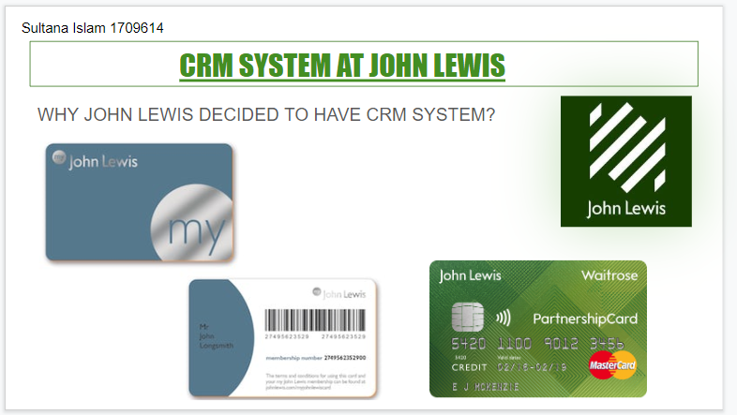

Slide 2:


