Torsion of Shafts
Mechanics and Dynamics (ACHA4026)
Word Count: 1,465

George Campling
2503449

University of Wales Trinity Saint David
Motorsport Engineering Beng Hons

04/12/2026

Contents:

- Introduction…………………………………………………………………………………...1
- Experiment Methodology……………………………………………………………………2
- Results………………………………..............................................................................5
- Analysis........................................................................................................................7
- Evaluation……………………………………………………………………………………11
- Further Work………………………………………………………………………………..12
- Conclusion…………………………………………………………………………………..13
- References………………………………………………………………………………….14

Figures:
- Figure 1, Unweighted Rotating Chuck……………………………………………………..2
- Figure 2, 10g Weights and Test Specimens………………………………………………3
- Figure 3, Weight Hanger…………………………………………………………………….3
- Figure 4, Aluminium Weighted at 400 grams……………………………………………..4
- Figure 5, Brass Empty Table of Results…………………………………………………...5
- Figure 6, Aluminium Empty Table of Results……………………………………………...5
- Figure 7, Steel Empty Table of Results……………………………………………………6
- Figure 8, Table of Symbol Meanings………………………………………………………7
- Figure 9, Brass Table of Results……………………………………………………………7
- Figure 10, Aluminium Table of Results…………………………………………………….7
- Figure 11, Steel Table of Results…………………………………………………………...8
- Figure 12, Brass T.L vs J.θ………………………………………………………………….9
- Figure 13, Aluminium T.L vs J.θ.……………………………………………………………9
- Figure 14, Steel T.L vs J.θ…………………………………………………………………10

Abbreviations:
- Deg – Degrees
- Rads – Radians
- Pa – Pascals
- SI – International System of Units
Chapter 1 – Introduction:

This report aims to systematically describe the process of carrying out a torsion experiment on a series of different material rods, and later analyse the results found.
The methodology of the experiment shall be described in detail and the process of gathering the required results shall be outlined.
Using said results, tables and graphs shall be drawn to illustrate the outcome of the experiment. Further research shall also be conducted into the validity of the found results and a comparison of them shall be done against results found elsewhere.
Finaly as some post experiment thought, ideas as to how the experiment could be made more accurate and reliable shall be presented.

1
Chapter 2 – Experiment Methodology:

This torsion experiment was conducted using an experiment test kit sourced from TecEquiptment Ltd.
When setting up the experiment make sure that all rig components are securely mounted to the work panel, if not done correctly results may be incorrect. Please also take note of the diameter and length of the metal rods before conducting any of the tests.
Once the test rig is built one must fit the chosen metal specimen, the three metals that are being tested are brass, aluminium and steel. To do so slide the chosen rod through the fixed end chuck, and using an Allen key tighten the grubscrews to secure the rod. After doing so repeat at the other end making sure to tighten the grubscrews in such a way that when not held the torque arm scale reads 0 deg. Figure 1 details this below.
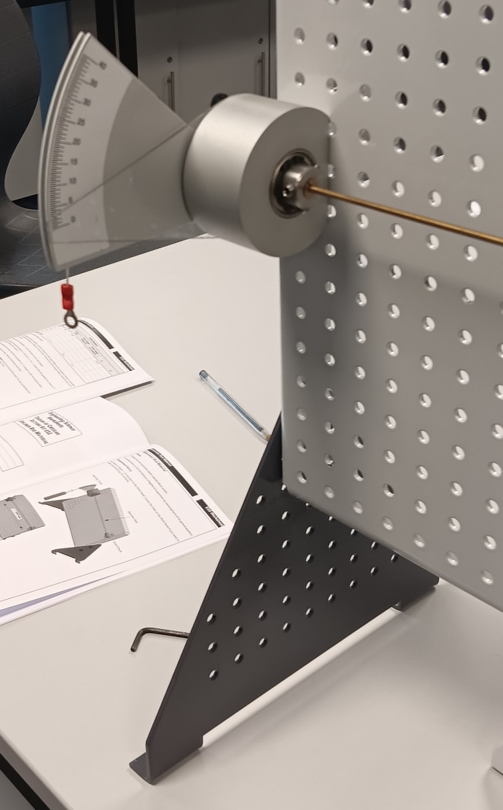
Figure 1, Unweighted Rotating Chuck
2
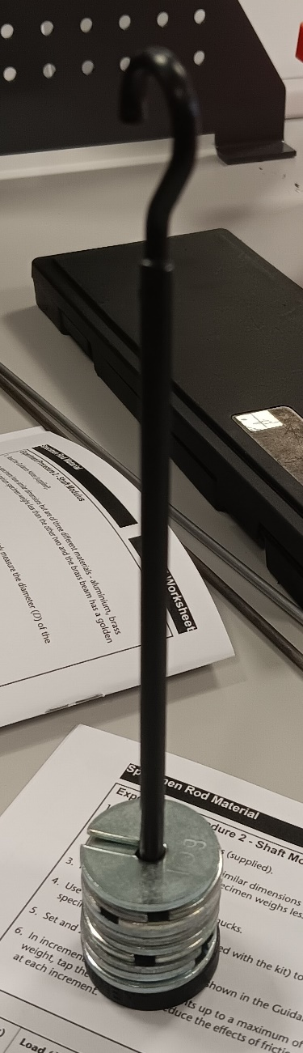
To start testing load 100 grams in 10 gram weights onto the hanger and loop the weight through the string that is attached to the rotating chuck.
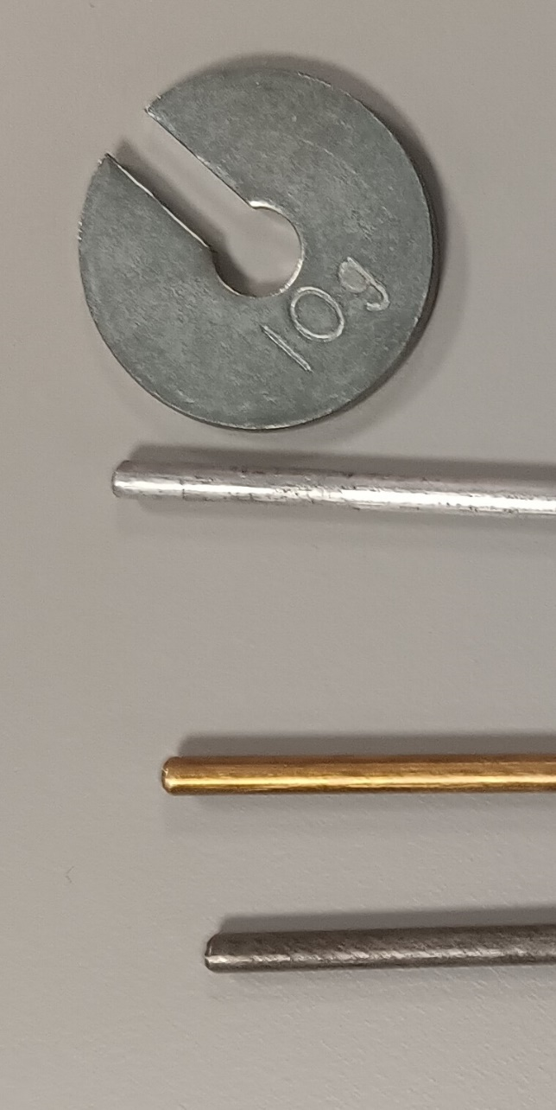

Figure 2, 10g Weights and Test Specimens Figure 3, Weight Hanger

Figure 2 shows the three different rods, and Figure 3 shows the weight hanger weighted to 100 grams.
Once the weight has been attached take note of the seen angle of twist shown on the torque arm scale. Repeat this procedure in 100 gram increments up to a combined weight of 500 grams, continuing to take note of the angle of twist. Please note that one should not exceed 400 grams on the aluminium rod as any extra weight may risk going beyond the elastic potentual of the material. Once five twist measurements have been recorded swap specimens.
3
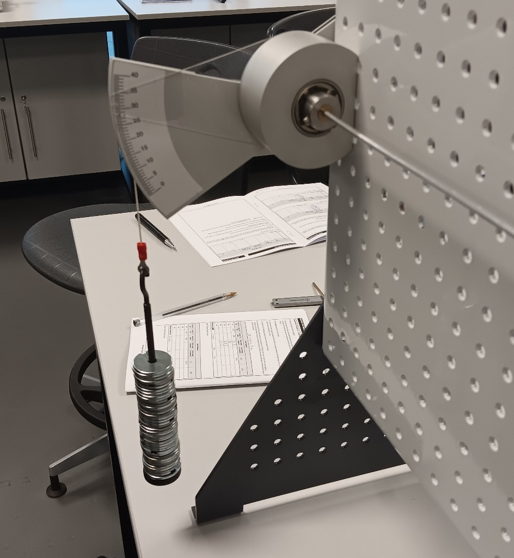
Figure 4, Aluminium Weighted at 400 grams

4
Chapter 3 – Results:

After completing the tests on the three rods, one should have three different tables of results that look like figure 5 that can be seen below, one table for every specimen.
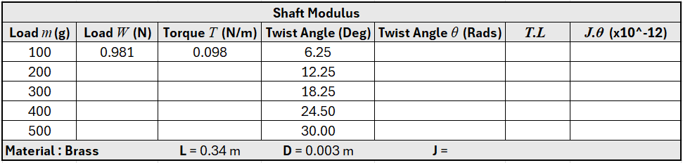
Figure 5, Brass Empty Table of Results

The values for load (in Newtons) and torque (in Newtons per metre) are given before the experiment is conducted.
All empty boxes shall be filled in, and how to calculate them shall be conducted in chapter 4.
Briefly analysing the seen results for the brass specimen, one could expect to see a linear pattern of results as the increase of weight is linear, however the above results show a non-linear pattern of results as the decimals do differ, averaging to a twist angle increase of 5.95 Deg per 100 grams. The non-linearity in most eventualities could be put down to the possibility of the grubscrews slipping marginally on the specimen at the fixed chuck end.
Examples of the tables for aluminium and steel can be seen below.
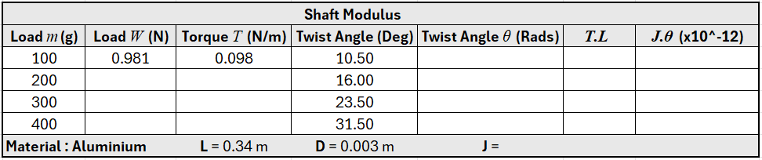
Figure 6, Aluminium Empty Table of Results
5
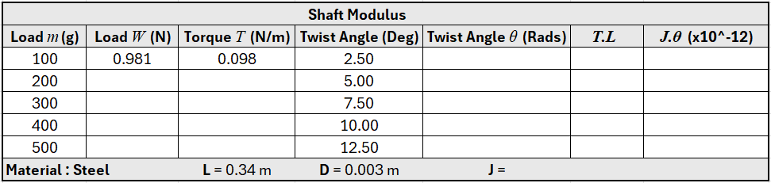
Figure 7, Steel Empty Table of Results

6
Chapter 4 – Analysis:

In order to fully understand how to fill in the rest of the boxes on the results tables, one needs to have an understanding of a series of scientific symbols, their meaning, and their units. A table of the relevant symbols is shown below.
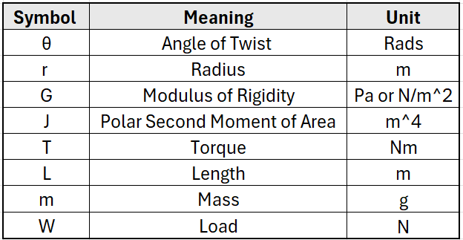
Figure 8, Table of Symbol Meanings

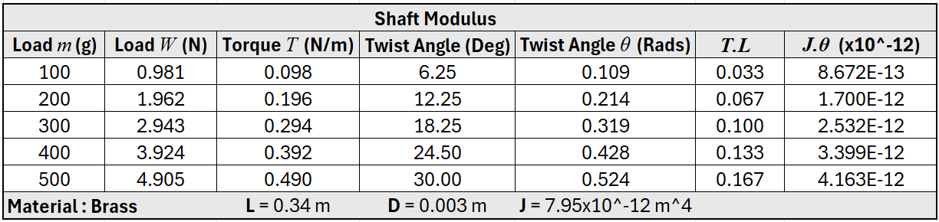
Figure 9, Brass Table of Results

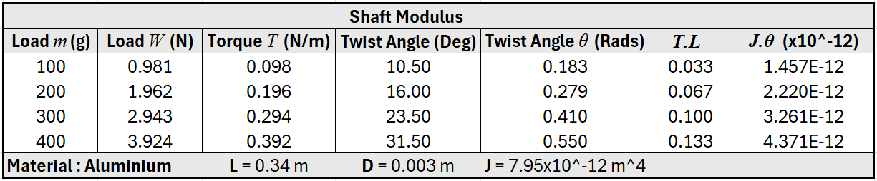
Figure 10, Aluminium Table of Results
7
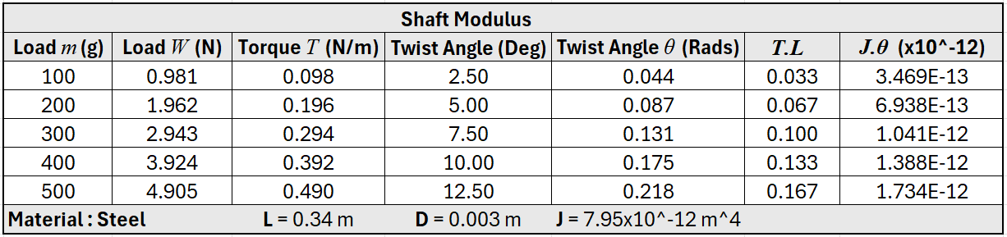
Figure 11, Steel Table of Results

As seen above in figures 9 to 11, all previously blank areas are now filled in.
To calculate to load in Newtons, one simply has to convert grams to Newtons. The Newtons at 100 grams as previously mentioned is already given (0.981), and one can use this as a conversion rate, simply times the load in grams by 0.981 for a value in Newtons.
When calculating torque, the load in grams is used again. Like the load the torque values are linear, making them easy to calculate. As 100 grams equals 0.098 N/m, for next torque value simply add 0.098 onto the previous value. Continue to do so up to 500 grams.
To calculate the twist angle in Rads use the equation 1 Deg x (2π/360) = 0.0174 Rads. Simply change the value for the degrees in the equation, to get the radians value.
T.L (Torque times Length) is self-explanatory take the torque value and times it by 0.34m (a constant between all three rods).
Finaly to find J.θ (Polar Second Moment of Area times Angle of twist in Rads), one first has to find the value of J. to do so use the equation πD^4 / 32. The values of J should be the same across all the rods as the diameter doesn’t change. Make sure that the diameter value is converted to meters before calculating J. after doing so one can then times J by θ.
After completing these calculations, one can now generate graphs that show T.L against J.θ.

8

Figure 12, Brass T.L vs J.θ

Figure 13, Aluminium T.L vs J.θ

9

Figure 14, Steel T.L vs J.θ

These graphs help to illustrate the gradual increase of the angle of twist and the torque experienced. If the elastic limit of one of the materials was exceeded the graphs would show a small dip followed by further increase leading to a plateau (Engineers Academy, 2020).
Using the data collected and the graphs one can now calculate the modulus of rigidity (or shear modulus). To do so one must find the gradient of the graphs, use the equation G = (T.L) / (J.θ) (Engineers Academy, 2020). The answer will come out in Pa, the value is most easy on the eyes when converted to GPa , divide the answer by one billion.
Values for Shear Modulus from data above:
- Brass = 40.11 GPa
- Aluminium = 30.42 GPa
- Steel = 96.30 GPa

10
Chapter 5 – Evaluation:

Having completed all calculations, one should validate their found values for shear modulus. This involves researching and finding external values for shear modulus:
Average Shear Modulus (MatWeb, 2025):
- Brass = 38.9 GPa
- Aluminium = 25.0 GPa
- Medium Alloy Steel = 80.0 GPa
Comparing these values to the above calculated values a few similarities and differences can be seen. The values for brass are very similar (within a 1.5 GPa difference), however the values for Aluminium and steel have a more than ten percent difference. The test kit guidence states to expect values for aluminium as 38.0 GPa, and Mild Steel as 79.6 GPa (TecEquiptment Ltd, 2012). These can be expected to change however, as over time the test specimens may have been changed, and replaced by different property metals, in the case of the steel seen above it’s most likely been replaced by a higher alloy steel, hence the higher shear modulus.
To eliminate errors across the experiment one should be extra cautious when zeroing the scale arm, and make sure that all the grubscrews are tightened securely as these two factors are the main things to do and go wrong. The only other area in which the data could be collected incorrectly is through the calculations. Make sure to double check the calculations and convert data to SI units where needed.

11
Chapter 6 – Further Work:

Given and unlimited amount of time and resources, I would have liked to have made the process of loading and testing a specimen more reliable.
Devising a system to that automatically zeros the scale arm reader would help to save time (as the zeroing process is fiddly), and making the scale easier to read and more accurate would help to increase the accuracy of the results.
Most importantly however I would modify the chucks. Instead of the grubscrews that are prone to slipping, I would make the chucks have female splines, and the rods have splined ends, this would guarantee that no slip in the chucks occurs.

12
Chapter 7 – Conclusion:

The aim of this report was to outline the process of conducting a torsion experiment. A summary of the test methodology was presented, followed by what data to collect and further how to calculate the necessary information to find the modulus of rigidity.
Analysis and evaluation on the results of the test has also been conducted, as well as how to make sure the tests are as accurate as possible, and some improvements that could be made to the test kit.

13
Chapter 8 – References:

- Engineers Academy. (2020) Finding Modulus of Rigidity of a Material Using Torsion Test Data. Availible at: https://www.youtube.com/watch?v=qZs9IkG179Y (Accessed: 29th December 2025).

- MatWeb (2025) Aluminum, AL, MatWeb. Available at: https://www.matweb.com/search/DataSheet.aspx?MatGUID=0cd1edf33ac145ee93a0aa6fc666c0e0 (Accessed: 30 December 2025).

- MatWeb. (2025) Overview of materials for brass, MatWeb. Available at: https://www.matweb.com/search/DataSheet.aspx?MatGUID=d3bd4617903543ada92f4c101c2a20e5 (Accessed: 30 December 2025).

- MatWeb (2025) Overview of materials for Medium Alloy Steel, MatWeb. Available at: https://www.matweb.com/search/DataSheet.aspx?MatGUID=f7666326ceb3482f87a9f41ace1d1fb0 (Accessed: 30 December 2025).

- Materials testing kit package (2026) TecQuipment. Available at: https://www.tecquipment.com/materials-testing-kit-package (Accessed: 04 January 2026).

- TecEquiptment Ltd (2012), Engineering Science Worksheets, Torsion of Circular Sections Kit ES5. (Accessed: 9th December 2025)
14

