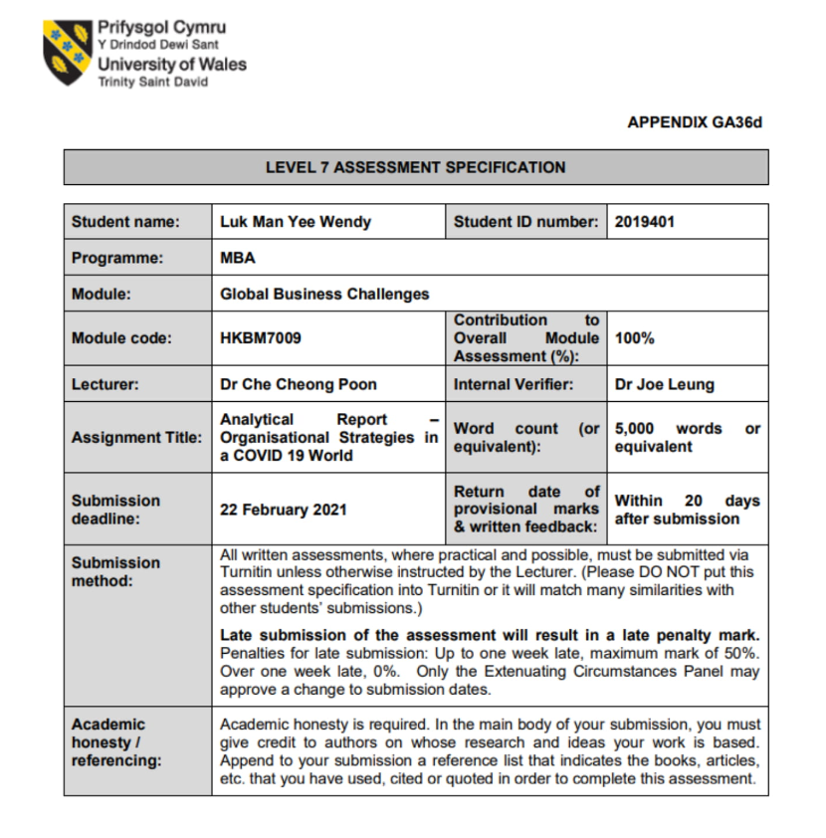

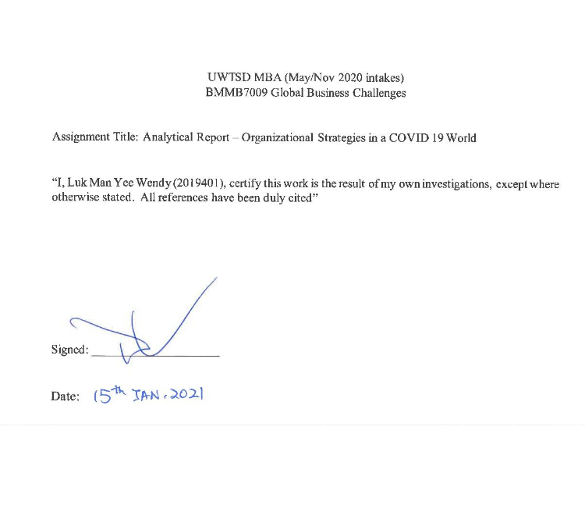

Table of Contents
1 Introduction 6
1.1 Research motivation 6
1.2 Research framework 6
2 Company Background 7
2.1 History in Hong Kong 7
2.2 Product Portfolio 8
2.3 Industry competition 9
3 Company’s business performance amid the economic disruption due to the COVID-19 outbreak 10
3.1 Macroeconomic Environment 10
3.2 The Cost Structure 11
3.3 The Revenue Structure 12
4 Analysis and discussion 13
4.1 Challenges facing the company 13
4.1.1 Costing Challenges 13
4.1.2 Pricing Challenges 14
4.1.3 Market Sharing Challenges 15
4.2 Strategies to ensure business continuity under the COVID-19 epidemic situation 17
4.2.1 The business continuity plan 17
4.2.1.1 Strengths 17
4.2.1.2 Weaknesses 18
4.2.1.3 Opportunities 18
4.2.1.4 Threats 18
4.2.2 Implementation process 19
5 Conclusion and Recommendations 20
5.1 Conclusion 20
5.2 Recommendations 20
References 21

Synopsis
The outbreak of COVID-19 has brought upon unprecedented global challenges for many businesses and there is no exception for Hong Kong. This report assesses the impact of COVID-19 on the 759 Store and evaluates its strategies to ensure its business continuity. To tackle these challenges, it is recommended the firm to adopt ecommerce to attract and retain its customers and to apply a new strategic approach by identifying a niche market to gain the competitive advantages over the business rivals.

1 Introduction
Since early 2020, the outbreak of the coronavirus has posed extraordinary challenges in almost every country globally. According to International Monetary Fund (IMF), the global economy has shrunk by 4.4% in 2020 (Jones et al, 2020). This pandemic has caused severe economic crisis in most countries with no exception to Hong Kong. In 2020, Hong Kong real GDP fell by 6.1% compared to 2019 (C&SD,2021). The objective of this report is to investigate the challenges brought to the 759 Store under the impact of COVID-19 by conducting literature reviews, publicly annual reports, SWOT analysis, and provide recommendations to overcome these challenges.

1.1 Research motivation
This study is to investigate the challenges posed to 759 Store, one of the discount grocery chain stores in Hong Kong, during the pandemic. Due to the outbreak of COVID-19, government imposed different kinds of measures including social distancing, self-isolation, and travel restrictions to reduce the risk of virus spread. Such measures have affected significantly on people’s daily lives, particularly on the change of consumers’ behavior. Statistics reveal that many consumers have been shifted towards spending on online platform, with an increase from 6% to 10% since the outbreak of coronavirus (UNCTAD,2020). With the rapid development of online platform, brick-and-mortar shops are struggling with the competition of online shops as well as the retail competitors. The researched company, 759 Store, merely offers its goods and services from the brick-and-mortar stores. With the shifts of consumers’ behavior, the firm’s customer base has shrunk comparatively.
Undoubtfully, the effect of epidemic has caused a drastically decline in the global economy. In Hong Kong, many of the retailers are facing the risk of closure since the third and fourth wave of coronavirus. Therefore, it is crucial for every business to have a business contingency plan in response to any unforeseen events. Although 759 Store has imposed business policies such as changing its procurement strategy to sustain its operation during this economic recession, the study found that the firm needs to expand its business growth by leveraging the online platform or consider global expansion to nearby countries like China, Taiwan, or Malaysia. The aim of this research report is to identify the challenges faced by the 759 Store under the pandemic situation, and to evaluate the strategic approaches it adopted to tackle the challenges.

1.2 Research framework
The objective of this report is to provide an analysis of findings based on the results of information collected from literature reviews, market research, company’s public annual report and SWOT analysis. The research problem defined in the section 1.1 will be further discussed in the following sections, and market research information will be used to support the analysis. Literature reviews will be used as an evidence for the argumentation stated in each section. A SWOT analysis will assess the strengths, weaknesses, opportunities and threats for 759 Store, to achieve the strategic planning.
Throughout the research, the researcher had conducted a phone interview with the management staff of the firm and performed a field observation to understand the strategic approaches adopted by the 759 Store under the impact of epidemic situation. According to the annual report of 2020, there was an increase of 9.1% on revenue from the changes in procurement strategy and downsizing on business structure (CEC International Holdings Ltd, 2020, p8). Aside from the changes of these two strategic approaches, the firm exercised its product differentiation marketing strategy to sustain its oligopolistic position in the discount grocery chain store market.

2 Company Background
This section will provide the overview of the research company (759 Store). The milestones of 759 Store in Hong Kong when it first established until present. How it formulates the business model in its direction of development. And how it gains the competitive advantages over its business rivals through its products differentiation strategy and the low-cost technique.

2.1 History in Hong Kong
759 Store was established in July 2010 by its parent company, CEC International Holdings Limited, as a retail chain store selling groceries and snacks (CEC International Holdings Ltd, 2019). The name ‘759’ came from the Hong Kong Stock Exchange code 759 of the Group (CEC International Holdings Ltd, 2019). The establishment of 759 Store was taken from Japanese local living perimeters consumption model (CEC International Holdings Ltd, 2019). It aims to provide a relaxing shopping experience to the local Hong Kong residents by importing wide range of products from Japan (CEC International Holdings Ltd, 2019).
The first 759 store opened in Kwai Chung Plaza and subsequently grew rapidly over the years between 2010 to 2016 (Incorporation HK, 2015). In 2010, some of the local suppliers stopped supplying the products to 759 Store (0759 CEC International Holdings Ltd Coils Electronic Co, 2020). Hence, the firm began to self-import the products from the country of origin such as Korea, China, Taiwan, South-East Asia, and Europe, etc. (CEC International Holdings Ltd, 2019, p1). In 2011, 759 Store expanded into a large retail chain store by capitalizing on the purchase mode of parallel imports and persistent to its business principle of “Quick Turnover with Lower Margin” (CEC International Holdings Ltd, 2019, p8). In the same year, 759 Store stopped selling Coca Cola after Swire Group, Coca Cola’s Hong Kong franchise holder, claimed that 759 Store's selling prices was below the suggested retail price. Swire Group subsequently used its monopoly power to increase the wholesale price of the product (Chan, 2016).
In 2012, there were 134 shops spread over 18 districts in Hong Kong. Most of the shops located in shopping malls, shop units in public and private housing estates (0759 CEC International Holdings Ltd Coils Electronic Co, 2020). Between 2013 to 2014, 759 Store has established new attempts by setting up new trade markets including household, frozen food and grocery, and personal care. The objective of these new attempts was to develop more products for customers’ selection (0759 CEC International Holdings Ltd Coils Electronic Co, 2020).
During 2015 and 2016, Hong Kong economy experienced a downturn in the retail businesses, 759 Store actively consolidated its market position by adhering to its business principle of “Quick Turnover with Lower Margin” and increased the supply of daily necessities that are not affected by the fluctuations of the economy (0759 CEC International Holdings Ltd Coils Electronic Co, 2020). Meanwhile, 759 Store decided to close 50 cost-inefficient shops upon their lease expirations to reduce its rental costs in 2017. As a result, the firm reflected a saving of 9.1% on the selling and distribution costs (CEC International Holdings Ltd, 2017, p7). Due to the increase of rent and lower number of tourists, the number of shops reduced to 190 in 2018 (0759 CEC International Holdings Ltd Coils Electronic Co, 2020). With the advent of COVID 19, the number of shops further reduced to 173 shops by the end of Oct 2020 (CEC International Holdings Ltd, 2020).
Over the years, 759 Store has been adopting new strategic approach to reorganize the business scale by reducing number of shops to keep the pace with the market trend, while continuing to provide the relaxation of shopping experience to the Hong Kong residents. To retain the leadership of the oligopolistic market, the firm insists to maintain certain number of shops in the market to obtain higher market share.

2.2 Product Portfolio
In the beginning, 759 Store focused on Japanese snacks in response to its primary consumption model. Later it began to adopt the self-import approach to source more varieties of their products directly from 57 countries around the world (CEC International Holdings Ltd, 2019, p8). Today, over 90% of its products are imported from overseas, in which about 46% are imported from Japan and South Korea, and the rest are imported from Thailand, Europe, Taiwan, China, America and other regions (CEC International Holdings Ltd, 2019, p8).
The product portfolio of 759 Store can be categorized into 5 segments including: snacks, staple food and food groceries, leisure goods, personal care and necessities, kitchenware, and others. The table below gives the sales revenue of the product mix by its product share. Throughout the research, the researcher had conducted a phone interview with the corporate office General Manager, Mr. Cheung. In addition, the researcher had performed field observations of the researched company. The product share percentage are derived from the benchmarking of prior years, the information given by Mr. Cheung during the interview and field observations. According to Mr. Cheung, the major change in the product portfolio compared with prior years is the increase of staple food and groceries, personal care and necessities. However, the main margin contributor remains in the snacks category because food groceries are considered low gross margin products.
Table 1: 759 Store Product Mix by Sales Revenue in 2019
Product Category | Product Share | Annual Sales Revenue (HKD)
Snacks | 32% | 553,608
Staple Food and Food Groceries | 25% | 432,507
Leisure Goods | 15% | 259,504
Personal Care and Necessities | 18% | 311,404
Kitchenware and Others | 10% | 173,001

Sources : - 759 Store
- CEC International Holdings Limited
- CEC International Holdings Limited

Table 1 shows that the main revenue drivers are the staple food and food groceries, personal care and necessities categories. In the financial year of 2019/2020, the sales revenue of these two categories was at 43% or HKD 743,911 in proportion to the total sales revenue of HKD 1,730,024 for the retail business. Following is the leading product category of the firm – Snacks, which was at 32% or HKD 553,608 in proportion to the total sales revenue (CEC International Holdings Ltd, 2019).
Despite snacks have been the most profitable product category to 759 Store in the past, the firm has shifted its procurement approach by increasing the low margin products such as staple food and groceries, and personal care and necessities, to fulfil the market demand due to the impact of COVID-19. In view of the saturation of snacks category in the local market, 759 Store must define its niche market to a specific group of customers, or products and services to stimulate the revenue.

2.3 Industry competition
The grocery retail market in Hong Kong comprises of many supermarkets, convenient stores, grocery stores, tuck stores and provision stores. Among them, Mart 360, Okashia Land, Aji Ichiban and the latest new entrant Don Don Donki are operating in the similar business model like 759 Store. In terms of pricing model, they all offer discount price for their products. These grocery chain stores also carry various products imported mainly from Japan and South Korea, and some from local suppliers. Moreover, these grocery stores operate at a relatively small business scale and mostly in highly populate locations such as shopping malls and residential areas. This causes a perfect competition in the grocery store market.
To attain and maintain the market leadership in the grocery retail industry, 759 Store offers distinctive products which are not available in the market. By selling exclusive products, 759 Store believes that consumers cannot compare the products with other grocery stores or supermarkets thus to differentiate itself from the competitors.
759 Store operates many smaller shops to sustain its market position in the oligopolistic market. The firm focuses on low pricing strategy to attract more customers which in return achieves higher market share in the industry. Meanwhile, the firm distinguishes itself from offering lower price to prevent other competitors to enter the market. Since 759 Store uses product differentiation and low-cost technique to gain competitive advantages, it gives the pressure to other competitors to increase prices. This creates the non-price competition where competitors require to seek other ways to compete with 759 Store.

3 Company’s business performance amid the economic disruption due to the COVID-19 outbreak
759 Store financial performance in 2020 reported a growth on its revenue compared with the same period of last year. According to the annual report of the Group, the firm reported HKD1,886 million revenue in the financial year as at the end of 30 April 2020 (CEC International Holdings Ltd, 2019). The firm has imposed the business policy to strictly control its costs by reducing number of oversized outlets and replaced with small shops. On top of that, the firm actively changed its procurement approach by importing more staple food to mitigate the loss of its best-selling category – snacks, which was the leading products in the past.

3.1 Macroeconomic Environment
Despite the unemployment rate constantly increase (6.6% in fourth quarter of 2020) due to the recession impacted by the coronavirus pandemic since early 2020, 759 Store has no intention to lay off its employees. The number of frontline employees remains the same level as per 2019 at an average of 3.7 persons per shop (CEC International Holdings Ltd, 2019).
In the first quarter of 2020, Hong Kong government had rolled out the first round of anti-epidemic fund to the affected industries. The subsides released to the retail sector was about HKD5,516 million (HKSAR,2020). As a result, the Group received approximately HKD40 million under the Employment Support Scheme (ESS) and another government relief of HKD1.4 million under the Anti-epidemic Fund of the Hong Kong Government, to release the financial burden for the year of 2019 to 2020 (CEC International Holdings Ltd, 2020).
Since the sources of 759 Store merchandise are mainly imported from overseas markets, the fluctuations of exchange rate will have direct influence the product costs. When exchange rate changes, the prices of imported products will change subsequently. The firm must react to the selling prices accordingly, otherwise, the costs of product will be absorbed by the firm. To mitigate the fluctuation on the risk of exchange rate, 759 Store has scattered the sourcing approach from importing products in various countries rather than focus on those countries that may bring exchange rate impact to the firm.
According to the IMF, the inflation rate for Hong Kong reflected a change of decline of 0.3 in 2020 (Knoema, n.d.). This change represents the overall consumption prices of the economy impacted by the outbreak of COVID-19 (Moya, 2019). However, it was not a major concern to 759 Store because it adheres to the business principle of offering high quality of products at lower cost. The firm insists to offer lower price and discount to the Hong Kong residents.
Figure 1: Hong Kong Inflation Rate between the years of 2010 to 2020
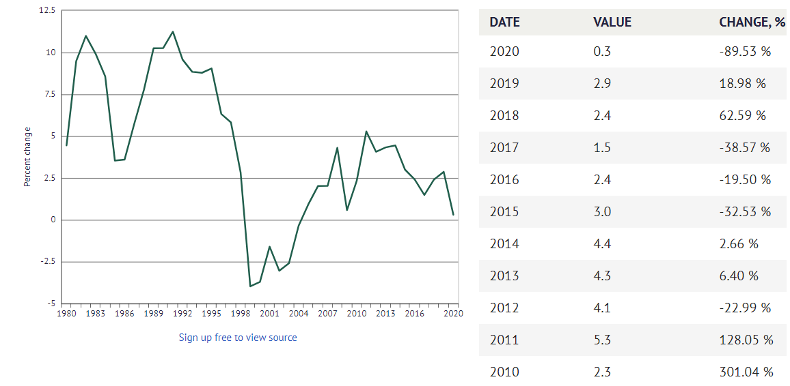
Source: IMF: World Economic Outlook (WEO) Database
Figure 1 shows that the annual percentage change in the cost of purchasing a basket of goods and services to the ordinary consumers (Knoema, n.d.).

3.2 The Cost Structure
The cost of goods sales is the main variable cost component of 759 Store. According to the annual report, 96% of revenue contributed to the Group is derived from the retail business (CEC International Ltd, 2019, p96). However, there was no information disclosed on the costs of goods sold and rental expenses for the retail segment. Hence, it is expected this major cost component of 759 Store is direct proportion to the revenue split, which estimated about HKD 1.2 million. As mentioned in section 3.1, the fluctuation of exchange rate risk has direct impact to the goods’ purchase prices. When there is a depreciation of exchange rate in the foreign countries, the cost of imported products by the firm will tend to increase Thus, the costs of goods sales mainly rely on the imported goods’ purchase prices.
In the financial year of 2020, 759 Store reported the total merchandise inventory of approximately HKD224 million versus HKD312 million in 2019 (CEC International Ltd, 2019, p109). The change of strategic approach from selling more fast-moving products than the slow-moving products had led to higher inventory turnover rate. The represents that there was a considerable demand of the fast- moving products.
According to the annual report, the total shop floor in operation was 359,000 square feet in 2020 versus 384,000 square feet in 2019, with a decrease of 6.5% (CEC International Holdings Ltd, 2019, p.9). The decrease of operating shop floor area was due to the closure of some of the oversized stores. Since the scale of operation reduced, the firm could benefit from economies of scale in the short run.

3.3 The Revenue Structure
759 Store carries varieties of products including snacks, staple food, leisure food, personal care, daily necessities, kitchenware, and others. Among them, snacks and leisure food are the major income source for the firm in many years.
According to the revenue split of 2019 sales in Table 1, staple food and personal care products and necessities had contributed more revenue to the firm over snacks. This is mainly due to the impact of the pandemic situation in early 2020 where consumers tended to purchase more staple food and personal care products and necessities than snacks and leisure food. As a result, the supply of staple food such as rice, noodle, frozen food, sanitary paper product has significantly increased. Meanwhile, the snack market has begun to saturate. Consumers have more choices to buy Japanese and Korean snacks in the market. To quickly restrain the revenue decline, 759 Store began to import more food grocery and personal care products to stimulate its revenue so to compensate the sales volume decrease of other products.
During the pandemic, the demand for food in grocery stores has increased due to the government restrictions. All restaurants are forced to suspend the dine-in service early and some even ceased their services after 6pm. These tightening restrictions are making people to spend more time at home and cooking at home becomes a new trend. With this new normal, people incline to buy fresh food in the market. Thus, this will be the challenge to 759 Store for the limited grocery food category.

4 Analysis and discussion
This section will focus on the challenges that 759 Store faced during the epidemic situation and the analysis of strategy approaches that the firm should adopt in response to the findings in the section 2 and 3 above.

4.1 Challenges facing the company

4.1.1 Costing Challenges
When a country exports is more than it imports, there is a high demand of its goods, and thus for its currency. Supply and demand economics states that when demand is high, prices rise, and currencies appreciates. Conversely, when a country imports is more than it exports, the demand of currency will decline, and the prices will depreciate (Lioudis, 2019). Hence, the fluctuation on the risk of foreign exchange rate will significantly affected on 759 Store purchasing costs.
Currently, 759 Store is sourcing from 57 countries around the world in which settlements are made in three different currencies such as Japanese Yen, Euro and United States Dollars (CEC International Holdings Ltd, 2019, p20). Assuming the product demand remains constant while foreign currency appreciates, the costs of the firm will also increase relatively.
The exchange rate fluctuations are determined according to many economic factors such as money supply, interest, inflation rates, GDP, unemployment rates and trades. In general, the currency of the country would rise if the factors mentioned above reflect a strong and growing economy of the country (Dhaval, 2020).
To tackle the challenge of the exchange rate risk, 759 Store can form a negotiable rate with the suppliers by increasing the volume of product to balance the fluctuation risk of exchange loss borne by the suppliers. Alternatively, the firm can set order limits to those importing countries that may incur excessive loss on exchange rate to avoid the increase of product costs.

Table 2: Hong Kong Exchange rates (HKD per unit of foreign currency)
Source: Census and Statistics Department
The table above shows the exchange rates of HKD exchange rate per unit of Japanese Yen, US Dollars and Euro between 2010 to 2020. According to the table above, Japanese Yen and Euro reflect an increase in 2020 and one of the reasons could be the impact by the pandemic.

4.1.2 Pricing Challenges
As mentioned in section 3.3, the main revenue driver for 759 Store is from selling the staple food and personal care products and necessities. The price elasticity for the two product categories has no response of demand to prices (Lumenlearning.com, 2019). The change in price of these products will cause small changes in the quantity supplied. Moreover, the grocery products are mostly low margin which require to sell more quantity to achieve higher profits.
759 Store has a discount policy of “everyday 23% off” offers to its membership card holders even during the pandemic. To attract more sales, offering discount is an efficient marketing strategy. However, it is also an additional cost to the firm.
With reference to the consumer analysis done by KPMG HK Ltd in Figure 3 below, consumer spending on essentials items has increased significantly (KPMG HK Ltd, 2020, p4). Increasing the supply of grocery products over other non-essential items may be the best solution for 759 Store to enforce pricing adjustments under the unprecedent pandemic situation.

Figure 3: Consumer spending in non-essential goods has dropped as a consequence of COVID-19.
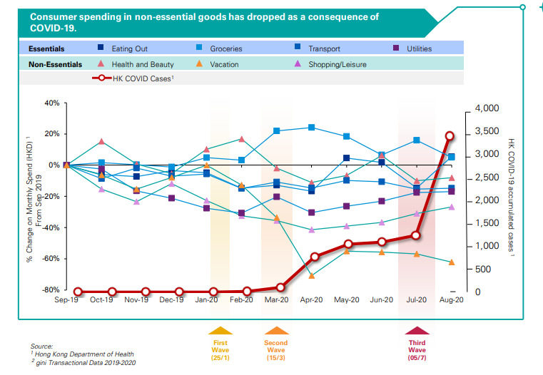
Source: KPMG HK Ltd
Figure 3 illustrates the consumer spending on non-essential goods decline drastically since early 2020. According to Census and Statistics Department (C&SD), the unemployment rate has reached to 6.4% by the third quarter of 2020. The rise of unemployment rate brings a negative impact to consumers’ spending. During the economic recession, people intend to restore their savings and reduce their consumption. Due to social distancing measures imposed by the government, people tend to cook at home and therefore increase the consumption on grocery products such as fresh food.

4.1.3 Market Sharing Challenges
Being the leading grocery discount chain store in the market, 759 Store strives to sustain its leadership by strengthening the procurement network to ensure the stability of supply and by offering competitive discount prices to attract the consumers. The firm positions itself by product differentiation and low-cost technique to sustain its market share in the oligopolistic market.
Competitions is inevitable in every business, in particularly if the competitors are providing the same goods and services. Best Mart 360 is one of the biggest competitors to 759 Store as they both run the same business model as shown in Table 3 below. In 2020, Best Mart 360 has 112 stores whereas 759 Store has 173 stores in Hong Kong (Bestmart360, 2020, p5). The market share for Best Mart 360 was 21.6% in 2018 (The Standard, 2018), and yet there was no market share information found for 759 Store. With the increase of number of stores, it is expected a slight increase of its market share by 2020.
To retain the leadership in the oligopolistic market is not easy, the leader often defend itself to sustain the market position by lowering prices. Eventually, the competitors would have to follow the oligopolist. Thus, the price decision in the market will be influenced by the leader. Conversely, if the competitors do not follow the set price, a price war is likely to occur in the market (‌Corporate Finance Institute, 2018).
Table 3: Comparison of Hong Kong Supermarkets and Grocery Store Chain 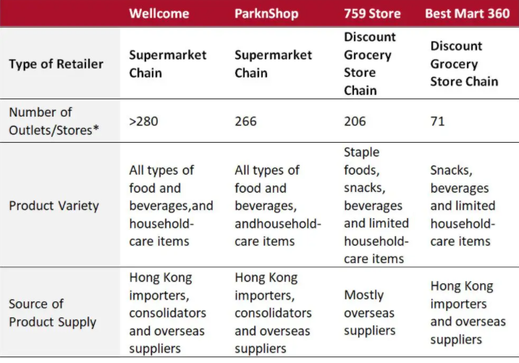
Source: Coresight Research, 2018
Table 3 above reflect that the more numbers of stores owned by 759 Store has as compared with Best Mart 360 means the more effective that the firm capture more customers in the market.

4.2 Strategies to ensure business continuity under the COVID-19 epidemic situation

4.2.1 The business continuity plan
In response to the sudden changes on consumers’ buying habit since the outbreak of COVID-19, 759 Store has proactively changed its procurement strategy. The firm has increased the procurement amount of food grocery to accommodate the high demand for the Hong Kong residents. Despite there was a shortage on food supply when the epidemic emerged, the firm exercised its long-term partnerships with the suppliers to stabilize its operations. Moreover, the firm adheres to its business principle of offering high quality products with low prices. During the pandemic situation, the firm insists to maintain its retail prices as possible to serve the community. Meanwhile, 759 Store has strictly enforced cost control by giving up some of the oversized stores and opened new shops in less prominent locations to reduce the rental costs (Inside Retail, 2020).
Even though 759 Store has imposed prudent business policies during the outbreak of pandemic situation to sustain its operation, it is suggested to strengthen the existing business continuity plan further to achieve better business performance by adopting an online platform.

Table 4: SWOT Analysis for 759 Store Strategic Planning
Table 4 illustrates the internal and external factors affecting the firm for forming an online platform.

4.2.1.1 Strengths
759 Store is a well-known discount grocery chain store in Hong Kong which offers wide range of products at low costs that other local grocery markets do not have. The firm operates over 170 stores mostly located in shopping malls and residential areas. Given the advantage of convenient locations, the firm successfully attract more customers and increase its brand recognition. Its unique product differentiation and diverse sources of product is the key to its success over the years. Under the long-term partnership with the overseas suppliers, 759 Store managed to stabilize the supply of goods to serve the local market under the epidemic.

4.2.1.2 Weaknesses
The firm merely operates with many small brick-and-mortar shops in the local market. Such small stores have limited storage space which result in shortfall once stocks ran out. Adhere to the firm’s business principle of fast inventory turnover, the firm does not carry high inventory. This will lead to a negative consequence to the firm’s image and causes customer dissatisfaction. Unlike other grocery competitors, 759 Store uses the word-of-mouth channel to promote its branding while the competitors promote themselves using social media channels. The engagement with the target group will reduce and the potential customers may turn to other competitors.

4.2.1.3 Opportunities
Many surveys have stated the new normal of home cooking is expected to continue even when the coronavirus is over. For 759 Store, this is an opportunity to expand its product range to fresh food product for the purpose of expanding the customer base to niche market. With the advancement of technology, many retail businesses have started to develop to online platform to improve the efficiency and competitiveness in the market. For 759 Store, this will be an opportunity to stimulate its sales thus to maximize its profits.

4.2.1.4 Threats
It is common that competitors to follow the first mover as they are the target for the competition in the market. This may cause a fierce competition where competitors will follow the same business strategy to fight for the customers within the market. The currency exchange rate fluctuation is another threat for 759 Store as most of its products are imported from overseas countries. The impact on the risk of exchange rate fluctuation has been discussed in section 4.1.1.
Regardless of how intensive the competition is in the discount grocery chain market; it is crucial for 759 Store to expand its business growth in response to the change of consumer’s spending habit. With the rapid growth of ecommerce today, many local retailers with online business had seen the benefits of how ecommerce saved their business and the opportunities of the business growth under the impact of COVID-19. Currently, none of the local discount grocery chain store provides online shops to their consumers. 759 Store should take the first move to establish the recognition before other competitors and new entrants.
Figure 4: Frequency of online purchases in Hong Kong as of May 30, 2020, by age group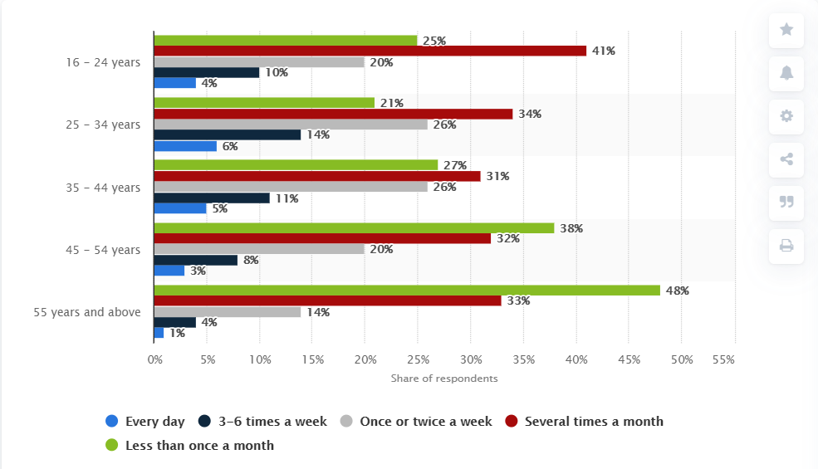
Source: Statista, 2021
Figure 4 shows that the most frequent online buyers in Hong Kong are the age group ranging from 25 years old to 34 years old (Statista, 2021). This data represents this age group has the most purchasing power in the market. When 759 Store define its niche marketing strategy, it will be worth to consider the group which has more purchasing power.
A niche market is a segment of a large market that can be defined by its own unique needs, preferences, or identity that makes it different from the market at large (Shopify, 2019). A niche marketing strategy is commonly used in most retail business for the purpose of gaining competitive advantages (Archer,n.d.) . 759 Store could target the niche customer groups by looking into the demographics such as age group, gender, or income level to obtain the market information of their wants and needs, and thereby to further diversify on its product mix.

4.2.2 Implementation process
To introduce an online platform requires lots of resources and time. Therefore, it is important to consider whether 759 Store has the capital and the capability to invest on this project. The management team needs to conduct an in-depth investigation of the current economic condition to avoid any barriers during the implementation process. Economic conditions are measured by several factors including gross domestic product, fiscal policy, unemployment rates, inflation, and exchange rate (Pooja Borkar, 2019). These factors are the key determinants to the supply and demand of retail businesses. By recognizing the market supply and market demand, it would determine what products to enter to the market over a given period.
A successful online platform must be convenient, quick, and user friendly. 759 Store may consider providing value-added services such as free delivery or bulk purchase promotions to enhance more online purchases. Quick navigation is an effective and powerful tool to increase customer revisit intention. Consumers are likely to engage with the same online shops again when the online shop appears to target their products easily.
In defining the niche market, 759 Store should embark on a process of research in a specific study group by narrow down into geographic segments, such as the age group, gender, and income level. Following is to conduct a survey research to understand their interests and preferences. Compared with mass market, niche market has different needs and wants. Evaluate what the firm can offer to the niche group and distinguish from the competitors.

5 Conclusion and Recommendations
The aim of this research is to analyze the challenges faced by 759 Store and provide the business contingency plan to the firm to sustain its operations under the impact of the epidemic. Below are the conclusion and recommendations suggested by the researcher.

5.1 Conclusion
The coronavirus pandemic has brought unprecedent challenges to the global economy since 2020. In addition to the health crisis, social activities, travel restrictions and international trade disruption, foreign exchange rate market was also affected. The fluctuation of exchange rate causes price challenges to the importing countries especially for the retail industry. Under the social distancing measure, the incline of home cooking trend and the change of consumers’ behavior drives 759 Store to adopt new strategic approaches in order to sustain its oligopolistic position in the discount grocery chain store market.

5.2 Recommendations
The research analysis of this report shows that the trend of ecommerce is accelerating, and the fresh food product demand has been increased due to the new normal. It is recommended 759 Store to invest on online platform to target the niche market to attract more customers as well as to improve the development of product diversification on fresh food.

References

Archer, C. (n.d.). The Advantages of Niche Companies in Marketing. Available at: https://smallbusiness.chron.com/references-businesslevel-strategy-25328.html
(Assessed on 08 February 2021).
‌China Business Knowledge. (2016). Talking to CEO: Coils Lam. [online] Available at: https://cbk.bschool.cuhk.edu.hk/spotlight-on-coils-lam-secrets-to-compete-with-supermarket-giants/ (Accessed on 12th January 2021).
‌Corporate Finance Institute. (2018). Oligopolistic Market - Overivew, Examples, How an Oligopoly Works. [online] Available at: https://corporatefinanceinstitute.com/resources/knowledge/economics/oligopolistic-market-oligopoly/.
(Assessed on 06 February 2021).

Dhaval (2020). Why Do Currencies Fluctuate? [online] www.upfx.co.uk. Available at: https://www.upfx.co.uk/latest-news/post/why-do-currencies-fluctuate#:~:text=The%20majority%20of%20the%20world. (Assessed on 04 February 2021).

Economics Online (2017). Oligopoly - characteristics | Economics Online. [online] Economicsonline.co.uk. Available at: https://www.economicsonline.co.uk/Business_economics/Oligopoly.html. (Assessed on 18 February 2021).

Hkeconomy.gov.hk. (2019). Hong Kong Economy - Hong Kong Economic Situation - Latest Development. [online] Available at: https://www.hkeconomy.gov.hk/en/situation/development/index.htm (Accessed on 6th January 2021)

Incorporation @ HONG KONG. (2015). News : HK grocery chain will launch online shopping. [online] Available at: https://hongkong-company-incorporation.com/news_blog/2015/07/23/hk-grocery-chain-will-launch-online-shopping/ (Accessed on 12th January 2021)

‌Inside Retail. (2019). 759 Store parent cuts rent burden, but posts full-year loss. [online] Available at: https://insideretail.asia/2019/07/29/759-store-parent-cuts-rent-burden-but-posts-full-year-loss-2/
(Assessed on 02 February 2021).

Inside Retail. (2020). 759 Store parent boosts store count despite tough market. [online] Available at: https://insideretail.asia/2020/01/02/759-store-parent-boosts-store-count-despite-tough-market/
(Assessed on 02 February 2021).

Knoema. (n.d.). Hong Kong Inflation rate, 1980-2020 - knoema.com. [online] Available at: https://knoema.com/atlas/Hong-Kong/Inflation-rate#:~:text=In%202020%2C%20inflation%20rate%20 (Assessed on 02 February 2021).

KPMG Hong Kong Ltd (2020). Impact of COVID-19 on Hong Kong Consumers’ Behaviours. [online] Available at: https://assets.kpmg/content/dam/kpmg/cn/pdf/en/2020/11/impact-of-covid-19-on-hong-kong-consumers-behaviours.pdf (Assessed on 06 February 2021).

‌Jones, L., Palumbo, D. and Brown, D. (2020). Eight charts on how coronavirus has hit the global economy. BBC News. [online] 29 Jun. Available at: https://www.bbc.com/news/business-51706225. (Assessed on 18 February 2021).

‌Lioudis, N. (2019). How does the balance of trade impact currency exchange rates? [online] Investopedia. Available at: https://www.investopedia.com/ask/answers/041515/how-does-balance-trade-impact-currency-exchange-rates.asp. (Assessed on 04 February 2021).

Lumenlearning.com. (2019). Price Elasticity of Supply | Boundless Economics. [online] Available at: https://courses.lumenlearning.com/boundless-economics/chapter/price-elasticity-of-supply/.(Assessed on 05 February 2021).

Moya, S. (2019). Hong Kong August Inflation Rate Rises to 3-Year High. [online] Tradingeconomics.com. Available at: https://tradingeconomics.com/hong-kong/inflation-cpi
(Assessed on 02 February 2021).

Pooja Borkar (2019). Economic Factors (Definition, Examples) | Top Factors Affecting Business. [online] Wallstreetmojo.com. Available at: https://www.wallstreetmojo.com/economic-factors/.
(Assessed on 08 February 2021).

‌Shopify (2019). Finding Your Niche: 8 Niche Market Examples to Inspire You. [online] Shopify. Available at: https://www.shopify.com/blog/niche-markets. (Assessed on 08 February 2021).

Statista. (n.d.). Hong Kong: online shopping frequency by age group 2020. [online] Available at: https://www.statista.com/statistics/1127751/hong-kong-online-shopping-frequency-by-age-group/.(Assessed on 08 February 2021).

The Standard (2018). Best Mart to open more stores. [online] The Standard. Available at: https://www.thestandard.com.hk/section-news/section/2/203646/Best-Mart-to-open-more-stores (Assessed on 06 February 2021).

‌UNCTAD (2020). COVID-19 has changed online shopping forever, survey shows | UNCTAD. [online] unctad.org. Available at: https://unctad.org/news/covid-19-has-changed-online-shopping-forever-survey-shows (Accessed on 26th January 2021)

Bestmart360 (2021). 優品360° 搜羅各國人氣商品. [online] Available at: https://www.bestmart360.com (Assessed on 06 February 2021).
‌
C&SD (2020). Press Release (20 Nov 2020) :Consumer Price Indices for October 2020 | Census and Statistics Department. [online] Available at: https://www.censtatd.gov.hk/press_release/pressReleaseDetail.jsp?pressRID=4702&charsetID=1
‌(Assessed on 05 February 2021).

C&SD (2020). Press Release (29 Jan 2021) :Advance estimates on Gross Domestic Product for fourth quarter and whole year of 2020 | Census and Statistics Department. [online] Available at: https://www.censtatd.gov.hk/press_release/pressReleaseDetail.jsp?charsetID=1&pressRID=4819
(Assessed on 18 February 2021).

CEC-COILS (2021). 0759 CEC International Holdings Ltd Coils Electronic Co., Ltd.CEC-United Electronics Ltd. CEC-Ecap Limited 線圈 线圈 磁芯. [online] Available at: http://www.0759.com/cecweb/HistoryBusDevp.aspx?lang=en (Accessed on 12th January 2021).

C&SD (2020). COVID-19 Thematic Website, Together, We Fight the Virus, Anti-epidemic Fund. [online] Available at: https://www.coronavirus.gov.hk/eng/anti-epidemic-fund.html
(Assessed on 02 February 2021).

GOVERNAMENT OF HKSAR (2021). Government announces launch of Retail Sector Subsidy Scheme under Anti-epidemic Fund. [online] Available at: https://www.info.gov.hk/gia/general/202003/16/P2020031600197.htm (Assessed on 02 February 2021).

‌

‌

