Question 1: ‘Where am I going?’
What is the role of the designer/maker in the 21st Century and how might this [your] role change in the future? Discuss your ideas/philosophies with reference to two/three creative practitioners or thinkers.

Research in Context (ADAD5003)
Lecturer: Matthew Archer
Keanu Markhoff

The role of a designer or maker is to create the output of an artifact, which is a “materialization of a thought” (Ingold, 2013) and continuously changes as “key advancements propelled our species forward” (Meggs et al, 2025, p.22), with Designers or makers fulfilling different roles for different societal needs. Designers and makers will highly likely continue to fulfil societal needs in the future, which makes it not a question of will they play a role in the future but instead a question of what role they will play in the future?
Previously there has been greater emphasis on the handmade however, technology is influential in advancing the way in which designers approach projects and how the artwork is promoted. This is because the future of designing and making is currently placed within the technology era and the rise of AI. As a result, man has been a significant factor as to how human and natural forces become intertwined this impact is called the Anthropocene, a geological period believed to start in the industrial revolution of humans influencing the earth’s climate and environment (Cambridge Dictionary, 2025). A negative impact for example, is the human extraction of resources including oil and fish and typically hostile critics downplay the “differences between Albertan oil barons and Malagasy subsistence fishers” which critics argue that “it is human beings in general who are responsible for ecological degradation” (Davies, 2016, p.41). In contrast, humans' connection to the natural world though Biophilia in design is also becoming prominent. Biophilia is the love things with nature so significant most humans are naturally born with it (Cambridge Dictionary, 2025). As a “powerful presence programmed at birth,” (Wilson,1986, p.5) to go through the exact learning lessons you go through in life. A natural example would be to “Kick open a rotting log and termites pour out” (Wilson, 1986, p.5).
Foyer Magazine states that there are several key areas that will take precedence within design these include Technology and Social Activism, Intersection of Art and Technology and Art and Environmental Activism (2024) of which I am interested in exploring. Several artists work show this development.
In London Paddington on an Inlet of the Canal of the Paddington Basin, one comes across a strange looking 12m long bridge called The Rolling Bridge. It came out of the mind of Thomas Heatherwick, a prolific designer who decided in 2002 to sketch and patent the design of the bridge on its fully closed and open positions and its functions, his design studio then completed the bridge in 2004 for public use (Heatherwick Studio). The design feels like it was influenced by animatronic dinosaurs that were used as props for the Jurassic Park franchise, however, has also been influenced by Biophilic Design which is an area very important to Hetherwick’s creative ethos. The bridge was designed to roll up until both ends join to make a circle so nothing on the other side of the bank was left behind. The bridge becomes a simple self-contained structure on one bank powered by hydraulic fluid.
Technological advancements have impacted design and make throughout history. Yet the role of a designer still exists with more roles than ever before, Thomas Heatherwick shows a great example of using technology incorporated into a design with the Rolling Bridge (2004). This is a bridge design that folds into something like a 2D Gyro sphere when the bridge is not in use, then folds out when in use. For a design like this to be manufactured by the maker, CAD can end up being a crucial element involved in the process of how the bridge will be animated to function. In fact, CAD in design and making is so useful that “employers frequently seek CAD skills” (Nimkulrat et al, 2016, p.42). Every technological advancement that gets made ends up resulting in creating designs that have never been made before. Therefore, every technological advancement that was portrayed to replace the role of a designer and maker has been unsuccessful. Another artist that has a connection with the natural world and is influenced creatively by man’s impact on the environment is David Popa.

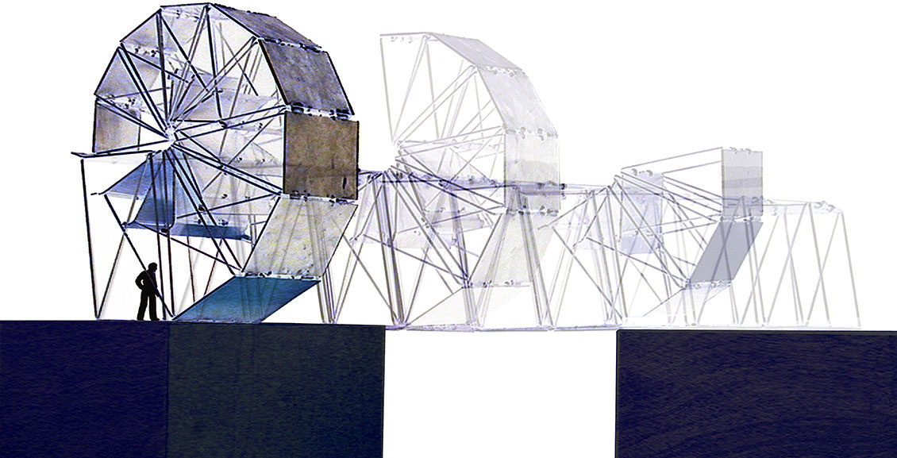
Figure 1: Rolling Bridge Design
As well as the past trends of a designer and maker’s role being unsuccessfully replaced, there is an increasing emphasis as a designer and maker of being involved in environmental activism, this is the area that David Popa as an artist is involved in.

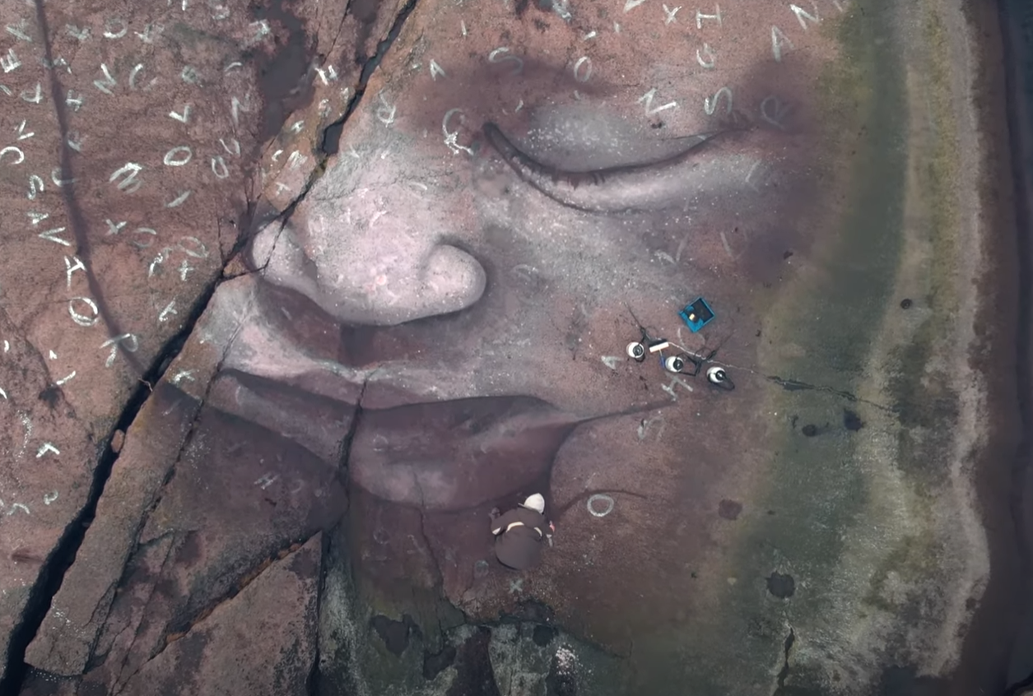
Fig. 2: Born of Nature project
David Popa was born and raised in New York City, but his projects require a certain natural environment in the world to come to fruition. So, David Popa relocated to Espoo, Finland to create interesting artefacts and one of them include David Popa’s 2019 project ‘Born of Nature’ which is a large-scale artwork that uses “all natural, biodegradable, washable earth pigments from nature” (Popa, 2019), all of which are mixed with the surrounding water and are completely harmless to the environment. A key part of the works that he creates is its impermanence as the artworks become part of the landscape. The work is captured by the Finnish Photographer Juuso Hamalainen with the use of drones, and a camera records the process of the artwork being crafted by David Popa himself.
David Popa used drones as his form of technology to capture his work from above while the next creative practitioner Sougwen Chung uses 2 kinds of robots programmed in unique ways as a form of a combined effort to create an artifact. As a result, if there were no technological advancements in electronics, avionics, digital programming, coding and all different kinds of engineering, all of which are becoming increasingly prevalent, artwork such as David Popa’s and Sougwen Chung’s would not be possible to make.
With the continual rise of Artificial Intelligence (AI), there is always the concern millions of jobs being replaced by AI which could carry out the same tasks. There is a chance that AI may carry out designing and making, however Sougwen Chung has figured out a way to carry out designing with an AI programmed in robots, instead of AI robots replacing the job of the designer completely. As a result, Sougwen has enabled the use of AI to create some interesting work in collaboration with her own brain’s ability to think and design in a way that has never been done before. Therefore, designers and maker have the potential to embrace such a practice of instead of the designer’s role being replaced, it will be a collaboratory opportunity with AI, this again could mean the creation of new roles that never existed before.
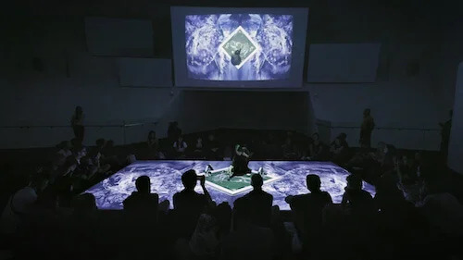
Figure 3: Drawing Operations (Duet) 2018
Drawing operations also known as Duet, is a kind of performance art that involves a collaboration between a human and a machine. This collaboration involved the use of 2 different drawing operations units. The generation 1 & 2 drawing operation units, which are robots designed to correspond to 3 different themes, which include Mimicry, Memory and Speculations (Chung, 2018). However, both generations have different capabilities, the generation 1 drawing operations unit is programmed to mimic the artist’s gesture through an overhead camera being the input of the hand gestures of the artist to then process it through a computer vision software processor in order to get a perfectly synchronized operation of an artist an a machine. But with generation 2, it is linked to a neural net train to extract past gestures the artist inputs of which the robot can speculate on artificial creativity similar how an artificial intelligence is programmed. The robotic behaviour is part of the wider artist’s exploration into the link between art, AI in Duet (see Figure 3) involves a 25-minute-long performance of Chung collaborating with the robotics.
Overall, there is always a fear of the unknown, particularly when it comes to the negative impacts of technological advancements. When reviewing the future which in now in the past and in history, the negative impacts of technological advancements did not turn out to be true most of the time. One example of bad outcomes from an advancement in technology failing to come true is the Luddites movement. The Luddites Movement in 1779 was when highly skilled English textiles workers feared technological industrialisation and progress, they feared mechanisation replacing their livelihood and their skills that took them years to acquire. As a result, the English textiles workers called the Luddites across the country, went and rioted out of fear of their skills being replaced (Brian, 2018). This created the economic theory called the Luddite Fallacy, of the mistaken belief that new technology results in job losses. However, while it resulted in job losses in the short term within the textiles industry, it also resulted in the lowering of costs of producing the clothing for textiles, which gets passed on to the consumer, so the consumers have a higher disposable income, and a higher disposable income means that the industries of wanted goods and services expand dramatically. Also, just because there is an investment in machines and mechanization, it could still mean workers get involved using these machines. The technological changes that get made may cause short term unemployment, but new jobs can end up being created in the long term due eventually to there being is a demand for new goods and services and new jobs in creating the new technology. For example, technological innovations lead to the decline in jobs within the coal industry from 1920 of 1.3 million jobs to fewer than 6000 in 2022. It does not mean 1.3 million people are unemployed, it just means the 1.3 million jobs that have been lost have gone to other sectors of the economy (Pettinger, 2022). However, the problem is not the changes in the number of jobs, it is the fact the new jobs would be in different geographical locations and would require different skills to the jobs they would originally use. Therefore, the few moments of when a luddite fallacy can come true is when technological breakthroughs are carried out by very few large companies with high levels of monopoly power such as Amazon, Apple, Google. With these companies having high levels of monopolistic power will mean even with technological innovations with AI, only the companies' costs will go down, and they could still charge the same price with the same quality of goods and services to only increase their profits which could go to tax havens combined with highly skilled jobs being replaced with machinery and as a result, the wealth from the technological advancements would not trickle down to the whole of our society (Pettinger, 2022). As a result, humans mostly likely do not fear progress but what they fear is the combination of the multitude of uncertainties of the outcomes that follow from a technological advancement of AI, but the one certainty they do have is their job being lost. Therefore, these fears of uncertainty, such as the unknown outcome of a lower paid job being created or replaced or worst of all no job at all being created in return, which gives humans the right to fear not just their job gone but their purpose gone and their income they need to survive being gone.
To conclude with the changes of the role of a designer maker, apart from David Popa’s artwork, designers and makers are usually never limited to geographic locations, when a new technological advancement comes to fruition. However, when new technology, such as AI replaces a role, the technology results in a new role being created and Sougwen Chung is a perfect example of this. For instance, because sketching by hand is something a machine can carry out, Sougwen Chung figured out a way to use an AI programmed robot to collaborate with her sketches. However, when new technology has a purpose in the role of a designer and maker, it will have to come with an understanding and skills of how to use the new technology of which most designers and makers will lack and need to learn but can learn, but there is always a transitionary period of personal growth and development.

List of Illustrations
Heatherwick, T. (2004) Rolling Bridge [Architectural Engineering]. Available at: https://heatherwick.com/project/rolling-bridge/ (Accessed: 4th November 2025)
Popa, D. (2019) Born of Nature [Environmental Painting]. Available at: https://www.davidpopaart.com/bornofnature (Accessed: 31st October 2025)
Chung, S. (2018) Drawing Operations [AI Collaborative Sketch]. Available at: https://sougwen.com/work/drawingoperations2018 (Accessed: 13th November)

Reference List
Ingold, T. (2013) Ingold – Thinking through Making. Available at: https://youtu.be/Ygne72-4zyo?si=yVGtNTodlyMvlGd1 (Accessed: 8th October 2025).
Meggs, P.B., Purvis, A. W., Maxa, S. and Sanders M. (2025) Meggs’ History of Grap hic Design. 7th edn. John Wiley & Sons.
Wilson, E. (1986) Biophilia. Harvard University Press
Davies, J. (2016) Birth of the Anthropocene. University of California Press
Paruthi, I. (2024) Beyond Aesthetics: Artists as Agents of change in the 21st century. Available at: https://foyermagazine.com/beyond-aesthetics-artists-as-agents-of-change-in-the-21st-century/ (Accessed: 10th December 2025)
Nimkulrat, N. Walton, K. Kane, F. (2016) Crafting Textiles in the Digital Age. Bloomsbury Academic.
Brian, J. (2018) The Luddites. Available at: https://www.historic-uk.com/HistoryUK/HistoryofBritain/The-Luddites/#:~:text=The%20Luddites%20were%20not%2C%20as,skilled%2C%20underpaid%20workers%20operating%20machinery (Accessed: 18th November)
Pettinger, T. (2022) The Luddite Fallacy. Available at: https://www.economicshelp.org/blog/6717/economics/the-luddite-fallacy/ (Accessed: 18th November)

