1703178
Confidential
Client name: Victoria Rogers
Client email address: Victoriarogers@rocketmail.com
Tribal ART LONDON VIRTUAL EVENT
Daisy Hay

Terms of reference
Daisy Hay is an independent student undertaking a consultancy project to investigate the potential opportunity for developing a virtual online event project for Tribal Art London.

Executive summary
Tribal Art London was first established in 2007, hosting an annual tribal art fair that takes place at the beginning of September located in the Mall Galleries. The event is recognised on an international level, enticing consumers to experience its lectures, talks and authentic art pieces displayed in the gallery. The outbreak of coronavirus has caused Tribal Art London’s 2020 event to be postponed.
In this report a range of research methods had been applied. Both qualitative and quantitative research had to be undertaken online due to restrictions caused by COVID-19. Primary and Secondary research was also conducted, secondary research being in the form of books, websites, and journals. Primary research including having undertaken a questionnaire. The questionnaire was conducted to interpret respondents’ wants and expectations from a virtual event.
Results of data analysed has shown that COVID-19 has made virtual events a creative solution for event organisations to be able to interact with an audience in a pandemic. The Coronavirus has supported virtual events, as it has caused a rise in digital demand due to consumers being more reliant of technology over recent months.
Virtual events are predicted to be the No.1 trend of 2020, with a growing number of organisations adapting to this trend. Virtual events have been recognised for reaching a much wider audience opposed to a physical event.
It has been examined that social media and online media play a vital role in boosting virtual events. Digital and traditional marketing being used to fuel a growth in interest from consumers in virtual events.
From the results obtained it is clear to see that Tribal Art London hosting a virtual event would be beneficial as there is a demand from consumers and a market for this type of events.
To support the potential of Tribal Art London going virtual, a series of recommendations had been made. It is recommended to put great emphasis on social media platforms to build upon a virtual event strategy. It is also recommended to use competitors as a benchmark and lastly it is recommended to host virtual events even when physical events are running again to capitalise on a wider audience.

Contents page
Page
1.List of tables of contents and figures…………………………………….……….……..4
2. Introduction………………………………………………………………….……….……5
3.Research Methodology………………………………………………….…………..……6
4. Findings……………………………………………………………...…………...……7-12
5. Discussion and Analysis………………………………………..……………….….12-13
6. Conclusion……………………………………………………….………………………14
7. Recommendations………………………………………….………………………..…14
8. Appendices…………………………………………………………….........................15
8.1 Appendices – Copy of questionnaire…………………………….………………15-17
8.2 Appendices – Copy of emails between the consultant and the organisation.18-23
8.3 Appendices – Consultancy updated/ new project plan…………………..………..24
9. Reference list ……………………………………………………………...………. 25-27
10. Bibliography………………………………………………………………...………28-30

- List of tables of contents and figures
Page
Figure 1. – Question 6………………………………………………………………..…..7
Figure 2. – Question 7………………………………………………………………..…..8
Figure 3. – Question 4……………………………………………………………..….….9
Figure 4. – Question 3……………………………………………………………………10
Figure 5. – Question 1……………………………………………………………………11
Figure 6. – Question 2……………………………………………………………………11
Figure 7. – Question 5……………………………………………………………………12
Table 1. ……………………………………………………………………………………13

- Introduction
The virtual event project for Tribal Art London had been introduced with set aims and objectives. The aim of the project was to explore the potential market for Tribal Art London to adapt their physical event to a virtual event. The objectives included assessing the current climate, undertaking market and event research in order to identify and evaluate to make recommendations for the organisation.
Tribal Art London had launched in 2007, having first started off in single space gallery in Nottinghill to then expanding to the Mall galleries due to receiving growing interest. The art fair is an annual event which takes place at the beginning of September, showcasing more than 20 exhibitors and engaging with an audience from across the globe (Tribalartlondon, 2020). Over the years, the event started to experience an increase in numbers of Tribal art dealers, many being from overseas. The increase of visitors and arts dealers led to the fair being recognised on an international level. In latest years, niche fairs have evolved into a valuable feature of the art world calendar, both in London and globally. London gaining great positioning of the Tribal Art market (Mallgalleries, 2020).
The fair provides visitors with the opportunity to purchase art pieces, take part in lectures and talks and admire the artwork showcased in the gallery. The fair represents tribal cultures including Africa, Australasia, Asia, America, Oceania and Europe (Timeout, 2020). Tribal Art London succeeds at offering its clientele masks, figures, shields, costumes, jewellery, furniture, and textiles. The pieces that are sold at the fair are best recognised for its quality and authenticity (Mallgalleries, 2020). Tribal Art London’s overall aim is to set a knowledgeable and friendly atmosphere for their potential audience with an interest in Tribal Art (Telegraph, 2015).
The event was set to take place in September 2020; however, the current climate has jeopardised this. The Coronavirus pandemic has caused numerous implications for event organisations resulting in events having to be postponed or cancelled, Tribal Art London being one of those events that had to be postponed. As of May 25^{th,} 2020, the United Kingdom had peaked 259, 559 coronavirus cases (Worldometer, 2020). The virtual event project had been implemented to explore the online opportunities for Tribal Art London. Organisations across the globe are now adapting and introducing virtual events, Tribal Art London could potentially be one of these.

- Research methodology
The original consultancy project plan of how to improve marketing at Tribal Art London had been changed in light of COVID-19. The original project plan was still feasible given the circumstances however, the researcher believed that the latest project plan of a virtual event was most suited in the current climate. The PID action plan had been updated to suit the latest project, this can be found in the appendices. The research methods that had been utilised in this report include qualitative and quantitative. Quantitative research focusing mainly on statistics and numbers and qualitative utilised to comprehend concepts and thoughts which formulate into words (Driscoll, D L.2007). The qualitative and quantitative research had been applied in the project from having undertaken a questionnaire and a competitor analysis. These methods of research had been used to reinforce the virtual event idea. Analytical research had also been applied in the report, this form of research had been conducted to locate and identify factors which support a more in-depth perspective of the topic.
The project had also consisted of primary and secondary research. Secondary research had been selected as it was cost effective and less time consuming opposed to primary research, the secondary data is easily available from accessing books, journals, online articles and websites. The primary research was essential to use as it provided fresh unedited data, which can be deemed as more accurate in comparison to secondary research. The primary research included conducting a questionnaire and focus groups, however due to implications brought on by COVID-19 the focus groups were no longer feasible and relevant.
The impact of COVID-19 had made the project more reliant on secondary research, however primary research was still deemed as a valuable approach of gathering data in the form of a questionnaire. A simple yet effective questionnaire was constructed to determine the participants attitude, opinions and wants from a virtual event. The questionnaire was formed of eight questions, which include primarily closed questions while also including one open question. Google forms was used to complete the questionnaire, which did not require any funding to complete. Respondents were able to access the questionnaire from social media platforms which, include Facebook, Instagram and Twitter. From displaying the questionnaire on social media platforms, it had resulted in receiving 105 responses (docs.google, 2020). The sample size from the questionnaire may not be entirely representative of the target market, however it does give an indication of consumer needs and wants from a virtual event. The questionnaire could be considered as being reliable, however if the sample size were to be bigger it would be more reliable.
COVID-19 had limited the consultancy project, some elements of the project were planned however, some elements were not which resulted in the project having to adapt to this. The implications caused by the coronavirus may reflect on the overall findings from the project, which makes it essential to re-evaluate this in the future.

- Findings
Tribal Art London had planned for their 2020 event to run between the 2nd and 5th of September, bringing together numerous experienced reputable art dealers and visitors from across the globe (Tribalartlondon, 2020). The event is extremely successful at it entices increasing number of visitors each year. In the year of 2019, TAL welcomed 500 visitors to the opening night and 500 on the first day. The event attracts approximately 400 visitors for the remaining days (Rogers, V. 2020). The event would have taken place in the Mall Galleries situated in London, however the new safety measures put in place and London currently peaking at 26,780 Coronavirus cases makes it impossible for the event to run (Quinn, A. 2020). COVID-19 has and will continue to heavily effect the events industry, potentially taking years for it to recover. A virtual event defines as an online event that takes place in a virtual environment opposed to a real-life event that takes place in a physical location (Liu, T et al. 2017). Tavares, A (2020) states that due to COVID-19 causing social distancing, it is imperative for event planners to rethink their live events and explore going digital.
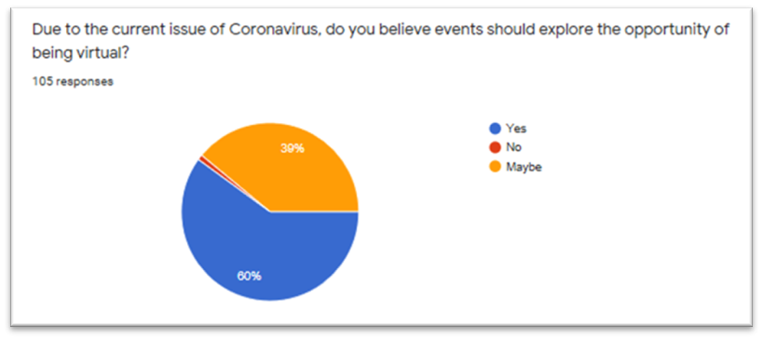
Figure 1. – Question 6
Question six shows that 63 out of 105 respondents (60%) believe that events should explore the opportunity of being virtual, while 41 out of 105 (39%) respondents had answered ‘Maybe’. One respondent had answered with ‘No’. Virtual events are expected to be the No.1 trend of 2020, the outbreak of COVID-19 has supported this (Blog.simplymarketingjob, 2019). Physical events are not expected to return any time soon due to the Coronavirus, which has made event planners explore the digital opportunities to hosting events (Lang, C et al. 2020).
The art sector has been majorly hit by COVID-19, resulting in galleries, artists and museums losing the ability to host events. Virtual events and tours have not only recently appeared due to the Coronavirus outbreak, over many years Google Arts and Culture had been compiling virtual tours of museums from across the globe. Google Arts and Culture offers over 500 tours of art institutions, ranging from touring London’s National Art Gallery to Amsterdam’s Rijksmuseum (Armstrong, A. 2020). With relevance to the global art market, numerous galleries have transitioned to putting their offerings online. An example of a gallery that has experienced a rise in digital demand is London’s National Gallery. With the number of people engaging with its virtual tour rising by 1000 percent compared to this time last year (Shehadi, S. 2020).

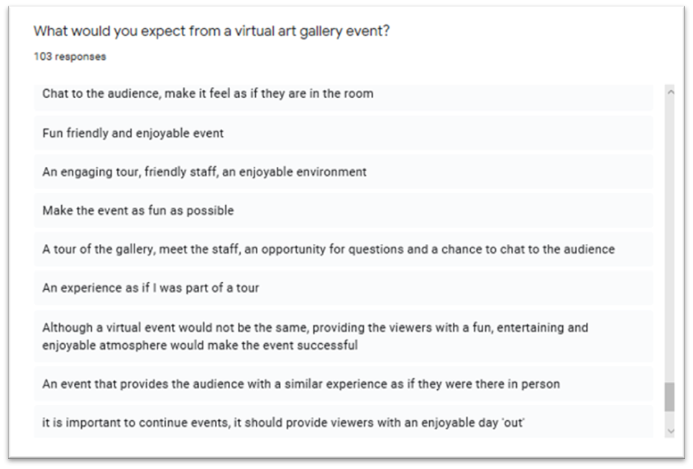
Figure 2. – Question 7
Question 7 was created with the aim to establish the wants and expectations from a virtual art gallery event. 103 respondents had addressed the question stating similar expectations from the virtual event. 20 respondents had stated that they would expect a virtual tour of the gallery from first entering the door to provide the audience with a feeling as if they were there in person. A few respondents had stated they would expect a virtual event to be interactive and engage with the audience. The respondents had stated that they expect a vibrant atmosphere, good camera quality, similar content to an in-person event, welcoming staff/hosts and memorable experience.
According to Digitalinformationworld (2020), by 2021 it is expected that online video including conferences and events will account for 80% of web traffic, predicting that virtual events will witness a growth in demand. The key factors that are fuelling the growth in virtual events include the increase of business events and the need to strengthen competitive responsiveness. Globalisation has driven an increase in information coverage that fuels the virtual event industry growth. The growing use of social media platforms and online media has supported and pushed the idea of virtual events (Grandviewresearch, 2020). Relating to the marketing mix 4’s promotion element, for a virtual event to engage with a high number of visitors, it is imperative to increase awareness and create interest by advertising and marketing the event traditionally and digitally (Acutt, M. 2012). Arjun, R K (2020) states that the advancement of technology has enabled organisations to adapt to this at a fast pace. The current climate has caused numerous constraints for the events industry however, some events have quickly adapted to this by utilising live streaming technology to host virtual events.
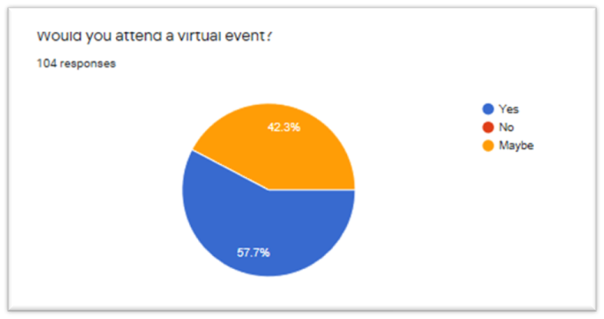
Figure 3. – Question 4
The fourth question was created with the aim to establish if virtual events would have an appeal. 60 out of 104 (57.7%) respondents had answered yes and 44 out of 104 (42.3%) had responded as a maybe. None of the respondents had answered with the option ‘No’. Cannon, J (2020) states that a large proportion of events are now opting to go virtual since the outbreak of COVID-19. Previously there was not a high demand for virtual events, however since lockdown physical events not being available has triggered a demand in virtual (Cannon, J).
Harad, K (2015) laid out nine vital steps on how to build a virtual attraction. The nine steps include commit, craft, compose, choose, campaign, complete, conduct, check in and capitalise. To achieve the craft step, it is essential to begin all marketing efforts by discovering the ideal target audience. To meet the campaign stage, an organisation must utilise multiple platforms to advertise the event to gain interest. To reach the capitalise step, the content from the virtual event can be used again and placed on various platforms. Capitalize on the power of content marketing, contribute all efforts into the event to develop months of messaging. Following the vital nine steps will provide numerous benefits when hosting a virtual event, the steps ranging from expert positioning, inexpensive, short time lead, easy setup, repeatable and building an asset.
The Coronavirus has made an increasing number of events and attractions competitors to Tribal Art London, resulting in the event being surrounded by competitors. An example of event organisation who had adapted their physical event to a virtual event is Hay festival. In relation to Porter’s five forces threat of substitutes force, Hay festival may not be a direct threat to Tribal Art London as they do not offer the same products and services, however they do fulfil the same need to consumers (Mindtools, 2020). Hay festival’s annual event had transformed into a virtual event, which had launched on the 18th May to 31st May 2020 (Hayfestival, 2020). The events that had taken place were interactive engaging with the audience, replicating a similar atmosphere to the physical Hay Festival event (Finnis, A. 2020). During the year of 2018, the event had sold 273,000 tickets (Accessaa, 2018). The statistics from the Hay festival virtual event 2020 had not yet been released, however the event had received a large amount of interactions and support when advertised on social media platforms which indicates that the event had engaged with a wide audience.
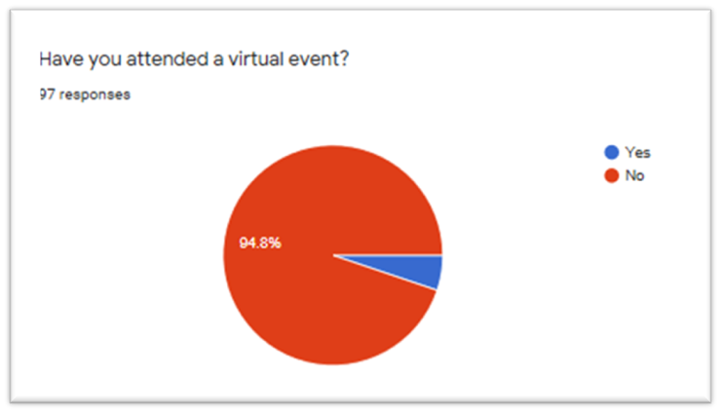
Figure 4. – Question 3
Question 3 asks the respondents if they have attended a virtual event. The results show that 92 out of 97 (94.8%) respondents have not attended a virtual event, while 5 out of 97 (5.2%) have. According to Barber, K (2020), the current climate has been a major threat for event organisations, this has fuelled a sudden increase for events to become virtual. Before the outbreak of COVID-19, Virtual events were not as well recognised in comparison to physical events. During recent months, virtual events have experienced an increase digital demand (Palmer, A. 2020).
An example of an international attraction that has turned virtual is the National Gallery of Art located in Washington, United States (NGA, 2020). The National Gallery of Art could be considered as Porter’s industry rivalry force. Although the attractions are located in different countries, they provide similar products and services and their virtual nature places them in the same pool. The National Gallery of Art has temporary closed due to COVID-19, however the attraction has enabled visitors to visit virtually. The attraction currently provides video tours of current exhibitions, online learning opportunities, recordings of lectures held by artists and curators and more. The virtual event can be accessed on the attraction’s website and on their app. During the year of 2018, the National Gallery of Art had attracted 4.4 million visitors (Statista, 2020). The current number of people that have accessed the virtual tours has not yet been released.

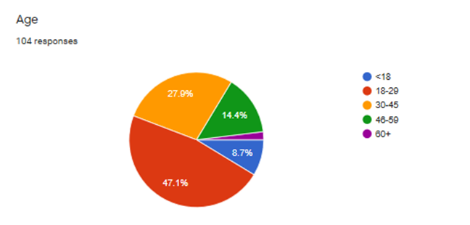

Figure 5. – Question 1
The first question asked the participants what their age was. The question was composed with the focus to determine the potential target audience. From the results displayed in the pie chart, 49 out of 104 of the respondents are aged 18-29 and the second highest age group was 30-45. In accordance to Chappelow, J (2019), demographic data is a vital element for organisations to acknowledge. In recent years, organisations have put a lot more emphasis on researching their customers age groups. This enables them to be able to determine the different needs and wants from each group. Slootweg, E. and Rowson, B. (2018) States that all generations are motivated and influenced differently so it is imperative to aim products and services and adapt strategies to appeal to each group. Imo Dara (2020) conducted a survey to discover who’s collecting African Art. The findings from the survey inform that 39% of respondents were aged 35-54 and 7 percent of the respondents were younger than 35.
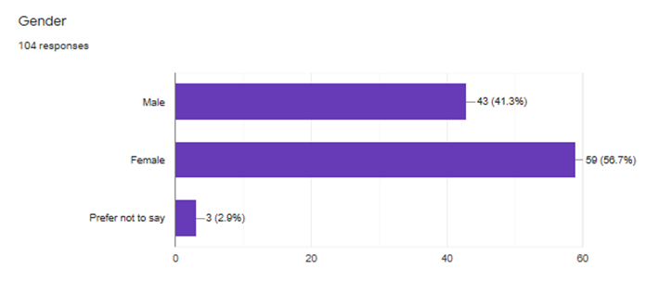
Figure 6. – Question 2
Question two was constructed to discover the split between each gender. The questionnaire responses indicate that 59 out of 104 were female (56.7%), while 34 out of 104 were male (41.3%) and 3 out 104 preferred not to say their gender (2.9%). From studying the results, it is shown that there is a possibility that there could be a slightly higher number of females viewing the virtual event opposed to males.

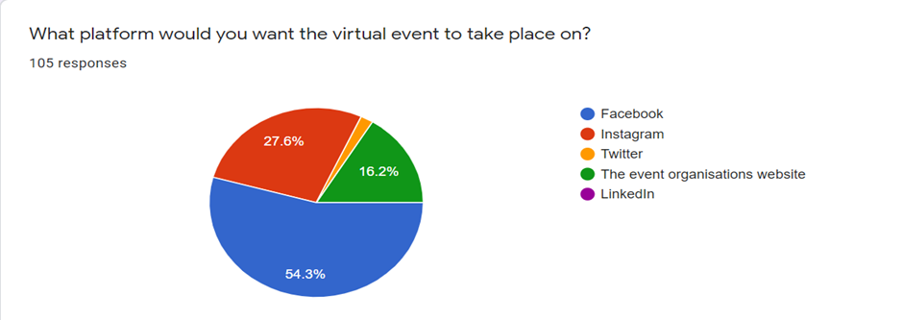
Figure 7. – Question 5
Question five was aimed at finding out what platform would be best suited to hold an online virtual event. 57 out of 105 (54.3%) respondents had selected Facebook, which suggests that it is the most recognised and popular platform. 29 out of 105 (27.6%) had chosen Instagram, 17 out of 105 (16.2%) had selected the event organisations website and 2 out of 105 (1.9%) had answered twitter. None of the respondents had selected LinkedIn as a platform they would like to see host the online event. According to Mae, I (2020), an organisations website is the most common platform for a virtual event to take place on. A vast minority of organisation use social media platforms to host an event, however this is expected to change as these platforms plan to introduce new features to help support hosting virtual events (Sehl, K. 2020).
- Discussion and analysis
The overall findings imply that virtual events are not just a temporary solution, they are expected to continue even after physical events are able to run again. However, it cannot be determined yet whether virtual events will still receive as much interest once physical events are made available. Nevertheless, virtual events should continue to be utilised by organisations as it is cost effective and flexible to host. It could be recommended that in future Tribal Art London should host both physical and virtual events to capitalise on a wider audience. From doing so, the event could gain better exposure and interest.
With relevance to Cohen’s model of typologies of tourists, the most suited tourist to attend a virtual event is the organised mass tourist. The drifter, the explorer and the individual mass tourist could be considered as a group of tourists a virtual event might struggle to reach. Introducing virtual tours where the tourist can follow their own path would be best suited for these specific tourist typologies (Kim, H et al. 2011).
As analysed in findings section, the questionnaire results have been found to support the potential for Tribal Art London to host a virtual event. The results signify that there is a market and an audience for a virtual event, which supports the overall aim of the report. It can be discussed that a majority of the respondents had not attended a virtual event but had declared an interest in attending. It could be argued that the number of respondents that had not attended a virtual event could potentially change in the near future as virtual events are now predicted to be the No.1 trend of 2020 and a range of virtual events are accessible.
It has been discovered that although the Coronavirus has brought physical events and exhibitions to a standstill, virtual events and exhibitions are now deemed as global events, which are accessible to all. Virtual tours and exhibitions can be deemed as innovative solutions for displaying art in a pandemic. Although some events may revert to being only physical, this could be considered as a missed opportunity as virtual events still have the potential to provide a range of benefits.
From having examined the nine steps on how to build a virtual attraction, it implies that digital marketing is an essential tool to utilise to help boost an audience for a virtual event. It is recommended that social media platforms are utilised to help build the virtual event strategy. It could be argued that organisations should not just focus heavily on digital marketing, traditional marketing needs to also be utilised to target all.
From having investigated competitors’ virtual events, it has been shown that event organisations are still able to convey their overall message through a virtual event and have been able to replicate a similar atmosphere to their physical event. With relevance to Tribal Art London’s overall aim of providing a knowledgeable and friendly environment, this can still be achieved from hosting a virtual event.
A SWOT analysis has been conducted and displayed in the table below. It had been utilised to determine the strengths, weaknesses, opportunities, and threats to hosting a virtual event.
Table 1.
SWOT analysis – Hosting a virtual event
Strengths  - Cost effective  - Flexibility – virtual events can stay live for up to 1 year  - Increase in an online audience – engage with an audience who may not have been able to attend the physical event | Weaknesses  - Not as good of an experience in comparison to a physical event  - No face to face networking  - The event may not be portrayed to the best of its ability
Opportunities  - Possibility to host more virtual events in the future  - Reach a new target audience | Threats  - Competitors  - Cyber security

- Conclusion

- To conclude, the Coronavirus has caused huge implications for physical events, however it has opened up a range of digital opportunities which include hosting virtual events, virtual exhibitions, and virtual tours.
- From having undertaken this report, it has been discovered that there is a demand and interest for virtual events from consumers. From examining the questionnaire findings, the respondents had been all in support for virtual events.
- It has been established that the art sector can adapt to virtual events and use it to their advantage by engaging with a wider audience that their physical event might not have reached.
- For a virtual event to be successful, marketing plays a crucial role in supporting this. It has been found that marketing is one of the most useful tools to gain an audience for a virtual event.
- The overall aim of the project had been met. It had been found that there is a potential market for Tribal Art London to adapt their physical event to a virtual event.
- The objectives had also been reached. The current climate had been assessed, which has resulted in discovering that COVID-19 has fuelled a boom in Virtual events. The pandemic has increased a high volume of digital demand, which supports virtual events.
- Market and event research had been undertaken, which has further supported the high demand in virtual events. Signifying that there are numerous benefits to hosting virtual events and there is a prediction that virtual events will continue to flourish.

- Recommendations
From the data collected, it displays that virtual events are and will continue to be successful way to host an event. Given the current climate, it makes it vital for organisations to adapt their physical event into a virtual event. In order to aid Tribal Art London in turning virtual, three recommendations have been put forward.
- It is recommended to utilise social media platforms to build upon a virtual event strategy
- It is recommended to examine competitors’ virtual events to gain a better perspective of how to host an event
- It is recommended to host numerous virtual events in the future to capitalise on a wider audience.

- Appendices

  - Copy of the questionnaire

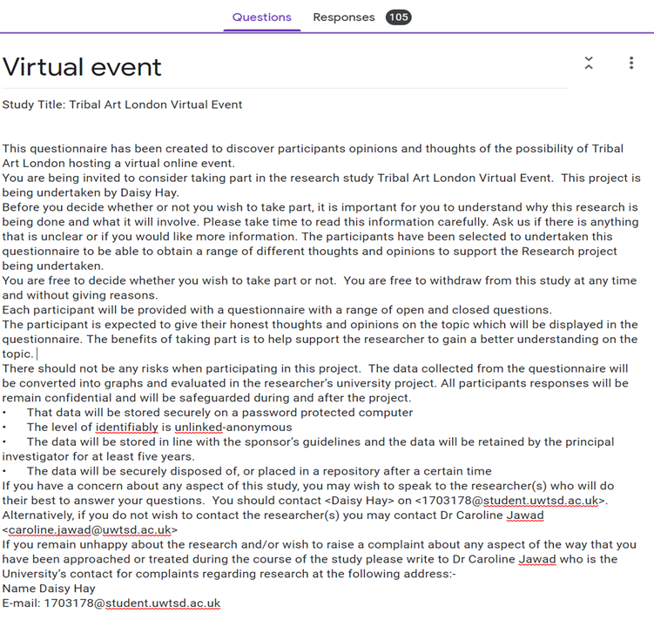

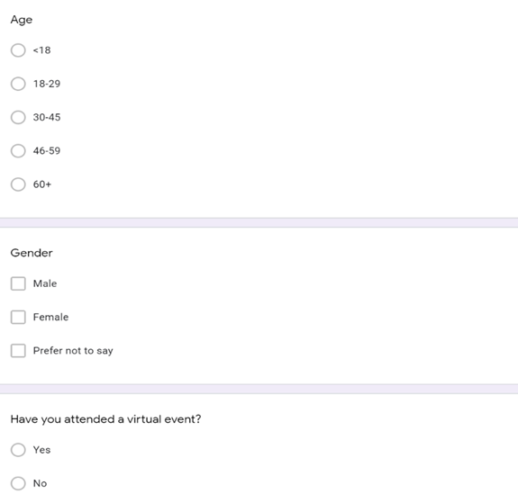

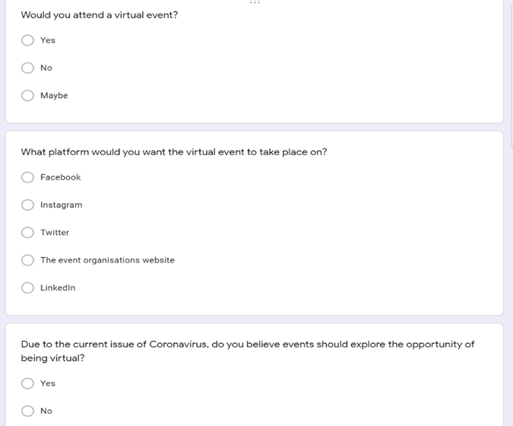

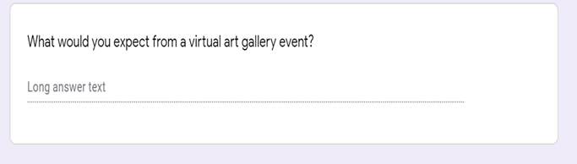

  - Copy of emails between the consultant and the organisation
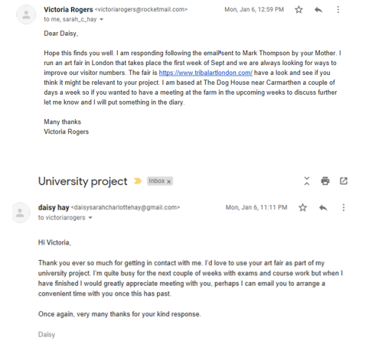

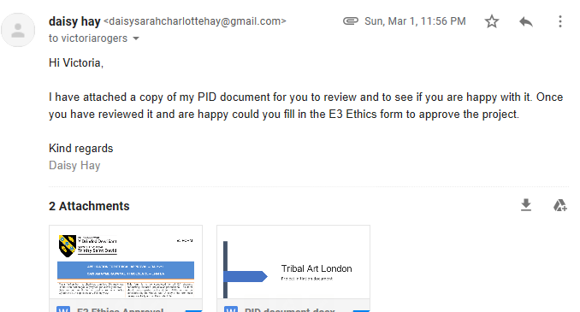
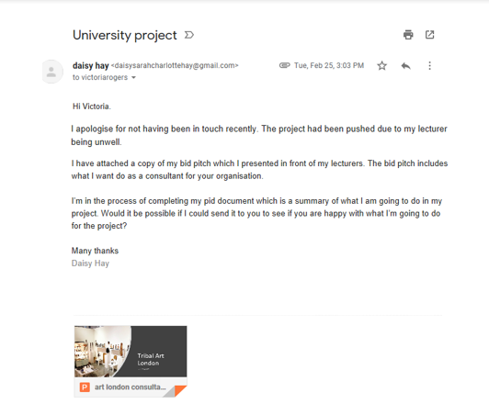

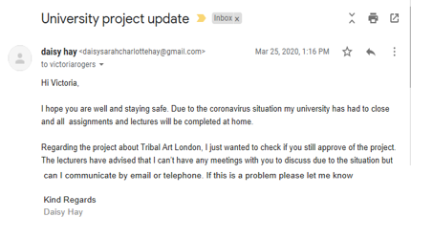
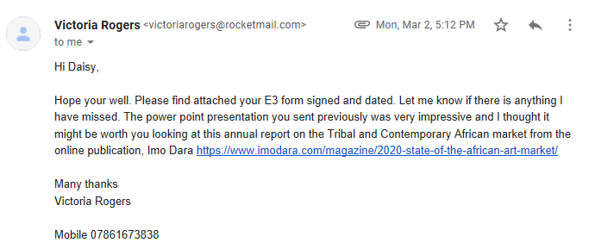

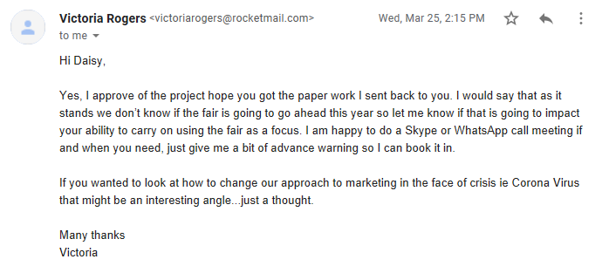

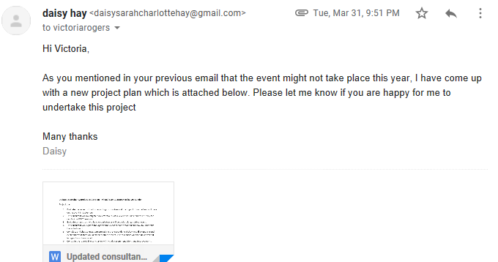

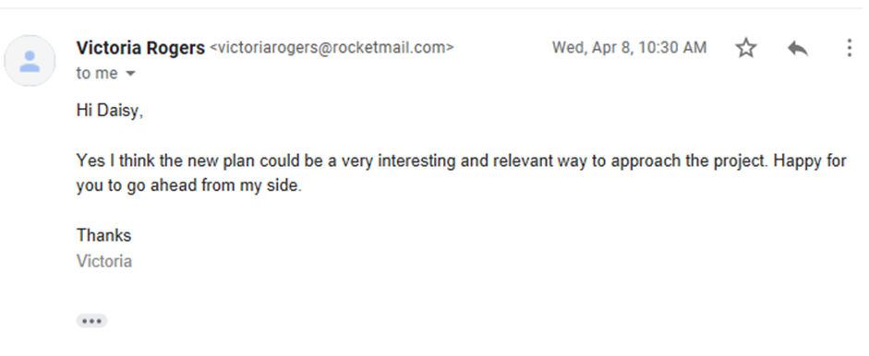

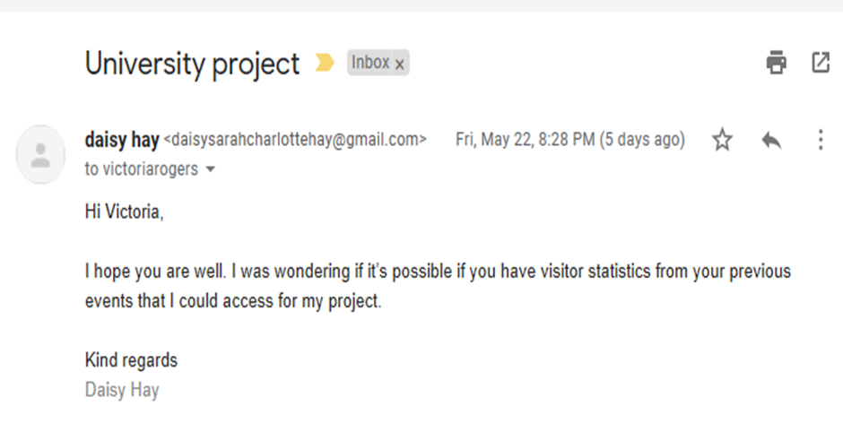

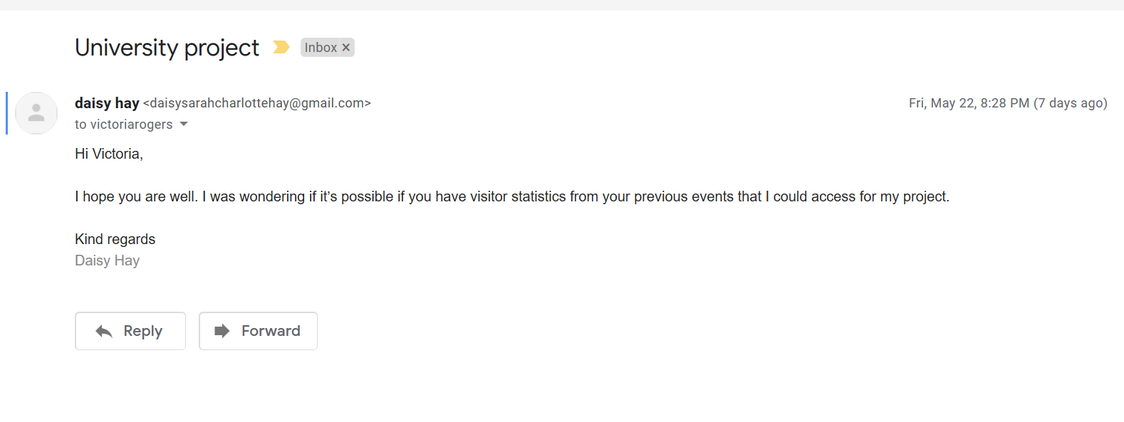

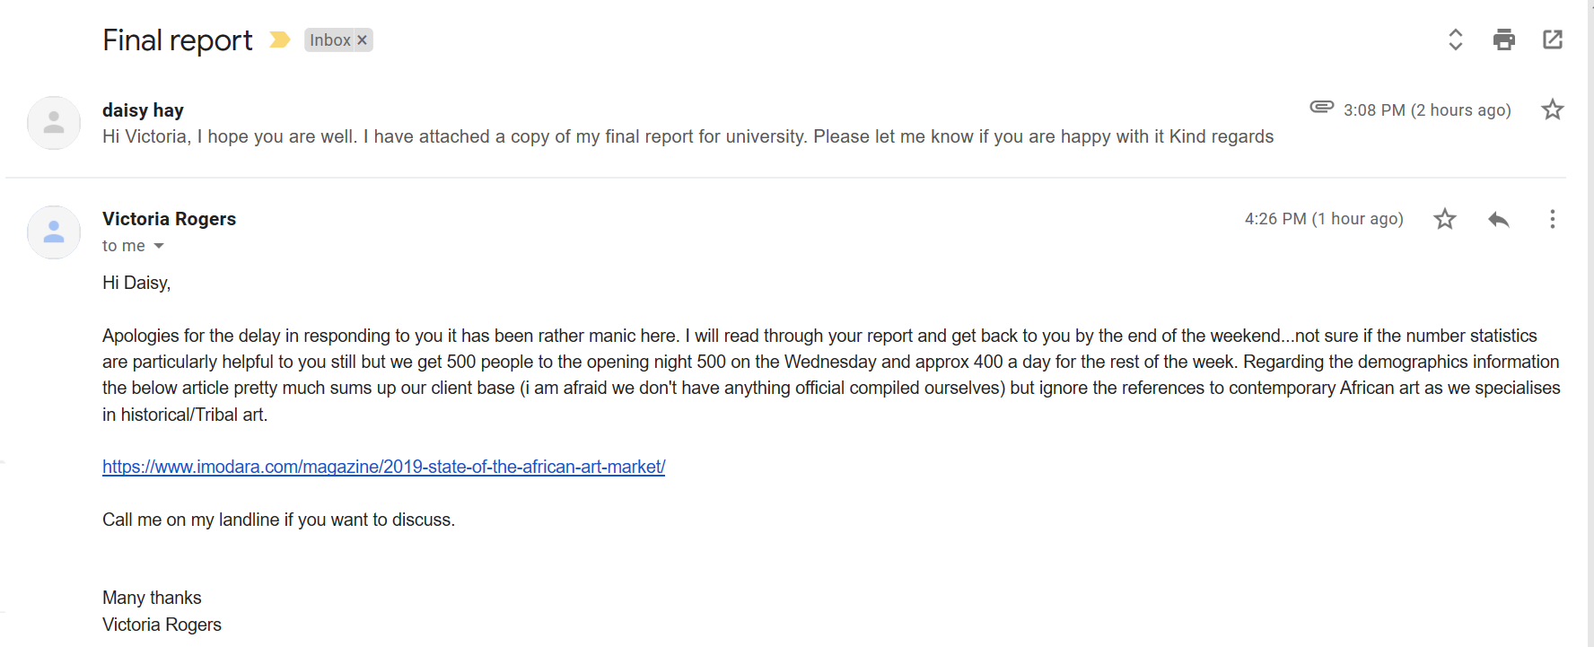

  - Consultancy project updated/new action plan
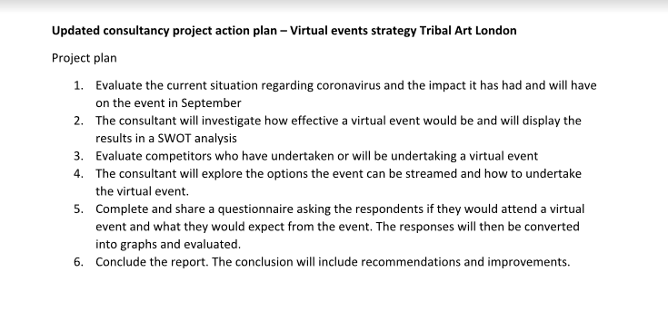

- Reference list
accessaa. (2018). AM-HAY-ZING FIGURES FROM HAY FESTIVAL 2018. Available: https://accessaa.co.uk/am-hay-zing-figures-from-hay-festival-2018/. Last accessed 23rd May 2020.
Acutt, M. (2012). Marketing Mix – Promotion (Promotional Strategy). Available: https://marketingmix.co.uk/promotion/. Last accessed 26th May 2020.
Arjun, R K. (2020). virtual events. Available: https://www.communicateonline.me/digital/virtual-events-the-pros-and-cons/. Last accessed 24th May 2020.
Armstrong, A. (2020). Museums, Curators, and Artists Find Innovative Solutions for Showing Art in a Pandemic. Available: https://www.artsy.net/article/artsy-editorial-museums-curators-artists-find-innovative-solutions-showing-art-pandemic. Last accessed 26th May 2020.
Barber, K. (2020). Publishers put virtual events to the test as in-person gatherings disappear. Available: https://digiday.com/media/publishers-put-virtual-events-test-person-gatherings-disappear/. Last accessed 03rd April 2020.
blog.simplymarketingjob. (2019). How virtual events are set to be the No.1 trend for 2020. Available: https://blog.simplymarketingjobs.co.uk/blog/event-trends-2020/. Last accessed 27th May 2020.
Cannon, J. (2020). Many marketing events are opting to go all-in on digital rather than cancelling due to COVID-19. What if you need an online event platform fast?. Available: marketingland.com. Last accessed 27th May 2020.
Chappelow, J. (2019). Demographics. Available: https://www.investopedia.com/terms/d/demographics.asp. Last accessed 02nd April 2020.
digitalinformationworld. (2020). The Future Of Virtual Events (infographic). Available: https://www.digitalinformationworld.com/2020/05/are-virtual-events-here-to-stay-infographic.html. Last accessed 26th May 2020.
docs.google. (2020). Virtual event. Available: https://docs.google.com/forms/d/1-ySIHmMBwQAcfE1gcdzmTyc-GFZRiDgjQGIgFhv4LQU/edit#responses. Last accessed 02nd April 2020.
Driscoll, D.L., Appiah-Yeboah, A., Salib, P. and Rupert, D.J., 2007. Merging qualitative and quantitative data in mixed methods research: How to and why not.
Finnis, A. (2020). Hay Festival online 2020: Digital literary event dates, full programme and how to watch it from home. Available: https://inews.co.uk/culture/books/hay-festival-2020-online-digital-when-dates-programme-full-how-watch-hay-on-wye-2855119. Last accessed 26th May 2020.
grandviewresearch. (2020). Virtual Events Market: Upsurge In Trend Due To Global Lockdown In The Wake Of COVID-19 Pandemic. Available: https://www.grandviewresearch.com/industry-analysis/virtual-events-market. Last accessed 26th May 2020.
Harad, K., C.F.P, 2015. 9 Steps to Building a Client-Attraction Virtual Event. Journal of Financial Planning, 28(3), pp. 19-21.
hayfestival. (2020). Hay Festival Digital 18-31 May 2020. Available: https://www.hayfestival.com/home. Last accessed 23rd May 2020.
imodara. (2020). explore museums. Available: https://www.imodara.com/. Last accessed 29th May 2020.
Kim, H,. et al., 2011. The relationship between types of tourist and destination authenticity.
Lang, C et al. (2020). Here's Your Comprehensive Guide to All the Events Cancelled Because of the Coronavirus. Available: https://time.com/5801956/events-canceled-coronavirus/. Last accessed 27th May 2020.
Liu, J et al., 2017, June. Internal multiple attenuation by iterative construction of virtual events. In 79th EAGE Conference and Exhibition 2017 (Vol. 2017, No. 1, pp. 1-5). European Association of Geoscientists & Engineers.
Mae, I. (2020). The 9 Best Virtual Event Software Platforms of 2020. Available: https://www.voipreview.org/blog/best-virtual-event-software. Last accessed 27th May 2020.
mallgalleries. (2020). Tribal Art London 2019. Available: https://www.mallgalleries.org.uk/whats-on/exhibitions/tribal-art-london-2019. Last accessed 23rd May 2020.
mindtools. (2020). Porter's Five Forces. Available: https://www.mindtools.com/pages/article/newTMC_08.htm. Last accessed 23rd May 2020.
nga. (2020). Experience Your National Gallery of Art. Available: https://www.nga.gov/. Last accessed 24th May 2020.
Palmer, A. (2020). How the Rise of Virtual Events Due to Coronavirus Could Change the Way We Meet. Available: https://www.northstarmeetingsgroup.com/Planning-Tips-and-Trends/Event-Planning/Event-Technology/Coronavirus-Online-Events-COVID-19-Impact-Future-In-Person-Meetings. Last accessed 27th May 2020.
Quinn, A. (2020). London coronavirus live: Updates as confirmed cases hit 26,780 in the capital and MPs call for Cummings to be sacked. Available: https://www.mylondon.news/news/health/london-coronavirus-live-updates-confirmed-18305866. Last accessed 25th May 2020.
Sehl, K. (2020). How to Host a Successful Virtual Event: Tips and Best Practices. Available: https://blog.hootsuite.com/virtual-events/. Last accessed 27th May 2020.
Shehadi, S. (2020). How coronavirus is making virtual galleries go viral. Available: https://www.newstatesman.com/culture/art-design/2020/03/virtual-galleries-art-museums-tours-online. Last accessed 26th May 2020.
Slootweg, E. and Rowson, B., 2018. My generation: A review of marketing strategies on different age groups. Research in Hospitality Management, 8(2), pp.85
statista. (2020). Number of visitors to the National Gallery of Art in Washington D.C. from 2007 to 2018 . Available: https://www.statista.com/statistics/247430/yearly-visitors-to-the-national-gallery-of-art-in-washington/. Last accessed 25th May 2020.
Tavares, A. (2020). How coronavirus will impact the events industry. Available: https://beamian.com/how-coronavirus-will-impact-events-industry/. Last accessed 24th May 2020.
telegraph. (2015). Tribal Art London: the rise of the niche fair . Available: https://www.telegraph.co.uk/art/barnebys-auctions/tribal-art-london/. Last accessed 27th May 2020.
timeout. (2020). Tribal Art London. Available: https://www.timeout.com/london/art/tribal-art-london. Last accessed 27th May 2020.
tribalartlondon. (2020). TAL. Available: https://www.tribalartlondon.com/. Last accessed 23rd May 2020.
Rogers, V. (2020). TAL statistics. Available: https://accounts.google.com/ServiceLogin/signinchooser?service=mail&passive=true&rm=false&continue=https%3A%2F%2Fmail.google.com%2Fmail%2F&ss=1&scc=1&ltmpl=default&ltmplcache=2&emr=1&osid=1&flowName=GlifWebSignIn&flowEntry=ServiceLogin/. Last accessed 29th May 2020
worldometers. (2020). United Kingdom. Available: https://www.worldometers.info/coronavirus/country/uk/. Last accessed 25th May 2020.

- Bibliography
Axelsen, M., 2006. Using special events to motivate visitors to attend art galleries. Museum Management and Curatorship, 21(3), pp.205-221.
Ayittey, F.K., Ayittey, M.K., Chiwero, N.B., Kamasah, J.S. and Dzuvor, C., 2020. Economic impacts of Wuhan 2019‐nCoV on China and the world. Journal of medical virology.
Bowdin, G., O'Toole, W., Allen, J., Harris, R. and McDonnell, I., 2006. Events management. Routledge.
Burnett, J. and Oeffinger, J., ARTICULEARN Inc, 2002. Method and system for creation of virtual events. U.S. Patent Application 09/845,947.
Cramer, D., 2003. Advanced quantitative data analysis. McGraw-Hill Education (UK).
creative-capital. (2020). Online Arts Events During the COVID-19 Outbreak. Available: https://creative-capital.org/2020/03/18/online-arts-events-during-the-covid-19-outbreak/. Last accessed 23rd May 2020.
Dickson, C. and Arcodia, C., 2010. Promoting sustainable event practice: The role of professional associations. International Journal of Hospitality Management, 29(2), pp.236-244.
Domschitz, P., Alcatel SA, 2009. Method and devices for implementing highly interactive entertainment services using interactive media-streaming technology, enabling remote provisioning of virtual reality services. U.S. Patent 7,480,727.
Dumitrescu, G., Lepadatu, C. and Ciurea, C., 2014. Creating Virtual Exhibitions for Educational and Cultural Development. Informatica economica, 18(1).
Erez, I. and Ikelle, L., 2006, January. The Concept of Virtual Events?? Atteuation of Internal Multiples. In 2006 SEG Annual Meeting. Society of Exploration Geophysicists.
Failla, John. "Producing Your First Virtual Event." Folio 38.6 (2009): 44. Web.
Fernandes, N., 2020. Economic effects of coronavirus outbreak (COVID-19) on the world economy. Available at SSRN 3557504.
Foo, S., 2008. Online virtual exhibitions: Concepts and design considerations. DESIDOC Journal of Library & Information Technology, 28(4), p.22.
Grassick, M. (2020). The best online exhibitions, museums and virtual tours. Available: https://discover.ticketmaster.co.uk/special-events/the-best-online-exhibitions-museums-and-virtual-tours-49853/. Last accessed 24th May 2020.
Greene, R., 2004. Internet art (Vol. 19). London: Thames & Hudson.
habitatmag. (2019). Tribal Art London. Available: https://www.habitatmag.co.za/tribal-art-london-4-7-september-2019/. Last accessed 24th May 2020.
Hall, C.M., 1992. Hallmark tourist events: impacts, management and planning. Belhaven Press.
Hoffman, H.G., Hullfish, K.C. and Houston, S.J., 1995, March. Virtual-reality monitoring. In Proceedings Virtual Reality Annual International Symposium'95 (pp. 48-54). IEEE.
Holton, J.A. and Walsh, I., 2016. Classic grounded theory: Applications with qualitative and quantitative data. Sage Publications.
Hudson, S., 1999. Consumer behavior related to tourism. Consumer behavior in travel and tourism, pp.7-32.
Jamal, T. and Budke, C., 2020. Tourism in a world with pandemics: local-global responsibility and action. Journal of Tourism Futures.
Kazdin, A.E., 2003. Methodology: What it is and why it is so important.
Lim, J.C. and Foo, S., 2003. Creating virtual exhibitions from an XML-based digital archive. Journal of Information Science, 29(3), pp.143-157.
Mateos-Rusillo, S.M. and Gifreu-Castells, A., 2017. Museums and online exhibitions: a model for analysing and charting existing types. Museum Management and Curatorship, 32(1), pp.40-49.
Maxwell, A.E., 1961. Analysing qualitative data (pp. 46-50). London: Methuen.
McLellan, H., 1998. Virtual events: A cyberspace resource for educators. Educational Technology, 38(2), pp.57-61.
Parry, A. (2020). Adapting your event to virtual or planning a virtual or hybrid event Conference Compass has you covered. Available: https://www.eventindustrynews.com/news/adapting-your-event-to-virtual-or-planning-a-virtual-or-hybrid-event-conference-compass-has-you-covered. Last accessed 23rd May 2020.
Patel, M., White, M., Walczak, K. and Sayd, P., 2003, July. Digitisation to Presentation-Building Virtual Museum Exhibitions. In VVG (pp. 189-196).
Perlman, S.G. and van der Laan, R., Sony Interactive Entertainment America LLC, 2015. Hosting and broadcasting virtual events using streaming interactive video. U.S. Patent 9,108,107.
Ramaiah, C.K., 2014. Guest Editorial: Trends in Online Exhibitions. DESIDOC Journal of Library & Information Technology, 34(2).
Ranathunga, S., Cranefield, S. and Purvis, M., 2012. Identifying events taking place in Second Life virtual environments. Applied Artificial Intelligence, 26(1-2), pp.137-181.
Sandelowski, M., 2000. Combining qualitative and quantitative sampling, data collection, and analysis techniques in mixed‐method studies. Research in nursing & health, 23(3), pp.246-255.
Serban, C., AT&T Intellectual Property I LP, 2014. Platform for hosting virtual events. U.S. Patent 8,781,932.
tribalgathering. (2020). Tribal Art London. Available: http://tribalgatheringlondon.com/gallery/. Last accessed 24th May 2020.

