
Strategic Change and Organisations
Skills for the Workplace
Module Assignment Submission
Student Name: | Carol Vaughan-Roberts
Student Number: | 1604568
Module No: | LCDB7005
Lecturer Name: | Prof. Amare Desta
Module Title: | Strategic Change and Organisations
Statement of Confirmation of Authenticity
By the act of making this submission, the student declares that this is the work of the student named above. The work has not, in whole or in part, been knowingly presented elsewhere for assessment, or where assessment has been built on a previous assessment, this has been identified. Where materials have been used from other sources it has been adequately acknowledged. If this statement is untrue, the student acknowledges that an assessment offence has been committed.
Attention is drawn to the plagiarism and unfair practice policies of both the University and of ILM.
Contents

INTRODUCTION 2
Deutsche Post DHL Group 4
Long term objectives views nature for the organisation. 5
Competitors 6
Strategic planning 6
The macro and Microenvironment 6
SWOT 6
PESTAL 7
Political: 7
Economic: 8
Socio-cultural 8
Technological 8
Environmental 8
Legal 8
Five Forces 9
Change 10
Identifying barriers to change 11
Implementing change 12
Strategy and culture 12
DPDHL Issues 13
Transitioning to a new system 14
Risk management 15
Conclusion 16
References 17

ASSUMING YOU ARE THE EXECUTIVE DIRECTOR OF A MAJOR TRANS-NATIONAL CORPORATION, DISCUSS HOW WOULD YOU DEVELOP IMPLEMENT “STRATEGIC ACTION PLAN” TO SUSTAIN THE CORE BUSINESS OF YOUR ORGANIZATION.

INTRODUCTION
Maintaining global competition is becoming more challenging. This paper explores the steps and decisions an executive director would need to make in their role in a multinational company. What they face in creating and executing a "Strategic Action Plan" to retain their core business. Using Deutsche Post DHL Group (DPHL) as a reference point looking at the challenges they have to face to stay in control of their strategic operations. The intention is to show a breakdown of how the author believes an executive director of a transnational corporation, is dealing with the complexity of the matter. One of transnationals' goals is to have a marked creased interconnection between people all over the world and a loosening of international borders (Syed & Metcalfe, 2017).
To achieve a competitive advantage, the executive must consider the company's structural transformation as it transitions away from its present environment and into a projected future state. It is a method for ensuring that the organisation's strategy process, human resource processes, and the larger environment are all in sync. Strategic change necessitates management and stakeholders to the technical, cultural, and political aspects of the organisation. This study looks at the logistic industry from the point of view of DPDHL.
Since planning is not a one-time operation, businesses must make ongoing, systemic, and rational improvements to their strategies in order to succeed and prosper. As strategy is not a one-time exercise, to compete and thrive, executives must make ongoing, systemic, and rational improvements to their strategy. The approach involves an integrated action plan that, if adopted, would result in better margins and infrastructure, enabling the organisation to retain a competitive edge (Ukil & Akkas, 2017).
The study will show the various environments and solutions a transnational company faces and how they can utilize and overcome them and survive strategically. Taken full advantage of the market's lucrative opportunities, transnational companies have to recognise the main markets where they should spend or devote their valuable resources, and then concentrate on developing solid networks with key stakeholders. The control of information transfers is important as is providing strategic guidance in joint ventures toward a long-term sustainable future (Ferreira, et al., 2020), ensure that each department has strong bonding with other departments in order to affect organisational change. As businesses grow their ventures into foreign markets, they must address the difficulties that management face in a transnational business world. As businesses grow and venture into foreign markets, the difficulties that management face in a transnational business world they must addressed. To achieve Strategic management the goals and objectives of the business need to be analysed along with the competitive environment and study the internal organisation (Kenton, 2019).
The executive must be dedicated to achieving the desired plateau by juggling performance, timelines, and investments while still having to innovate in their operations and services. The execution of a business strategy that establishes deadlines, promotes best practises, and evaluates the outcomes However, due to scale, venue, public vs. private, products vs. resources, time and commitment spent promoting sustainability, degree of employee interest in sustainability, and other factors, what works for one company may not work for another (Bazaras, et al., 2018).

The executive should be aware of the variety of trends that have emerged from studies on public-sector strategic planning; a discussion of what strategic planning is in terms of theory and practically. The methods previously mentioned may be thought of as normative, their ostensive view, however in reality, they must be implemented contingently and sensitively their performative view. Scholars differ about whether strategic planning is a general or performative term. Also, trend focuses on determining when and how strategic planning works. The responses are influenced by how strategic planning is formulated and implemented, which is understandable. The results of strategic planning are the subject of another theme. Typically, the outcomes measured have been performance-related, such as quality and efficacy, but some studies concentrate on intermediate outcomes, such as engagement and learning, and a few studies focus on a wider spectrum of societal ideals, such as accountability or equality. Another theme examines what factors influence strategic planning performance. Efficient leadership, organisational ability and finances, and engagement, among other things, are all factors that contribute to performance (Bryson & Edwards, 2019).

Twaissi & Aldehayyat (2021) study showed that formal strategic planning could improve an organization's success. Consequently, the findings revealed that involving stakeholders could improve the connection between structured strategic planning and organisational success. Moreover, the findings revealed that involving stakeholders could improve the connection between structured strategic planning and organisational success. Previous research has shown that as a whole strategic management is critical to improving an organisation's performance. The study also discovered that formal strategic planning and stakeholder involvement had the greatest impact on performance (Twaissi & Aldehayyat, 2021).

When an executive is developing a logistics plan, they need to identify the quality of service from which the logistics department is to be most cost-effective. Since their supply chains are still growing and developing, the organisation has to create several logistics strategies for different product lines, countries, or consumers.

Strategic leadership, according to Lussier and Achua (2010), is "the process of having the guidance and motivation required to develop and execute a company's vision, mission, and strategies in order to achieve organisational objectives" (Castellanos & George, 2020).

Deutsche Post DHL Group

DPDHL is a publicly traded company based in Bonn, Germany. The DPDHL offers an international service range that includes letter and parcel transfer, postal shipping, freight distribution, supply chain management, and e-commerce solutions under the Deutsche Post and DHL brands. They are in over 220 countries and territories across the world, the Group hires nearly 550,000 employees.
The triad of a consistent plan for their Community is their purpose, vision, and values. A revived Group-wide pledge to success complements these long-term aspects. Their mission is to be exceptional and deliver. They achieve their goal by performing it well around the three bottom lines in a long-term manner:
- Employer of Choice
Motivated and skilled employees deliver exceptional quality.
- Provider of Choice
Exceptional quality delights their Customers and leads to loyalty.
- Investment of Choice
Customer loyalty leads to profitable growth. (Post, 2021)

Long term objectives views nature for the organisation.

As one of the world's leading logistics companies (Glynn, 2021), the Group links people and customers and facilitates global trade. The four most critical developments affecting logistics in recent years will continue to influence the sector in the future: Globalization, Digitalisation, E-Commerce and Sustainability. They are on track to continue their success storey with their Strategy 2025. The company’s mission is “Delivering excellence in a digital world" by setting the groundwork for the world's leading logistics firm, DPDHL, to continue its prosperous future development. The group would devote ever more resources to optimising the long-term benefit opportunities of its key logistics businesses. It will also drive the Group's digital transition, which is now ongoing in all company units (Post, 2021).
DPDHL has partnered with a number of businesses to help it grow, gaining cooperation and facilitating the exchange of best practises while both lowering costs while ensuring that contract commitments are fulfilled. In DHL Global Forwarding and Decathlon joined in August 2019 to support Decathlon's global supply chain activities. In July 2019, the company strengthened its last-mile parcel distribution service in Slovakia and the Czech Republic by extending its relationship with Austrian Post. DHL Supply Chain collaborated with Tetra Pak in the same month to introduce an automated supply chain solution for its Singapore warehouse leveraging digital twin technologies (Marketline, 2020).

Competitors
In 2019, the global transportation services market grew at a modest pace. COSCO SHIPPING Holdings Co., Ltd., Deutsche Post AG, FedEx Corp, and A.P. Moller-Maersk A/S are the four major players in the industry. The top corporations are in China, Germany, the United States, and Denmark, demonstrating the industry's well-diversified presence of transportation service providers. As the counties borders closed due to COVID-19 the result caused disruptions to foreign freight movements, it also had a strong effect on rail freight. A variety of questions have been raised about how rail freight firms can handle the downturn in freight flows and what COVID-19's long-term effect will be on this industry. Furthermore, as of January 2020, maritime freight carriers must take such precautions, such as inspection and monitoring provisions for ship crews, additional maintenance practises, hand washing, sanitising regularly touched surfaces, restricting shore side contacts, maintaining physical distance in the office, and wearing protective clothing (Marketline, 2020).

Strategic planning
Strategic planning is the first step toward a clear action plan. This is where the organisation's mission and vision, as well as the objectives and expectations are set and laid out. SMART targets that are in line with the business strategy are made. The priorities should include the measures needed to take to accomplish them. Clearly define each action item so that everyone knows what needs to be done. At this point the executive would need to lay out all the specifics. DPDHL will be focussing on their core mail and logistics business.

The macro and Microenvironment

SWOT
Alam, et al., (2018) study found that Although the proposed regional digital futures plans are vulnerable to internal and external influences, strategic planning enables them to be managed. The results of their study also showed that adaptive strategic planning can help control the impact of internal and external factors that influence individual and corporate responses to digital change, and that these factors can help boost regional competitiveness. This aids in the process of developing long-term and short-term strategies.
The research aids in the development of an effective digital futures plan focused on the region's strategic advantages and digital competence by rating and prioritising the SWOT variables. As a result, Alam, et al., (2018) found, that both digital orientation and acceptance variables are needed for increased digital competence in regional economies. The SWOT analysis methodology will aid in the creation of more solid digital futures strategies. Other regional economies seeking to match their digital futures strategies with the knowledge generated by an overview of their response to digital capital may benefit from this information (Alam, et al., 2018).
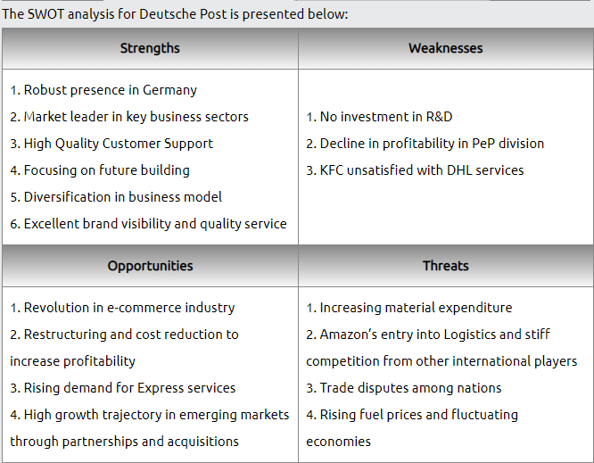
(PESTEL.com, 2020)

PESTAL
Political: Taxation, labour law, regulations, trade-related controls, and official charges or tariffs would be included in this section of the report. Political issues that influence industry are often given a lot of weight as several facets of government policy will impact industry. Executives must determine how pending regulations will impact their operations. Organisations may be influenced by the political climate in a variety of areas. They may introduce a risk factor that could result in a significant loss. The political considerations are made up of changes in government policy (Savy, 2016).
Economic: economic topics such as economic growth, currency valuation increases, interest rate fluctuations, changes in market prices, or changes in the buying power of money (inflation and deflation) are included in this section of the analysis. (Soeters, 2021).
Socio-cultural This part of the analysis includes things such as social trends and attitudes and lifestyles, age distribution, family demographics, educational levels, as well as rising or falling trends in population.
Technological - The executive must examine the organisations operations from the standpoint of the socio-cultural context which includes key aspects that influence these activities: Traditions, linguistic comprehension, negotiating skills, attitudes towards construction hours, and so on. Global companies, especially those in logistics, are heavily influenced by the socio-cultural climate. Diverse regions are characterised by their distinct socioeconomic environments, which often cause challenges in international relations, which are typical in logistics activities (Bazaras, et al., 2018).
Environmental Politicians are attempting to minimise waste and influence consumer behaviour by urging business to use low-cost vehicles and alternative energy sources in order to decrease harmful gas emissions. Climate, environmental pressures and rules, carbon footprint, recycling, and biodiversity are among the topics included in the study (Radojevi & Radi, 2017).
As part of the Science Based Target Initiative, Deutsche Post DHL Group has agreed to aggressive CO2 emission goals in the fight against climate change. Without the latest sustainability roadmap's plans, the Group estimates that the emissions will be about 46 million tonnes in 2030. Emissions were 33 million metric tonnes in 2020 (Transport, 2021).
Legal This section of the analysis is linked to the political section which covers topics such as anti-discrimination laws, consumer protection, competition, workers' rights, employers' wellbeing, and worker safety and health. Transport logistics should be considered a dynamic economic and legal phenomenon, legal organisation, and form of business operation before introducing these measures. The relations arising in transport logistics are justified by the conclusion of independent civil contracts for logistics services defined in the transport obligations system. To provide efficient oversight of the given ties, modifications and additions to operating federal laws, as well as the acceptance of new by-laws, are proposed (Filippova & Voronina, 2021).
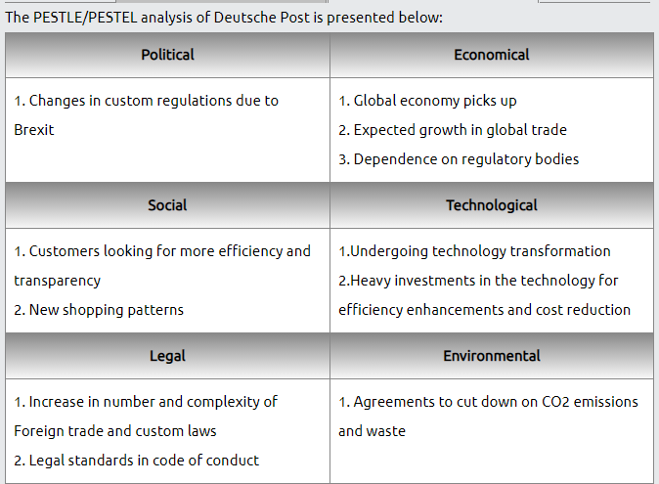
(PESTEL.com, 2020)

Five Forces
Transportation organisations are a complex industry that includes freight transportation via road, sea, and air. Which leaves generalisations about the market forces that affect this business category challenging. Although air and maritime transportation have declined globally in recent years, rail and road freight have increased. The supply power of resources such as fuel, transportation equipment, utilities, and containers determine supplier control in the transportation services industry. The challenge of outsiders differs greatly between sub-industries because entry barriers vary from low via the road to very high railways.
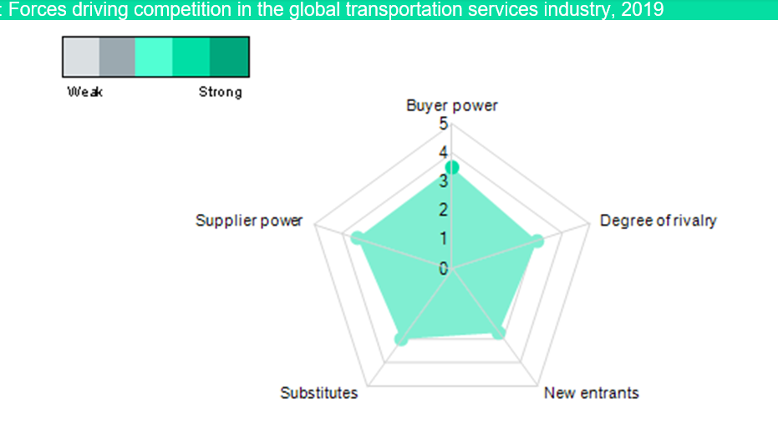
(Marketline, 2020)

The rail, air, and maritime sectors are all notoriously difficult to get into. The road market, on the other hand, has much lower entry barriers, and new entrant penetration is far more likely. While each industry in the community will serve as a replacement for others, each has its own set of benefits and drawbacks for consumers (Kingsnorth, 2016).
The strength of competition varies depending on the market – for example, the road transportation sector typically has the most rivalry, while railways, as 'normal monopolies,' have far fewer real competitors. The level of market competitiveness within each industry is heavily influenced by the global economy and trading relationships.

Change
The need for senior executives to improve expertise in managing planned change, especially strategic change, is continuing and unabated. There are two facets of senior executives' position in strategic change: Strategic analysis is concerned with policy development, while strategic acting is concerned with aligning the organisation with the desired strategy.
The change senior executives must consider at starting point as to where the change is begun and created, be able to describe it clearly as top-down or bottom-up leadership approaches, although there are other alternatives. Clear and well-directed goals can also help in change management. Change management would be defeated by poorly implemented corporate practises and a misalignment of top-down and bottom-up ideologies (Galli, 2018).
The distinctions between transformational and organisational change are important, and they must be recognised within the organisation. It is critical for organisations seeking to reform to recognise how they contribute to the failure of large-scale transition efforts on a constant basis. Change is characterised as tweaks or improvements to processes in a business context. It is transformational to move goods, systems, programmes, and cultural traditions from their present state to an often very different future state. Although change and transformation are associated, the scale and effect of the change is also what makes it transformative (Iles & Sutherland, 2001).
The value of innovative approaches to senior leadership in the twenty-first century, including an emphasis on executive’s ability to study their organisational contexts and restructure them to be change-friendly. This frequently necessitates senior leaders being self-aware, with the potential to reorganise the context surrounding them through their own behaviour. In the aftermath of the financial crash and economic recession demonstrates, there is a call for leaders to take a less superhero approach to leadership, focusing more on building good relationships with those in their organisations and highlighting their own integrity and dignity (Balogun, et al., 2016).
DPDHL executives have chosen the transformative route as shown in their 2017 annaul report “In order to continue to grow profitably, we are designing a market-based cost structure by adapting our networks to the dynamic market conditions and shipment structures. We also cut costs wherever possible and sensible, whilst investing in technologies, automation, innovation and growth areas” (Post, 2017).

Identifying barriers to change
Sustainable growth necessitates revolutionary improvements and progressive developments, and existing major industrial corporations must be able to create this to adapt to a sustainable environment. Economic, structural, organisational, attitudinal, and technical barriers all exist. They are often marked by a desire to improve convergence between a variety of diverse backgrounds and domains of business, as observed in regard to innovation management (Ritzéna & Sandström, 2017).

Implementing change
One of the most difficult challenges that senior executives face is implementing substantial structural reforms in their organisation. Successful change management relies on four core principles, understanding change, planning change, implementing change, and communicating the change. Kurt Lewin's three-step model is a template for expected transition.
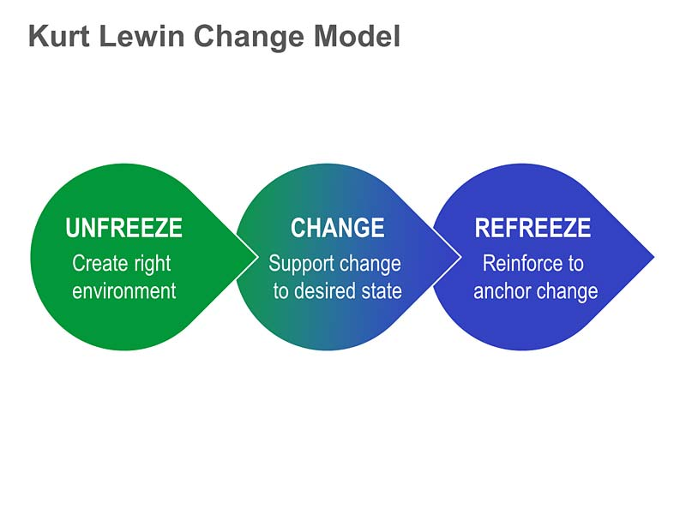(Bhirawit, 2014)

The three-step model has been criticised for several reasons, the most common of which is that Lewin "never created such a model." The three-step model is hardly "straightforward" or "never created," but rather a solid method to comprehending the complexities of human behaviour and how it could be revised (Burnes, 2020). These measures, however, cannot be seen in isolation from other interconnected methods such as action testing, social dynamics, and force field analysis. The transformation state necessitates deliberate thought on how it would be planned and handled.
Strategy and culture people, methods, experiences, thoughts, and attitudes all contribute to the culture of the company. The plan determines where the organisation is heading, what direction it will follow, and how it will get there. Culture cannot survive without plan, and vice versa. the culture is like a home; if it is not in order, no amount of policy can get the organisation any place. If leaders want their culture to improve success, they must consider culture types as well as key corporate and business factors. External issues to consider include region and industry; important internal concerns include compatibility with policy, leadership, and organisational style (Groysberg, et al., 2018).
Internal and external frameworks are similar to the strategy and culture frameworks. The policy is based on the external world. Gain data from the clients and competitors to identify the organisations strengths and threats by looking at the business and the outer environment in order to find the opportunities and threats. The organisation’s internal strengths and weaknesses can be identified through workforce surveys, board reports, and financial statements (Alam, et al., 2018).

Ken Allen Chief Executive Officer, DHL eCommerce Solutions, DPDHL wrote, “Corporate culture can have a significant impact on the world as employees promote a spirit of tolerance. Companies have the resources to assist workers with their personal growth as well as how they interact with others. The willingness of multinational companies to push transformation is one way to drive a more inclusive global agenda” (Allen, 2020).

DPDHL Issues

In its domestic post industry, DPDHL is experiencing a supply decline. The PeP division's sales suffered as a result of the fall in number. Around 2017 and 2018, the number of mail communications dropped from 7,964 million to 7,707 million (DPDHL, 2019). This decline, according to the company, is linked to a spike in electronic substitutions. Mail communications revenue has been steadily declining over the years, but it still accounts for a significant portion of the overall revenue generated by this industry. The PeP division of DPDHL relied heavily on sales from outside sources. The Resource Dependence Theory is clearly supported by this dependency (Salancik & Pfeffer, 2003). This hypothesis reflects on how external influences affect corporate behaviour and proposes that through transition, organisations can adjust their dependence and instability. DPDHL's reliance is based on a customer-supplier partnership. The company's global network spans more than 220 countries and territories, allowing it to establish itself as a leading eCommerce logistics provider. The PeP division has depended heavily on domestic post and parcel over the last four fiscal years, as their international eCommerce operations have not been successful (DPDHL, 2018).

Transitioning to a new system
The executive has to focus on the organisations vision as it is a representation of an organisation's core values. A vision serves as a focal point for evaluating departmental and organisational success. A vision brings everyone together in cross-functional tasks. The idea is to break down organisational walls and inspire workers who believe in the vision would like to see it realised (Dr., 2018). What would be needed is a transition approach built on existing digital sophistication, with technology acting as both a catalyst and a mechanism for progress and integrated across all divisions. The problems faced by digital transformation must be addressed from a systemic viewpoint. A vision is a representation of an organization's core values. A vision serves as a focal point for evaluating departmental and organisational success.
Three transformation phases can be identified in the transition state: mobilise, pass, and maintain. Jim Collins offered a basis for bringing an organisation from a point of break-even to a position of business value using the flywheel principle in his book "From Good to Great." Disciplined People, Disciplined Thought, and Disciplined Action are the three phases of change defined by Collins (Collins & Collins, 2006). The mechanism of individual adjustment and the transformation curve, though, must be recognised as underpinning all three phases of any organisational shift. Only by improving the individuals inside an organisation can it affect what it does. It is important to provide a view of the ideal future state to plan the transition levers and interventions. The ability to visualise the ideal future state can also be used to identify possible transition hurdles. When a technique like the cultural network is used to create a vision of the ideal potential organisation, some of the levers and interventions are found. Some would be based on an understanding of thoughts on how to work with transition barriers and how to reach change readiness. Others may have been discovered as a result of the initial design decisions for the shift lever (technical, political, cultural and interpersonal) (Folke, et al., 2019).
Additional approaches, particularly in the areas of communications, education, development, career development, human resource structures, and resistance management, must be considered. The four organisational subsystems that are part of the design choices within the mobilise, transfer, and maintain processes can be used to help complete the design of the levers and interventions, as well as determine how to sequence the selected interventions. These four subsystems assist in focusing emphasis on the additional levers and strategies required to assist individuals in navigating transition while also facilitating the implementation of effective organisational adjustments. A further level of implementation sophistication is ensuring that the chosen change solution and the design of the transition state are compatible (Balogun, et al., 2016).
The buying and selling of goods and services over the internet is known as electronic commerce, or eCommerce. According to a new poll, millennials (ages 22 to 37) do sixty percent of their shopping online (Melton, 2019). eCommerce has been appealing due to consumer appetite from younger generations for easy online access to products and services, as well as anticipated sales increases. Companies who use eCommerce platforms reap a slew of advantages. By spreading globally, they will be able to attract a larger client base. The rise in popularity of online shopping has resulted in an increase in residential package delivery and, as a result, carbon emissions. DHL Innovation centres have been established in Singapore, Troisdorf, and Chicago to help the company find solutions and improve market trends. The elimination of fuel-based cars used for transportation is one of the company's major areas of focus.

Risk management
Corporate fraud risk prevention is becoming more and more of a long-term market growth priority. International programmes often collapse due to a variety of reasons at the global scale. Large international programmes have almost no potential of obtaining scale, time, expense, or efficiency. The majority of international surveys and published literature have emphasised this fact (Atkinson, 1999) (Varajão, et al., 2017) (Ika, et al., 2020). By incorporating adequate risk response plans, effective risk control plays a critical role in avoiding project failure. Understanding different risk groups that directly concern foreign programmes, analysing their interdependence, prioritising them according to their significance, and developing risk management plans based on the prioritisation would be key to risk management performance (Dandage, et al., 2019). The strengths-threats approach is used to formulate the solutions by defining the different internal strengths of the project organisation in order to address the various threats posed by the danger categories that are identified in foreign projects.

Conclusion
The main lesson from my research is that digital transformation is something that all businesses should and can do, but it must be done correctly. There are many analyses an executive need to do to lead their team through. At the employee, leadership, and organisational levels, the most promising digital transitions begin with a change in perspective. This transition results in a shift in the company's ethos, allowing it to become more agile, risk-tolerant, experimental, and collaborative. As the example of DPDHL all businesses, presidents, and staff can learn to succeed in a new environment if they do so correctly. This cannot happen without strategic action planning to create a new business environment and spend time, energy, and money in the best ways to make it happen. Many who begin with technology, on the other hand, are often frustrated. Their initiatives and acquisitions aren't having the desired effect, putting the firm in a weaker spot in the future.
The problem with DPDHL was with two issues: The eCommerce logistics industry, how to optimise activities in a shrinking market and how to deliver services effectively and sustainably. Due to the two distinct issues, it was decided to report on each division separately because they entail different tasks. Domestic post was refocused to maximise last-mile deliveries over short distances, increase profitability to lower running costs, and leverage technology to streamline processes. Since the restructuring of the company was just recently initiated, it is unclear if it would address the previously mentioned issues. However, the latest divisions' recent results in the first three quarters of 2019 have been encouraging.

References
Alam, K., Erdiaw-Kwasie, M. O., Shahiduzzaman, M. & Ryan, B., 2018. Assessing regional digital competence: Digital futures and strategic planning implications.. Journal of Rural Studies, Volume 60, pp. 60-69.
Allen, K., 2020. Why corporate culture has a critical role to play in making the world a better place. [Online]
Available at: https://www.weforum.org/agenda/2020/01/why-corporate-culture-has-a-critical-role-to-play-in-making-the-world-a-better-place/
[Accessed 16th April 2021].
Atkinson, R., 1999. Project management: cost, time and quality, two best guesses and a phenomenon, its time to accept other success criteria. International journal of project management, 17(6), pp. 337-342.
Balogun, J., Hailey, V. H. & Gustafsson, S., 2016. Designing the transition: the implementation path. In: Exploring Strategic Change fouth edition. Harlow: Pearson Education Limited, pp. 137 - 169.
Balogun, J., Hailey, V. H. & Gustafsson, S., 2016. Transition management: building enabling conditions. In: Exploring Strategic Change fouth edition. Harlow: Pearson Education Limited, pp. 172 - 198.
Bazaras, D. et al., 2018. Assessment of the Influence of Social-Cultural Environment in the Context of Global Logistics. International Conference on Reliability and Statistics in Transportation and Communication , Springer, (Cham.), pp. 647-657.
Bryson, J. & Edwards, L. H., 2019. Strategic Planning in the Public Sector. Public Administration Review, 79(6), pp. 810-819.
Burnes, B., 2020. The Origins of Lewin’s Three-Step Model of Change. The Journal of Applied Behavioral Science, 56(1), p. 32–59.
Castellanos, J. D. & George, B., 2020. Boardroom leadership: The board of directors as a source of strategic leadership. Economics and Business Review, 6 (20)(1), pp. 103-119.
Collins, J. C. & Collins, J., 2006. Good to Great and the Social Sectors: A Monograph to Accompany Good to Great. London: Random House Business Books.
Dandage, R. D. V., Mantha, S. S. & Rane, S. B., 2019. Strategy development using TOWS matrix for international project risk management based on prioritization of risk categories. [Online]
Available at: https://www.emerald.com/insight/content/doi/10.1108/IJMPB-07-2018-0128/full/html
[Accessed 9th April 2021].
DPDHL, 2018. 2018 Annual Report of Deutsche Post DHL Group., Bonn : Deutsche Post AG.
DPDHL, 2019. 2019 Financial Year, Bonn: Deutsche Post AG .
Dr., N. J., 2018. Organizational Evolution - How Digital Disruption Enforces Organizational Agility. IFAC-PapersOnLine, 51(30), pp. 486-491.
Ferreira, J., Mueller, J. & Papa, A., 2020. Strategic knowledge management: theory,practice and future challenges. Journal of Knowledge Management, 24(2), pp. 121-126.
Filippova, T. A. & Voronina, S. V., 2021. Organizational and Legal Aspects of Transport Logistics as a Factor of Sustainable Development. Earth and Environmental Science, 670(1), p. 012048.
Folke, C. et al., 2019. Corporations and development The barriers to effective corporate social responsibility (CSR) in a neoliberal age. Nature ecology & evolution, 3(10), pp. 1396-1403.
Galli, B. J., 2018. Change Management Models: A Comparative Analysis and Concerns. IEEE Engineering Management Review, 46(3), pp. 124-132.
Glynn, F., 2021. Get to know the 20 top logistics companies in the world. [Online]
Available at: https://6river.com/top-logistics-companies/
[Accessed 13th March 2021].
Groysberg, B., Lee, J., Price, J. & Cheng, J. Y.-J., 2018. The leader’s guide to corporate culture. Harvard Business Review, 96(1), pp. 44-52.
Ika, L. A., Söderlund, J., Munro, L. T. & Landoni, P., 2020. Cross-learning between project management and international development: Analysis and research agenda. International Journal of Project Management, 38(8), pp. 548-558.
Iles, V. & Sutherland, K., 2001. Organisational change. A review for health care managers, professionals and researchers., London: NCCSDO.
Kenton, W., 2019. Investopedia - Strategic Management. [Online]
Available at: https://www.investopedia.com/terms/s/strategic-management.asp
[Accessed 1st July 2019].
Kingsnorth, S., 2016. Porter’s five forces. In: Praise for Digital Marketing Strategy An integrated approach to online marketing. London: Kogan Page, p. 13.
Marketline, 2020. MarketLine Industry Profile, s.l.: www.marketline.com.
Melton, J., 2019. Digitalcommerce360. [Online]
Available at: https://www.digitalcommerce360.com/2019/03/26/millennials-online-shopping/
[Accessed 11th May 2021].
PESTEL.com, S. S. &., 2020. Deutsche Post SWOT PESTLE Analysis. [Online]
Available at: https://www.swotandpestle.com/deutsche-post/
[Accessed 14 April 2021].
Post, D., 2017. Group Management Report – GENERAL INFORMATION – Group management. [Online]
Available at: https://annualreport2017.dpdhl.com/report/group-management-report/general-information/group-management
[Accessed 17th March 2021].
Post, D., 2021. Strategy 2025 – Delivering excellence in a digital world A world powered by logistics – a company powered by people. [Online]
Available at: https://www.dpdhl.de/en/about-us/mission-and-strategy.html
[Accessed 13th March 2021].
Radojevi, K. & Radi, S., 2017. Enviroment and logistic: Impact and trends. Belgrade, Serbia, s.n.
Ritzéna, S. & Sandström, G. Ö., 2017. Barriers to the Circular Economy – integration of perspectives and domains. Procedia Cirp, Volume 64, pp. 7-12.
Salancik, G. R. & Pfeffer, J., 2003. The External Control of Organizations: A Resource Dependence Perspective. Stanford: Stanford University Press.
Savy, M., 2016. Logistics as a political issue. Transport Reviews, 36(4), pp. 413-417.
Soeters, J., 2021. Economics, Logistics, and (Human Resources) Management in Military Sciences. Management Science Letters, 11(7), pp. 2135-2150.
Syed, J. & Metcalfe, B. D., 2017. Under western eyes: A transnational and postcolonial perspective of gender and HRD. Human Resource Development International, 20(5), pp. 403-414.
Transport, F., 2021. Deutsche Post DHL Group accelerates Roadmap to Decarbonization using Science Based Targets. [Online]
Available at: https://fleet.ie/deutsche-post-dhl-group-accelerates-roadmap-to-decarbonization-using-science-based-targets/#:~:text=In%20the%20fight%20against%20climate%20change%2C%20Deutsche%20Post,In%202020%2C%20emissions%20were%2033%20million%20metric%20tons.
[Accessed 16th April 2021].
Twaissi, N. & Aldehayyat, J., 2021. Do stakeholders matter? Stakeholders as moderators in the relationship between formal strategic planning and organizational performance. Management Science Letters, 11(4), pp. 1175-1188.
Ukil, M. I. & Akkas, M. A., 2017. Determining success factors for effective strategic change: Role of middle managers' strategic involvement. Serbian Journal of Management, 12(1), pp. 29 - 40.
Varajão, J., Colomo-Palacios, R. & Silva, H., 2017. ISO 21500:2012 and PMBoK 5 processes in information systems project management. Computer Standards & Interfaces, Volume 50, pp. 216-222.

