

A Case Study into the development of a Business Intelligence System Mapping data against the Well-being of Future Generations (Wales) Act
by
Richard Martin

Supervisor: Mr Mike Dacey
Second Marker: Dr Kemi Ademoye

Project submitted as part of the requirements for the award of BSc(Hons) Web Development

April 2017

Declaration FORM AND FORM OF CONSENT
DECLARATION

I, Richard Martin declare that I am the sole author of this Project; that all references cited have been consulted; that I have conducted all work of which this is a record, and that the finished work lies within the prescribed word limits.

This work has not previously been accepted as part of any other degree submission.

Signed: .............................................

Date: ...............................................

FORM OF CONSENT

I Richard Martin hereby consent that my Project, submitted in candidature for the B.S.c Web Development degree, if successful, may be made available for inter-library loan or photocopying (subject to the law of copyright), and that the title and abstract may be made available to outside organisations.

Signed: .............................................

Date: ...............................................

ABSTRACT
The overall aim of the project is to conduct a case study into the development of a BIS using UWTSD data mapped against the Well-being of Future Generations (Wales) Act 2015. The development will adopt the User Cantered Design Methodology along with elements of the Agile Methodology to keep stakeholders involved in the development process throughout the development lifecycle. Usability tests using eye tracking and tried and tested evaluation techniques will then be used to evaluate the success of the application.

Contents
Declaration FORM AND FORM OF CONSENT i
ABSTRACT ii
Table of figures vii
Table of Tables viii
1 Introduction 1
1.1 Aim 3
1.2 Objectives 3
2 Research and Review of Literature 4
2.1 Business Intelligence Systems (BIS) 4
2.2 Existing BIS for higher education 5
2.2.1 The Association for the Advancement of Sustainability in Higher Education 5
2.2.2 Quantarc UWTSD Help Desk 7
2.3 User Interface (UI) Design Patterns 9
2.3.1 Navigation 9
2.3.2 Page Layout 10
2.3.3 Actions and Commands 10
2.3.4 Showing Complex Data 11
2.3.5 Data Input 11
2.4 Data Visualisation 12
2.5 Geographic Information Systems (GIS) 13
2.6 Architecture 14
2.7 Requirements 15
2.6 Testing 17
2.7 Summary 17
3 Research Methodology 18
3.1 Research Philosophy 19
3.2 Methodical Choice 19
3.3 Strategies 19
3.4 Time Horizon 19
3.5 Techniques and Procedures 19
3.6 Questionnaire 20
4 Development Methodology 22
4.1 User Centred Design (UCD) 22
4.2 Agile Software Development (Agile) 22
4.3 Chosen Methodology 22
5 Requirements 24
5.1 Requirements Elicitation 24
5.2 Prototype design 25
5.3 Use Case Development 29
5.3.1 User Stories 29
5.3.2 Actors 30
User Role: Dept. Head 30
User Role: External User 30
User Role: Department User 30
User Role: Super User 31
User Role: Casual User (student) 31
User Role: System Administrator 31
5.4 Use Cases 31
5.5 Requirements Specification 32
6 Design and implementation 33
6.1 Database Design 33
6.2 Development 34
6.3 UI Design 35
6.4 Development 35
6.5 Design Validation 37
6.6 Stakeholder Meeting 38
6.7 Usability Testing 39
7 Evaluation 44
8 Conclusion & Recommendation 46
9 Reflection 47
10 References 48
Appendix 01. 56
Usability & User Experience Questionnaire 56
Appendix 02. 60
Existing Spreadsheet 60
Appendix 03. 61
UWTSD existing databases 61
Appendix 04. 63
User Stories 63
Appendix 05. 67
Use Cases 67
Appendix 06. 75
System Requirements Specification 75

Table of figures
Figure 1 STARS participating institutions 6
Figure 2 Example Report from STARS for Yale University 6
Figure 3 UWTSD Help Desk 8
Figure 4 The Research Onion Saunders and Tosey , [60] 18
Figure 5 Initial Dashboard Prototype 26
Figure 6 Initial GIS prototype 27
Figure 7 Initial Data Entry Prototype 28
Figure 8 User Stories 29
Figure 9 Initial Schema 34
Figure 10 Attention Map 40
Figure 11 Scan Path 41

Table of Tables
Table 1 Use Case Index 32

Introduction
In 2015 the welsh government introduced an act named the “Well-being of Future Generations (Wales) Act 2015” [1] (here by referred to as ‘the act’). The act was officially started on the first of April 2016 [2]. The act lays out a set of rules and guidelines which all Public Service Bodies (PSB) must adhere to, to help improve “the social, economic, environmental and cultural well-being of Wales”[1]. The act is aimed at all PSB members throughout wales and officially became a law in April 2015.
The act consists of five ways of working (WoW): Long Term, Prevention, Integration, Collaboration, Involvement; seven goals: A Prosperous Wales, A Resilient Wales, A Healthier Wales, A More Equal Wales, A Wales of Cohesive Communities, A Wales of Vibrant Culture and Thriving Welsh Language, A Globally Responsible Wales; and forty-six Population indicators (PI). The PI’s are there to allow organisations keep track of their performance against the seven goals, and all organisation need to work with the WoW in mind at all times. The organisations that the act applies to will need to produce annual reports detailing how they are performing against the act [3]. The first report will need to be produced by April 2017.
Although the act is not directly aimed at universities and the Higher Education Funding Council of Wales will be reporting on behalf of all higher education facilities. The University of Wales Trinity Saint David (UWTSD) along with all their partners in wales have decided to adhere to the act voluntarily. UWTSD don’t currently have any means of reporting on the act and like most organisations don’t yet record their data in a suitable way to report on the act. As the act is still in its infancy UWTSD has decided to develop an application that will help the organisation adhere to the act, with the potential of being rolled out to the PSB’s. If a tool is not developed it will be difficult for organisations to meet the goals and targets set out in the act.
UWTSD will develop its own system to meet their own internal needs. The system being developed is not intended to replace any existing used by a partner organisation. However, where a partner organisation does not currently have any means of collecting data and reporting data based on the act then the application could offer a possible solution. To accommodate the PSB’s individual needs the system may need bespoke development for each organisation. It is predicted that the system will be able to be adapted to meet the needs of all PSB’s throughout Wales. The initial development will be focused in three counties Swansea, Carmarthen & Ceredigion where the UWTSD has a large presence within the community. Local PSB’s will be invited to regular meetings from these communities. As it is expected to offer PSB’s use of the application for no cost but charge them for training and support. The app must be developed using open source software, which also fits into the ethos of the act.
The Case Study will be based on the development of a pilot application using UWTSD data set against the act. The application will initially be developed using the UWTSD sustainability data. The sustainability data was decided for the proof of concept as some effort had already been made to start to collect the sustainability data in a format that would be suitable for reporting on the act. The application developed will allow users to quickly analyse how their department is performing against the act and other departments, and how the university as a whole is performing. The application will allow users to enter activities that their department is involved in that will help the university meet the targets set by department heads of the university.
The application will need to gather data from UWTSD and map the data to the PI’s. Before this can be done the PI’s must be mapped to the Goals. The record must then be given a score based on the number of possible PI’s it could have hit and the percentage of those hit. These values will then be assigned to hits on goals. The goals will then be calculated by campus and faculty within the university. Each Campus will have their own dashboard view so that faculties can see how they are performing against other faculties within the university. The university as a whole will also be given a total score against the goals.

Aim
The development of a web based Business Intelligence System (BIS) for collecting and visualising higher education data. Using University of Wales Trinity Saint David (UWTSD) sustainability data measured against the Well-being of Future Generation (Wales) Act as a case study.

Objectives
- Investigate and evaluate web based business intelligence system’s
- Gather requirements based on feedback from iterative rapid prototyping validating the design leading to the development of an initial pilot test.
- Develop a proof of concept application based on the requirement gathered and feedback on the initial pilot test. Utilising unit tests, usability testing and feedback from demos to validate the application meets the requirements.

Research and Review of Literature

Business Intelligence Systems (BIS)
IBM first introduced the idea of a “Business Intelligence System”[4] in 1958. Although, the technology wasn’t available for a legitimate Business Intelligence System until much later IBM had seen the trend of data visualisation utilising computing and knew their technology would soon be ready to accommodate the needs in business. Business Intelligence Systems where produced straight away although they took around thirty years to mature into systems that businesses both need and want to use [5]. The first implementation of Business Intelligence Systems was with Decision Support Systems. The Decision Support System was first introduced in 1951 the Lyons computer. The idea for this system first came about in the 1930’s when John Simmons [6] who worked as a clerk in Lyons tea shop dreamt up a computer system that could help handle Accounts and logistics [7]. The next step in Business Intelligence Systems evolution was the Executive Information System these systems were designed for business executives to use to monitor how their business is performing by giving them the critical information for their business to succeed and prosper [8]. Executive Information Systems were arguably the birth of the modern-day Business Intelligence Systems.
In recent years Dashboards have become one of the most popular ways of analysing data [9][10]. “Today, everybody wants a dashboard” S. Few [10, p. 3]. The purpose of a dashboard is to display data in a way that the user can quickly understand and analyse. The idea is similar to the design of a dashboard in a car or plane. Where the driver/user is able to process a lot of information quickly without having to worry about the underlying information [11]. However, taking this metaphor to literally can have a negative effect on the design. “Insisting on sexy displays similar to those found in a car when other mechanisms would work better is counterproductive” S. Few [10, p. 36]. Poorly designed dashboards can cause more harm than good. Many dashboards will be designed with lots of flashy charts and graphics. As stated by Stephen Few “Most vendors have spent more time making their displays look like automobile gauges and meters, and even traffic lights (a metaphorical leap), than they have on creating displays and functions that effectively support monitoring” [12, p. 1]. This isn’t to say that dials and traffic lighting systems don’t have their place in data visualisation but they should only be used when appropriate. Users will quickly loose interest and become frustrated with a dashboard that has been designed for form over function [10][12][13].

Existing BIS for higher education

The Association for the Advancement of Sustainability in Higher Education
One of the existing similar products looked at was developed by “The Association for the Advancement of Sustainability in Higher Education (AASHE)” Maragakis [14, p. 2]. The AASHE directors are a conglomerate of deans, directors and senior staff members from the following universities: Stanford University, Claflin University, University of Alberta, University of Connecticut, Cornell University, University of Arizona. National Association of College and University Business Officers (NACUBO) et al. AASHE were asked in Aug 2006 by the Higher Education Associations Sustainability Consortium (HEASC) to develop a system to record sustainability rating in Higher education facilities. In February 2008 AASHE started to distribute pdf versions of their rating system so institutions could start to prepare their data in the correct format, in September 2009 they released their first early release version of the application [15]. Since 2009 they have continued development and as of December 2016 have 794 institutions registered with their system [16].
The AASHE system was developed to cover the sustainability of education facilities and has a lot of similarities in the concept of the application to the one being developed for this case study. For the application AASHE developed a rating system “Sustainability Tracking, Assessment & Rating SystemTM (STARS)” [17]. The STARS system works by assigning weighting to activities based on the sustainable gains of that activity not the difficulty of the activity itself [17]. The WoW Model could adopt a similar waiting system for the Goals and PI’s. The way that the PI’s are mapped to the goals and the records are scored against how many population indicators each activity meets means that the records will also be scored on the effectiveness of the activity towards meeting its goal not the difficulty of the activity. The University taking part in the STARS system is given training on gathering data against the STARS, the data is then submitted to AASHE who independently review the data and produce the reports and enter the data into their dashboard system. This differes from the WoW Model as the users will enter their own data into their system which will populate their charts. Each organisation will have their own version of the application hosted locally or externally f they so choose. The Stars system is mostly locked behind membership passwords. However from the data that is made available it is clear that the system is web based with membership instutions submitting and viewing data through the web. From analysys of their charts and maps it is clear that the have used Google Charts to display their data see Figure 1.
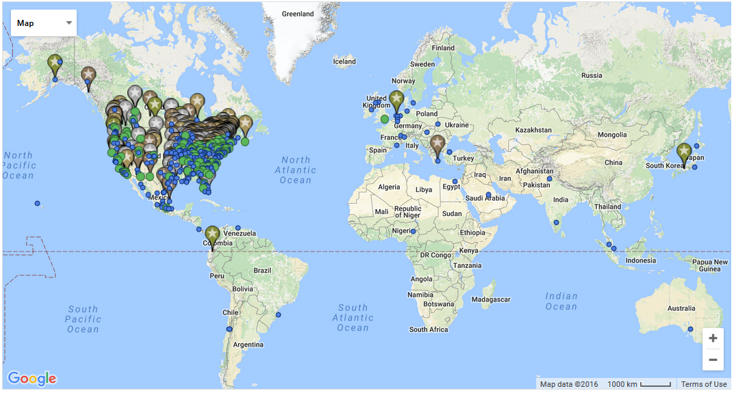
Figure 1 STARS participating institutions
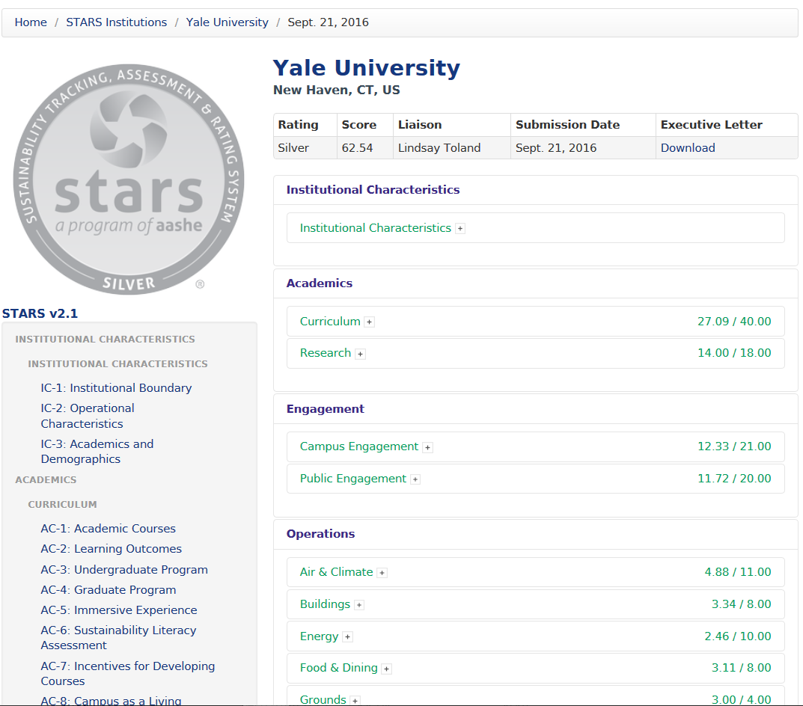
Figure 2 Example Report from STARS for Yale University
The Data gathered by AASHE is made publicly available although the organisations do have the option to opt out of their data being shared [17]. The shared data shows how the institution is performing against all the aspects of the STARS as well as an overall score see Figure 2. The WoW Model again differes from the AASHE system here. External users will only be able to see high level data showing how the organisation is scoring against the Goals in the act but not the underlying data.
AASHE took a year and a half to develop their scoring system and a further year and a half to develop their prototype by which time they already had 37 institutions on board with the project [18]. The AASHE STARS project is a very mature product which has already established its presence in the market. AASHE could easily adapt their existing system to cover the Well being of Future Generations (Wales) Act 2015. However, membership to use the STARS application costs as much as $1400 a year depending on where the institution is from, they also only offer membership to universities and as the Well being of Future Generations (Wales) Act doesnot yet directly cover Universities and is focused on PSB’s the STARS application is not an imminent threat to the WoW Model. Maragakis [14, p. 3] states that the AASHE system “falls short of providing a concrete system for comparing institutions.”. However in the survey undertaken by Maragakis , [14] 95% of institutions want a uniform way of recording and reporting against sustainability. It is suggested that the STARS system could become the uniform rating system for sustainability across higher education. With 88% saying they had heard of STARS and 60% stating that the STARS systme is the ideal system. However, the WoW Model does not just focus on sustainability and the scoring system for the Well being of Future Generations (Wales) Act are set out by the Welsh government.

Quantarc UWTSD Help Desk
Another system analysed was the UWTSD Help Desk supplied by Quantarc ltd. Quantarc is a Small Medium Enterprise (SME) based in Swansea. They provide estates management software to large estates such as universities and hospitals. Quantarc has been developing estates software for twenty years so although it’s only an SME they have lots of experience developing bespoke software for universities. Both Directors of the company come from a University estates background so they have first-hand experience how universities are structured and the day to day running of a university.
The Quantarc system has been developed for UWTSD to help monitor and track issues within the university raised by staff and students. The system is set up to the universities Active Directory accounts allowing staff and students to log in with their existing university login details. This functionality would be nice to have in the WoW Model but is likely out of reach for the first release of the system. It would be a good feature to be added in further development. Where the Quantarc does have similarities with the WoW Model is in the Request Entry system. The Data entry process is split across multiple pages. When the user enters a request they first must choose the Campus to enter a request for (see Figure 3). Depending on the selection the user then gets different options to choose from in the data entry section of the application. This approach could be adopted in the WoW Model as activities as the data entry process is has the potential to be quite large. Another area that is similar is with the user permissions. The Quantarc system is set up for both university staff and students to use, depending on which type of user is logged in different sets of options are displayed. The user role system in the WoW Model is more complex than this as there will be different department users but users will also have different view and write privileges on the different levels of data in the system.
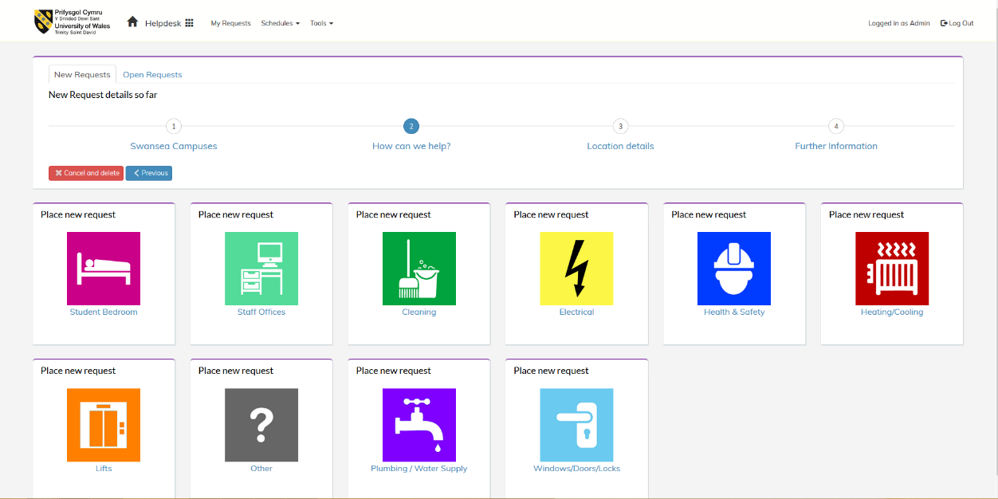
Figure 3 UWTSD Help Desk
There is no evidence to suggest that Quantarc are developing a system for the Well being of Future Generations (Wales) Act 2015. However, they do have a lot of experience in a similar area working with public sector organisations producing bespoke BIS. As the act is still in its infancy it is the projected that the WoW Model will likely be the first system to get to market.

User Interface (UI) Design Patterns
Developing successful software cannot just be measured on the extent of which the software meeting the requirements. For a software system to be truly successful it must incorporate usability practices [19] [20]. As stated by Mahemoff, Johnston , [21] analysing prototypes and fixing defects does not guarantee usability. When designing user interfaces there are many common recurring problems that designers face. As a result of this there have been several UI design patterns created to aid designers to overcome these problems with tries and tested solutions which also incorporate usability. There is no definitive set of UI Design patterns there are many collections and variations from different researchers Deng et al , [22]. Dearden, et al , [23] states that a good collection of design patterns are detailed by Tidwell , [24]. Tidwell proposes a complete set of general Interaction design patterns. However, as stated by Dearden, et al , [23] patterns are not always the best solution to the problem and should be used in context when relevant. The following patterns are a few of Tidwell’s patterns that potentially fit into the context of the case study.

Navigation
A global navigation system is common across most web applications. Tidwell , [24] Global Navigation pattern is a pattern that should be used whenever an application has multiple sections which are needed frequently by the user. Having a global navigation helps increase the user’s confidence in using an application as they can quickly find their way to multiple locations. The global navigation should contain all the high-level Information Architecture links. As stated by Tidwell , [24] “On the Web, a global navigation bar is a well-established convention, so users expect it there”. Applications with a complex tree based hierarchy can also utilise the Breadcrumbs pattern that allow the user to easily work their way back up the tree or branch of the information architecture. As the case study is for a higher education application the information architecture of the application is likely going to be based on the university structure and thus will be split by campus and or faculty. Breadcrumbs will allow the user to quickly determine which section of the system they are currently in and offer the user a way to quickly navigate back up to any location further up the current branch of the application. Tidwell’s , [24] Colour coded sections pattern is useful when an application has many different pages with groups of pages relating to specific section. Each area can then be colour coded to allow the users to quickly determine which section of the application they are currently using. With the case study being split into campus and or faculty the colour coded section pattern could be utilised to differentiate the different faculties or campuses.

Page Layout
The Visual Framework pattern should be used in any complex application Tidwell , [24]. The visual framework pattern states that every page of the application should adopt the same basic layout and style this will help tie all pages of the application together and keep the design consistent with global elements being displayed in the same place and style on every page. This will help to increase the confidence of the user when using the application as they can quickly determine where certain aspects of the application will be. Along with the Visual Framework pattern. Tidwell’s , [24] Centre stage pattern can be utilised to keep the design consistent. The Centre Stage patter is when the main content of the application takes up most of the page and is clearly the primary part of the page. The centre stage pattern should be used by any BIS as the main purpose of a BIS is to convey information to the user. As stated by Tidwell , [24] the Centre Stage pattern should be used when “The page’s primary job is to show coherent information to the user”. For this case study, this will be displaying data relating to the Act and allowing user to enter data relevant to the Act. Using the centre stage pattern will help users to determine where the main content of the application is going to be displayed and help avoid confusion which when dealing with business data is of utmost importance. Tidwell’s , [24] Extras on demand pattern can also be very effective when dealing with complex data. The Extra on demand pattern hides complex interactions from the user unless they are needed.

Actions and Commands
The case study has the potential to have a lot of functionality and this can lead to a confusing and difficult interface. The Button Group pattern will help to reduce confusion by grouping buttons with similar functionality together. Groups of buttons with similar functionality will improve usability of the application by allowing users to quickly find buttons to perform the functionality needed to complete their tasks. When grouping buttons, care must be taken to insure consistency across groups. Buttons must be kept in the same order, kept the same size and position in relation to each other this will help reduce errors particularly from experienced users who will likely perform tasks more quickly and expect buttons to be in similar position to other pages of the application [25]. The Prominent “done” button pattern states that buttons at the end of transactions should be placed in a clear and prominent position Tidwell , [24]. Buttons should also be well labelled so that the buttons functionality is clear. Buttons should be labelled in such a way that the functionality of the button cannot be misinterpreted [26].

Showing Complex Data
As the Case study is going to contain a large amount of data tables. Complex tables should adopt the Row Striping pattern. Tidwell , [24] states that complex tables should use colour to differentiate rows. This pattern also complies with two of the Gestalt principles Continuity and Closure Chang, et al , [27]. Continuity in the design allows the eye to follow the natural path within the design by differentiating the colour of the row the eye will naturally follow the row. Closure by utilising two different colours for the rows the user is able to easily see the different rows in the table Chang, et al , [27]. The Sortable table pattern states that tables should have the ability to be re ordered by different columns in the table. Sorting a table gives the user more control over their data and will give them the ability to discover things from their data that they never would have seen without custom sorting the data Tidwell , [24]. As the app developed for this case study will contain large amounts of data the sortable table pattern should be utilised on tables of data. Displaying data is a big part of the case study to allow users to get a snap shot of their data. The Datatips pattern will provide a means for users to get more information from the graphs or graphics from rollovers Tidwell , [24]. The Datatips pattern is essentially tooltips for data.

Data Input
To aid the Data input there are a few of Tidwell’s , [24] design patterns that can be utilised. The case study is likely going to have a complex form to input the data to be measured against the act. The Fill-in-the-blanks pattern Tidwell , [24] could be utilised to reduce the complexity. Complex forms with traditional inputs and a simple descriptive label can leave the user confused as to what data should be entered. “Fill-in-the-Blanks helps make the interface self-explanatory” Tidwell [24, p. 222]. The Fill-in-the-blanks pattern structures the form in a sentence format with missing sections to filled in with the data input fields. Adding the verbal description of the intention of the data input helps put the field in context and reduce confusion as to what should be entered. The Input hint pattern is again aimed at reducing confusion when entering data into complex forms. The input hint pattern displays a hint for inputs that might be a bit ambiguous at to what data should be entered. Similar to the Input hints pattern the Input Prompt pattern Tidwell , [24] gives an indication of what to enter into an input box. The difference being the Input hints give an example of the type of data to be entered whereas the Input Prompt indicates the type of data to be input. The data entry forms for the app could potentially utilise all three of these design patterns depending on the context of the input field. Not all the inputs of the Apps form will be free text. UWTSD has a set number of faculties these can utilise the Dropdown chooser pattern Tidwell , [24] date input can also utilise this pattern maintain a consistent date format being entered. The Dropdown Chooser pattern helps reduce errors by only allowing the user to select form pre-determined data sets. Tidwell also introduces the Good defaults pattern this pattern can be utilised to pre-populate certain fields to logical values. This pattern could be used to populate the ‘Is Complete’ input to ‘ongoing’ for example because it’s likely that items will be entered before they are complete. To aid data entry Tidwell , [24] also introduces the Same-page error messages pattern which states that error messages should be displayed on the same page as the data input form.

Data Visualisation
Data is crucial for the day to day running of any business and is now being collected on a monumental scale as stated by A. Agrawal “40 zettabytes expected to be created by 2020.” [28]. With huge amount of data comes the potential huge levels of confusion and frustration. From a study undertaken by Forbes 35% feel that information overload leaves them feeling stressed and 65% feel that needing to keep up with all the information is a major concern [29]. Therefore, it is vitally important for businesses to find a way to filter through the data to find the relevant information and reduce the stress and confusion developed from information overload.
A study in 2012 performed by Mindlab showed that displaying data visually reduces Brain activity by 20% [30]. Visualising data isn’t a new concept visual representation using maps and star charts were used as early as the 14th century. Graphical charts and representation of statistical information has been utilised since the early 19th Century [31]. In the early 20th Century advances in data visualisation started to drop off as the passion for data visualisation died down [32][31][33][34] this period being referred to as the “"modern dark ages" of statistical graphics.” Soci et al [32, p. 53]. Mid to late 20th century data visualisation started to grow again. With new developments in displaying data emerging [34][31]. Technological advances also allowed data to be visualised quicker and cheaper [33]. Computers started to be available towards the end of the 20th century [35]. The introduction of computing brought with it advances in image creation as well as data storage [Visualisation in Scientific Computing]. The introduction of computing to data visualisation allowed it to mature into a legitimate research area [31].
The WoW Model application is all about data; entering data and getting some sort of meaningful output from that data. From the research above a good visualisation can go a long way towards this. A good visualisation will also keep the user engaged with the application. However, a poor or complicated visualisation could lead to more frustration in the users than no visualisation at all. This would destroy user experience of the application. For visualising and displaying spatial data GIS are widely accepted and powerful tool Dragićević , [36].

Geographic Information Systems (GIS)
Maps are becoming more and more popular in web applications. Kraak , [37] States that maps are often used as a metaphor to access data. This approach could be adopted in the WoW Model application as the university is split across many campuses in different geographical areas across Wales. The data could be filtered by campus through the GIS interface. Web GI Map Interfaces can be used as an interface over more complex data adopting the Extras on Demand UI Pattern proposed by Tidwell , [24] detailed above. Kraak , [37] states that users expect to be able to interact with a Map interface on the web and the interface is perceived dull of there is not interaction. Web GI interfaces often have zoom and pan functionality when using mobile devices this functionality is needed however also can be a disadvantage to the overall design. Some Web GI Map interfaces when used on a mobile device the user can get stuck in the map interface. If the map interface fills the mobile devices’ screen then there is a potential that when the user tries to move around the web page itself they will instead be panning around the map.

Architecture
There are many options that could be used for the architecture of the WoW Model each with their own advantages and disadvantages. One of the requirements for the case study is that Open Source options must be utilised wherever possible.
For the Server side code for the application there are many options. Two of the most popular server side languages for web applications are PHP: Hypertext Pre-processor (PHP) and Microsoft Active Server Pages ASP [38]. Since the writing of Royappa , [38]2000 ASP has been succeeded by ASP.NET, ASP.NET offers more support for additional languages and provides everything to build enterprise serve side applications [39]. For the purpose of this study the two server side languages being evaluated will be PHP and ASP.NET.
Many ASP.NET frameworks have been made Open Source [40] whereas PHP has been Open Source since its creation. Lawton , [41] states that the LAMP (Linux, Apache, MySQL, and PHP) stack offers lower costs and more flexibility than propriety stacks. ASP.NET typically uses the Microsoft proprietary stack consisting of Windows OS, IIS server and SQL. Apache server is one of the most popular servers used for web applications “running 69.6 percent of Web servers, according to a July 2005 survey by NetCraft” Lawton [41, p. 1]. For this reason; PHP, MySQL and Apache will be the stack used for the development. The AdminLTE Bootstrap theme was adopted for the client side development as it includes a variety of open source JavaScript libraries for visualising data in addition the Google Charts API will be utilised.

Requirements
The Software Requirements Specification (SRS) is crucial to any systems success. Davis, et al , [42] states that the SRS is often poorly defined. Tavolato, et al , [43] references DeMarco stating the over 50% of errors in software are lined to errors in the SRS. Davis, et al , [42] identifies two categories for errors in the SRS knowledge based and specification based errors. Specification errors are caused by poorly specifying the requirements after the requirement has been identified. Knowledge based errors are introduced into the SRS from not knowing the business needs when specifying requirements. “Knowledge based errors can be reduced through prototyping” Davis, et al [42, p. 142]. Zhang , [44] identifies four different methods for requirement elicitation: Conversational, Observational, Analytic and Synthetic.
Conversational methods include interviews, focus groups, workshops, etc. conversational methods are particularly effective when the stake holders have strong domain knowledge regarding the specific problems of the application to be developed. Christel and Kang , [45] states that interviews are the most common method for requirement elicitation. Interviews allow the developer or analyst to gather in depth information from stakeholders Paetsch, et al , [46].
Observational methods require the developer to shadow users in their environment. Zhang , [44] states although observational methods are not as effective as other methods they can be very affective in the early stages of the requirement elicitation. Viller and Sommerville , [47] state that observing users the developer can obtain a deep understanding in the workings of the organisation. Users could be observed when completing the existing spreadsheet relating to the act.
Analytic methods differ from observational and conversational methods as they do not require the developer to meet with stake holders which can be difficult and timely to organise Christel and Kang , [45]. Analytical methods allow the developer to obtain knowledge of specific problems relating to the development. In this case study, analytic methods can be used to analyse the documentation around the act itself.
Synthetic Methods combine all the above methods into a single method Zhang , [44]. Synthetic methods are an interactive process involving both the developer or analyst and stakeholders. Common approaches include storyboards and prototypes Zhang , [44]. Prototypes allow stakeholders to visualise the system at an early stage. Providing stakeholders with prototypes in the requirement elicitation process can get them thinking of the fine details needed in the application producing requirements that may have been otherwise overlooked Zhang , [44]. A study undertaken by Davis, et al , [48] concludes that the use of prototypes does not help in requirement elicitation. However, Davis goes on to state that there is little evidence to back up the hypotheses. As the act is in its infancy there is little domain knowledge on the act within the university. When developing a system to tackle a new domain problem prototyping can increase understanding of the problem from both the developer and stakeholders Zhang , [44]. Christel and Kang , [45] states that when the user has limited experience then prototyping is the recommended method.
Tasks taken from interviews and observations can be turned into use cases for the new system Nuseibeh and Easterbrook , [49]. Use cases can be derived from the requirement elicitation stage and then shape the design process Jacobson , [50]. Use cases are generally used for two purposes wither to create user stories or to build the requirements Cockburn , [51]. Jacobson , [52] first introduced the use case in 1992. Since their original creation there have been many different modification on the original concept. Cockburn , [51] introduces a semi-formal approach based on the original model proposed by Jacobson , [52]. Cockburn’s , [51] semi-formal approach consists of Actors, Goals, Scenarios and Conditions. Actors can be a user of the system the system itself or another system. Goals are the primary objective of a use case, all scenarios in the use case should be related to the same goal. Scenarios provide details of the actions needed to complete the scenario. To keep Use cases concise scenarios can utilise further use cases or extensions. The Conditions dictate which scenario will be used depending on the state. Then finally there is an outcome where the goal is either achieved or fails, when a goal fails there is often a fall-back use case to perform another action. This approach allows for simpler use case documentation while retaining the formal underpinning Cockburn , [51].

Testing
With the exponential growth in web technologies testing web applications has never been more important. As stated by Paolo Tonella et al. [53, p. 1] “Testing is the most widely used and effective approach to ensure quality and dependability of the software, including web applications.”. Brooks , [54] stated in 1975 that fifty percent of development time should be assigned to testing. However, a lot of development teams skip or at least rush testing. This can be for a number of different reasons Parveen, et al. , [55] states that one of the elements preventing comprehensive testing is the “complexity of managing all of the test cases for large-scale projects” Parveen, et al. [55, p. 1]. Developers also tend to underestimate the amount of testing that should be undertaken as stated by Brooks “we usually expect the number of bugs to be smaller than it turns out to be. Therefore, testing is usually the most miss-scheduled part of programming.” Brooks [54, pp. 19–20]. Software testing is a huge task in its self a lot of developers feel that the amount of time needed to sufficiently test an application out ways any benefits gained [56]. From the study conducted by Beller et al. , [55] concluded that 85% of the developers in the study performed tests. However, they only performed tests on 15% of their sessions. This concluded that “developers do not test as much as they believe they do” Beller [57, p. 188]. Testing is one of the most important element to successful software. However, testing is rarely utilised to the level at which it should be [55].

Summary
One of the key findings from the research is that dashboards are the common trend for BIS systems to display data. It was also concluded that usability and user interface design are paramount to the success of any BIS. As a result of this the development of application will adopt usability tests and validation throughout the development lifecycle.

Research Methodology
To evaluate the effectiveness of the development a research methodology will be adopted this will give structure to the research as well as allowing others to replicate the case study. A common approach to developing a research methodology is ‘The Research Onion’ developed by Saunders, et al , [58]. The onion splits research into five sections: Philosophy, Approach, Strategy, Time and Data Collection Method. Its common practice to choose one item per segment of the onion. However, Knox and Karl , [59] propose that all elements in the inner segments of the onion can be mixed as long as only one research philosophy is chosen. Saunders and Tosey , [60] proposed a revision of the onion design in 2011 show in Figure 4 the main modification in this revision is the second segment now named ‘Methodical Choice’ which now proposes approaches that combine quantitative and qualitative methods. The revised version of the onion will be used to develop the methodology for this case study.

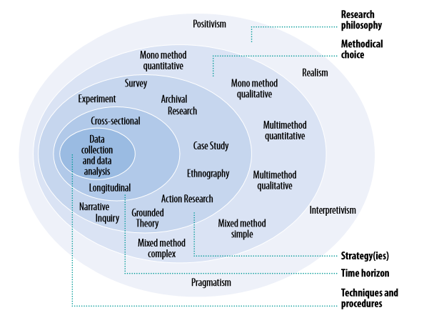
Figure 4 The Research Onion Saunders and Tosey , [60]

Research Philosophy
The research philosophy chosen for the case study will be ‘Interpretivism’.

Methodical Choice
The ‘Mixed method simple’ approach will be adopted because both Quantitative and Qualitative data will be collected and analysed. The Qualitative data will not be analysed Quantitively so the complex method will not be used.

Strategies
Lau , [61] states that Action Research involves a change focused iterative process. The purpose BIS being developed for the case study is to replace the existing procedure involving data collection through spreadsheets; this would involve an organisational change within the university. The ‘Action Research’ strategy will be used involving active practitioners both internal and external to the university. Action research is an iterative process involving four stages plan, action, observation and reflection Boud , [62]. The ‘Action Research’ strategy will be backed up using surveys and interviews.

Time Horizon
A study undertaken by the Canadian Institute for Work and Health , [63] states that Longitudinal study the design should be driven by the research. Longitudinal time frame is often combines with the ‘Action Research’ strategy Saunders and Tosey , [60]. The study will be undertaken in a ‘Longitudinal’ manner with the research going on throughout the development process meaning research will be undertaken at different snap shots of the development lifecycle.

Techniques and Procedures
In this case study, the early stages of the action research strategy will utilise rapid prototype development to determine the requirements of the application. The iterative process will involve designing a prototype of the application, demo the prototype to public service board members, collect feedback and comments, analyse feedback. After each stage the prototype will be modified to include changes decided on from the previous stage and the process will be repeated.
After the initial stages the application will be given to a select few people to use under observation followed by an informal interview to gather feedback on the application.
The application will then be demonstrated in the universities Sustainability committee meeting to university sustainability members across all campuses. The sustainability members are the members of staff currently using the spreadsheet that the application is aimed at replacing and will be the pilot user group of the finished application.
After the demo, all sustainability members will be given the opportunity to attend one on one interviews with the developer for a personal demo and a chance to interact with the application under observation where their feedback and comments will be collected.
The application will then also be tested with a usability task based evaluation where the user will be given a specific task to complete under observation this test will also utilise an eye tracking device and will be followed up with a questionnaire to collect feedback.
Eye tracking is an effective method for evaluating Human Computer Interaction (HCI) [64]. Eye Tracking offers a lot of data to the tester to determine usability and can offer an important tool in usability evaluation [65]. By analysing fixation points, gaze and scan path testers can get a clear indication of issues in the design.

Questionnaire
The questionnaire developed has been designed to cover both usability and user experience (UX) of the app (See Appendix 01.). To cover the usability section of the questionnaire the adopts the System Usability Scale (SUS) which has been proven to be an effective method of evaluating usability [66] [67]. Created in 1986 by John Brooke SUS has been utilised many times and referenced in over 1300 articles and is now the industry standard method for measuring usability [68]. UX combines both Hedonic and pragmatic aspects to the evaluation Rauschenberger, et al , [69]. Hedonic aspects are subjective and thus harder to quantify Hartson, et al , [70]. To cover UX The User Experience Questionnaire (UEQ) will be adopted developed by Laugwitz, et al , [71]. Although not the industry standard method the UEQ is an effective tool for measuring both usability and UX of any interactive system [72] and has been cited in more than 20 journals. The strategy of combining the SUS and UEQ to evaluate both usability and UX was also adopted by Santoso, et al , [73] with positive results regarding the evaluation technique.

Development Methodology

User Centred Design (UCD)
The Key principle of UCD is to get the User involved with the design process as early as possible. Designing software without the user’s involvement can lead to the user becoming frustrated and angry with the software McLoone, et al , [74]. UCD is an iterative process consisting of initial prototypes which are put under usability testing involving users of the system. The feedback and comments are then used to make operative changes to the prototypes until a final design is decided upon which is then passed to the development team. Involving the users form an early stage and having them involved throughout the development process helps give stakeholders realistic representations of timescales and also gives them a sense of ownership with the final product as they have been fully involved in the development [75]. One of the main issues with usability testing is that it is very expensive and time consuming compared to other testing techniques.

Agile Software Development (Agile)
Agile methodology is one of the most common methodologies used in software development. Agile uses prototypes and code iterations to develop software with minimal documentation [76]. One of the key elements of Agile development is involving the stakeholders in the development process [77]. Agile offers a rapid and responsive methodology by emphasising rapid delivery of working iterations of functionality [77]. Extreme Programming (XP) possibly the most popular Agile framework [76] introduced User Stories for the process of requirement elicitation. User stories are similar to the scenarios with use cases McInerney and Maurer , [78]. User stories are not as complex ae use cases Landhäußer , [79] this makes them easier for non-technical stakeholders to grasp. A user story describes a desired goal to be achieved by a user. User Stories are often the only documentation regarding requirements in agile methodologies.

Chosen Methodology
Choosing a development methodology is important and can aid development as well as allowing other developers to understand the development process. However, as stated by Zakerifard and Ramsin [80, p. 434] “there is no general-purpose methodology that suits every project situation.”. The development methodology adopted for the case study will combine elements of both Agile and UCD. Both methodologies offer iterative user focused techniques and can be incorporated into the Action Research methodology. The findings from a study conducted by Fox, et al , [81] found that the combination of Agile and UCD has worked successfully in a number of cases in industry.

Requirements
The case study started with a very limited set of requirements this is largely due to the fact that the act is in its infancy so there has been little research done in the area. The starting requirements were simply that the app must incorporate UWTSD data mapped against the act and that the application should be developed using open source software.

Requirements Elicitation
The first step to gather requirements was to research the act itself. After thorough research into the act it was decided that the PI’s could be mapped to the goals, then each item entered into the application could be mapped to a set of PIs’ which in turn would populate a percentage of the goals. It was felt that this method would give a more accurate representation than the current method where activities are mapped against all goals with a simple 1 or 0 depending on whether the act meets the goal. See Appendix 02. for the Existing Spreadsheet.
The next step was to meet with members of the sustainability committee. In this informal meeting, it was clear that one of the issues with the current method is that there is no centralised point of information. Most of the information needed is already stored in different databases within the university however it can be difficult to know where the data is stored. Sustainability members fill in the spreadsheet from information that they know about and would not know where to find additional information needed. Another problem noticed with the existing system is that the spreadsheets would be re-used year after year. The existing spreadsheet contains pivot charts and graphs however, due to the way the spreadsheets have been re-used a lot of the charts formulas are no longer correct so the charts and graphs no longer accurately represent the data and can be misleading.
Stakeholders were observed while entering data into the existing spreadsheet. It was clear from the observations that the spreadsheet was confusing. The observation showed that the users just copied old data and modified specific cells to update the data. This could lead to incorrect data as each item should be entered as an independent item. Analysing the existing data (snap shot in Appendix 02.) backs up the premise that the spreadsheet is confusing as data in the goal’s columns should be 1 or 0 indicating yes or no however some rows have other data in these cells.
The developer then investigated the option of mining existing data with the intension of building a data warehouse for the WoW Model. This would provide a centralised point of information within the application. After the meeting with the IT department it was concluded that the task of data mining all the existing tables (Appendix 03.) to analyse the data and determine the data needed for the warehouse and subsequently develop the application would be un-achievable in the timeframe of the project. It was decided that a proof of concept application would be developed using a relational database before undertaking the data analyses needed to create the data warehouse.

Prototype design
From the initial research into the act, interviews and observations some initial colour prototypes were developed. The initial prototype Figure 4 as developed for two primary reasons: to investigate data visualisation techniques using open source JavaScript chart libraries; and to be demonstrated to stakeholders and potential users to gather feedback for requirements elicitation. The prototype was demonstrated to obtain feedback on the designs as well as to get potential users thinking about what their business needs are from the application. As stated earlier in the
Research and Review of Literature section of this document. Prototypes are an effective way to gather and validate requirements. The initial design was developed with a different data visualisation for each of the WoW. As the decision on how to collect and display data on the WoW had not been made at this early stage.
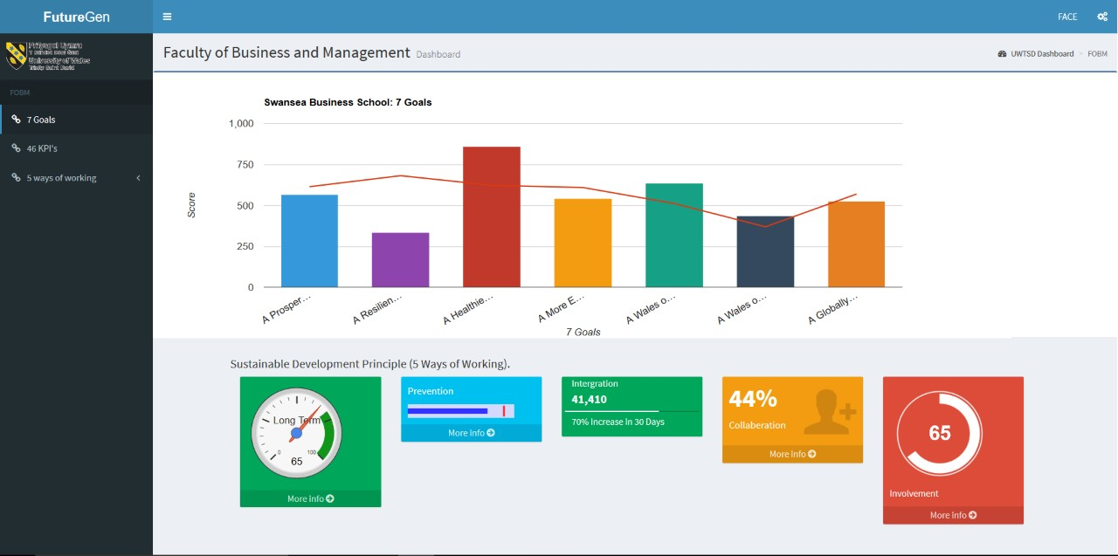
Figure 5 Initial Dashboard Prototype
Of the five different designs for the WoW the dial design was received very well by all of the PSB’s. The original dial design in Figure 5 was developed to show a percentage with a target area the main stakeholders of the project also liked this idea particularly if it could be developed to incorporate a traffic light system rather than just a target area. Another item raised from the PSB’s was the need to show their geographic locations in the application. This was of interest from councils and National parks organisations.
The next iteration of the prototype development incorporated the GIS Figure 6. As Google charts had been used for the original combo chart for the goals the Google Map API was utilised for the GIS display. This is the same API that was used in the The Association for the Advancement of Sustainability in Higher Education system discussed in the Existing MIS for higher education section.
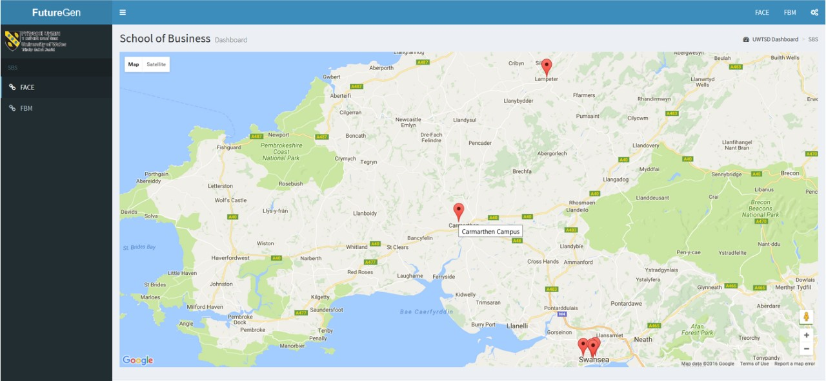
Figure 6 Initial GIS prototype
One of the most important elements brought up from the demo of this iteration of prototype to the PSB’s was that collaboration was a major issue. The south wales fire department stated that they had recently set up an event very like an event the police set up at a similar time in the year. They stated that if they had, had a system to inform them of the other’s activity they could have combined resources and joined forces in one event. To achieve this level of collaboration data for all PSB’s would need to be stored in a central location or accessed from a central application. This would likely cause issues with data protection and PSB members stated they would each want to host their own data internally. An alternate approach to achieve his would be to allow external members access to certain levels of data. This approach was favoured by the PSB’s. It was also mentioned that quantifying the WoW could lead to misrepresentation of results.
The next iteration of prototype removed the WoW dial visualisation as at this stage the WoW data collection method has not been decided upon and from comments on the previous prototype it was decided that it should be removed until the data collection method for the WoW was finalised. This iteration also incorporated the data entry form Figure 7. Another additional element added to this prototype iteration was an opportunities section. This came from the comments from the police and fire brigade regarding collaboration. The idea of the opportunities would be for users to add opportunities and comments on collaboration directly into the system.
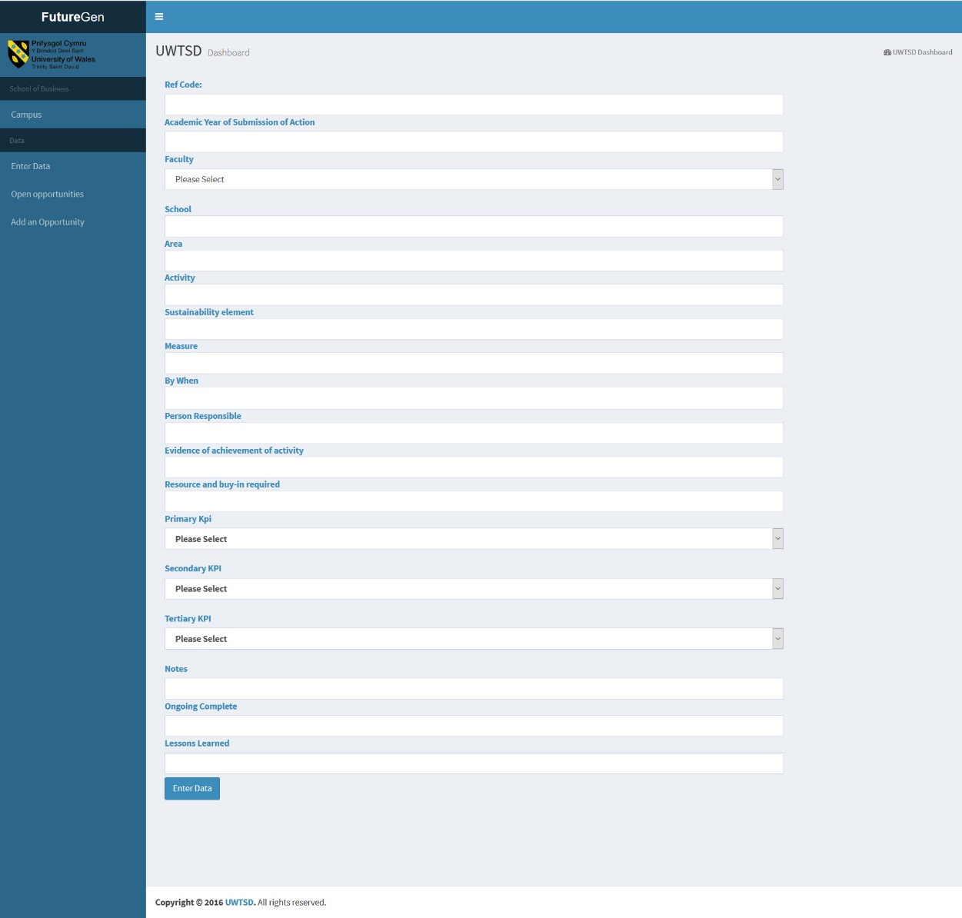
Figure 7 Initial Data Entry Prototype
From the demo of this iteration Howard Davies (Head of Corporate Planning Natural Resources Wales) Stated “There is a danger that by making the link too firm (activity definitely links to outcome) then reported results might give a false or misleading sense of comfort that progress is being made but in terms of change in outcome it’s not.”. Scoring each activity on the PI’s linked to each goal should limit the misrepresentation of data as activities will score a percentage of a goal depending on the number of PI’s met. This will also allow activities to hit multiple goals when the PI is represented in different goals. However, there may be issues when activities are only partially complete. Partial completion of an activity does not necessarily collate to partial completion of the goal.

Use Case Development
From the research carried out into the act, the interviews and observations on the existing data collection method and the first stages of the action research strategy enough information was gathered to start development of Use Cases from which the requirement will be identified.

User Stories
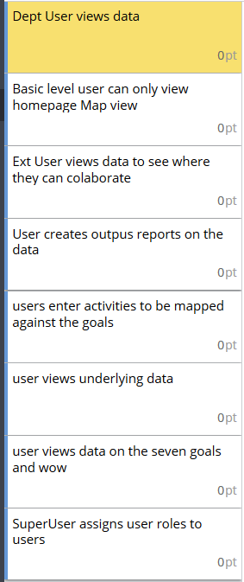
Although user stories are not traditionally part of use case design they were adopted here because the informal approach of user stories allowed for rapid generation and development of ideas. The user stories will be used as scenarios to base use cases around. User stories are developed collaboratively with stakeholders and developers because of the difficulties in organising meetings with all stakeholders an online tool was utilised to collate the user stories (https://www.targetprocess.com/).
An informal meeting with some of the key stakeholders was organised to investigate the functionality of the WoW Model. In this session, the feedback and information gathered during the requirements elicitation stage was analysed to create user stories to generate key tasks.
The User stories Figure 8 generated in this session did not cover all the tasks for the system. This is typical of user stories as traditionally in XP User Stories would be added to throughout the development lifecycle. Gathering User Stories throughout the development lifecycle was not possible due to the difficulty in organising meetings with key stakeholders along and the online resource not being fully utilised by stakeholders. As a result of this it was decided the user stories would be mapped to use cases rather than design implementation. The user stories developed in the session did provide some of the basic functionality needed from the application. More detail on the user stories can be seen in Appendix 04.
Figure 8 User Stories

Actors
The requirement elicitation process identified a few key roles. The comments from the police and fire brigade made it clear that external users would need access to the system. Stakeholders internal to the university stated that they would high level users who could set targets, lower level users to enter data and students who would only have read privileges. All PSB members were concerned about data protection and stated they wanted control over which users could see data. From all the information gathered the following user roles were developed which will be used as actors in the use case design.

User Role: Dept. Head
Not necessarily particularly computer literate but likely highly educated. Will use the application intensely generally using the application to compile reports from information not necessarily entering any data. The Dept. Head will have full access to their department’s data at all levels but only view access to over departments. Dept. Heads will likely have large workloads and limited time to spend on tasks. Dept. Head will likely want to compile reports from the application and know what information they want to get out of the system.

User Role: External User
External users will come from all levels of technical background and age groups. External users will only have limited view only privileges and of only top level data. External users will likely want to do one of two tasks either view how the organisation is performing possibly to compare against their own organisation. Or they will have an idea of an opportunity that the two organisations can collaborate to help boost one or both organisations population indicators to meet goals.

User Role: Department User
Likely very computer literate. Department User will likely not be interested in other departments data and just want to enter and view the data relevant to their department. Department users will only have access to their departments data and not all Department Users will have write privileges.

User Role: Super User
Super users will likely be highly computer literate. Super users will not necessarily have any interest in the data being displayed. One task a Super user would perform would be granting access to different levels of the application. For example, giving a Dept. head user view access to another department data, or granting write privileges to a Department User to their department. Super Users will be the only users able to set targets on departments goals. Possibly there would need to be a Super User for each dept./possibly one Super user who will maintain the whole system.

User Role: Casual User (student)
An internal casual user will have varied levels of computer literacy, education and demographic groups. Internal casual users will only have read privileges and only to top level data they will not have access to any detailed or sensitive data. They will likely not have access to view the opportunities but may have access to enter opportunities.

User Role: System Administrator
System Admin user will be highly computer literate. The System Admin user will be tasked with adding users, adding user privileges to users. The System Admin user may also have access to change the goals, WoW and KPI’s. They will have full access to change and modify all system level data.

Use Cases
The user stories were used as scenarios to identify some key use cases. The User stories did not cover all the functionality needed so further analyses on the feedback from the demos and interviews was utilised to develop further use cases. Table 1 shows an index of the use cases discovered during this stage Appendix 05. shows the use cases in more detail. Cockburn’s , [51] semi-formal approach to use case development was adopted in the creation of the use cases.

Number | Name | Goal
01 | Login | Authenticate the user and determine their roles.
02 | Register User | Register an account for the user.
03 | Data Entry | Enter Data into the system
04 | Add Opportunities | Add opportunities to the database
05 | View Opportunities | View current opportunities in the system.
06 | Import CSV file | Bulk import data into the database from Excel files.
07 | Export CSV file | Export Data to a CSV file so the data can be reported on through Excel.
08 | Set Goal Targets | User sets targets on the Goals
09 | View Data | The User wants to view the underlying data.
10 | Dashboard View | User views a summary of how a department is performing.
11 | Add User Privileges | Add additional Read/Write Privileges to Users
12 | Revoke User Privileges | Remove privileges from specific User
13 | Add User | Add a new user to the system.
14 | Drop User | Remove user from the system.
Table 1 Use Case Index

Requirements Specification
A detailed requirement specification document was written from the use cases and information gathered. Key stakeholders then reviewed the document with the developer to determine priorities for the first release see Appendix 06. for the software requirements specification. Writing a detailed SRS goes against the Agile Methodology however does fit into the UCD methodology. Using a SRS will ease the development process when there is only a single developer.

Design and implementation
Once the SRS had been signed off developed development could start. As the prototypes had been developed using agile techniques and implementing code iterations throughout the rapid prototyping some functionality was already implemented at this stage. However, the system was still using hard coded data in JSON (JavaScript Object Notation) files for all the elements within the design.

Database Design
The database was designed combining both the fields from the existing spreadsheet and the tables needed to link the data to the goals. The database was developed using third normal form (3NF) to limit data duplication. Figure 9 shows the initial database schema developed.
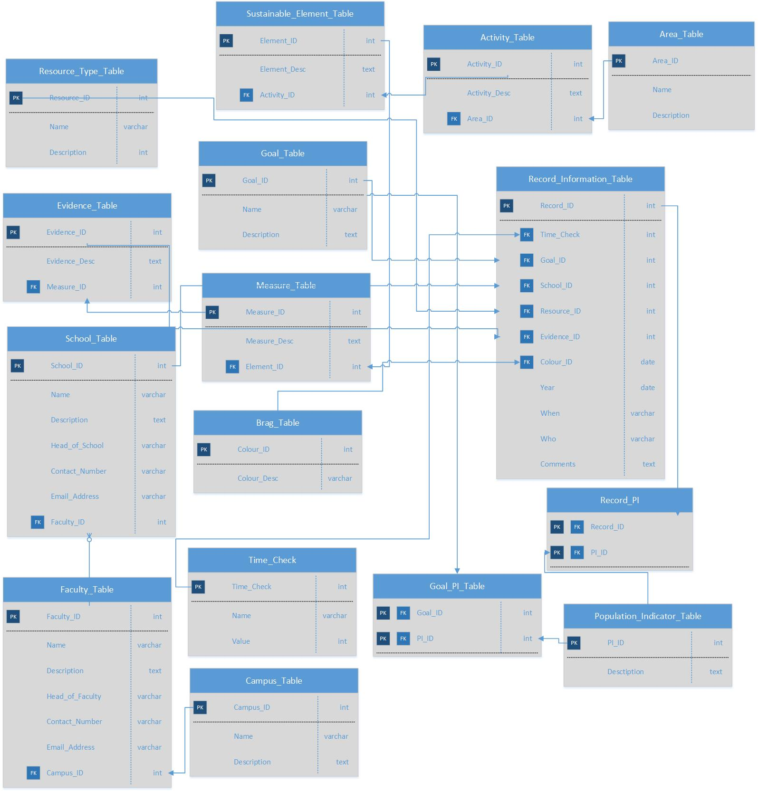
Figure 9 Initial Schema

Development
The application has been developed adopting both Agile and UCD Methodologies. A full agile methodology is difficult to adopt with just a single developer. Both methodologies require collaboration with the customer throughout the prototype and development stages.
The initial pilot application was developed in time to be demonstrated at the annual sustainability meeting. The meeting attendees included key internal stakeholders of the application as well as the pilot user group for the system. The sustainability committee members form all campuses and departments of the university. Demonstrating the pilot application at this point provided a good opportunity to gather feedback on the application as there would be many users and stakeholders attending the meeting.

UI Design
The layout of the application adopts a visual framework to keep the design consistent with a centre stage where the content will change depending on the current page being viewed. The use of the bootstrap framework also aided in the consistency of the design. The navigation of the application a global navigation system was developed the main menu bar was implemented on the left of the screen where users can access different campuses as well as view and input data. The decision was made to display the main navigation on the left so the top bar could be used for additional navigation links the navigation on the top bar would be utilised to navigate between faculties within the chosen campus. The top navigation would therefore change depending on the chosen campus. The application has a hierarchal information architecture so breadcrumbs were implemented to aid users in navigation back up the tree as well as allowing them to ascertain which section of the application they are currently viewing. Each Campus also utilises colour coded section to again to ensure the user knows which section they are currently viewing. The navigation has also been developed adopting a mobile first approach to help achieve this a the AdminLTE bootstrap framework was adopted. For the GIS, the google maps API was utilised although this would require a small license fee there are many advantages from utilising the API. The visualisation of the goal data combines two data visualisation techniques in a single chart. This design was chosen to display both the value and the data on a single chart. This gives the user a clear indication of the current progress on each goal.

Development
To populate the google chart widgets AJAX functions were used to return JSON formatted string from the database to populate the charts. A PHP file was used to query the database and return a JSON file which was then passed to a JavaScript function to populate the charts. When dealing with the Google Charts Table the JSON format was more difficult to structure. The Google Charts Table was used as it included many of Tidwell’s , [24] UI design patterns. To structure the JSON for the Google Charts Table two Arrays had to be used one for the column headings and one for rows. Each containing associate Arrays of data the snippet below shows an example of the code used to populate the table although not actual implementation code for clarity.
<?php
include "../Connection.php";
$stmt = $dbh->prepare([query]);
$stmt->execute();
$table = array();
$table['cols'] = array(
array('label' => 'Record ID', 'type' => 'string')
);
$rows = array();
while ($record = $stmt->fetch())
{
$temp = array();
// each column needs to have data inserted via the $temp array
$temp[] = array('v' => $record['Key']);
// insert the temp array into $rows
$rows[] = array('c' => $temp);
}
$table['rows'] = $rows;
$jsonTable = json_encode($table);
header('Cache-Control: no-cache, must-revalidate');
header('Content-type: application/json');
echo $jsonTable;
?>

One issue that occurred during the development of the application was with implementation of the import from CSV file. There was an error which was difficult and time consuming to debug. The error was Unicode null characters being imported into the database. The code snippet below shows the regular expression that was used to resolve the issue. The code snippet shows part of the while loop used. The loop iterates through all the items in the CSV file assigning them to the $filesop variable. The PHP preg_replace function is then used to replace any Unicode null characters. In later testing it was also discovered that the same issue occurs if the user copy and pastes data into an input where the copied data contains a Unicode null character.
while(($filesop = fgetcsv($handle, 1000, ",")) !== false)
{
$regex = <<<'END'
/
(
(?: [\x00-\x7F] # single-byte sequences 0xxxxxxx
| [\xC0-\xDF][\x80-\xBF] # double-byte sequences 110xxxxx 10xxxxxx
| [\xE0-\xEF][\x80-\xBF]{2} # triple-byte sequences 1110xxxx 10xxxxxx * 2
| [\xF0-\xF7][\x80-\xBF]{3} # quadruple-byte sequence 11110xxx 10xxxxxx * 3
){1,100} # ...one or more times
)
| . # anything else
/x
END;
$filesop = preg_replace($regex, '$1', $filesop);

Design Validation
The application was demonstrated at the Sustainability meeting this was the first demo with an integrated database. The way the database had been designed allowed for the existing structure of the departments data to be entered directly into the system. Most of the data had been imported prior to the demo using the CSV import implemented.
The feedback from the demo was very positive and all sustainability members agreed that the system would simplify their data entry and reporting tasks. Some additional points were raised:
- Information on the Act is needed.
- Users wanted Reminders when items are nearing completion date and not marked as complete.
- Summary graphs on the GIS map icons.
- Inline edit on table rows should be added.
From a one on one meeting with a key stakeholder Dr Stephen Hole the following comments were made
- The Map Should be zoomed more into Wales to make the display clearer.
- Year of submission should be a drop down not free text.
- Input fields too wide multi columns should be used.
- School and Faculty Drop down should have name as well as abbreviation.
- Option for entering recursive events.
- Person responsible pre-populated to User entering data.
- PI selection confusing.
From the one on one interview with Tyra Oseng-Rees one of the key stakeholders a few points were raised. Firstly, she did not see the need for the GIS system as the universities structure is not split by location. For example, one department may span many sites and campuses. This issue occurred because although the application being developed is for internal use within the university it is being built with the potential of rolling the system out to PSB’s in the future and a GIS system was a desired feature for many PSB members. The existing spreadsheet also did not accommodate for splitting the data across campus. Tayra also raised issues with the existing spreadsheet which had now been implemented into the system. Tayra did not want to insert her departments data by school but by teaching programme. Tayra also suggested that the WoW could be quantified by simply asking if each task meets the WoW and if the activity does meet the WoW additional info could be supplied.

Stakeholder Meeting
All the data form feedback the developer received was collated and taken to a meeting with the key stakeholders. This was a very lengthy meeting where all the feedback and information gathered was discussed in detail. This meeting resulted in many changes in the requirements to the application. There were two major issues raised firstly the universities IT department did not support the open source PHP MySQL stack that the system had been built on but only supported a Microsoft stack consisting of IIS and SQL. After some research and time spent on the server the developer was able to get MySQL and PHP running on the IIS server using PHP Web PI. It was also decided that the login and user system would be handled via active directory this was outside the scope of the case study and would not be developed within the deadline. The other major change was a complete database change. After the review of the system and feedback it was concluded that the original spreadsheet being used did not collect the data that was needed. Changing the database structure at this late change in the project meant it would not be possible to complete all the requirements by the April deadline to start training the sustainability pilot users. With the database change a lot of already implemented functionality would be lost and at such a late date in the development lifecycle would not be re implemented by the deadline. This resulted in a change of requirement priorities to keep the system in track and on deadline. The Priorities became implement the new database for Campus level allowing users to enter and view data through the dashboard and tables.

Usability Testing
After this meeting the new database was designed from a new spreadsheet provided from the stakeholders. The WoW implementation was also implemented as suggested by Tayra. Usability tests were then conducted on the system these tests utilised a task based test where users were given data to enter into the system and then export the data to an excel file. The test was run under observation while also utilising an eye tracking device test subjects were then also given the usability questionnaire to complete.
The attention map Figure 10 from all participants from the usability test shows that the Users viewed the application in the F Pattern this suggests that users were able to process the data quickly [82].
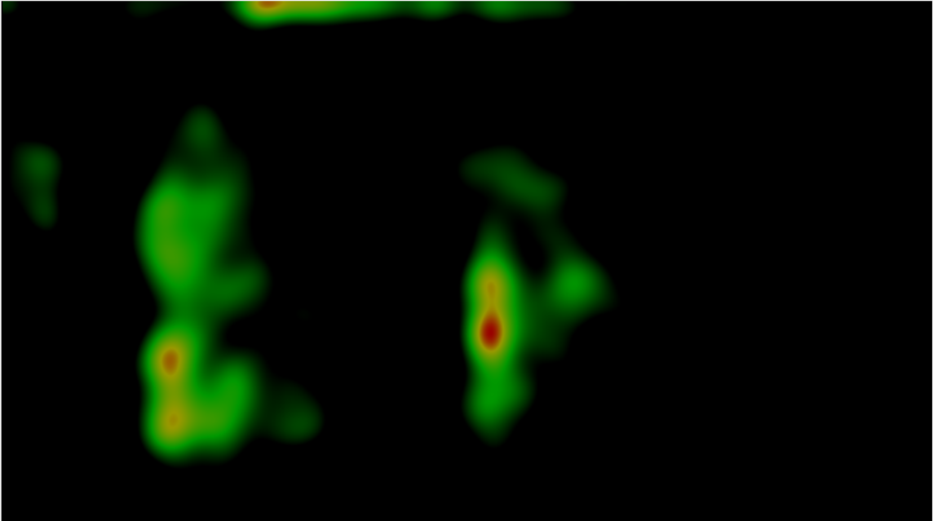
Figure 10 Attention Map
From the observing the test subject performing the task it was clear the data input page is difficult to use. This backs up previous comments from Dr Stephen Hole that the PI selection was confusing. To help reduce confusion the data input could be split across multiple pages. This design would be similar to the work produced by Quantarc discussed in the Existing MIS for higher education section. The complications in the form came from the Goal selection because the user must select items from the PI’s that are linked to the goal the form quickly becomes over whelming for the user with large amounts of data to filter through. Although the Hairline UI pattern has been adopted to break up the elements the sheer amount of data is still overwhelming and difficult for the user to process. This is again backed up by the eye tracking analyses, analysing the number of fixation points during the data entry stage and the gaze path also becomes scattered and no longer follows the F pattern Figure 11.
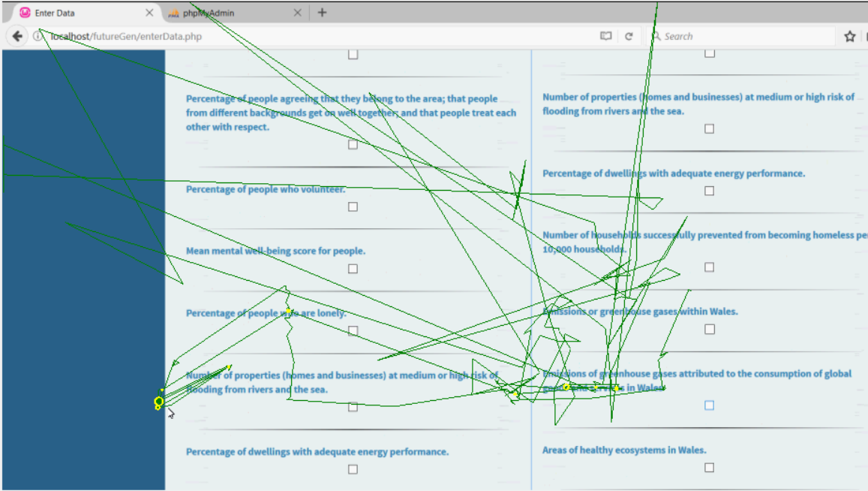
Figure 11 Scan Path
Other areas where the user has difficulty using the application were finding where to export data from. The navigation link to export data on the main navigation is labelled View Data. This was confusing for many users as they did not make the association with viewing and exporting data. To make this clearer and improve User experience of the application the button label should be re-designed to be clearer. Another element of the data input that was difficult for the user was the WoW entry some users did not understand the data entry for this section. The WoW section could be improved by implementing the Fill-in-the-blanks pattern developed by Tidwell , [24]. The input could be structured in a conversational way to make the intent clearer i.e. ‘This activity [does/does not] include Collaborative elements.’. The drop downs containing the resources and Implications were also confusing for two reasons. Some users did not instinctively think of using ‘ctrl click’ to select multiple items Tidwell’s , [24] Input Prompt pattern could be used to indicate to the user the functionality of the select. The labelling for the add item message box could also be improved as some users took some time to work the functionality out when they had a missing element. Although the time was negligible and most users found the functionality quickly there is some ambiguity with the input method so user experience could be improved here.
The Results from qualitative data form the questionnaire again backed up the premise that the data input was to complex and confusing with many users commenting on the form that the process was confusing and difficult particularly the PI selection.
The Results from the SUS Score indicate a positive result for all aspects. The SUS questions alternate between positive and negative questions to try and reduce inconsistency in results if a user fills in five for every question for example. With the results from the qualitative feedback, eye tracking results and expert review question 2 and 8 contradict the results as they have been scored positively.

Chart 1 Mean SUS Score
The same anomaly is found in the analysis of the UEQ Evaluation. From the comments made and the analysis an assumption could be made that the efficiency would be low as so many users found the data entry confusing and the research suggests that the design of the data input form could be significantly improved to increase the usability and user experience of the data input. However, from the analysis of the quantified results the system was above average in these areas. The standard deviation depicted by the error bar is fairly small indicating that the results were consistent across all test subjects.

Chart 2 UEQ Score

Evaluation
The overall aim of the project was met although the finished system does not have much of the required functionality this is due to the changing of requirements and much of the previously developed functionality no longer worked after the change of the database. Had the database change not occurred then the finished system would be much more feature rich. Most of the objectives were met successfully however again due to the changing requirements the code was not fully tested Unit Tests would have been advantageous to the project to ensure that the code written successfully completes the task that its created to solve. The time constraints on the project were un-realistic for the scale of the system. Mainly since the stakeholders only had vague view of what they needed and the information provided for the database was incorrect. This led to ever changing requirements and requirement creep although this is typical for a large-scale application development a fully working application was unachievable in the time scale. However that being said the result is usable and is being used within the university as a training aid for the sustainability committee. Although the application is not fully complete the system furthered the universities goal of analysing data and reporting against the act. Had the case study not been undertaken the flaws in the existing spreadsheet method would likely not have been discovered for some time. Another issue that disrupted the development process was the changing of key stakeholders in the middle of the project. This change resulted in the business needs for the application changing.
Some interesting results were found the eye tracking and qualitative analyses of the system backed up the usability research of the system. However, SUS data which is the industry standard for evaluating usability and the UEQ analyses showed conflicting results. This may be due to the size of the sample being to small however from this study it does indicate that questionnaires are not as effective for evaluating usability and UX as interviews, observations and eye movement analysis.
Combining the two methodologies proved an effective method for development and resulted in a very effective requirement elicitation process. However, if this study was to be undertaken again more time would need to be allocated due to the scope of the application.
Alternatively, the development could be split into two case studies. One study fully utilising the UCD methodology producing a highly-detailed SRS along with UML (Unified Modelling Language) and a detailed set of Use Cases. The second study could then adopt the Waterfall Methodology and produce a fully working application.

Conclusion & Recommendation
To summarise the case study first the act itself was researched and then BIS’s were researched to gain an underlying knowledge in the application.
Then Iterative rapid prototyping was undertaken adopting techniques from UCD. Where each prototype was developed and then evaluated through interviews and questionnaires. The prototyping stage then adopted agile methods of implementing code iterations in the prototype development while still utilising the UCD techniques if evaluation. This led to in-depth analysis and feedback which was used to base the requirements. Agile user stories were then utilised to obtain key scenarios form the stakeholders. As User Story generation is an iterative process between Developer and Stakeholders this method was not very successful in this study. This resulted in use cases being developed which was far more successful approach in this study as the developer could analyse all the comment and feedback from the requirement elicitation process to develop the use cases which led on to the requirement specification.
The development process was also affective and due to the adoption if the UCD approach it was clear that stakeholders felt ownership with the application being involved throughout the development lifecycle. Although the change in the database scheme did set back the development its felt the development was still successful and has proved that the application can not only be a successful method for recording and analysing UWTSD data against the act but far surpasses the existing methods.
To complete the system further research would need to be complete into Active Directory. As one of the findings from the study is that Active Directory was a must have requirement. Again, this was only discovered late in the development process so there was insufficient time to cover this in this case study. As Active directory is a Microsoft service and the UWTSD IT department only support systems developed on a Microsoft proprietary stack. It is suggested that the system be re developed using ASP.NET technologies. This case study would provide the developer of the updated ASP.NET version most of the information required for this development.

Reflection
Conducting this case study gave in-depth insight into the whole development process in a real-world scenario. One of the main lessons learned from the case study is the potential for large scale project to become unwieldly. To help counteract this working as a single developer and not as part of an Agile team detailed requirements showed be documented and signed off by stakeholders as early as possible. However, if this approach had been used then one of the key findings the change in business needs resulting in a change of database would likely not have been discovered until completion. This would result in an expensive re-write of the system instead of furthering the development.
One of the main realisations from this study is the importance of thorough research undertaken before development starts. It’s felt that this was not achieved in this study to keep up with the demanding deadlines of a real-world application. The research undertaken into the research methodology was also beneficial to the developer. The benefits of adopting tried and tested resarch methods was made clear through this case study.
Another discovery from the case study is the difficulty in modifying precrural code and the benefits of OOP (Object Oriented Programming) were really brought to light from the development of the application. Another finding was the benefit of involving stakeholders in the development process adopting the UCD Methodology.

References
[1] Llywodraeth Cymru Welsh Government, “Well-being of Future Generations Act (Wales),” 2015.
[2] W. Government, “A Guide to the Wellbeing of Future Generations Act This is an Easy Read document from the A Guide to the Wellbeing of Future Generations Act,” no. March, 2016.
[3] K. E. Y. Concepts, I. Well-being, T. H. E. Future, G. Commissioner, and F. O. R. Wales, “Well-being of Future Generations ( Wales ).”
[4] H. P. Luhn, “A Business Intelligence System,” IBM J. Res. Dev., vol. 2, no. 4, pp. 314–319, 1958.
[5] H. R. Koeppel, “The history of business intelligence and analytics and what comes next.” [Online]. Available: http://searchcio.techtarget.com/opinion/The-history-of-business-intelligence-and-analytics-and-what-comes-next. [Accessed: 10-Oct-2016].
[6] G. FERRY, A COMPUTER CALLED LEO. 2003.
[7] Daniel J. Power, “Using computerized decision support systems, and the history of DSS.” [Online]. Available: http://searchbusinessanalytics.techtarget.com/tutorial/Using-computerized-decision-support-systems-and-the-history-of-DSS.
[8] H. J. Watso and J. W. Satzinge, “Establishing Viable Programs of Research : The Executive Information System Progra m at the University of Georgi a,” Data Base, vol. 1994, no. August, pp. 40–50, 1994.
[9] J. Cutroni, Google Analytics. O’Reilly Media, 2007.
[10] S. Few, “Clarifying the vision,” Inf. Dashboard Des. Eff. Vis. Commun. Data, p. 223, 2006.
[11] “Short History on Data-Driven Dashboards.” [Online]. Available: http://www.dashboardinsight.com/news/news-articles/data-driven-dashboards.aspx.
[12] S. Few, “Dashboard Confusion Revisited,” Percept. Edge, pp. 1–6, 2007.
[13] S. Few, “Common Pitfalls in Dashboard Design,” ProClarity Corp., no. February, p. 31, 2006.
[14] A. Maragakis and A. van den Dobbelsteen, “Higher Education: Features, Trends and Needs in Relation to Sustainability,” J. Sustain. Educ., vol. 4, no. January, 2013.
[15] AASHE, “Timeline | About | AASHE STARS.” [Online]. Available: https://stars.aashe.org/pages/about/timeline.html. [Accessed: 12-Dec-2016].
[16] AASHE, “Rated Institutions | AASHE STARS.” [Online]. Available: https://stars.aashe.org/institutions/participants-and-reports/. [Accessed: 12-Dec-2016].
[17] AASHE, “STARS technical manual version 2.1,” no. May, 2016.
[18] University of illinois, “Sustainability tracking , assessment & rating System ( STARS ) for colleges and universities,” p. 16, 2009.
[19] J. Karat and T. Dayton, “Practical education for improving software usability,” Conf. Hum. Factors Comput. Syst. - Proc., vol. 1, pp. 162–169, 1995.
[20] National Research Council, Human Factors Specialists’Education and Utilization: Results of a Survey. National Academies Press, 1992.
[21] M. J. Mahemoff and L. J. Johnston, “Pattern languages for usability: an investigation of alternative approaches,” Proceedings. 3rd Asia Pacific Comput. Hum. Interact. (Cat. No.98EX110), pp. 25–30, 1998.
[22] J. Deng and E. Kemp, “Managing UI Pattern Collections,” pp. 31–38, 2005.
[23] A. M. Dearden and J. Finlay, “Pattern languages in HCI : a critical review Pattern Languages in HCI: A critical review,” Hum. Comput. Interact., vol. 21, no. 1, pp. 49–102, 2006.
[24] J. Tidwell, Designing Interfaces. O’Reilly.
[25] R. Mahajan and B. Shneiderman, “Visual and textual consistency checking tools for graphical user interfaces,” IEEE Trans. Softw. Eng., vol. 23, no. 11, pp. 722–735, 1997.
[26] Microsoft, “Command Buttons (Windows).” [Online]. Available: https://msdn.microsoft.com/en-us/library/windows/desktop/dn742402(v=vs.85).aspx. [Accessed: 20-Mar-2017].
[27] D. Chang, L. Dooley, and J. E. Tuovinen, “Gestalt Theory in Visual Screen Design — A New Look at an old subject,” Proc. Seventh world Conf. Comput. Educ. Conf. Comput. Educ. Aust. Top., vol. 8, pp. 5–12, 2002.
[28] A. Agrawal, “Why Data Is Important for Companies and Why Innovation Is On the Way | Inc.com.” [Online]. Available: http://www.inc.com/aj-agrawal/why-data-is-important-for-companies-and-why-innovation-is-on-the-way.html. [Accessed: 14-Nov-2016].
[29] B. Marr, “Why Too Much Data Is Stressing Us Out,” Forbes, 2015. [Online]. Available: http://www.forbes.com/sites/bernardmarr/2015/11/25/why-too-much-data-is-stressing-us-out/#1fc380fb2186. [Accessed: 14-Nov-2016].
[30] F. Graham, “Pretty pictures: Can images stop data overload? - BBC News,” BBC News, 2012. [Online]. Available: http://www.bbc.co.uk/news/business-17682294. [Accessed: 14-Nov-2016].
[31] M. Friendly, “A Brief History of Data Visualization,” Handb. Data Vis., p. 15–56 (1–43), 2008.
[32] O. D. E. L. A. Soci, A. D. E. Statistique, and E. Discussion, “Michael Friendly, Denis Daniel,” J. la Société Française Stat., vol. 4, no. 141, pp. 51–60, 2001.
[33] M. Friendly, “The Golden Age of Statistical Graphics,” Stat. Sci., vol. 23, no. 4, pp. 502–535, 2008.
[34] M. Friendly, “Milestones in the history of data visualization: A case study in statistical historiography,” Classif. ubiquitous Chall., pp. 34–52, 2005.
[35] L. Press, “Before the Altair: The History of Personal Computing,” Commun. ACM, vol. 36, no. 9, pp. 27–33, 1993.
[36] S. Dragićević, “The potential of web-based GIS,” J. Geogr. Syst., vol. 6, no. 2, pp. 79–81, 2004.
[37] M. J. Kraak, “The role of the map in a Web-GIS environment,” J. Geogr. Syst., vol. 6, no. 2, pp. 83–93, 2004.
[38] A. V Royappa, “The PHP web application server,” J. Comput. Small Coll., vol. 15, no. 3. pp. 201–211, 2000.
[39] “Learn | The ASP.NET Site.” [Online]. Available: https://www.asp.net/learn. [Accessed: 13-Dec-2016].
[40] “Open Source | The ASP.NET Site.” [Online]. Available: https://www.asp.net/open-source. [Accessed: 26-Apr-2017].
[41] G. Lawton, “LAMP lights enterprise development efforts,” Computer (Long. Beach. Calif)., vol. 38, no. 9, pp. 18–20, 2005.
[42] A. Davis, S. Overmyer, K. Jordan, J. Caruso, F. Dandashi, A. Dinh, G. Kincaid, G. Ledeboer, P. Reynolds, P. Sitaram, A. Ta, and M. Theofanos, “Identifying and Measuring Quality in a Software Requirements Specification,” Ieee, pp. 141–152, 1993.
[43] P. Tavolato and K. Vincena, “A prototyping methodology and its tool,” 1984.
[44] Z. Zhang, “Effective Requirements Development-A Comparison of Requirements Elicitation techniques,” Tampere, Finland, INSPIRE, no. May, p. 9, 2007.
[45] M. Christel and K. Kang, “Issues in requirements elicitation,” Requir. Eng. Proj., no. September, pp. 1–77, 1992.
[46] F. Paetsch, A. Eberlein, and F. Maurer, “Requirements engineering and agile software development,” WET ICE 2003. Proceedings. Twelfth IEEE Int. Work. Enabling Technol. Infrastruct. Collab. Enterp. 2003., pp. 308–313, 2003.
[47] S. Viller and I. Sommerville, “Social analysis in the requirements engineering process: from ethnography to method,” 4th IEEE Int. Symp. Requir. Eng. RE 1999, no. April 2017, pp. 6–13, 1999.
[48] A. Davis, O. Dieste, A. Hickey, N. Juristo, and A. M. Moreno, “Effectiveness of requirements elicitation techniques: Empirical results derived from a systematic review,” Proc. IEEE Int. Conf. Requir. Eng., pp. 176–185, 2006.
[49] B. Nuseibeh and S. Easterbrook, “Requirements engineering: a roadmap,” Proc. Conf. Futur. Softw. Eng. - ICSE ’00, vol. 1, pp. 35–46, 2000.
[50] I. Jacobson, “Use cases and aspects-working seamlessly together,” J. Object Technol., vol. 2, no. 4, pp. 7–28, 2003.
[51] A. Cockburn, “Structuring use cases with goals,” J. Object Oriented Program., vol. 1997, no. 5, pp. 1–16, 1997.
[52] I. Jacobson, Object-Oriented Software Engineering: A Use Case Driven Approach, 2nd ed. Addison-Wesley Pub, 2011.
[53] P. Tonella, F. Ricca, and A. Marchetto, Recent advances in web testing, vol. 93. 2014.
[54] F. P. Brooks, the Mythical man-month Essays on Software Engineering. Addison Wesley, 1975.
[55] T. Parveen, S. Tilley, and G. Gonzalez, “A case study in test management,” Proc. 45th Annu. southeast Reg. Conf. - ACM-SE 45, p. 82, 2007.
[56] “Meeting Shipment Deadline or Removing Bugs-Which Challenge is Greater.” [Online]. Available: http://www.softwaretestinggenius.com/meeting-shipment-deadline-or-removing-bugs-which-challenge-is-greater. [Accessed: 01-May-2016].
[57] M. Beller, G. Gousios, A. Panichella, and A. Zaidman, “When, how, and why developers (do not) test in their IDEs,” Proc. 2015 10th Jt. Meet. Found. Softw. Eng. - ESEC/FSE 2015, pp. 179–190, 2015.
[58] M. N. K. Saunders, P. Lewis, and A. Thornhill, Research methods for business students. Prentice Hall, 2009.
[59] K. Knox, “A Researcher ’ s Dilemma - Philosophical and Methodological Pluralism,” Electron. J. Bus. Res. Methods, vol. 2, no. 2, pp. 119–128, 2004.
[60] M. Saunders and P. Tosey, “The_Layers_of_Research_Design.”
[61] F. Lau, “A Review on the Use of Action Research in Information Systems Studies,” IFIP 8.2 Work. Gr. Conf. Inf. Syst. Res. Inf. Syst. Qual. Res., 1997.
[62] D. Boud, R. Keogh, and D. Walker, Reflection, turning experience into learning. .
[63] Canadian Institute for Work and Health, “What researchers mean by... Cross-sectional and longitudinal studies,” Work, no. 81, p. 2, 2015.
[64] R. J. K. Jacob and K. S. Karn, “Eye Tracking in Human-Computer Interaction and Usability Research. Ready to Deliver the Promises.,” Mind’s Eye Cogn. Appl. Asp. Eye Mov. Res., pp. 531–553, 2003.
[65] & K. Goldberg, J. H., “Eye movement-based evaluation of the computer interface,” Adv. Occup. Ergon. Saf., no. January, pp. 529–532, 1998.
[66] A. Bangor, P. Kortum, and J. Miller, “Determining what individual SUS scores mean: Adding an adjective rating scale,” J. usability Stud., vol. 4, no. 3, pp. 114–123, 2009.
[67] K. Finstad, “The System Usability Scale and Non-Native English Speakers,” English, vol. 1, no. 4, pp. 185–188, 2006.
[68] Assistant Secretary for Public Affairs, “System Usability Scale (SUS),” 2013. [Online]. Available: https://www.usability.gov/how-to-and-tools/methods/system-usability-scale.html. [Accessed: 26-Apr-2017].
[69] M. Rauschenberger, M. Schrepp, M. Perez-Cota, S. Olschner, and J. Thomaschewski, “Efficient Measurement of the User Experience of Interactive Products. How to use the User Experience Questionnaire (UEQ).Example: Spanish Language Version,” Int. J. Interact. Multimed. Artif. Intell., vol. 2, no. 1, pp. 39–45, 2013.
[70] H. R. Hartson, T. S. Andre, and R. C. Williges, “Usability Evaluation Methods,” Society, vol. 13, no. February 2015, pp. 373–410, 2001.
[71] B. Laugwitz, T. Held, and M. Schrepp, “Construction and Evaluation of a User Experience Questionnaire,” HCI Usability Educ. Work, pp. 63–76, 2008.
[72] H. B. Santoso, R. Y. K. Isal, T. Basaruddin, L. Sadita, and M. Schrepp, “Research-in-progress: User Experience Evaluation of Student Centered E-Learning Environment for Computer Science Program,” 2014 3rd Int. Conf. User Sci. Eng., pp. 52–55, 2014.
[73] H. B. Santoso, I. Nurrohmah, S. Fadhilah, and W. H. Goodridge, “Evaluating and Redesigning the Self-Monitoring Tool,” Int. J. Adv. Sci. Eng. Inf. Technol., vol. 7, no. 1, p. 228, 2017.
[74] H. E. McLoone, M. Jacobson, C. Hegg, and P. W. Johnson, “User-centered design and evaluation of a next generation fixed-split ergonomic keyboard,” Work, vol. 37, no. 4, pp. 445–456, 2010.
[75] Y. Rogers, H. Sharp, and J. Preece, Interaction design : beyond human-computer interaction. Wiley, 2011.
[76] J. A. Livermore, “Factors that significantly impact the implementation of an agile software development methodology,” J. Softw., vol. 3, no. 4, pp. 31–36, 2008.
[77] R. S. Pressman, “The Manifesto for Agile Software Development,” Agil. Dev., pp. 1–58, 2009.
[78] P. McInerney and F. Maurer, “UCD in agile projects: dream team or odd couple?,” Interactions, vol. 12, no. 6, pp. 19–23, 2005.
[79] M. Landhäußer and A. Genaid, “Connecting User Stories and code for test development,” 2012 3rd Int. Work. Recomm. Syst. Softw. Eng. RSSE 2012 - Proc., pp. 33–37, 2012.
[80] H. Zakerifard and R. Ramsin, “UCDMD : Use Case Driven Methodology Development,” no. c, pp. 434–440, 2014.
[81] D. Fox, J. Sillito, and F. Maurer, “Agile methods and user-centered design: How these two methodologies are being successfully integrated in industry,” Proc. - Agil. 2008 Conf., pp. 63–72, 2008.
[82] J. Nielsen, “F-Shaped Pattern For Reading Web Content,” 2006. [Online]. Available: https://www.nngroup.com/articles/f-shaped-pattern-reading-web-content/. [Accessed: 27-Apr-2017].

Appendix 01.

Usability & User Experience Questionnaire

Usability (SUS)
To what extent do you agree or disagree with the following statements.
Please select one answer per row: 1 being strongly agree and 5 being strongly disagree.
 | Questions | Strongly Agree | 1 | 2 | 3 | 4 | 5 | Strongly Disagree
 | I think that I would like to use this system frequently | Strongly Agree |  |  |  |  |  | Strongly Disagree
 | I found the system unnecessarily complex | Strongly Agree |  |  |  |  |  | Strongly Disagree
 | I thought the system was easy to use | Strongly Agree |  |  |  |  |  | Strongly Disagree
 | I think that I would need the support of a technical person to be able to use this system | Strongly Agree |  |  |  |  |  | Strongly Disagree
 | I found the various functions in this system were well integrated | Strongly Agree |  |  |  |  |  | Strongly Disagree
 | I thought there was too much inconsistency in this system | Strongly Agree |  |  |  |  |  | Strongly Disagree
 | I would imagine that most people would learn to use this system very quickly | Strongly Agree |  |  |  |  |  | Strongly Disagree
 | I found the system very cumbersome to use | Strongly Agree |  |  |  |  |  | Strongly Disagree
 | I felt very confident using the system | Strongly Agree |  |  |  |  |  | Strongly Disagree
 | I would need to learn a lot of things before I could get going with this system | Strongly Agree |  |  |  |  |  | Strongly Disagree

User Experience (UEQ)
Please indicate to which side of the scale you feel most accurately represent your impression of the application. Try not to think too much about the response and tick the first circle you of. Please fill in one circle per line and remember there is no wrong answer.
annoying |  |  |  |  |  |  |  | enjoyable
not understandable |  |  |  |  |  |  |  | understandable
creative |  |  |  |  |  |  |  | dull
easy to learn |  |  |  |  |  |  |  | difficult to learn
valuable |  |  |  |  |  |  |  | inferior
boring |  |  |  |  |  |  |  | exciting
not interesting |  |  |  |  |  |  |  | interesting
unpredictable |  |  |  |  |  |  |  | predictable
fast |  |  |  |  |  |  |  | slow
inventive |  |  |  |  |  |  |  | conventional
obstructive |  |  |  |  |  |  |  | supportive
good |  |  |  |  |  |  |  | bad
complicated |  |  |  |  |  |  |  | easy
unlikable |  |  |  |  |  |  |  | pleasing
usual |  |  |  |  |  |  |  | leading edge
unpleasant |  |  |  |  |  |  |  | pleasant
secure |  |  |  |  |  |  |  | not secure
motivating |  |  |  |  |  |  |  | demotivating
meets expectations |  |  |  |  |  |  |  | does not meet expectations
inefficient |  |  |  |  |  |  |  | efficient
clear |  |  |  |  |  |  |  | confusing
impractical |  |  |  |  |  |  |  | practical
organized |  |  |  |  |  |  |  | cluttered
attractive |  |  |  |  |  |  |  | unattractive
friendly |  |  |  |  |  |  |  | unfriendly
conservative |  |  |  |  |  |  |  | innovative

Additional Info
What was the best aspect of this system?

What drawbacks do you think the system has?

What Changes would you make to the system?

Do you have any other comments?

Appendix 02.

Existing Spreadsheet
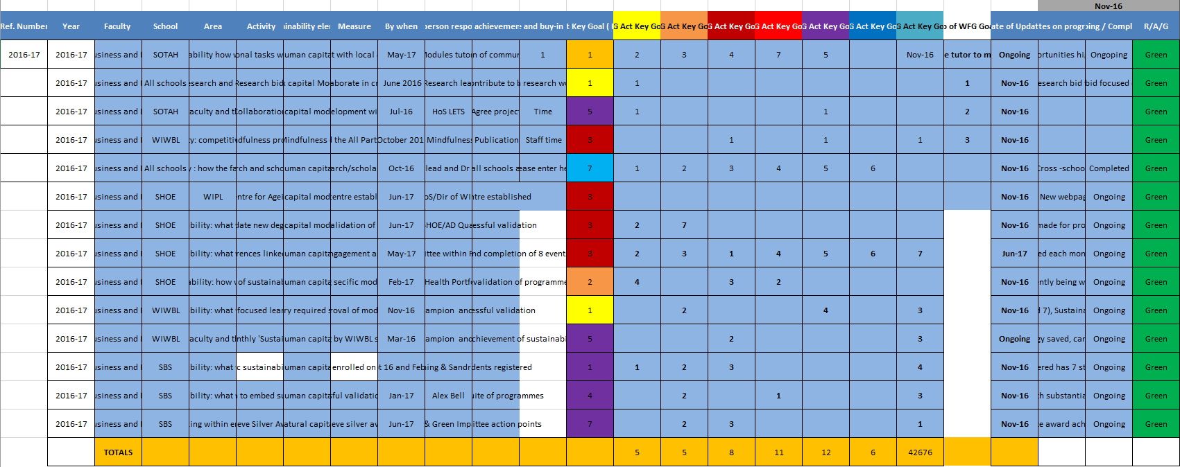

Appendix 03.

UWTSD existing databases
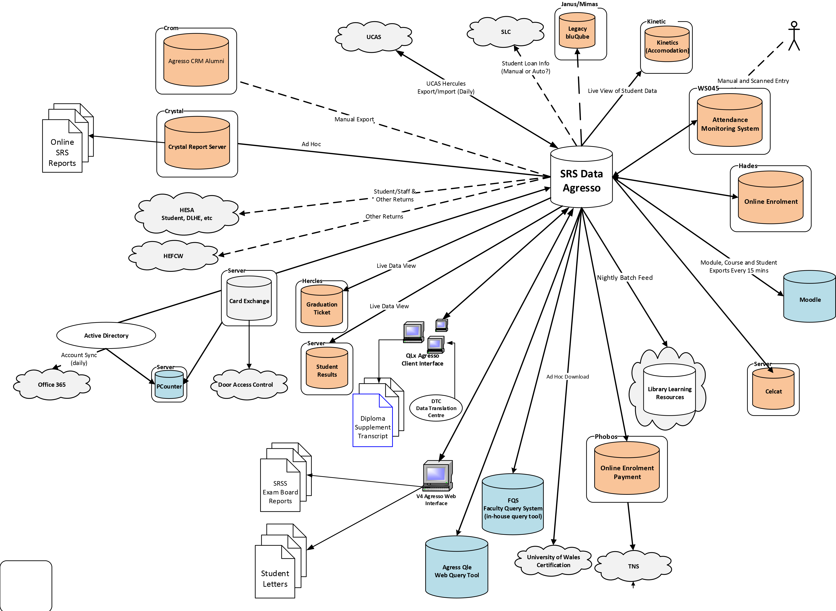

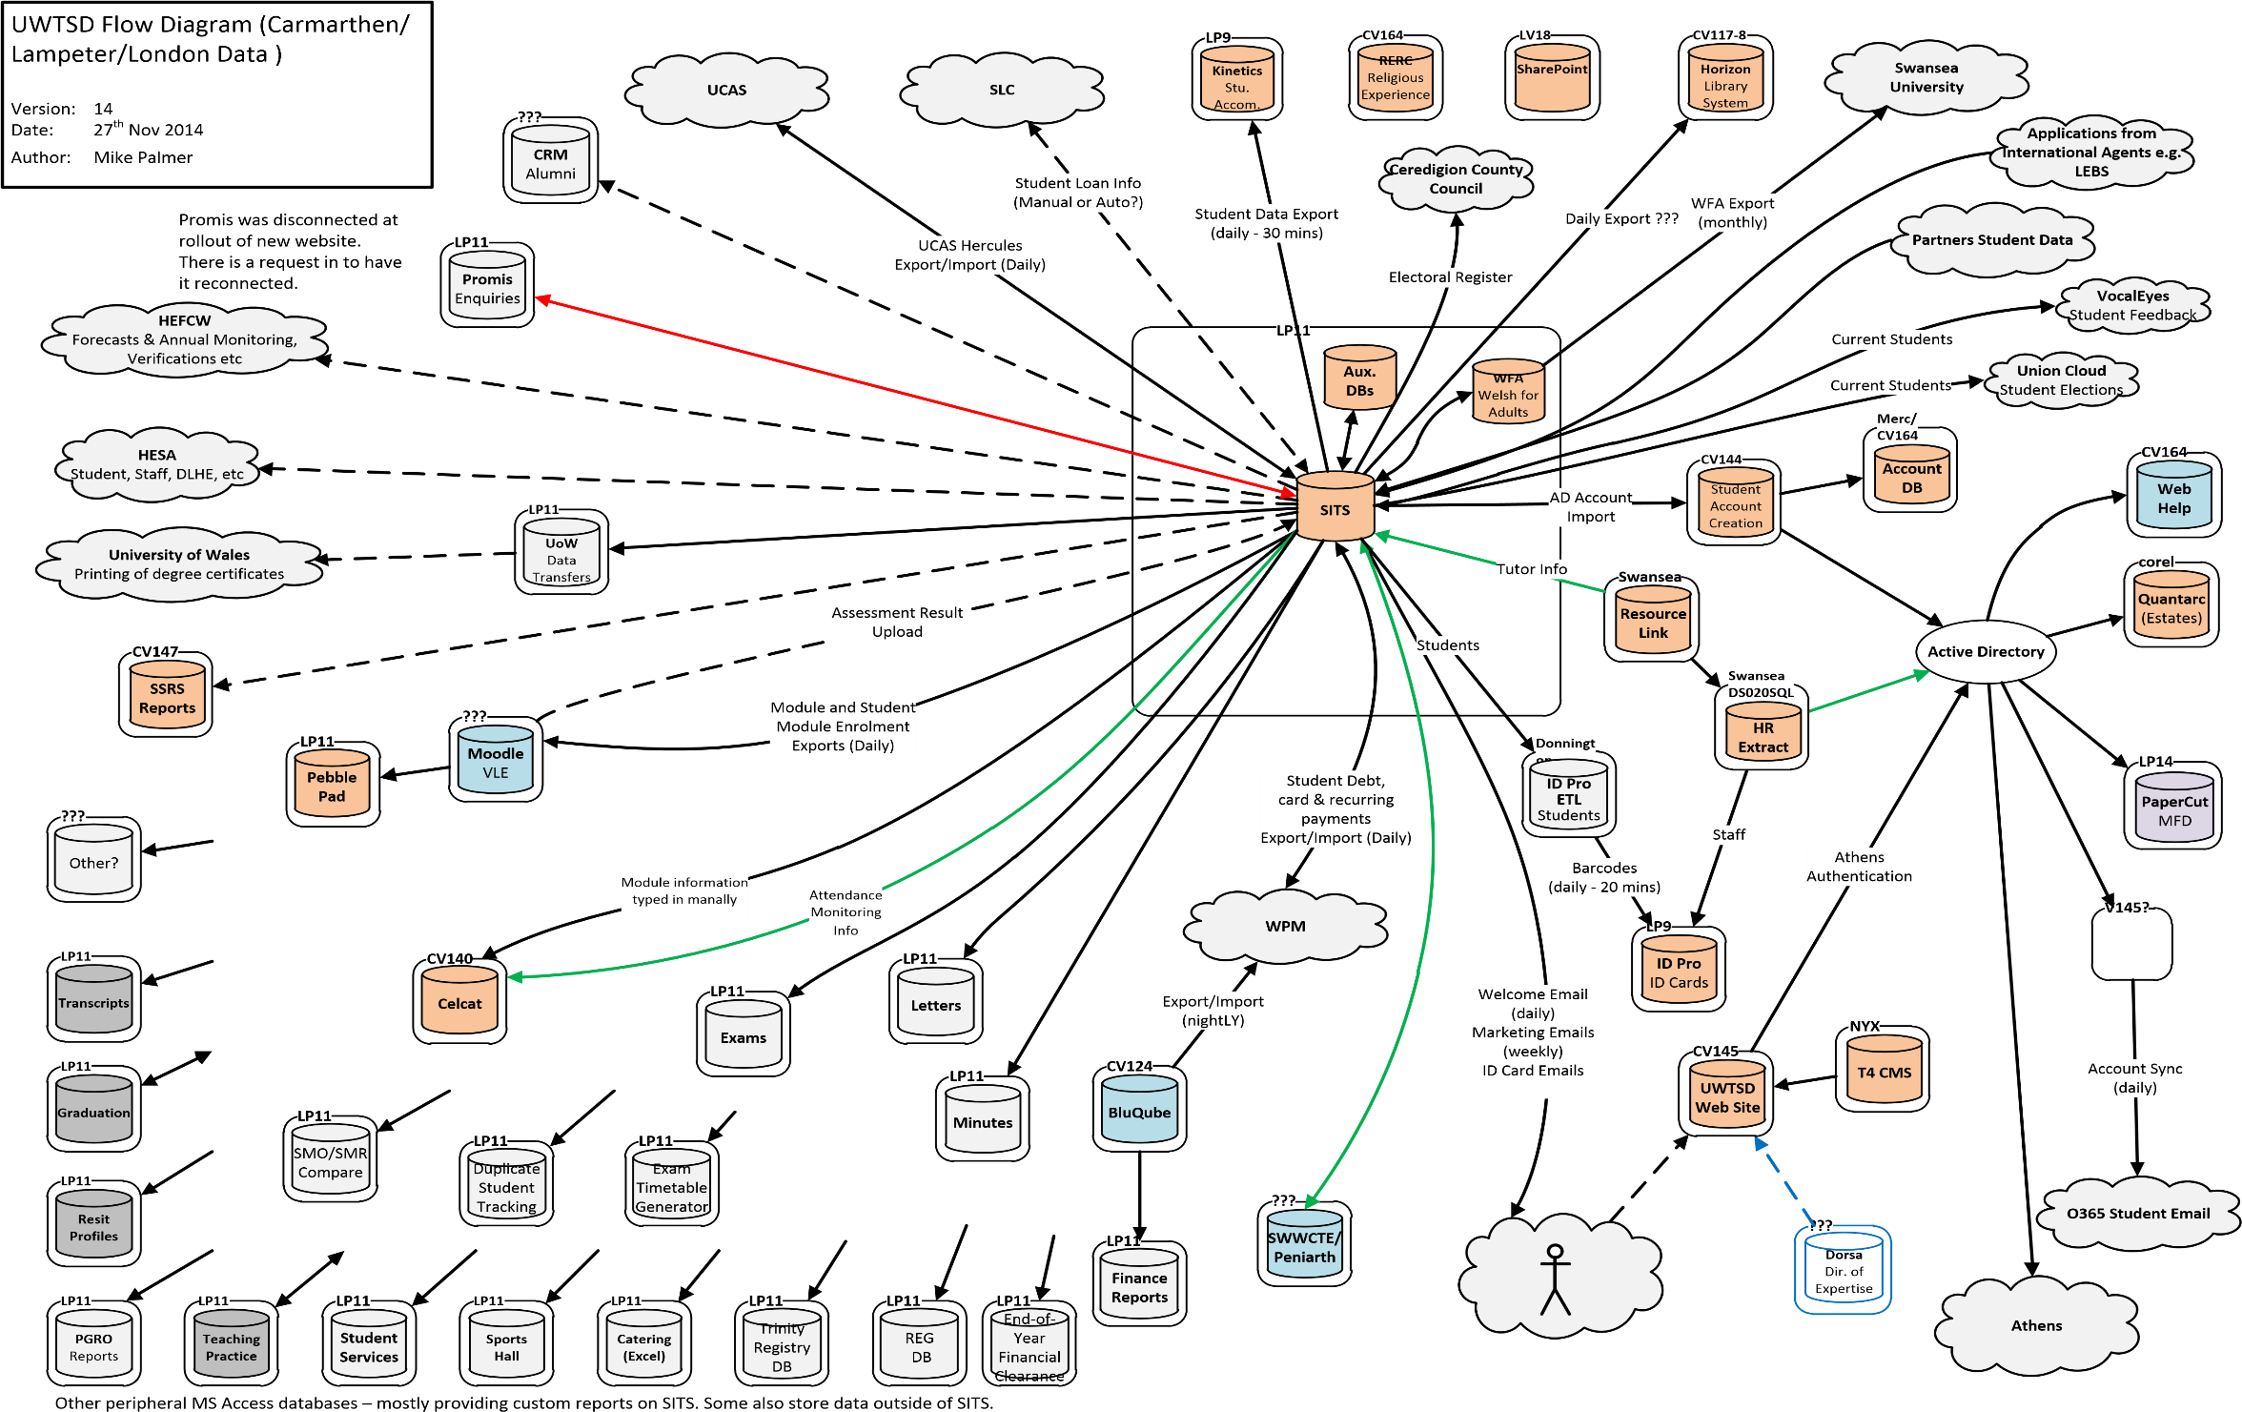

Appendix 04.

User Stories
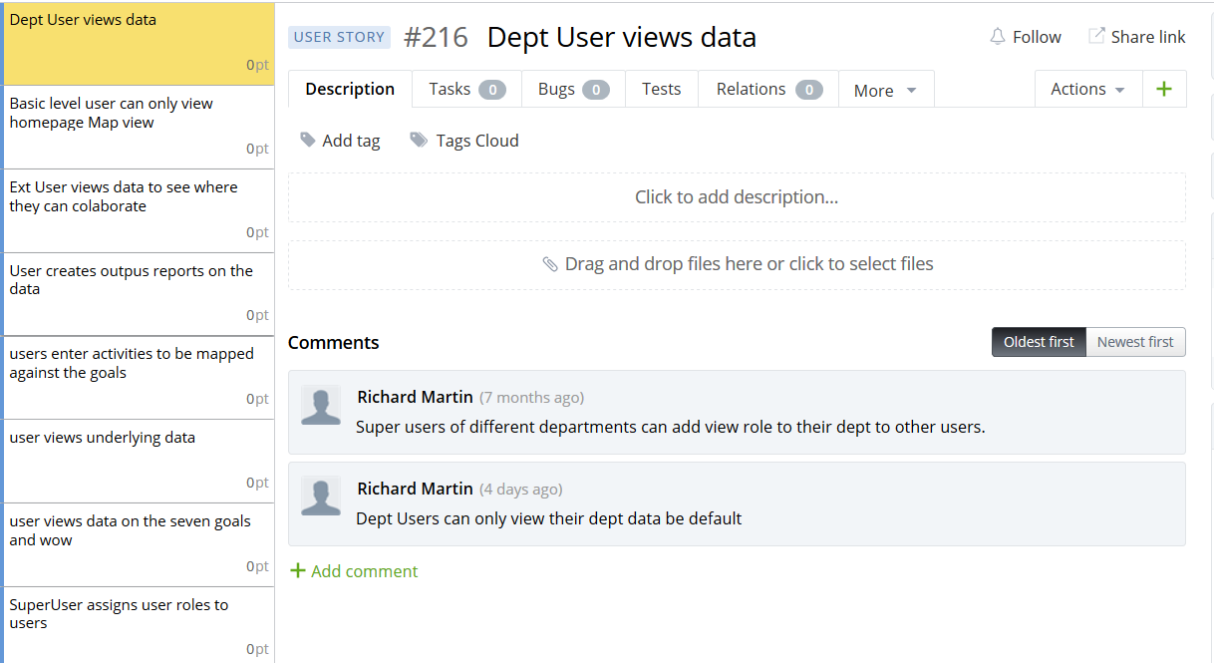
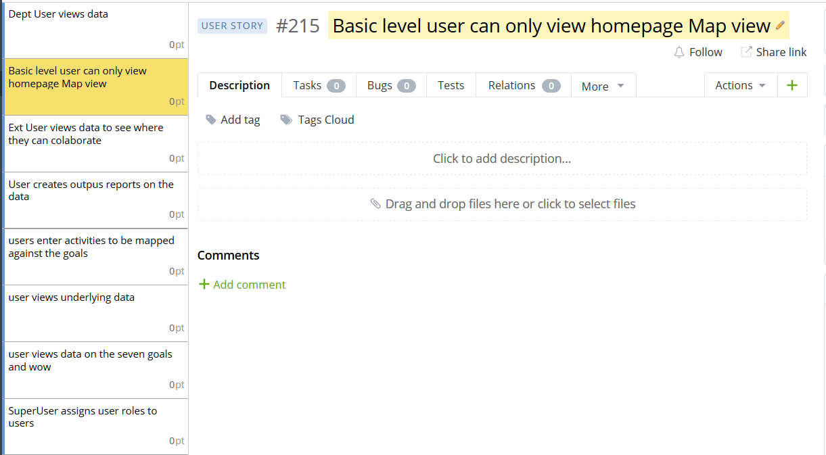
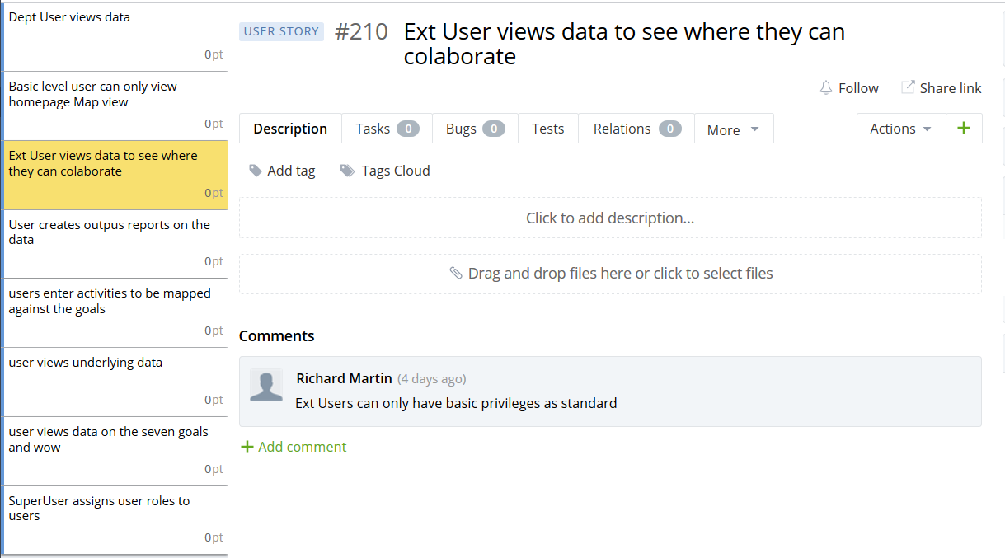
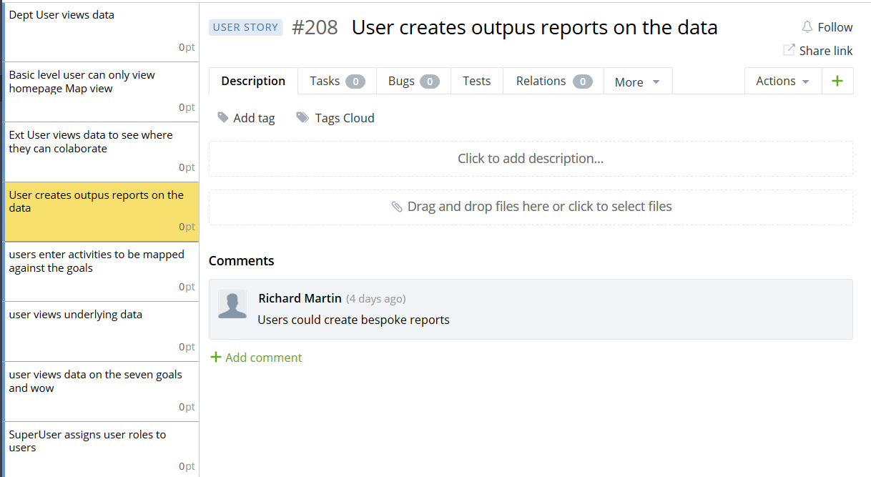
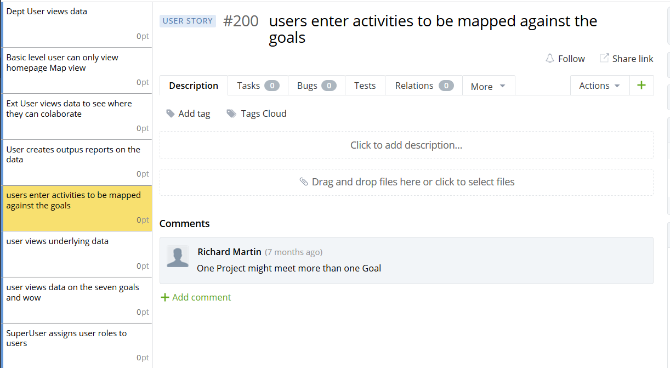
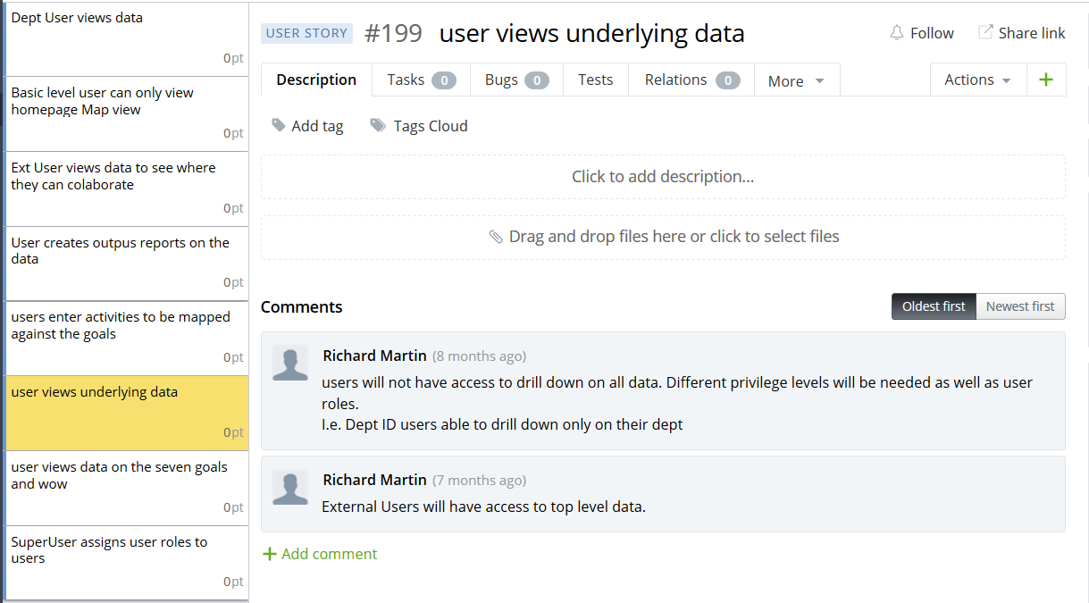
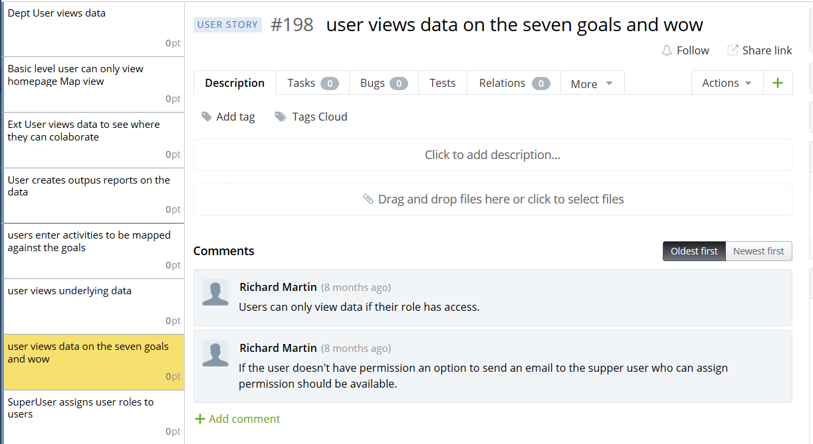
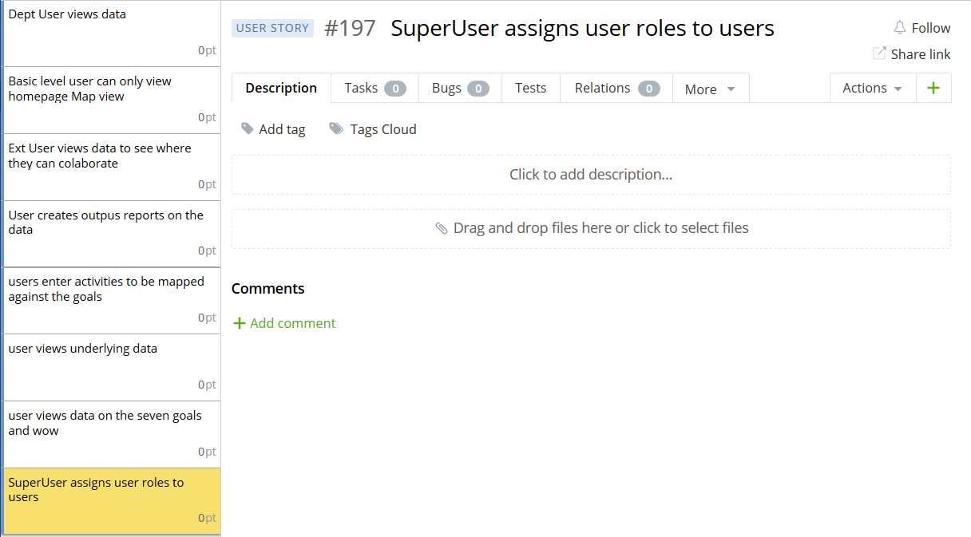

Appendix 05.

Use Cases
Use Case Number: | 01. | Use Case Name: | Login
Actor/Actors: | - Dept. Head  - External User  - Department User  - Super User  - Casual User  - System Administrator
Goal: | Authenticate the user and determine their roles.
Preconditions: | - User must have a registered account.
Postconditions: | - User Session is set.
Normal Flow: | - User entered their username and password.  - The System checks the Login details are correct.  - The System determines the User roles.  - The System sets the user session.
Alternate Flow: | 3A. The System determines the password entered is incorrect.  - The System prompts the user to re-enter the password.  3A1. The system determines the re-entered is incorrect.  - The system offers an option to reset the password.  3B. The System determines the Username is not correct.  - An error message is displayed prompting the user to re-enter the credentials.
Variations: | N/A

Use Case Number: | 02. | Use Case Name: | Register User
Actor/Actors: | - User
Goal: | Register an account for the user.
Preconditions: | N/A
Postconditions: | - User account set up.  - Session set to the newly registered user.
Normal Flow: | - User clicks on register.  - User enters their details.  - System confirms the Username is unique.  - System adds details to the user database.  - System sets Casual User Role to the user.  - System sets the user Session.
Alternate Flow: | 3A. The Username is already taken.  IF Entered number of times Username entered is taken <3.  REPEAT  - The System displays an error message and prompts the user to enter a different Username.  UNTIL Username is unique.  ELSE  REPEAT  - The System displays an error message with a suggested unique Username and prompts the user to enter a different Username.  UNTIL Username is unique.
Variations: | N/A

Use Case Number: | 03. | Use Case Name: | Data Entry
Actor/Actors: | - Dept. Head  - Department User  - Super User
Goal: | Enter Data into the system
Preconditions: | - User Logged in
Postconditions: | - Update database
Normal Flow: | - User clicks on Enter Data.  - System Checks the User has the correct privileges to enter data.  - Data entry form is displayed.  - User enters all relevant data.  - User Submits the Data Entry Form.  - The System update the relevant database tables.  - A Message is displayed to the User confirming that the data was entered successfully.
Alternate Flow: | 2A. The User does not have Write privileges.  - An Error message is displayed.  6A. There is an Error inputting the data to the database.  - An Error message is displayed.
Variations: | N/A

Use Case Number: | 04. | Use Case Name: | Add Opportunities
Actor/Actors: | - Dept. Head  - Departmental User  - External User  - Casual User  - Super User
Goal: | Add opportunities to the database
Preconditions: | - User Logged in
Postconditions: | - Update database
Normal Flow: | - User clicks on Add Opportunity button.  - System Checks the User has the relevant permissions.  - Opportunity data input form is displayed.  - User enters opportunity details and submits.  - System inputs opportunity data to the database.  - Success Message displayed.
Alternate Flow: | 2A. The User does not have Write privileges.  - An Error message is displayed.  5A. There is an Error inputting the data to the database.  - An Error message is displayed.
Variations: | N/A

Use Case Number: | 05. | Use Case Name: | View Opportunities
Actor/Actors: | - Dept. Head  - Departmental User  - External User  - Casual User  - Super User
Goal: | View current opportunities in the system.
Preconditions: | - User Logged in
Postconditions: | N/A
Normal Flow: | - User clicks on Add Opportunity button.  - System Checks the User has the relevant permissions.  - Open Opportunity are displayed.
Alternate Flow: | 2A. The User does not have Write privileges.  - An Error message is displayed
Variations: | N/A

Use Case Number: | 06. | Use Case Name: | Import CSV file
Actor/Actors: | - Dept. Head  - Departmental User  - External User  - Casual User  - Super User
Goal: | Bulk import data into the database from Excel files.
Preconditions: | - User Logged in
Postconditions: | - Update database
Normal Flow: | - User clicks on the Enter Data button.  - System Checks the User has the relevant permissions.  - User clicks on the Template Import button.  - User Browses for the file to upload.  - System checks the MIME type of the file is CSV.  - System inputs the data to the database.  - Success Message displayed.
Alternate Flow: | 2A. The User does not have Write privileges.  - An Error message is displayed.  5A. The MIME type is not CSV.  - An Error message is displayed.  6A. There is an Error inputting the data to the database.  - An Error message is displayed.
Variations: | N/A

Use Case Number: | 07. | Use Case Name: | Export CSV file
Actor/Actors: | - Dept. Head  - Departmental User  - External User  - Casual User  - Super User
Goal: | Export Data to a CSV file so the data can be reported on through Excel.
Preconditions: | - User Logged in
Postconditions: | N/A
Normal Flow: | - User clicks on the View Data button.  - System Checks the User has the relevant permissions.  - User Filters the data to what they want to export.  - User clicks on the Export button.  - System generates a CSV from the data.
Alternate Flow: | 2A. The User does not have Read privileges.  - An Error message is displayed.
Variations: | N/A

Use Case Number: | 08. | Use Case Name: | Set Goal Targets
Actor/Actors: | - Super User
Goal: | User sets targets on the Goals
Preconditions: | - User Logged in  - User has Super User Role
Postconditions: | - Update database
Normal Flow: | - System Checks the User has the relevant permissions.  - Set Target button is displayed.  - User clicks on the Set Target button.  - Set target data entry form is displayed.  - System inputs the data to the database.  - Success Message displayed.
Alternate Flow: | 1A. User does not have the correct privileges.  - The Set Target button is not displayed.
Variations: | N/A

Use Case Number: | 09. | Use Case Name: | View Data
Actor/Actors: | - Dept. Head  - Departmental User  - External User  - Casual User  - Super User
Goal: | The User wants to view the underlying data.
Preconditions: | - User Logged in
Postconditions: | N/A
Normal Flow: | - User Clicks on Campus.  - System checks the User has Read privileges for top level data.  - User Clicks on View Data.  - System checks the User has Read privileges for underlying data.  - System queries the database returning the data.  - System generates Json file containing the current data.  - System populates the data table to be displayed.
Alternate Flow: | 2A. User does not have the correct privileges.  - Error message is displayed.  4A. User does not have the correct privileges.  - Error message is displayed.
Variations: | N/A

Use Case Number: | 10. | Use Case Name: | Dashboard
Actor/Actors: | - Dept. Head  - Departmental User  - External User  - Casual User  - Super User
Goal: | User views a summary of how a department is performing.
Preconditions: | - User id Logged in
Postconditions: | N/A
Normal Flow: | - User Selects Campus to view data.  - System Checks the User has the correct privileges.  - System gathers data for campus.  - System processes data and assigns scores against Goals based on the PI waiting.  - System prepares Json data file to populate graphs.  - Chart is displayed.
Alternate Flow: | 1A. User Does not have correct privileges.  - Error message displayed.
Variations: | N/A

Use Case Number: | 11. | Use Case Name: | Add User Privileges
Actor/Actors: | - System Admin
Goal: | Add additional Read/Write Privileges to Users
Preconditions: | - User Logged In  - User has System Admin Role
Postconditions: | - User details updated in database.
Normal Flow: | - System Checks User Role.  - User clicks on User Privilege Link.  - User Selects User to update privileges.  - User selects privileges to add to the User in question and clicks submit.  - Database Updated.  - Success Message displayed.
Alternate Flow: | N/A
Variations: | N/A

Use Case Number: | 12. | Use Case Name: | Revoke User Privileges
Actor/Actors: | - System Admin
Goal: | Remove privileges from specific User
Preconditions: | - User Logged In.  - User has System Admin Role.
Postconditions: | - User Details updated in database.
Normal Flow: | - System Checks User Role.  - User clicks on User Privilege Link.  - User Selects User to update privileges.  - User selects privileges to Revoke from the User in question and clicks submit.  - Database Updated.  - Success Message displayed.
Alternate Flow: | N/A
Variations: | N/A

Use Case Number: | 13. | Use Case Name: | Add User
Actor/Actors: | - System Admin
Goal: | Add a new user to the system.
Preconditions: | - User is logged in.  - User has System Admin Role.
Postconditions: | - New User added to the database.
Normal Flow: | - System Checks User Role.  - User clicks on User Link.  - User fills in new user details and submits.  - Database Updated.  - Success Message displayed.
Alternate Flow: | N/A
Variations: | N/A

Use Case Number: | 14. | Use Case Name: | Drop User
Actor/Actors: | - System Admin
Goal: | Remove user from the system.
Preconditions: | - User is logged in.  - User has System Admin Role.
Postconditions: | - User dropped from the database.
Normal Flow: | - System Checks User Role.  - User clicks on User Link.  - Selects User to be removed.  - User clicks Remove.  - User Prompts for confirmation.  - User confirms.  - Database Updated removing user.  - Success Message displayed.
Alternate Flow: | 6A. User clicks cancel.  - System reverts to User Page.
Variations: | N/A

Appendix 06.

System Requirements Specification
Contents
01. Introduction: 2
01.01. Purpose: 2
01.02. Scope: 2
01.03. Definitions and Abbreviations 2
01.04. Overview 2
02. Overall Description 3
02.01. Product Perspective 3
02.02. Product Functions 3
02.03. User Roles 3
User Role: Dept. Head 3
User Role: External User 3
User Role: Department User 4
User Role: Super User 4
User Role: Casual User (student) 4
User Role: System Administrator 4
03. Requirements 6
03.01. External Interface Requirements 6
03.01.01. User Interface 6
03.01.02. Hardware Interface 6
03.01.03. Software Interface 6
03.02. Functional Requirements 6
03.02.01. System Requirements 6
03.02.02. User Role - None 8
03.02.03. User Role – All 9
03.02.04. User Role – Super User 9
03.02.05. User Role – System Admin, Super User 9
03.02.06. User Role – System Admin 10
03.03. Performance and Quality Requirements 10
03.03.01. Accessibility 10
03.04. Security Requirements 11

01. Introduction:

01.01. Purpose:
The purpose of this document is to detail the System Requirement Specification for the Wales Future Generation Toolkit. The document is intended for customer’s approval and as a guide to the developer.

01.02. Scope:
The Wales Future Generation Toolkit is an application that will allow users to enter data and measure that data against the 5 Ways of Working, 7 Goals and 46 Performance Indicators of the act. The application will display data to users through a dashboard showing how the organisation is performing against the “Well-being of Future Generations (Wales) Act 2015” [1]. The application will be web based. Giving users the ability to register to view and or enter data.
All registered users will initially be given the Casual User role with only view access to the top level of data.
All Departmental Users will have access to their departments data with read privileges and some will have write privileges. Further privileges can be requested.
Super Users can grant privileges to users and set targets on the Goals of the “Well-being of Future Generations (Wales) Act 2015”.
The web application will need an internet connection to fetch and display map data. System level data will be stored in a database which will be located on a web server.

01.03. Definitions and Abbreviations
Term | Definition
WoW Model | Wales Future Generation Toolkit
The Act | Well-being of Future Generations (Wales) Act 2015
MySQL | My Structured Query Language
MSSQL | Microsoft Structured Query Language
DESC | Description
RAT | Rational
DEP | Dependency
PI | Population Indicators

01.04. Overview
The further chapters of this document specify the details of the WoW Model application.
Chapter two provides an overview of the requirements and User Roles of the WoW model.
Chapter three provides details of the WoW Model Requirements.
Appendix One detail the requirements to be implemented in version one of the WoW model.

02. Overall Description
This section gives an overview of the system as a whole. Explaining the systems functionality and user groups.

02.01. Product Perspective
The WoW Model will display all locations within the organisation on a map view. The map view will be available to all user roles.
The system will utilise a database to fetch and display data to the users. Users with correct privileges will be able to enter and view data at different levels.

02.02. Product Functions
The WoW Model will give users the ability to view how the organisation is performing against the Act.
Targets on the Goals of the Act will be set by Super Users which departments will need to strive to achieve.
Users will be able to output data to utilise in reports or presentations.
Users will be able to add opportunities where they think a task or activity could boost a goals performance.

02.03. User Roles

User Role: Dept. Head
Not necessarily particularly computer literate but likely highly educated. Will use the application intensely generally using the application to compile reports from information not necessarily entering any data. The Dept. Head will have full access to their department’s data at all levels but only view access to over departments. Dept. Heads will likely have large workloads and limited time to spend on tasks. Dept. Head will likely want to compile reports from the application and know what information they want to get out of the system.

Default Privileges:
- View access on their department
- Write access on their department
- View access on opportunities
- Write access on opportunities
- View access on top level Data (Map and Organisation as a whole)

User Role: External User
External users will come from all levels of technical background and age groups. External users will only have limited view only privileges and of only top level data. External users will likely want to do one of two tasks either view how the organisation is performing possibly to compare against their own organisation. Or they will have an idea of an opportunity that the two organisations can collaborate to help boost one or both organisations population indicators to meet goals.

Default Privileges:
- View access on opportunities
- Write access on opportunities
- View access on top level Data (Map and Organisation as a whole)

User Role: Department User
Likely very computer literate. Department User will likely not be interested in other departments data and just want to enter and view the data relevant to their department. Department users will only have access to their departments data and not all Department Users will have write privileges.

Default Privileges:
- View access on their department
- View access on opportunities
- Write access on opportunities
- View access on top level Data (Map and Organisation as a whole)

User Role: Super User
Super users will likely be highly computer literate. Super users will not necessarily have any interest in the data being displayed. One task a Super user would perform would be granting access to different levels of the application. For example, giving a Dept. head user view access to another department data, or granting write privileges to a department user to their department. Super Users will be the only users able to set targets on departments goals. Possibly there would need to be a Super user for each dept./possibly one Super user who will maintain the whole system.

Default Privileges:
- View access on all department
- Write access on their department
- View access on opportunities
- Write access on opportunities
- View access on top level Data (Map and Organisation as a whole)
- Add Privileges to users
- Revoke Privileges form users
- Set Gaol targets

User Role: Casual User (student)
An internal casual user will have varied levels of computer literacy, education and demographic groups. Internal casual users will only have read privileges and only to top level data they will not have access to any detailed or sensitive data. They will likely not have access to the opportunities but may have access to enter opportunities.

Default Privileges:
- View access on opportunities
- Write access on opportunities
- View access on top level Data (Map and Organisation as a whole)

User Role: System Administrator
System Admin user will be highly computer literate. The System Admin user will be tasked with adding users, adding user privileges to users. The System Admin user may also have access to change the goals, WoW and KPI’s. They will have full access to change and modify all system level data.

Default Privileges:
- All Privileges

03. Requirements
This section details the specific requirements for the application.

03.01. External Interface Requirements
This Section details all inputs and out puts of the system and describes hardware software and communication.

03.01.01. User Interface
Unregistered and logged out users will see a map view showing all the organisations locations. They will also have access to a Login/Register page and top level data to see how the organisation as a whole is performing. They will not have access to any departmental data.
The map Should include a map page to show the organisations locations. This could be boundaries of organisations ownership not just pin points.
The WoW Model will need to have a data input page to take information from the user to be measured against the Act.
The Wow Model will have functionality to export data so that it can be used in reports.
The colours of the seven goals are set by the legislation the system must utilise these colours.

03.01.02. Hardware Interface
The hardware required for the WoW Model would be one or more web servers.
The System may need to interact with additional hardware to integrate with existing data sources.

03.01.03. Software Interface
The first release version of the application will be developed using open source technologies.
The WoW Model will need to create, read, update and delete data from a database. Initially this will be developed in MySQL to satisfy the open source requirement but will later be migrated to MSSQL.
The System may need to interact with additional software to integrate with existing data sources.

03.02. Functional Requirements
This Section details the requirements needed to achieve the functionality of the WoW Model.

03.02.01. System Requirements
ID: FR1
TITLE: Data Entry
DESC: The system must be able to take data from the user to be stored.
RAT: Allowing users to enter data directly into the application
DEP: None

ID: FR2
TITLE: User Details
DESC: The System Should store which user entered data and what time and date.
RAT: Help keep track of data in the system.
DEP: FR1

ID: FR3
TITLE: Store Data
DESC: The WoW Model must be able to store data from the organisation to measure against the Act.
RAT: Data must be stored so it can be displayed to show how the organisation is performing against the Act.
DEP: FR1, FR2

ID: FR4
TITLE: Organisation Performance
DESC: The System must be able to display how the organisation as a whole is performing against the act.
RAT: This will help meet rules set out in the Act that organisations must make their performance against the Act available.
DEP: FR3

ID: FR5
TITLE: Departmental Performance
DESC: The System must be able to display how each department is performing against the act.
RAT: Internal members of the organisation can monitor their own performance.
DEP: FR3

ID: FR6
TIILE: Opportunities
DESC: The System should have the ability to store opportunities from users that could help the organisation meet goals or WoW.
RAT: Internal department and external organisations should be able to let the organisation know of ways to improve performance. This will also help meet the Collaboration way of working.
DEP: None

ID: FR7
TITLE: Automatic Emails
DESC: The System should incorporate automatic e-mails. (For Opportunities and tasks nearing completion date for tasks still ongoing).
RAT: Improve usability and help insure items aren’t missed by the users.
DEP: FR1, FR2, FR3, FR6

ID: FR8
TITLE: Reporting
DESC: The System should be able to output reports.
RAT: Allow users to output reports directly through the system
DEP: FR3

ID: FR9
TITLE: Forum
DESC: The System could have a forum/message board.
RAT: To allow users to communicate
DEP: None

ID: FR10
TITLE: import CSV
DESC: Could have the ability to import csv files to populate database.
RAT: Aid users when entering legacy data
DEP: FR3

ID: FR11
TITLE: export CSV
DESC: Could have the ability to export data into csv files.
RAT: Aid users when compiling reports
DEP: FR3

03.02.02. User Role - None
ID: FR12
TITLE: User Registration
DESC: The user should be able to register through the application. When users are first registered, they will be granted the Casual User role.
RAT: Allowing users to register to add opportunities.
DEP: None

03.02.03. User Role – All
ID: FR13
TITLE: Opportunities
DESC: All Registered Users should be able to add opportunities.
RAT: Any user may have opportunities that can boost performance. Helps meet collaboration way of Working.
DEP: FR12

03.02.04. User Role – Super User
ID: FR14
TITLE: Goal Targets
DESC: Only Super Users will have the ability to set goals on targets.
RAT: To stop users changing their own Goal targets.
DEP: None.

03.02.05. User Role – System Admin, Super User
ID: FR15
TITLE: Assign Privileges
DESC: Assign users different privilege levels. (Read, Write)
RAT: Users may need additional privileges than the default for their role.
DEP: FR12

ID: FR16
TITLE: Revoke Privileges
DESC: Revoke users different privilege levels. (Read, Write)
RAT: Privileges may only be assigned for temporary purpose or misuse of privileges.
DEP: FR12

03.02.06. User Role – System Admin
ID:FR17
TITLE: Add Locations
DESC: Organisations locations need to be added to the map.
RAT: Additional locations may be obtained.
DEP: None

ID:FR18
TITLE: Remove Locations
DESC: Organisations locations need to be removed to the map.
RAT: Locations may be sold or over wise no longer used.
DEP: None

ID: FR19
TITLE: Population Modification
DESC: Details of the PI details may need to be changed
RAT: The government may change PI’s
DEP: None

ID: FR20
TITLE: Drop Users
DESC: Users may need to be dropped form the system.
RAT: Employee leaves organisation for example.
DEP: FR12

03.03. Performance and Quality Requirements

03.03.01. Accessibility
ID: QR1
TITLE: Screen Reader accessibility
DESC: The application should be accessible with the use of screen readers. All users should be able to access information.
DEP: None

ID: QR2
TITLE: Responsive Design
DESC: The application should utilise responsive design techniques. Allowing the application to be used on mobile, tablets and desktop machines.
DEP: None

ID: QR3
TITLE: Data Filtering
DESC: Users should be able to replicate recurring events data without having to re-enter all similar data.
DEP: FR1

ID: QR4
TITLE: Forum messages External and Casual users
DESC: External and Casual Users should be able to post messages/Ask questions and see responses to their questions.
DEP: FR9

ID: QR5
TITLE: Forum messages Internal Users
DESC: Internal Users would have full access to the forum data.
DEP: FR9

ID: QR6
TITLE: reporting performance figures
DESC: The system could show the monthly/quarterly performance figures against the act.
DEP: FR4, FR5

03.04. Security Requirements
ID: SR1
TITLE: Adding Data
DESC: Only Users with Write privileges and the particular Department access will be able to enter data.
RAT: Maintain Data Integrity
DEP: FR1

ID: SR2
TITLE: Viewing Data
DESC: Only Users with Read privileges and the particular Department access will be able to view data.
RAT: Maintain Data Integrity
DEP: None

ID: SR3
TITLE: Request Privileges
DESC: If a user does not have sufficient privileges they should be able to request the privileges.
RAT: Allow users to gain further privileges than their roles default.
DEP: None

