Qualification: CIPD Diploma in Applied Human Resources

Module Name: Understanding the Management of Employment Relations

How has Mid and West Wales Fire and Rescue Service (MAWWFRS) been affected by the recent global pandemic of COVID 19.

Word Count: 844 words

Student Name: Nicola Westcott
Student Number: 1909408
CIPD Membership Number: 55478551

By signing below, I confirm that the work/evidence presented is my own, unaided work. I understand the regulations pertaining to candidate malpractice and the action that may be taken as a result.

Signed: N Westcott
Date: 31/05/2020
How has Mid and West Wales Fire and Rescue Service (MAWWFRS) been affected by the recent global pandemic of COVID 19.

‘The spread of COVID-19, commonly referred to as the coronavirus, is an exceptional circumstance with ongoing ramifications for organisations, individuals and society on every level’ (CIPD, 2020d).
Government guidance released on 19 March 2020, defines Fire and Rescue Service staff (including support staff) as key workers for public safety and national security (GOV.UK, 2020b), therefore it meant that it was business as usual for MAWWFRS, although this would be undertaken in a very different way. As a public sector organisation, no employees were furloughed.
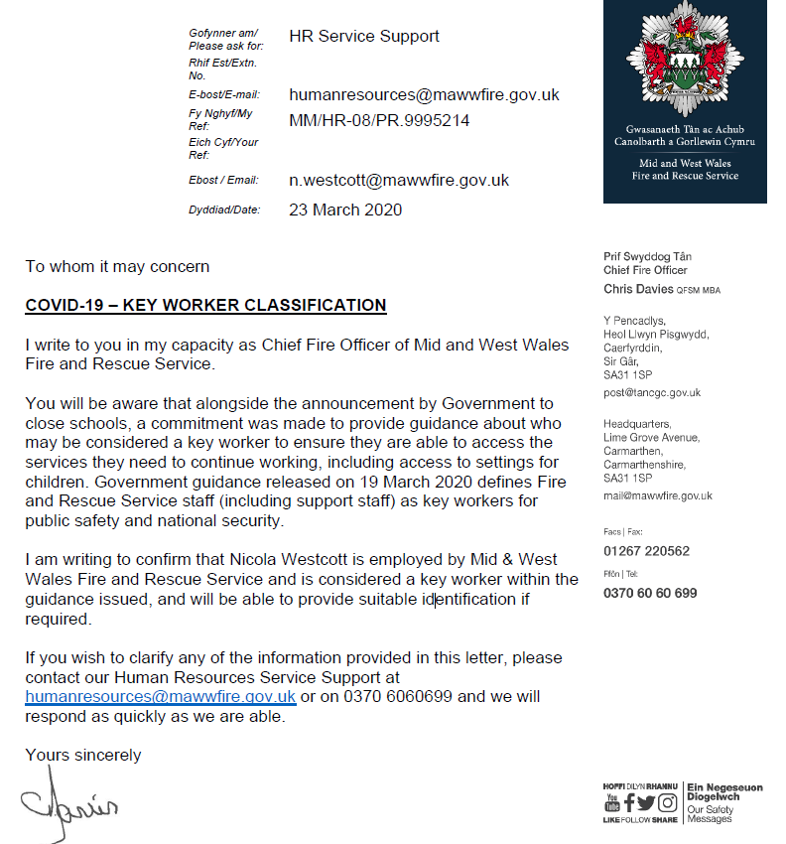
Source: MAWWFRS 2020
The Chief of MAWWFRS/key individuals ensured all messages were communicated in a variety of ways.
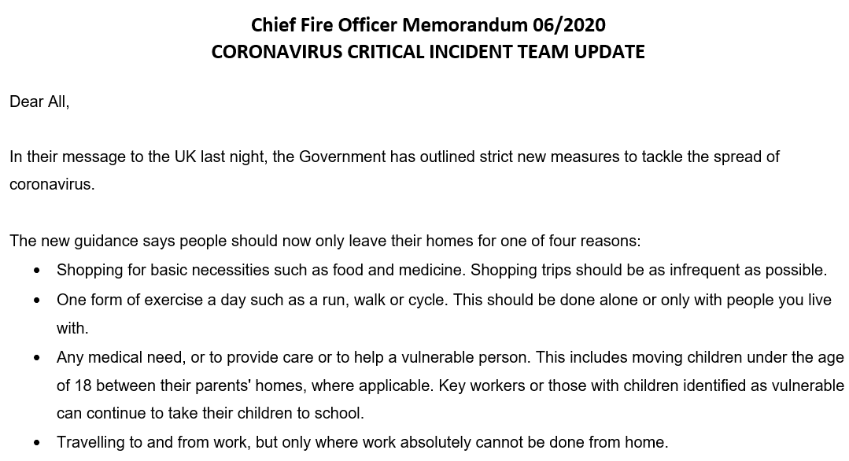
Source: MAWWFRS 2020
In the two weeks before lockdown a critical incident team was established, consisting of all heads of departments/commands. Tasked with ensuring all departments business continuity plans were up to date/implemented, all key communication was circulated, issues were identified/measures put in place to resolve (MAWWFRS Website, 2020).
It was essential that all staff were aware of new procedures/legislation/equipment, done through regular email updates/video messaging/information was issued as well being available on the services’ intranet under the Covid-19 section for perusal at any time (MAWWFRS, 2020).
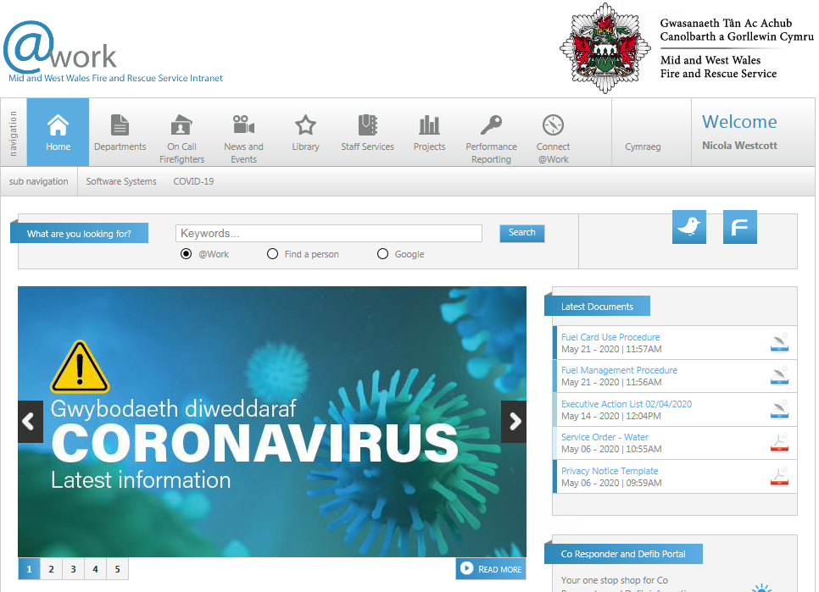
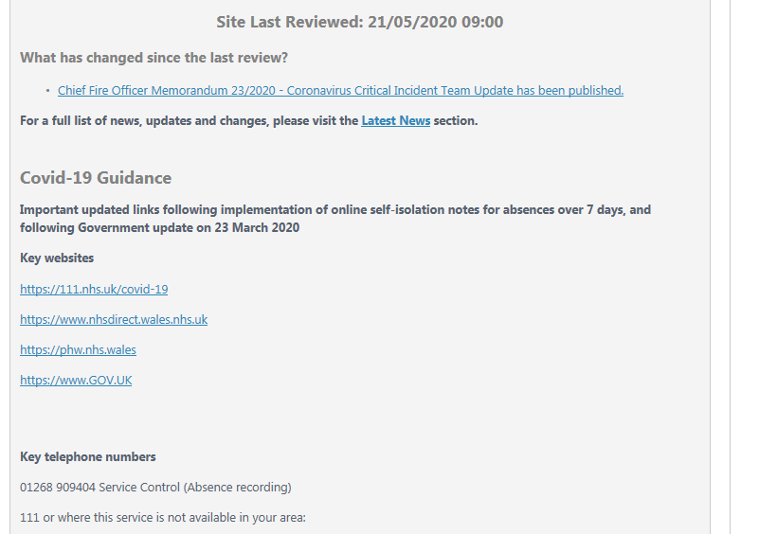
Source: MAWWFRS 2020

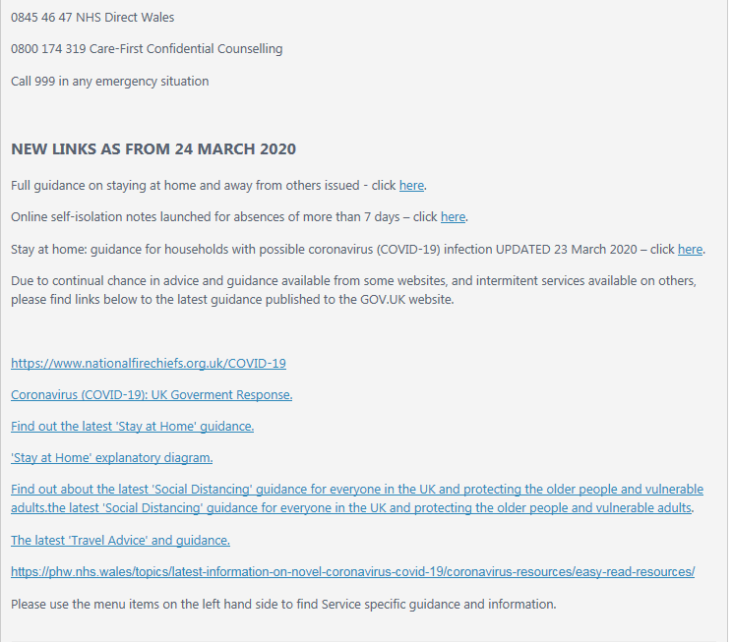
Source: MAWWFRS 2020
The HR department have been instrumental in managing employee relations by ensuring the numerous communications were issued to all employees/managers on the current situation, including home working guidance, guidance for employees/managers if an employee has symptoms/tests positive (ACAS, 2020a), how to manage staff who are remote working, Government/PHW notifications/legislation as well as numerous HSE updates.
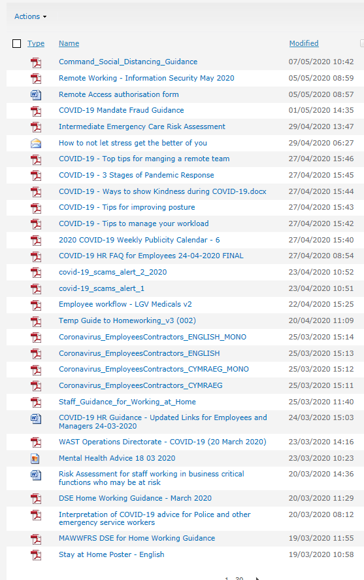
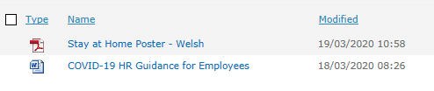
Source: MAWWFRS 2020
As an emergency service all stations/emergency control centre were immediately only accessible to those who worked in those areas, in order to keep the areas uncontaminated.
All support staff/community safety staff were to work from home where possible. The Service has a remote working procedure in place however, this was extended to all where possible. Employees with underlying health conditions were advised to work from home or if unable to, were placed on special leave.

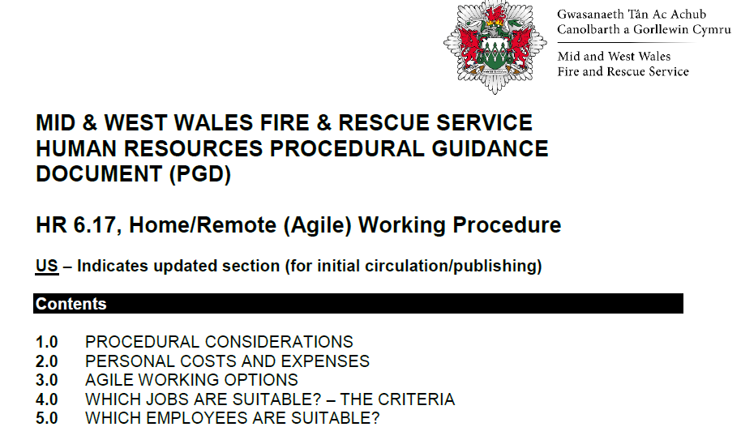
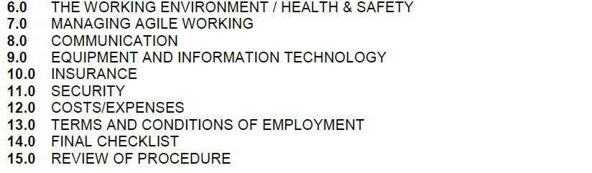
Source: MAWWFRS 2020
‘Employers and employees should be practical, flexible and sensitive to each other's situation when working from home because of the coronavirus pandemic’ (ACAS, 2020b).
The current situation means that it is likely that both employers/employees are experiencing a high level of stress and anxiety. The service has been managing this by ensuring that employees, especially those that are home working have regular contact to not feel isolated, access to well-being assistance/any equipment that may be required to work safely.
‘By law, employers are responsible for the health and safety of all employees, including those working from home’ (ACAS, 2020).
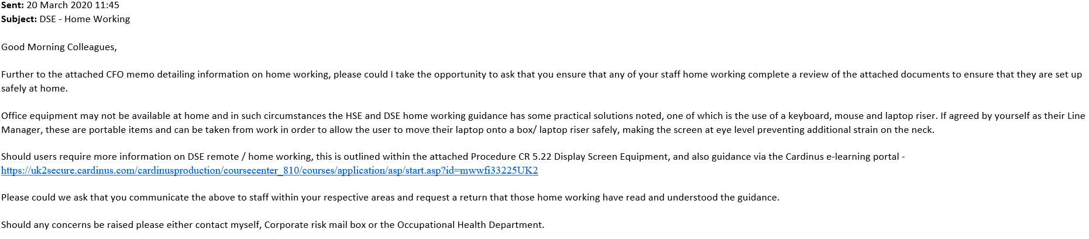Source: MAWWFRS 2020
‘Employees who work from home are subject to the same rules/procedures and expected standard of conduct and performance as all other employees’ (Barnett, (2020).
Throughout the pandemic a limited number of HR/other departments have maintained a presence in the office, via a rota basis whilst ensuring adherence to the 2-metre rule (GOV.Wales, 2020).
As part of the Government plans, the fire service was tasked with working in partnership with the WAST. This meant after undertaking appropriate training, firefighters could volunteer to become drivers, deliver food parcels/medicine or undertake the removal of bodies (Sky News, 2020).
Many of MAWWFRS 730 on-call firefighters were furloughed from their primary employer or being self-employed had little/no work. Due to this they were able to provide more hours of cover, which has assisted greatly as the Service often struggles with adequate cover at certain times/areas. It was particularly beneficial due to the increased number of grass fires that occurred during the first few weeks of lockdown.
Social distancing at a fire station is extremely difficult however, measures were put in place for staff to attend drills nights on a rota and crew were limited to a minimum of 5 rather than 6 when attending an incident (BBC, 2020).

As at 31st May 2020:

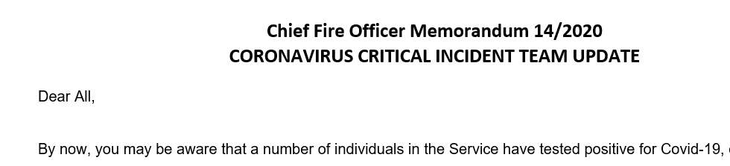
Source: MAWWFRS 2020
This increase in absence placed stress on those remaining individuals. All costs for absence/special leave/additional equipment is recoded for statistics for WG/ONS. Measures were put in place to ensure that no employees suffered any detriment to pay by ensuring the average pay calculation was used.
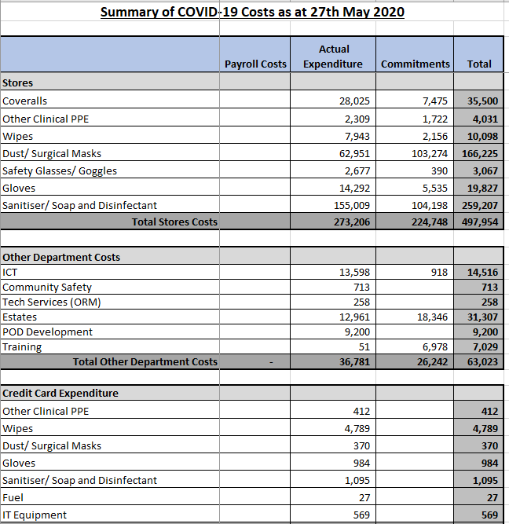
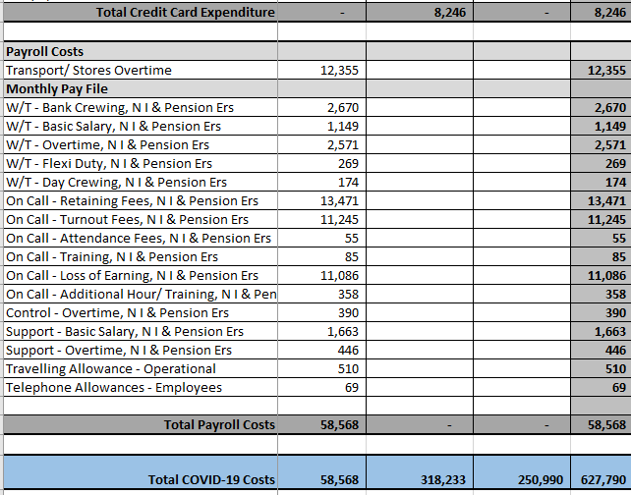
Source: MAWWFRS 2020
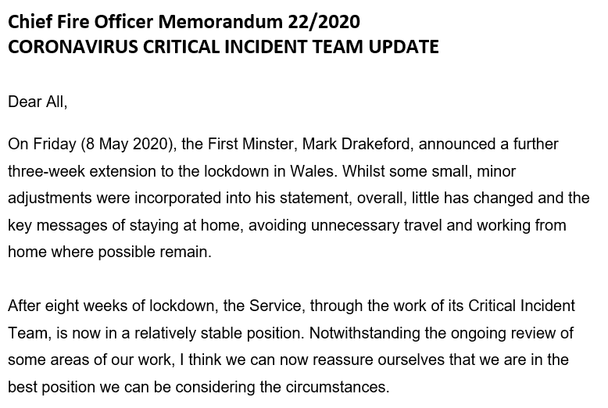
Source: MAWWFRS 2020
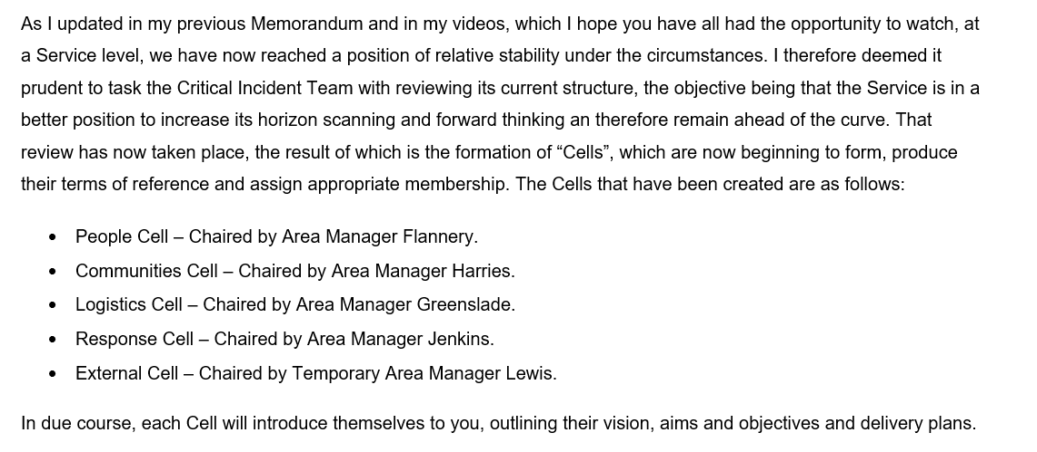
Source: MAWWFRS 2020
In response to the pandemic, the way the Service operated changed immediately. The IT department was under pressure to ensure systems were accessible/functioning remotely. Increased use of technology such as teams/skype/emails was crucial in ensuring business continued as usual. This new way of working is likely continue in the future due to the many advantages, reducing the carbon footprint/travel time between locations, as the service covers 12,000 square km in Wales.
HR was beginning the process of online expenses/onboarding, and the current situation has highlighted the need for this. Whilst workarounds have been put in place for claims to be electronically submitted/approved and onboarding undertaken via Teams/Moodle (Personnel Today, 2020), the process will be streamlined when the modules are introduced fully in the future.
Whilst Wales remains on lockdown, in England the Government outlined plans for employees to gradually return to work, the CIPD urged business to ensure three key criteria were met (CIPD, 2019b):

MAWWFRS is preparing for the unlock phase in Wales by issuing questionnaires to ensure all employees have a say in what happens next. The service has already introduced many measures in the workplace with social distancing/rotas/staggering start/end/lunch times/availability of hand-sanitiser but there will be many more changes to the workplace in the future.
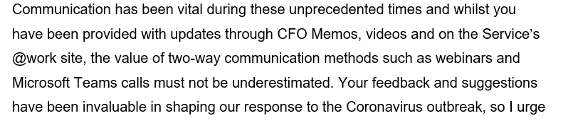
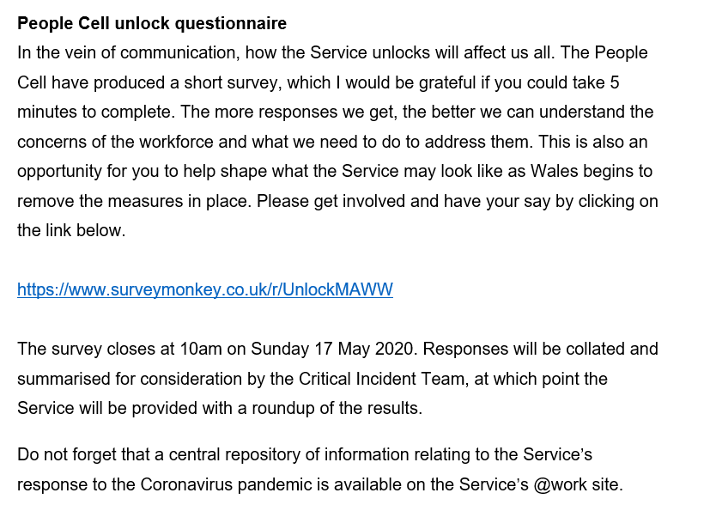

Source: MAWWFRS 2020

References
ACAS (2020a) Coronavirus (COVID-19): advice for employers and employees. Available at: https://www.acas.org.uk/coronavirus/if-someone-has-coronavirus-symptoms-at-work (Accessed 25 May 2020).
ACAS (2020b) Working from home. Available at: https://www.acas.org.uk/working-from-home (Accessed 20th May 2020).
Barnett, D. (2020) Homeworking Policy. Available at: https://policies2020.com/wp-content/uploads/2020/03/Homeworking-HR.pdf (Accessed 29 May 2020).
BBC (2020) Coronavirus: Welsh workplace two-metre rule 'not absolute ban' 6 Apr 2020. Available at: https://www.bbc.co.uk/news/uk-wales-politics-52182486.
CIPD (2020a) Coronavirus Covid-19 Employers Response Guide. Available at: https://www.cipd.co.uk/knowledge/fundamentals/emp-law/health-safety/coronavirus-employer-response-guide (Accessed 24 May 2020).
CIPD (2020b) Covid-19 returning to the workplace [Factsheet] 18 May 2020. Available at: https://www.cipd.co.uk/knowledge/fundamentals/emp-law/employees/workplace-guide-returning-after-coronavirus (Accessed 25 May 2020).
CIPD (2020c) Managing remote working and business closures. Available at: https://www.cipd.co.uk/news-views/coronavirus/faqs/remote-working-business-closures (Accessed 24 May 2020).
CIPD (2020d) Responding to the coronavirus. Available at: https://www.cipd.co.uk/news-views/coronavirus (Accessed 24 May 2020).
GOV.UK (2020a) Coronavirus outbreak FAQs: what you can and can’t do. Available at: https://www.gov.uk/government/publications/coronavirus-outbreak-faqs-what-you-can-and-cant-do (Accessed 20 May 2020).
GOV.UK (2020b) Guidance Critical Workers who can access schools or educational settings Updated 14 May 2020. Available at: https://www.gov.uk/government/publications/coronavirus-covid-19-maintaining-educational-provision/guidance-for-schools-colleges-and-local-authorities-on-maintaining-educational-provision (Accessed 30 May 2020).
GOV.WALES (2020) Coronavirus regulations: frequently asked questions. Available at: https://gov.wales/coronavirus-regulations-guidance (Accessed 23rd May 2020).
MAWWFRS (2020) Mid & West Wales Fire and Rescue Service [intranet, email and video messaging].
MAWWFRS Website (2020) Newsroom Coronavirus. Available at: https://www.mawwfire.gov.uk/eng/newsroom/coronavirus/ (Accessed 25 May 2020).
People Management (2020) How can HR remotely manage … onboarding? 26 Mar 2020. Available at: https://peoplemanangement.co.uk/experts/advice/how-can-hr-remotely-manage-onboarding (Accessed 28 May 2020).
Sky News (2020) Coronavirus: UK firefighters deliver medicines to the elderly and vulnerable 18 Apr 2020. Available at: https://news.sky.com/story/coronavirus-uk-firefighters-deliver-medicines-to-the-elderly-and-vulnerable-11975004 (Accessed 25 May 2020).

