  Component One: Student Journal (learning log)  Contribution to Overall Module Assessment: 25% | Student No: | 2246594
 | Module Title: | Hotel Administration and Front Office Operation
 | Module Code: | BMIH4004
 | Lecturer: | Daniel Payne
The department of housekeeping is one of the most vital areas in a hotel in terms of improving customer satisfaction. I have done the practice in the hotel of Premier Inn as a housekeeping staff at the location of Ashby de la Zouch and I will share my experiences regarding the job role. There are different types of situations that I have faced and I will share it by using the Gibbs reflective cycle.
Description
Description is regarded as the first step in the reflective cycle and it defines the overall experiences of the situation. I have a The department of housekeeping is one of the most vital areas in a hotel in terms of improving customer satisfaction. I have done the practice in the hotel of Premier Inn as a housekeeping staff at the location of Ashby de la Zouch and I will share my experiences regarding the job role. There are different types of situations that I have faced and I will share it by using the Gibbs reflective cycle.
Department of housekeeping and I have to report to the staff about the demand and needs of the customers. I feel that in the arena of working, my skills of communication have been developed. Communication skills are one of the basic needs in the workplace of the housekeeping department (Cunha, A. and Oliveira, 2021). I have to attend to the new guest who comes to Premier Inn and engage with interaction skills. It opens the area to increase the skills of critical thinking. Customer interaction is one of the important factors for the development of the business in the hospitality industry (Hossain et al., 2023). The responsibilities in my job profile help me to interact with different customers in the hotel Premier Inn.
Feelings
Feelings are noted as the next step in the reflective cycle and it helps to express the feelings of the situation. In the initial phase, I was nervous to attend to all the customers and to know about the needs of the room services. I learned that understanding the emotions of the customers is important to provide them with accurate housekeeping services. Maintaining the connection between the front desk and the housekeeping is an important part of the operation (Bardi, 2011). I have maintained the process of perfect connection with the housekeeping department in providing efficient room services.
Evaluation
Evaluation is the stage of keeping notes of positive and negative experiences from a situation. I have faced different types of situations in my practice session regarding skills. A close connection with the housekeeping staff and the front office is necessary for a Hotel (Belias and Trihas, 2022). I have noticed that multiple numbers of customers have demanded clean water in the room. I have failed to arrange on several occasions and it has affected my performance. There exists a high level of stress in managing all the housekeeping aspects from the front office (Alcalde-González et al., 2021). I have learned time management skills that will help me to proceed in my career.
Analysis
Analysis is the core step in Gibb's reflective cycle that helps to focus on the key perspectives of the situation. The practice of the job role improves the skills in the hospitality sector (Corgel et al., 2011). I have performed a few housekeeping tasks to gain wider knowledge and skills improvement. Job satisfaction is an important factor in the hotel industry (Andrade et al., 2021). I feel that the negative situation has helped me to grow my practical knowledge of housekeeping needs.
Conclusion
Conclusion is the step to get the findings of the overall experiences. I have noticed that there are a definite number of skills that I have developed in my practical experience at Premier Inn. The hotel had premium offerings to the customers and the duty of the front is crucial to satisfy the customers in are initial stage. I observed that the skills of managing stress and critical thinking need to be developed more to become more professional in the workplace. Perfect housekeeping services are the key to attracting a large range of customers to the hotel. I have to increase more knowledge in the housekeeping department to understand the needs of the customers to provide them with the best possible services.
Action plan
The action plan is the final step of Gibb's reflective cycle and it defines the planning of the improvement needed in future. Action plan helps to keep the skills development process perfect and open the scope for success (Cottrell, 2021). The role in the front office has a major role in keeping the interaction with the customers. I have to improve the issues in my practice to increase the role of collaboration and connection with different departments. The housekeeping services are one of the highlighted points for Premier Inn to attract customers. The skills enhancement is needed to work with more confidence in the hospitality sector. The feedback regarding any issues will be collected to solve the queries of the customers in a more relevant method.

Component Two
Contribution to Overall Module Assessment: 25%
Trip Advisor Review Response
Respected Ma’am,
I have received the positive feedback that you have provided on the offerings of the services from the side of our hotel. I hope that the services that were offered to you have been able to provide you the happiness and satisfaction essence while staying in our hotel. The most positive view of your review is on the topic of customer care. I assure you that you will get the full care and support from our customers if you visit us next time. The positive rate of feedback helps us to work harder to upscale the level of satisfaction for the customers. The key points you have highlighted on the breakfast menu and the availability of the choices. In the context of that, we will try to improve the taste and the quality of the items. The room refurbishing is a long process and it will take time. In your next visit, I expect to provide you with the best possible services from the side of our organisation Premier Inn.

Screen shot of referenced Trip Advisor review used:
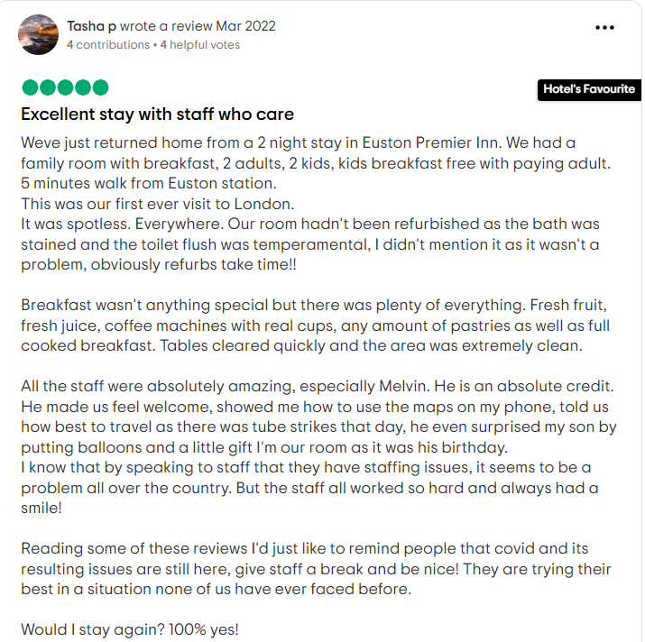
Figure 1: Response
(TripAdvisor, 2024)
Letter of complaint response
Respected sir/ma'am,
I have reduced other negative feedback that you have provided on the basics of the services that have been offered to you in the hotel Premier Inn. I am regretting and expressing sorry for the experiences that you have faced. The room number you stayed in was 330. I have seen that the room was unhygienic and it keeps the rate of disappointment for you in staying. The feedback on the room services is important for us to solve the issues and to provide better care for the customers. I am assuring that on visiting next time, we will provide you with the best in the classroom with proper maintenance of hygiene. The process of cleaning the bathroom will be improved by the working staff in our organisation. We have received your feedback on the Wi-Fi services of the hotel. I am sorry that you have faced the issues of slow speed in the internet connectivity. The services of the Wi-Fi and network will be checked by the technician and you will get satisfactory outcomes when you will visit us next time. I know that network services are crucial in the modern days and the issues faced by you have embarrassed our whole team. The major problem that you have faced in the Wi-Fi services is the lack of speed in quality and connectivity issues. I will discuss with the higher authorities how to increase the speed of the Wi-Fi with the implementation of high-speed digital services.
The valuable feedback of every customer is important to us. I have noticed that you have mentioned the sound problem in the rise of the noise level inside the room. I apologise for it again as is one of the major parts of our hotel services. Premier Inn is known for high-quality services to the customers and it has been a mistake from us that we were causal in the approach of providing the services to you. I have contacted the room designer and a meeting was held regarding the matter. The wall of the room has been found of average quality and the soundproofing was not up to the level. I assure you that we will change the system of soundproofing in this room and will check all the other rooms. The partitions of the wall were low and it affected your normal sleep during the sleeping time. I know that night's sleep is quite important to everyone and I ensure that on your next visit, all the problems will be solved we are expecting to provide you with a high-quality service. The level of the services to our customers matters the most. The complaint in your letter regarding the unresponsive of the staff is a huge problem and I understand the situation that you have faced. It is our deep responsibility to solve all the problems that have affected your stay in our hotel. Every feedback is important to us and I would like to thank you for the valuable feedback as it shows a range of mistakes in the management system. I hope all the issues will be resolved and we will be able to provide a whole new range of services at the time of your next visit.

Component Three:
Contribution to Overall Module Assessment: 50%
Key Skill 1 – Customer Service Skills

The work profile in the front office required several key skills that helped to perform the job with more accuracy and to provide superior facilities to the customer in the hotel. Customer service skills are one of the key skills that are required to ensure the rate of customer satisfaction. Customer service skills play a major role in the development of the management system (Lucas, 2022). Premier Inn is one of the premium hotels in the UK and the management system needs to be well-maintained in the industry. The services in the front office have a direct involvement in the process of providing customer services. The booking of the room and providing the hospitality services to the customer is done by the staff of the front office in the hotel. The relationships between the hotel representatives and the customer will be strong on cementing the services provided by the front office staff. Technical skills related to soft skills are one of the primary elements of customer service skills. The digital transformation has enhanced the services in the front office in a more relevant way (Carlisle et al., 2023). The service related to the collection of feedback and problem-solving is another important part of customer service skills. There are different numbers of guests in the hotel of Premier Inn and issues may occur to anyone. It is the duty of the front office to collect the feedback of the guest and to provide an evident solution.
Key Skill 2 – Communication Skills

Communication skills are one the most vital skills in the hospitality industry and it helps to communicate with the guests and the hotel staff. Communication skills are related to the development of interpersonal skills of the managers in the hotel and it helps to increase the performance of the employee (Weber et al., 2020). The essence of communication skills helps to develop a better process of interacting with the customers of the hotel industry. In the modern world of digitisation, the booking of a hotel room is done by the customers by the way of digital methods. Communication skills help to connect wot the customer in a more evident way on the digital platform. The gap in digital skills in the sector of hospitality can be reduced with an effective increase in communication skills (Minor et al., 2023). Premier Inn has a definite brand image in the hotel industry of the UK. The service related to luxury rooms and a family-friendly environment is the major highlighting point of the organisation (Premierinn, 2024). The skills of communication for the staff in the front office will help to promote the services to the customers. The satisfaction rate of the customers can be increased by providing premium services. Diversity management is one of the primary advantages of communication skills in the hotel industry (Nguyen et al., 2022). The team bonding can be developed in the organisation and helps to boost performance. There are increasing rate of competition in the hotel industry and the performance of the organisation is necessary to create a competitive advantage for the brand.
Key Skill 3 – Organisational Skills

Organisation skills are one of the key factors that help to increase the abilities of the staff in managing all the tasks more effectively. Organisation skills enable the way to set effective strategies in the work and to manage excessive workload (Billett, 2020). The work function in the front office of the hotel has a high amount of pressure to handle all the queries of the customers and to meet the demands. The skills of organising increase the capabilities to ensure the task priority and to manage a stipulated time for each task. The process of management helps to develop the arena of increasing customer services and increased experiences (Rahimian et al., 2021). Premier Inn in the aspects of maintaining the respective brand value in the market needs to increase the flow of the customers. The rise in the rate of customer satisfaction will help to generate the amount of revenue (Hammer, 2016). The arena of organisational skills opens the path to managing time and the workplace in a better way and to completing the interaction process with the customers. The development of the business of the organisation needs to attract a new range of customers and a group of investors. Organisation skills in the front office help to increase the supportive aspects of the customers and enable the arena to attract more customers to the hotel. The making of strategic moves will be able to develop to expand the business in more areas.
Key Skill 4 – Problem Solving Skills

Problem-solving skills are another vital skill that is needed to be present to keep the flow of customer services in hospitality management. Problem-solving skills help to develop the quality of emotional intelligence for the staff in the hospitality sector (Kırıcı Tekeli and Özkoç, 2022). The customers in the hotel may have issues regarding different departments of food and room services. The responsibility of the managers is to keep listening to the problems that have been faced by the customers and to provide them the effective solutions. There are different types of categories present in the part of problem-solving tasks involving the front office staff. The steps of identification of the problem, analysis of the problem and planning an effective solution are important to enhance problem-solving skills. The effect of extra load in the front office creates pressure for the staff in the front office to solve all the queries of the arriving visitors in the hotel. The count of the visitors is relatively high in Premier Inn due to the reason of high-quality services. The ability of the staff to communicate evidently with the customers helps to reduce the problems in a faster way. An effective view of customer service by solving problems will help to increase the rate of customer satisfaction. Guests are most important for organisations in the hotel industry and priority needs to be given to solving these issues. Enhancing the way of collecting the feedback from the guests is necessary to obtain the best strategy for problem-solving. It helps to improve the quality of the services for the guests in the organisation.

Reference List
Alcalde-González, V., Mozo, A.G. and Bustos, A.V., 2021. No clean rooms, no hotel business: Subversion tactics in Las Kellys’ struggle for dignity in hotel housekeeping. Annals of Tourism Research, 91, p.103315.
Andrade, M.S., Miller, D. and Westover, J.H., 2021. Job satisfaction factors for housekeepers in the hotel industry: a global comparative analysis. International Hospitality Review, 35(1), pp.90-108.
Bardi, J. 2011 Hotel Front Office Management, Wiley, London
Belias, D. and Trihas, N., 2022, April. Human Resource Training of Front Office Employees and Change Management in Hospitality Sector during Crisis. In FEMIB (pp. 101-106).
Billett, S., 2020. Learning in the workplace: Strategies for effective practice. Routledge.
Carlisle, S., Ivanov, S. and Dijkmans, C., 2023. The digital skills divide: evidence from the European tourism industry. Journal of Tourism Futures, 9(2), pp.240-266.
Corgel, JB, Sturman, MC and Verma, R. 2011 The Cornell School of Hotel Administration on Hospitality: Cutting Edge Thinking and Practice, John Wiley & Sons, Incorporated, Hoboken.
Cottrell, S., 2021. Skills for success: Personal development and employability. Bloomsbury Publishing.
Cunha, A. and Oliveira, M., 2021, May. Human Resources in the Housekeeping Department: A Case Study. In ICTR 2021 4th International Conference on Tourism Research (Vol. 158). Academic Conferences International.
Hammer, J. 2016 Revenue superstar! The simple rules of hotel revenue management. Great Britain: Amazon.
Hossain, M.S., Sambasivan, M., Abuelhassan, A.E. and Khalifa, G.S.A., 2023. Factors influencing customer citizenship behaviour in the hospitality industry. Annals of Leisure Research, 26(1), pp.65-88.
Kırıcı Tekeli, E. and Özkoç, A.G., 2022. The mediating role of emotional intelligence on the impact of perfectionism on problem-solving skills: an application for tourist guides. Journal of Hospitality and Tourism Insights, 5(3), pp.588-611.
Lucas, R., 2022. Customer service. McGraw-Hill US Higher Ed USE.
Minor, K., McLoughlin, E. and Carlisle, S., 2023. Digital Skills Gap–is it time to rethink the needs of tourism and hospitality organizations in the UK?.
Nguyen, N.T., Yadav, M., Pande, S., Bhanot, A. and Hasan, M.F., 2022. Impact of diversity management on organizational performance in hotel organizations: a conceptual framework. International Journal of System Assurance Engineering and Management, pp.1-11.
Premierinn, 2024. From booking to bed, we're here to help you rest easy [Online] Available at: <https://www.premierinn.com/gb/en/home.html> [Accessed on: 30tth January 2024]
Rahimian, S., ShamiZanjani, M., Manian, A. and Esfidani, M.R., 2021. A framework of customer experience management for hotel industry. International Journal of Contemporary Hospitality Management, 33(5), pp.1413-1436.
Solomon, M. 2018 The Heart of Hospitality. New York: SelectBooks, Inc.
Tripadvisor, 2024. Premier Inn London Euston Hotel [Online] Available at <https://https://www.tripadvisor.co.uk/Hotel_Review-g186338-d215522-Reviews-Premier_Inn_London_Euston_hotel-London_England.html> [Accessed on: 30tth January 2024]
Weber, M.R., Lee, J. and Crawford, A., 2020. A suggested best practices for enhancing performance of soft skills with entry-level hospitality managers. Anatolia, 31(1), pp.76-87.

