Transcription Exercise
Understanding the political nature of the British suffrage movement between 1900-1916, helps researchers decide which materials, resources and websites hold relevant information. Searching the National Archives, UK Parliamentary Archives, National Records of Scotland, and the Centre for Research Collections of the University of Edinburgh, results in multitudes of un-transcribed documents relating to the suffrage movements’ many activities.
All of the sources featured in this paper, are related to activities undertaken by suffrage campaigners. The documents have varied authors, recipients, and purposes. For example, Emiline Pankhurst’s letter to Prime Minister David Lloyd George, a Police report regarding a demonstration at the Houses of Parliament, or a letter from one campaigner to another. The common feature of these documents, is that they are all important pieces of historical information regarding the suffrage movement.
Each of these sources were hand written, and transcribing them required a large amount of patience, concentration, and effort. This was largely due to some very elaborate penmanship, phonetic spelling, corrections, and smudges. It was normal in this era to correspond via written communication (the equivalent to texting), and this resulted in some very illegible scrawls or the writing was so flourishful that the words are nearly illegible. In both the Pankhurst and Cecilia Wolseley Haig letters, individual words and letters often blended together. This made them obscure and changed the words, sentences, and their intent, until closer examination revealed them. As all three of these sources have been digitalised, using the computer to magnify the document really helped with the transcribing process.
Utilising exact transcription techniques, the sources have been recorded verbatim. This was to ensure that the intent of the writer was captured. Summarising and adjusting for spelling mistakes and repetition, would have ultimately altered the source. This would have meant that the document lost its relevance because it would have been the transcribers interpretation of the text, not the authors.
Document 1
The source featured below, is a handwritten police report filed by Chief Inspector C. Scantlebury of the Metropolitan Police. At the time, he was part of the Houses of Parliament detachment. It is addressed to the Sergeant at Arms, and dated 22nd November 1911. The report details the events relating to a suffrage protest, that took place inside and outside of the Houses of Parliament, and the response by the police that were present. There is also mention of the key figures involved, and their roles in the event. This report is significant because of the context of the protest.
In November of 1911 the second Conciliation bill had been defeated, and thus abandoned. The bill had been focused on expanding the voting requirements for men, with a proposed amendment for female suffrage. The bill’s failure, and the ever increasing physically, and at times barbaric treatment the authorities dealt with suffrage campaigners, protesters, activists, and prisoners, led to an increase in scale and ferocity of the organised demonstrations. This Parliament protest, was the start of a series of organised, largescale, window smashing campaigns implemented by the WSPU. These resulted in thousands of pounds in damage, and were defined by Emiline Pankhurst, leader of the WSPU, as critical. She stated “‘The argument of the broken pane of glass’, Mrs Pankhurst told members of the WSPU, ‘is the most valuable argument in modern politics”.
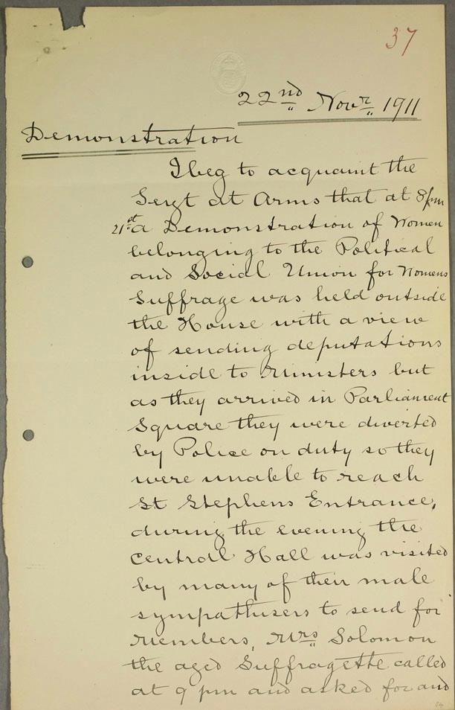
(Page 1)
Parliamentary Archives, UK Parliament, “Demonstration in Parliament Square”, November 22nd 1911, HC/SA/SJ/10/12 item 37, (Accessed December 21st 2023), Available from: https://www.parliament.uk/about/living-heritage/transformingsociety/electionsvoting/womenvote/parliamentary-collections/collections-suffragettes/parliament-square/

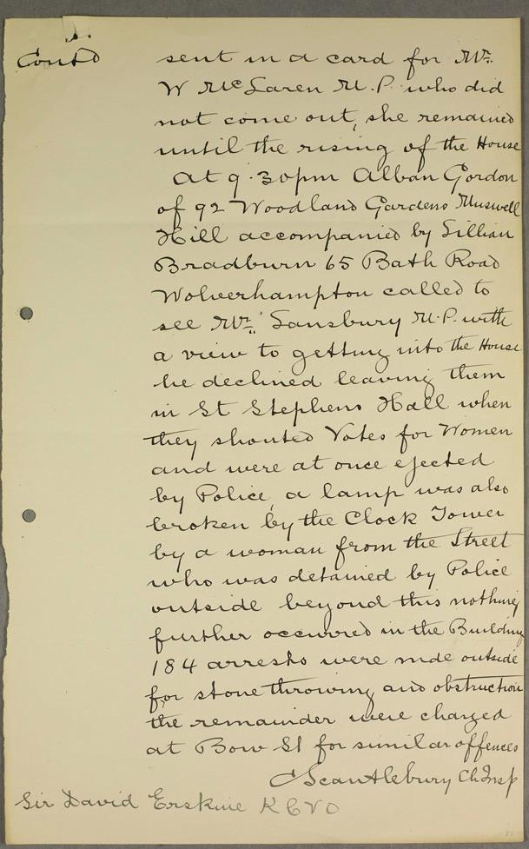
(Page 2)
Parliamentary Archives, UK Parliament, “Demonstration in Parliament Square”, November 22nd 1911, HC/SA/SJ/10/12 item 37, (Accessed December 21st 2023), Available from: https://www.parliament.uk/about/living-heritage/transformingsociety/electionsvoting/womenvote/parliamentary-collections/collections-suffragettes/parliament-square/

22nd Nov 1911
Demonstration
I beg to acquaint the Sergt at arms that at 8pm 21st a demonstration of women belonging to the Political and Social Union for womens suffrage was held outside the house with a view of sending deputations inside to ministers but as they arrived in Parliament square they were diverted by Police on duty so they were unable to reach St Stephens Entrance, during the evening the Central Hall was visited by many of their male sympathisers to send for members, Mrs Solomon the aged Suffragette called at 9pm and asked for and
Contd
sent in a card for Mr W Mc Saren M.P. who did not come out, she remained until the rising of the House at 9.30pm alban Gordon of 92 Woodland Gardens Muswell Hill accompanied by Sillian Bradburn 65 Bath Road Wolverhampton called to see W Sansbury M.P. with a view to getting into the House he declined leaving them in St Stephens Hall when they shouted Votes for women and were at once ejected by Police a lamp was also broken by the clock tower by a woman from the street who was detained by Police outside beyond this nothing further occurred in the building 184 arrests were made outside for stone throwing and obstruction the remainder were charged at Bow St for similar offences
C Scantlebury Ch Insp
Sir David Erskine K.C.V.O

Document 2
In order to function well, National organisations require regional branches that support and expand their membership, the suffrage movement was no different. Numerous factions operated throughout the UK, and members would hold meetings, organise rallies and arrange demonstrations. The groups welcomed all classes of society into their association. One of these groups was the Women’s Social Political Union (WSPU), and Cecillia Wolseley Haig the main author of this source was an active member.
The letter featured below was written in 1908 by Haig, to Caroline Louise Lorimer. The recipient was a highly educated member of the “Edinburgh National Society for Women’s Suffrage”, and she appears to have formulated her response after Haig had finished writing (using the same piece of paper). Lorimer, later in life, advocated peacefully, for the enfranchisement of women.
Considering Wolseley Haig was the daughter of a barrister, her writing in this letter was very hard to read. It is obvious that she frequently corresponded, as there are few spelling mistakes, rarely phonetically spelt words, and no ink smudges or blots on the letter. There are occurrences when she has forgotten to add words or information, but she has corrected herself. She appears to have quickly written this letter, as most of the words and sentences are elongated (nearly to the point of squiggly lines). These factors combined, highlight the fact that the main author was very accustomed to writing. Lorimer’s script is also written in ink, and is slightly easier to read. It is bigger and bolder than Haig’s, and more spaced out,
Magnification of the text was frequently needed to transcribe this letter and response. The contents are the two women trying to arrange a mutually convenient time to meet, future suffrage events and a suffrage protester in prison. However, research showed that Florence (the prisoner in Holloway), was Cecillia’s sister. She had been sentenced and imprisoned for undertaking destructive acts of protest. Ms Lorimer’s response, “Isn’t it loathsome? Think of an educated woman like Florence Haig kicking + biting + brawling till she’s locked up; showing she’s fit to make the laws by breaking them; fine logic”, highlights the divide in opinion of suffrage campaigners, between the route of passive peaceful or direct destructive protest.

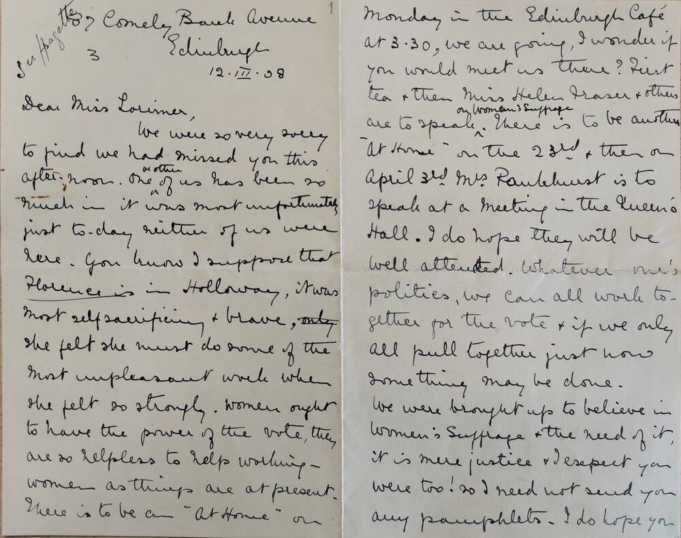

(Page 1. 2)
Centre for Research Collections, University of Edinburgh, “Letter dated 12 March 1908 from Cecilia Wolseley Haig to Caroline Louise Lorimer, Lorimer Family Letters, 1870s–1930s”, March 12th 1908, Collection 27, MS 2482, Available from: Cora Alexander, “A letter from a suffragette”, National Trust for Scotland, August 11th 2022, (Accessed December 18th 2023), Available from: https://www.nts.org.uk/stories/a-letter-from-a-suffragette

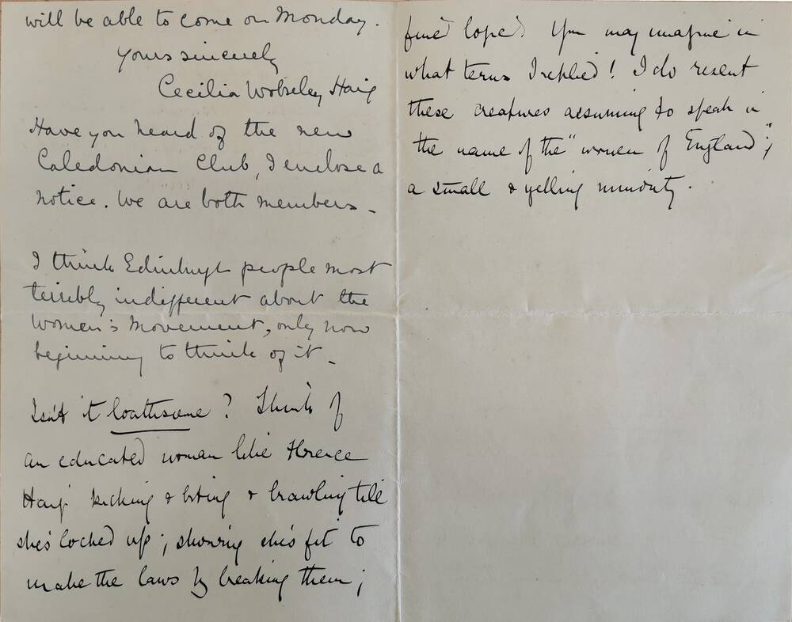
(Page 3, 4)
Centre for Research Collections, University of Edinburgh, “Letter dated 12 March 1908 from Cecilia Wolseley Haig to Caroline Louise Lorimer, Lorimer Family Letters, 1870s–1930s”, March 12th 1908, Collection 27, MS 2482, Available from: Cora Alexander, “A letter from a suffragette”, National Trust for Scotland, August 11th 2022, (Accessed December 18th 2023), Available from: https://www.nts.org.uk/stories/a-letter-from-a-suffragette

Suffragette 87 Comely Bank Avenue
3 Edinburgh
12.III.08
Dear Miss Lorimer,
We were so verry sorry to find we had missed you this afternoon. One or other of us has been to lunch in it was most unfortunately just today neither of us were here. You know I support that Florence is in Holloway, it was most self-sacrificing + brave, (only) she felt she must do some of the most unpleasant work when she felt so strongly. Women ought to have the power of the vote, they are so helpless to help working – women as things are at present. There is to be an “at home” on Monday in the Edinburgh café at 2.30, we are going, I wonder if you would meet us there? Just tea + then miss Hellen Hasen + others are to speak (>) on women’s suffrage. There is to be another “at home” on 23rd + then on April 3rd Mrs Pankhurst is to speak at a meeting in the queen’s. I do hope they will be well attended. Whatever one’s politics, we can all work to-gether for the vote + if we only all pull together just now something may be done.
We were brought up to believe in women’s suffrage + the need of it, it is mere justice + I expect you were too! So I need not send you any pamphlets. I do hope you will be able to come on Monday,
Yours sincerely
Cecillia Wolseley Haig
Have you heard of the new Caledonian Club, I enclose a notice. We are both members.
I think Edinburghs people most terribly indifferent about the women’s movement, only now beginning to think of it.
Isn’t it loathsome? Think of an educated woman like Florence Haig kicking + biting + brawling till she’s locked up; showing she’s fit to make the laws by breaking them; fine logic. You may imagine in what terms I replied! I do resent these creatures assuming to speak in the name of the “women of England”, a small + yelling minority.

Document 3
Between 1914-1918, World War I ravaged Europe. Millions of men and boys answered the call to fight, in what would be called the “great war”. With the men gone, the nation needed women to fill their positions in the workplace. It is estimated that nearly “two million women took on jobs which had been previously been filled by men, an increase from 24 per cent of women in employment in July 1914 to 37 per cent by November 1918”. They worked in munitions factories, and as firefighters, nurses, farmers, and every other essential area that meant the country survived. A temporary cessation of the suffrage movement was initiated, even the WSPU ceased their actions. As “Emmeline Pankhurst suspended the activities of the Women's Social and Political Union and concentrated her efforts on helping the government recruit women into war work”.
This letter from Pankhurst to Prime Minister, David Lloyd George, is undated, however, the contents place it just before he formed his cabinet in 1916. This was a very difficult source to transcribe, because of the handwriting. Written in ink on unlined paper, the lines of text are uneven, sometimes faint, sometimes bold and in some places nearly illegible. Knowing the context of this letter, helped the deciphering of its contents. Again, the ability to magnify the document had enormous benefits regarding this source, as it helped ascertain what a squiggle was trying to represent.

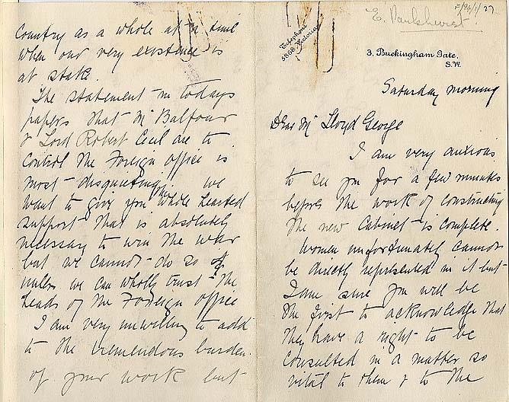
(Page 1, 2)
Parliamentary Archives, UK Parliament, “Letter from Emmeline Pankhurst to Lloyd George”, December 1916, LG/F/94/1/27, (Accessed December 20th 2023), Available from: https://www.parliament.uk/about/living-heritage/transformingsociety/electionsvoting/womenvote/parliamentary-collections/collections-suffragettes/emmeline-pankurst-letter/

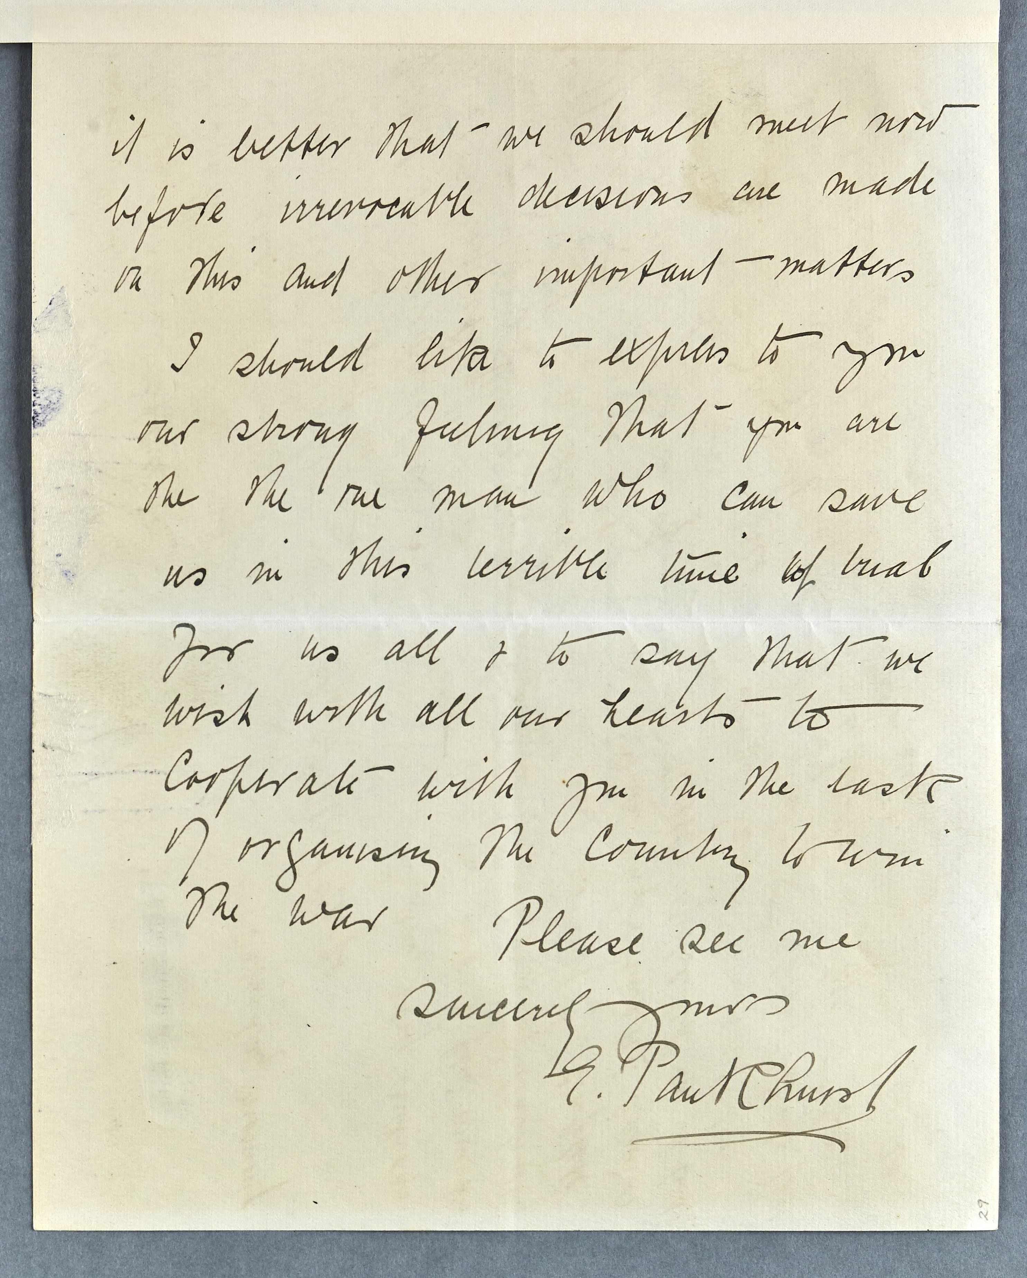
(Page 3)
Parliamentary Archives, UK Parliament, “Letter from Emmeline Pankhurst to Lloyd George”, December 1916, LG/F/94/1/27, (Accessed December 20th 2023), Available from: https://www.parliament.uk/about/living-heritage/transformingsociety/electionsvoting/womenvote/parliamentary-collections/collections-suffragettes/emmeline-pankurst-letter/

.
(? Library Reference written in pencil) F/24/1/27
E. Pankhurst.
Telephone
3568 Victoria
3. Buckingham Gate.
S.W.
Saturday morning
Dear Mr Lloyd George
I am very anxious to see you for a few moments before the work of instructing the new cabinet is complete. Women unfortunately cannot be directly represented in it but – I am sure you will be the first to acknowledge that they have a right to be consulted in a matter so vital to them + to the country as a whole at a time when our very existence is at stake.
The statement in todays papers that Mr Balfour + Lord Robert Cecil are to contact the foreign office is most – disquieting. We want to give you the whole hearted support – that is absolutely necessary to win the war but we cannot – do so (if) unless we can wholly trust - the heads of the Foreign Office.
I am very unwilling to add to the horrendous burden of your work but it is better that we should meet now before irreversible decisions are made to this and other important – matters
I should like to express to you our strong feeling that you are the the one man who can save us in this terrible time of hurt for us all + to say that we wish with all our hearts – to cooperate – with you in the task of organising the country to win the war
Please see me
Sincerely yours
E. Pankhurst

Numerous notable aspects can be garnered from the process of transcribing, analysing, and understanding each of the sources featured above. The “Police Report” provides insight into how the authorities responded to, and documented interactions / arrests with suffrage protesters. Although comprehensive, this report notably lacks punctuation, something that we would expect from an official document. This oversight could be because it was compiled quickly, to inform the relevant people directly.
The second source, the Haig letter, highlights a more personal aspect of the suffrage movement. It shows an insight into the relations between the different groups. We gain an appreciation of the difference in approaches, and opinions of the individuals who supported either peaceful, militant, or direct actions. This letter also provides an insight into the support a suffrage prisoner received from her peers and suffrage community.
Document three, highlights the political nature of the suffragettes and suffragist groups. Leading, notable campaigners wholeheartedly supported the reorganisation of the country during WW1. This letter from Pankhurst to Lloyd George, agreed that women would be vital to the country, and would willingly step up. However, the key point being, that the women’s groups contributions would ultimately be remembered and rewarded later.
.

References
Centre for Research Collections, University of Edinburgh, “Letter dated 12 March 1908 from Cecilia Wolseley Haig to Caroline Louise Lorimer, Lorimer Family Letters, 1870s–1930s”, March 12th 1908, Collection 27, MS 2482, Available from: Cora Alexander, “A letter from a suffragette”, National Trust for Scotland, August 11th 2022, (Accessed December 18th 2023), Available from: https://www.nts.org.uk/stories/a-letter-from-a-suffragette
Ellen Castelow, “World War One: Women at War”, Historic UK, January 20th 2015, (Accessed December 19th 2023), Available from: https://www.historic-uk.com/HistoryUK/HistoryofBritain/World-War-One-Women-at-War/
Parliamentary Archives, UK Parliament, “Demonstration in Parliament Square”, November 22nd 1911, HC/SA/SJ/10/12 item 37, (Accessed December 21st 2023), Available from: https://www.parliament.uk/about/living-heritage/transformingsociety/electionsvoting/womenvote/parliamentary-collections/collections-suffragettes/parliament-square/
Parliamentary Archives, UK Parliament, “Letter from Emmeline Pankhurst to Lloyd George”, December 1916, LG/F/94/1/27, (Accessed December 20th 2023), Available from: https://www.parliament.uk/about/living-heritage/transformingsociety/electionsvoting/womenvote/parliamentary-collections/collections-suffragettes/emmeline-pankurst-letter/
UK Parliament, “Suffrage in wartime”, www.parliament.uk, (Accessed December 20th 2023), Available from: https://www.parliament.uk/about/living-heritage/transformingsociety/electionsvoting/womenvote/overview/suffragetteswartime/#:~:text=At%20the%20outbreak%20of%20the,recruit%20women%20into%20war%20work.
Vicky Iglikowski-Broad, Katie Fox, Rowena Hillel, “Suffragettes, 1912: ‘Rather broken windows than broken promises’”, The National Archives, March 9th 2018, (Accessed December 2nd 2023), Available from: https://blog.nationalarchives.gov.uk/rather-broken-windows-broken-promises/

Bibliography
Alwyn Collinson, “How Black Friday changed the Suffragette struggle”, Museum of London, November 14th 2018, (Accessed December 1st 2023), Available from: Https://www.museumoflondon.org.uk/discover/black-friday
Biography.com Editors, “Emmeline Pankhurst Biography”, Biography, April 2nd 2014, (Accessed November 22nd 2023), Available from: https://www.biography.com/activists/emmeline-pankhurst
Centre for Research Collections, University of Edinburgh, “Letter dated 12 March 1908 from Cecilia Wolseley Haig to Caroline Louise Lorimer, Lorimer Family Letters, 1870s–1930s”, March 12th 1908, Collection 27, MS 2482, Available from: Cora Alexander, “A letter from a suffragette”, National Trust for Scotland, August 11th 2022, (Accessed December 18th 2023), Available from: https://www.nts.org.uk/stories/a-letter-from-a-suffragette
C. J. Bearman, “An Examination of Suffragette Violence”, The English Historical Review, Volume 120, Number 486, Pages 365-397, April 2005, (Accessed December 11th 2023), Available from: https://www.jstor.org/stable/3490924
Ellen Castelow, “No Vote, No Census – 1911 Census Protests”, Historic UK, February 22nd 2015, (Accessed November 25th 2023), Available from: https://www.historic-uk.com/HistoryUK/HistoryofBritain/No-Vote-No-Census-1911-Census-Protests/
Ellen Castelow, “World War One: Women at War”, Historic UK, January 20th 2015, (Accessed December 19th 2023), Available from: https://www.historic-uk.com/HistoryUK/HistoryofBritain/World-War-One-Women-at-War/
Hansard, UK Parliament, “Parliamentary Franchise (Women) Bill.”, March 28th 1912, volume 36, cc615-731, (Accessed November 26th 2023), Available from: https://api.parliament.uk/historic-hansard/commons/1912/mar/28/parliamentary-franchise-women-bill#S5CV0036P0_19120328_HOC_305
Helen Alice Douglas, “Lloyd George and the Suffragette Bomb Outrage”, Exploring Surreys Past, (Accessed December 8th 2023), Available from: https://www.exploringsurreyspast.org.uk/themes/subjects/womens-suffrage/the-womens-suffrage-movement-in-surrey-new/activism-and-militant-suffragettes-in-surrey/lloyd-george-and-the-suffragette-bomb-outrage/#:~:text=Lloyd%20George%20writes%20in%20the,issues%2C%20like%20the%20housing%20problem.
Historic Newspapers, “A History of the Daily Mirror”, www.historic-newspapers.co.uk, November 3rd 2021, (Accessed December 10th 2023), Available from: https://www.historic-newspapers.co.uk/blog/daily-mirror-history/
Karen Manners Smith, “Women’s Social and Political Union”, Britannica, October 15th 2014, (Accessed November 23rd 2023), Available from: https://www.britannica.com/topic/Womens-Social-and-Political-Union
Katherine E. Kelly, “Seeing Through Spectacles: The Woman Suffrage Movement and London Newspapers, 1906–13”, The European journal of women's studies, Volume 11, Issue 3, Pages 327-353, 2004, (Accessed December 9th 2023), Available from: https://journals-sagepub-com.ezproxy.uwtsd.ac.uk/doi/abs/10.1177/1350506804044466
Kathleen Kuiper, “Emily Davison”, Britannica, April 22nd 2013, (Accessed November 22nd 2023), Available from: https://www.britannica.com/biography/Emily-Davison
Lyndsey Jenkins, “Lady Constance Lytton: 1869-1923 – Lyndsey Jenkins”, Women’s’ History Network, May 23rd 2023, (Accessed November 21st 2023), Available from: https://womenshistorynetwork.org/lady-constance-lytton-1869-1923-lyndsey-jenkins/
Museum of London, London, “Daily Sketch”, June 9th 1913, 2003.46/188, (Accessed November 22nd 2023), Available from: https://collections.museumoflondon.org.uk/online/object/748733.html
Museum of London, London, “Photograph”, 1909, NN22684, (Accessed November 22nd 2023), Available from: https://collections.museumoflondon.org.uk/online/object/496521.html
Museum of London, London, “Public Meeting, Steinway Hall”, 1909-1911, 50.82/686, (Accessed November 25th 2023), Available from: https://collections.museumoflondon.org.uk/online/object/287785.html
Museum of London, London, “Rebellion To Tyrants is Obedience to God”, 1909, NN22641, (Accessed November 22nd 2023), Available from: https://collections.museumoflondon.org.uk/online/object/453961.html
Museum of London, London, “The Daily Mirror”, 1912, 2008.1/19, (Accessed November 24th 2023), Available from: https://collections.museumoflondon.org.uk/online/object/772371.html
Museum of London, London, “The Tactics of the Suffragettes”, 1907-1910, 50.82/538, (Accessed November 24th 2023), Available from: https://collections.museumoflondon.org.uk/online/object/287124.html
Museum of London, London, “Votes for Women, men & Women help the Suffragettes to Rush the House of Commons”, 1908, 50.82/647b, (Accessed November 22nd 2023), Available from: https://collections.museumoflondon.org.uk/online/object/477502.html
National Record of Scotland, Scotland, “The letters and diaries of Lady Frances Balfour, a selection”, 1907-1918, (Accessed December 15th 2023), Available from: https://www.nrscotland.gov.uk/files/exhibitions/women-suffrage/gd433.html
Parliamentary Archives, UK Parliament, “Demonstration in Parliament Square”, November 22nd 1911, HC/SA/SJ/10/12 item 37, (Accessed December 21st 2023), Available from: https://www.parliament.uk/about/living-heritage/transformingsociety/electionsvoting/womenvote/parliamentary-collections/collections-suffragettes/parliament-square/
Parliamentary Archives, UK Parliament, “Letter from Emmeline Pankhurst to Lloyd George”, December 1916, LG/F/94/1/27, (Accessed December 20th 2023), Available from: https://www.parliament.uk/about/living-heritage/transformingsociety/electionsvoting/womenvote/parliamentary-collections/collections-suffragettes/emmeline-pankurst-letter/
Parliamentary Archives, UK Parliament, “1918 Representation of the People Act, second page”, February 6th 1918, HL/PO/PU/1/1918/7&8G5c64, (Accessed November 26th 2023), Available from: https://www.parliament.uk/about/living-heritage/transformingsociety/electionsvoting/womenvote/case-study-the-right-to-vote/the-right-to-vote/birmingham-and-the-equal-franchise/1918-representation-of-the-people-act/1918-representation-of-the-people-act-second-page/
Robert Norman William Blake, “David Lloyd George”, Britannica, November 16th 2001, (Accessed December 18th 2023), Available from: https://www.britannica.com/biography/David-Lloyd-George
Spartacus Education, “The Conciliation Bill: 1910-1912”, spartacus-educational.com, (Accessed December 5th 2023), Available from: https://spartacus-educational.com/Conciliation.htm
Suffragette Stories, “Cecilia Haig”, suffragettestories.omeka.net, (Accessed December 19th 2023), Available from: https://suffragettestories.omeka.net/bio-cecilia-haig
Tara Morton, “Suffrage Societies Database Guide”, Women's Suffrage Project, (Accessed December 3rd 2023), Available from: https://www.suffrageresources.org.uk/resource/3231/suffrage-societies-database-guide
The Editors of Encyclopaedia Britannica, “women’s suffrage”, Britannica, February 28th 2022, (Accessed November 23rd 2023), Available from: https://www.britannica.com/topic/woman-suffrage
The National Archives, London, “‘Black Friday’ statement, 1”, November 18th 1910, MEPO 3/203, (Accessed November 22nd 2023), Available from: https://www.nationalarchives.gov.uk/education/resources/suffragettes-on-file/black-friday-statement-1/
The National Archives, London, “‘Black Friday’ statement, 2”, November 18th 1910, MEPO 3/203, (Accessed November 21st 2023), Available from: https://www.nationalarchives.gov.uk/education/resources/suffragettes-on-file/black-friday-statement-2/
The National Archives, London, “‘Bomb at St Paul’s’”, May 8th 1913, HO 45/10700/236973, (Accessed December 1st 2023), Available from: https://www.nationalarchives.gov.uk/education/resources/suffragettes-on-file/bomb-at-st-pauls/
The National Archives, London, “Census Boycott”, 1911, RG14-118, (Accessed November 22nd 2023), Available from: https://www.nationalarchives.gov.uk/education/resources/suffragettes-on-file/census-boycott/
The National Archives, London, "Divisions in Prison”, May 1909, ZPER 34/134, (Accessed November 21st 2023), Available from: https://www.nationalarchives.gov.uk/education/resources/suffragettes-on-file/divisions-in-prison/
The National Archives, London, “‘Fierce attacks on women’”, September 23rd 1913, HO 45/10689/228470, (Accessed December 3rd 2023), Available from: https://www.nationalarchives.gov.uk/education/resources/suffragettes-on-file/fierce-attacks-on-women/
The National Archives, London, “Hiding in Parliament”, April 6th 1910, WORK 11/117, (Accessed November 22nd 2023), Available from: https://www.nationalarchives.gov.uk/education/resources/suffragettes-on-file/hiding-in-parliament/
The National Archives, London, “Instructions for arrest”, February 28th 1912, DPP 1/23, (Accessed November 22nd 2023), Available from: https://www.nationalarchives.gov.uk/education/resources/suffragettes-on-file/instructions-for-arrest/
The National Archives, London, “Lady Constance Lytton”, December 8th 1911, HO 144/1119/203651, (Accessed November 23rd 2023), Available from: https://www.nationalarchives.gov.uk/education/resources/suffragettes-on-file/lady-constance-lytton/
The National Archives, London, “‘Pillar-box militancy’”, December 20th 1912, ASSI 52/212, (Accessed November 23rd 2023), Available from: https://www.nationalarchives.gov.uk/education/resources/suffragettes-on-file/pillar-box-militancy/
The National Archives, London, “Postman burnt by acid”, May 1913, TS 27/19, (Accessed December 1st 2023), Available from: https://www.nationalarchives.gov.uk/education/resources/suffragettes-on-file/postman-burnt-by-acid/
The National Archives, London, “Suffragettes at Number 10”, June 9th 1906, MEPO2/1016, (Accessed November 22nd 2023), Available from: https://www.nationalarchives.gov.uk/education/resources/suffragettes-on-file/suffragettes-at-number-10/
The National Archives, London, “Women speak out”, September 23rd 1913, HO 45/10689/228470, (Accessed December 4th 2023), Available from: https://www.nationalarchives.gov.uk/education/resources/suffragettes-on-file/women-speak-out/
The National Archives, “The Suffragettes: Deeds not words”, Learning Curve, (Accessed December 4th 2023), Available from: https://www.nationalarchives.gov.uk/documents/education/suffragettes.pdf
UK Parliament, “'Deeds not words'”, www.parliament.uk, (Accessed December 4th 2023), Available from: https://www.parliament.uk/about/living-heritage/transformingsociety/electionsvoting/womenvote/overview/deedsnotwords/
UK Parliament, “Start of the suffragette movement”, www.parliament.uk, (Accessed December 4th 2023), Available from: https://www.parliament.uk/about/living-heritage/transformingsociety/electionsvoting/womenvote/overview/startsuffragette-/
UK Parliament, “Suffrage in wartime”, www.parliament.uk, (Accessed December 20th 2023), Available from: https://www.parliament.uk/about/living-heritage/transformingsociety/electionsvoting/womenvote/overview/suffragetteswartime/#:~:text=At%20the%20outbreak%20of%20the,recruit%20women%20into%20war%20work.
UK Parliament, “Women and the vote”, www.parliament.uk, (Accessed December 4th 2023), Available from: https://www.parliament.uk/about/living-heritage/transformingsociety/electionsvoting/womenvote/#:~:text=These%20two%20groups%20were%20the,acts%20which%20attracted%20much%20publicity.
UK Parliament, “Women get the vote”, www.parliament.uk, (Accessed December 7th 2023), Available from: https://www.parliament.uk/about/living-heritage/transformingsociety/electionsvoting/womenvote/overview/thevote/
UK Parliament, “Women's Freedom League”, www.parliament.uk, (Accessed December 4th 2023), Available from: https://www.parliament.uk/about/living-heritage/transformingsociety/electionsvoting/womenvote/overview/womens-freedom-league/
University of Bath Library, “Working with data: Transcription”, University of Bath, December 7th 2023, (Accessed December 19th 2023), Available from: https://library.bath.ac.uk/research-data/working-with-data/transcription
University of the Arts London, “The Daily Sketch”, collections.arts.ac.uk, (Accessed December 8th 2023), Available from: https://collections.arts.ac.uk/people/10128/the-daily-sketch;jsessionid=747B2E8B3274403EA405C591288755E7
Vicky Iglikowski-Broad, Katie Fox, Rowena Hillel, “Suffragettes, 1912: ‘Rather broken windows than broken promises’”, The National Archives, March 9th 2018, (Accessed December 2nd 2023), Available from: https://blog.nationalarchives.gov.uk/rather-broken-windows-broken-promises/

Vicky Iglikowski-Broad, Katie Fox, Rowena Hillel, “Suffragettes, 1912: ‘Rather broken windows than broken promises’”, The National Archives, March 9th 2018, (Accessed December 2nd 2023), Available from: https://blog.nationalarchives.gov.uk/rather-broken-windows-broken-promises/
Centre for Research Collections, University of Edinburgh, “Letter dated 12 March 1908 from Cecilia Wolseley Haig to Caroline Louise Lorimer, Lorimer Family Letters, 1870s–1930s”, March 12th 1908, Collection 27, MS 2482, Available from: Cora Alexander, “A letter from a suffragette”, National Trust for Scotland, August 11th 2022, (Accessed December 18th 2023), Available from: https://www.nts.org.uk/stories/a-letter-from-a-suffragette
Ellen Castelow, “World War One: Women at War”, Historic UK, January 20th 2015, (Accessed December 19th 2023), Available from: https://www.historic-uk.com/HistoryUK/HistoryofBritain/World-War-One-Women-at-War/
UK Parliament, “Suffrage in wartime”, www.parliament.uk, (Accessed December 20th 2023), Available from: https://www.parliament.uk/about/living-heritage/transformingsociety/electionsvoting/womenvote/overview/suffragetteswartime/#:~:text=At%20the%20outbreak%20of%20the,recruit%20women%20into%20war%20work.

