Why is Information Design important? Explore how Information Design helps to shape the world around us as well as our understanding of it.
Student Number: 2403969
BA Course title: Research in Context
Word Count: 2520
Lecturer’s name: Donna Williams
For this assessment, I confirm that I have NOT used Generative AI to support me in structuring my submission, including creating a draft argument structure, identifying parts and headings.
I confirm that I have not used Generative AI to create text for my submission. I confirm that I have not used Generative AI for creative materials, such as images.

Content list
List of figures ........................................................................................................... 3
Introduction ............................................................................................................... 4
Chapter One: Prehistoric Cave Art as Early Information Design .............................. 5
Chapter Two: Cuneiform and the Origins of Design Information Systems ............... 7
Chapter Three: Hieroglyphs: From Image to Symbol .............................................. 9
Chapter Four: Continuities and Changes in the Design Landscape ....................... 11
Conclusion ............................................................................................................... 19
Bibliography ............................................................................................................. 20

List of illustrations
Figure 1: Sevela.P, (2016) , The Dun Horse, World History, Available at: https://www.worldhistory.org/image/5589/painting-of-a-horse-lascaux-cave/ (Accessed 1/12/2025)
Figure 2: Alveraz, S, (2021), The Altamira Bull, Ancient Archive, Available at: https://www.ancientartarchive.org/altamira-cave-spain/ (Accessed 1/12/2025)
Figure 3: Puhvel, J (2025), Sumerian cuneiform tablet, Britannica, Available at https://www.britannica.com/topic/cuneiform (Accessed 1/12/2025)
Figure 4: Loureiro, A (2023) Hieroglyphs, Medium, Available at https://medium.com/mythology-journal/the-mystical-power-of-hieroglyphs-919f1f5d3bf0 (Accessed at 1/12/2025
Figure 5: The DOT pictograms from the United States Department of Transportation, Medium Available at: https://medium.com/design-bootcamp/pictograms-symbols-and-icons-in-ui-design-2d0797f7076f (Accessed at 1/12/2025)
Figure 6: Hewitt, C, 2022, Give me a sign, Available at: https://www.cooperhewitt.org/2022/12/15/give-me-a-sign-the-language-of-symbols-exhibition-to-open-this-spring-at-cooper-hewitt/ (Accessed at 1/12/2025)
Figure 7: Different animals in the Lascaux (2016) Available at https://www.ibtimes.co.uk/lascaux-cave-paintings-new-replica-prehistoric-wonders-open december-2016-1547525. (Accessed at 29/11/2025)
Figure 8: Animal Warning Traffic Signs (2024). Available at: https://www.shutterstock.com/image-vector/animal-signs-element-design-templates-2473386677?trackingId=dfc5cb86-bcbf-4204-81c0-c0e54c19fe25 (Accessed at 1/12/2025)
Figure 9: A count of goats and rams in cuneiform script (2018) Available at https://www.historyextra.com/period/ancient-egypt/cuneiform-6-things-you-probably-didnt-know-about-the-worlds-oldest-writing-system/. (Accessed: 29.11.2025)
Figure 10: Sherbina, N, (2023) Best 7 Airport Wayfinding Signage, Available at: https://www.aiscreen.io/airport/best-airport-wayfinding-signage/ (Accessed: 1/12/2025)
Figure 11: Brecelj, B (2016) Decoding the Secrets of Ancient Egyptian Hieroglyphs, Available at https://news.artnet.com/art-world/the-hunt-how-to-read-hieroglyphs-2673593 ( Accessed at 1/12/2025)
Figure 12: Clay, (2024) 5 Pro Tips to Improve your Logo Design Fast Available at: https://clay.global/blog/improve-logo-design (Accessed at 1/12/2025)

Introduction
Information design is something that is constantly around us, whether it is advertisements or books or any other form of media, and screens that dominate modern-day media. It shapes how we understand the world around us, sharing the knowledge that we have with the masses. The International Institute for Information Design defines information design as “design thinking to solve complex communication problems, and so to improve every aspect of human life.” You can see it when we look at our past and how we evolved; we can see that information design has always played an important role in our development. This essay will explore how information design developed from prehistoric communication to contemporary practice through the exploration of symbolism, clarity and abstraction.

Chapter One: Prehistoric Cave Art as Early Information Design
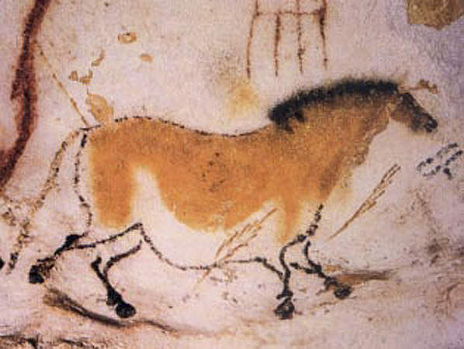
Figure 1: The Dun Horse Painting (2016)
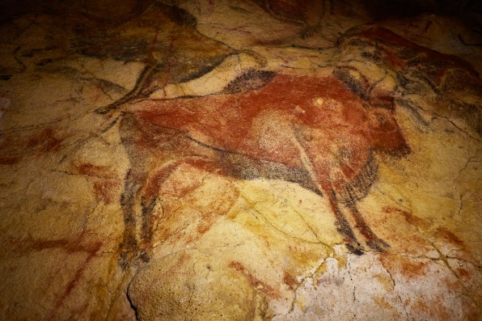
Figure 2: Altamira bull (2021)
Hurlburt (2011) notes that “pictorial histories on cave and other dwelling walls constitute the earliest forms of preserved communication”. This implies that these painters had an intention behind their works. When looking at the infamous cave paintings as shown in figures 1 and 2, we can see that the markings on these animals are quite prominent and that they stand out. The precision of these animal paintings shows how an early human recognised that this animal held significance for the community, and these pieces aren’t small; they are rather quite large pieces, further implying their importance. Miyagawa et al (2018) suggest that these paintings are an early form of cross-modal information transfer.
This is the process of information that is gained through one sense (such as sound) that helps improve the processing of information better through another sense (such as visual representation). These scholars are suggesting that these cavemen or women translated environmental sounds from these animals into visual icons.
While not definitive, we can gather that cave paintings were an early form of information design, as the animals that are depicted the most, such as horses or bison, have a strong and distinct sound to them. Whitworth (2001) suggests that “when early humans drew their cave paintings at sites such as the Lascaux, they made fundamental changes to the process of exchanging information”. This reinforces that early humans wanted to communicate about their surroundings to other members of their community. Combining these theories, we can infer that these early designers wanted to communicate about these animals to other members of their group. These visuals may have functioned to communicate about food, or just alert others of what is in the surrounding environment, which is supported by Adir, G, et al (2022). The need for communication shows that they were also starting to realise that their chances of survival are better if they are all together. These theories suggest that these artworks were functional cognitive tools and not just artistic expressions. As the creators of signs, symbols and pictograms as Adir, G, et al (2022) went on to describe us, combined with the previous theories, we can see intention and richness in meaning; this is one of the many foundations of information design. These early designers take a common sighting, something that requires caution and depict it on a large scale to be easily visible and quickly understood. In this sense, prehistoric cave paintings represent some of the earliest known examples of information design.

Chapter Two: Cuneiform and the Origins of Design Information Systems
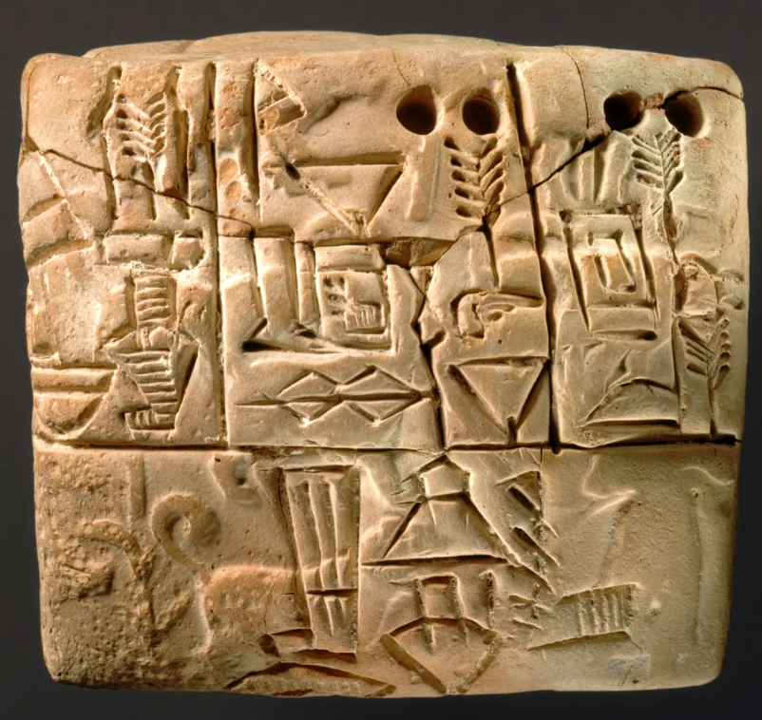
Figure 3, Sumerian Cuneiform tablet, (2025)
These early visual systems laid out the groundwork for structured forms of communication, and as societies became more complex, methods of recording and organising information evolved to meet their needs. This evolution resulted in one of the earliest preserved writing systems: Sumerian Cuneiform. Schmandt-Besserat (1982) argues that tokens made of clay were needed for durable record-keeping, which then encouraged the development into tablets. Archaeologists found clay tokens in “various shapes” (Schmandt-Besserat, 1982) that functioned as counters; different forms represented different goods. Over time, these token systems were abstracted into inscribed markings on clay tablets, a medium that enabled information to be consolidated. This resulted in making the information manageable, shareable, and enabling societies to function at a larger and more complex scale, as we do in the modern world.

Schmandt-Besserat found a cuneiform tablet listing and counting various livestock items.
The “hollow tablet - or envelope, a list written in cuneiform script itemized 48 animals, obviously corresponding to the 48 counters. The list read: n21 ewes, 6 female lambs, 8 full grown rams,4 male lambs, 6 she-goats that have given birth, 1 he-goat, 2 female kids11.” (Schmandt-Besserat, D, (1982)

The organisation of these symbols introduced a system that almost laid the stage for large-scale administration. Whitworth (2001) suggests that “information could also long outlive its creators,”. While this was talking about cave paintings, the same principle applies to cuneiform. Written records outlast individuals and enable continuity of knowledge and system. The tablet shown in Figure 3 shows structured communication; the markings are arranged in columns to separate categories, facilitating quick comprehension. This reveals an evolving understanding of how information should be structured to support clarity and accuracy, core aims that define information design, both historically and today.

Chapter Three: Hieroglyphs : From Image to Symbol
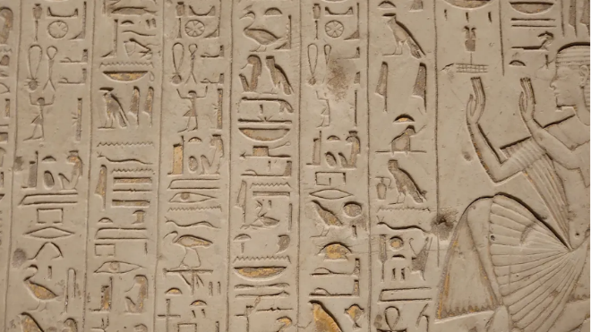

Figure 4, Hieroglyphs, 2023)
South of Mesopotamia was another emerging civilisation: The Egyptians. Though these civilisations developed around the same time, their writing systems reflect the opposite, as they have very different approaches to visual communication; more specifically, how they display and share information. In contrast to cuneiform, hieroglyphs were more pictorial, depicting objects, animals, and people. Although they resembled a certain object or person, the meaning of it wasn’t straightforward. Depuydt (1998) notes that hieroglyphic writing consisted of “ideograms, phonograms and determinatives, a system that closely resembled the semiotic system. Ideograms convey whole concepts, phonograms represent sounds to build words, and determinatives clarify meaning.
Goldwasser (1995) argues that as hieroglyphs transitioned from pictures to symbols, they became abstracted, they started to represent physical objects and progressed to conveying ideas or sounds through the association of metaphors.
Goldwasser (1995) goes on to say that the sign completes a full semiotic cycle: image becomes a symbol, which then transforms into an abstract sound marker, and ultimately returns to being treated as a potent object. This is especially evident when it comes to rituals and funeral contexts. This is because Egyptians believed that the sign, even when used phonetically, could magically regain the power of the object it depicted. As a result, potentially harmful signs, such as animals associated with danger, were sometimes mutilated to nullify their power. This evolution illustrates how information design is also shaped by cultural meaning, not just functional needs. This system balances cultural symbolism with being clear, which is a central feature of modern-day information design.

Chapter Four: Continuities and Changes in the Design Landscape
These early systems of communication laid the foundation for how humans have conveyed information through design. Across these different cultures and systems, we see early success in organising knowledge to reduce ambiguity and create standardised symbols, which are core principles of information design.
Though separated by time and distance, these different systems had the aim of making meaning clear, easily and quickly understandable. Modern iconography and pictograms follow the same logic as they use simplified and standardised visuals to get information across barriers like spoken language.


Figure 5: Pictograms (2024)
“Iconography in art is the discipline that studies the visual content of artworks to determine their motifs and themes and to characterise the ways these are represented” (Milani & Fraternali, 2021). This definition closely aligns with information design’s focus on structuring content to facilitate accurate interpretation. People process visual information very quickly, especially when it is recognisable and connected to prior experience. This is supported by Anderson and Pearson (1984) quoted in Hattan et al (2024), who “stated that reading comprehension entails 'the interaction of new information with old knowledge” (p.255)”. This suggests that designers will rely on established forms that trigger pattern recognition.
With repeated exposure, the trigger becomes quicker and becomes muscle memory; this enables icons and pictograms to communicate meaning instantly. This would apply to symbols that are unfamiliar to the viewer, following Anderson’s and Pearson’s (1984) theory, unfamiliar symbols would be interpreted through the knowledge that the viewer has already acquired.
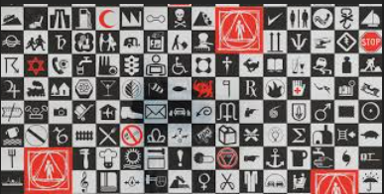
Figure 6: Give me a sign exhibition (2022)
Berger’s (2024) review of the Cooper Hewitt exhibition Give me a sign: The Language of Symbols (2022) highlights that the relationship between symbols and communication is not only seen in just ancient systems but is also central to contemporary design practice. This exhibition provided visitors with a history of how symbols evolved into a communication tool (Berger, 2024.

It emphasises the same principles that existed in structured writing, standardisation and meaning through repeated use, something that is a very important tool in how information design functions to this day, from signage to digital interfaces. Iconography is described as a “cultural marker” by Milani and Fraternali (2021); it can be inferred that this is because these cultural markers are interpretable across languages and societies. While these scholars emphasised its “fundamental role in art history” (2021), its principles are quite evident in information design. This ability to convey meaning enables modern systems of signs, from wayfinding icons to digital interface symbols, to function across diverse languages and contexts. This is further supported by Berger (2024), who notes that “symbols are essential in every form of media from smartphones to brochures”. Symbols that display information that is required for them in everyday life. Having looked at the groundwork for modern information design, we now turn to specific examples of modern icons and pictograms to show how principles have evolved to enhance user experience.

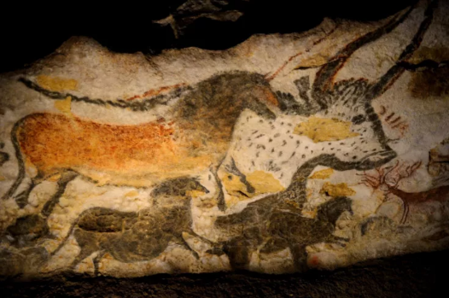

Figure 7: Lascaux - different animals (2016)
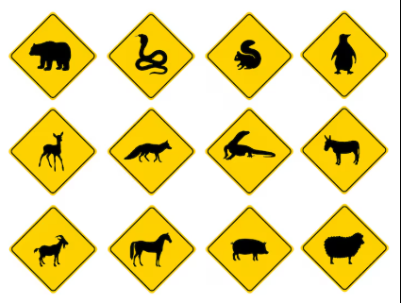
Figure 8: Animal Warning Traffic Signs (2024)

Looking at these two different warnings, we can observe how their meanings are simplified in each form. When looking at the cave art, we see numerous animals depicted. If looking at these images through the lens of cave paintings of animals as warnings, these are not straightforward. While some prehistoric humans may have understood it, if they were unfamiliar with the depicted animal, they likely wouldn’t have known their significance. Therefore, the imagery is ambiguous, leaving the message to be interpreted.

Whereas when modern-day humans grew up, we became familiar with what certain signs mean or what they imply, even when we are not familiar with a specific sign, humans construct meaning by interpreting new information through the framework of existing information, or schemas. This is another reason why information design is central to our species. Through learning, we learn what certain visuals mean in different contexts. Their shapes and colours, and symbols are chosen to give meaning quickly and consistently. While the goal of the warning remains, the modern signs saw a need to prioritise clarity and to ensure rapid comprehension.

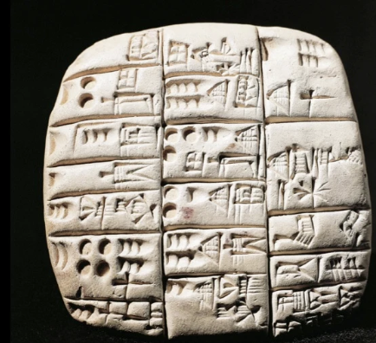
Figure 9: A count of goats and rams in cuneiform script (2018)

Figure 10: Airport Wayfinding Navigation, Nikita Sherbina (2023)
While Sumerians used clay tablets to record goods such as livestock, these ancient accounting practices laid the base for writing. A modern parallel in terms of concepts would be any airport signage. Shown in Figure 10, you can see symbols for gates, baggage claims, exits and weather information. Like cuneiform symbols, these pictograms form a standard visual language that communicates to visitors how to find their way around the airport quickly and effectively. To a diverse audience, this is important, as Symonds (2017) states, “In these spaces, wayfinding is an important process, given that these people need to be moved in a time-effective”. While Figure 9 concerns administrative information and Figure 10 concerns an airport's system, the underlying design principles are similar. Both systems rely mostly on recognisability and clarity. This enables users to interpret essential information without having to read lengthy texts or complex instructions. As Symonds (2017) further states, “Moreover, users from many countries and cultures with varying mother tongues, and of varying abilities need to navigate these spaces.”
The viewer can act almost immediately based on the system that they are looking at. While Cuneiform required symbols that were precise and culturally standardised, airport signage must be universally understood; they both facilitate understanding and coordination. By looking at these systems across time, we can see that information design is a fundamental aspect of how societies organise, preserve and convey knowledge.

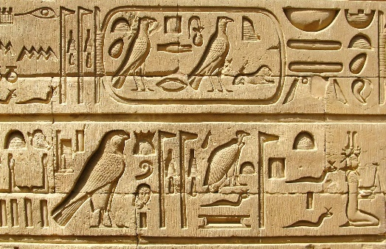

Figure 11 (Egyptian Hieroglyphs, Bojan Brecel, 2016)
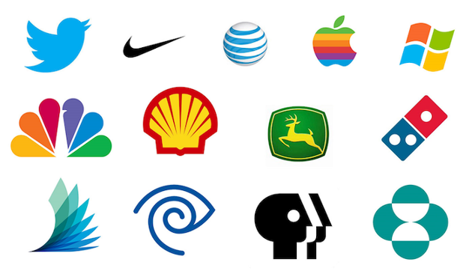
Figure 12 (Logos, Clay.
Egyptian Hieroglyphics demonstrate how early symbols operated not just as a writing system but also as a form of cultural identity and communication. This makes them a great comparison to modern-day brand logos. Hieroglyphs carved onto tombs in the Valley of Kings, as shown in Figure 5, illustrated how visual forms convey identity and authority. These symbols were carved into durable materials to have a lasting impact, so they could be remembered. As Dorman (2019) notes, walls showed the king and underworld deities and magical texts aiding his journey after death.

Each of the symbols in these inscriptions’ functions not only as a linguistic element but also as a marker of status. If we look at modern-day logos, they echo a very similar outlook. They aim to create designs that endure and are easily recognisable. Where they differ is that modern logos can be interpreted by people in the way that it was intended, whereas hieroglyphics rely on the viewer’s ability to decode signs within a shared cultural system: the visual form is designed to be recognisable and memorable and culturally resonant. For example, in Figure 12, you can see the Nike swoosh or Apple logo that immediately conveys brand identity, values and quality without any text. The swoosh represents swiftness, and, from a semiotic perspective, it resembles a check mark, which implies they are the right brand for their audience. Another infamous brand is Apple, which exemplifies the principle of keeping it straightforward. Crow (2010) similarly describes logos as “compressed communication”, noting that the logos that leverage a shared cultural knowledge, conveys complex identity and values instantly. This demonstrates key information design principles: reducing complexity, standardisation for recognisability, and layering to convey multiple messages effectively.

Conclusion
Through looking at the evolution of information design, we see that information design has always been important to our world, and how we navigate, whether we look at cave paintings of animals as drawings or our earlier writing systems, they all helped us make sense of the world around us and navigate our way through it to where we are today. They are social communications that can be shared and preserved well to pass down knowledge. Across time, from these examples, you can see the principles of information design: clarity, abstraction, symbolism, and standardisation remain constant. When examining information design through a historical lens, we also know that it didn't matter what type of media was used to convey knowledge, but rather that it met the viewer's needs. This shows its importance further, as humans knew to put their information anywhere that they could, so it could convey that knowledge to other people.

Bibliography
Adîr, G. et al. (2022) ‘SIGNS, SYMBOLS, PICTOGRAMS - GRAPHICS BEYOND THE BOUNDARIES OF SPOKEN LANGUAGES’, JIDEG, 17(1), pp. 25–28.
Almansa-Villatoro, M.V. (2025) ‘Seeing Images, Reading Hieroglyphs: A Reassessment of the Functions of Nonalphabetic Writing and Literacy in Old Kingdom Egypt’, Written communication, 42(4), pp. 735–772. Available at: https://doi.org/10.1177/07410883251349207.
Alvarez, S. (2021). Altamira cave. [online] Ancient Art Archive. Available at: https://www.ancientartarchive.org/altamira-cave-spain/ [Accessed 21 Nov. 2025].
Baines, J. (1983) ‘Literacy and Ancient Egyptian Society’, Man, 18(3), pp. 572–599. Available at: https://doi.org/10.2307/2801598.
Barham, L. and Everett, D. (2021) ‘Semiotics and the Origin of Language in the Lower Palaeolithic’, Journal of archaeological method and theory, 28(2), pp. 535–579. Available at: https://doi.org/10.1007/s10816-020-09480-9.
Craig Berger (2024) ‘Exhibit Review: Give Me A Sign’, Interdisciplinary journal of signage and wayfinding, 8(1).
Depuydt, L. (1998) ‘From Icon to Metaphor: Studies in the Semiotics of the Hieroglyphs’, Journal of the American Oriental Society. Ann Arbor: American Oriental Society, pp. 289–290. Available at: https://doi.org/10.2307/605912.

Bianchi, R.S. (1997) ‘From Icon to Metaphor: Studies in the Semiotics of the Hieroglyphs’, Journal of the American Research Center in Egypt. American Research Center in Egypt, pp. 273–274. Available at: https://doi.org/10.2307/40000818.
Dorman, P.F. and Drower, M.S. (2019). Valley of the Kings | archaeological site, Egypt | Britannica. In: Encyclopædia Britannica. [online] Available at: https://www.britannica.com/place/Valley-of-the-Kings.
Goldwasser, O. (2005) ‘Where Is Metaphor?: Conceptual Metaphor and Alternative Classification in the Hieroglyphic Script’, Metaphor and symbol, 20(2), pp. 95–113. Available at: https://doi.org/10.1207/s15327868ms2002_1.
Greenwalt, K.A. (2020) ‘The Mind in the Cave: The Paleolithic Era in the American World History Curriculum’, The History teacher (Long Beach, Calif.), 53(3), pp. 497–527.
Hancock, P.A. (2008) ‘Fredric Bartlett: through the lens of prediction’, Ergonomics, 51(1), pp. 30–34. Available at: https://doi.org/10.1080/00140130701802692.
Hattan, C., Alexander, P.A. and Lupo, S.M. (2024) ‘Leveraging What Students Know to Make Sense of Texts: What the Research Says About Prior Knowledge Activation’, Review of educational research, 94(1), pp. 73–111. Available at: https://doi.org/10.3102/00346543221148478.
Holden, C. (1995) ‘Notes From the Valley of Kings’, Science (American Association for the Advancement of Science), 267(5205), pp. 1764–1764. Available at: https://doi.org/10.1126/science.267.5205.1764-a.
Hurlburt, G.F. and Voas, J. (2011) ‘Storytelling: From Cave Art to Digital Media’, IT professional, 13(5), pp. 4–7. Available at: https://doi.org/10.1109/MITP.2011.87.
Iiid.net. (2024). Information Design. [online] Available at: https://www.iiid.net/about/information-design/.
Lewis-Williams, D.J. and Clottes, J. (1998) ‘The Mind in the Cave - the Cave in the Mind: Altered Consciousness in the Upper Paleolithic’, Anthropology of consciousness, 9(1), pp. 13–21. Available at: https://doi.org/10.1525/ac.1998.9.1.13.
Miyagawa, S., Lesure, C. and Nóbrega, V.A. (2018) ‘Cross-Modality Information Transfer: A Hypothesis about the Relationship among Prehistoric Cave Paintings, Symbolic Thinking, and the Emergence of Language’, Frontiers in Psychology, 9, p. 115. Available at: https://doi.org/10.3389/fpsyg.2018.00115.
Paul Symonds (2017) ‘Wayfinding Signage Considerations in International Airports’, Interdisciplinary journal of signage and wayfinding, 1(2). Available at: https://doi.org/10.15763/issn.2470-9670.2017.v1.i2.a10.
Schmandt-Besserat, D. (1982) ‘How Writing Came About’, Zeitschrift für Papyrologie und Epigraphik, 47, pp. 1–5.
Sérgio Ricardo Fiori (2014) ‘PUBLIC INFORMATION SYMBOLS IN TOURISM: IMPORTANCE, CHALLENGES, DIMENSIONS AND EMPIRICAL RESEARCH’, Revista brasileira de cartografia, 66. Available at: https://doi.org/10.14393/rbcv66n0-44748.
Whitworth, A. (2001) ‘The Web page as cave painting: some observations on the art of communicating through the World Wide Web’, International journal of information management, 21(4), pp. 317–320. Available at: https://doi.org/10.1016/S0268-4012(01)00026-3.
Yang, H. (2024) ‘Visible signs: an introduction to semiotics in the visual arts (3rd edition): by David Crow, London, Bloomsbury, 2017, 192 pp., $35.07 (e-book), ISBN 1350092657’, Social semiotics. Routledge, pp. 742–746. Available at: https://doi.org/10.1080/10350330.2022.2113970.
Yang, H. (2024) ‘Visible signs: an introduction to semiotics in the visual arts (3rd edition)’, Social semiotics. Abingdon: Taylor & Francis LLC, pp. 742–746. Available at: https://doi.org/10.1080/10350330.2022.2113970.
Yushu, G. (2010) ‘The Sumerian Account of the Invention of Writing —A New Interpretation’, Procedia, social and behavioral sciences, 2(5), pp. 7446–7453. Available at: https://doi.org/10.1016/j.sbspro.2010.05.110.

