

NAME: YAWAR ABRAR HOSSAIN

STUDENT ID: 1916654

MODULE: DIGITAL SKILLS AND RESEARCH METHODS

ASSIGNMENT TITLE: A REPORT ON THE IMPACT OF VIRTUAL LEARNING ENVIRONMENT (VLE)

MODULE CODE: BMSW4003

LECTURER: SUNETH FERNANDO

SUBMISSION DATE: 1ST OF SEPTEMBER

CONTENTS
PAGE
- INTRODUCTION ……………………………………….... 3

- OVERVIEW - VLE ……...…………………………...…... 3

- BACKGROUND………………………………………....... 4

- LITERATURE REVIEW – VLE ......................................... 4

- AIMS AND OBJECTIVES .................................................. 4

- AIMS OF THIS RESEARCH .............................................. 5

- RESEARCH METHOD........................................................ 5

- RESULTS FROM THE SURVEY ....................................... 6

- RESULTS DRAWN FROM CASE STUDY ....................... 10

- CONCLUSION .................................................................... 11

- REFERENCES .................................................................... 12

- APPENDICES...................................................................... 13

INTRODUCTION:

A virtual learning environment is an online based platform used by the educational institution to provide students with education support materials for the course they are studying. Most educational institution has similar structure in terms of virtual learning support, these resources are useful for the students to prepare themselves for understanding the course, study materials such as lecturer notes, module description, syllabus, assessment details, digital library, etc. VLE does not replace classroom based learning or existing educational practices, it enhances the learning experience.
Virtual environment is part of the modern-day creation which allows the people to access it through their smart phones, tablets and laptops. It has developed high standards of living for the people, mostly people use them for social media, health, education and entertainment.

Distance learning was used back in 1840s when Sir Isaac Pitman used shorthand method (shorter version of words) to communicate to his students via mail and the students would return it back for correction. In 1999, electronic learning term was first used in CBT systems seminar in Los Angeles. It has evolved drastically in the past few decades.

OVERVIEW OF VIRTUAL LEARNING ENVIRONMENT (VLE):

The study suggested, “the acceptance and use of a virtual learning environment in advanced learning by using the unified theory of acceptance and use of technology (UTAUT) model” (Venkatesh et.al. 2013). According to the research which was carried out on 1032 students who were studying in undergraduate degree in Turkey and United Kingdom; The students were using the same virtual learning environment. “The role of performance expectancy, effort expectancy, social influence and facilitating conditions were evaluated and tested for both countries. The study results demonstrated that the behavioural intention and use behaviour regarding the utilization of a virtual learning environment in higher education differed between the two countries, and that the level of impact of the factors that shape behavioural intention and use behaviour also differed from one factor to another.” (Efiloğlu Kurt and Tingöy, 2017). Studies specified that there are number of important factors which affects the acceptance and use of information technologies by each person be linked to different states and cultures. In 1980s where the scholars first made use of the Technology Acceptance Model (TAM), it was based on social and behavioural theories. Further revision and development took place before it was finalised as the unified theory of acceptance and use of technology (UTAUT). According to the studies which was carried out between two countries, Turkey and United Kingdom (Sakaraya University and Leeds University), showed that British students have higher level of intention to use and more frequency of use than of Turkish students. It also showed that the British students were comfortable to adapt to VLE, as the studies suggested that the students have better access to internet and digital technology. The significant differences which was noticed between two countries were behavioural intention to use and behaviour to use and also relation to the factors which affects intention and behaviour. The study also concluded that using VLE has far better academic performance and grades.

BACKGROUND:

In addition to classroom-based teaching, higher educational institution uses VLE. Due to Covid 19 and to follow government guidelines all the educational institution was asked to shut down. Most educational institution chose to provide online based lessons, with the support of VLE and online teachings which has evolved in the last few years, to minimise any disruptions. Some schools in the UK were providing online lessons, and asked parents or carers to look into school VLE, so the younger students would not miss any school lessons. This was an easier choice for the institutions, as it will adhere with the current government policy of social distancing. In 2018, there has been a change in law. The law states that access to VLE on digital world would be advantageous for all learners. The higher education (HE) and further education (FE) are obliged to give digital access for the learners, as it is cost-effective and have most of the resources and it will provide greater improvements for the learners’ objectives and better experience for the learners.

LITERATURE REVIEW – VLE:

There has been a significant increase in use of VLEs in higher education. The dramatic increase due to influence on national developments and policy initiatives. Agreement between the EU member states in 2005, supported by eLearning and eTEN confirms that all higher education institution should offer guaranteed online access for the students and researchers to increase the condition and productivity of studying developments and activities (Konrad, 2003). The virtual learning environment reduces or terminates the complete use of face to face teaching. Learning is not only based on emails and online forums which helps students with their assignments and progress. This learning system is helpful however it does not change how the students are taught. VLE includes computer based, internet based, remote teacher online, blended learning, facilitated virtual learning, online learning, full time online. (Kanimozhi, 2018). This technology provides teachers with teaching support, learners with learning support, one to one support, feedback from the teachers, resources for learners, IT support, assignment information, etc. Due to the advancement in information technology, the traditional classroom-based study has moved on to more interactive and collective atmosphere. This was only possible due to the demand on distance learning, improvement in IT infrastructure, higher education institutions would like to promote their courses globally and increase their existence in the market and competing with other education providers and also flexibility by the students (Suman et.al. 2010). In 2007, the meeting with stake holders in European Commission (EC) suggested the improvement of e-learning and how the EC would focus on delivering and implementing their ideas on all the European countries. The main focus was to encourage countries on national level to strengthen technology, so it stays the most attractive place to live and do business. To take the full advantage of the strategic goals by information and communication technologies (ICT), more qualified ICT practitioners and skilled workers are required. (Aceto et.al. 2010)
There are few challenges which VLE faces, replacing face to face communication, barrier in IT skills, using as a tool rather than archive, internet access is mandatory, concerns with data protection, etc.

AIMS AND OBJECTIVES:
VLE is a web-based software system comprises of selection of tools and applications that enables the learners to communicate online, collective learning, uploading course works, learner assessments and feedback and course administration. The VLE has been developed to assist teachers and students and it totally depends on individuals how it would impact on educational activity and its implementation, whether the individuals been engaging correctly. “In a recent study examining the implementation of VLEs in schools in the United Kingdom, (Read, et al. 2013) reported only limited use of the collaborative learning aspects of VLEs, instead their primary function was as a repository for instructional and assessment materials.” Despite the steady growth in e-learning, still needs to further understand on learners perception on e-learning and how it enhances the learners on the application of those learning (Smart and Cappel, 2006).
According to Barker and Grossman (2013), VLE adds value in terms of teaching, learning and the student experience. The only way to measure VLE is to evaluate the academic performance of the individuals. There have been mixed results of the research. Some authors concluded that VLE has positive outcome (Means et.al. 2013), other researchers have conclusive results (Morrice and Demien, 2012). The other authors found in their research that some students have negative perceptions and tutors explain that using the VLE as an online textbook and have some sort of benefit that taught little which is already provided in VLE (Love and Fry, 2006). In another study, De Lang et. al. (2006) suggested that some students have positive experience to VLE on problem-based learning in the process of tutorial group work; it has resulted on less effect on self-learning. Lee and Lee (2004) suggested on their research that nursing students provided positive impact on learning outcome on using VLE and enjoyed the experience. The research carried out by Campbell et.al. (2008) suggested that the students who participated in online discussion received higher marks in their exams rather than traditional face to face method. This shows that VLE has link to higher success and greater achievement.

AIMS OF THIS RESEARCH:
Primary and secondary research has been carried out to understand what services are available on VLE, technologies which are required on VLE, advantages, disadvantages and challenges which is currently faced by learners, tutors and admin. Both qualitative and quantitative data were collected and correctly applied during my research.

Research Method:

Primary Research:
Most students grew up in the digital era, it is easier for them to access Blackboard and other VLE tools. Web-based software will always help them in the education endeavour than the use of any VLE tools would not be difficult for them. Students prefers face to face teaching than VLE (Mori 2008). McGill and Hobbs (2018) proved that VLE is suitable in higher learning educational institution but it does not constitute that it is better than traditional face to face method. Students with learning disability (anxiety) have negative effect on VLEs satisfaction. (Sun et.al. 2008). Bridge and Appleyard (2008) concluded that the 88% students provided positive feedback in terms to submitting their assignments through blackboard and found it easy and cost saving method. 93% student preferred feedback via Blackboard.
The study conducted by APLU (2009) suggested that only one quarter of the faculty members delivered one online course. Over third of the faculty members agreed to have deliver one online lesson. Figure also suggests that the most experienced teachers with 15 years of experience delivering online lessons are equivalent to least experienced teachers. One tenth of lecturers reported that they were on the process of developing online lectures. There are equal percentage who has delivered online lessons and who are developing them. Woods et.al. (2004) showed that lecturers use the Blackboard as administrative purposes and course management.
VLE depends on internet connection, some materials could be downloadable and use it offline. Breakdown or maintenance work of the software could lead to no access to the VLE site.

RESULTS FROM THE SURVEY:
Secondary Research:
Secondary research questionnaire has been attached in the appendices. Survey questionnaires were sent to the students via email and data has been recorded. There were 15 questions in the survey and 15 people responded to the survey. The research tool, which was used, google form and then it has been added to excel sheet to transform into the charts. No personal data has been collected in the process, followed the correct legislation which is GDPR.
Question 1
Questions | All the time | Most of the time | Some time | Rarely | Never
Q1 | 7 | 7 | 1 | 0 | 0

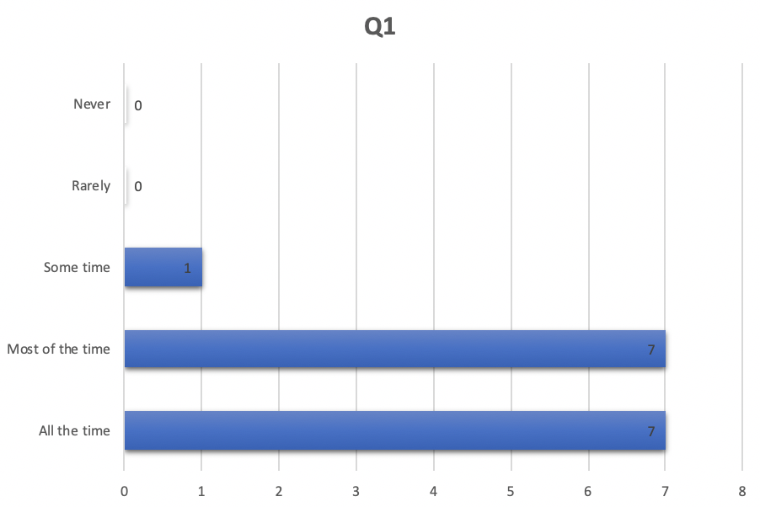
The data shows 15 people participated in the survey, and majority would login to the university online portal.

Questions 2-7
Questions | Yes | No | Maybe
Q2 | 15 | 0 | 0
Q3 | 12 | 2 | 1
Q4 | 14 | 0 | 1
Q5 | 13 | 1 | 1
Q6 | 7 | 7 | 1
Q7 | 10 | 1 | 4

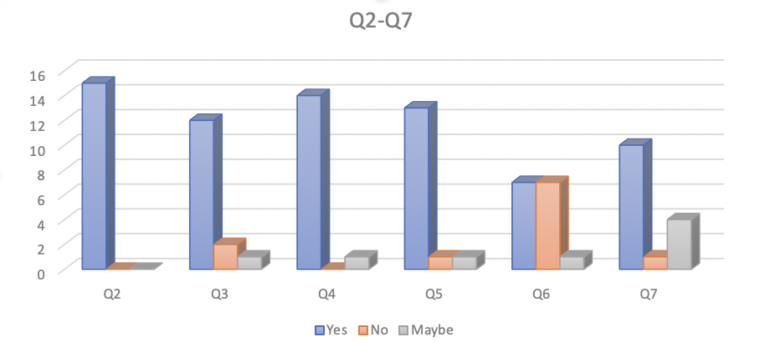
Q2 data shows that everyone would login to the online portal. Majority of 80% said it was easy to access library in Q3. In Q4, over 90% said it was user friendly. 13 out of 15 responded that it was easy to ask questions on lectures in Q5. There was mixed result in Q6, half agreed that the interaction between the student and the lecturer is limited and another half said it is not. In Q7, over 60% said they would prefer online learning and over 20% prefers traditional face to face lessons.

Question 8
Questions | Very much | Some what | Not at all
Q8 | 3 | 8 | 4

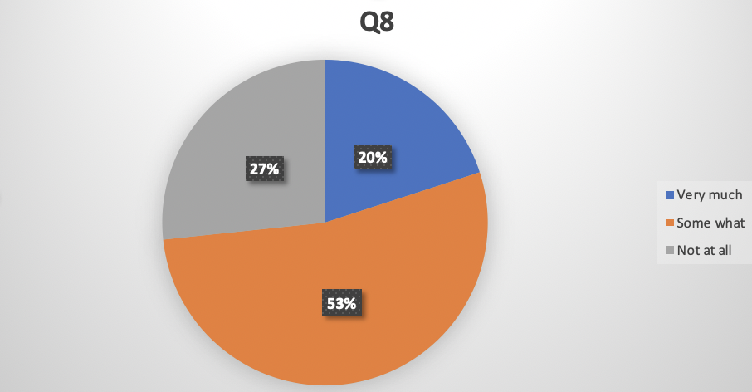
Over 50% said they were somewhat affected by online lessons and 27% said it does not have any impact on them. 20% said it has affected them very much.

Questions 9-12
Questions | 1 | 2 | 3 | 4 | 5 | 6 | 7 | 8 | 9 | 10
Q9 | 0 | 0 | 0 | 0 | 1 | 0 | 1 | 3 | 1 | 9
Q10 | 0 | 0 | 0 | 0 | 1 | 0 | 3 | 2 | 0 | 9
Q11 | 0 | 0 | 0 | 0 | 0 | 1 | 3 | 2 | 0 | 9
Q12 |  |  |  |  | 1 | 0 | 3 | 2 | 0 | 10

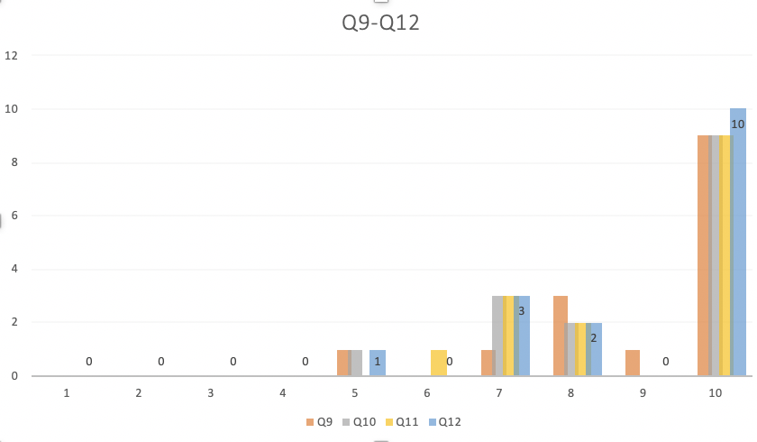
In Q9, majority rated the online portal as an excellent. Most of them preferred Q10 and rated as an excellent platform. In Q11 and 12, most of them rated as excellent for the service they have received from Microsoft Teams and had pleasant experience.

Questions | Strongly Agree | Agree | Neutral | Disagree | Strongly Disagree
Q13 | 2 | 0 | 1 | 5 | 7
Q14 | 8 | 5 | 1 | 1 | 0
Q15 | 10 | 3 | 2 | 0 | 0
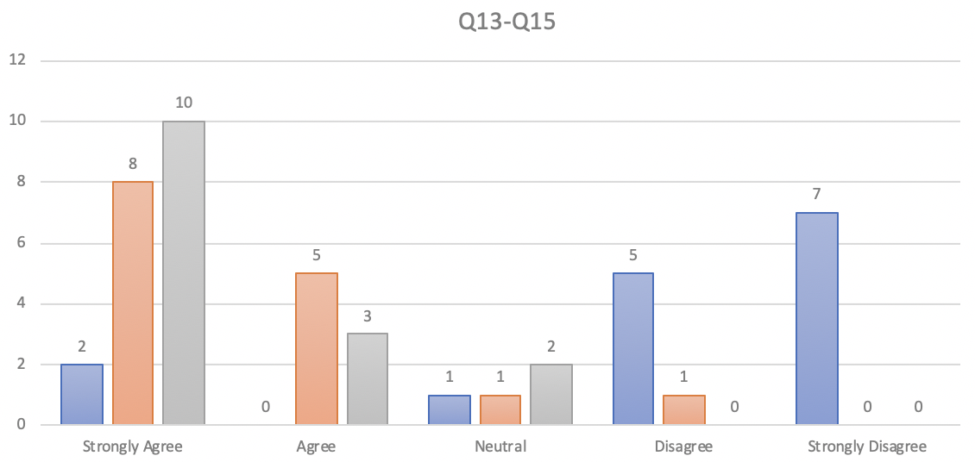
According to Q13, most of them disagreed that there were little or not many distractions on online studying. In Q14, over 50% strongly agreed that one to one session helps. Majority agreed that feedback provides valuable information for the learners, over 60% strongly agreed in Q15.

Case Study:
In this report, I have carried out extensive research on the topic. Both primary and secondary research has been taken into account to understand the impact of VLE on the students. The primary research which was carried by individuals and has been analysed to understand whether it has positive impact or not. The research which I have personally carried out shows that the VLE has greater good for the University students. According to (Campbell et.al. 2008), the VLE user has greater success and achievements amongst the learners.
Secondary research was carried out as a survey, I have prepared 15 questionnaires for the survey and was sent to the university students via google form (survey tool). The questions were related to the use of VLE, how it impacts students and availability of the resources. The results were recorded, and data was collected and transferred them to excel sheet to form charts. All the data has been collected in terms with GDPR. Overall, the data shows that most students uses VLE tools regularly, resources are fairly easy to access, prefers online lessons, rated highly moodle (VLE tool). Half of the students agreed that the interaction between students and lecturer limited and the other hand said it is not limited.
This research particularly helped me to understand the primary and secondary research, qualitative and quantitative data and how to analyse them. It also taught me how to use the survey tool (google form) to form a questionnaire and excel sheet to form the chart.

CONCLUSION:
There has been a significant change in VLE, how the learners access them and use them for study materials and the lecturers use them for teaching tools and other admin purposes. According to the researches previously carried, which explains that using VLE has higher success and greater achievement amongst the learners (Campbell et.al. 2008).
The research carried out in New Zealand, it was found that student accessed Blackboard to download study materials (Santhiveeran, 2006). The study conducted by JISC UK showed that learners in UK would only be interested in Blackboard features that would interest according to their needs.
The secondary research was conducted, and data was recorded, all the evidences has been added. Results shows that majority students would login to VLE tools regularly, find it easy to locate resources, rated fairly high on the scale for VLE tools, due to covid 19 most preferred online classes, it was easy to speak with the lecturer and feedback plays a vital part for the learners for their improvement. On the other hand, first half said that interaction between the lecturer and learners are limited and another half said it is not.
After analysing the facts and my research, I can conclude that using VLE has improved students’ performances which has greater impact on the students.

REFERENCES:

- Cassidy, S. (2016). Virtual Learning Environments as Mediating Factors in Student Satisfaction with Teaching and Learning in Higher Education. Journal of Curriculum and Teaching, 5(1).
- Efiloğlu Kurt, Ö. and Tingöy, Ö. (2017). The acceptance and use of a virtual learning environment in higher education: an empirical study in Turkey, and the UK. International Journal of Educational Technology in Higher Education, 14(1).
- Konrad, J. (2003). Review of educational research on virtual learning environments [VLE] - implications for the improvement of teaching and learning and access to formal learning in Europe. [online] www.leeds.ac.uk. Available at: http://www.leeds.ac.uk/educol/documents/00003192.htm
- Suman, S., Amini, A., Elson, B. and Reynolds, P. (2010). Design and Development of Virtual Learning Environment Using Open Source Virtual World Technology. Key Competencies in the Knowledge Society, pp.379–388.
- www.policyconnect.org.uk. (n.d.). Accessible VLEs - making the most of the new regulations | All-Party Parliamentary Group for Assistive Technology. [online] Available at: https://www.policyconnect.org.uk/appgat/research/accessible-vles-making-most-new-regulations [Accessed 12 Aug. 2020].

Appendices:

Question 1

Question 2
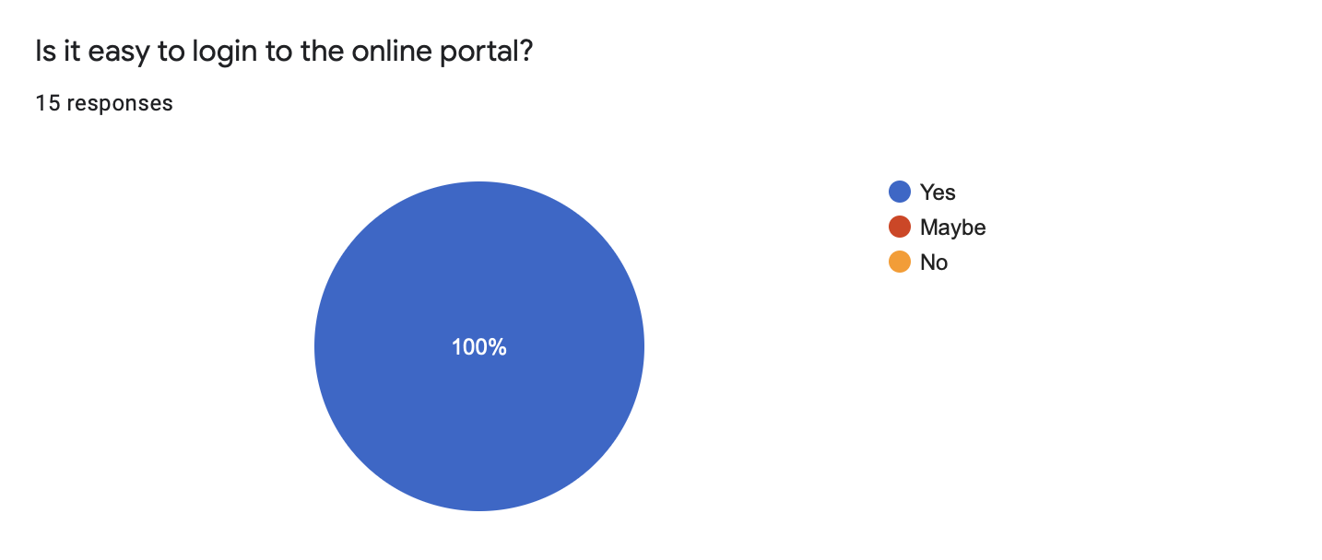

Question 3
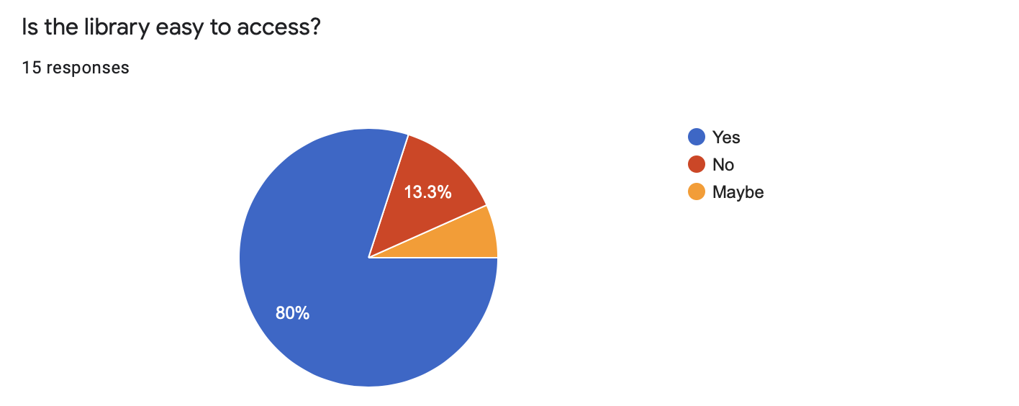

Questions 4
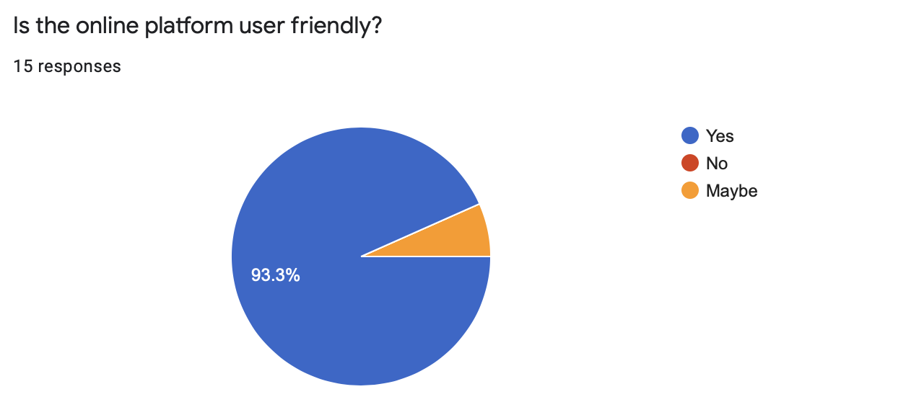

Question 5
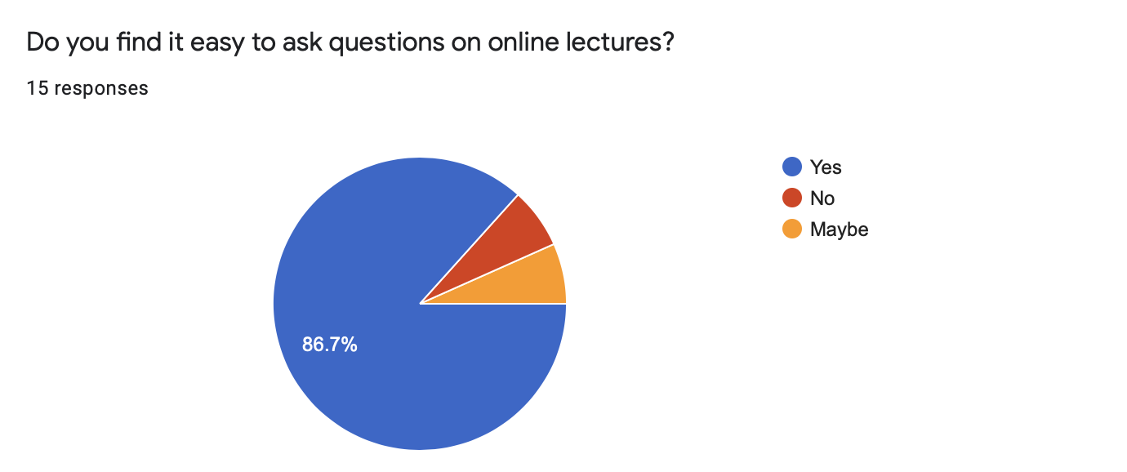

Question 6
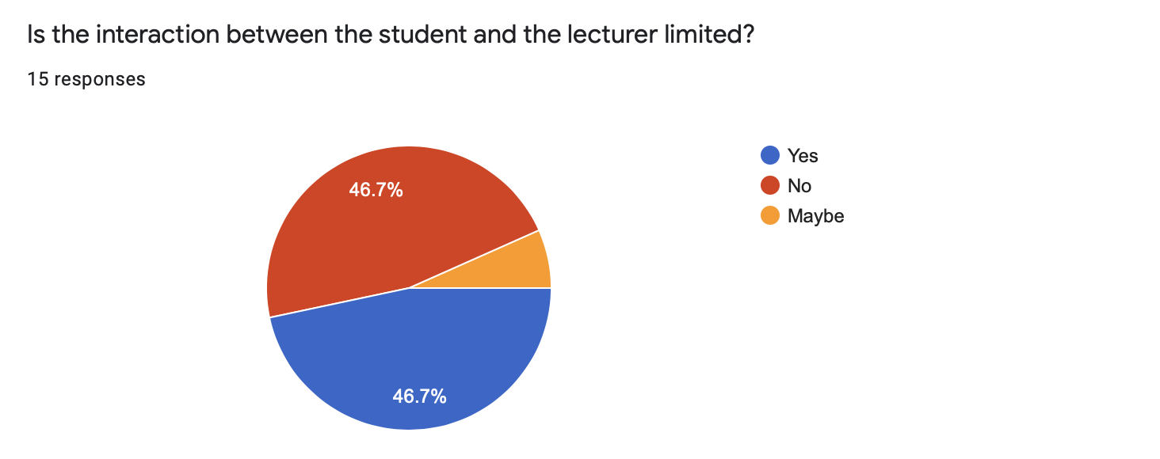

Question 7
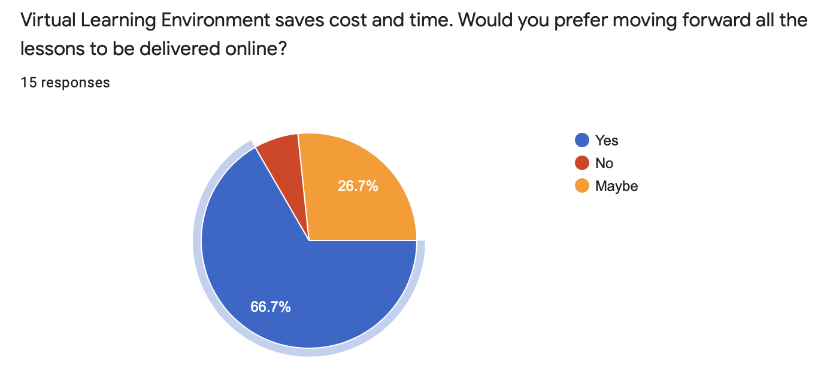

Question 8
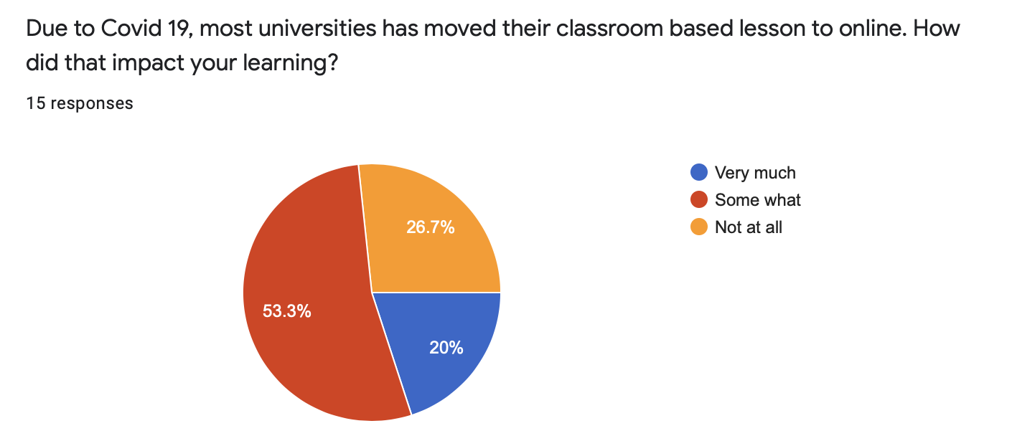
Question 9

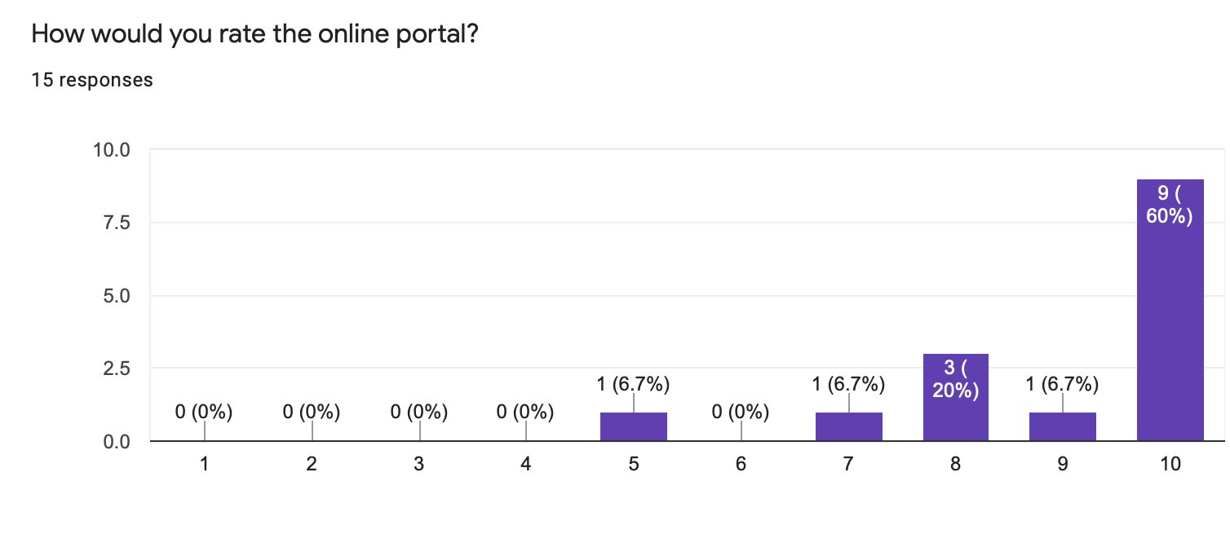
Question 10

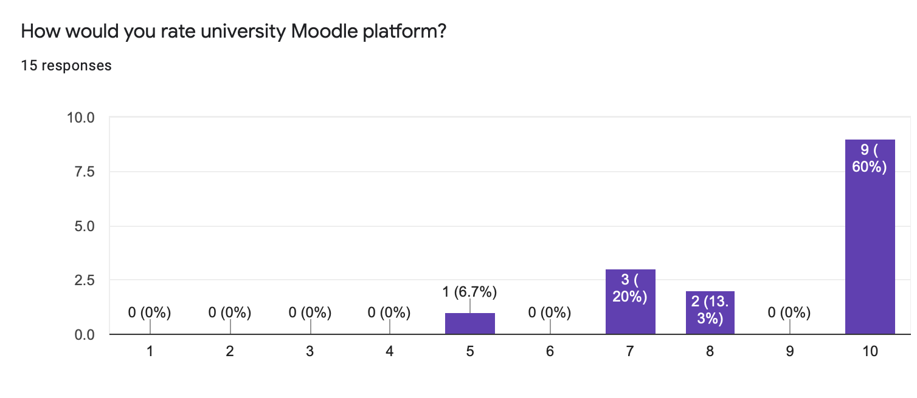

Question 11

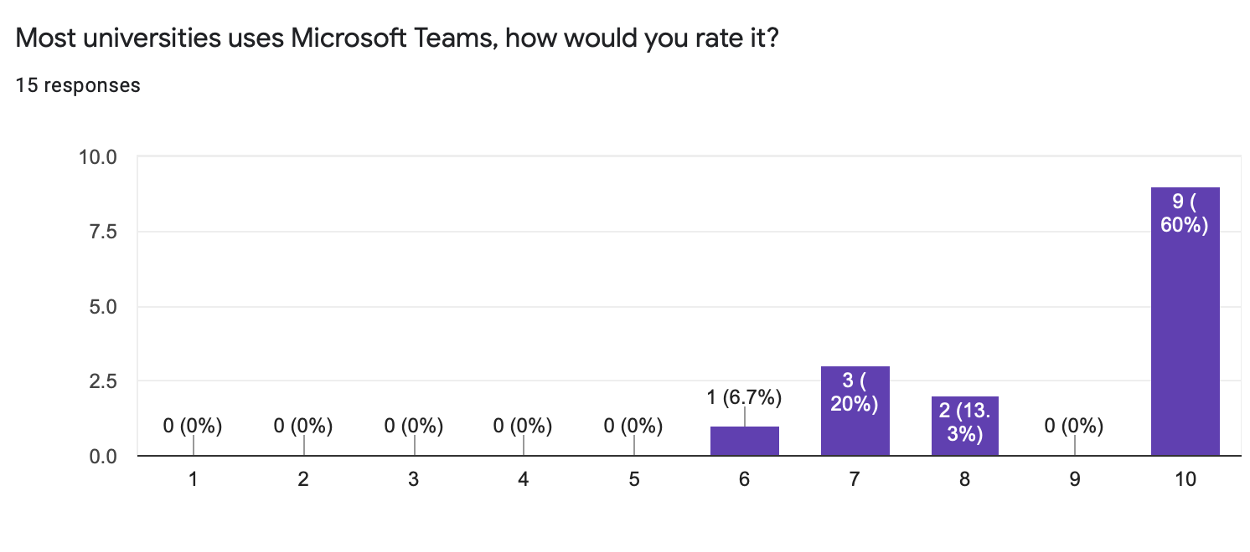
Question 12

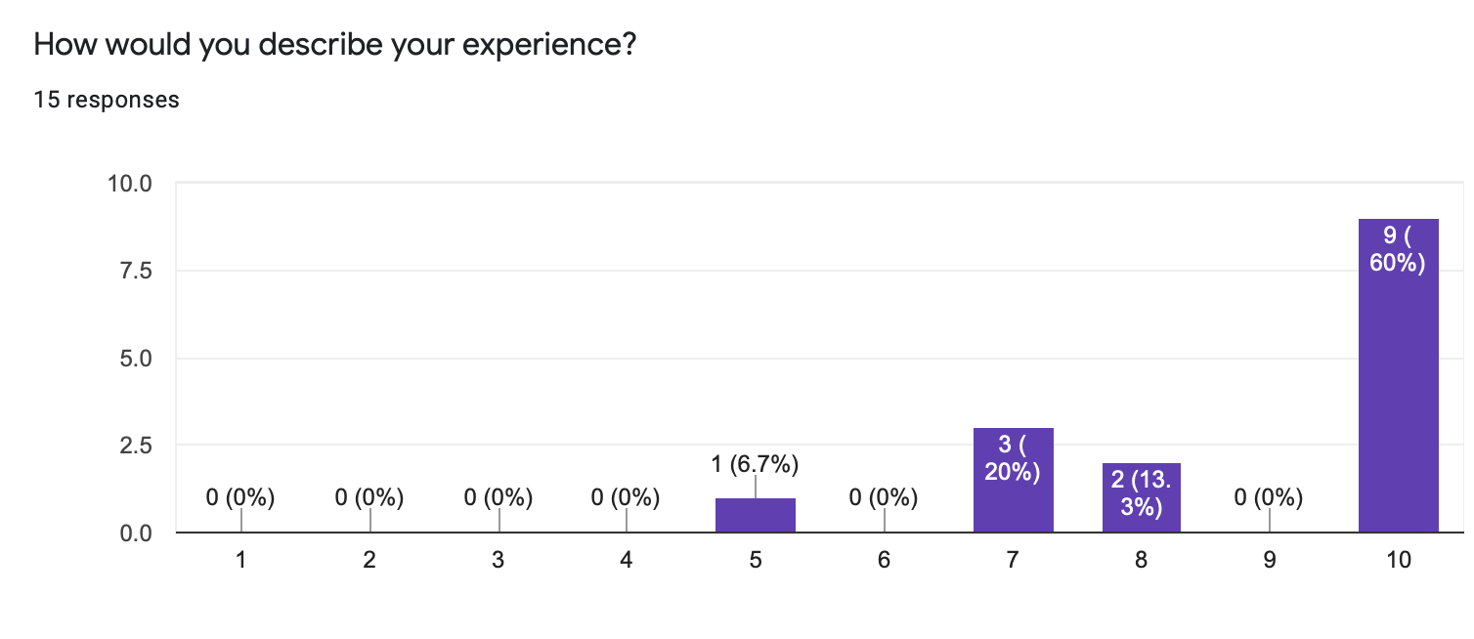
Question 13

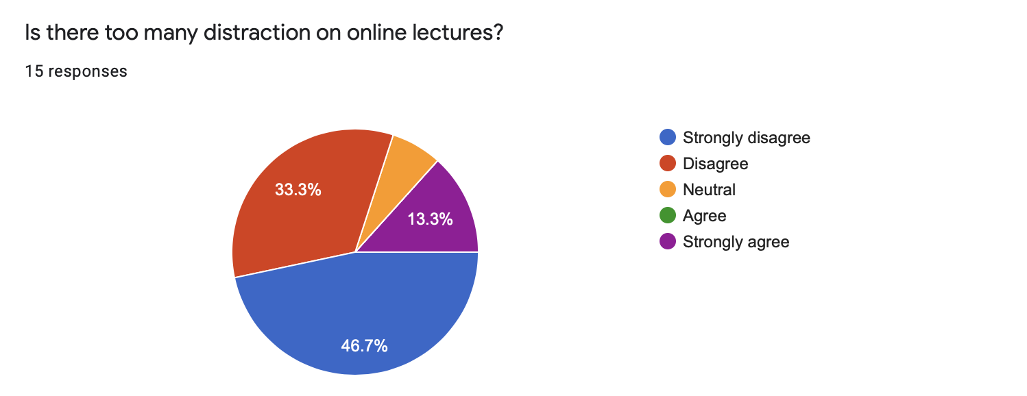

Question 14

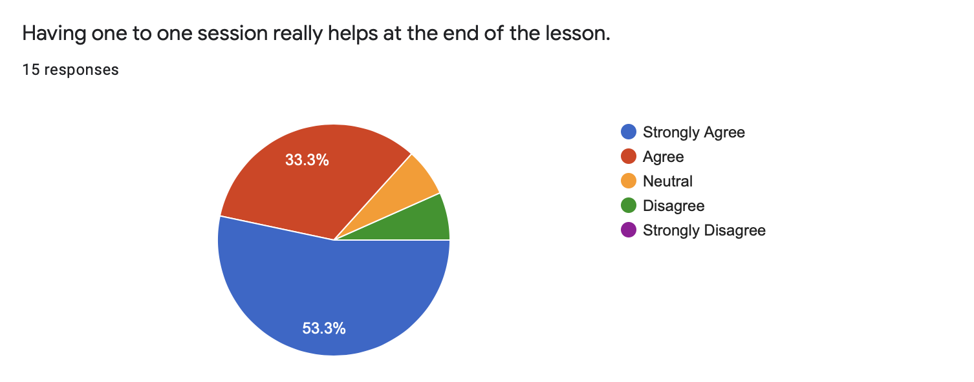

Question 15



