International Entrepreneurship

An Analysis of International Entrepreneurship and Government Commitments



APRIL 2018

MODULE NAME: International Entrepreneurship

Project Name: business management
Name: FEI XUE
Student Number: 1703629
Table of Contents

Executive Summary 4
1.0 Introduction 4
1.1 The Definitions of Entrepreneurship and International Entrepreneurship 4
1.2 The Importance of Entrepreneurship 5
1.3 Controversies about The Qualifications of Entrepreneurs 5
1.3.1 Model A: Black or White 5
1.3.2 Model B: Everyone is Entrepreneur 5
1.3.3 Model C: Instinctive Entrepreneur and Potential Entrepreneur 6
2.0 The Thinking Blueprints of Entrepreneurs 6
2.1 The Firs Step: Recognize Opportunities That Are Valuable 6
2.2 The Second Step: Conducting Market Research to Learn the Actuality 6
2.3 The Third Step: Making Business Plans in the New Market 6
3.0 The Nature of Entrepreneurship: Three Stages 7
3.1 Factor-Driven Economies 7
3.2 Efficiency-Driven Economies 7
3.3 Innovation-Driven Economies 7
4.0 Causes That Might Influence International Entrepreneurship 7
4.1 Political and Legal Environment 7
4.2 A Different Economic System 8
5.0 An Evaluation of 5 Contrasting Regions of International Entrepreneurship 8
5.1 Libya in Africa 8
5.1.1 Political Evaluation 9
5.1.2 Economic Evaluation 9
5.1.3 Overall Evaluation 9
5.2 Colombia in Latin America 10
5.2.1 Political Evaluation 10
5.2.2 Economic Evaluation 11
5.2.3 Overall Evaluation 11
5.3 France in Europe 11
5.3.1 Political Evaluation 12
5.3.2 Economic Evaluation 12
5.3.3 Overall Evaluation 12
5.4 Japan in Asia 13
5.4.1 Political Evaluation 13
5.4.2 Economic Evaluation 13
5.4.3 Overall Evaluation 14
5.5 Canada in North America 14
5.5.1 Political Evaluation 15
5.5.2 Economic Evaluation 15
5.5.3 Overall Evaluation 15
6.0 Recommendations 16
7.0 Conclusion 16
8.0 References 17

Executive Summary
This report delves into a look about the theories and implications of international entrepreneurship, critically analyzes the selected 5 contrasting countries in the global communities, in terms of their entrepreneurial activities and government contributions in this process. This report firstly takes a look at the definitions as well significance of entrepreneurship both domestic and international, evaluates their roles in a world which is increasingly linked with commercial activities. Then this report analyzes the political, economical, legal and other noticeable factors that might contribute or intervene the development of international entrepreneurship. Also, the natures of entrepreneurship are introduced with the three stages evolution of national economies. And this report combines the entrepreneurship theories above, critically evaluates the 5 contrasting regions based on the data adopted from the GEM website, in terms of political evaluation, economical evaluation and overall evaluation. In the end, this report drives recommendations and conclusions on the basis of the whole analysis.

1.0 Introduction

1.1 The Definitions of Entrepreneurship and International Entrepreneurship
As defined by Stevenson in 2013, entrepreneurship is considered as a pursuit of opportunities of business without regards to the resources that are being currently controlled(Stevenson,2013). The most important feature of entrepreneurship is a wise eye at some opportunities that are of values, since most other persons can not fully recognize those chances at the first place. Another extraordinary feature of entrepreneurs is that they can persist on the opportunities until they make theme come true despite of numerous time and efforts(Agostini,2017).International entrepreneurship is the evolution format of entrepreneurship in a highly economically globalized world. International entrepreneurship is defined as the commercial activities by entrepreneurs that are across the boundaries of nations(Botins,2013). It is not hard to find that international entrepreneurship has been playing an important role in international trades and economic performance.

1.2 The Importance of Entrepreneurship
Entrepreneurship firstly brings much economic values for the nation, particularly those with a large population(Guthrie,2000)Entrepreneurship activities can not only improve the total GDP significantly for the country, but also provide a great number work positions and thus greatly ameliorating the unemployed situation. Apart from that, entrepreneurship has brought many innovative advancements for the global communities, including creative products and services, which actively process the development of societies. What is more, international entrepreneurship can help spread the ideology, culture customs and other key features of a country to the external world, which remains very important to enhance the overall status of the country.

1.3 Controversies about The Qualifications of Entrepreneurs
As for the qualifications of being an entrepreneur, there are many controversies about the natures and conditions of the identification as entrepreneurs. Below are three models which conclude the most prevalent opinions.

1.3.1 Model A: Black or White
In this model, it is believed there are only two types of human beings concerning the qualifications of being an entrepreneur,which are entrepreneur and non-entrepreneur(Hayton,2015). This model believes that some of the traits of entrepreneurs can not be easily gained later in life, since they are unique to some special persons who were born with these personalities, such as a sense of creative ideas, a strong persistence to the goals and so on.

1.3.2 Model B: Everyone is Entrepreneur
This model is more inclusive and positive, since it believes the idea that everyone can be an entrepreneur(Krueger,2000). Although some persons can be naturally good at being innovative, it does not necessarily mean that others would not have the chance of being entrepreneurs, as long as they are willing to contribute enough to their pursuit.

1.3.3 Model C: Instinctive Entrepreneur and Potential Entrepreneur
This model combines the features of the two models above, which holds the view that although there are instinctive entrepreneurs, who were born for this position, there are many other potential entrepreneurs who are waiting to be explored.

2.0 The Thinking Blueprints of Entrepreneurs
There is not a fixed regime to evaluate the thinking process of entrepreneurs, because they are not machines who can react and think differently according to the various situations. Despite of that, there is a usual thinking blueprints of entrepreneurs with three steps.

2.1 The First Step: Recognize Opportunities That Are Valuable
The first step of the thinking process of entrepreneurs is to recognize chances that are of values, and stick to them until their values have been fully achieved (Link,2009). One of the most extraordinary points of entrepreneurs is that they can take whatever they can to achieve their destination despite of challenges.

2.2 The Second Step: Conducting Market Research to Learn the Actuality
The second step of entrepreneurship is to conduct a sufficient amount marketing research in order to take a careful look at the actuality, including the market size, consumer taste, the advancement level of technology and so on. This step is considered as important preparation work.

2.3 The Third Step: Making Business Plans in the New Market
The third step is making business plans in the new market, which includes employing managing talents and other working stuff, dealing with potential clients, figuring out publicizing channels and so on. This step is the practical period to shorten the distance of the completion of goals which were set up earlier.

3.0 The Nature of Entrepreneurship: Three Stages

3.1 Factor-Driven Economies

Factor-driven economy is the first stage of entrepreneurship, where growth is completed on a basis of the unskilled labor force and natural resources(Martina,2013). In this stage, infrastructure, health care system and other basic factors are most emphasized.

3.2 Efficiency-Driven Economies
Efficiency-driven economy is the second stage of entrepreneurship, which not only emphasizes on the efficiency of making products but also on the qualities of products(Sveiby,2014). The key indicators in this stage are the size of the market, the efficiency of labor market and so on.

3.3 Innovation-Driven Economies
Innovation-driven economy is the most advanced level of entrepreneurship, and it is usually applicable to many developed regions(Wu,2005). In this stage, the business sophistication and innovative advancement are paid much attention to.

4.0 Causes That Might Influence International Entrepreneurship

4.1 Political and Legal Environment
Political influence can show fundamental impacts on the development of international entrepreneurship(Jason,2013). To start with, the steadiness of the political parties is one of the most important considerations for entrepreneurs to choose a market in a new region. Secondly, the political polices can determines the extent to which entrepreneurship is supported, by means of entrepreneurship programs and other relevant supports. Thirdly, the government polices have the final say about the macro economic polices, which can directly influence the economic performance of international corporations.
And it is worth noting that different legal system can play an important role for processing international entrepreneurship. For instance, the standards for the qualities in different regions can vary, so it is the same with safety regulations.

4.2 A Different Economic System
A different economic system is one of the biggest challenges for international entrepreneurship to enter a new market(Yin,2011). To start with, international entrepreneurs are predicted to spend much time getting used to the new currency system. Secondly, the the employer-employee relationship and work customs in each place can vary, which might be a barrier for international corporations. Moreover, different places can pose various economic polices concerning the support of entrepreneurship, which would make international corporations spend time and capitals to adjust to.

5.0 An Evaluation of 5 Contrasting Regions of International Entrepreneurship

5.1 Libya in Africa
Libya is a developing county is the northern Africa, with a population of 6.3 million. It has a factor-driven economy and heavily on natural resources, especially petroleum. Libya has a nominal GDP of $33.2 billion and its GDP per capita is $14200. And Libya’s economy is factor driven. In Global Entrepreneurship Monitor, there are only data in 2013, and based on these data, we can have a general idea of Libya’s entrepreneurial framework conditions.
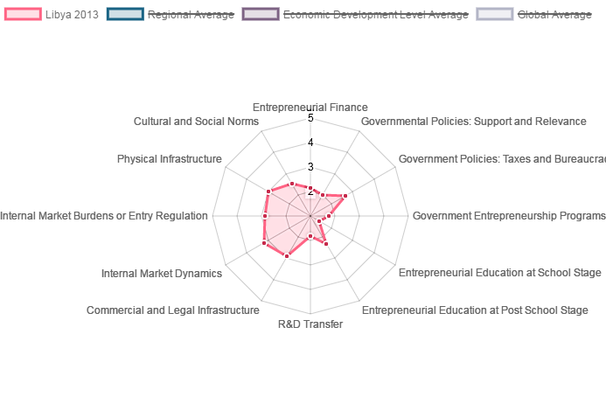
Sources: http://www.gemconsortium.org/country-profile/81

5.1.1 Political Evaluation
As for political factors, it seems that Libya government did not have enough attention on entrepreneurial programs, with a low score of the factor. And the government policies related to support and relevance were not supportive, either. As interpreted from the picture, only government policies connected to taxes and bureaucracy were comparatively conductive, decreasing the burden of entrepreneurial activities.

5.1.2 Economic Evaluation
As a country that needs to develop urgently, Libya had an energetic internal market, though it was not as energetic as other countries in the same region. However, the entrepreneurial finance in Libya was much worse than that of global average. This may be as a result of war, and the country needs more money to invest the reconstruction.

5.1.3 Overall Evaluation
In terms of infrastructure, the hardware part may be destroyed by the war, but the software part like legal infrastructure is excellent in comparison with other African countries. Therefore, the foundation of entrepreneurial activities in Libya was not solid, at least in 2013. With regard to entrepreneurial education, like the general education of Libya, both the school stage and post entrepreneurial education were short, which lost many opportunities to cultivate entrepreneurial talents. What is worse, the low score of R&D transfer determined that Libya could only stay in the factor driven economy.

5.2 Colombia in Latin America
Colombia is a developing country located in the southern America, with a population of 48.2 million. It is the fourth largest economy entity in Latin America, with a GDP of $293.2 billion and a GDP per capita of $6084. It has an efficiency-driven economy.
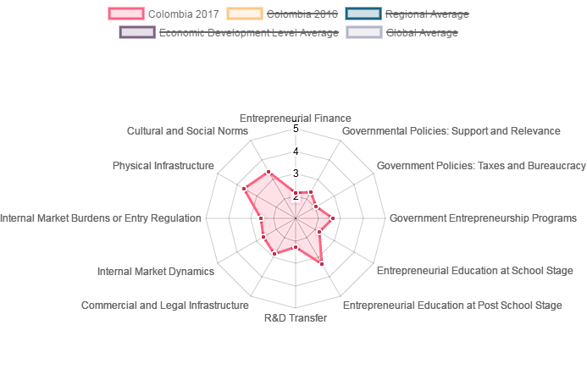
Sources: http://www.gemconsortium.org/country-profile/52

5.2.1 Political Evaluation
All of the government related factors decreased from 2017, what is worse, some of them are even below the global average level. Having a tax and bureaucracy burden is hard to development an advanced type economy, especially when the support is not insufficient. To some extent, the conductive government behavior is an incentive to entrepreneurship.

5.2.2 Economic Evaluation
It is the same with the political factors in Colombia. The economic factors of Colombia are not very outstanding. Its internal market dynamics is not as good as the global average dynamics and it has declined compared to last year. The decrease of entrepreneurial finance may be connected this phenomenon.

5.2.3 Overall Evaluation
From the picture above, it seems that Colombia put lots of importance on entrepreneurial education both at school stage and at post school stage. In this aspect, Colombia is ahead of other countries in the same region. However, the low rate of R&D transfer may be a key reason why Colombia is not an innovation-driven economy, though Colombia has seen a tiny development in this factor. though Colombia has seen a tiny development in this factor In accordance with the spider picture, physical infrastructure is not very satisfying. The lack of infrastructure is disadvantageous for the development of any kind of entrepreneurial activities.

5.3 France in Europe
France is one of the most developed countries in Europe, with a nominal GDP of 2421.6 billion. With a population of 64.3 million, its GDP per capita is $37675. France is a member of the Organization for Economic Co-operation and Development (OECD) and the Group of Eight (G8), and it is quite famous for its luxury industry, with a highly globalized economy. The economy of France is innovation driven.
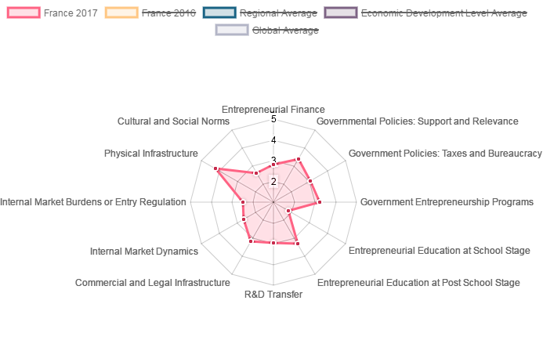
Sources: http://www.gemconsortium.org/country-profile/62

5.3.1 Political Evaluation
As for the political factors, France has a high score in government policies related to support, relevance, taxes and bureaucracy. There are also many government entrepreneurial programs to improve the atmosphere of entrepreneurship.

5.3.2 Economic Evaluation
Though the internal market dynamics of France is not attractive, as mentioned before, with a highly globalized economy, there are many opportunities in France. As a solid foundation of entrepreneurial activity, the entrepreneurial finance of France is sufficient in comparison with other developed countries in the same region.

5.3.3 Overall Evaluation
As a developed country, the physical infrastructure of France is world class, and the commercial and legal infrastructure is also outstanding and getting better. In terms of entrepreneurial education, compared to education at school stage, France attachés more attention on education at post school stage. Like other innovation driven economy country, France also has a very rate of R&D transfer.

5.4 Japan in Asia
Japan is a developed country in Asia, with an innovation-driven economy. Though the national territorial area of Japan is 378 thousand square kilometers, it has a population of 126.9 million and a nominal GDP of 4123.3 billion, the third largest economy entity.
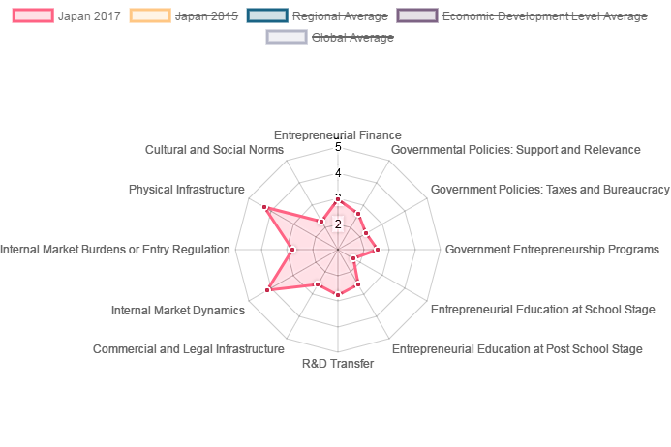
Sources: http://www.gemconsortium.org/country-profile/76

5.4.1 Political Evaluation
As for political factors, especially the related government policies, it is not advantageous in recent years. Apart from government entrepreneurial programs is getting better, the government policies connected to taxes, bureaucracy and support are less attractive.

5.4.2 Economic Evaluation
In terms of economic factor, Japan has a blossoming internal market dynamics, which means it is conductive to run a domestic entrepreneurial activity. What is more, the entrepreneurial finance is growing from last year, and the level of Japan’s entrepreneurial finance is much higher than the global average level. However, the internal market burdens or entry regulation of Japan is tight, which may be an obstacle to entrepreneurs there.

5.4.3 Overall Evaluation
Though the entrepreneurial education in Japan is not supportive for the development of entrepreneurship, the high rate of R&D transfer determines that Japan is an innovation-driven economy. Because of the scarcity of resources, Japanese people have no choice but to develop their technology and innovation.

5.5 Canada in North America
Canada is an innovation-driven economy. Though its population is only 35.8 million, it has a nominal GDP of $1552.4 billion and GDP per capita of $43332. From the data given by the Global Entrepreneurship Monitor (2018), it is rational to say that Canada offers a highly supportive culture and condition for entrepreneurship.
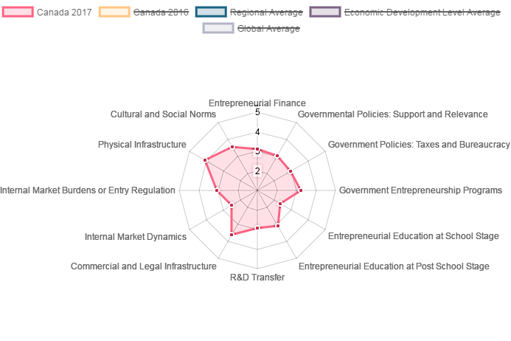
Sources: http://www.gemconsortium.org/country-profile/49

5.5.1 Political Evaluation
Firstly, it is obvious that Canada government offers many conductive policies to help the development of entrepreneurship. As interpreted in this picture, Canada government uses policies to decrease the burden from taxes and bureaucracy and it also offers many supports by this way. What is more, there are many government entrepreneurial programs which can accelerate the development of entrepreneurial activities. One thing should be mentioned is that all these policies and programs are still developing, which can realize a sustainable entrepreneurship.

5.5.2 Economic Evaluation
Secondly, in terms of economic factor, entrepreneurial finance in Canada is advantageous compared to America, another in the Northern America. And Canada government has shed more light on this area, the score rising from 2.68 to 3.10. Though the internal market dynamics are not that energetic, a broad world market makes up for the shortage of it.

5.5.3 Overall Evaluation
The main reason why Canada is an innovation-driven economy can be found in the cultural factors. Canada attaches lot of importance on entrepreneurial education, both at school stage and at post school stage, which may inspire potential talents to become a real entrepreneur. Another reason is that Canada’s score of R&D transfer is outstanding, which means investment in research and development can be transformed into earnings and the rate of return is quite high. Therefore, people here prefer to choose innovation related topic as their beginning of entrepreneurial activities.
Overall, Canada is a good place to run an international business. With high level infrastructure and software support from government, it is easy to have a fast and sustainable development.

6.0 Recommendations
Among all the five countries discussed, Canada, Japan and France are developed countries and all of them have innovation driven economy. One thing in common is that their scores of R&D transfer are very high. Therefore, to countries that have efficiency driven economy, such as Colombia, it is necessary to improve its capability to transfer investment on research and development into earning, which is the capability to commercialize the knowledge, in other words. Only by doing this, can upgrade a country from efficiency driven to innovation driven.
It is obvious that entrepreneurship is not only about economy, the political policies and physical conditions are also related and necessary. Taking Libya as an example, being stuck in a terrible war, the government cannot attach enough attention on entrepreneurial activities. Therefore, it is very important for a country to keep peace in order to have a peaceful environment to develop. It is also advisable that a country is supposed to improve infrastructure construction, because it is the basis of development in any forms. Like Libya, without favorable infrastructure, it is impossible to develop traditional industry, not to mention innovation driven economy.
Another suggestion for all five countries is that attach more importance on entrepreneurial education at school. Though it may not take too much time, it can bring the students who want to be or may be entrepreneurs in the future with some inspiring ideas. And the earlier they reach these information and knowledge, the more they can know what their interest and potential is.

7.0 Conclusion
In a conclusion, this report takes advantage of entrepreneurship theories, analyzes the definitions and significance of international entrepreneurship, both for the individuals and for international states. International entrepreneurship is not only effective to provide incredible economic values, but also can promote the communicate of various nations, thus contributing a more harmonious environment. There are PEST factors that might make a difference for the development of international entrepreneurship, while political and economic factors are the most noticeable. International corporations have to overcome the inconvenience brought by different government polices and macro economic environments. The natures of entrepreneurship can be interpreted in three stages, respectively factor-driven economies, efficiency-driven economies and innovation-driven economies. Usually developed regions belong to the third stage level, while developing regions belong to the first two. This report uses 5 contrasting regions in the global communities, combined with their government polices and social norms concerning for the treatment towards entrepreneurial activities, so as to drive several recommendations that are applicable to most nations to promote the development of entrepreneurial activities. Attach more importance on entrepreneurial education at school. Though it may not take too much time, it can bring the students who want to be or may be entrepreneurs in the future with some inspiring ideas. For instance, it is a wise idea for the government to widen the education both in school stage and post school stage in order to enhance the activeness and recognition of inhabitants towards the values of entrepreneurial activities. Moreover, the government is suggested to enhance the effectiveness of financing channels for entrepreneurs to solve short terms financial problems.

8.0 References
Stevenson,C.(2013). What is Entrepreneurship. Harvard Business Review.

Agostini, L. (2017). Innovation in Entrepreneurship Activities. Journal of Intellectual Capital.

Bontis, N. (2003). Entreprneurship And Its Implications. Management Decision.
GEM Website,(2018). Accessed on
[http://www.gemconsortium.org/about/news]

Guthrie, J.(2000).International Corporations and Economy. Journal of Intellectual Capital.

Hayton, J. (2005). Competing in the new economy .Journal of Business Ventures.

Krueger, N. (2000). Competing models of entrepreneurial intentions. Journal of Business Venturing.
GEM Website,(2018). Accessed on
[http://www.gemconsortium.org/data]

Link, A. (2009). The intellectual Properties of Entrepreneurs. Cambridge, MA.

Martina, M.(2013). The Role of Intellectual Capital in Young Firms. ENTREPRENEURSHIP THEORY and PRACTICE.
GEM Website,(2018). Accessed on
[http://www.gemconsortium.org/report]

Sveiby, K. (2014). The intangible assets of Entrepreneurship Monitor. Journal of Human Resource .

Wu, A. (2005). The integration between Innovation and Management. Journal of Intellectual Capital.

Jason,L.(2013). How Do Entrepreneurs Think? Asia Pacific Journal of Management, 30.

Yin, I. (2011). An competitive asset for innovation of Entrepreneurship.Engineering Management Journal.
GEM Website,(2018). Accessed on [http://www.gemconsortium.org/country-profile/81]
GEM Website,(2018). Accessed on [http://www.gemconsortium.org/country-profile/76]
GEM Website,(2018). Accessed on [http://www.gemconsortium.org/country-profile/62]
GEM Website,(2018). Accessed on [http://www.gemconsortium.org/country-profile/52]
GEM Website,(2018). Accessed on [http://www.gemconsortium.org/country-profile/49]

