

Master of Business Administration
LCMB7037 Business Development Proposal
Business Development Proposal

Evaluating the Commercial Viability of Solar Powered Cooling Cart Rentals for Fruit and Vegetable Street Vendors in India

Student Name: Om Prakashbhai Sadrakar
Student ID: 2526083
Table of Content
1. Introduction 4
1.1 Business problem and opportunity 4
1.2 Market and industry context 4
1.3 Proposed business concept 4
1.4 Aim, objectives and questions 4
2. Literature review 5
2.1 Perishable food loss and informal retailing 5
2.2 Jobs to Be Done framework 5
2.3 PESTLE analysis 5
2.4 Value proposition canvas 5
2.5 Business model canvas 6
3. Methodology 6
3.1 Research approach 6
3.2 Primary research 6
3.3 Data analysis 6
3.4 Ethics and reliability 6
4. Initial market opportunity analysis 7
4.1 Evidence of the market problem 7
4.2 Target customer and segmentation 7
4.3 Jobs to Be Done analysis 7
4.4 PESTLE opportunity assessment 8
4.5 Value proposition and competitive alternatives 9
4.6 Business model and revenue logic 10
5. Limitations 10
6. Timeframe 11
7. Conclusion 11
References 12

1. Introduction

1.1 Business problem and opportunity
The situation of the informal fruit and vegetable vendors in India is severe in terms of substantial losses due to inadequate last mile cold chains for their produce (Rangar et al., 2025). Losses of 30-40% between harvest and consumption for fruits and vegetables, and an additional 30-50% may be experienced between harvest and consumption during the summer at 40-45°C (ADB, 2023). This presents a clear opportunity for affordable solar powered cooling carts which cut down on waste, preserve income and are a major benefit to the freshness of produce.

1.2 Market and industry context
The street vendors in India are about 10 million and post-harvest losses in urban markets for fruits and vegetables are 6.02% to 15.05% and 4.87% to 11.61% respectively, highlighting the need for low cost, decentralised cooling solutions in urban markets (Gov.in, 2024).

1.3 Proposed business concept
Smart Cooling will offer affordable solar powered refrigerated carts, rented by the day, month and storage option, which will help reduce spoilage among the street vendors for fruits and vegetables without the hassle of expensive equipment ownership.

1.4 Aim, objectives and questions
Aim: The aim is to evaluate the commercial viability of a solar powered cooling cart rental service for fruit and vegetable street vendors in India, with particular emphasis on reducing produce spoilage, improving affordability and developing a sustainable revenue model.
Objectives:
- To examine the extent to which inadequate cooling and produce spoilage affect the operational performance and earnings of fruit and vegetable street vendors.
- To assess street vendors’ demand, willingness to pay and preferred payment model for solar powered cooling cart services.
- To evaluate the external market, competitive and technological factors influencing the feasibility of introducing solar powered cooling carts.
- To develop an appropriate value proposition and revenue model for a scalable Cooling as a Service business serving fruit and vegetable street vendors.
Questions:
- How do inadequate cooling facilities and produce spoilage affect the operational performance and earnings of fruit and vegetable street vendors?
- What level of demand, willingness to pay and payment preference exists among street vendors for solar powered cooling cart services?
- What market, competitive and technological factors influence the commercial feasibility of solar powered cooling carts?
- What value proposition and revenue model can support a commercially viable and scalable Cooling as a Service business for fruit and vegetable street vendors?

2. Literature review

2.1 Perishable food loss and informal retailing
One of the biggest problems in informal fruit and vegetable retailing is perishable food loss due to poor access to refrigeration that contributes to the deterioration of produce and the decrease in saleable produce (Bancal and Ray, 2022; Alsbu, Yarlagadda and Karim, 2023). The street vendors are especially vulnerable due to heat, non-existent storage facilities and limited capital, which means they have a greater need for affordable decentralised cooling solutions (Mkhize and Cele, 2025).

2.2 Jobs to Be Done framework
The JTBD framework defines the functional, economic and pragmatic results that vendors want from cooling solutions (Miller, 2026). It aids to evaluate the capabilities of solar cooling carts in the reduction of spoilage, preservation of income and convenience in comparison with the current preservation methods (Ribeiro, Monteiro and Luttembarck, 2019).

2.3 PESTLE analysis
PESTLE analysis assesses the political, economic, social, technological, legal and environmental factors that affect the proposed cooling service (Kansongue, Njuguna and Vertigans, 2023). It provides insights into external opportunities and constraints which impact affordability, adoption, regulatory compliance, and solar technology use and long-term commercial viability.

2.4 Value proposition canvas
The Value Proposition Canvas investigates how the proposed cooling service fits into vendors' jobs, pains and expected gains (Schutselaars et al., 2023). It helps to optimize the mix of lowered spoilage, customer affordability and convenience, boosting product market fit and adoption potential.

2.5 Business model canvas
The Business Model Canvas covers the proposed business venture in terms of the customer segments, value propositions, channels, business relationships, revenue streams, resources, activities, business partners and costs (Salwin et al., 2022). It helps in assessing the commercial viability of solar cooling carts for sustainable operations without increasing the cost for the street vendors.

3. Methodology

3.1 Research approach
A deductive research approach will be employed with primary quantitative data collected to test the pre-determined assumptions on vendor spoilage, demand, willingness to pay and acceptance of solar powered cooling cart services (Fife and Gossner, 2024).

3.2 Primary research
A cross sectional quantitative survey design will be used to gather numerical data from the fruit and vegetable street vendors at a specific time (Maier et al., 2023). Structured questionnaires will be used to assess those who have experienced spoilage, existing cooling practices, willingness to pay and preferred solutions and intentions to adopt solar powered cooling carts. The target respondents for this study will be recruited through a purposive sampling method which will be those who are directly related to the proposed business concept (Azzam, 2026). The street vendors in the selected study area who sell fruit and vegetables will be the eligible participants. This method is suitable since the study has to be conducted on respondents who have experience in produce storage, spoilage and daily produce retailing.

3.3 Data analysis
Frequency analysis will be conducted using Microsoft Excel to summarise respondents’ answers through counts and percentages (Villaseñor, 2021). The analysis will reveal the prevalent patterns of spoilage, customer cooling practices, willingness to pay, preferred rental services and intentions to adopt the rental service, which will help evaluate customer demand and the commercial viability of the proposed cooling service.

3.4 Ethics and reliability
Ethical standards will be upheld by informed consent, voluntary participation and anonymity and secure handling of respondent data. Reliability will be enhanced by using a standardized questionnaire, by using a consistent data collection process, and by using clear questions to minimize ambiguity, researcher bias and inconsistencies in the information provided.

4. Initial market opportunity analysis

4.1 Evidence of the market problem
India loses a significant amount of fresh produce, losing around 30-40% of fruits and vegetables from the time they are harvested until they are eaten (Jhala, 2026). In summer, losses can be as high as an additional 30-50% with temperatures of 40-45°C (Gov.in, 2024). Furthermore, more than 80% of fresh produce trade is done through unorganised channels and has very limited access to cooling, highlighting the high unmet need for affordable last mile cooling solutions.

4.2 Target customer and segmentation
The target customers mainly include urbanized fruit and vegetable street vendors who are facing multiple issues of spoilage and less availability of fridge. Segmentation will determine the vendors based on product type, daily sales figures, their mobility, operating location and level of spoilage exposure, and thus prioritize customers whose cooling requirements are greater and whose rental capacity is higher.

4.3 Jobs to Be Done analysis
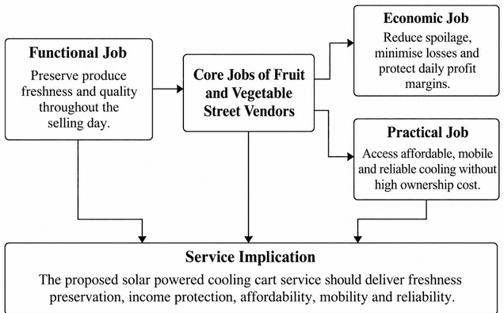
Figure 1: Jobs to be Done analysis
(Self-developed)
The Jobs to be Done analysis involves uncovering the fundamental results that street vendors are looking for from cooling solutions. From a functional perspective, vendors must keep produce fresh; from an economic point of view, they want to minimize losses and maintain margins; from a practical aspect, they need to have access to affordable, mobile, reliable refrigeration. The jobs these roles play directly affect the proposed service's value proposition and positioning.

4.4 PESTLE opportunity assessment
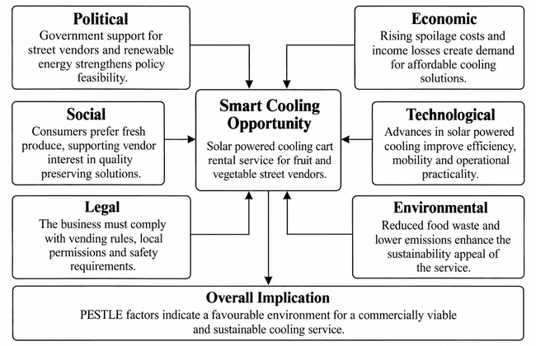
Figure 2: PESTLE analysis
(Self-developed)
PESTLE shows that the situation for the proposed service is favourable. Rising spoilage costs drive economic demand and street vendors' social status raises their political viability (World Bank, 2025). The advantages of social preference for fresh produce are useful for adoption, while solar cooling technology has developed to make the use of fresh produce viable. The compliance to vending law is still required and the decreased food wastes and emission contribute to the environment's attractiveness overall.

4.5 Value proposition and competitive alternatives
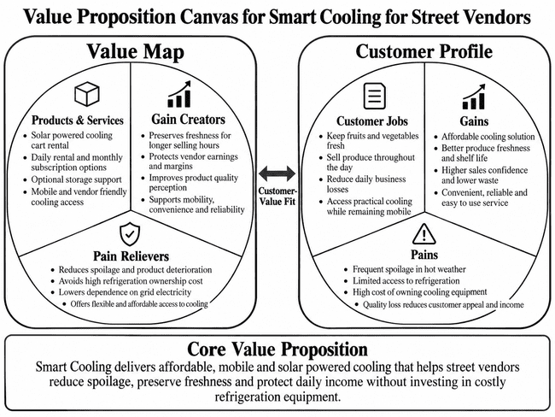
Figure 3: Value proposition canvas
(Self-developed)
The proposed service provides mobile, solar-powered cooling at a manageable cost without the vendors having to buy costly refrigeration equipment. Compared to other cold storage methods like ice boxes, wet cloths, fixed cold storage and conventional refrigerators, the rental model offers increased accessibility, flexibility and decreased reliance on grid electricity.

4.6 Business model and revenue logic
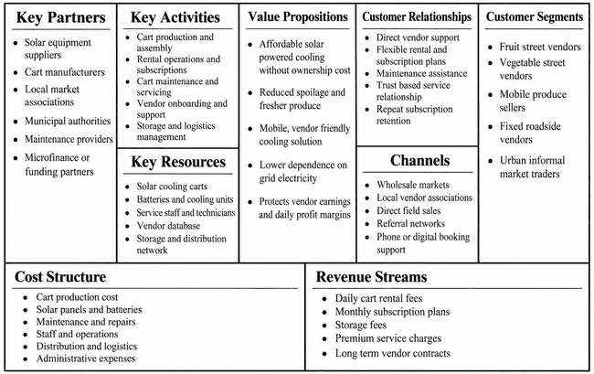
Figure 4: Business model canvas
(Self-developed)
The business model will create a regular source of income for the business with daily rentals of carts, monthly subscription and extra storage charges. The main costs are production of the carts, solar equipment, maintenance and distribution. The profitability will depend on keeping the price down and making sure that the vendor makes a profit on the reduced amount of spoilage over the cost of renting it.

5. Limitations
The study might include a small purposive sample, have limited geographical scope, and rely on self-reported vendor information. This can limit generalisability and result in response bias. The survey results will be triangulated with secondary evidence and standardized in the administration of the questionnaire, which will increase reliability and credibility.

6. Timeframe
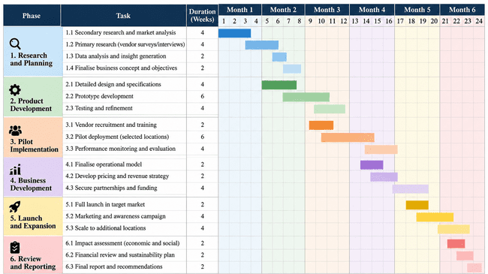
Figure 5: Proposed timeframe
(Self-developed)

7. Conclusion
The proposal shows that it is a feasible opportunity to use solar powered cooling carts to tackle produce decay among street vendors. The study will assess the viability of a rentable based cooling service and the expected commercial value through customer validation and market assessment, in addition to business model analysis to help achieve operational efficiency and income protection for vendors.

References
ADB (2023). Bridging the Cold Chain Gap. [online] Adb.org. Available at: https://challenges.adb.org/en/challenges/tic-coldchain/pages/background?lang=en [Accessed 23 Oct. 2026].
Alsbu, R.A.S., Yarlagadda, P. and Karim, A. (2023). Investigation of the factors that contribute to fresh fruit and vegetable losses in the Australian fresh food supply chain. Processes, [online] 11(4), p.1154. doi:https://doi.org/10.3390/pr11041154.
Azzam, Z. (2026). Purposive sampling in research: Types, justifications, applications, and limitations. Journal of Medicine, Surgery, and Public Health, [online] 10, p.100249. doi:https://doi.org/10.1016/j.glmedi.2026.100249.
Bancal, V. and Ray, R.C. (2022). Overview of food loss and waste in fruits and vegetables: From issue to resources. Fruits and Vegetable Wastes, pp.3–29. doi:https://doi.org/10.1007/978-981-16-9527-8_1.
Fife, S.T. and Gossner, J. D (2024). Deductive qualitative analysis: Evaluating, expanding, and refining theory. International Journal of Qualitative Methods, 23(1), pp.1–12. doi:https://doi.org/10.1177/16094069241244856.
Gov.in (2024). Answer to Rajya Sabha unstarred question on post-harvest food loss due to rising temperature. [online] Gov.in, pp.Answered on 09th August, 2024. Available at: https://www.mofpi.gov.in/sites/default/files/_annex_265_au2145_qhinz4.pdf [Accessed 23 Oct. 2026].
Jhala, A. (2026). FOOD WASTE IN INDIA: KEY STATISTICS FOR 2026 (AND WHAT’S BEING DONE). [online] The Misfits. Available at: https://mymisfits.in/blogs/news/food-waste-india-statistics [Accessed 23 Oct. 2026].
Kansongue, N., Njuguna, J. and Vertigans, S. (2023). A PESTEL and SWOT impact analysis on renewable energy development in Togo. Frontiers in Sustainability, [online] 3(1). doi:https://doi.org/10.3389/frsus.2022.990173.
Maier, C., Thatcher, J.B., Grover, V. and Dwivedi, Y.K. (2023). Cross-sectional research: A critical perspective, use cases, and recommendations for IS research. International Journal of Information Management, 70(70), p.102625. doi:https://doi.org/10.1016/j.ijinfomgt.2023.102625.
Miller, K. (2026). The Jobs to Be Done Framework Explained & Real-World Examples. [online] Business Insights - Blog. Available at: https://online.hbs.edu/blog/post/jobs-to-be-done-examples [Accessed 23 Oct. 2026].
Mkhize, X. and Cele, T. (2025). Market shocks, climate vulnerability, and income loss in informal indigenous food systems: Evidence from street vendors in Durban, South Africa. Frontiers in Nutrition, 12. doi:https://doi.org/10.3389/fnut.2025.1621204.
Rangar, S., Dangwal, A., Jadoun, R.S. and Singh, A. (2025). Cold chain infrastructure for fruit and vegetable crops in India: Challenges and prospects. International Journal of Social Science and Education Research, [online] 7(2), pp.378–383. doi:https://doi.org/10.33545/26649845.2025.v7.i2e.368.
Ribeiro, Á., Monteiro, P. and Luttembarck, L. (2019). The use of the ‘job to be done’ methodology to identify value co-creation opportunities in the context of the service dominant logic. Brazilian Business Review, [online] 16(1), pp.32–45. doi:https://doi.org/10.15728/bbr.2019.16.1.3.
Salwin, M., Jacyna-Gołda, I., Kraslawski, A. and Waszkiewicz, A.E. (2022). The use of business model canvas in the design and classification of product-service systems design methods. Sustainability, [online] 14(7), p.4283. doi:https://doi.org/10.3390/su14074283.
Schutselaars, J., Romme, A.G.L., Bell, J., Bobelyn, A.S.A. and van Scheijndel, R. (2023). Designing and testing a tool that connects the value proposition of deep-tech ventures to SDGs. Designs, [online] 7(2), p.50. doi:https://doi.org/10.3390/designs7020050.
Villaseñor, J.A.R. (2021). Frequency analyses of natural extreme events. [online] Cham: Springer International Publishing. Available at: https://doi.org/10.1007/978-3-030-86390-6 [Accessed 23 Oct. 2026].
World Bank (2025). Strengthening strategic grain reserves to enhance food security public disclosure authorized public disclosure authorized public disclosure authorized public disclosure authorized. [online] World Bank. Available at: https://documents1.worldbank.org/curated/en/099042625211562573/pdf/P504545-488431b2-0565-40f9-852c-e8db32d22559.pdf [Accessed 23 Oct. 2026].

