
professional career development
RIPARA BEGUM 01759528

March 29, 2018
University of Wales Trinity Saint David

Executive Summary
The purpose of this report is to analyse……..
DO THIS SECTION LAST!!!!!!
NOT INCLUDED IN WORD COUNT

Table of Contents
Executive Summary 1
Terms of Reference 3
Procedure 4
Introduction 5
Findings 6
conclusion 15
Bibliography 16
Appendices 17
Acknowledgements 17

Terms of Reference

On march shiela khan requsted a report from ripara begum. To be submitted on 29th march the report covered professional career development. The writer discusses the top in depth needs in

Procedure

Introduction

Professional development is important this can advance your career potions and it comes in form of formal learning which includes coursework, internships or apprenticeships and informal learning which include attending conferences and seminars or networking. How you choose your professional development depends on personal career goals and chosen style of learning [career & professional development 2018,].
To enhance your study skills to be able to contribute towards working effectively for employment. To take the opportunity and practise those skills available to develop the skills you need to find that their promotional prospects. The skills that are important for enable to study well are time management, critical thinking, essay writing and communication skills [Morgan, P. 2017,].
The aim of the report is to show how I have developed the skills an above and knowledge which will contribute towards working effectively and being employment ready for the future.
The recruiting process that an organisation takes before recruiting an ideal candidate for a position in their company and the steps necessary to recruit for the particular post. The processes include job description, personal specification, application process, job advertisement and interview methods used [ Morgan, p. 2017,].

Findings

Reflect on my learning journey
Reflective learning is way to allow are self as a student to review are learning experience and improve better as well as develop critical thinking skills and future performance to analyse are experience. Understanding assessments given acting on feedback and improving on personal development planning. Reflective learning can be applied in many ways by keeping a log to reflect back on participate on personal and academic discussion on employability issues with other members [The university of Sheffield, 2018,].
This is a personal reflection on my learning journey since starting university higher education I have been reflecting on what skills that myself as a learner, what personal strengths and weakness and areas for further development needed to establish employment goals. The skills and knowledge needed for working effectively in employment. Reflecting on planning to gain confidence and competence as an effective employee also, to develop a personal action plan to establish employment goals and aims in career life and as a person [ Morgan, P.2017,].
In university attending classes I have developed skills for employability and academically stronger. The step-by-step explaining different theory’s and models I have learnt while learning the styles of different ways of learning preferences. By using life experiences, you can reflect on using different models like Johari window, Maslow’s theory of needs and SMART goals to achieve career goals. Also used Kolb’s learning cycle which reflects on life experiences.
Since starting the course I have worked as part of a team and found many positives about working in a group sharing ideas, sharing workload, shared responsibility’s working as a group was also challenging as each member had different ideas and not communicating with each other members in the team sometimes. Working as team to achieve goals common experience for many teams achieve amazing results. Teams accomplish tasks related to common goals to do this member need to interact with one another form or fashion [skills for the workplace student yearbook, Maund, A. 2017,].
Skills needed for academic success
Employability skills
The development of personal skills
Setting good goals

Skills Audit
To identify what skills, I had and the skills I needed to develop for future did a skills audit on myself.
Skills audit your existing skills against the skills needed for now and identify skills needed for the future. Also carry out voluntary work roles effectively and to plan, develop improve skills knowledge needed for future. To carry out skills audit is a five-stage process.
Stage one: existing skills and knowledge identification list the knowledge and skills consider to be important for voluntary work refer to the job description.
Stage two: future skills and knowledge identification of skills which I consider to be important in future career.
Stage three: rating your ability once listed the skills need to rate current ability against each one. Is done by three-point rating of strong, weak and somewhere in-between or can use a five-point scale.
Stage four: review your ability rating a friend or supervisor to review your list give feedback. Ensure choose someone honest tell the truth.
Stage five: your future development the final stage using the information concentrate to develop the skills that I scored low.
The skills which I consider to be important for current voluntary activity and rated them 1-5 one being weak to five being strong.
Communication-5
Relating with others-5
Problem solving-3
ITC skills-2
Management-4
Time management-4
Listening skills-5
Leadership skills-3
Under pressure-3
Mathematical skills-3
Writing essay skills-3
Presentation skills-3
Skills and knowledge, I consider to be important for my future.
Problem solving-3
ITC skills-2
Management skills-4
Time management skills-3
Leadershipskills-4
Mathematical skills-3
Writing skills-3
Presentation skills-3
Reading skills-3
I also did a personal effectiveness questionnaire to help reflect on personal effectiveness. The questionnaire consisted of 40 questions by answering them truthfully, I found out that my strengths are learning orientation, high personal power, focused energy. Based on the response I give skills audit the areas I needed to improve and develop further [career smart .2018,]. After doing the skills audit I found out the skills listed with low marks are areas I need to develop more on skills like reading, writing, present skills mathematical skills they are some of the skills need to develop on these skills are all important for employability as well [Morgan, P. 2017,].

Maslow’s hierarchy of needs
Maslow’s hierarchy of needs a motivational theory comprising a five-tier model of needs in humans divided in levels in a pyramid. Maslow theory started 1943-1954 it stated people are motivated to have certain needs that some needs are important over others, most basic needs are physical survival, most important needs first that motivates our behaviour. Each level is fulfilled the next level up motivates us to go on and reach the top of the pyramid [simple psychology. 2018,].

Maslow’s hierarchy pyramid five-tier

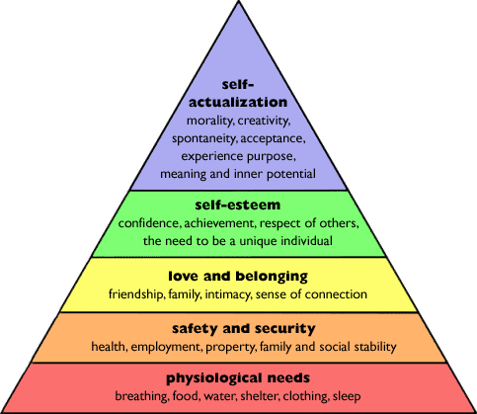

The five-stage model divided into deficiency needs and growth needs. First four levels are often referred to as deficiency needs, are often referred to as deficiency needs, (D-needs) top level is known as growth or being needs (B-needs). Deficiency needs said to motivate people when are unmet. Motivate to fulfil needs become stronger the longer duration they are denied. For example, the longer someone goes without food, the hungrier they will become. Maslow (1943) started individuals must satisfy lower level needs before progressing on to the higher-level growth needs. To grow as a person when your growth needs have reasonably satisfied than can you reach the highest level called self-actualization. Sometimes because of personal reasons we fail to meet the lower level needs it causes fluctuate between levels of hierarchy. We will not all move through the levels in a unidirectional manner but move back and forth between the different types of needs [simple psychology. 2018,].

In learning to be self -confident we need to analyse are self and how we patriate yourself and how we self-confident is a character which helps you defend yourself to negotiate, complain to build self-confident. By having more knowledge and understanding of internal and external influences of personal development needs [national college. 2018,].
The Johari window of developing your self-awareness is a model used to simple tool to improve self-awareness and understanding between individuals with in a group. Johari window was developed by American psychologist Joseph Luft and harry Ingham in the 1950, researching group dynamics. The model is especially important in soft skills related like behaviour, empathy, co-operation, inter-group development and interpersonal development which are all important to have [ national college. 2018,].

The Johari windows developing your self-awareness

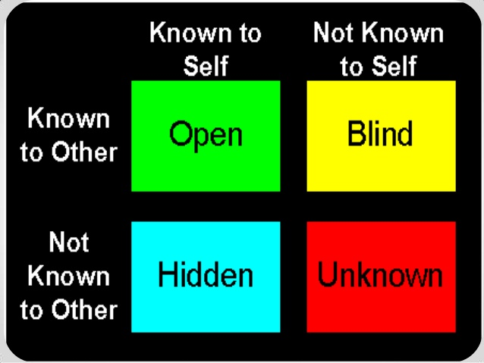

There are four regions in Johari window:
- What is known by the person about him/herself and is also known by others-open area, open self/free area.
- What is unknown by the person about him/herself but which others know-blind area, blind self or blind sport.
- What the person knows about you that others do not know-hidden area hidden self-avoided area avoided self or façade.
- What is known by the person about you and is also known by others-unknown area or unknown self [national collage. 2018,].
By doing this model I can share aspects of information that makes me happy and want to share with others. Aspect of myself that would like feedback on that am lacking on areas that I would develop also explore further in to improve on with mentor at university.

Swot analysis is a technique used to understand your strengths and weaknesses and identifying both opportunities open to you and treats you face. By using this swot framework on myself can find out my strengths and weakness and how I can make them my opportunities and find strategies to distinguish my threats successfully to be career focused and develop myself [mindtools. 2018,].

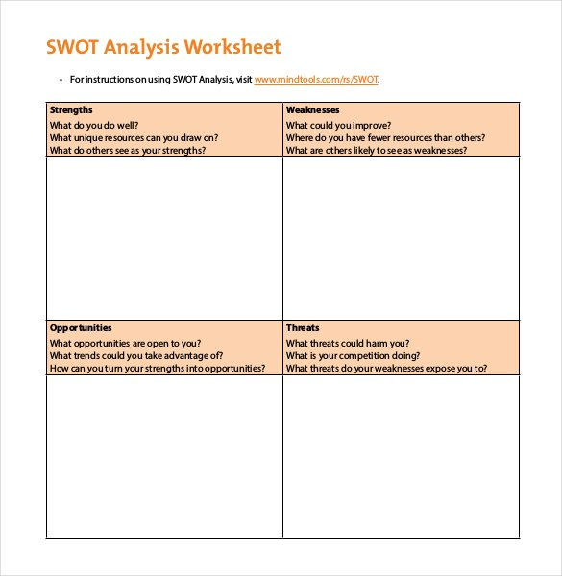

Here is a development needs of my own personal SWOT:
Strengths:
- My listening and communicate with others well
- Good at cooking different recipes
- Good as working in a group as a team member with leadership skills
Weaknesses:
- Managing time
- Presentation skills
- It skills
- Researching and use library skills
Opportunities:
- Do more public speaking to improve my presentation skills
- Need Manage my time more effectively by keeping a dairy and prioritizing time well by planning ahead
- to take part on a IT course to improve IT skills
- Use all the resources more for better resourced assignments
Treats:
- Better skilled candidates applying in the same sector
- Lack of skills less career opportunities
The outcome of my personal analysis
Strengths:
- Shows and develop existing skills more to be stronger and developed person
- To achieve an ideal job with all my strong skills already possess.
Weaknesses:
- To complete a course for IT skills to improve
- Mange my time better and plan ahead
- Use all resources well around me
Opportunities:
- Build up job goals with my strengths and make them my opportunities
- Take up all opportunity that come my way to build on career plans
- Look at opportunities around me to develop my soft-skills at university
Treats:
- By developing and planning to overcome barriers around me
The SWOT is a powerful tool to help uncover opportunities that you wouldn’t have noticed. By not understanding your weaknesses to eliminate treats to be able to move on forward to advance your career help achieve personal goals [mindtools. 2018,].
Learning style
Recognising and using our preferred learning style and varying your experiences can make revision easier less of a chore and more effective [skills you need. 2018,]. One of the learning style questionnaire I applied on my self was honey and Mumford. Honey and Mumford learning styles were developed by peter honey and Alan Mumford in 1986. Also inspired from and built on Kolb’s learning styles model but produced their own learning style questionnaire. They found Kolb’s learning style was low validity with mangers. Honey and Mumford gave a questionnaire that probes general behavioural tendencies. Knowing what learning style helps to make better decisions and gives individual opportunities best learning preference for them to increase and improve learning skills also awareness [ ELN resources. 2018,].
- Honey and Mumford identified four basic style of learning, which they characterised as:
- Activists who learn by doing, ‘getting down and dirty’, and trying things out.
- Pragmatists who are chiefly interested in how ideas can be applied in the ‘real word’.
- Reflectors who like to reflect on their experience and that of others.
- Theorists who like to understand how their study fits into a broader theoretical framework.
By doing the honey and Mumford learning style questionnaire on appendix (A) I have learnt that am a reflector and a theorist. Reflectors like to experience and observe from many different views. They will get data first hand and from others around them. Reflector’s like to think it through before coming to any conclusion about the situation as long as possible considering before making a move. Enjoy observing from a distant other people in action have a low profile when they participate from a wide picture include the past as well as present situations. Theorists like to adapt and integrate observations into complex and logical sound theories. Theorists like to think problems through step-step logical process and are perfectionists like having things are tidy and fit into rational scheme. They approach problems in consistently logical. Mentally prefer to maximise certainty and feel uncomfortable with subjective judgments [ELN resources. 2018,].

Kolb’s learning cycle is well-known theory which said that we can learn from our experiences of life. On an everyday basic it looks at reflection as an integral part of learning. According to Kolb (1984), the process in learning follows a Patten or cycle consist of four stages, which involves that Kolb refers to as ‘’reflective observation’’.
These are stages are illustrated below:
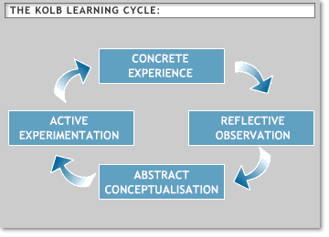
Stage 1: experience (Kolb’s concrete experience) life is full of experience we learn from at home or work, out socializing they are a lot of opportunities to kick start the learning cycle.
Stage 2: reflect (Kolb’s reflect observation] which involves as thinking about what experience we do whether it comes naturally are good at. Others train themselves to be deliberate reviewing on experiences and recording them.
Stage 3: conceptualise (Kolb’s abstract conceptualization) we pass thoughts about our experience to interpreting them into the realm of conceptualization is to generate a hypothesis about meaning of our experience.
Stage 4: plan (Kolb’s active experimentation) learning from experience is not sufficient by just having them. We only go back to stage one of the cycle experience are potential yield to learning. If we pass through Kolb’s stages by reflecting on our experience to test our interpretations. [Leeds becket university. 2018,].
By slimming learning experiences are key element needed to reflect on most of us don’t theorize about what we are learning without knowing were follow Kolb’s cycle all the time and reflect on our day-to-day life’s [Leeds becket. 2018,].
The other learning style which applied to myself is the VARK learning style questionnaire on appendix (B). The VARK learning style is by Neil D. Fleming it is a background questionnaire which is widely used by coaches, tutors or teachers to teach the differences in learning among their students to match there needs. This learning style is to understand visual, aural, read/write, kinaesthetic and multimodal preferences. Which reflect the experience of both students and teachers [VARK-learn-com. 2018,].
These are the learning style meaning VARK:
Visual (V) this learning style is preference which include information in maps, spider diagrams, charts, graphs, labelled diagrams that people use been presented in words. When used to draw diagram and symbols different things that will help those with visual preference and those who have a read/write preference as well.
Aural/auditory (A) this preference of learning for information that is heard or spoken by the learner main preference reported that they learn best in group discussions, radio, email using phones, talking things through. Aural prefer talking out loud and talking to them self. People want to sort things out speaking first and learn through saying it to themselves-their way.
Read/write (R) this learning preference is having information displayed as words or in written. A lot of students and teachers prefer learning this way. Being good at writing and reading well widely mostly by employers of graduates. This emphasizes on text-based input and out put reading and writing. Especially manuals, report and essay writing assignments people who prefer using PowerPoint the internet doing presentations with PowerPoint like to use auditory channel or a presentation that uses visual symbols.
Kinesthetics (K) this learning style refers to perceptual preference related to the use of experience and practice (simulated or real). People who prefer its style are connected to reality. People who prefer to learn from experience of doing something they value own background of experience of others.

Lectures support teacher like manna and family members support

Task
Multimodality (MM) this mode is used because life multimodal or is sufficient that is why a four-part VARK profile provides four scores which are mixtures of those four modes the questionnaire provides to people who don’t have a standout mode with one preference sore well above other scores are defined as multimodal [VARK-learn. 2018,]. As u can see from doing the questionnaire on appendix (B) it shows that I’m a visual (V) learner and aural/auditory (A) learner too these are the preferred style suggested by doing the questionnaire.
S.M.A.R.T goals
SMART objectives:
S: specific what exactly you want completed
M: measurable how you will know you have completed it or not
A: achievable likely to be able to achieve this goal/complete
R: realistic in time scale allocated enough time to reach with available resources
T: time bound by when you want to complete this
My goal is to achieve a degree by the end of my three-years course by having a certificate at the end when completed to show I have one. This is attainable if am focused a lot put hard work and manage my time while. Which I have control over by using my strengths into opportunities. It is relevant to me because will use all the skills already possess and develop them though out the course which started at 2018 already.
My personal go mad framework:
By doing a skills-self assessment we can develop skills quickly to be more successful for career planning and our academic skills develop stronger. Skills are needed for academic success as well as success in starting a career. Also understanding why skill development works when planned well. We should take the opportunities to develop are skills development [Morgan, P. 2017,].

Personal Development plan

Deployment Objective | Specific Actions | Barriers and how they will be roved | Support required | How I will know I have achieved the objective
Presentation skills | Need to practise more and have a more in depth manged presentation, my body language | A bite more eye contact with audience and need more self-confidents | Need friends and family members to practise on and do more research on presentation skills | When I give a presentation and get top marks and good feedback
IT skills | Using the computer more to practise do a course on IT skills get more knowledge try different packages | Use micro soft windows in doing assignments and get more formula using it | Need support from support teacher manner or IT specialist | When I can use it independently on my own and confident using it for assignments

By having a personal development plan helps you to record your learning experience and reflect what you have learnt listing points. Plan on how to implement the plan and how to go about doing it using SMART as objectives [Morgan, P. 2017,].
Personal branding
Creating your unique personal branding includes reputation values and principles your personal profile presence web and social media on yourself. The authentic your unique selling point. The process to create your name and career express and communicate your skills, personality. Uniqueness makes as stand out from the rest and draws people to what we’re selling personal branding is important to everyone to control career development and how people see u in the market. To build your platform to get that ideal job. Use websites and media accounts to represent and brand yourself [the balance. 2018,].

What to include in a cv
What is required in your curriculum vitae known as a CV or resume it shows employers that you’re the ideal candidate for the job it’s the first point in selling yourself. The CV should cover these elements:
- Your detail
- Personal statement
- Work experience
- Education
- Skills
- Hobbies and interests
- References
Keep the CV simple layout clear to anyone reading the CV the person scanning the CV can quickly match up your experience with the job description. Employers generally spend at most 20 seconds reviewing each cv make a good impression to get an interview its important to get it right [ monster.2018,].

The organisation is looking to recruit a retail manager for its brunch.
How the organisation would go about recruiting and selecting for a retail managers position. The recruiting process has different steps before a person is selected for a job the organisations first step generates more people would be to advertise for the position and invite candidates to apply for the position [Morgan, P. 2017,].
Advertising is a key part of the recruitment process. The right job advert helps and allows the right candidate to apply for the position and create quality applicants to select from. If the advertisement is poor and doesn’t attract the ideal candidates you want for the organisation it results in the wrong candidates appealing. An effective job advertisement attracts right candidates using good marketing draws attention, generate more interest to apply for the position to select from [Harrison human resources.2018,].
The process of job analysis to identify the requirements involved for the position and qualities they want as a company in the ideal candidate the organisation have to take in consideration the values and culture in mind while taken job description and other information for a personal specification. The skills and knowledge, abilities, experience and other qualities their looking for [Morgan, P.2017,].
Personal specification
The organisation will have some required qualities that that they want from the successful candidate. This is usually known in terms of knowledge and skills, abilities and experience and other qualities the organisation wants for example:
- Leadership skills
- Critical thinking abilities
- Interpersonal and communication skills
- IT literacy and presentation skills
- Problem solving and creative abilities
- Organisational and time management abilities [Morgan, P.2017,].
The job description general tasks or duties and responsibilities of the retail manager are:
- organizing all the store operations
- supervising and guiding staff towards maximum performance
- preparing the stores budget expenditure [ Workable.2018,].
The job brief looking for an experienced retail manager to see the daily running of our brunch to ensure maximize sales and minimize costs while operating the brunch. The ideal candidate for the position will posses experience as a brunch manager. Have knowledge of running a business has sales marketing skills to motivate staff to perform maximum capacity and develop the business [ workable.2018,].
Job responsibilities as a retail manager.
- Organise store operations and allocate responsibilities to staff
- Supervise and guide staff to perform their best
- Deal with complaints from customers maintain stores reputation
- Prepare stores budget expenditure
- Monitor stock levels and purchases [Workable.2018,].
Requirements of the position
- Proven experience as a retail manger in other managerial position
- Knowledge of retail management practices
- Good communication and interpersonal skills
- Excellent organizing and leadership skills
- Analytical mind data analysis and BSC/BA in business administration sales or relevant field is desirable [ Workable. 2018,].
How the organisations selection process works.
The selection process is to select from the pile of applicants that have applied for the position and the applicants that don’t meet the organisations criteria’s that they’re looking for. The screening process is examining the applications most appropriate for the position and invite them for an interview [ Morgan, P.2017,].
Screening CV electronically scanned by relevant software this means the CV and cover letter need to be eye catching and relevant to the position. The candidate needs a good cover letter and CV to successfully sell their skills, knowledge and abilities to prospective organisation [career advice & expert guidance. 2018,]
Implementing the selection process
After carrying out the selection process the organisation will identify those candidates they are interested in. the chosen candidate will receive an invitation to attend for interview and then an assessment centre [ Morgan, P.2017].
Interview methods and types:
Interviews can choose from different methods and style to interview candidates. To get as much information on the candidate as possible, as well as how they react to different situations at the workplace. The different methods and style enables the organisation to do that [American military university. 2018,].
Types of methods:
Behavioural- based interviews
This type of interview focuses specific past performance and experience questions on past work experience a framework for describing work experience and skills.
Case interviews
This type of interview is commonly used in consulting interviews candidates are given scenarios to task analytical ability, questions vary.
Information interviews
This type of interview compares the nature of the industry their expectations with the position the positive and negative aspects of the position it is an informal interview without performance pressure [ American military unversity.2018,].
Types of interviews
One-to-one interview
In person (traditional) one-on-one interview on opportunity to show the employer why they should hire you.
Phone interview
The phone interview is least formal method of interview the phone interview gives a candidate in ability to sense subtle non-verbal. It’s important to pay attention to your interview’s voice and write things down if you forget questions.
Second interview
Return for a second interview because employers are having difficulty deciding between few strong candidates. Second opportunity to demonstrate why you’re the perfect candidate for the job.
Group or panel interview
Group or panel interview is being interview is being interviewed by more than one person of the organisation or a group of candidates also, be a more effective use of time [ American military unversity.2018,].
The organisation well interview candidate which are selected good use of time is critical as interviewing people cost money and time. They will be using a structured interview where set of standardized questions based of job analysis not individual answers we will interview candidates on a one- two-one interview. Interview consist of number of questions usually towards situational interviews or behaviour description interviews. The sort of questions we would ask are one of the employees is performing badly because of personal home issues. How would u handle complaint from the other member of the team lack of performance? Other question would be how did you show leadership in current or past job? [ human resource management. 2018,].
After the interview u should send a thank you letter or an Email to the interviewers its polite to appreciation when a person has taken time to attend the interview on that day [the balance. 2018,].
- Fairly deciding on the right person
- Offer letter/written particulars of employment/references
- Induction date
- Probationary period

Employability- the journey

conclusion

Bibliography

Appendices

Acknowledgements

