

How Responsible Business fits in to the Circular Economy: A case study of L’Oréal Group

Laura Davies 1910723
Dr Alex Bell
Globally Responsible Business (BMSP6001)
Executive Summary
This report uses a case study of L’Oréal Group to demonstrate how responsible businesses can use the principles of the circular economy to tackle global issues. The linear economy is a model that takes, makes and waste raw materials and depletes the worlds natural stock. This is turn is contributing to global issues such as climate change. The circular economy offers many solutions to the many problems caused by the linear economy model. L’Oréal, the number one cosmetic brand in the world has a long lineage of researching and innovation so they can bring beauty to the planet whilst being respectful of the natural environment. This report highlights how L’Oréal have achieved their success to date and what challenges lay ahead for them. From analysis, solutions are given to address these challenges.
Introduction
“Circular economy is an economic system that is regenerative by design. … The linear economy is the prevailing model because simply the world is just not in tune or necessarily aware of the circular model and it’s economic and societal benefits.” Bjorn Smeets, Former Manager: National Procurement, Dura Vermeer
This report will use L’Oréal, the global beauty brand as a case study in examining the relationship between the circular economy and business. It aims to identify where L’Oréal currently resides in the economy, if it follows a linear concept or if it has adopted a circular one and to what extent. The linear economy and the circular economy will be discussed in terms of what they are and how they differ in principles. The sharing economy will be touched upon to highlight how it benefits the circular economy. L’Oréal’s sustainability status will defined following an enriched insight into L’Oréal’s offerings and their sustainability efforts. This report aims to identify what challenges lay ahead for L’Oréal by way of a SWOT analysis giving priority from the highest impact to the lowest. Solutions to the challenges identified will be then offered. The Ellan Macarthur Foundation highlights the advantages of sustainable business practices with circular economy principles underpinning them. Some of these benefits are new avenues of profit, cost savings from being less reliant on raw materials and building strong bonds with customers (Ellen MaCarthur Foundation, 2022).
Linear Economy
The linear economy is the world’s current economic model. Its foundations are built on a take, make and waste model. Taking raw materials, creating products from, or using them as energy and when it is at the end of its single-use life cycle it is no longer considered as valuable and is thrown away. This linear model is to blame for pollution, climate change, waste in oceans and landfill and creates unhabitable environments resulting in the loss of biodiversity (Ellen McArthur Foundation, 2022). A growing global population will increase the demand for already scarce raw materials to satisfy the growing consumption rate and further impact the earth negatively and threaten its future (William M.Mayes. Susan L.Hull, 2022). The economic disadvantages to the linear economy are also great as the increasing demand of raw materials cause price fluctuations in the market, making it difficult for businesses to strategically forecast prices that could put them in a more competitive position than companies that are less reliant on raw materials. This then filters through the supply chain causing more uncertainty (Economy, 2021). Another economic consequence of the linear ‘business as usual’ model is that investors are investing less in the sectors that extract and process raw materials. There is a growing awareness of companies that see a way to make a positive global impact and to participate profitably in a circular economy as opposed to the linear one that currently exists but, as data shows this is not at the pace needed to steady climate change and provide for the growing middle class of the world and the quality of living they will expect (Circle Economy, 2018).
Circular Economy
In contrast, the circular economy has a zero-waste model that offers a solution to the problems caused by the linear economy. The circular economy could be beneficial to the environment, to people and to businesses. Its three principles are to design out waste and pollution, to keep products and materials in use and to regenerate natural systems. The Ellen MacArthur Foundation demonstrate that through separating materials in to biological and technical groups, they can be holistically managed. This known as the cradle-to-cradle approach (Aprinnova, 2022). Biological materials can safely re-enter the natural environment after being through their use cycle more than once. These materials include wood, oxygen, water, soil, food, and fibres and either return to the biosphere or would biodegrade offering new nutrients to the planet (Ellen MacArthur Foundation, 2022). Technical materials are originally sourced from raw, finite materials and then processed so they have no way of returning to their natural environment like biological materials can. Technical materials therefore must be kept in motion. Before disposing of products after a single use, these products could be categorised by way of re-use, repair, remanufacture and recycle so they are given a new lease of life as apposed to an end of life (Stahel, 2016). The circular economy has the potential to ease pressure on the already delicate planet, it allows for raw materials to be viewed as borrowed (must be replenished) to preserve the earths natural stock, create opportunities to collaborate and innovate, boost economic growth, and create new employment opportunities (European Parliament, 2021).
Sharing Economy
The sharing economy model works as an element of the circular economy model and is driven by the concept that accessing services and goods rather than the traditional method of owning something can create a more sustainable economy and be ecologically beneficial. The sharing economy has other terms such as, Peer to Peer or the collaborative economy. The concept brings people together by one party offering their own goods for sale or hire and the other party participating as the customer. Other activities within the sharing economy include offering skills, time, and experiences (Beretta, 2017). By encouraging consumers to see value in ‘using’ rather than owning, the economy will still grow as money is still being spent and circulating as paying for services would be a more regular occurrence whereas owning something would be a one-off purchase. Fewer natural resources would be required to make new products. Poor and less well-off people can use this model to lift themselves out of poverty and secure future wealth. Fuel consumption would reduce due to the car-sharing initiative with the sharing economy model (Anders Fremstad, 2018).
L’Oréal Group
L’Oréal are the number one cosmetic group in the world, acquiring 36 different brands, in 150 countries, they employ 88,000 people and have made 29.0 billion euros worth of sales as of 2019 (L’oréal Groupe, 2022).
L’Oréal develop and produce hair dye, hair care, make-up, skin care including sun protection and perfume. In 1909, L’Oréal Group’s beginnings were made when the French chemist, Eugène Schueller developed a hair dye that he sold to Parisian hair salons. From there he continued his ‘research and innovation in the service of Beauty’ L’Oréal Heritage (L’oréal groupe, 2022).
L’Oréal started its global expansion over the course of the last century and invested heavily in the research field to keep innovating new products and services. Along with research, the iconic marketing of products such as the ‘Because You’re Worth It’ slogan used in ad campaigns, has helped to strengthen their brand image. Between the late 80’s and early 2000’s L’Oréal achieved global dominance in the beauty industry (Shatzman, 2021).
From 2006 to today, L’Oréal have continually outlined and updated their global growth agenda, stating that diversification, ethical, environmental, social, and digital responsibility are the focused initiatives, in the interest of sustainability for everyone (L’oréal groupe, 2022).
L’Oréal’s status so far in sustainability
L’Oréal’s pursuit of sustainability suggests high virtue as is evident in their annual reports. In these reports they provide both financial and non-financial disclosures. In 2013, L’Oréal announced their ‘Sharing Beauty with all’ Programme. This programme enlisted set goals that the company wanted to achieve by 2020 so they may better inform consumers and help them make sustainable choices. L’Oréal recognise the need to address the environmental impacts within their model and throughout their supply chain, as a starting point to addressing the wider global environmental crisis. The four pillars of their approach were:
- Innovating sustainably-to produce products with 100% rate of environmental and social benefits. L’Oréal focus not just on the environmental impact of their packaging but also the environmental profile of their products and have improved the environmental formula of 39% of all new products (LOreal, 2020). L’Oréal appear to be ahead of the game with the pro-active action of removing certain ingredients from their formulas before they become banned (Life, 2020).

- Producing sustainably-to increase customers by one billion, at the same time, reduce their environmental footprint by 60%. They take into consideration the water consumption that is involved with developing the products but also water consumed when the products are in use by consumers. 17 of the company’s plants had water treatment systems in place by 2020. The water systems make it possible for water to be reused and then for wastewater to be retreated. With the help of diverse technology, they can extract high quality water, allowing it to serve a new purpose. (L'Oreal Groupe , 2022). There has been a 49% decrease in water use in all their plants since 2005 (LOreal, 2020).
- Living sustainably-to increase consumer awareness and enable them to make the desired sustainable choices they want by way of being a sustainable company in both practice and product supply. L’Oréal’s Garnier hair care range have a sustainability impact score for all their products. Products are given a score from A-E on the level of sustainability in terms of social and environmental impact. Customers can compare products by individual sustainability measures. This digital labelling system has taken five years to create and there are plans to provide this for transparency across all of L’Oréal’s brands (Garnier Sustainability Team, 2020) (Culliney, 2020).

- Developing sustainably- to improve provisions for employees through health care, education and training and social protection.
-to select all suppliers based on their social and environmental performance
-to have a 100% participation rate on the supplier sustainability program with their suppliers (Yeomans, 2013).
By 2020, they exceeded their target of helping 100,000 underprivileged people access employment through their community and educational programmes (L'Oreal, 2020).

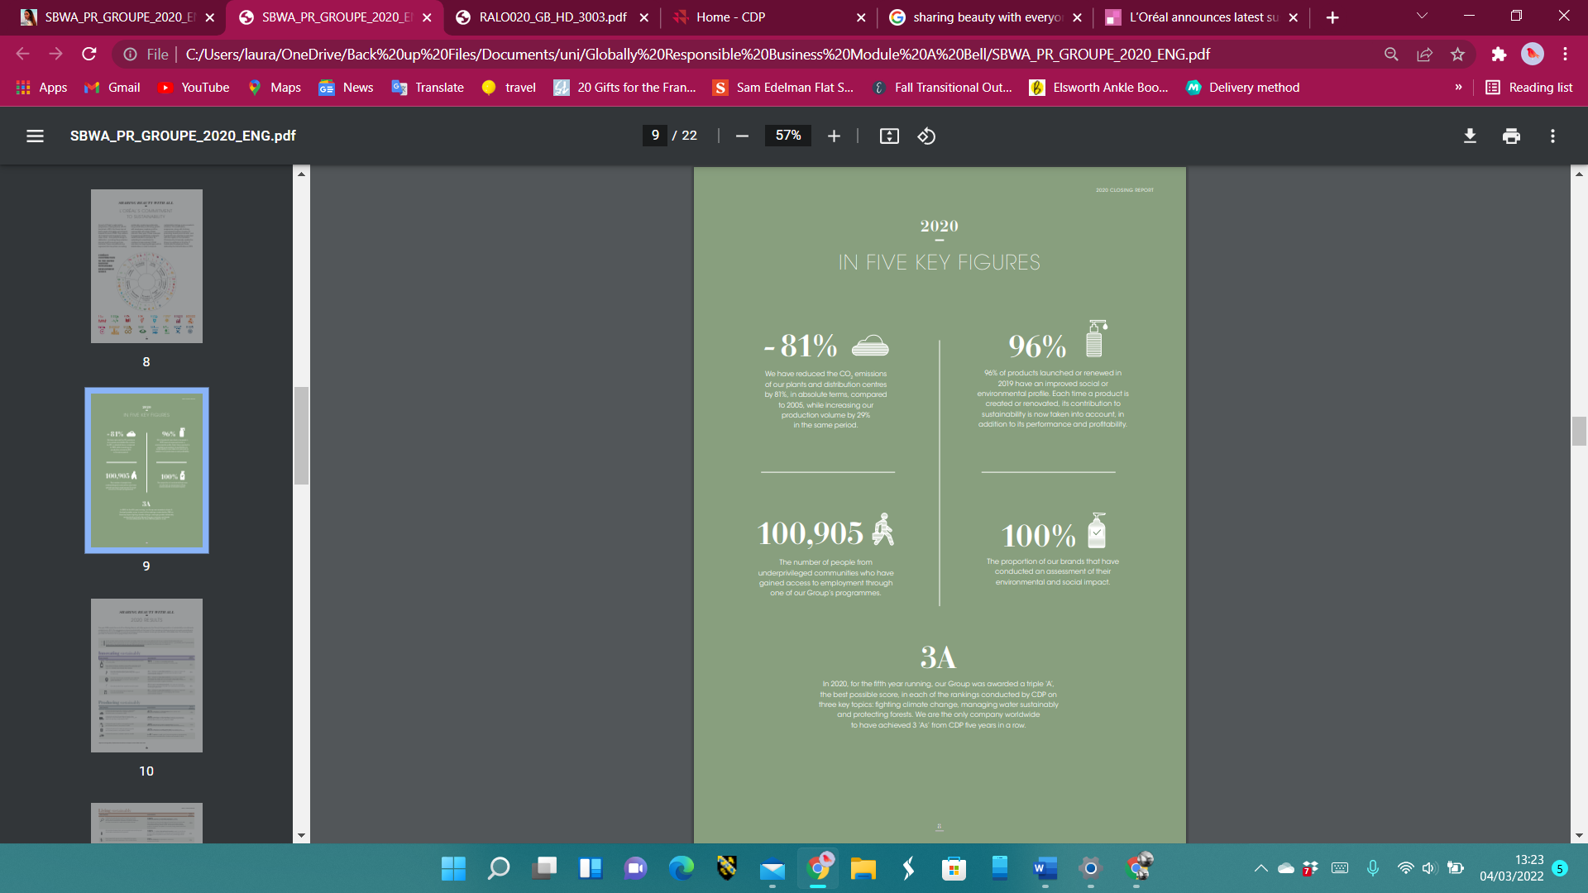
In 2020, they released the results of the programme demonstrating a high level of success. Image 1 below highlights the five key figures they have achieved from the goals set.
Image 1 (L’Oréal, 2020).
In the 2020 report they announced the ‘L’Oréal for the Future- ‘Because our planet is worth it’ programme. Scientists believe there is approximately 9 years left to complete the change to a circular economy to halt the expeditious progression of climate change (L'Oréal Groupe, 2020). Emphasising their awareness of needing a collective effort to have a positive impact on global challenges, L’Oréal have outlined their objectives for 2030. Moving forward L’Oréal aim to be recognised as leaders for change and influential in encouraging all people to take action (L’Oréal Group, 2021). This programme, like the previous one is built on pillars. Their strategy has been compacted into three pillars of the same principle but with bigger ambitions. Packaging optimisation to induce the circular economy shift, changing formulas of products so they can remain the same whilst being in harmony with the environment. Investing in environmental programs that reap social benefits that empower women (L’Oréal Groupe, 2022). Although ambitious, it is an elevation of their sustainable efforts.
L’Oréal state that their ethical approach is both proactive and voluntary allowing them to maintain a trusted relationship with their stakeholders. For further transparency, L’Oréal are registered with CDP. CDP are a not-for-profit charity that provides a global disclosure system. Companies, investors, and places such as cities, states and regions register and disclose their sustainability practices and report their progress annually. They are awarded through a ranking system that allows them to highlight their successes to their stakeholders and recognise shortcomings to rectify and improve on them (CDP, 2022). L’Oréal have upheld a triple ‘A’ score (highest score attainable with CDP) for 5 years running and the first company to do so with CDP. This score is the result of Loreal’s pro-action to climate change, water consumption, resource use and biodiversity.

Challenges
To identify the challenges L’Oréal still face in attempting to be completely encapsulated in the circular economy, a SWOT analysis is performed. 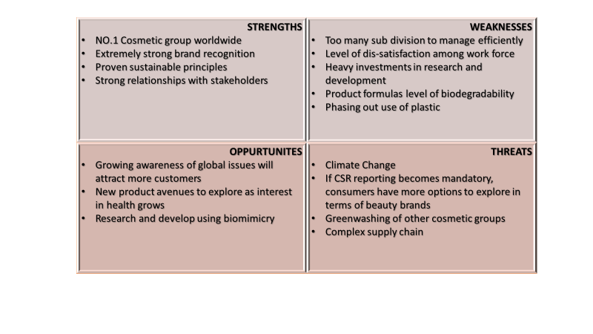
The challenges identified in the SWOT analysis have been prioritised in order of highest to lowest impact.
- Climate Change- Climate change is increasingly showing itself as the biggest threat to our planet and human health (National Geographic, 2022). Every effort to halt this change would make a difference. The European Union have a target of achieving 55% emissions reduction by 2030 and then climate neutrality by 2050 (Climate Action Tracker, 2022). In 2019, America noted that the largest amount of greenhouse gases was result of transportation (United States Enviroment Protection Agency, 2022). Enabling remote work opportunities for employees would help to reduce green house gas emissions.
- Corporate Social Responsibility (CSR Reporting) becoming Mandatory
If CSR reporting became mandatory, it would create a level playing field and accelerate the change to a circular economy. Although these are positive steps, for individual businesses it creates a more competitive environment, new innovators would come on the scenes and companies may greenwash if reporting isn’t regulated. For the honest, long-established companies, it puts them in a worrying position. They must adapt, collaborate, advocate and innovate in a circular economy manner. (Hans Bonde Christensen, 2019) L’Oréal Group is just one cosmetic group in the world, but they are also ‘the’ number one group in the world with a mass following and their brand carries heavy weight in terms of leadership and creating movements. They already hold trust in their stakeholders (Loreal , 2022). Using their platform, they could collaborate with industry associations which would allow them to push for policy changes. As time is of the essence in respect of saving the planet, policy’s must be enforced as waiting for everyone to do the right thing is not happening quick enough (Murphy, 2021).
- Phasing out the use of Plastics
L’Oréal’s aim to use only plastics that are recyclable or bio-based by 2030 (Packaging Europe, 2022). Ask Nature highlight how the use of mycelium from mushrooms can produce a biodegradable, water resistant, thermal insulating packaging. A mold of the mycelium and cellulosic material is created. Through this technique, mycelium knits a substrate together and forms a solid mass. When drying out, the mycelium growth is halted. This type of packaging has 0% toxicity meaning they are hazard free to the people and wildlife. Taking natural waste and creating another use for it before it is composted and then put back into the earth to create new nutrients, illustrates the loop that the circular economy is trying to mimic.

Conclusion
The linear economy and the circular economy currently coincide with the linear economy resisting extinction. This resistance has created grave danger to the existent of human life on the planet in the very near future. Businesses are in a position to act responsibly but also be leaders for change amongst themselves and people. This The evidence provided in this report suggests that L’Oréal group are already charging ahead with their change over to a circular economy model. They look to take a serious stance of advocating the need for change through their philanthropy, research and development and engagement with their customers. Their commitments are evident in the execution of their sustainability programmes and annual reporting. Whilst the company’s efforts are grand. To truly become submerged in the circular economy, the option of working from home needs to be common, more collaboration to push forward policy’s that secure sustainable practices for all are needed. Lastly, exploration of biological materials should as a packaging means should be a key initiative to lessen the dependency on plastic and other toxic materials. This report lends itself to the conclusion that businesses and people can and must do more to immerse themselves in the circular economy to protect future economies.

References
Anders Fremstad, A. U. (2018, March). The Environmental Impact of Sharing: Household and Urban Economies in CO2 Emissions. Ecological Economics, pp. 137-147.
Aprinnova. (2022, March 6th). Inspiring Examples of the Circular Economy. Retrieved from aprinnova.com: https://aprinnova.com/the-circular-economy-cosmetics/
Beretta, G. (2017). Taxation of Individuals in the Sharing Economy. Intertax, 2-11.
Buck, K. (2022, March 4th). Russian soldiers are raping our women, Ukraine's foreign minister warns. Retrieved from uk.news.Yahoo.com: https://uk.news.yahoo.com/invading-russian-soldiers-are-raping-women-in-ukraine-foreign-minister-warns-130724653.html
CDP. (2022, March 4th). About Us. Retrieved from cdp.net: https://www.cdp.net/en
Circle Economy. (2018). Linear Risks. Circle Economy.
Climate Action Tracker. (2022, March 6th). EU. Retrieved from climateactiontracker.org: https://climateactiontracker.org/countries/eu/
Culliney, K. (2020, June 30th). L'Oreal rolls out sustainability impact scores across Garnier hair care range. Retrieved from cosmeticdesign-europe.com: https://www.cosmeticsdesign-europe.com/Article/2020/06/30/L-Oreal-s-Garnier-rolls-out-sustainability-impact-scores-on-hair-care-in-France
Economy, I. C. (2021, March 17th). Economic Disadvantages of Linear Economy. Retrieved from www.YouTube.com: https://www.youtube.com/watch?v=rv11g9APvR8
Ellen MaCarthur Foundation. (2022, March 5th). Business and the circular economy. Retrieved from ellenmacarthurfoundation.org: https://ellenmacarthurfoundation.org/resources/business/overview
Ellen MacArthur Foundation. (2022, March 1st). The Circular Economy in Detail. Retrieved from ellanmacarthurfoundation.org: https://archive.ellenmacarthurfoundation.org/explore/the-circular-economy-in-detail
Ellen McArthur Foundation. (2022, February 28th). What is a circular economy? Retrieved from ellenmcarthurfoundation.org: https://ellenmacarthurfoundation.org/topics/circular-economy-introduction/overview
European Parliament. (2021, March 3rd). Circular economy: definition, importance and benefits. Retrieved from europarl.europa.eu: https://www.europarl.europa.eu/news/en/headlines/economy/20151201STO05603/circular-economy-definition-importance-and-benefits
Garnier Sustainability Team. (2020). Sustainability Progress Report.
Hans Bonde Christensen, L. H. (2019, August 12th). Adoption of CSR and Sustainability Reporting Standards: Economic Analysis and Review. Retrieved from Harvard Law School Forum on Corporate Governance: https://corpgov.law.harvard.edu/2019/08/12/adoption-of-csr-and-sustainability-reporting-standards-economic-analysis-and-review/
Jefferson, L. R. (2004). In war as in peace: Sexual violence and women’s status. Human Rights Watch World Report 1.
L’Oréal Group. (2021). L’Oréal for the Future. Paris: L’Oréal Group.
L’oréal Groupe. (2022, March 3rd). About L’oréal. Retrieved from loreal.com: https://www.loreal.com/en/group/about-loreal/
L’Oréal Groupe. (2022, March 6th). L’Oréal Paris Unveils Its Sustainable Initiatives To Preserve Our Planet. Retrieved from loreal.com: www.loreal.com
L’oréal groupe. (2022, March 3rd). Our History The adventure of Beauty. Retrieved from loreal.com: https://www.loreal.com/en/group/culture-and-heritage/l-oreal-history/
Life, E. (2020, November 6th). L’Oréal’s sustainability effort driven in all value chains. Retrieved from expatlifeinthailand.com: https://expatlifeinthailand.com/health-and-beauty/loreals-sustainability-effort-driven-in-all-value-chains-2/
Loreal . (2022, March 6th). Building Trust and Supporting Growth. Retrieved from www.loreal-finance.com: https://www.loreal-finance.com/eng/annual-report-2014/administration-finance
L'Oreal. (2020). Sharing Beauty With All. Paris: Societe Anonyme.
LOreal. (2020). Sharing Beauty With All The Loreal Sustainability Commitment. Paris: Loreal Group.
L'Oreal Groupe . (2022, March 5th). Optimised Water Consumption And Recycling Water On Site. Retrieved from loreal.com: https://www.loreal.com/en/articles/sharing-beauty-with-all/optimised-water-consumption-and-recycling-water-on-site/
L'Oréal Groupe. (2020, August 3rd). Discover L'Oréal for the Future - L'Oréal. Retrieved from YouTube: https://www.youtube.com/watch?v=hD2gMbq5oUI
Murphy, b. (2021, June 25th). How Brands Can Address Climate Change. Retrieved from Forbes: https://www.forbes.com/sites/forbescommunicationscouncil/2021/06/25/how-brands-can-address-climate-change/?sh=30de93f61966
National Geographic. (2022, March 5th). Why climate change is still the greatest threat to human health. Retrieved from national geographic: https://www.nationalgeographic.com/science/article/why-climate-change-is-still-the-greatest-threat-to-human-health
Owyang, J. (2016, October 3rd). Facebook joins the Collaborative Economy with Marketplace. Retrieved from web-strategist.com: https://web-strategist.com/blog/2016/10/03/facebook-joins-the-collaborative-economy-with-marketplace/
Packaging Europe. (2022, March 6th). As part of a wider sustainability program, the French cosmetics company L’Oréal has pledged to make all the plastic it uses in its packaging either recycled or bio-based by 2030. Retrieved from www.packagingeurope.com: https://packagingeurope.com/100-of-plastic-used-by-loreal-to-be-recycled-or-bio-based-by-2030/1594.article#:~:text=Upcoming%20Industry%20Events-,100%25%20of%20plastic%20used%20by%20L'Or%C3%A9al%20to%20be%20recycled,or%20bio%2Dbased%20by%202030&text=As%20p
Shatzman, C. (2021, March 5th). L’Oréal Paris Celebrates 50 Years Of Their Iconic ‘Because You’re Worth It’ Slogan. Retrieved from Forbes: https://www.forbes.com/sites/celiashatzman/2021/03/05/loral-paris-celebrates-50-years-of-their-iconic-because-youre-worth-it-slogan/?sh=224516e55a24
Simona Fortunati, L. M. (2020). The Strategic Role of the Corporate Social. Sustainability, 1-28.
Stahel, W. R. (2016). The Circular Economy. Nature, 435–438.
United States Enviroment Protection Agency. (2022, March 3rd). Fast Facts on Transportation Greenhouse Gas Emissions. Retrieved from epa.gov: https://www.epa.gov/greenvehicles/fast-facts-transportation-greenhouse-gas-emissions
Wallsten, S. (2015). The Competitive Effects of the Sharing Economy: How is Uber Changing Taxis? Technology Policy Institute, 4-22.
William M.Mayes. Susan L.Hull, H. I. (2022, February 28th). Volume 1: Management and Policy. Circular Economy and Sustainability, pp. 409-431.
Yeomans, M. (2013, October 25th). L'Oreal announces latest sustainability plan. Retrieved from cosmeticsdesign-europe.com: https://www.cosmeticsdesign-europe.com/Article/2013/10/25/L-Oreal-announces-latest-sustainability-plan

