
Cerebral Palsy
Nichola Landers 1708203


University of Wales Trinity Saint David

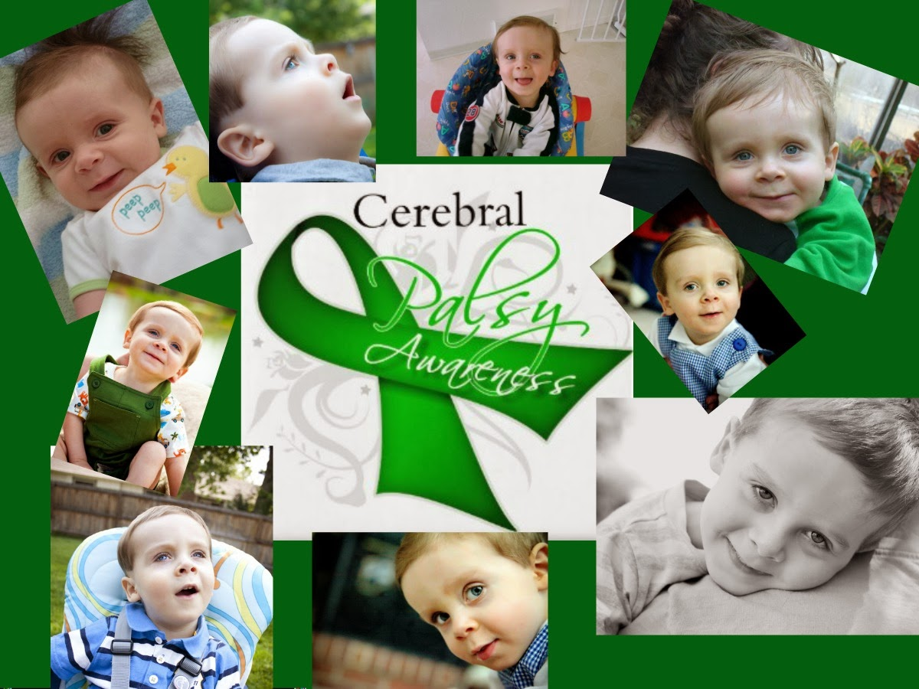
This assignment will examine and propose strategies for the role of health, care and family services in promoting health, well-being and development of the child. Key terms will also be defined with an analyse of strategies, research and supporting organisations that influence services on delivering support for children with Cerebral Palsy (CP). Strengths, limitations and benefits of strategies within the role of health, care and family services will be discussed followed by recommendations for future progress.
Cerebral Palsy (CP) is a condition that effects muscle control and movement effecting one in 400 children in the United Kingdom. CP is usually caused by injury to the brain usually caused during or after birth. The main causes are infection during pregnancy, lack of oxygen to the brain, abnormal brain development or genetically (Scope, 2020).
The Equality Act (2010) describes that a person is disabled if they have a physical or mental impairment that can be seen as extensive and long term and effects daily activities. The Equality Act (2010) also notes that all disabled people have equal rights and should be treated equally. This act protects disabled people against discrimination within education, employment, facilities and services (Disability rights UK, 2012). Within education an inclusive school should treat all pupils equally making some adaptions to meet individual needs. A child with cerebral palsy may need adaptions made for wheelchair access and may require additional adjustments.
CP is caused by damage to the brain which controls voluntary movement it also delays signals in which the brain can send to the muscles effected by the pyramidal tracts. The pyramidal tracts is connected to the motor cortex found on both sides of the brain. Damage to the right side of the motor cortex effects movement to the left side of body, if the damage is to the left side movement will be effected to the right side. The two terms commonly used when describing the effects on muscle tone with CP these are hypotonia and hypertonia. Hypotonia effects strength and firmness and is within the low muscle tone, Hypertonia causes spasmodic and rigidity within high muscle tone (Cerebral Palsy guide, 2020).
The National Health Service (NHS) (2020) report that there are four types of CP. Spastic Cerebral Palsy causing the muscles to become tight and stiff whilst making movement. Spastic cerebral palsy is the most common type and accounts for seventy five percent of cerebral palsy cases causing increased muscle tone. Spasticity can cause abnormal movements, movement inhibition, delayed developmental milestones for moving and difficulties moving from one position to another. Types of spasticity include ‘spastic quadriplegia’ affective the child’s upper and lower body greatly restricting mobility. ‘Spastic diplegia’ only impairs the lower body and some children can still walk only with a few restrictions but may still need walkers to assist them. ‘Spastic hemiplegia’ affects one side of the body and most children with hemlegia can still walk.
The second most common type of CP is Dyskinetic Cerebral Palsy. This causes uncontrolled movements, athetosis (writhing movements), dystonia which is repetitive or twisting motions, ‘chorea’ which is unpredictable movements, painful movements, poor posture and makes swallowing or talking difficult (Jansheki, 2020). Ataxic Cerebral Palsy affects balance and co-ordination. It is the least common and causes poor balance, tremors and shaking. Mixed Cerebral Palsy when a person has a mixture of symptoms from the other types.
Some effects of CP can be difficulty talking, walking or making fine motor skills. Children with CP may have difficulty with movements, stiffness, weakness can occur muscle spasms and floppiness. CP does not progress over time but symptoms do become more noticeable and not every child will experience the same difficulties (Cerebral Palsy Society, 2018). CP can also effect a child’s speech, eyesight, hearing, and learning. CP can also cause epilepsy (Macintyre, 2010). Cerebral palsy is not a condition on its own. It is classed as a group of neurological disorders and disabilities. It is the most common movement and motor disability in children with one in three hundred and forty five children having the condition. Children with cerebral palsy often have other conditions and epilepsy is the most co-occurring. Cerebral palsy is more common in boys (Jansheski, 2020).
BMJ 2011, report that the World Health Organisation (WHO) define health as a condition of physical, mental and social well-being not only as an illness. Kronenfeld (2002) also define health as an absence of disease or illness. Harvey (2013) report that health and wellbeing can be defined in several ways including absence of disease including social, personal and physical capabilities. The World Health Organisation (DATE) also define health as a state of complete physical, psychological, and social well-being and not simply the absence of disease or infirmity.
Stevenson (2010) define wellbeing as being healthy, happy and comfortable. The United Nations rights of the child (UNCRC) acknowledge five articles within the rights of the child which include wellbeing of children these include the right to a childhood; the right to education; the right to be healthy; the right to be treated fairly and the right to be heard (Bradford, 2012). Wellbeing is also integrated within the National curriculum for Wales, Te Whariki includes in the national curriculum and concludes that children’s wellbeing is considered both mental and physical (Scanlan & Stebletsova, 2018). Te Whariki states that every child has the right to have their health and wellbeing promoted and the right to be protected from harm (Ministry of health, 2017).
Development is defined as having a healthy growth. Development in children makes reference to the sequence of changes occurring from birth to adulthood which include thought and emotional changes, languages and physical changes. It is within this process whereby the child’s dependence upon their parents shifts towards independency. The developmental process is highly influenced by genetics and environmental factors of which affect the child’s capacity to learn (Kid Sense, 2017).
A child’s development is based on possessing five skills. Cognition, which includes the ability to problem solve and learn. Social interaction and emotional regulation which includes self-control and the ability to interact with others. Speech and language in order to effectively communicate along with possessing reading skills. Physical skills including gross motor skills which include skills using the whole body and fine motor skills which are skills using the fingers. Lastly, sensory awareness which is the ability to register sensory information (Kid Sense, 2017).
The main cause of cerebral palsy is brain damage. However, there are many different factors that may trigger that damage thus the exact cause of cerebral palsy cannot in every case be determined. Causes of cerebral palsy include: poor brain development in the womb, disruption of blood flow to the developing brain, ingestion of toxins or drug usage during pregnancy, complications incurred during premature delivery, maternal infections or medical conditions, genetic conditions and damage to the head or the skull during delivery (Jansheski, 2020).
A child with Cerebral Palsy may require physical therapy to help with their balance control, posture, walking, crawling and climbing. Physical therapy is an intervention for people with Cerebral Palsy, it also offers preventative benefits which help to reduce complications and disability. Physical therapy may take place in hospitals specialized centres, inpatient rehabilitation centres, special education classrooms or at home depending on the child’s needs. The child firstly would get assessed to its individual needs with then a therapy plan provided. Attending physical therapy will also support the child to gain confidence, independence and will help the child overcome obstacles and to learn about the different equipment that is available to help them (Cerebral Palsy Guidance, 2020). Physical therapy is beneficial to children and young people with cerebral palsy by providing different mobility aid such as wheelchairs and walking aids. Physical therapy usually take 6 – 8 weeks to show results and for the soft tissue to heal.
Children and young people with CP will receive an improved educational performance within the schools educational program. There are several options of education for a CP child these include receiving tutoring, public school, private school or home schooling (Cerebral Palsy guide, 2020). Public schools are inclusive schools giving all children equal rights to education. The school will provide adaptions to adhere to every child’s individual needs, and provide a child with an Individual health plan (IHP) or an individual education plan (IEP). Extra support may be provided within a school setting. The Individuals Disability Education Act (IDEA), 2020 report that the individual’s disability education act was set in 1975 to support people with disabilities, amendments were made in 2004 with the Equality Act being introduced.
Another therapy that could aid a child with CP is Aqua Therapy. Aqua therapy is a therapy provides deep, intense exercise with the water promoting physical functioning. The Cerebral Palsy Foundation (2020) express that aqua therapy is one of the greatest to help physical functioning for a child with CP, if the water is warm helps stimulate and massage joints, muscles and ligaments. Aqua therapy provides many advantages to people with CP it helps ease stress and tension within muscles and joints, it encourages a wider range of movement, provides resistance and improves the condition to the cardiovascular by increasing the body’s blood flow rhythm whilst in water. Disadvantages for children and young people with CP include only receiving 3 lessons a week for a ten-week course through the National Health Service, (NHS) if parents wish to continue with the aqua therapy they will need to pay privately putting a stress on family finances (Scope, 2020).
Speech and language therapy is also known as ST (Speech therapy) is another therapy that is aimed to support children with cerebral palsy to improve their speech and thoughts to benefit their communication skills within the world. Advantages to speech and language may include assisting the child’s confidence and independence, improving the way they interact and communicate with others, developing relationships with families and improving their social skills and interaction. Speech and language also helps support a child’s learning through education improving literacy skills. There are many other tools that may assist non-verbal children including speech and language, picture books, computers, specialised software and computerised voice systems. Social therapy may assist children with challenges such as anxiety, depression, attention deficit, relationship problems and panic attacks. Social therapy is a relatively new therapy which was introduced in the 1970’s its intervention is based within groups or as individuals, it is performed in hospitals, outpatient centres, mental health facilities and is performed in schools through assessments. . The benefits to social therapy include enhancing relationships with others, reducing stress and anxiety, developing personality, enhancing social interaction and skills and encouraging social skills.
Occupational therapy is part of a Cerebral Palsy patient’s treatment programme aiming to promote the child’s ability to perform daily activities to enhance their quality of life.
Hippo therapy is a therapy supporting physical, occupational and speech therapy that uses horsey movement to develop and enhance neurological and physical functioning. Hippo therapy is set for an individual’s neuromuscular development and is enhanced when the body makes adjustments in movement. Advantages disadvantages
Using Play Therapy can also be effective. Children with cerebral palsy can often sense that they are different from other children which results in them worrying about it. Using a variety of different toys in different public places, they can have fun whilst learning how to interact with other children which is advantageous as they learn about themselves and to build self-confidence (Birth Injury Guide, 2020).
Acupuncture is used to aid children and adults with CP and is a new therapy. Acupuncture is a form of medicine which was invented in China with the intention to treat disease and relieve pain, it is commonly used for pain relief from headaches, back pain, joint pain and neck pain. Studies are being conducted for various symptoms experienced by those with Cerebral Palsy, for example it is being studied for chronic pain relief, brain injury repair, and hypertonicity.
After 16 weeks of acupuncture treatment it is seen that acupuncture is beneficial to children and young people if is done at an early stage and done properly, it will improve a child with CP ability to physically function. There are possible risks within acupuncture it is a danger if a patient has a bleeding disorder or takes blood thinners, in some cases a needle may break causing damage to the internal organ. Whilst receiving acupuncture to the chest or upper back there is risk of collapsed lung but it very rare. However if performed correctly it is safe and there are minimal side effects and is beneficial to control some types of pain if other medicines are unsuitable and can be effectively combined with other treatments.
Chiropractic intervention and massage therapy can be beneficial to children with cerebral palsy for many reasons. Constant spasms inflict a lot of stress on the musculoskeletal system which means that chiropractic intervention is needed for basic spinal alignment and health. This can also lengthen and stretch muscles as after therapy when the muscles relax they are more likely to be more strong and healthy which is essential when learning how to walk. However, this type of therapy is not advantageous for children suffering with spina bifida as the nerves are raw and exposed which means there is a likelihood of them being mishandled which can cause more problems (Birth Injury Guide, 2020).
Massage therapy is manipulation into the soft tissue and is directed in a painless comforting way and can heal and balance the mind, body and soul. Massage therapy is also thought to be a complement and has extensive results. Massage therapy can be very therapeutic
and can have some rehabilitative benefits towards the bodies’ musculoskeletal, lymphatic and towards the circulatory system. Deep massages are seen to release fibrous bands that are formed between the organs and tissues. Some light superficial massages sometimes interrupts pain causing chronic pain.
There are many areas to make recommendations for cerebral palsy. Recognising risk factors is important in antenatal factors – including preterm birth, maternal respiratory tract or genitourinary infection treated in hospital; perinatal factors, including low birth weight, neonatal sepsis; and postnatal factors including meningitis. An enhanced clinical and developmental follow-up programme should be provided for children who have any risk factors. If cerebral palsy is not clear from antenatal, perinatal and postnatal history, the child’s developmental process, findings on clinical examination or results of cranial ultrasound examinations, then MRI should be used to assess the cause. Recommendations should also be given on multidisciplinary care and information and support. Any child suspected to have cerebral palsy should be referred to a child development service for an urgent multidisciplinary assessment and it should be recognised that children and young people with cerebral palsy and their parents have a central role in decision-making and car planning. Mediation should be optimised in accordance to what type of cerebral palsy the child has. Furthermore, there should be constantly updated information that provides clear and up-to date information to parents/carers on diagnosis, aetiology, prognosis, expected developmental process, comorbidities, availability of specialist equipment and transition.
In order to achieve effective management there should be strategies and goals in place to improve children with cerebral palsy with eating drinking and swallowing. Individualised plans should be created taking into account the understanding and knowledge of parents and other people involved that asses the role of postural management and positioning whilst eating, modifying fluid and food textures and flavours, feeding techniques such as pacing and spoon placement, optimising mealtime environment, strategies for managing behavioural difficulties and communicating difficulties.
The pain, discomfort and distress should also be considered and the causes of this should be recognised and addressed. Things that should be recognised include musculoskeletal problems, increased muscle tone, muscle fatigue and immobility, constipation, vomiting and gastro-oesophageal reflux disease.
Sleep disturbances should also be recognised such as breathing disorders, seizures, pain and discomfort, need for repositioning because of immobility and poor sleep hygiene (NICE, 2017).
To conclude this assignment has examined and discussed strategies for the role of health, care and family services in promoting health within Cerebral Palsy with discussion on children’s development and well-being. Throughout key terms and strategies were discussed along with discussion of organisations operated that influence support for children and young people with Cerebral Palsy. The organisations that influence cerebral palsy were discussed with their advantages and disadvantages and how they benefit a child with cerebral palsy. Future recommendations were also considered.

References.

Birth Injury Guide (2020) Types of Therapy for Cerebral Palsy. Available at: https://www.birthinjuryguide.org/cerebral-palsy/treatment/therapy/ (Accessed January 7th 2020).

Bradford, H. (2012) The wellbeing of children under three. Oxon. Routledge.

Cerebral Palsy Guide (2020) Special Education. Available at: https://www.cerebralpalsyguide.com/community/special-education/ (Accessed January 15th 2020).

Cerebral Palsy Guide (2020) Categorizing Cerebral Palsy. Available at: https://www.cerebralpalsyguide.com/cerebral-palsy/types/ (Accessed January 7th 2020).

Cerebral Palsy Guidance (2020) Cerebral Palsy and Physical therapy. Available at: https://www.cerebralpalsyguidance.com/cerebral-palsy/treatment/physical-therapy/ (Accessed January 13th 2020).

Cerebral Palsy Society (2018) Effects of Cerebral Palsy. Available at: https://cerebralpalsy.org.nz/cerebral-palsy/what-is-cerebral-palsy/effects-of-cerebral-palsy/ (Accessed January 7th 2020).

Disability Rights UK (2012) The Equality Act and disabled people. Available at: https://www.disabilityrightsuk.org/equality-act-and-disabled-people (Accessed January 14th 2020).

Kid Sense (2017) What is Child Development. Available at: https://childdevelopment.com.au/areas-of-concern/what-is-child-development/ (Accessed January 7th 2020).

Jansheski, G. (2020) Cerebral Palsy. Available at: https://www.cerebralpalsyguidance.com/cerebral-palsy/ (Accessed January 7th 2020).

UK Government, (2020) Definition of disability under the Equality Act 2010. Available at: https://www.gov.uk/definition-of-disability-under-equality-act-2010 (Accessed January 15th 2020).

Harvey, J. & Taylor, V. (2013) Measuring health and wellbeing. London. Sage.

Kronenfeld, J. (2002) Health Care Policy: Issues and Trends. London. Praeger publishers.

Macintyre, C. (2010) Play for children with special needs: supporting children with learning difficulties 2nd Ed. London. Routledge.

Scope (2020) Introduction to Cerebral Palsy. Available at: https://www.scope.org.uk/advice-and-support/cerebral-palsy-introduction/ (Accessed January 8th 2020).

The Individuals with disabilities act (2020) History of IDEA. Available at: https://sites.ed.gov/idea/about-idea/#IDEA-History (Accessed January 15th 2020).
The World Health Organisation (2020) Health. Available at: https://www.who.int/search?query=DEFINE+HEALTH&page=1&pagesize=10&sortdir=desc&sort=relevance&default=AND&f.Countries.size=100&f.Lang.filter=en&f.RegionalSites.size=100&f.Topics.size=100&f.contenttype.size=100&f.doctype.size=101&facet.field=RegionalSites&facet.field=Topics&facet.field=doctype&facet.field=Countries&facet.field=contenttype&facet.field=Lang&tune=true&tune.0=3&tune.1=2&tune.2=2&tune.3=3&tune.4=180&tune.5=75&cname=highlight-en&cname=emronew&cname=who&cname=euro&cname=afro&cname=amro&cname=pmnch&cname=searo&cname=workforcealliance&cname=wpro&f.RegionalSites.filter=Global&f.contenttype.filter=html (Accessed January 14th 2020).

The BMJ (2011) ‘How should we define health?’, 343, pp 1. DOI: https://doi.org/10.1136/bmj.d4163
Stevenson, A. (2010) Oxford dictionary of English. Oxford. Oxford University Press.
The National Health Service (2020) Types of Cerebral Palsy. Available at: https://www.nhs.uk/conditions/cerebral-palsy/symptoms/ (Accessed: January 7th 2020).
Scope (2020) How can I access hydrotherapy? : Private healthcare. Available at: https://www.scope.org.uk/advice-and-support/hydrotherapy/ (Accessed January 12th 2020).
Scanlan, B. & Stebletsova, G. (2018) Child wellbeing integrated in the curriculum. He Kupu, 5 (3), 66-74.
The Cerebral Palsy foundation (2020) Goals of therapy. Available at: https://www.yourcpf.org/expert-videos/goals-physical-therapy/ (Accessed January 12th 2020).
National Institute for Health and Care Excellence (NICE) (2017). Cerebral palsy in under 25s: assessment and management. Available at: https://www.nice.org.uk/guidance/NG62/chapter/Recommendations#multidisciplinary-care (Accessed January 10th 2020).
Ministry of Health. (2017). Māori health models – Te whare tapa whā. Available at: https://www.health.govt.nz/our-work/populations/maori-health/maori-health-models/maori-health-models-te-whare-tapa-wha (Accessed January 11th 2020).

