
VLE – Moodle and its impact on the students of university of wales trinity saint david

Student Name: | Ivelina Succaria
Student Number: | 2010919
Module No: | BMSW4003
Module Title: | Digital Skills and Research Methods
Lecturer: | Modak Koushik

Abstract
This report is based on research about the impact the Virtual Learning Environment – Moodle has on students at the University of Wales Trinity Saint David, London Campus. It will discuss and analyse the attitude students have towards the VLE, how it corresponds to their learning needs, and the possibilities it gives to the learning community. This research involves 20 first-year students who attend the academic course of Research and Digital Skills and use Moodle as their only learning environment. The study is made as a questionnaire, and the participants answer seven questions on the topic. This research aims to measure and analyse students' readiness, needs, and attitude to use Moodle for their academic education needs.
Contents
Abstract 1
Table of contents 1
Introduction 1
Rationale 1
Research objectives 1
Literature review 1
Research Methodology 2
Research methods 2
Primary and secondary data, data collection 3
Population, sample, and sample size 3
Ethics in data collection 3
Findings analysis 3
Conclusion 10
Appendixes 12
Appendix A 12
Appendix B 13
References 14

Introduction
VLEs could be defines as a particular software system, designed for the needs of education, which is able to synthesise and functionalise communications with the help of software. They could be explained as online methods of delivering course materials. As a VLE, Moodle has a wide usage for the school and academic study needs and may include a wide range of tools and resources – lesson plans, teaching materials and resources, quizzes, homework assignment section, discussions, chats, wiki pages, tests.
This report will analyse primary data, collected online and from written sources, and secondary data, compiled with a questionnaire and organised into tables and charts, and analysed. The study will give a clear vision of the impact Moodle has on students in UWTSD. It will show their readiness to work with a VLE and the way they are using it. The report will point out their personal preferences, use the VLE, and estimate Moodle as a study environment.

Rationale
This research aims to provide a clear view of students' perception of the usage of VLE in particularly Moodle, for the needs of academic study and preparation. The questionnaire will also focus on the level of personal understanding of the platform and its practical implementation.

Research objectives
The author's primary purpose in conducting this research is to prove its general practical use and learning advantages. Furthermore, based on the study's analysis, the author will outline possible drawbacks of Moodle and how it could be improved for future use.

Literature review
Moodle is a widely used virtual learning environments in the academic world and is one of the most popular. It has been widely discussed and studied since its development and launch. In 2005 in his research "To Moodle or not to Moodle: Can It Be an Ideal e-Learning Environment?", Kazunori Nozawa does a detailed analysis on Moodle and the way it is used in a Japanese university, pointing out the pros and cons of its essential functions. Based on personal experience and using the quantitative method, the author finds the positive sides of using the VLE in his classes. He concludes that "Moodle … is an efficient, communicative way to interact with both teachers and students" (Nozawa, K. 2005). Casquero et al. (2010) say that Moodle is a VLE that allows students access to all the materials for their study with the only condition for them to have online access. Therefore, Bertera & Littlefield (2003) state that this allows students to go through complicated or time-consuming issues in a more relaxed and pleasant atmosphere, working from their home, for example. In 2019 Leyla Hasan conducted the following research, "THE USEFULNESS AND USABILITY OF MOODLE LMS AS EMPLOYED BY ZARQA UNIVERSITY IN JORDAN," based on primary data collected in two phases amongst 80 students in the University of Zarqa. She pointed out that Moodle's interface and features should be adapted to each University's students' needs. There should be close contact between them and Moodle's administrator. The research found one serious problem in the usage – the assessment of students' assignments. The report stresses the need to "considering and involving students when employing Moodle LMS" (Hasan, L. 2019) so that it could be most effective for its primary users.
All the issues discussed here lead to this current report's research, which focuses on Moodle's impact on the students at the University of Wales Trinity Saint David, the London campus.

Research Methodology

Research methods
The research methodology is how a researcher will solve a problem and explain how research should be carried out (Goundar, S., 2012). Each research needs to collect data and make analysis and conclusions based on it. There are two main methods of research to do it. The first one is called qualitative and is based on collecting concepts, thoughts, or ideas. It is non-numerical, descriptive, based on interviews and observations, and applies to the reason (Goundar, S. 2012). The other one is called quantitative and consists of collecting data based on the number of figures, compiled by surveys based on closed questions, and experiments or observations recorded as numbers. Here the result is based on quantities, not on qualities (Goundar, S.2012). The mixed-method approach combines the two and gives complex data, combining the two existing methodologies. I will use the combined method for the report's aims, using both qualitative and quantitative questions.

Primary and secondary data, data collection
The report will be based on primary and secondary data, collected with a survey questionnaire and online. Primary data is collected by a researcher and does not exist and cannot be accessed in the public space (Parveen, H. and Showkat, N. 2017). On the other hand, each piece of data, collected by someone else and accessible in the public space, is secondary. This data is being used in prior research by other authors and could be found in different types of documents like authorities and government papers, reports, and records (Parveen, H. and Showkat, N. 2017). The process of data collection is a complex activity and may use several tools – interviews, questionnaires, or quizzes. The primary data for this report has been collected with an online questionnaire. The secondary data, cited and used in this report, is collected online from different books, journals, articles, and the University of Wales library.

Population, sample, and sample size
Each research population is the entire group that a researcher wants to conclude (Bhandari, P. 2020). In this report, the population is the first-year students at the University of Wales. Since it is challenging to research all the people you want to study, it is necessary to create a sample group and study it. The sample size is always less than the number of all populations (Bhandari, P. 2020). The sample used for this report is 20 first-year students at UWTSD.

Ethics in data collection
There are a few essential ethical issues that should be considered when collecting data (WIC, 2008). The researcher should identify clearly and be careful not to give a false impression of who they are and why they are collected. The questions in the questionnaire should be exact and not stressful, too personal, or offending. The participants have the right to stay anonymous, and the privacy of their answers should be kept. In this report, the author has given clear information about my research and the data's needs. I have not manipulated the responses and have not altered any of the sample group's data.

Findings analysis
For this report's needs, the author has made a questionnaire of seven questions (Appendix A). The results are presented in percentage and numbers:
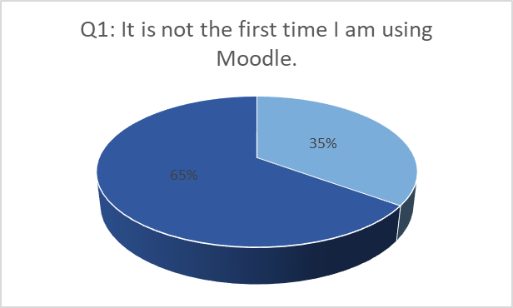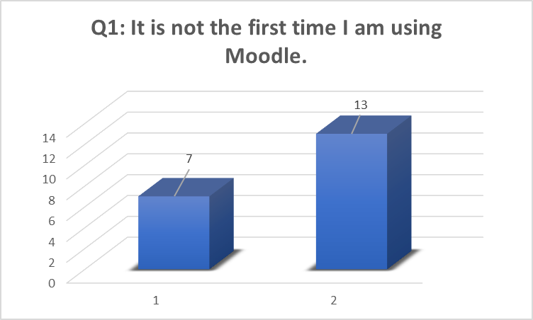

Q1: Analysis of the graph. As it is clear from the chart, 65% of the interviewed, which is 13 people are familiar with Moodle and do not use it for the first time. The rest, 35% or 7 of the sample group, are trying it for the first time. The results show that the percentage of people who have never seen or experienced work in a VLE is significantly high. This high level requires serious consideration from the UWTSD and strong technical support. Practically every third or fourth person sees the platform for the first time and needs instructions and training to work with it. It should also be projected in the possible results and outcomes of this 35%. It would be unreasonable to expect their participation and work in the platform to be the same as those already familiar with it.

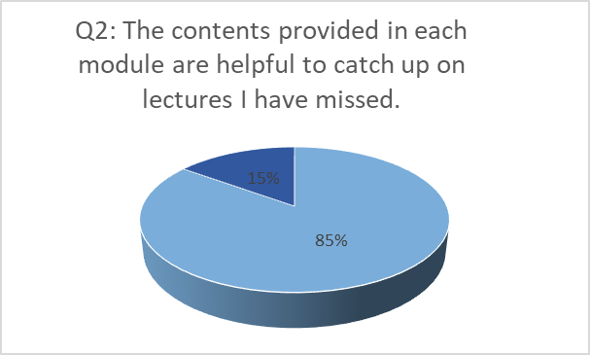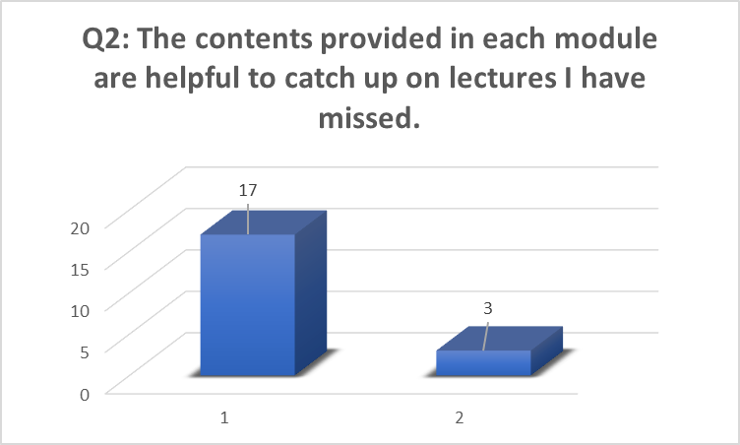

Q2: Analysis of the graph: 85% of the students, 17 of them, find the content uploaded in Moodle helpful to catch up with the lectures they have missed. 15% of them or only three students in the sample group are not useful and cannot agree with the statement. The high percentage shows that the lecturers and administrators are doing serious work in helping students in their studies. For the author of this report, this 15% is a signal there are either not considerate about their research, or do not know how to use the VLE effectively or use another way to catch up on lectures. This could be a problem for further study.
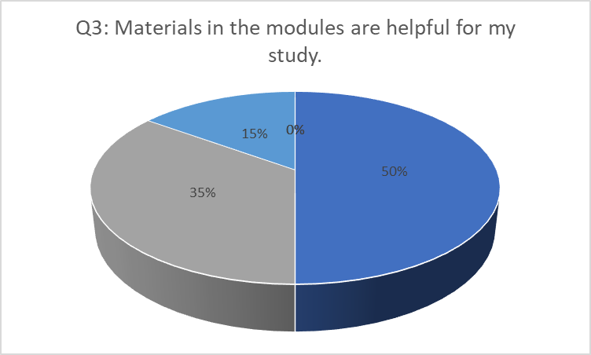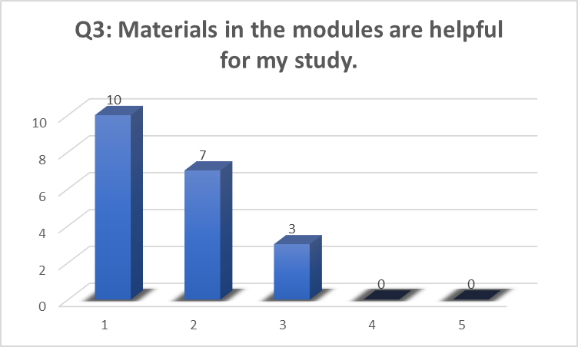
1 – Agree
2 – Agree somewhat
3 – Not sure
4 – Disagree somewhat
5 - Disagree
Q3: Analysis of the graph: 50%, or 10 of the respondents, agree that Moodle positively affects their study. 35% or 7 of the respondents agree somewhat that it is a helpful tool in their research; 15% or three students are not sure and stay neutral. These results are showing the severe impact of Moodle on the students' overall performance. There should be concluded that there is practically no negative perception of it, and the percentage of neutral students is significantly low. Like the above question, the same percentage of people are either unsure or do not know how to use their Moodle materials to study. The author may conclude that students need further explanation and training to clarify the VLE usage and helpfulness.
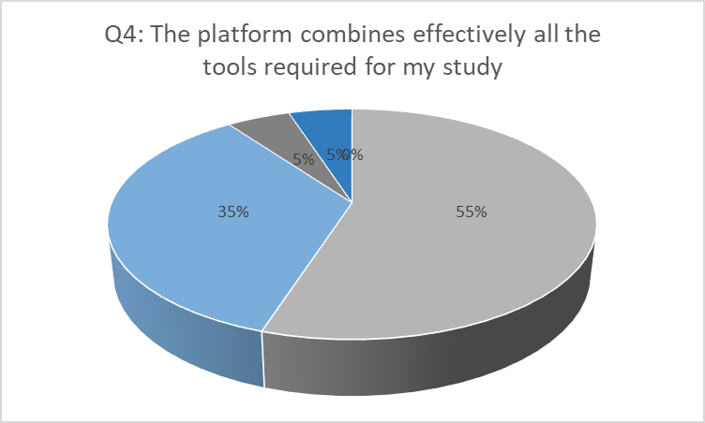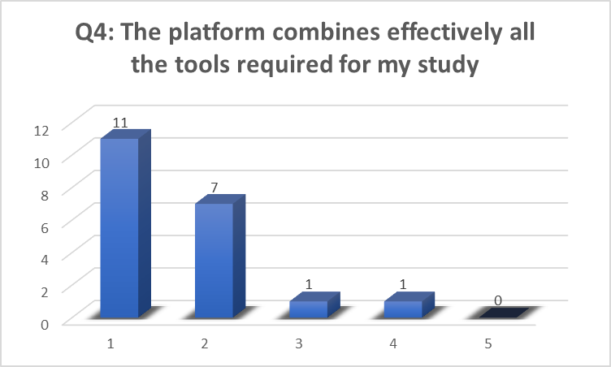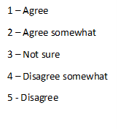
Q4: Analysis of the graph: 55% or 11 of the respondents answer "agree." 35% agree somewhat (these are 7 of the sample group), and 5% provide respectively "not sure" and "disagree somewhat' answers. Once again, the results are seriously in favour of Moodle, showing good knowledge of its tools and the possibilities they give to students in their study and self- preparation. There are only 5%, which is practically one person of the whole group of 20 respondents, who gives a negative answer and 5%, another student who provides neutral response and cannot provide a more decisive decision. The sample group was assigned various examples of the tools they might consider when answering – office 365, library access, etc. Based on these results, the author can conclude that Moodle's organisation and the additional tools that are opening on it are of great importance for most students. Even though there are percentages of negative and neutral answers, they are significantly small since they represent only one of the respondents.

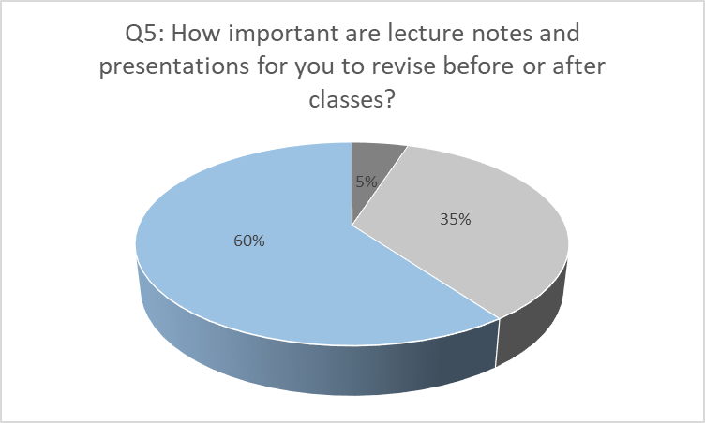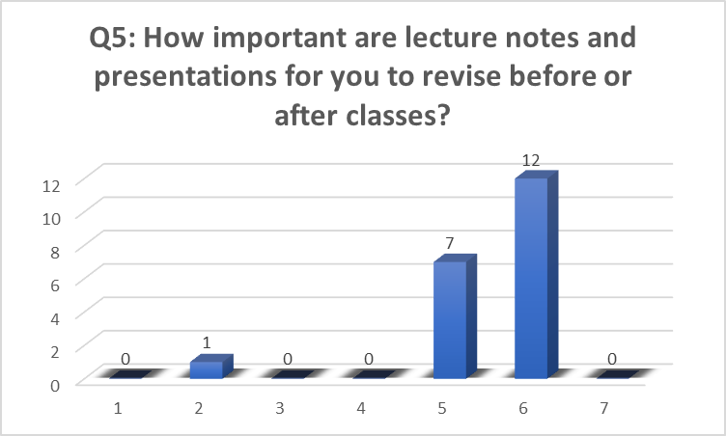
1 – Not important at all
2 – Low importance
3 – Slightly important
4 – Neutral
5 – Moderately important
6 – Very important
7 – Extremely important
Q5: Analysis of the graph: As seen from the charts for 60% of students, lecture notes and presentations are fundamental. Another 35% find them moderately important. There are only 5%, only one of the respondents, who finds them low necessary. The conclusion here is that although the notes and presentations added by lecturers are very important for the whole preparation for the students, they are not rated with the highest option. The results here are very encouraging and show that 19 of all 20 respondents are aware of the practical need for module materials and use them, if not regularly, then quite often. The fact that so a high percentage of people revise before and after classes shows undoubtfully that this application of Moodle is of serious help for almost all first graders.

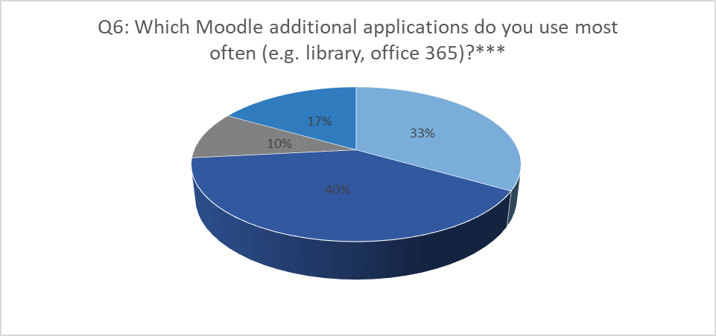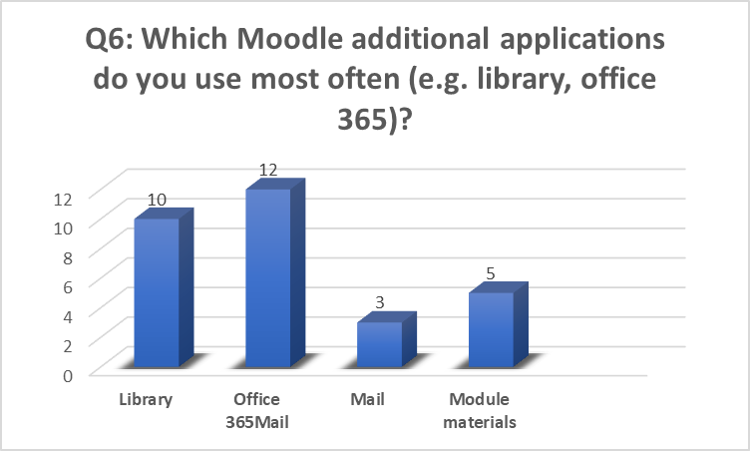

Q6: Analysis of the graph: This is an open answer or quality question. Although it is not typical to make a graph for such questions, the answers here follow a frame and make it possible to create an appropriate chart. There were four answers given, and the number is more than 20 because some of the respondents have provided more than one answer. Ten of all 20 students use the Library access from the Moodle page. It is 33% of all respondents. Twelve people, or 40% of all, use Office 365 from the Moodle page. 10% use their student email from Moodle directly, and 17% use Moodle's materials. These results show that the VLE is used during and after classes for self-study and revision. Still, it is also a very convenient platform, giving students fast access to different applications. Still, the small number of variable answers shows that the students do not know the platform in detail and its full potential.

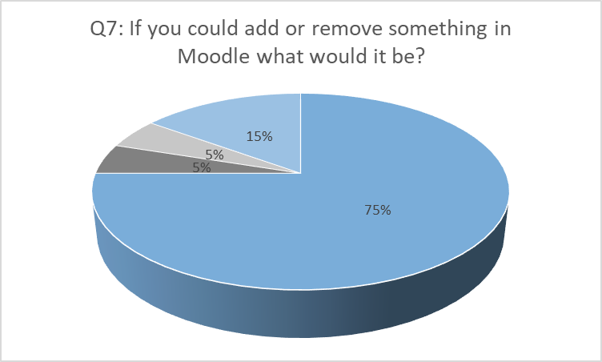

Q7: Analysis of the graph: This is another quantity question, and as explained above, the answers follow a pattern that allows the author to organise them in a chart. 75% of the respondents answer that they would not change anything in Moodle. 15% or 3 of the respondents say they do not know what should be changed, and there is 5%, which is one student, who says they will add a search machine and another 5% who say they will add a chat option. Two different points of view could analyse the results. On the one hand, the fact that the respondents do not want to add or remove anything in Moodle may show that the platform is successfully designed to answer all students' needs and any further changes are not necessary. On the other hand, having in mind that the students are in their first year at the university, there might be concluded that they are not familiar with Moodle in detail and cannot give reasonable suggestions.
All in all, the survey and its results lead to the following conclusions – most first-grade students at the University of Wales Trinity Saint Davis are informed and technically literate to use the VLE-Moodle for their study's needs. Not all of them are aware of Moodle's full potential, but they can take the maximum it offers to self-study and effectively use the materials included in it. Students know how to reach additional applications and have the knowledge and experience to use them when needed.

Conclusion
To sum up, the usefulness of Moodle for the needs of university students is undoubtfully proved. It combines study materials and applications, giving a wide range of sources and information for students' learning development. Furthermore, the VLE is an environment which offers a lot of benefits and can improve and ease students' performance and self-study. Unfortunately, the platform is still not entirely familiar for several students, which hinders them from using its full potential. However, the author has concluded that by going further in their study, students will have the opportunities to discover the other advantages of Moodle and use them efficiently in their research. What is more, the University should flexibly approach the platform's usage, having in mind that the platform is unfamiliar for a considerable number of students. Sufficient and continuous support and guidance will let them enter this kind of study environment smoothly and efficiently.

Appendixes

Appendix A

In-Class exercise: Questionnaire Design
Student Name: Ivelina Succaria__________ Student ID: 2010919
Module Name: Digital Skills and Research Methods (H&Sc) Term 1 Group: 3
VLE – Moodle and its impact on the students of UWTSD
Question 1: It is not the first time I am using Moodle.
o Yes
o No

Question 2: The contents provided in each module are helpful to catch up on lectures I have missed.
o Yes
o No

Question 3: Materials in the modules are helpful for my study.
o Agree
o Agree somewhat
o Not sure
o Disagree somewhat
o Disagree

Question 4: The platform effectively combines all the tools required for my study (Office 365, materials, library access).
o Agree
o Agree somewhat
o Not sure
o Disagree somewhat
o Disagree

Question 5: How important are lecture notes and presentations for you to revise before or after classes?
1 – Not important at all
2 – Low importance
3 – Slightly important
4 – Neutral
5 – Moderately important
6 – Very important
7 – Extremely important

Question 6: Which Moodle additional applications you use most often (e.g., library, office 365)?
…………………………………………………………………………………………………………………………………………………………………………………………………………………………
Question 7: If you could add or remove something in Moodle, what would it be?
…………………………………………………………………………………………………………………………………………………………….…………………………………………………………
Thank you!

Appendix B

References

Bertera, M. and Littlefield, M. (2003). Evaluation of electronic discussion forums in social work diversity education: a comparison of anonymous and identified participation. Journal of Technology in Human Services, 21 (4), pp.53–71.
Bhandari, P. (2020). Population vs sample: what's the difference?. [Online] Available at: https://www.scribbr.com/methodology/population-vs-sample/#:%7E:text=A%20population%20is%20the%20entire%20group%20that%20you,research%2C%20a%20population%20doesn%E2%80%99t%20always%20refer%20to%20people. (Assessed 7th Dec 2020).
Casquero, O., Portillo, J., Ovelar, R., Benito, M. and Romo, J. (2010). iPLE network: an integrated eLearning 2.0 architecture from a university's perspective. Interactive Learning Environments, 18 (3), pp. 293–308.
Donelly, R. and O'Rourke, K. (2007). What now? Evaluating eLearning CPD practice in Irish third-level education. Journal of Further and Higher Education, 31 (1), pp.31–40.
Goundar S. (2012). Cloud Computing: Understanding the Technology before Getting "Clouded". In: Gaol F. (eds) Recent Progress in Data Engineering and Internet Technology. Lecture Notes in Electrical Engineering, 157
Hasan, L. (2019). THE USEFULNESS AND USABILITY OF MOODLE LMS AS EMPLOYED BY ZARQA UNIVERSITY IN JORDAN, Journal of Information Systems and Technology Management, (16).
Nozawa, K. (2011). To Moodle or not to Moodle: Can It Be an Ideal e-Learning Environment?. [Online] Available at: https://www.academia.edu/8664279/To_Moodle_or_not_to_Moodle_Can_It_Be_an_Ideal_e_Learning_Environment. (Assessed 10th Dec 2020).
Praveen, H., & Showkat, N. (2017). Research Ethics. ResearchGate. [Online] Available at: https://www.researchgate.net/publication/318912804_Research_Ethics. (Assessed 7th Dec 2020).
WIC, (2008). Basic Ethical Standards in Social Research. [Online] Available at: https://study.cardiffmet.ac.uk/AcSkills/Documents/Research/Research_Ethics_elesson/page_10.htm . (Assessed 10th Dec 2020).

