

Programme: Master of Business Administration
Module: International Marketing: Principles and Practices
Module code: LCMB7026

Student Name: Sharmin Akther
Student ID: 2521545

Tutor Name: Dr Jamiu Odugbesan

Word Count: 5486

AI use acknowledgement
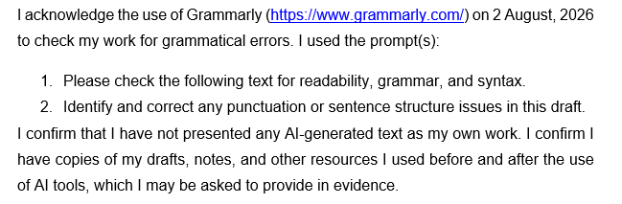

Table of Contents
Introduction 4
Company Overview: Toyota Motor Corporation 5
Comparative Analysis of the Macroenvironment (PESTEL Analysis) 6
Comparative Analysis of STP and International Marketing Mix (7Ps) of Toyota in Japan and India 15
Comparison of Brand’s STP strategies 15
Comparison of International Marketing Mix (7Ps) Strategies 19
Market Entry Strategy in India 28
Ethical Evaluation of Toyota’s Marketing Mix in India 30
Strategic Recommendations 31
Reflective Part 32
Conclusion 35
References 36

Introduction
International marketing is the management of the marketing process beyond national boundaries in order to meet the objective of the organization and the consumer (Baack, 2018). This report examines the world-renowned automotive behemoth, Toyota Motor Corp, in a comparative analysis of their mature markets in Japan and their fast-growing markets in India. Analysing such diverse markets will deliver valuable insights into the need for an automotive brand to maintain brand identity on a global level whilst addressing the local requirements. This report aims to critically discuss the global strategy of Toyota. The report carries out a comparative macro-environmental (PESTEL) and cultural (Hofstede) analysis, followed by an STP analysis of Toyota, 7Ps Marketing Mix, Joint-Venture market entry strategy in India, ethical practices and future strategic recommendations.
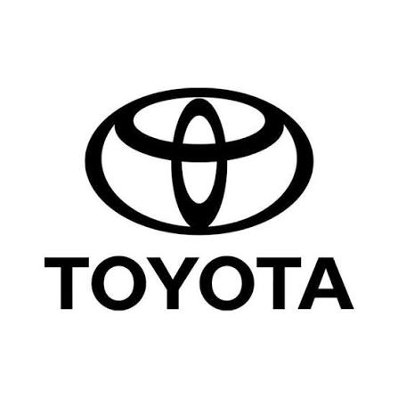
Figure 1 Toyota, Japanese multinational automotive manufacturer; Source: (Toyota Motor, 2022)

Company Overview: Toyota Motor Corporation
In today's highly competitive global automobile market, Toyota Motor Corporation continues to maintain its position as a market leader with its unique brand positioning and strategic management strategy. Established in Japan in 1937 by Kiichiro Toyoda, a spin-off from the automatic loom company founded by his father, Sakichi Toyoda (Toyota Manufacturing UK, 2022). Toyota expanded into its target market with a joint venture with the Kirloskar Group in 1997, forming Toyota Kirloskar Motor (Toyota, 2019). According to Akshaya (2024), Toyota Motor Corporation (TMC) holds 89% of the share, and the remaining 11% is owned by the Kirloskar Group.
Toyota operates under the mission "to produce happiness for all by leading the mobility society," and its vision is ‘carbon neutrality and software-defined mobility' (Toyota, 2024). The core driver of Toyota’s strategic success is its revolutionary Toyota Production System (TPS), built on "Just-in-Time" manufacturing and continuous improvement (Kaizen) (Faraj and Milod, 2024). Today, Toyota does not spend on pure acquisition but establishes strategic equity partnerships (Suzuki, Mazda, Subaru) to co-develop electric and hybrid technology and operates with extreme efficiency.
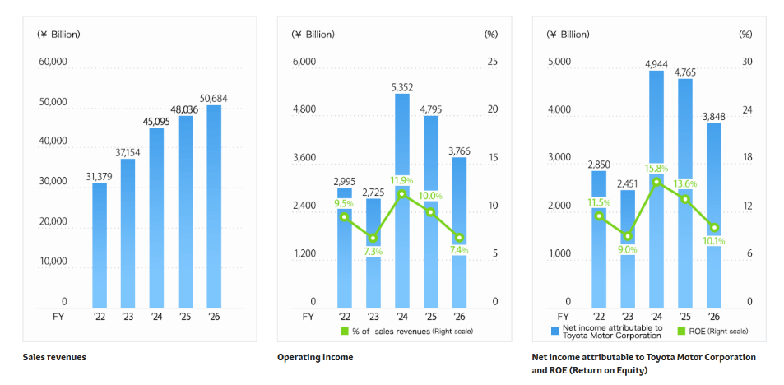
Figure 2 Financial Performance of Toyota; Source: (Toyota Motor Corporation, 2024)
Toyota remains the world's biggest automotive maker by volume in terms of financials. For FY2025, Toyota generated ¥48.0 trillion in revenue, a 6.5% increase year-on-year (Figure). The brand generated an operating income of ¥4.8 trillion, maintaining a strong 10.0% operating margin (Toyota Motor Corporation, 2024). The surge in global demand for hybrid-electric vehicles (HEVs) and strict cost control helped to strengthen Toyota's market position in the developed domestic markets and in emerging markets, such as India.

Comparative Analysis of the Macroenvironment (PESTEL Analysis)
PESTEL analysis is a macroenvironmental analysis that is employed to analyse the Political, Economic, Social, Technological, Environmental, and Legal forces that have an impact on the business environment (Citilci and Akbalik, 2019).
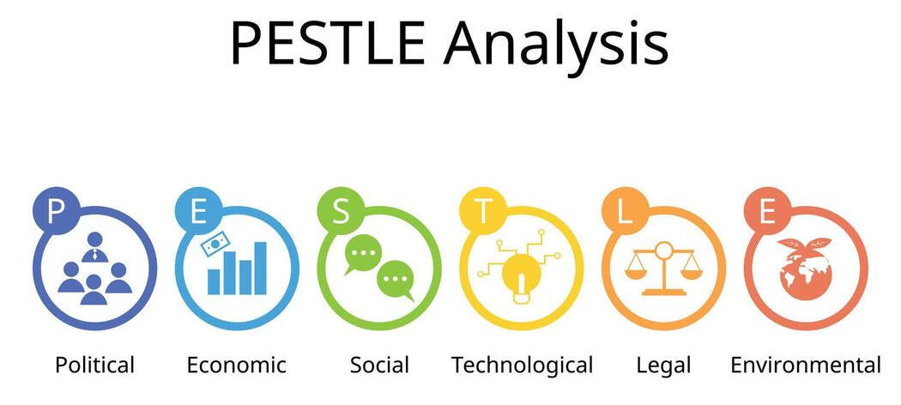
Figure 3 PESTEL framework; Source: (Citilci and Akbalik, 2019)
Political Factors
Japan
Japan is a democratic and constitutional monarchy and has a parliament. Emperor Naruhito acceded to the Chrysanthemum Throne on 1 May 2019 (Department of Foreign Affairs and Trade, 2025), marking the beginning of the Reiwa ('beautiful harmony') Era in Japan. In June 2025, the Government of Japan (GOJ) established a target of 120 trillion yen of foreign direct investment (FDI) into Japan by 2030 (Ministry of Foreign Affairs of Japan (MFA), 2024). Ultimately, this political stability and strong government backing for green automotive innovation create a highly favourable political climate for Toyota's home operations.
India
India has a stable democratic system with strong domestic production incentives in place, such as long-term industrial policies like Make in India and Production Linked Incentive (PLI) schemes for automotive and auto-component manufacturing. In addition, national policy promoting green vehicles and local production provides a favourable political landscape for Toyota to grow its regional production network in a secure manner.
Economic Factors
Japan
- GDP Growth Analysis: According to the Department of Foreign Affairs and Trade (2025), Japan's highly industrialised market economy was the fourth-largest in the world in 2025. In 2025, Japan's economy grew by about 1.1% (Figure 4), indicating improved business spending on capital goods and continued pickup in domestic service industries.
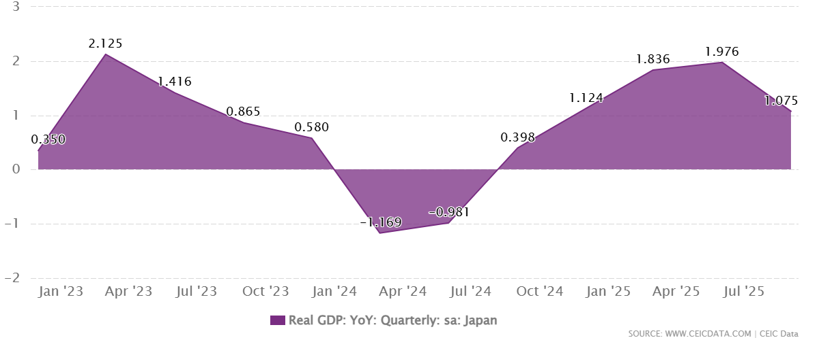
Figure 4 Japan Real GDP Growth; Source: (CEICdata.com, 2018)
- Inflation Rate Dynamics: Japan's annual inflation rate increased from 1.5% in May 2026 to 1.7% in June (Figure 5), indicating a positive trend toward moderate price increases, although manufacturing input costs remained generally low.
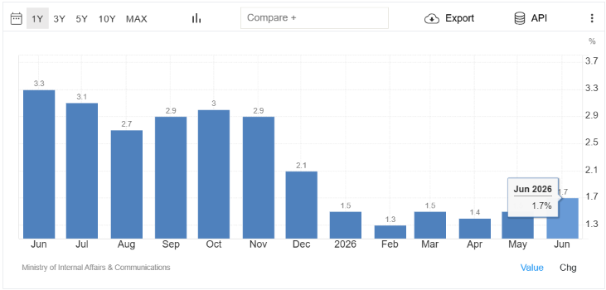
Figure 5 Japan Inflation Rate; Source: (Trading Economics, 2025)
- Unemployment Rate Trends: According to World Bank (2026) data, Japan's national unemployment rate remained at 2.5% to 2.6%, which guarantees near full employment and stability of wage incomes within the Japanese workforce.
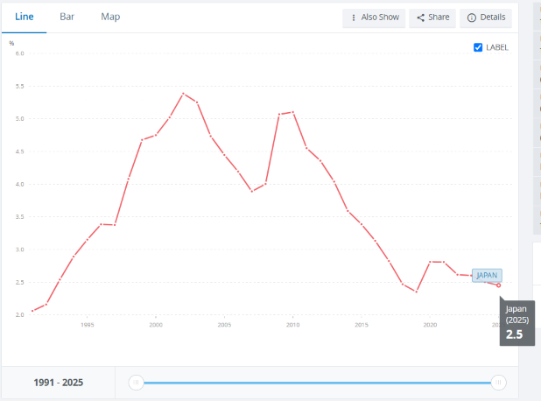
Figure 6 Japan Unemployment Rate; Source: World Bank (2026)
- Consumer Purchasing Power: High raw material prices have imposed some financial pressure, but Japanese consumers have kept their purchasing power for reliable, fuel-efficient and hybrid vehicles.
In short, Japan’s rapidly aging and shrinking population poses an unfavourable structural challenge. As urban youth prefer not to own vehicles, growth in car sales volume is projected to slow down gradually in the longer term.
India
India has a developing mixed economy, the sixth largest in the world by nominal GDP and third largest by purchasing power parity (PPP) (Verma, 2026), with robust key sectors such as agriculture, services and manufacturing.
- GDP Growth Analysis: In terms of Purchasing Power Parity (PPP), India is the 4th largest economy in the world, having Gross Domestic Product (GDP) of more than US$ 3.8 trillion (Verma, 2026).
- Inflation Rate Dynamics: According to the Salve (2026) report, India's consumer price inflation in June rose to 4.38% from 5.93% in May, alleviating inflationary pressures on consumer living costs and allowing vehicle financing costs to stabilize.
- Unemployment Rate Trends: The unemployment rate in India remained unchanged from the previous month at 5.5% in June 2026, signalling strengthening labour market conditions and expanding formal employment.
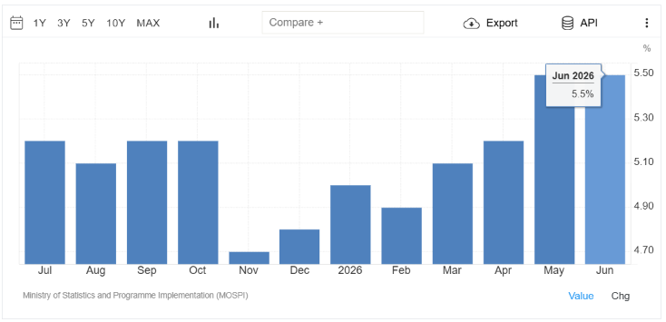
Figure 7 India Unemployment Rate; Source: (Trading Economics, 2025a)
- Consumer Purchasing Power: Private consumption and demand for personal mobility were stimulated by the significant increase in middle-class incomes and the expansion of their disposable household budgets.
It is a very favourable economic environment for Toyota's volume growth in India given its rapid growth in GDP, easing inflation, and growing middle-class purchasing power.
Socio-Cultural Factors
- Consumer Behaviour Analysis
The Japanese car-buying attitude focuses on engineering precision, zero defect quality, ultra-sophisticated car safety features, and environmental performance (Piao, Nasuda and Li, 2025), whereas the Indian mindset is driven more by price sensitivity, fuel efficiency, low pressure on maintenance cost, and multi-utility requirement for a family vehicle. Conversely, the Indian consumer base is price-sensitive (Srivastava, 2026), values exceptional engineering for all road types, and values social image established through impressive SUV aesthetics. Toyota balances quality, durability, and reliability (QDR) with adequate localised vehicle platforms such as multi-purpose vehicles (Innova) and co-developed small vehicles to embrace the volume growth in India. Overall, the fact of these contradictory consumer profiles creates a favourable socio-cultural environment that helps Toyota keep up a profitable operation in the Japanese market and build a niche in India.
- Cultural Forces & Hofstede Analysis
Japan
As described by Hofstede Cultural Dimensions Theory (1984), Japan is a country with a rigid company culture, risk aversion, perfectionism, high values of corporate loyalty, continuous process improvement (Kaizen), and multi-decade strategic planning. With high uncertainty avoidance (92), Japanese consumers tend to buy a product that has proven technology as well as precise manufacturing, thus creating a highly favourable culture for the precision engineering of Toyota.
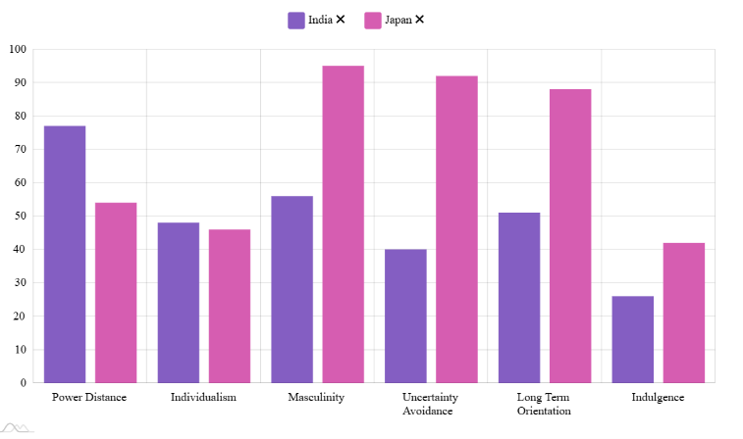
Figure 8 Hofstede 6 Culture Dimension Between Japan and India; Source: Author
India
India's Hofstede cultural Model (1984) can be described as a status-conscious, hierarchical society, in which the authority in the organisation is respected whilst people are flexible, highly adaptable, and at ease with the day-to-day ambiguity and change. The socio-cultural environment is favourable for local market entry because high power distance (77) drives the aspiration for high-status luxury vehicles from the consumers, and low uncertainty avoidance (40) makes Indian customers more open to innovative hybrid technology and JVs.
- Evaluation of the Hofstede Model
- Advantages of Hofstede Model: The Hofstede model is very useful for Toyota as it offers a clear quantitative starting point to form a rational basis for the positioning differences in the markets (Toyota, 2024). It explains why Toyota’s standardized, highly disciplined production system (TPS) operates seamlessly in high-UAI Japan, but requires a more flexible, relation-based management style to succeed in India’s high-PDI and low-UAI workplace environment.
- Disadvantages of Hofstede Model: The major difficulty is that the Hofstede model is general at the national level and does not account for significant internal differences between states in India, including economic and cultural differences. The model does not consider rapid changes in tech-savvy younger consumers.
Technological Factors
Japan
Japan is a world leader in advanced robotics, automated vehicle assembly, research into hydrogen fuel cells and hybrid powertrain systems (Yarime, Shiroyama and Kuroki, 2008). (Bureau, 2026) reported that Japan's total research and development (R&D) expenditure reached a record high of 23.79 trillion yen ($150+ billion) in fiscal year 2024. Toyota uses these state-of-the-art domestic research foundations to constantly improve its automated production facilities and co-create next-generation solid-state battery systems (Toyota, 2024). This world-class technological infrastructure provides a highly favourable operational environment that allows Toyota to maintain its global engineering leadership and low production defect rates.
India
As of Majid, Rajesh and Ahmed (2024), India has a booming technology ecosystem with world-class software engineering talent, expanding digital connectivity and rapidly developing electric vehicle (EV) infrastructure. Toyota is taking advantage of this local technological strength by forming strategic engineering partnerships, including its global collaboration with Suzuki to develop low-cost hybrid and smart cars for emerging markets. India's robust technological strengths and digital development thus provide the favourable conditions for Toyota to design cost-competitive products and connected car services.
Environmental Factors
Japan
The Government of Japan considers carbon neutrality as an absolute necessity for the automotive industry, establishing a target of achieving it completely across production life cycles by 2050 (The Government of Japan, 2024). Toyota has decided to inject up to 730 billion yen (about $5.6 billion) into Japan and the United States to enable the supply of automotive batteries for battery electric vehicles (BEVs) that are seeing increased demand and plans to launch battery production between 2024 and 2026 (Toyota Motor, 2022). The environmental conformity of corporate manufacturing contributes to a favourable market image, further elevating Toyota's worldly reputation for "green automotive engineering".
India
India has enacted rigorous environmental policies to address high levels of air pollution in urban areas, such as Bharat Stage VI (BS-VI) emission standards and Corporate Average Fuel Efficiency (CAFE-II) rules (International Energy Agency, 2023). But Indian environmental law puts an unfavourable regulatory roadblock in the way of Toyota's main product lineup.
Legal Factors
Japan
Japan’s legal system is structured as a “Civil Law” system, based upon codified statutes (U.S. Embassy & Consulates in Japan, 2025). There is a clear and consistent judicial system along with strong IP laws, IBMG standards, and product safety laws in place in the country. Japanese law is strong on patents, and infringing on proprietary means of copying hybrid and engine technology is out of the question. The legal culture ensures a favourable setting to safeguard Toyota's investments in its intellectual property and brand image.
India
India maintains a robust legal framework with strict consumer protection rules and evolving motor vehicle safety standards (such as mandatory crash test ratings) (Singh, Dharme and Bisht, 2026). By manufacturing locally through its joint venture (Toyota Kirloskar Motor), Toyota complies with national safety codes and navigates operational regulations successfully (Toyota, 2024). Conversely, India’s legal and tax framework presents highly unfavourable tariff barriers for imported luxury/flagship vehicles and components.
Similarities and Differences in PESTEL Analysis
Japanese and Indian politics provide stability, while India has more and more consumers, making it a good choice for Toyota with limited challenges. Nevertheless, the Japanese environment is characterised by the latest technology and precision engineering, and low inflation, whereas India has strengths in its fast-growing GDP, price sensitivity of demand, and growing purchasing power of the middle class. The differences reflect Japan's upper-end hybrid-dominated market and India's low-price market.

Comparative Analysis of STP and International Marketing Mix (7Ps) of Toyota in Japan and India

Comparison of Brand’s STP strategies
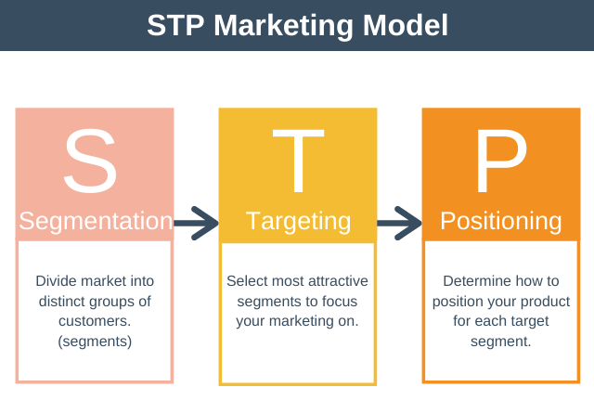
Figure 9 STP Marketing Model; Source: (Geoghegan, 2019)
Market Segmentation
Market segmentation is the process of dividing a large niche market into smaller market segments with similar lines of products (Schlager, 2021). This allows companies to create and execute an effective marketing mix.
Japan
- Demographics: Toyota is based on middle-aged to older working adults and small urban households due to their large amounts of disposable income (Toyota, 2024).
- Psychographics: Toyota appeals to those who are eco-friendly, risk-averse, technologically obsessed, and status-conscious.
- Geographics: Toyota's cars are sized for densely populated markets such as Tokyo, where traffic is heavy, and streets are narrow.
- Behavioural: Toyota targets consumers who are loyal to the brand and are mainly into predictable driving experiences (Toyota, 2024).
- Benefit Segmentation: The benefit point comes when there is a local opportunity to adopt eco-friendly transportation options through advanced self-charging hybrid vehicles.
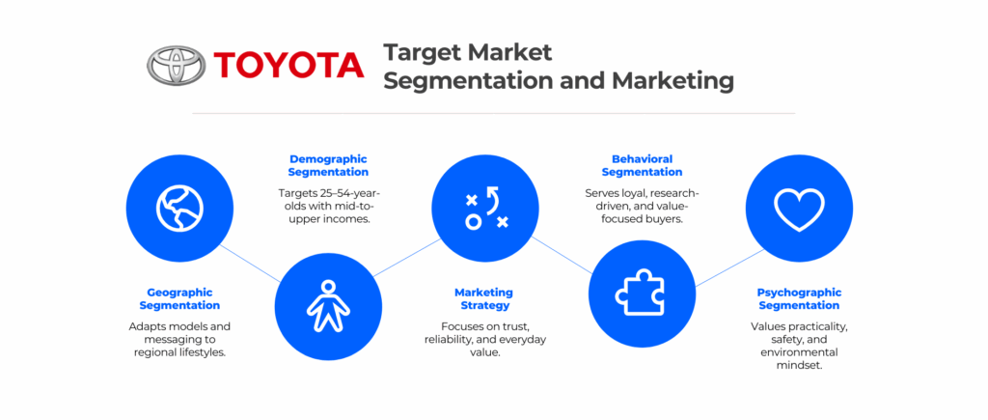
Figure 10 Toyota’s Target Audience; Source: (Toyota, 2024)
India
- Demographics: Toyota caters to the young working professionals, the growing size of family households, and large joint families.
- Psychographics: Toyota appeals to highly price-sensitive and aspirational customers who also look for practical value, social prestige, and durability of the vehicle (Toyota, 2024).
- Geographics: Toyota focuses on tier-1 cities, as well as tier-2 markets where resale demands would be higher in markets that are rougher on cars.
- Behavioural: Toyota targets those that appreciate deep family utility, low maintenance, and high resale value (Toyota, 2024).
- Benefit Segmentation: The benefit point is the availability of an opportunity to have lower ownership costs and engine reliability in the long run.
Targeting Strategy
The targeting strategy involves segmenting the market, choosing which segments of the market are appropriate, and determining the products that will be offered in each segment (Wind, 1972).
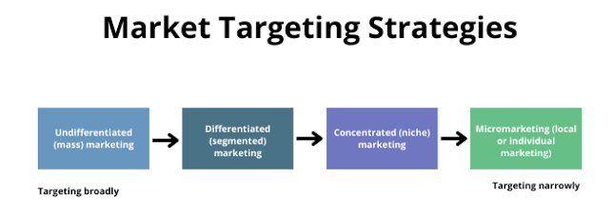
Figure 11 Market Targeting Strategy; Source: (Profiroiu, 2020)
Japan: Differentiated Marketing Strategy
Toyota has a differentiated targeting strategy in Japan as it supplies different customers or customer segments at various income levels (Profiroiu, 2020). The company focuses on young commuters with smaller options such as the Yaris, those who prefer to purchase an eco-friendly option such as the Prius, and executive professionals who look for prestige as represented by the Crown series.
India: Differentiated Marketing Strategy
Toyota adopts a differentiated targeting strategy in India because they offer their customers a range of products and services meeting different market needs (Toyota, 2019). The company focuses on high-end family buyers and business owners with high-end SUVs and MPVs such as the Innova Hycross and the Fortuner (Toyota, 2024), and first bidders with the models that the company has co-developed for them, such as the Glanza and Urban Cruiser Taisor.
Positioning Strategy
Positioning is the particular perception of a brand in consumers' minds, as compared to the key competitors (Brzaković and Brzaković, 2021).
Benefit Positioning
Japan: Existing on the pillars of environmental sustainability, silent hybrid performance, and active safety via Toyota Safety Sense (Toyota, 2024). This is a position for Toyota that will further deepen its technology drive for mobility solutions.
India: Standing out at the joint unbreakable engine durability (QDR: Quality, Durability, Reliability), multi-seat comfort, and high resale value. It creates buyer confidence when purchasing for personal transport, which will eventually be less risky.
Competitive Positioning
Japan: The country was the biggest domestic market, with the technological leadership in the country solid enough (Yarime, Shiroyama and Kuroki, 2008) to outsmart its local rivals Honda and Nissan. That stance highlights Toyota's engineering prowess in Japan.
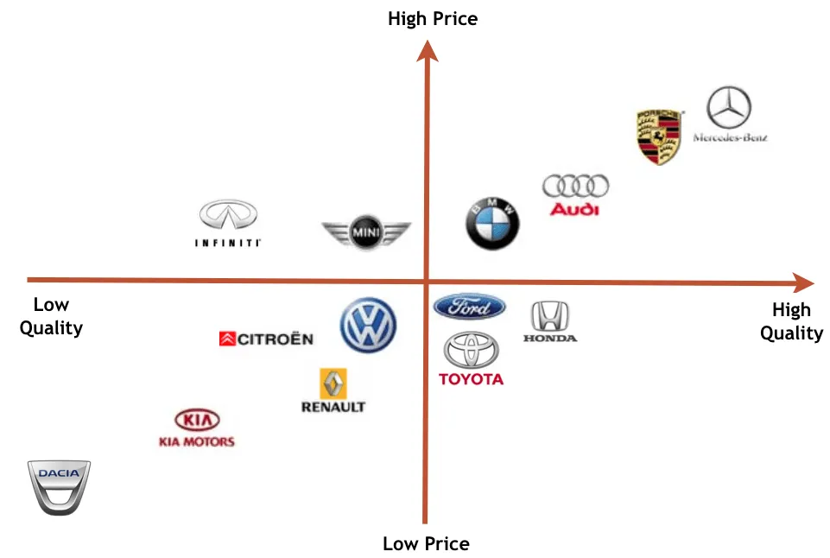
Figure 12 Toyota Market Positioning; Source: (Corporate Finance Institute, 2024)
India: Established as a high-quality luxury brand that exists above the budget brands such as Tata Motors and Maruti Suzuki. This positioning is worth a premium because the benefits of a longer product life are justified (Brzaković and Brzaković, 2021).
Similarities and Differences in STP Strategy
Both markets adopt a differentiated targeting strategy and cater to different income groups. Also, both markets are dependent upon Toyota's primary brand vision of product quality and resale value. In Japan, segmentation is based on urban driving in hot, small vehicles and its hybrid systems. However, in India, segmentation is about affordability, family-friendly seating options, and the most obvious look of the SUV, which is considered a symbol of prestige.

Comparison of International Marketing Mix (7Ps) Strategies
This section evaluates the marketing mix strategy that Toyota has applied to their established market in Japan and to the emerging market of India, which is experiencing robust growth.
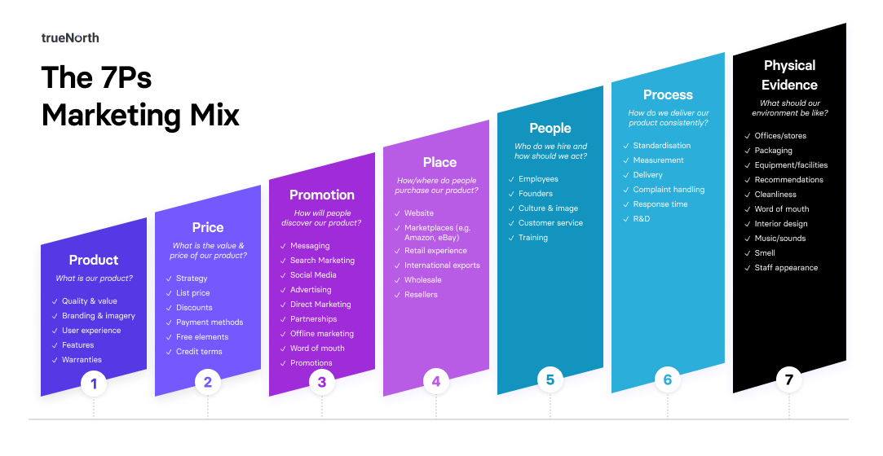Figure 13 International Marketing Mix (7Ps) Strategies; Source: (Saidani, 2019)
Product Strategy
Japan Product Strategy: Toyota in Japan sells a full international product category. The brand offers extraordinary opportunities inherent in its product depth through various engine options (HEV, PHEV, Battery Electric Vehicles) (Toyota, 2024), and extensive product width, from compact city cars to minivans and executive sedans. In Apr 2024, Toyota added the new 250 series to the Land Cruiser lineup in Japan (Toyota, 2024).
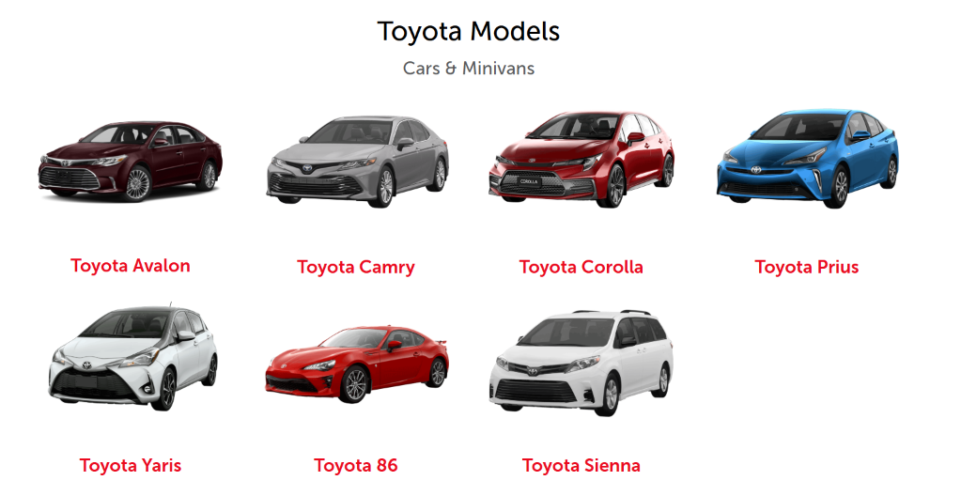
Figure 14 Toyota Product Variations; Source: (Toyota, 2024)
India Product Strategy: In India, Toyota adapts with customised product depth around high ground clearance utility quotes and product width via the co-developed small-sized model of Glanza. High-power distance and consumer behaviour norms in India dictate that dimensions of the product should be sized in a manner to indicate the spacious seating opportunity, strong road presence, and sturdy air conditioning.
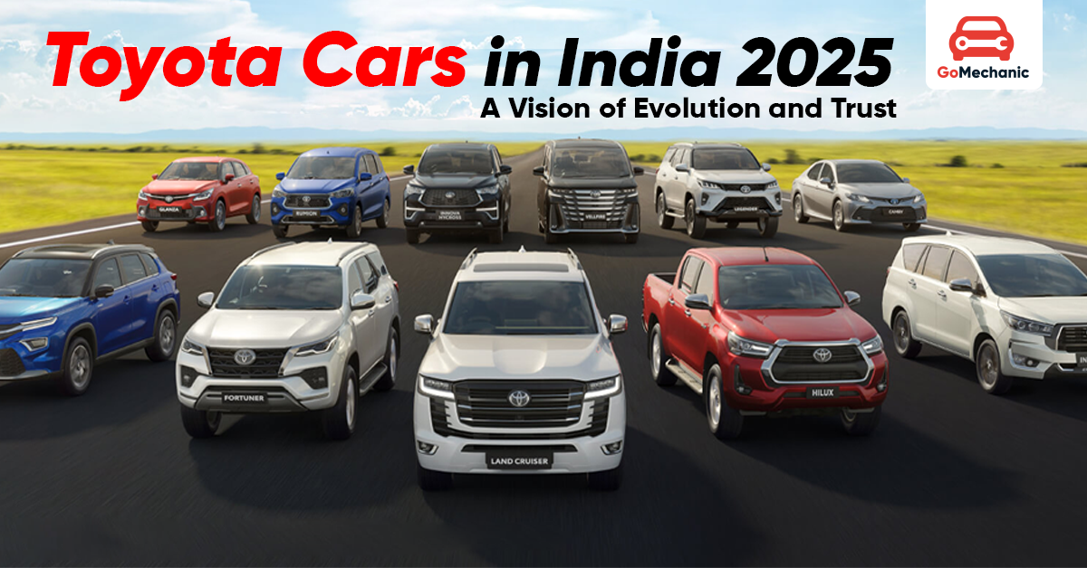
Figure 15 Toyota Car Models in India; Source: (Toyota, 2024)
Price Strategy
Price is the subjective economic valuation of products and services, which is an important demand determinant in the international marketing mix (Saidani, 2019).
Japan Price Strategy: Toyota uses competition-based pricing and value-based pricing with hybrid and premium segments in Japan (Johnson, 2025). Attributed to the moderate inflation rates around 2.0% to 2.4% and the high buying power of Japanese households, the price is found to be moderate in the dealer network. Toyota customizes its pricing strategy to ensure its prices appeal to value-conscious and premium-seeking customers (Toyota, 2024).
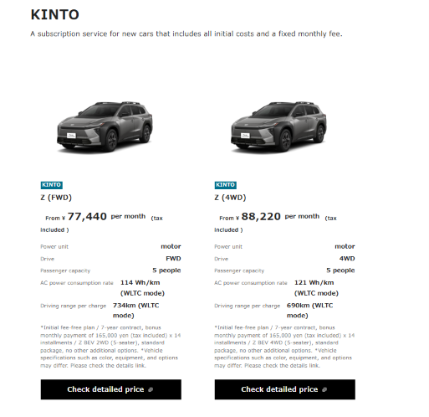
Figure 16 Toyota Car Pricing in Japan; Source: (Toyota, 2024)
According to Toyota (2024) financial report, in FY 2025, Japan accounted for nearly 50% of Toyota’s revenue. Domestic buyers are hesitant to new and experimental vehicles; with this in mind, Toyota has introduced an array of vehicle financing and long-term lease packages, including KINTO (Johnson, 2025), to attract the conservative and risk-averse.
India Price Strategy: Toyota applies a "cost-based pricing" approach to its locally developed utility vehicles and a penetration pricing approach to entry-level vehicles co-developed with Suzuki (Johnson, 2025).
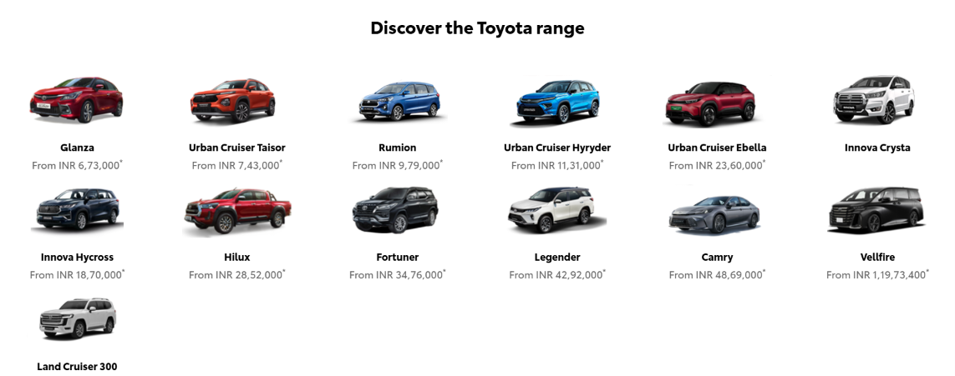
Figure 17 Toyota Car Pricing in India; Source: (Toyota, 2024)
The company has a strategy of maintaining low prices for its spares and adopting a premium pricing policy for flagship models such as the Fortuner to cater to India's growing middle class (Toyota, 2024).
Place (Distribution) Strategy
Japan Place Strategy: Toyota operates in over 170 countries (Johnson, 2025). Johnson (2025) also reported that the company established its manufacturing plants and assembly lines in strategic locations to enhance distribution efficiency and improve supply chain management.
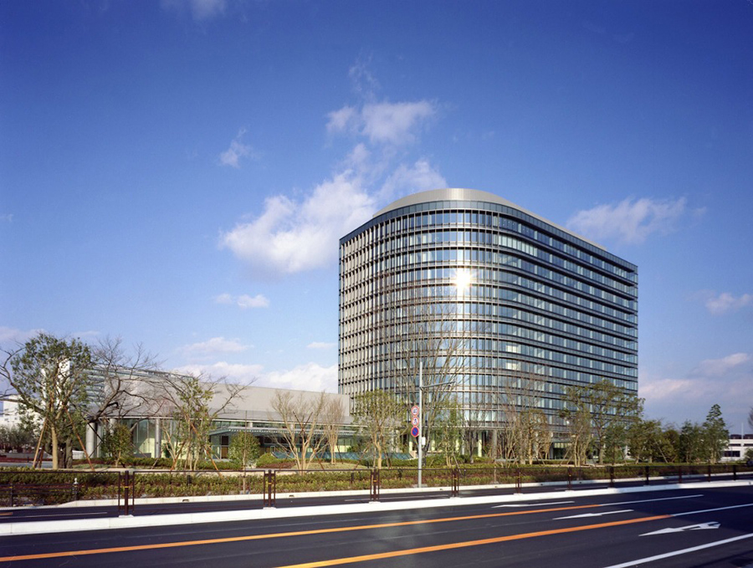
Figure 18 Toyota Head Office in Toyota City, Aichi Prefecture 471-8571, Japan; Source: (Toyota, 2024)
Toyota has an advanced omnichannel retailing approach in Japan, where digital configuration features are used with the assistance of a physical dealership visit. Its distribution system is an indirect channel with exclusive dealer distribution channels (Toyota, 2024).

Figure 19 Toyota Channel Diagram (Japan); Source: Author
An intensive distribution strategy is employed in urban markets because there are hundreds of localised showrooms which ensure broad coverage (Toyota, 2024).
India Place Strategy: In India, Toyota has adopted a hybrid place strategy, covering metropolitan cities and growing regional hubs (By, Nurul and Khan, 2026). The company follows an indirect channel distribution system with an exclusive dealership network, Toyota Kirloskar Motor (TKM) (Toyota, 2024).

Figure 20 Toyota Channel Diagram (India); Source: Author
According to Nurul and Khan (2026), Toyota follows a selective distribution strategy and operates a large 3S business (Sales, Service, Spares) in bigger cities, while only operating secondary 3S centres in smaller cities.
Promotion Strategy
Integrated Marketing Communication (IMC) is the coordination of all marketing communications tools, channels and messages to create a consistent experience for the customer (Saidani, 2019). Promotion is a highly regulated element of the marketing mix in many countries (Doole, 2012).
Japan Promotion Strategy: Toyota's promotion strategy in Japan is cultural integration, zero-emission technology messaging through multiple touch points, and a shared dealer network. Toyota's branding strategy focuses heavily on a pull approach, because of campaign events such as Reborn and Toyota Town (By, Nurul and Khan, 2026), with the demand of consumers propelled through the implementation of a variety of community sponsorships, mass broadcast media campaigns, and corporate storytelling.
India Promotion Strategy: Toyota in India mixes direct sales incentives and a powerful pull approach, which includes emotional marketing. Promotional messages emphasize the brand values (QDR: Quality, Durability, Reliability), Environmental values, and Family values (By, Nurul and Khan, 2026). Toyota actively utilises its festive campaigns, star endorsements, and a strong presence in digital media to appeal to those who want to be seen as important (Toyota, 2024).
People Strategy
People Management Strategy in Japan: Toyota has 73,133 (Consolidated 390,927) employees in Japan (Toyota, 2024). The company operates a strong union collaboration strategy built on mutual trust between management and labour unions (Toyota, 2024). Toyota has an ongoing trainee approach based on long-term apprenticeship and “Kaizen” (continuous improvement) philosophies. Collective teamwork and lifelong learning are key to its approach to people management.
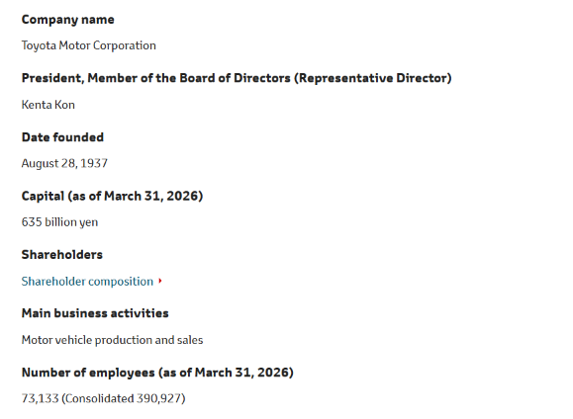
Figure 21 Toyota Company Background (Japan); Source: (Toyota, 2024)
People Management Strategy in India: Toyota Kirloskar Motor in India has its own workforce of several thousand manpower at its manufacturing plants in Karnataka. The company has a highly focused trainee programme using the Toyota Technical Training Institute (TTTI) (Toyota, 2024). It uses a performance-based route for advancement and career progression, global skill swap initiatives, and total-level security incentives.
Process Strategy
Japan Process Strategy: The process strategy of Toyota in Japan is grounded in "Just-in-Time" (JIT) inventory control and the world-famous Toyota Production System (TPS) (Faraj and Milod, 2024). As far as retail activities go, Toyota has a very formal customer grievance system in place with field comments feeding into enhancements to product and service within days.
India Process Strategy: In India, Toyota adapts its process strategy by introducing digitized booking platforms and expressive express-service bays (60-minute quick service) (By, Nurul and Khan, 2026). It has a specific customer complaints procedure, and its objectives lie in fast-solving complaints by its dedicated dealer relations managers to ensure its high customer satisfaction score.
Physical Evidence Strategy
Japan Physical Evidence:
Toyota has grown to become one of the world's largest and best-known automobile manufacturing businesses headquartered in Toyota City, Aichi, Japan (By, Nurul and Khan, 2026).
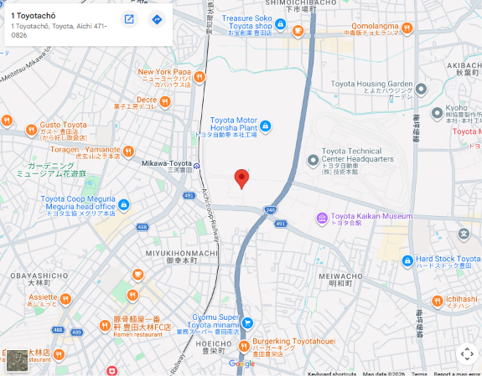
Figure 22 Toyota Head Office (Honsha) Location on a Map; Source: (Toyota, 2019)
There is an unmatched level of sleekness, sophistication, and standardization, dotted throughout with high-spec tech in the form of digital car configurators, pristine service bays, and separate quiet lounges in Japan. In good correlation to the current Japanese aesthetic, it strives for cleanliness, sophisticated technologies, and subtle luxury.
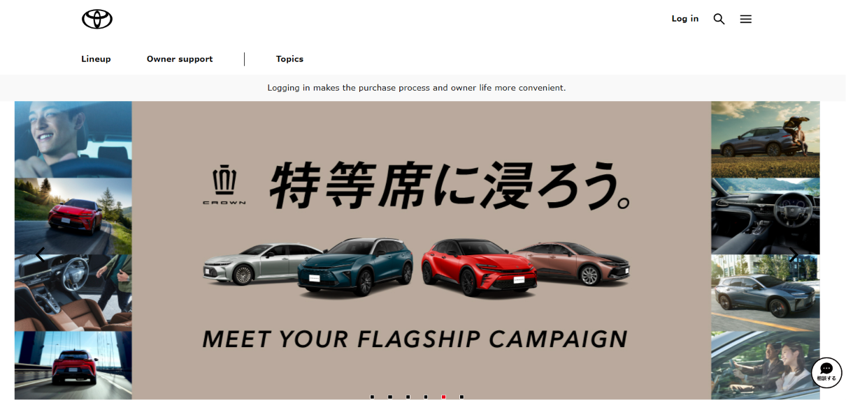
Figure 23 Toyota Official Website in Japan; Source: (Toyota, 2019)
India Physical Evidence: Throughout India, the emphasis lies on the grand and tall 3S dealership buildings intended to communicate institutional pride. Showrooms boast air-conditioned VIP delivery bays, comfortable waiting lounges for the family, and large-scale announcements of Toyota's engineering awards to ward off status-conscious buyers.
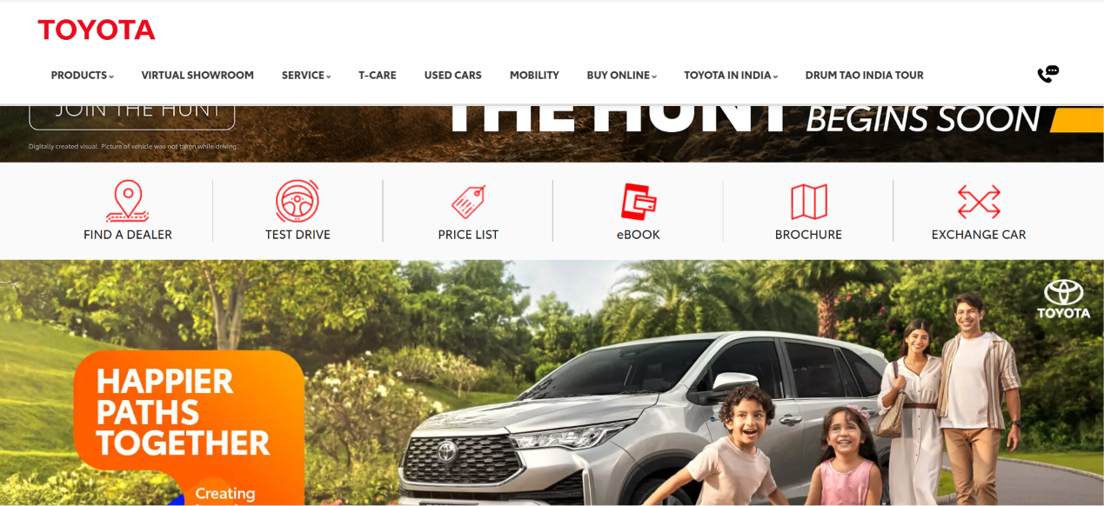
Figure 24 Toyota Official Website in India; Source: (Toyota, 2019)
Similarities and Differences in the 7Ps Marketing Mix
Similarities: While maintaining high operational standards and safeguards throughout the various dealership categories globally, Toyota also has consistent indirect selling frameworks and service processes based on the Toyota Production System (TPS) in both countries.
Differences: The Japan market is based on value-based pricing, a high level of integration of the omnichannel and pull-based technology promotions for a “mature market”. On the other hand, India adopts a cost-based penetration pricing strategy, a selective 3S retail strategy, and a prestige marketing strategy to attract an emerging, status-conscious market.

Market Entry Strategy in India
Definition of Market Entry Strategy
Market entry strategy is a planned approach to making a product or service available to a new target country (Czinkota, 2011). It is a key institutional choice which covers target market selection, entry mode choice, marketing implementation, and governance control systems (Mathur, 2008). The entry mode decision could be one of the most important strategic decisions in international business since it balances commitment of resources versus risk of the market.
Evaluation of Entry Mode in India
In 1997, Toyota Motor Corporation introduced its passenger car brand into India through a Joint Venture (JV) with the Kirloskar Group (a local manufacturer) known as Toyota Kirloskar Motor Private Ltd (TKM) (Akshaya, 2024). This strategic partnership enabled Toyota to establish its own vehicle assembly facilities while addressing several critical considerations regarding investment, control, and risk.
- Risk Mitigation and Knowledge Acquisition: Operating in India by itself exposed significant legal and operational risks, including complicated laws and high import duty (Akshaya, 2024). An existing local conglomerate provided Toyota with a shot at domestic business knowledge and familiarity with local regulations.
- Capital Investment and Shared Control: To localise the manufacturing, significant capital cost was needed. The JV model helped them to share the capital cost of the plant for TKM in Karnataka. Toyota gave up autonomy from a fully owned subsidiary, but gained important insights into networking with local suppliers.

Ethical Evaluation of Toyota’s Marketing Mix in India
The ethical assessment involves assessing corporate conduct and activities to determine whether they are conducted fairly, transparently and responsibly, and are socially acceptable (De Búrca, 2004). Toyota has highlighted some positive examples of ethical practices, as well as some interesting marketing issues in each component of the marketing mix in India.
Ethical Marketing Practices
Community Skill Development: To give underprivileged rural youth free technical education and structural employment opportunities, a technical training institute called the Toyota Technical Training Institute (TTTI) was established in Karnataka (TOYOTA MOTOR, 2022). This is an initiative that is actively creating local human capital and demonstrates a true sense of responsibility for social good.
Transparent Eco-Efficiency Messaging: Toyota is also making fuel economy performance data verifiable and battery warranties transparent in its hybrid range (Innova Hycross) (Toyota, 2024). This transparency ensures that Indian buyers are not misled or misinformed when making environmentally or financially sound purchases.
Unethical Marketing Practices
Greenwashing via Hybrid Branding: In India, Toyota has been identified as engaging in greenwashing through Hybrid Branding (Johnson, 2025), despite using fuels derived from fossil-fuel energy sources. Adding a hybrid option as a full zero-emission product is leading to consumer confusion over real zero emissions.
Delayed Safety Disclosures: Toyota came under fire for delayed disclosures on safety issues such as the Takata airbag, diesel engine test compliance, etc. (Nguyen, 2023). Delayed disclosure in the host markets affects product transparency and undermines consumer trust in product safety.

Strategic Recommendations
Toyota is evaluating the macro-environmental, cultural, and marketing mix of its two countries, Japan and India, and balancing the two. The next strategic suggestions could create obvious methods for internationalization:
Recommendations for Japan
Recommendation 1: Toyota needs to invest in the advancement of solid-state battery technology and pure electric cars faster to ensure that it remains technologically dominant over other EV manufacturers in the domestic market.
Recommendation 2: The company must expand digital mobility services in order to gain more of the younger Japanese commuters that prefer mobility over ownership.
Recommendations for India
Recommendation 1: Toyota should also install local battery assembly and EV manufacturing plants in India to avail maximum government incentive schemes and provide competitive retail prices.
Recommendation 2: To meet the growing middle-class appetite for SUVs, TKM will need to add more sales/service partners (3S) in fast-growing Tier-2 and Tier-3 cities in the region.

Reflective Part
This reflective report applies the Gibbs Reflective Cycle (1989) in order to reflect on my experience in conducting and preparing the international marketing report on Toyota in Japan and India.
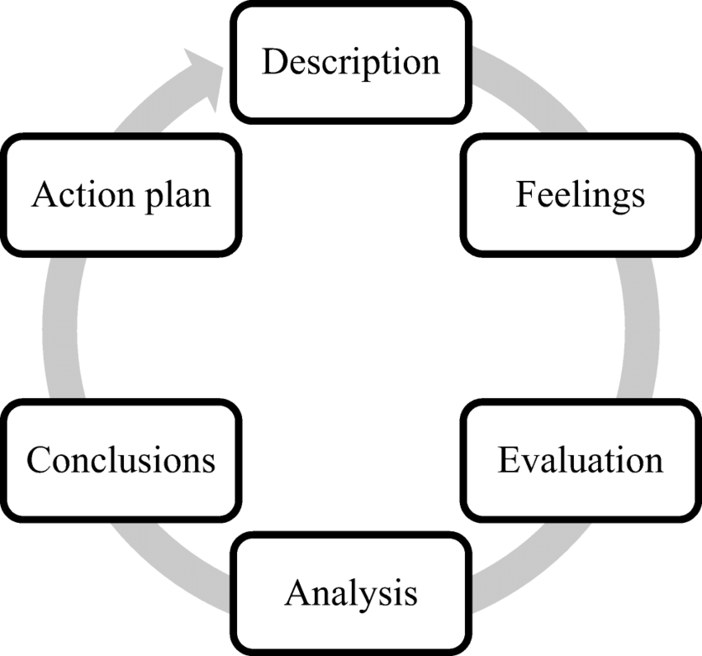
Figure 25 Gibbs Reflective Cycle; Source: (Sellberg and Wiig, 2020)
Description
In this assessment, I made a detailed comparative analysis of global marketing strategies followed by Toyota Motor Corporation in two different countries, namely Japan (home country) and India (host country). The main task was to synthesize secondary data belonging to the academic literature, annual corporate reports, and industry publications. I used the following theoretical concepts learned in class: PESTEL analysis, Hofstede's DICA, STP analysis, 7Ps marketing mix model. In this process, I appraised the influence of the macro-environment and the socio-cultural factors on strategic marketing decision-making in mature and emerging markets.
Feelings
When the project started, I had already been struck with a feeling of being a bit overwhelmed by all of the financial and strategic information available for a global organisation like Toyota. Making sure to choose the proper frameworks and conceiving a comparative analysis in a logical structure was a concern for me. As I systematically made my way through each section following the words of the assessment brief, however, I increased my confidence level. Observing how Toyota built its presence in India through a joint venture sparked my genuine interest in evaluating international market entry decisions. Looking back, I don't have much to say that it was difficult to adhere to the word-count guidelines and to discuss both countries and all seven aspects of the marketing mix.
Evaluation
In terms of overall experience, a few of the following points were favourable. Coupled with the use of Hofstede's cultural framework, I was able to systematically compare the two contrasting national contexts for snapshots of the differences in consumer behaviour. I did well in analysing the marketing mix of Toyota for the Globe and adapting it locally. But I did experience problems with assessing the ethos of companies in India. Leading a research process on the controversies around greenwashing and on recall processes proved to be a lengthy exercise. I admit that I found it difficult to keep, especially, the critical evaluation balance for an objective and academic presentation.
Analysis
My study process has been observed, and the processes identified the knowledge components of my strengths as well as some of the components I need to work on. I discovered that in having to use structured models such as PESTEL and STP, I was able to make the complex mass of market data comprehensible and valuable for strategic actions. This reflects the power of the theoretical frameworks to make possible the seemingly irresolvable aspects of real business situations. In addition, I realised that it is important to study ethical marketing mix practices as global corporations are held more accountable by the public nowadays with regard to their sustainability claims. By examining entry mode trade-offs, I recognized that Toyota used a Joint Venture to gradually build local market knowledge while sharing economic and regulatory risks. I have since determined that one has to critically screen and be thorough in the selection of secondary data in order to ensure the academic credibility of the data in secondary data synthesis.
Conclusion
Finally, when I finished this report, I enhanced my knowledge of the theory of marketing internationally and market adaptation. I learnt about how cultural dimensions such as power distance and uncertainty avoidance have a direct impact on the positioning and pricing of any product. I feel my access to massive amounts of market information and to not only learn, but present it in such a short and academic format has definitely positively shaped the way forward. But I realize I must learn to use more efficient time and data, screen management methods in the future for post-graduation.
Action Plan
Skills Needed to Improve | Tasks | Expected Outcomes
Advanced Secondary Data Screening | Search peer-reviewed academic databases (Emerald, ScienceDirect) and filter publications from the last five years. | Higher quality citations and stronger critical evidence in academic reports.
Concise Academic Editing | Practice summarizing complex business models using short, direct sentence structures. | Improved clarity, better word count management, and natural human writing tone.

Conclusion
The report demonstrated that in order to be a top competitor in the global automotive industry, the company has to complement the mass production's excellence with local adaptation. Toyota's comparison of Japan and India reveals how stability and cultural differences at the macro level affect the positioning and 7Ps in the marketing of STPs. Moreover, a Joint Venture entry mode would mean that the risk of getting tangled up in emerging markets would be controlled. However, strict ethical transparency involving an EV innovation localized in the emerging market would be necessary in order to maintain the brand equity. To conclude, Toyota's business approach enables it to maintain satisfactory margins in its established domestic markets and grow revenue in premium markets internationally.

References
Akshaya, M. (2024). Beyond manufacturing, Toyota’s business focuses on productivity through improving its people and implementing sustainable practices. [online] Business India. Available at: https://businessindia.co/magazine/automobiles/beyond-manufacturing [Accessed 25 July 2026].
Baack, D. G. (2018). International marketing, 2nd edition. London: SAGE Publications.
Brzaković, A. and Brzaković, S. (2021). Positioning a Brand on the Market. 3Rd International Scientific Conference ITEMA Recent Advances in Information Technology, Tourism, Economics, Management and Agriculture.
Bureau, S. (2026). Statistics Bureau Home Page/News Bulletin January 28, 2026. [online] Stat.go.jp. Available at: https://www.stat.go.jp/english/info/news/20260128.html [Accessed 25 July 2026].
By, P., Nurul and Khan, I. (2026). Strategic &amp; Operational Analysis of TOYOTA Motor Corporation &quot; A comprehensive Business Research Report&quot;. [online]
CEICdata.com (2018). Japan Real GDP Growth. [online] Ceicdata.com. CEICdata.com. Available at: https://www.ceicdata.com/en/indicator/japan/real-gdp-growth [Accessed 25 July 2026].
Citilci, T. and Akbalik, M. (2019). The Importance of PESTEL Analysis for Environmental Scanning Process. Advances in Marketing, Customer Relationship Management, and E-Services, [online] pp.336–357. doi: https://doi.org/10.4018/978-1-7998-2559-3.ch016.
Corporate Finance Institute (2024). Market Positioning. [online] Corporate Finance Institute. Available at: https://corporatefinanceinstitute.com/resources/management/market-positioning/ [Accessed 26 July 2026].
Czinkota, M.R. (2011) International Marketing. Hampshire: Cengage Learning.
De Búrca, S., Fletcher, R. and Brown, L. (2004) International marketing: an SME perspective. 1st ed. Harlow, England: FT Prentice Hall.
Department of Foreign Affairs and Trade. (2025). Japan country brief (Political overview). https://www.dfat.gov.au/geo/japan/japan-country-brief [Accessed 25 July 2026].
Doole, I. and Lowe, R. (2012) International marketing strategy: analysis, development and implementation. Cengage Learning.
Faraj, O. and Milod, T. (2024). Case Study Analysis of Toyota Company and make time to market. ResearchGate. [online] https://www.researchgate.net/publication/378291359_Case_Study_Analysis_of_Toyota_Company_and_make_time_to_market
Geoghegan, D. (2019). STP Marketing Model. [online] Expert Program Management. EPM. Available at: https://expertprogrammanagement.com/2019/11/stp-marketing-model/ [Accessed 26 July 2026].
Hofstede, G. (1984). Cultural Dimensions in Management and Planning. Asia Pacific Journal of Management, 1, 81-99. https://doi.org/10.1007/BF01733682
International Energy Agency (2023). Bharat Stage (BS) VI emission standards – Policies. [online] IEA. Available at: https://www.iea.org/policies/7454-bharat-stage-bs-vi-emission-standards [Accessed 25 July 2026].
Johnson, K. (2025). Toyota Marketing Strategy. [online] Business Strategy Hub. Available at: https://bstrategyhub.com/toyota-marketing-strategy/ [Accessed 26 July 2026].
Majid, M.A., Rajesh, C. and Ahmed, A. (2024). Advances in Electric Vehicles for a self-reliant Energy Ecosystem and Powering a Sustainable Future in India. E-Prime - Advances in Electrical Engineering Electronics and Energy, [online] 10. https://doi.org/10.1016/j.prime.2024.100753.
Mathur, U. C. (2008). International marketing management: text and cases. SAGE.
Ministry of Foreign Affairs of Japan . (2024). Foreign Direct Investment in Japan. In Ministry of Foreign Affairs of Japan. https://www.mofa.go.jp/policy/economy/japan/invest/ [Accessed 25 July 2026].
Nguyen, T.Q. (2023). Toyota’s Recall Crisis: Root Causes and Solutions. ResearchGate. [online]
Piao, X., Nasuda, A. and Li, S. (2025). Electric Vehicle Adoption: Japanese Consumer Attitudes, Inter-Vehicle Transitions, and Effects on Well-Being. Sustainability, 18(1), p.195. https://doi.org/10.3390/su18010195.
Profiroiu, M., Kaneko, H., Vlad, C., Dutescu, A. and Ishida, H., 2020. Toyota Motor Corporation's Culture Strategy. Revista De Management Comparat International, 21(4), pp.458-489.
Saidani, B. (2019). Marketing Mix-7Ps: The Effect on Customer Satisfaction. Jurnal Pendidikan Ekonomi dan Bisnis (JPEB), 7(1), pp.81–94. Salve, P. (2026). India’s inflation accelerates to 4.38% in June, exceeding forecasts. [online] CNBC. Available at: https://www.cnbc.com/2026/07/13/india-june-inflation-oil-food-iran-war.html [Accessed 25 July 2026].
Salve, P. (2026, July 13). India’s inflation accelerates to 4.38% in June, exceeding forecasts. CNBC. https://www.cnbc.com/2026/07/13/india-june-inflation-oil-food-iran-war.html [Accessed 25 July 2026].
Schlager, T. and Christen, M., 2021. Market segmentation. In Handbook of Market Research (pp. 939-967). Cham: Springer International Publishing.
Sellberg, C. and Wiig, A.C. (2020). Telling Stories from the Sea: Facilitating Professional Learning in Maritime Post-Simulation Debriefings. Vocations and Learning, [online] 13(3), pp.527–550.
Singh, A., Dharme, A. and Bisht, J. (2026). Enhancing Road Safety through Vehicle Modifications: A Critical Study of the Indian Legal Framework. Advanced International Journal for Research, 7(2). https://doi.org/10.63363/aijfr.2026.v07i02.4305.
Srivastava, A., 2026. GST 2.0: A New Gear for Accelerating the Indian Automobile Sector.
The Government of Japan (2024). Together for Action: Japan’s Initiatives for Achieving the Common Goal of Net Zero by 2050. [online] The Government of Japan - JapanGov. Available at: https://www.japan.go.jp/kizuna/2024/01/together_for_action_japan_initiatives.html [Accessed 25 July 2026].
Toyota (2019). Global Website | 75 Years of Toyota | Section 3. Expansion of Asian Markets and Developments in Oceania | Item 1. From Stagnation to Growth. [online] Www.toyota-global.com. Available at: https://www.toyota-global.com/company/history_of_toyota/75years/text/leaping_forward_as_a_global_corporation/chapter4/section3/item1_d.html [Accessed 25 July 2026].
Toyota (2024). New Cars, Trucks, SUVs & Hybrids | Toyota Official Site. [online] Toyota.com. Available at: https://www.toyota.com/ [Accessed 25 July 2026].
Toyota Manufacturing UK (2022). History of Toyota. [online] Toyota. Available at: https://www.toyotauk.com/about-toyota/history-of-toyota [Accessed 25 July 2026].
TOYOTA MOTOR (2022). Toyota to Invest Up to 730 Billion Yen in Japan/U.S. Battery Production | Corporate | Global Newsroom. [online] Toyota Motor Corporation Official Global Website. Available at: https://global.toyota/en/newsroom/corporate/37964997.html [Accessed 25 July 2026].
TOYOTA MOTOR CORPORATION (2024). Financial Data | Shareholders & Investors News | Toyota Motor Corporation Official Global Website. [online] Toyota Motor Corporation Official Global Website. Available at: https://global.toyota/en/ir/finance/ [Accessed 25 July 2026].
Trading Economics (2025a). India Unemployment Rate. [online] Tradingeconomics.com. TRADING ECONOMICS. Available at: https://tradingeconomics.com/india/unemployment-rate [Accessed 25 July 2026a].
Trading Economics (2025b). Japan Inflation Rate. [online] Tradingeconomics.com. TRADING ECONOMICS. Available at: https://tradingeconomics.com/japan/inflation-cpi [Accessed 25 July 2026b].
U.S. Embassy & Consulates in Japan (2025). Technical Difficulties. [online] Jp.usembassy.gov. Available at: https://jp.usembassy.gov/services/ipca-background-information/ [Accessed 25 July 2026].
Verma, S. (2026). Indian Economy – An Overview / T.C. Dışişleri Bakanlığı. [online] Www.mfa.gov.tr. Available at: https://www.mfa.gov.tr/indian-economy-_-an-overview-.tr.mfa [Accessed 25 July 2026].
Wind, Y., and Douglas, S. P. (1972). International market segmentation. European Journal of Marketing, 6(1), 17–25.
World Bank (2026). World Bank Open Data. [online] World Bank Open Data. Available at: https://data.worldbank.org/indicator/sl.uem.totl.zs?end=2025&locations=jp&start=1991&view=chart [Accessed 25 July 2026].
Yarime, M., Shiroyama, H. and Kuroki, Y. (2008). The Strategies of the Japanese Auto Industry in Developing Hybrid and Fuel Cell Vehicles. ResearchGate, [online] pp.187–212. Available at: https://www.researchgate.net/publication/263468810_The_Strategies_of_the_Japanese_Auto_Industry_in_Developing_Hybrid_and_Fuel_Cell_Vehicles [Accessed 25 July 2026].

