University of Wales Trinity Saint David
Wales Institute of Science and Art


Logbook

Workshop and Practice (ACHA4011)

Charlie Wint
(2305014)
December 2023
Contents
1 Health and Safety Overview 3
2 Machine Workshop 4
3 Engine Strip Sessions 8
4 Guest Lecture Entry 13

Health and Safety Overview

In the workshops, it is crucial to wear the correct PPE as the machinery used is extremely dangerous if used incorrectly. If your hair is long enough, it is required to be tied back to ensure it does not get caught in the machinery and drag you into it. Safet goggles are also required in case of loose debris comes flying out of the object or machine. The university provide these safety goggles as well as an overcoat and steel-toe-cap shoes. The overcoat is to prevent any lose clothing from dragging someone into the machine and causing potentially fatal injuries. The steel-toe-cap boots help to prevent foot damage from falling debris that have a large mass which would be capable of crushing a person’s foot without it. All of the PPE is strictly required by the university to ensure protection of both students and staff.

Machine Workshop

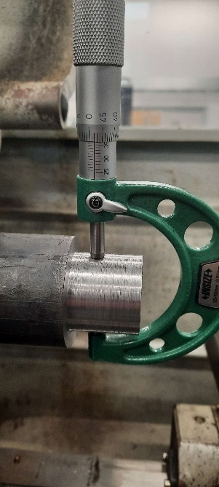
The picture to the side shows a micrometre which was used in the workshop to measure the diameter of the piece to ensure the piece was machined to the correct size. They are extremely delicate and could be deemed useless as the measurements would be too far out and inaccurate due to the thread being stretched inside the twistable adjuster.

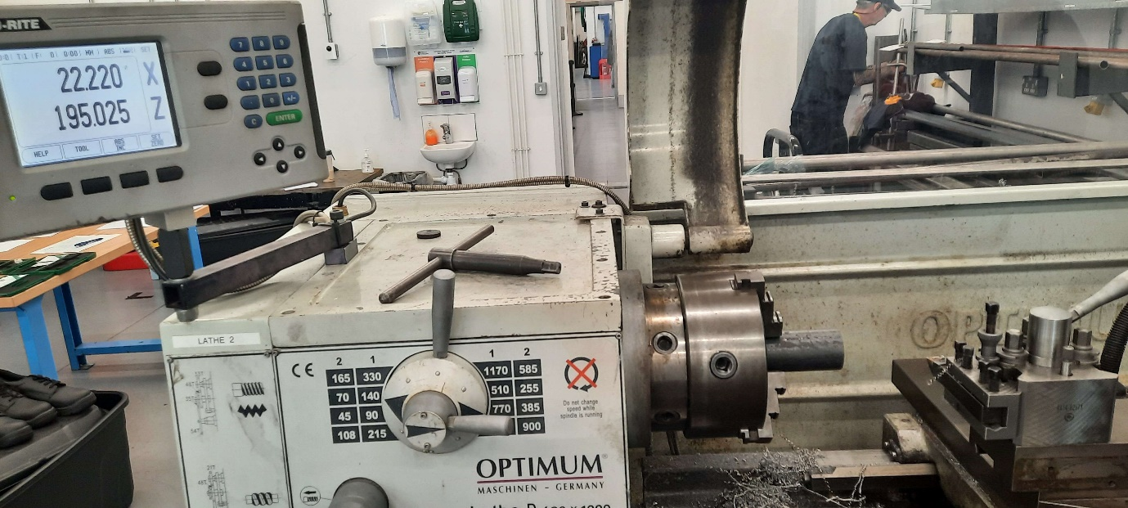
The photo above shows the guard that goes over the chuck on the lathe. The lathe will not start up unless the guard is down in its protective position to prevent any loose items firing out of the chuck into the operator. The arrows to the side of the indicate the rotation speed of the chuck. The X and Z on the screen show the position of the cutting piece in millimetres. The piece on the far right of the image is the cutting tool which gets locked in position before you use it so it doesn’t make contact and move which could potentially injure you.

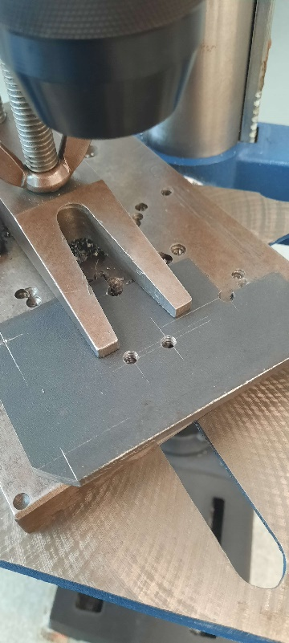
The 2 finger-like pieces are tightened by the butterfly nut above to clamp onto the work piece beneath, so it does not move when the pillar drill comes down to drill the hole into it. Outside of the picture, just above where the drill piece goes, it’s a shield that is held down by a spring when in use so that swarf and pieces of the drill bit don’t fly off and hit the user potentially causing harm. The drill comes down from a rotary handle on the side of the machine, when you let go of the handle, it automatically returns to the top to keep it away from any hands that could be reaching to the workpiece.

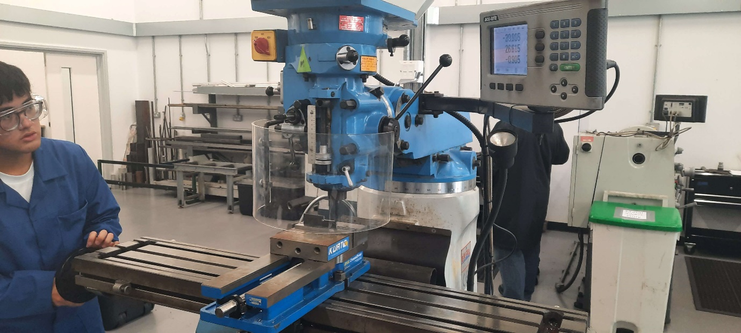

The photo above shows a milling machine. The guard is in place because the machine is operational at the time the picture was taken, the handle on the left moves the workpiece along, from left to right from the camera’s perspective, there are two further dials to move the workpiece forwards and backwards as well as up and down. The screen at the top of the image shows the coordinates of the workpiece in millimetres from the point of origin. The operator can ‘zero’ the coordinates to help with positioning the workpiece so its easier to read how far over the workpiece is. The red and yellow switch at the top of the machine controls if the machine spins anti-clockwise or clockwise, if the red switch is perfectly vertical, the milling machine will not spin at all. The technicians ensure you switch it off before moving the guard away so there is no chance of it starting up when you go to pick up the workpiece.

Engine Strip Sessions
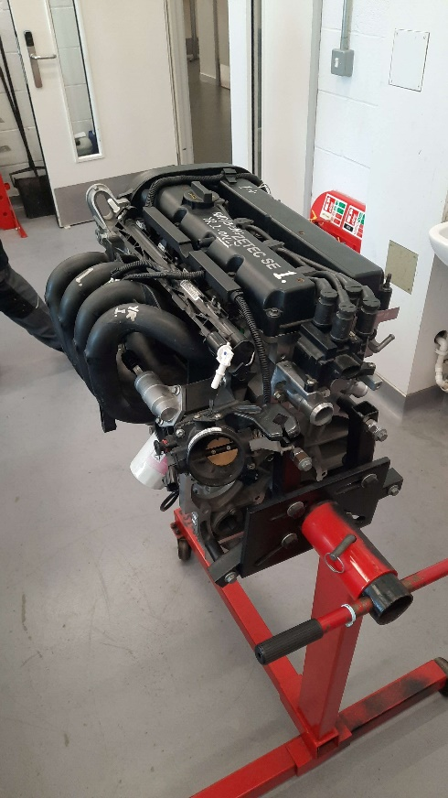
The image to the left shows an engine during week 1 of the engine strip sessions. This is where the technician goes through the necessary health and safety procedures as well as the information about the engine that you need to know to understand how to strip it before putting it back together again. This session also covers the different tools that will be used during the engine strip sessions.

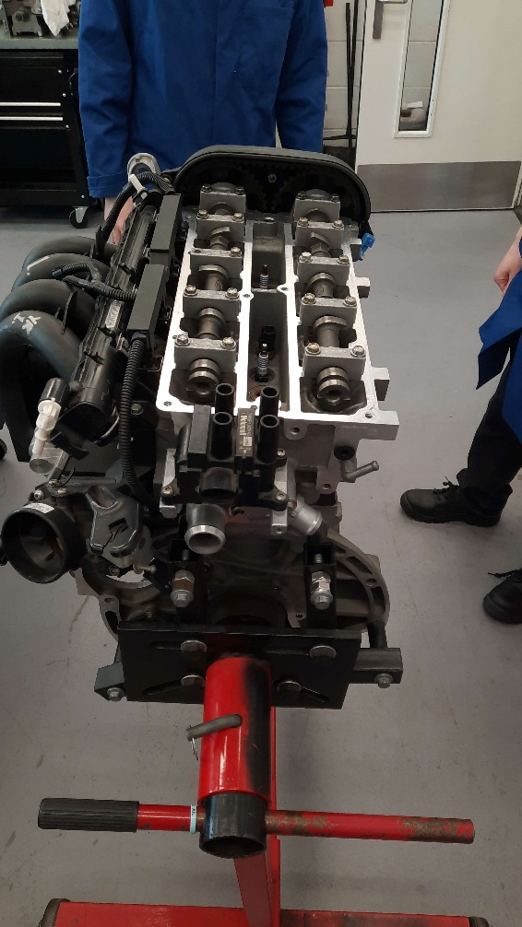
The image to the left follows the previous image as the upper plastic has been removed from the block. This took only a couple of minutes as there were 3 people working on it at the same time. Once that was removed, we were able to access the camshaft and sparkplugs which easily unscrewed from the block. Following the picture, the remaining plastic was removed.

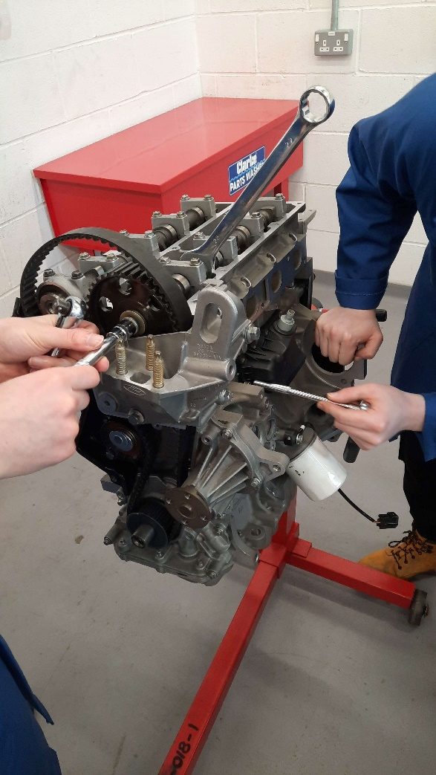
This image is the follow-up to the previous one after all the plastic as been removed from in front of the camshaft and to the side of the engine block. The spanner on the camshaft is there to stop it from rotating as the belt cogs are removed. Without the spanner, the camshaft would rotate with the bolt making it impossible to remove. The pieces used vary between 6 to 10 millimetres to fit around the bolts with the occasional one that may be slightly bigger.

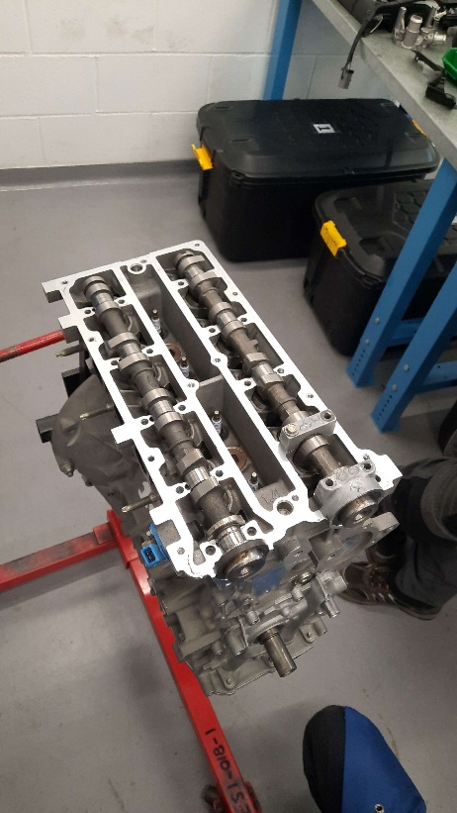
This image shows the successfully removed belt and cogs as well as the other pieces that helped to keep those attached and operational. As the front pieces were now removed, this made it possible to remove the camshaft housing and camshafts. It is important to remember which side the camshafts are fitted to as one of them has an extra notch on it for the ECU to make sure the timing is still good. That is connected to the blue square on the front corner of the block.

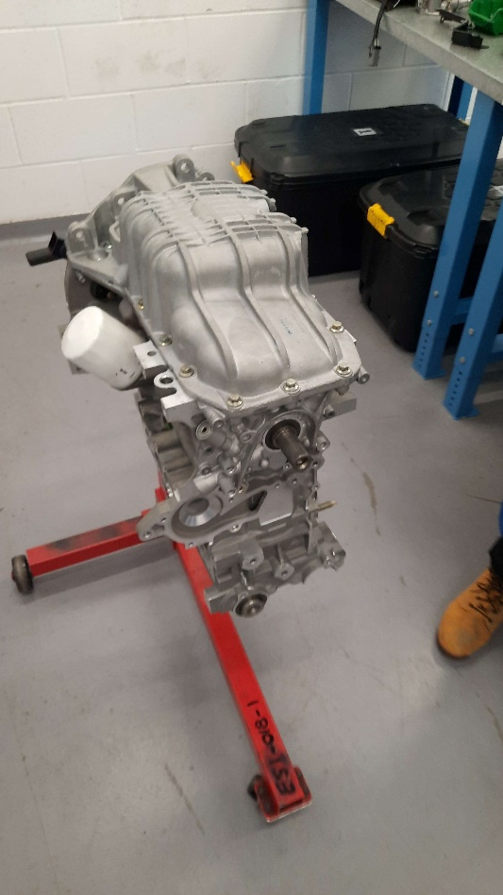
This image is the final part of the stripping process. The engine was rotated 180 degrees so it is upside down so we could remove the sump from the block. Once this was completed, it was time to reverse the process and rebuild the engine. The engine was able to be rebuilt within 1 session as there was three people working on it. Which made it quick and efficient when there were multiple pieces able to be fitted at one stage of the process.

Guest Lecture Entry

I have attended two guest lectures so far this academic year, the first was on the 15th of November 2023, hosted by Fuchs lubricants. They discussed the different types of lubricants they produce and sell as well as their purpose and where they should be used. They also covered the side affects of using the wrong lubricants in certain aspects like causing corrosion on components which would destroy the mechanism. The second.

The second guest lecture I attended was on the 21st of February 2024, hosted by Nick Fry, who owned the 33% stake in the Brawn GP F1 Team in 2009. He is now occupying a crucial role at McLaren Applied Technologies who design and manufacture electronic components for a wide variety of applications, such as timing sensors for all 10 Formula 1 teams on the current grid, regulated by the FIA to prevent any disadvantages to McLaren’s rivals in F1.

