Miss Kelsey Amber Dutton

BA Youth and Community Work
2019

How key Youth Work practices affect Young People and their transition into adulthood.


Undergraduate ARP Certificate

Name of the Programme of Study: Youth and Community Work

Name of Student (Capital Letters): KELSEY AMBER DUTTON

DECLARATION

I certify that the whole of this work is the result of my individual effort, and that all sources have been acknowledged.

Signed ..................................................................

Date ...............................................................

DECLARATION

I am satisfied that this work is the result of the Student’s effort.

Signed .............................................................. (Lecturer)

Date ..............................................................

This research project will demonstrate the policies and practices that are impacting young people today. It is also demonstrating how Youth Work is impacting the world of work and how it has become an important aspect in today’s society. It is now understood that Youth Work has grown since it first began. It will include a focus group and unstructured interviews. These will demonstrate how young people and adults today view the practices of youth work and how important the practice affects their development.
It was essential to be able to gather as much data and literature as possible to be able to give the reader a better understanding to how Youth Work is able to affect young people. This applied research project is to also allow the reader to be able to understand how young people are, and what Youth Work can do to better their life and make their future successful to become valued citizens within our communities.

Contents Page
Chapter 1: Introduction.......................................………………..…5
Chapter 2: Literature Review.......................................……………7
Chapter 3: Methodology for Data Collection.................................13
Chapter 4: Presentation of Results.....................................……...16
Chapter 5: Discussion, Critical Reflection an Conclusions .........33
Chapter 6: Recommendations............................................……...37
Reference List.....................................................................……...38
Appendicies........................................................................……...42

Chapter 1: Introduction
This Applied Research Project (APR) was inspired by Young People. This research will explore the key Youth Work practices and how they can affect the Young People in relation to their transition into adulthood. The issue that has been identified is that Young People do not get the support from services that is required to be able to transition successfully. There is a lack of support for Young People who are in care, living at home, homeless young people and many more. They do not have any form of guardian support. They lack support with basic necessities such as support with their independent living, education and employment, social skills, health and wellbeing and support with difficult circumstances.
The issue of this research is to develop an understanding on what level of participation Youth Work Practice as a whole and how it already affects and supports the Young People. However, young people are still suffering with the impacts due to the lack of support within the system. A question arisen is, how have these issues not been resolved. Is there not enough support in our local communities available for these Young People.
This Applied Research Project will inform other professionals what services and support is available for Young People at the moment. This can also overlap to introduce services that are available in general, and if there are enough services to be able to support Young People’s needs in 2018.
Within the next chapter, it will explore the research and literature that shows the elements of issues of young people within all elements. It was ask questions such as which young people are affected, what are they affected by, what support is available for them at the moment, It will also explore how Youth Work has impacted this.

Chapter 2: Literature Review.
‘The main objective of Youth Work is to provide opportunities for Young People to shape their own futures’ (CYWU, 2010,p1).
Within this chapter I will be considering and analysing literature that helps support my research. It is expected that new ideas will emerge from this. The aim of this is to be able to understand how young people transition into adulthood and what aspects affect this. It is important to be able to focus on the knowledge that has already been accumulated. This will help to be able to find gaps in the research. There are many young people who have been brought up differently. These differences of their childhood differentiate the young people now and has affected them in different ways to define who they are today.
‘‘A review of existing research concludes that the transition to adulthood is more difficult and complicated than in the past. There is no sharp distinction between childhood and adulthood: it is a complex mixture of continuing dependency on parents stretching into the twenties and beyond, and autonomy in specific areas from the early teenage years’ (JRF, 1996, p1).
Young people in the UK have a range of issues, Gibb and Edwards suggest that Young People’s lives are ‘chaotic’ resulting in;
‘homelessness or unstable housing, money worries, pregnancy, substance misuse, criminal activity, unhealthy relationships, mental health issues and threatened deportation. Nonetheless, they also tended to report spending a lot of time at home; sleeping, watching TV and surfing the internet. They typically spoke of feeling bored with this lifestyle and wanting more structure in their lives.’ (Gibb, Edwards 2017, p14).
Youth Work has a high set of standards that help support young people. Youth work ‘…provides or facilitates…places and relationships within which young people can enjoy themselves, feel secure, learn to take greater control of their lives and recognise and resist the damaging influences which may affect them’ (CWVYS, 2018). In Youth Work practice it has been a priority to be able to help support any young person who has a need, or is struggling with their every day lives, as ‘good youth work develops the ability of young people to think for themselves and act for others’ (CYWU, 2010,p1), which makes the young people positive role models within society.
It has been shown that young people are becoming very difficult to be able to understand, and with this they have also been shown to be more ‘risky’ (Williamson, H. 1999, p1). Youth Work has always demonstrated its use of principles and methods to be able to have a secure voluntary bond and relationship with young people. This is the foundation for the best learning for young people. As Youth Workers, we can provide ‘advice, guidance, personal support and opportunity’ (Williamson, 1999, p1).
In today’s society, many groups of young people are struggling with the transition into adulthood. They are struggling in various different ways. For example, studies have shown that young people today are struggling with personal issues. This has resulted in young people not being able to survive on their own and having to move back home with guardians/parents. This has become apparent in Sarah Young’s research, as young people are being prone to becoming more depressed if they have moved back home after being independent at one point in their lives (Young, 2018, np). Reasons for depression within these young people are due to the lack of success. If moving back home is the only option then they have a sense of ‘not achieving goals’ (Young, 2018, np) due to ‘income declines and partnership losses’ (Young, 2018, np). This can highly impact a young person’s transition into adulthood and result in ‘mental health consequences’ (Young, 2018, np) as it is not allowing the young people to have their own powerful independence that gives them feeling of achievement. (Young, 2018, np).
Another example of research is that young people need a ‘rite of passage’ (Lott, 2014, np) to help them be eased into adulthood. This has resulted in an organisation called ‘A Band of Brothers’ (Lott, 2014, np) to be able to give these young men mentors and proving Accomodation that gets them away from their current lives to give them a better chance of transitioning successfully (Lott, 2014, np). In our history, rites of passage were in every community, boys were part of the military to be able to prove to their communities that they are worthy of being a ‘man’ and that they are then considered an adult (Lott, 2014, np). It has also been seen with women. In the past, women were separated from their communities and were monitored by wise women who were able to give them to title of being a ‘woman’ (Lott, 2014, np). Tim Lott is not suggesting that we return to those old traditions in history, but has suggested there to be a rite of passage that allows a sense of achievement for young people, instead of ‘teenage girls may prov(ing) their fertility by getting pregnant, and teenage boys may demonstrate(ing) their manhood by ritualised violence through gang warfare’ (Lott, 2014, np).
There are also care leavers who are struggling with the transition into adulthood as; ‘before the Leaving Care Act (2000), there was no statutory framework in place for care leavers, with each local authority determining what level of support it provided’ (HM Government, 2016, p9). The 2000 Act was a requirement of the local services to provide young people with access to help support the young person to a successful future and to develop a ‘pathway plan’ (HM Government, 2016, p9). In aspects, this act has proved itself to be successful, as some young people feel that they can ‘get the support’ they need and that they can ‘build good relationship(s)’ with someone they can ‘trust’ (HM, Government, 2016, p27).
Young people are unaware of what they are entitled to, they are unaware of the services they have (HM, Government, 2016, p29). Young people are more likely to be involved with ‘risky behaviour’ compared to others their age in the general population. Risky behaviour includes ‘offending’, ‘drug and alcohol use’. For example, between a ‘quarter and a half of those in young offender institutions have been in care’. Homelessness and unsecure accommodation is a contribution to this outcome (Gibb, Edwards 2017, p14).
‘Youth work ‘’…provides or facilitates…places and relationships within which young people can enjoy themselves, feel secure, learn to take greater control of their lives and recognise and resist the damaging influences which may affect them’’ (PYOG, 2016). Within Youth Work it is fundamental to have relationships. Relationships ‘is based on a principle of non-formal/informal learning with the educative power of playing one’s part in a group or association being a defining feature of youth work since its inception, perhaps most strongly articulated 4 in the Albermarle Report (1960)’ (PYOG, 2016). With this, the Youth Work Service contributes to The Learning & Skills Act (2000) as Youth Workers are able to ‘provide, secure or participate’. This follows the five pillars or values in Youth Work. These are;

Figure 1: (PYOG, 2016).
Youth Work acts as a service that prevents young people from needing further support, such as, social servicing, housing, police, CAHMS and other services. However, many young people today are already ‘disengaged’ and ‘vulnerable’. (PYOG, 2016). To prevent this;
‘The Welsh Government’s current programme Together for Children & Young People (T4CYP) seeks to “…reconfigure emotional and mental health services provided for children and young people in Wales, in line with the principles of prudent healthcare” with an emphasis on prevention. (PYOG, 2016).
The Wellbeing of Future Generations (Wales) Act 2015 (Welsh Government, 2015) and the different views available from Donaldson’s Successful Futures review (Donaldson, G. 2015) gives the perspective of Youth Work practiced in Wales a revitalised chance to demonstrate its value and purpose and is able to create a new way to be able to be sustainable and effective for Young People (Jones-Mead, 2016).
This Act accommodates the Public Services Board to be available in each authority within Wales. (Jones-Mead, J. 2016). ‘A priority must be to engage and involve young people and youth workers in the work of the Public Services Boards and for the sector to follow the participation standards set out in ‘Having a Voice, Having a Choice’ (CYPPCW 2011).
This policy has allowed Wales to be able to differentiate to other countries. It allows the Policy Agenda to be able to have a sense of uniqueness to Youth Work. (Jones-Mead, 2016). ‘This includes: young people’s participation supported by Extending Entitlement (Welsh Assembly Government 2002); the rights-based approach in the UN Convention on the Rights of the Child (UNCRC) (Unicef, 1989).
The next chapter will be discussing methods used to capture the data.

Chapter 3: Methodology for data collection
The first method will be Focus Groups or Group Interviewing. Group interviewing or focus groups is a ‘general term, where the researcher works with several people simultaneously, rather than just one’. (Punch, 2014, p146). ‘Focus groups have a lot in common with semi-structured interviews’. ‘focus groups are used to find out how people experience and understand the issue raised by the research topic’ (Matthews and Ross, 2010, p236). Focus groups also ‘have a lot in common with semi-structured interviews’. ‘focus groups are used to find out how people experience and understand the issue raised by the research topic’. (Matthews and Ross, 2010, p236)
When doing a focus group it is important to consider;
‘What resources do you have to do this work (e.g. funding premises, equipment, etc.)?’ ‘Are you using other data collection methods as well as focus groups?’ ‘How much time have you got?’ (Matthews and Ross, 2010, p241,242).
This will be done within an education centre. There will be between five to seven participants. There will be a mixed gender within this group. There will be a discussion on what services the young people have had and then they will discuss how it could have, did have or did not help them. This is vital information for the research project.
There will be a use of structured interviews. This method was vital to use as the use of unstructured interviews allows there to be depth within the discussions which then demonstrates that the ‘participant’ is ‘substantially in control of the interview’ and is ‘enabled by the researched to tell their own story, in their own way’. (Matthews and Ross, 2010, p220). Strengths of the use of interviews are, for example, they are ‘inexpensive, data-rich, flexible, stimulating’ and ‘elaborative’. (Punch, 2014. p147).
The unstructured interviews will also be done within an education centre. The interviews will happen individually to allow full concentration. It will be a discussion through open ended questions. As mentioned before it allows them to be able to be in control which then can represent truthful data which will be valuable to this research project.
As a Youth Worker role, it is vital that the ‘participant is comfortable and fully informed about the nature, length and format’ of these methods. This allows for the young people to feel that they can engage if they want to and allows for them to have a decision. It is important to be able to keep them encouraged throughout discussion as it is important to express if they ‘feel that they have experiences or opinions to contribute’. This is important for the data collection. If there were any sensitive topics or there was a discussion that the young person was uncomfortable with then they are able to leave if they would like. Also, if any of the young people have received support from prior experiences, then ‘participants are asked’ to ‘draw out some of the general points about the range of services they have used’ as this will help support the research project. (Matthews and Ross, 2010, p229). This is also good for the data collection and can allow for raw data.
As a result of these, as the researcher is hoping that due to the ‘active participants in the stages of knowledge development, including defining the problem, gathering the information, and using the results’, that the young people will be able to have the ability to go further and be able to ‘define their own problems rather than discuss the ones given by adult authorities’, (Checkoway and Richards-Schuster, 2003, p22).
These methods that were chosen were chosen specifically for these young people as the author thought it would be the best way to get as much data as possible that would be able to answer the focus of this research project. The methods that were used cause the least amount of ethical issues as they were open to the staff and young people, causing the information to be completely raw and in their control.
Within the next chapter will be the results of the data collected from the focus group and unstructured interview.

Chapter 4: Presentation of Data
Results of Focus Group
What is the definition of achieve?
Young people suggested that achieving is a ‘personal achievement’ according to young person 6. Young person 1,10,7,8 all considered that achieving is an ongoing thing that keeps going throughout your life. Young person 11 and 3 thought that to achieve is hard to do when you come from ‘troubled background’. There is not enough ‘opportunity’.

It shows within this pie chart that the number of young people who think that they are achieving is the same. Another aspect within this table is that they also are not motivated.

This pie chart shows a representation of how the young people felt about being able to achieve. It shows here that the majority said that they can achieve, however there was one young person who did not think that they could.

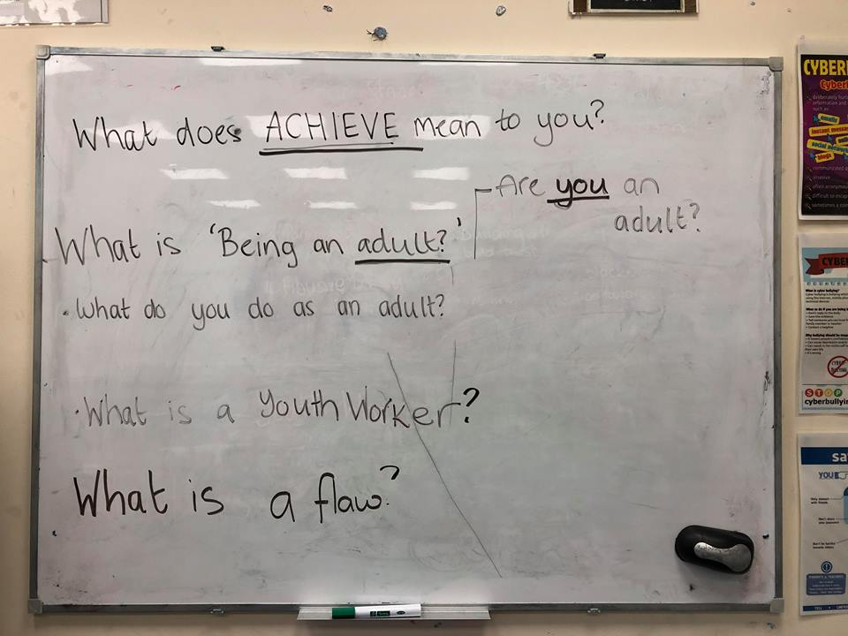

This is what the young people asked whilst the researcher introduced what the focus group was to be about.

Could the young person live on their own?

All young people suggested that they could live on their own. This was before having a discussion about what living on your own means.

This pie chart is showing the amount of young people who could live on their own after having a discussion about what living on your own includes.
One young person suggested that they ‘wouldn’t live on (their) own if they had the choice, but if (they) were forced to then (they) would force (themselves) to adapt’. (Young Person 10)

What is important for a young person when living on your own?
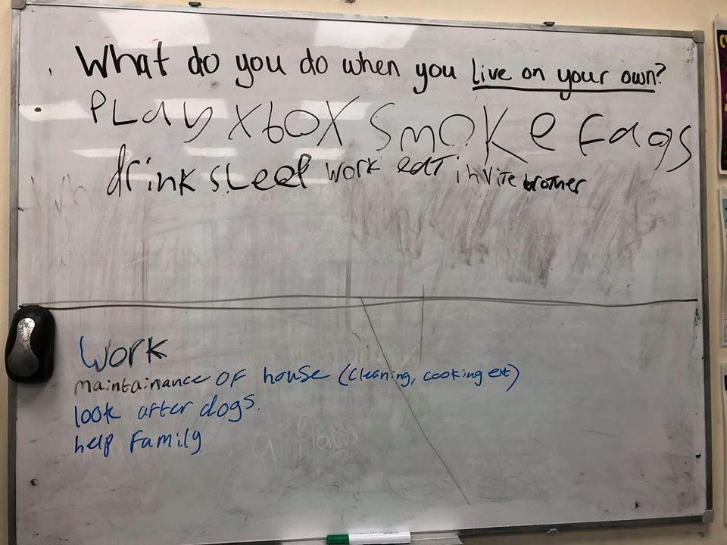
The researcher asked, ‘what do you do when you live on your own?’. This is what the young people originally wrote.
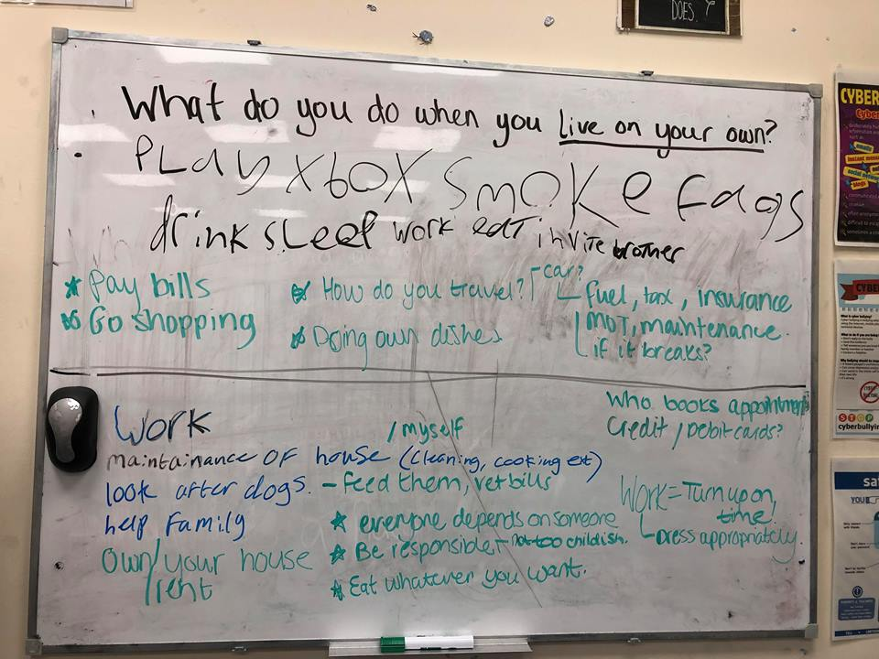
After discussing with the researcher, this is what the result of the discussion. Extra parts were ‘pay bills’, ‘own/rent own house’, who makes dentist and doctor appointments and ‘how do you travel?’. They also discussed about what an adult was and when you become one. Questions asked were, ‘how do you define an adult?’ ‘How quickly do you have to be one? ’and also ‘What day do you become an adult’? (Young Person 4 and 7)

Many young people suggested that they would not want to have full responsibility. One young person suggested that they ‘wouldn’t ‘’like’’ it, but if (they) had to, (they) wouldn’t mind’. Another young person suggested that being an adult is ‘too serious and they don’t have fun’. Whilst this young person was in conversation it was brought to attention that there is a ‘tough line between adult and young person’.
This brought up a theme of ‘what is the difference?’ Which resulted in the majority of young people saying ‘being able to being able to do what they want’.
One young person said that they like to think of themselves as an adult within the ‘mind’, knowing what is right and what is wrong, however, they did not know exactly the experience of what being an adult is like.

Education
Do young people enjoy the education system?
The data collected shows that the majority of the young people who were part of the focus group did not think that they enjoyed the education system. Young person one said, ‘I didn’t feel that I was learning any real skills and it was all just to help the school be successful’. Young person 2 said that ‘even though I enjoyed school I thought it was more fun to talk to people and go out after school than actually doing work because it was boring’.
Another young person suggested that the ‘current school system favours those that prefer a linear style of learning, but it is flawed towards people that favour practical work’.

This chart shows many aspects of what the young people were thinking
This graph is quite detailed. It is a representation of aspects that stand out for young people. Young people suggested that school was ‘fun’ however said it was ‘not important’. More than half of the young people thought that school was ‘stressful’.
Do young people enjoy the education system?
The data collected shows that the majority of the young people who were part of the focus group did not think that they enjoyed the education system. Young person one said, ‘I didn’t feel that I was learning any real skills and it was all just to help the school be successful’. Young person 2 said that ‘even though I enjoyed school I thought it was more fun to talk to people and go out after school than actually doing work because it was boring’.
Another young person suggested that the ‘current school system favours those that prefer a linear style of learning, but it is flawed towards people that favour practical work’.

Support the Young people get from a Youth Worker

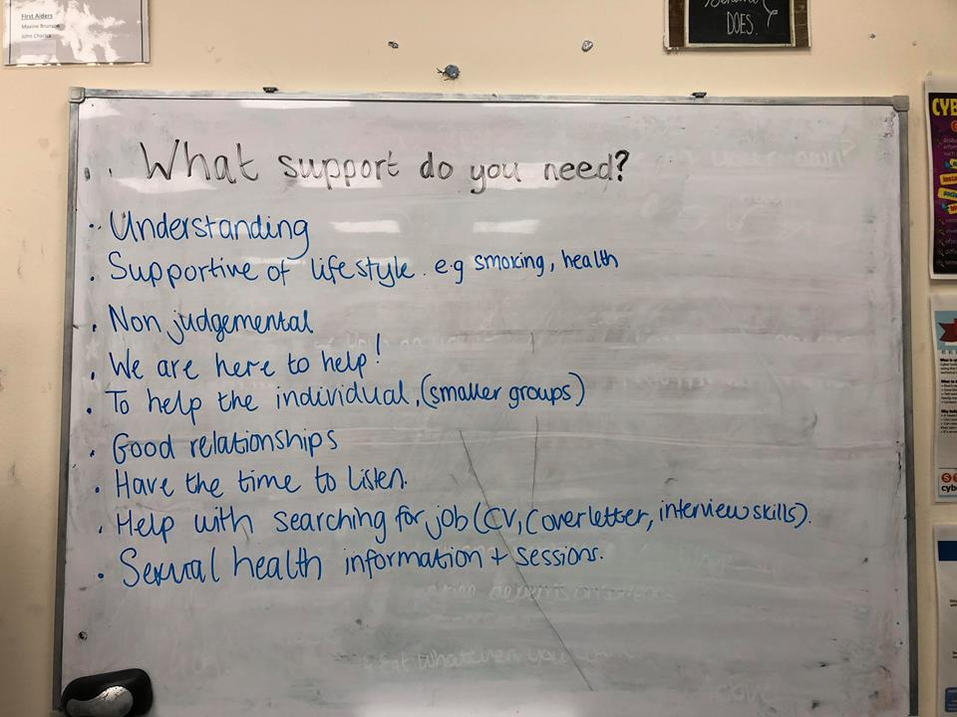
The next question for young people to be able to identify what they would need out of the support that they would get from a Youth Worker. This is what that discussion resulted in.

Results of Unstructured Interview
How do you perceive young people?
A few members of staff had similar answers, such as challenging, that some are difficult to work with depending on their background, but as they work with young people they are open to any young person who ‘walks through the door’.

There is a high success rate with the young people who achieve.

This shows that the majority of young people who receive support do not enjoy the education that they receive.
A lot of the members of staff stressed that the education system is flawed. They suggested that it was ‘old-fashioned’ and ‘out-dated’ to what the young people today need. The support they need is a lot more ‘complicated’ than it used to be ‘back in the day’. There are a lot more ‘rules and policies’ that have to be considered when working with a young person.

The members of staff stressed that only a few young people received support from youth workers, however they did think that there were a lot more young people who could probably do with the support, however there is not enough ‘resources’ to be able to handle all young people who have issues. Also, staff members stressed what requires a young person to be able to have a youth worker?

Here shows that the majority said ‘yes’. One member of staff said ‘no’ as it was difficult ot stay in contact with the Young Persons youth worker. This affects their work with their learner/young person which has a reflection on the ‘attitude’ of the young person.
The members of staff suggested that the importance of Youth Workers in on the rise. Youth Workers are needed more within organisations and they are becoming a ‘vital’ aspect within a team.
One member of staff said ‘Youth Workers are required and desired in companies such as the one I am working in. It allows for us to be able to do our jobs without feeling that weight of another person’s job on top of ours, however the government aren’t thinking about this issue’.

The majority of young people were proved to be happier when having access to a Youth Worker.
The next chapter will be a discussion, critical reflection and a conclusion of all the data that has been collected from the focus group and unstructured interview.

Chapter 5: Discussion, Critical Reflection and Conclusions
During this chapter the author will be able to answer the initial question asked, which is; how key Youth Work practices affect Young People and their transition into adulthood.
What the author has been able to discover is that this process will be ongoing. There will never be a specific answer to this question. As mentioned within the presentation of results it is clear that, ‘the support they need is a lot more ‘complicated’ than it used to be ‘back in the day’. There are a lot more ‘rules and policies’ that have to be considered when working with a young person’. This is showing that Youth Work is forever changing and there is no definition of how far a Youth Workers work can go. This was also mentioned within the literature review as;
‘‘A review of existing research concludes that the transition to adulthood is more difficult and complicated than in the past. There is no sharp distinction between childhood and adulthood: it is a complex mixture of continuing dependency on parents stretching into the twenties and beyond, and autonomy in specific areas from the early teenage years’ (JRF, 1996, p1).’’
It shows that young people struggle to achieve and be able to be successful and that they are lacking the motivation to be able to be a successful young person within their community. The young people had suggested that their ability to achieve was up to how they were brought up and what their backgrounds were. This is similar and is supported by Gibb and Edwards as they suggested that ‘homelessness or unstable housing, money worries, pregnancy, substance misuse, criminal activity, unhealthy relationships, mental health issues and threatened deportation. (Gibb, Edwards 2017, p14).
A lot of the young people had questions about what important aspects are such as what does ‘achieve’ mean? What do you do as an ‘adult?’ is the transition ‘easy’? A few of the young people, after discussing about the topic it became clear that a lot of the young people were confident enough to be able to look after themselves. As Young person 10 suggested within the focus group that they ‘wouldn’t live on (their) own if they had the choice, but if (they) were forced to then (they) would force (themselves) to adapt’. This is suggesting that young people are not able to live on their own, however in some situations they have to. This suggests to the researcher that when a young person has to live on their own that they must have extra support from a Youth Worker. As suggested by a member of staff they said that young people were demonstrating that they were happier when having access to a Youth Worker. This is supported by Jones-Mead as they suggest that Youth Work in Wales is capable to be able to give a sustainable and effective practice for Young People (Jones-Mead, 2016).
When asked by the researcher about what you do when you live on your own. Initial responses to this were relaxed answers such as ‘smoke fags’, ‘play Xbox’, ‘eat’ and ‘drink’. This evidence was important as this is what the young people thought of first. This is shown within Image 3. This young person is contradicting to what Gibb and Edwards suggests. They suggested that more young people wanted more ‘structure’ and were ‘bored with theis lifestyle’. (Gibb, Edwards 2017, p14).
However, After discussing with the researcher about what else could be added there was a large amount missing that the young people did not think about. This helped the young people realise how quickly they have to mature. A theme that emerged from this was ‘how do you define an adult?’ and also ‘What day do you become an adult’?
The young people became quite stressed about how difficult it sounded, however, some young people had the support from outside organisations such as CAHMS, Youth Workers and carers. These young people had seemed to demonstrate a more relaxed nature as it could be suggested that they felt that they had the support already in place for them. This is supported as by having a Youth Worker this ‘…provides or facilitates…places and relationships within which young people can enjoy themselves, feel secure, learn to take greater control of their lives and recognise and resist the damaging influences which may affect them’ (PYOG, 2016).
In consideration to how the young people feel about the education system runs and how they feel about themselves within the school system it is suggesting that a lot of young people enjoy the social aspect of school but do not enjoy the work. ‘Youth work provision is accessible to all young people in Wales and acts as an effective preventative service, supporting young people’s engagement and progression in education and training in preparation for employment and wider adult life’ (Welsh Government, 2018, p8). This suggests that youth work practices has an affect on how the young people live their everyday lives and that Youth Work engages within their progression to become better members of society.
This is also supported by the data that shows that young people believe that youth workers should be ‘understanding, ‘supportive of lifestyle’, have a ‘good relationship’, ‘help with searching for a job’, ‘sexual health’, etc. This is key findings for youth work. It demonstrates how much impact a Youth Worker can have on a young person and that they are positive aspects in their lives.
The staff had suggested that Youth work practice is a positive aspect to all types of work places. They had emphasised that young people have the ability to achive and that there are a lot more ‘rules and policies’ that have to be considered when working with a young person. Due to this their job becomes more difficult, however a member of staff said that ‘Youth Workers are required and desired in companies such as the one I am working in. It allows for us to be able to do our jobs without feeling that weight of another person’s job on top of ours, however the government aren’t thinking about this issue’.
This is showing that there is a lack of youth workers in workplaces. Meaning that if Youth Workers are desired, then youth workers are causing a positive impact for all types of people, and not just young people.
In conclusion, Youth Works policies and practice is able to impact all types of people. This can affect young people, adults, and others who have professional relationships with a Youth Worker. As previously mentioned, Youth Work is never ending, and is proving in today’s society to be a vital and desired by those who work with young people.
The next chapter will be considering the recommendations.

Chapter 6: Recommendations for practice
This chapter will be a summary of the main findings of this research project. The main findings within this research project were;
Young people appreciate and acknowledge that they can have the support when needed. They also understand that it can be quite difficult to be able to transition into adulthood all on their own. However, with the support from all types of organisations and a Youth Worker then the transition will be more successful than without.
To recommend further, it would be beneficial to have different focus groups and interviews within different organisations to be able to understand the differences within different organisations rather than just young people. Also, it may be useful to be able to read further into the education system and how this can affect the attitudes and motivations for young people.

Reference List
Checkoway, B. Richards-Schuster, K. (2003) Youth Participation in Community Evaluation Research. Sage Publications:London.
CWVYS, Youth Work in Wales, Principles and Purposes, (2018) Available at: http://www.cwvys.org.uk/wp-content/uploads/2018/11/YOUTH-WORK-IN-WALES-PRINCIPLES-AND-PURPOSES.pdf Accesson on:15/11/2018
CYWU, 2010, The Benefits of Youth Work, Available at: https://www.cywu.org.uk/assets/content_pages/187799973_Benefits_Of_Youth_Work.pdf Accessed on: 23/10/2018
Donaldson, G. (2015). Successful Futures. Independent Review of Curriculum and Assessment Arrangements in Wales. Cardiff. Welsh Government.
HM Government (2016) Keep on Caring, Supporting Young people from care to independence, Available at: https://assets.publishing.service.gov.uk/government/uploads/system/uploads/attachment_data/file/535899/Care-Leaver-Strategy.pdf Accessed on: 1/10/2018 Accessed on: 14/10/2018
HM Government, 2011, Positive for Youth, A new Approach to cross-government policy for young people aged 13-19. Available at: https://assets.publishing.service.gov.uk/government/uploads/system/uploads/attachment_data/file/175496/DFE-00133-2011.pdf Accessed on: 23/10/2018

Gibb, J, Edwards, A. The Princes Trust. (2017) From Care to Independence, Findings from research supported by The Big Lottery, conducted in partnership with The Prince’s Trust, Available at: https://www.princes-trust.org.uk/From-Care-to-Independence-Full-Final-Report.PDF,( Accessed on: 3/10/2018)
Jones-Mead, J. (2016) A sustainable future: youth work’s contribution to Welsh Government’s ‘Wellbeing of Future Generations’ policy and ‘Successful Futures’ review. Available at: http://www.youthworkwales.org.uk/wp-content/uploads/2017/11/a_sustainable_future_article.pdf (Accessed on: 11/11/2018)
Joseph Rowntree Foundation, 1996, Young people’s transition to adulthood, Available at:
https://www.jrf.org.uk/file/37634/download?token=hma4heNr&filetype=findings (Accessed on: 06/12/2018)
Joseph Rowntree Foundation, 1996, Young people’s transition to adulthood, Available at: https://www.jrf.org.uk/file/37634/download?token=hma4heNr&filetype=findings (Accessed on: 06/12/2018)
Lott, T, (2014) Adolescents need a rite of passage to ease them into adulthood, Available at: https://www.theguardian.com/lifeandstyle/2014/jan/03/adolescents-need-rites-passage-into-adulthood (Accessed on: 17/12/2018)
Matthews, B, D. Ross, L. (2010) Research Methods: A Practical Guide for the Social Sciences. Pearson Education Limited: England.
Nice, (No Date) Looked After Children Draft Guidance, Available at: https://www.nice.org.uk/guidance/ph28/documents/looked-after-children-draft-guidance2, Accessed on: 1/10/2018
Office for National Statistics, (2018), Young People not in Education, Employment or Training (NEET), UK, Available at: https://www.ons.gov.uk/employmentandlabourmarket/peoplenotinwork/unemployment/bulletins/youngpeoplenotineducationemploymentortrainingneet/november2018(Accessed on: 5/12/2018)
Punch, F, K. (2014) Introduction to Social Research Quantitative & Qualitative Approaches. 3rd Edition. Sage Publications: London
PYOG, Principal Youth Officers’ Group, (2016), Emotional Wellbeing and Mental Health of Young People in Wales – What contribution can youth work make? Available at: http://www.youthworkwales.org.uk/wp-content/uploads/2017/11/youth_work__emotional_wellbeing_of_young_people_in_wales_(eng).pdf (Accessed on: 22/11/2018)
Stein, (1997) Research Review, Available at: http://eprints.whiterose.ac.uk/4159/1/ResearchReview.pdf (Accessed on: 12/12/2018)

Unicef (1989) The United Nations Convention on the Rights of the Child. Unicef Welsh Government (2015) The Wellbeing of Future Generations (Wales) Act: The Essentials. Cardiff. Welsh Government (Accessed on: 11/11/2018)
Williamson, H. United Kingdom Youth Work Alliance, Youth Work and Government Policies towards young people, supporting Young People’s transitions into adult life. Available at: http://www.youthworkwales.org.uk/wp-content/uploads/2017/11/United-Kingdom-Youth-Work-Alliance---Supporting-Young-Peoples-transition-to-Adult-life-1998.pdf Accessed on: 12/11/2018
Young, S. (2018) Young people who move back in with their parents are more likely to experience depression, Available at: https://www.independent.co.uk/life-style/young-people-mental-health-depression-moving-back-home-parents-study-a8642431.html (Accessed on: 17/12/2018)

Appendices
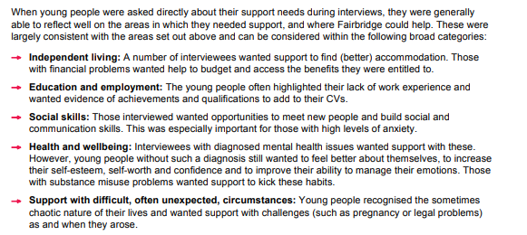
Image 1: (Gibb, J, Edwards, A. 2017, p15)


Image 2: (Gibb, J, Edwards, A. 2017, p17).
‘For the first time, the Department for Children, Schools and Families presented data on the emotional and behavioural health of looked-after children and young people, finding that about 60% of those looked after in England were reported to have emotional and mental health problems.
It also reported that a high proportion of looked-after children and young people experience poor health, educational and social outcomes after leaving care (Department for Children, Schools and Families 2009c).
Consultation with looked-after children and young people indicates that they have clear expectations for their care and wellbeing (Children’s Rights Director for England 2007) They expect to take part in decisions that affect their lives, be kept healthy and safe, be treated with respect, and be treated equally to other children and young people. However, local variations in service access and support can mean that these expectations are not always met.’ (Nice, No Date, p6)

‘Leaving care services can also assist young people successfully with life skills, and there is evidence from Scottish research of a significant association between preparation before leaving care and ‘coping’ after care (Dixon & Stein 2005). Leaving care services can also help young people to some extent in furthering social networks, developing relationships and building self-esteem, although these dimensions are also closely connected with young people having positive, supportive informal relationships with family members or friends, or former foster carers (Biehal et al. 1995; Marsh & Peel 1999).

Research has shown that young people who go on to higher education are more likely to have had stable care experiences, continuity in their schooling, which may compensate for placement movement, have been encouraged by their birth parents, even though they were unable to care for them, and have been greatly assisted by their foster carers in their schooling (Jackson et al. 2003; Ajayi & Quigley 2006)’ (Stein, 1997, p5).

APPLICATION FOR ETHICAL APPROVAL

In order for research to result in benefit and minimise risk of harm, it must be conducted ethically. A researcher may not be covered by the University’s insurance if ethical approval has not been obtained prior to commencement.

The University follows the OECD Frascati manual definition of research activity: “creative work undertaken on a systematic basis in order to increase the stock of knowledge, including knowledge of man, culture and society, and the use of this stock of knowledge to devise new applications”. As such this covers activities undertaken by members of staff, postgraduate research students, and both taught postgraduate and undergraduate students working on dissertations/projects.

The individual undertaking the research activity is known as the “principal researcher”.

Ethical approval is not required for routine audits, performance reviews, quality assurance studies, testing within normal educational requirements, and literary or artistic criticism.

Please read the notes for guidance before completing ALL sections of the form.

This form must be completed and approved prior to undertaking any research activity. Please see Checklist for details of process for different categories of application.

SECTION A: About You (Principal Researcher)

Full Name: |  |  | Kelsey Amber Dutton
Tick all boxes which apply:
Member of staff: | ☐ | Student: |  | ☒ | Honorary research fellow: | ☐

Faculty/School/Centre: | University of Wales Trinity Saint David
Campus: | Carmarthen
E-mail address: | 1601185@student.uwtsd.ac.uk
Contact Telephone Number: | 07908915572
For students:
Student Number: | 1601185 | Undergraduate | ☒
Programme of Study: | Youth and Community Work | Taught Postgraduate | ☐
Director of Studies/Supervisor: | Angharad Lewis | Research | ☐

SECTION B: Approval for Research Activity

Has the research activity received approval in principle?  (please check the Guidance Notes as to the appropriate approval process for different levels of research by different categories of individual) |  | YES | ☒ | NO | ☐
 |  |  |  | Date
If Yes, please indicate source of approval (and date where known): | Research Degrees Committee |  | ☐
 | Faculty Research Committee |  | ☐
 | Other (write in)  Supervisor: Angharad Lewis |  | ☐ | 25/10/18
Approval in principle must be obtained from the relevant source prior to seeking ethical approval.

SECTION C: External Ethical Guidance Materials

Please list the core ethical guidance documents that have been referred to during the completion of this form (including any discipline-specific codes of research ethics, and also any specific ethical guidance relating to the proposed methodology). Please tick to confirm that your research proposal adheres to these codes and guidelines.
British Educational Research Association (BERA) guidelines | ☒
Code of Occupational Ethics for the Youth Service in Wales | ☒
Community Based Participatory Research : A Guide to Ethical principles and practices: University of Durham. | ☒

SECTION D: External Collaborative Research Activity

Does the research activity involve collaborators outside of the University? |  | YES | ☐ | NO | ☒
If Yes, please provide the name of the external organisation and name and contact details for the main contact person:
Institution
Contact person name
Contact person e-mail address

Where research activity is carried out in collaboration with an external organisation
Does this organisation have its own ethics approval system? | YES | ☐ | NO | ☐
If Yes, please attach a copy of any final approval (or interim approval) from the organisation

SECTION E: Details of Research Activity

Indicative title: | How key Youth Work practices affect Young People and their transition into adulthood.
Proposed start date: | 12th November 2018 | Proposed end date: | 1st January 2019
Purpose of research activity (including aims and objectives)
Outline the purpose, aims and objectives of the research activity, including key research questions. Show briefly how existing research has informed the proposed activity and explain what the research activity will add and how it addresses an area of importance. (Maximum 300 words)
The purpose and aim of this study will be to research how the key Youth Work Practices could or do affect the development young people in Carmarthen. This is in relation to their transitioning into adulthood. During my time last year within my placement, more young people who attended my placement and through group discussions and through conversation it is easy to identify which young people are struggling in their transitioning. Some young people can easily embrace change and others cannot. I have identified that they are hungry, more tired, however, more outgoing. They lack support with basic necessities such as support with their independent living, education and employment, social skills, health and wellbeing and support with difficult circumstances.
Questions that will be asked are do young people have access or have a youth workers support, and are they offered support when they transition? Also, I will be asking the young people about their day to day lives to then be able to examine the data. It is also important to be able to know whether we can support young people to be positive members of society and that they can do good for their communities.
(this box should expand as you type)
Proposed methods
Provide a brief summary of all the methods that may be used in the research activity, making it clear what specific techniques may be used. If methods other than those listed in this section are deemed appropriate later, additional ethical approval for those methods will be needed. (Maximum 600 words)
A method that I have decided to choose qualitative, and this is focus groups. This is similar to group interviewing.‘Group interviewing is a general term, where the researcher works with several people simultaneously, rather than just one’. (Punch, F, K, 2014, p146). This is important as it allows for group discussion to allow the young people to be able to be in charge of what they would like to talk about instead of me asking questions. We can do sessions that are more interactive to be able to make it feel as natural as possible.
Also, I will be doing interviews with members of staff. Reasons that I have chosen to do this is due to the amount of depth it offers through discussion. This way, it can show that the ‘participant’ is ‘substantially in control of the interview’ and is ‘enabled by the researched to tell their own story, in their own way’ (Punch, F, K, 2014, p220).
I will also be researching online and within books as this will allow me to get my quantitative research.

(this box should expand as you type)

Location of research activity
Identify all locations where research activity will take place.
Carmarthen

(this box should expand as you type)
Research activity outside of the UK
If research activity will take place overseas, you are responsible for ensuring that local ethical considerations are complied with and that the relevant permissions are sought. Specify any local guidelines (e.g. from local professional associations/learned societies/universities) that exist and whether these involve any ethical stipulations beyond those usual in the UK (provide details of any licenses or permissions required). Also specify whether there are any specific ethical issues raised by the local context in which the research activity is taking place, for example, particular cultural sensitivities or vulnerabilities of participants.
None
(this box should expand as you type)

SECTION F: Scope of Research Activity

Will the research activity include: | YES | NO
Use of a questionnaire or similar research instrument? | ☐ | ☒
Use of interviews? (With members of staff) | ☒ | ☐
Use of diaries? | ☐ | ☒
Participant observation with their knowledge? | ☒ | ☐
Participant observation without their knowledge? | ☐ | ☒
Use of video or audio recording? | ☐ | ☒
Access to personal or confidential information without the participants’ specific consent? |  | ☒
Administration of any questions, test stimuli, presentation that may be experienced as physically, mentally or emotionally harmful / offensive? | ☐ | ☒
Performance of any acts which may cause embarrassment or affect self-esteem? | ☐ | ☒
Investigation of participants involved in illegal activities? | ☐ | ☒
Use of procedures that involve deception? | ☐ | ☒
Administration of any substance, agent or placebo? | ☐ | ☒
Working with live vertebrate animals? | ☐ | ☒
Other primary data collection methods, please explain in this box  Focus Groups. | ☒ | ☒

If NO to every question, then the research activity is (ethically) low risk and may be exempt from some of the following sections (please refer to Guidance Notes).

If YES to any question, then no research activity should be undertaken until full ethical approval has been obtained.

SECTION G: Intended Participants

Who are the intended participants: | YES | NO
Students or staff at the University? | ☐ | ☒
Adults (over the age of 18 and competent to give consent)? | ☒ | ☐
Vulnerable adults? | ☐ | ☒
Children under 18? | ☒ | ☐
Prisoners? | ☐ | ☒
Young offenders? | ☐ | ☒
Those who could be considered to have a particularly dependent relationship with the investigator or a gatekeeper? | ☐ | ☒
People engaged in illegal activities? | ☐ | ☒
Others (please identify): | ☐ | ☒

Participant numbers and source
Provide an estimate of the expected number of participants. How will you identify participants and how will they be recruited?
Recruited within Placement. Under 10 participants.

this box should expand as you type)

Information for participants: | YES | NO | N/A
Will you describe the main research procedures to participants in advance, so that they are informed about what to expect? | ☒ | ☐ | ☐
Will you tell participants that their participation is voluntary? | ☒ | ☐ | ☐
Will you obtain written consent for participation? | ☒ | ☐ | ☐
Will you explain to participants that refusal to participate in the research will not affect their treatment or education (if relevant)? | ☐ | ☐ | ☒
If the research is observational, will you ask participants for their consent to being observed? | ☒ | ☐ | ☐
Will you tell participants that they may withdraw from the research at any time and for any reason? | ☒ | ☐ | ☐
With questionnaires, will you give participants the option of omitting questions they do not want to answer? | ☐ | ☐ | ☒
Will you tell participants that their data will be treated with full confidentiality and that, if published, it will not be identifiable as theirs? | ☒ | ☐ | ☐
Will you debrief participants at the end of their participation, in a way appropriate to the type of research undertaken? | ☒ | ☐ | ☐
If NO to any of above questions, please give an explanation
(this box should expand as you type)

Information for participants: | YES | NO | N/A
Will participants be paid? | ☐ | ☒ | ☐
Is specialist electrical or other equipment to be used with participants? | ☐ | ☒ | ☐
Are there any financial or other interests to the investigator or University arising from this study? | ☐ | ☒ | ☐
Will the research activity involve deliberately misleading participants in any way, or the partial or full concealment of the specific study aims? | ☐ | ☒ | ☐
If YES to any question, please provide full details
(this box should expand as you type)

SECTION H: Anticipated Risks

Outline any anticipated risks that may adversely affect any of the participants, the researchers and/or the University, and the steps that will be taken to address them.

If you have completed a full risk assessment (for example as required by a laboratory, or external research collaborator) you may append that to this form.
Yes ☐
No ☒

Risks to participants
For example: emotional distress, financial disclosure, physical harm, transfer of personal data, sensitive organisational information
There may be risks of having information from a young person being told to myself. This could involve the young person being in harm’s way, causing others harm, or being involved in a crime, if this were to happen then I will have to know the procedures to be able to solve the problem. If a risk were to occur, this would be considered a severe safeguarding issue, then the line manager, safeguarding officer and manager will be informed immediately.
There could be emotional distress. The young people have come from more difficult backgrounds. Some young people could have had difficult pasts, unsecure homes, etc. I will need to put in place a procedure to allow them to know that they can leave sessions if they are upset. I will check they are okay or another member of staff will do so. I will refer to Iechyd da if required. Iechyd da is situated in Pibwrlwyd College. A nurse comes into my placement to talk to Young People about any issues and if they are referred, they have weekly sessions with her.
I will keep my notes safe by ensuring that laptops and computers have secure passwords. I will also keep all of my information in the office if I were to take my laptop into placement. This is vital as young people cannot enter the office without staff’s authorization.

(this box should expand as you type)
If research activity may include sensitive, embarrassing or upsetting topics (e.g. sexual activity, drug use) or issues likely to disclose information requiring further action (e.g. criminal activity), give details of the procedures to deal with these issues, including any support/advice (e.g. helpline numbers) to be offered to participants. Note that where applicable, consent procedures should make it clear that if something potentially or actually illegal is discovered in the course of a project, it may need to be disclosed to the proper authorities
There is an opportunity to access a safeguarding officer within this research project. I would contact her if there were any concerns with the young person/people.
Also, at the end of every session I will be doing a reflection, and time to be able to let the young people debrief what they have learned, and it is also a time for the young people to be able to talk to myself or other members of staff about any issues that they have. There are many policies in place for every kind of situation within the office.
If any problems were to arise then I will be quick to respond. It is about having all information at hand and being able to be efficient for the young person and people involved.

(this box should expand as you type)
Risks to investigator
For example: personal safety, physical harm, emotional distress, risk of accusation of harm/impropriety, conflict of interest
I think that the only risks that I will encounter will be mentally/emotionally hard. I think it may be tough to be able to understand what the young people have gone through and how their lives have been affected by others, and actions by themselves. If this happens, I will discuss the situation in supervision or with a member of staff. During this time I will be with the young people as a group or one to one.

(this box should expand as you type)
University/institutional risks
For example: adverse publicity, financial loss, data protection
I will keep my work safe by ensuring that laptops and computers have passwords. I will also keep all of my information in the office if I were to take my laptop into placement. This is vital as young people cannot enter the office without staff’s authorization.

(this box should expand as you type)
Adverse outcomes
List measures put in place to limit any adverse effects or outcomes of research activity where appropriate. Include any emergency protocols.
Keep young people and staff informed about the research process.
Gain consent to carry out the research. (For young people under age of 18 need consent within Placement).
Prepare research material in advance
Adhere to data protection policy.
Ensure that I know all Policies that are in place.
Ensure members of staff know if any activities are going to be done for the research process. Also include any risk assessments if I have done them.
Inform Safeguarding Officer and Manager if any issues were to happen.

(this box should expand as you type)

Disclosure and Barring Service
If the research activity involves children or vulnerable adults, a Disclosure and Barring Service (DBS) certificate must be obtained before any contact with such participants. | YES | NO | N/A
Has a DBS certificate been obtained? | ☒ | ☐ | ☐

SECTION I: Feedback, Consent and Confidentiality

Feedback
What feedback will be provided to participants, how will this be done and when?
There will be no feedback.

(this box should expand as you type)
Informed consent
Describe the arrangements to inform potential participants, before providing consent, of what is involved in participating. Describe the arrangements for participants to provide full consent before data collection begins. If gaining consent in this way is inappropriate, explain how consent will be obtained and recorded.
Consent will be obtained and recorded by using a contract. I will go through the contract with the young people so that they understand what I will be doing with them. I think that this Is important as they are able to participate themselves and have their decisions.

(this box should expand as you type)
Confidentiality / Anonymity
Set out how anonymity of participants and confidentiality will be ensured in any outputs. If anonymity is not being offered, explain why this is the case.
I will be anonymizing everyone within this research, it is important that their information is safe as the young people are with other organizations that require for their information to be safe.

(this box should expand as you type)

SECTION J: Data Protection and Storage

In completing this section refer to the University’s Research Data Management Policy and the extensive resources on the University’s Research Data Management web pages (http://uwtsd.ac.uk/library/research-data-management/).
 | YES | NO
Does the research activity involve personal data (as defined by the Data Protection Act)?  “personal data” means data which relate to a living individual who can be identified—  (a) from those data, or  (b) from those data and other information which is in the possession of, or is likely to come into the possession of, the data controller, and includes any expression of opinion about the individual and any indication of the intentions of the data controller or any other person in respect of the individual. | ☐ | ☒
If YES, provide a description of the data and explain why this data needs to be collected:
(this box should expand as you type)
Does it involve sensitive personal data (as defined by the Data Protection Act)?  “Sensitive personal data” means personal data consisting of information as to –  (a) the racial or ethnic origin of the data subject,  (b) his political opinions,  (c ) his religious beliefs or other beliefs of a similar nature,  (d) whether he is a member of a trade union (within the meaning of the Trade Union and Labour Relations (Consolidation) Act 1992),  (e) his physical or mental health or condition,  (f) his sexual life,  (g) the commission or alleged commission by him of any offence, or  (h) any proceedings for any offence committed or alleged to have been committed by him, the disposal of such proceedings or the sentence of any court in such proceedings. | ☐ | ☒
If YES, provide a description of the data and explain why this data needs to be collected:
(this box should expand as you type)

Will the research activity involve storing personal data on one of the following: | YES | NO
Manual files (i.e. in paper form)? | ☒ | ☐
University computers? | ☐ | ☒
Private company computers? | ☐ | ☒
Home or other personal computers? | ☒ | ☐
Laptop computers/ CDs/ Portable disk-drives/ memory sticks? | ☐ | ☒
“Cloud” storage or websites? | ☒ | ☐
Other – specify: | ☐ | ☒
For all stored data, explain the measures in place to ensure data confidentiality, including details of password protection, encryption and anonymisation:
Data will be highly secured with passwords. Personal laptop will be stored in placement office if my laptop is needed for placement that day. Door to office requires PIN.
Personal laptop has a password.
Manual Files will always be in office or within personal space.

(this box should expand as you type)

Will the research activity involve any of the following activities: | YES | NO
Electronic transfer of data in any form? | ☐ | ☒
Sharing of data with others at the University? | ☐ | ☒
Sharing of data with other organisations? | ☐ | ☒
Export of data outside the European Union or importing of data from outside the UK? | ☐ | ☒
Use of personal addresses, postcodes, faxes, emails or telephone numbers? | ☐ | ☒
Publication of data that might allow identification of individuals? | ☐ | ☒
Use of data management system? | ☐ | ☒
Data archiving? | ☐ | ☒
If YES to any question, please provide full details, explaining how this will be conducted in accordance with the Data Protection Act (and/or any international equivalent):
Only analysed data will be shared with the university
Research will be shared between myself and lecturers for help. This could be shared with the university.

(this box should expand as you type)

List all who will have access to the data generated by the research activity:
University

(this box should expand as you type)
List who will have control of, and act as custodian(s) for, data generated by the research activity:
University of Wales Trinity Saint David.

(this box should expand as you type)
Give details of data storage arrangements, including where data will be stored, how long for, and in what form. Will data be archived – if so how and if not why not.
My data will be in my personal home where no one will have access.

(this box should expand as you type)

SECTION K: Declaration

The information which I have provided is correct and complete to the best of my knowledge. I have attempted to identify any risks and issues related to the research activity and acknowledge my obligations and the rights of the participants.

In submitting this application I hereby confirm that I undertake to ensure that the above named research activity will meet the University’s Research Ethics and Integrity Code of Practice
Signature of applicant: | K.A.Dutton | Date: | 24/10/2018

For students:
Director of Studies/Supervisor: | Angharad Lewis
Signature: | 
Date: | 15.12.18

For staff:
Head of School/Assistant Dean:
Signature:
Date:

Checklist: Please complete the checklist below to ensure that you have completed the form according to the guidelines and attached any required documentation:
☒ | I have read the guidance notes supplied before completing the form.
☒ | I have completed ALL RELEVANT sections of the form in full.
☒ | I confirm that the research activity has received approval in principle
☒ | I have attached a copy of final/interim approval from external organisation (where appropriate)
☒ | I have attached a full risk assessment (and have NOT completed Section H of this form) (where appropriate)
☒ | I understand that it is my responsibility to ensure that the above named research activity will meet the University’s Research Ethics and Integrity Code of Practice.
☒ | I understand that before commencing data collection all documents aimed at respondents (including information sheets, consent forms, questionnaires, interview schedules etc.) must be confirmed by the DoS/Supervisor, module tutor or Head of School.

RESEARCH STUDENTS AND STAFF ONLY
All communications relating to this application during its processing must be in writing and emailed to pgresearch@uwtsd.ac.uk , with the title ‘Ethical Approval’ followed by your name.
You will be informed of the outcome of your claim by email; therefore it is important that you check your University and personal email accounts regularly.

STUDENTS ON UNDERGRADUATE OR TAUGHT MASTERS PROGRAMMES should submit this form (and receive the outcome) via systems explained to you by the supervisor/module leader.

This form is available electronically from the Academic Office web pages: http://www.uwtsd.ac.uk/academic-office/

Application Process

All staff research projects and all research students must submit the Ethical Approval Form to the University Ethics Committee via the Academic Office (pgresearch@uwtsd.ac.uk). Staff research directly in relation to personal study for taught undergraduate or Masters programmes should be submitted via the Faculty procedures explained below.

Taught masters and taught undergraduate research Ethical Approval Forms are considered within Faculties. Faculties will provide details of the specific processes for this. Where the Ethical issues within any single ethical application are of particular concern the Faculty will refer these to the University Ethics Committee. Any student activity that involves the collection of primary data needs to undergo Ethical approval, this includes assignment work as well as dissertations.

Notes for guidance in completion of this form

Section A: About You
Please complete all relevant sections

Section B: Approval for research activity
Research proposals must be approved in principle before applying for Ethical Approval. The proposal approval only becomes final when the ethical approval is received.

The process for proposal approval varies according the individual and programme of study:
- Research students, by application on form PG1 to the Research Degrees Committee
- Taught students by review of research proposal within Faculties (Faculties provide specific details of these processes)
- Staff, by agreement by the Head of School/Assistant Dean

Section C: External Ethical Guidance materials
Many discipline areas are required to operate with the discipline specific codes of research ethics (for example health, psychology, education etc.), any such codes must be listed and you must tick to confirm that you have consulted with these.

Section D: External Collaborative Research Activity
Provide details of the external collaborative partners, where appropriate you might want to submit a copy of the external collaboration agreement with the Ethical Approval Form. If the partner requires the research to be subject to its own internal Ethical approval process then please provide details of that process and a copy of any final (or interim) approvals received from the organisation.

Section E: Details of Research Activity
Remember that the individuals reviewing this Ethical Approval Form may not have seen your research proposal, and also may not be experts in the specific area of your research. The information provided should therefore be jargon free and clearly stated.
Indicative Title: please use the same title as used on the research proposal.
Purpose: the Ethical approval process will want to ensure that the methods you propose are adequate and appropriate to address the research aims and objectives. Excessive additional data collection can be seen as unethical.
Proposed Methods: the Ethical approval process seeks to ensure that you understand the methods that are intended, and that the implementation of those methods will be appropriate and without unnecessary impact on respondents. Please be specific.
Location: this needs to mention geographical location and also local situation (for example, within Local Authority Offices in Cardiff, using a private room but close to other individuals). If you are collecting data within an organisational setting then you need to explain the permissions that you have obtained to do this.
Research Activity outside of the UK: please complete this section in detail, and note any guidance you have received. Also describe your own familiarity (or not) with the location that you will be utilising.

Section F: Scope of Research Activity
Please tick ALL of the research activities that might be undertaken. If any additional types of activity are intended then please add an extra box and describe these.
If you have answered no to all questions in F then sections G and J do not need to be completed. Section H should be considered, and may be completed. Signatures are still required in section K.

Section G: Intended Participants
Please tick all categories that might apply.
Numbers & Source: if you are using a series of different methods or research activities please list numbers for each stage/phase. Be clear about how you will find respondents. Will you use intermediaries, and if so how? How will you ensure compliance with your sampling strategy?
Information for participants: all participants should be appropriately informed about the research, what is expected of them and what will happen to the information that they provide. The Ethical review process does not ask to see this documentation, but requires this to be reviewed and approved by the Director of Studies in the case of research students, the supervisor/module tutor in relation to students on taught programmes and the Head of School/Assistant Dean in relation to staff research.

Section H: Anticipate Risks
All research carries some level of risk. The answers you provide to questions in this section will be reviewed to ensure that you have an appropriate understanding of the type of risks involved and how you can mitigate against these risks. If you have completed a full risk assessment, as required for example for laboratory work, field work, clinical tests, diving operations, or by a collaborative partner, you may append that to this form. In that case, please tick the box indicating this has been provided. You will not then be required to complete Section H.
Risk to participants Think very carefully about how your actions/questions/discussions might affect the people you are involving as participants. You might identify the risk as small but it would still be a risk. Many types of question have the potential to make respondents less content with their life / job; you need to recognise and try to ameliorate any such effects
If these are business owners, time with you may reduce profit.
In some locations physical risk is very real to both participants and yourself, please consider this.
Risk to you, the researcher Think about where you will meet people, if there are any dangers involved in the location. If you are meeting people as individuals think about using a public place. In general do not visit people in their own homes or remote locations. If you are talking to individuals about certain issues think about how their responses might affect you emotionally. What about the risk of collecting insufficient data?
Risk to the University When undertaking your research, you are acting as a member of the University (student or staff). Professionalism is important, so it is important to be well organised and well prepared. Punctuality, clarity etc. are all part of this. What will you do to ensure this? You must ensure you do not harm the good name of the University in any way and do nothing to undermine the reputation of the research it conducts and sponsors. Upholding high standards of conduct and integrity are vital in this regard. You must also conduct the research in such a way to minimise the potential for claims of negligence made against the University, its researchers and any collaborating individual or organisation. In this respect you should always comply with ethical, legal and professional frameworks, obligations and standards as required by statutory and regulatory authorities, as well as the university’s Research Integrity and Ethics Code of Practice. Research misconduct in this respect can take many forms, including:
- fabrication: making up results or other outputs (eg, artefacts) and presenting them as if they were real
- falsification: manipulating research processes or changing or omitting data without good cause
- plagiarism: using other people’s material without giving proper credit
- failure to meet ethical, legal and professional obligations: for example failure to declare competing interests; misrepresentation of involvement or authorship; misrepresentation of interests; breach of confidentiality; lack of informed consent; misuse of personal data; and abuse of research subjects or material
- improper dealing with allegations of misconduct: failing to address possible infringements such as attempts to cover up misconduct and reprisals against whistle-blowers

Adverse Outcomes. Think carefully about the possibilities, and cover here

Section I: Feedback, Consent and Confidentiality
Feedback to participants: outline your approach. Will interview transcripts be shared with respondents to check accuracy? Will summaries of questionnaire analysis be made available to respondents in some way? Will an overview report be provided? How and when?
Informed consent: Draft letter / e-mail / or heading (or footer) section of questionnaire must be approved by DoS/supervisor (if research student), supervisor/module tutor if taught student, or Head of School / Assistant Dean if a member of staff.
Confidentiality/Anonymity. Explain clearly how you will ensure confidentiality and anonymity.

Section J: Data Protection and Storage
Before completing this section it is necessary to read the University’s Research Data Management information. The questions that follow are designed to ensure compliance with the Data Protection Act as well as established research protocols.

Many research activities will involve electronic transfer of data and use of data management systems in the summarisation and analysis of data. You will need to explain these in relation to compliance with the Data Protection Act.
Think carefully about who will have access to your data, this will include supervisors and examiners. Also that a thesis will be made available via the University library and the British Library system. If you are seeking an access bar for a period of time after completion then mention it here. If you will provide a copy of your findings, or intend to give a presentation, to a facilitating/ supporting/accessing organisation then explain that in this section. But also think about the general principle of data sharing, as explained in the Research Data Management information.
In terms of storage of data please ensure security, and also mitigate against loss of data.

Section K: Declaration
Ensure the appropriate countersignatures have been provided
Look carefully at the checklist and ensure that you comply with and tick all that are relevant to your research.

Focus Group Questions
I would like to find out a little more about you.
- Can you think of a time you felt proud of something you have achieved at the project?
- List some of the things/people that have helped you during your time at the project
- Do you enjoy the education system? If ‘yes’, why? If ‘no’, why?
- Do you think you could be able to live on your own? If ‘yes’, why? If ‘no’, why?
- “how do you feel about the responsibility that comes with living independently, such as daily chores etc?” “Do you feel prepared for these responsibilities?”
- Can you describe what do you think ‘being an adult’ is?
- Do you consider yourself an adult already?
I would like to find out about any support you may be receiving.
Do you get support from Youth Workers? Are you receiving support from anyone else?

- Do you find the support from the Youth Worker helpful? Do you think that it helps you with your everyday issues and concerns?
- With what you know do you think Youth Workers should be within all education services? Such as; Schools, Training centres, Job Centres, etc.
- Is the support successful?
- What could change? What is good about a Youth Worker? What do they help you or others do?
Change in yourself?
- Do you see change in yourself since being supported by a Youth Worker? Can you explain further?
- What impact has this had on you ?
- Is there always support from the youth worker for you?

Unstructured Interview
How key Youth Work practices affect Young People and their transition into adulthood.
How do you perceive young people?
- What do young people do here?
- Do you think young people here achieve? How are they supported?
- What do you think the young people think about in regards to their education?
- Do you think it is flawed? If so, why?
Do young people get support from Youth Workers?
- Has this company had any support from the Youth Worker? Do you feel it helps your role in your place of work?
- What kind of support has been given?
- Should Youth Work be within all education services. (Schools, Training centres, Job Centres, etc)
- With what the Youth Worker has done, do you think it is successful? If so, why?
- What could change? What is good about Youth Work Practice?
Change the Young People
- What change do you see in the young people who have been with a Youth Worker?
- Do you think they have they had a positive impact on the young person?
- Do you think that there is there always support from the youth worker for the young person?


Rhif Adnabod Cyfranogwr:
Participant Identification Number:
FFURFLEN GANIATÂD CYFRANOGIAD | PARTICIPATION CONSENT FORM
Teitl Y Prosiect: / Project Title: How key Youth Work practices affect Young People and their transition into adulthood.
Enw'r Ymchwilydd / Name of Researcher: Kelsey Dutton

Rhowch Llythrennau cyntaf eich enw yn y blwch / Please initial box
1 | Cadarnhaf fy mod wedi darllen a deall y daflen wybodaeth dyddiedig ar gyfer yr astudiaeth uchod. Rwyf wedi cael y cyfle i ystyried y wybodaeth, gofyn cwestiynau, ac rwyf wedi cael ateb boddhaol i’r rhain. |  | I confirm that I have read and understand the information sheet dated for the above study. I have had the opportunity to consider the information, ask questions and have had these answered satisfactorily.
2 | Deallaf fy mod yn cymryd rhan o’m gwirfodd a bod croeso i mi dynnu’n ôl ar unrhyw adeg, heb roi rheswm. |  | I understand that my participation is voluntary and that I am free to withdraw at any time, without giving any reason.
3 | Deallaf y gellir defnyddio unrhyw wybodaeth a roddir gennyf mewn adroddiadau, erthyglau neu gyflwyniadau gan y tîm ymchwil. |  | I understand that any information given by me may be used in future reports, articles or presentations by the research team.
4 | Deallaf na fydd fy enw’n ymddangos mewn unrhyw adroddiadau, erthyglau neu gyflwyniadau. |  | I understand that my name will not appear in any reports, articles or presentations.
5 | Cytunaf i gymryd rhan yn yr astudiaeth  uchod. |  | I agree to take part in the above study.
Enw’r Cyfranogwr Name of Participant |  |  |  | Llofnodwyd  Signature
Enw’r Rhiant/Gwarcheidwad (os yn berthnasol)  Name of Parent/Guardian (if relevant) |  |  |  | Llofnodwyd  Signature
Ymchwilydd  Researcher |  |  |  | Llofnodwyd  Signature

Cewch wrthod cymryd rhan yn yr astudiaeth hon. Cewch ddod â’ch cyfranogiad yn yr astudiaeth hon i ben unrhyw bryd. Os penderfynwch barhau’n ddienw, bydd sicrhau hynny’n flaenoriaeth a chymerir pob cam ymarferol i guddio pwy ydych. Os yw’n well gennych fod yn anhysbys, ni fydd unrhyw wybodaeth yn eich enwi ar dapiau sain na thrawsgrifiadau o’r cyfweliad hwn nac o unrhyw un arall. Ni fydd neb yn clywed unrhyw dapiau sain nac yn gweld unrhyw drawsgrifiadau heb eich cydsyniad o flaen llaw. Bydd deunyddiau a grëir yn sgil y cyfweliad hwn neu unrhyw gyfweliad arall yn aros yn gyfrinachol. | You may decline to participate in this study. You may end your participation in this study at any time. If you decide to remain anonymous, maintaining your anonymity will be a priority and every practical precaution will be taken to disguise your identity. If you prefer anonymity, there will not be any identifying information on audiotapes or transcripts of this or any interview. No-one will hear any audiotapes or see any transcripts without your prior consent. All materials generated from this or any interview will remain confidential.

Ar ôl llenwi’r ffurflen, dychwelwch hi yn yr amlen a ddarperir (lle bo’n berthnasol). Rhoddir un copi i’r cyfranogwr a chedwir y gwreiddiol yn ffeil y tîm ymchwilio yn: | When completed please return in the envelope provided (if applicable). One copy will be given to the participant and the original to be kept on the file of the research team at:
ENW A CHYFEIRIAD YR YMCHWILYDD | NAME & ADDRESS OF RESEARCHER  Kelsey Dutton  University of Wales Trinity Saint David  Carmarthen  SA31 3EP



Rhif Adnabod Cyfranogwr:
Participant Identification Number:
FFURFLEN GANIATÂD CYFRANOGIAD | SAMPLE PARTICIPANT INFORMATION SHEET
Teitl Y Prosiect: / Project Title: How key Youth Work practices affect Young People and their transition into adulthood.

Dear Participant:

My name is Kelsey and I am studying at The University of Wales Trinity Saint David.
I would like to invite you to participate in my research project. The overall aim is to study Young People and how Youth Work can impact their transitioning into Adulthood. This includes their development, health, housing, support and support in the world of work. It is about researching if there are enough resources for Young People out there in the UK that they can access. By asking these questions it aims to provide the researcher with the information to be able to ask if young people are transitioning successfully and how they are doing it.
Your knowledge as a Young Person is the most important for my research!
This focus group will be kept strictly confidential to the researchers involved and at NO time will individual opinions be released to the general public. This gives you a chance to express your views on your programme in a confidential and anonymous forum and still be able to make a difference. Your participation in this study is completely voluntary so you can withdraw from the questionnaire at any stage.

The focus group should take about 1 hour to complete, but there is no time constraint. There are also no right or wrong answers. Attached to this letter is a consent sheet. As this is a new project, your feedback is also important to us and we would be much obliged if you could also complete the feedback sheet. We understand that your time is at a premium but your opinions are very valuable to us.
After careful and precise analysis of the data obtained from this focus group, I will be happy to provide you with a copy of the findings at your request. The results of this focus group will hopefully enhance my understanding of how Youth Work can impact Young people are their transitioning into Adulthood.
This information will be stored on hard copies and laptop. The results of the research will be fed back to lecturers of the University.

All names will be anonymous!

I thank you in advance for your time and participation. If any questions do arise, feel free to contact me at your convenience.

ENW A CHYFEIRIAD YR YMCHWILYDD | NAME & ADDRESS OF RESEARCHER  Kelsey Dutton  University of Wales Trinity Saint David  Carmarthen  SA31 3EP

Rhif Adnabod Cyfranogwr:
Participant Identification Number:
FFURFLEN GANIATÂD CYFRANOGIAD | SAMPLE PARTICIPANT INFORMATION SHEET
Teitl Y Prosiect: / Project Title: How key Youth Work practices affect Young People and their transition into adulthood.

Dear Participant:

My name is Kelsey and I am studying at the University of Wales Trinity Saint David.

I would like to invite you to participate in my research project. The overall aim is to study Young People and how Youth Work can impact their transitioning into Adulthood. This includes their development, health, housing, support and support in the world of work. It is about researching if there are enough resources for Young People out there in the UK that they can access. By asking these questions it aims to provide the researcher with the information to be able to ask if young people within Carmarthenshire? are transitioning successfully and how they are doing it

*Attached to this letter is a set of questions developed by Kelsey. These will be asked in your interview. Through your participation in the interview this will provide me with your opinion on how we feel young people are developing in today’s society. I believe your opinions will be extremely helpful to me.

This interview will be kept strictly confidential to the researchers involved and at NO time will individual opinions be released to the general public. This gives you a chance to express your views on your programme a confidential and anonymous forum and still be able to make a difference. Your participation in this study is completely voluntary so you can withdraw from the questionnaire at any stage.

The interview should take about 30 minutes to complete, but there is no time constraint. There are also no right or wrong answers. Attached to this letter is a consent sheet. As this is a new project, your feedback is also important to us and we would be much obliged if you could also complete the feedback sheet. We understand that your time is at a premium but your opinions are very valuable to us.

After careful and precise analysis of the data obtained from this focus group, I will be happy to provide you with a copy of the findings at your request. The results of this interview will hopefully enhance my understanding of how Youth Work can impact Young people are their transitioning into Adulthood.
This information will be stored on hard copies and laptop. The results of the research will be fed back to lecturers of the University.

All names will be anonymous!

I thank you in advance for your time and participation. If any questions do arise, feel free to contact me at your convenience.

ENW A CHYFEIRIAD YR YMCHWILYDD | NAME & ADDRESS OF RESEARCHER  University of Wales Trinity Saint David  Carmarthen  SA31 3EP

