EFFECTIVE TEAMWORK AND COMMUNICATION

COMPONENT 1
Name of the Student: MIRELA MIHAELA URZICA
Student ID: 1922003
Name of the University: TRINITY SAINT DAVID
Name of the Lecturer: AKINSEYE ALUKO

Contents
INTRODUCTION 3
MAIN BODY 4
COMMUNICATION 4
TEAM WORKING 5
GROUP VS TEAMS 6
INTERPERSONAL COMMUNICATION 6
BELBIN TEAM STRUCTURE 7
DIFFERENT MODELS OF COMMUNICATION 10
CONCLUSION 12
REFERENCES 13
APPENDICES 14

INTRODUCTION
This assignment is made to study some theories and concepts to understand the basics of teamwork and communication in the context of an organisation. The aim of making this assignment is to create awareness for the wide range of communication that integrates success at the workplace by enhancing some skills and knowledge. Here different models of communication are discussed through some examples and workplace context.
McDonald’s is the public limited and American company providing fast food services. The McDonald’s was founded in 1940 as a restaurant then after a few years, they converted their business activities into the franchise. The service and products of the McDonald's are offered throughout the world with 38,695 locations and provides a variety of fast food products like French fries, soft drinks, desserts, wraps, coffee, hamburgers, salads, etc. 210,000 employees are working within the McDonald's throughout the world to serve the customers with delicious fast food with different taste and wide variety (Mayorova, 2020).

MAIN BODY

COMMUNICATION
Communication is an act of sharing and transferring some information or message to the concerned members from one place, group, or person to others. There are different media used to share messages or information to share or convey feelings, emotions, information, or some knowledge. If we talk about the organisation like McDonald’s that have a large number of employees and perform their business activities across the world should use some effective way of communication to stay informed with all the required information and data.
Organisational communication can be defined as the process of sending and receiving the information that can hold any specific information of or for the organisation that might bring some changes in the business activities of the McDonald’s and can help the individual or group to achieve the particular goal or objective of the business because lack of effective communication within the organisation can make one to bring all the ideas and strategies planned in real (Xu and Jeong, 2019). The organisational communication can be divided into different terms:
VERTICAL COMMUNICATION
This type of communication message is followed between the subordinates and their superiors within the organisation to make an easy flow of communication (Klopack., 2018).
HORIZONTAL COMMUNICATION
This type of communication usually takes between the employees within the organisation who all together work in the same workplace like departments or units (Klopack., 2018).
UPWARD COMMUNICATION
This type of communication message or information has flowed from the lower level to top-level following the proper hierarchy of the organisational structure (Klopack., 2018).

DOWNWARD COMMUNICATION
This type of communication is normally found within the organisation, like here message or information is shared or flowed from top-level management to lower level following the organisational hierarchy (Klopack., 2018).
The communication is further divided into two main types:
VERBAL COMMUNICATION
This type of communication involves words to express or share feelings.
NON-VERBAL COMMUNICATION
This type of communication uses visual or non-visual clues like signs to understand one’s message or information.
For an organisation like McDonald’s, both these types of communication are effective and important because many employees are working within the organisation who lack verbal communication so in such places at least the employees working within the same department should learn and understand sign languages so that no employees must be felt neglected and should bring effective teamwork as well that have effective communication (GUMENYUK, 2020).

TEAM WORKING
There is a great importance of teamwork within the McDonald’s as they have a large number of employees whom they provide mentor and provide training, they also hire a specific number of employees after a specific period and provide them provide training and development programs so that they can effectively work in the team (Rangappa, 2017).
Teamwork is considered important for the McDonald’s because this brings many benefits like multi-faceted for example, working together makes the employees to learn more skills and knowledge while working together like if any member of the team is highly skilled will help his or her colleagues to gain or learn that skill while performing some activity together. This not only enhances the skills but also makes the workplace a better place to work where employees well socialize and perform all the work together as a fun (Caswell, 2017).

GROUP VS TEAMS
The term group and team are very similar but have some differences as well that makes them different for the organisational term (Morgan et al., 2019).
GROUP | TEAM
The group member discusses the task and its responsibilities and delegates to task respectively among the group members.  The group members made focused on their tasks that have been delegated to them. | The team members make proper discussion for the topic or task they have to perform then they work all together.  The team members share leadership roles and responsibilities that help them to accomplish the task objective.

INTERPERSONAL COMMUNICATION
The term interpersonal communication means the process of sharing and exchanging ideas, feelings, and information between two or more than two people or groups within the organisation who work together or deserve to be informed (Chandiok and Sharma, 2017). This can be either in verbal or non-verbal form which includes both use of word and facial expressions to share messages. Within the McDonald’s they usually communicate with their customers and stakeholders as the external communication and share interpersonal communication with the managers, employees and overall crew members and staff who deal with customers to make them satisfied with the products offered and convince the stakeholders for good investment with a surety of returning a high profit.
COMMUNICATION IN THE WORKPLACE
McDonald’s uses different forms of communication within the workplace as multi-channel communication that ensures the use of all such methods through which messages can be transferred and shared with all the concerned members of the restaurant. They use different forms of technology including print, online forms that help all the concerned employees to receive and information to continue the organisational task. The McDonald’s also publishes two magazines for their employees to make them informed.
EFFECTIVE LISTENING AND ITS EFFECT ON WORKPLACE
Active and effective listening is the key component for any workplace that enhances the productivity and profitability on certain levels. The crew members and managers of the McDonald’s focus on the listening activities because its absence can make the employees fail in performing their task and different jobs within the McDonald’s (Zhansultan, 2019). This makes the importance of the listening more efficient.

BELBIN TEAM STRUCTURE
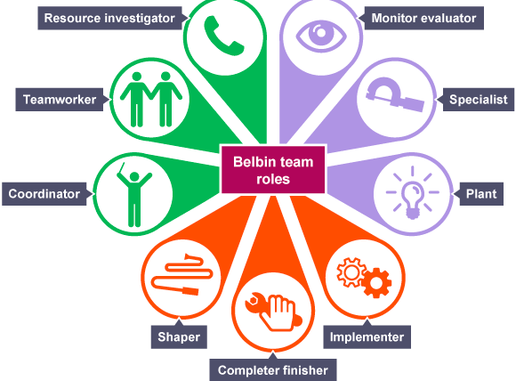
Image: Belbin team structure
Source: Zhansultan, 2019

The Belbin team structure includes 9 team roles and further divides them into three main categories, action-oriented, thought oriented, and people-oriented. These different team roles have different behavioral weakness and strength that shows interpersonal skills and behavior (Thornton et al., 2016).
ACTION ORIENTED
There are three key roles in the action-oriented:
SHAPER: these are the individuals who challenge different teams to make some essential changes in their team performance. This team role usually includes individuals who are dynamic and extrovert who like stimulating others and making up the best approaches and solutions to help others.
IMPLEMENTER: these are such individuals who focus on accomplishing the task and complete the task in reality. They plan ideas and make the required effort and bring the result into real by bringing up the ideas or concepts accomplished (Finlay et al., 2020).
COMPLETE FINISHER: this team role ensures that all the tasks accomplished are under control and have completed successfully that no emission or error can take place and get and collect all the basic and small details of the job or task delegated.
THOUGHT ORIENTED
This type of Belbin role model also includes three types of role model:
PLANT: this role shows that the employees hold a creative and innovative mind to bring new approaches and ideas and focus on thriving on praise. This team role includes such employees or crew members who are introverted and like to do work other than the job.
MONITOR EVALUATOR: this type of team roles are called to be the best at analysing and evaluating the ideas that crew members of the McDonald’s bring with the motive of profitable change. This type of employee is found as the shrewd and objective (Chia et al., 2020).
SPECIALIST: this team roles include such employees, crew members, or managers who are found to have specialized knowledge and carry professional status within the McDonald’s as they are expert to perform the particular job role.
PEOPLE ORIENTED
This team role also includes three types of roles as:
COORDINATOR: this type of team role acts as the traditional team leader who has also been referred to as the Chairman for the McDonald’s. They guide and develop the team members ‘skills to make them complete their task and are found as the effective listeners.
TEAM WORKER: these are recruited as the extra employees or crew members within the McDonald’s so that they can help and provide support to ensure that all the team members are working effectively and efficiently. They usually play the role of negotiators.
RESOURCE INVESTIGATOR: this type of team roles includes such team members who are innovative and curious as they are always in search of the available options by developing contacts and negotiating for resources. Such type of team roles makes the individuals extrovert (Povod et al., 2016).

DIFFERENT MODELS OF COMMUNICATION
SHANNON AND WEAVER MODEL OF COMMUNICATION

Image: Shannon Weaver model
Source: Mathe-Soulek et al., 2016
The Shannon Weaver model of communication was made in 1948 and is based on the Mathematical Theory of Communication. This model includes different steps that show the effectiveness of the communication like the way how one message or information is shared. This can also be understood through the image above as there a complete process is shown through which a message is transferred and how one gets the response (Mathe-Soulek et al., 2016).
Five steps of communication can also be called as the communication process:
SENDER
The sender is the person who shares or sends the message to the concerned person or groups through the specific channel that ensures that the message of information could reach to the concerned group or individual of the McDonald’s and without any emission or hurdle. The sender is also known as the information source.
ENCODER
This stage of the communication process encodes the message or knowledge send by the sender through any media or technology, here the one encodes the message received in such language or form that the reader or receiver could understand. This refers to the transmitter who transmits the message to the machine who gets it decoded into easy signals or binary data (Chia et al., 2020).
CHANNEL
The channel is the medium to send or share some information, message, idea, or knowledge. The senders use the most appropriate channel to convey his message that can be either in written form or through audio or video. The sender sends the message using that channel that can easily send the message without making any errors or obstacles.
DECODER
The decoder interprets the received message in such form or language that the receiver could understand the message and its purpose and can react accordingly. The effectiveness of the communication is proved when the motive of the sent message is accomplished and this can only be done after decoding the message in simple terms, language, or signals (Chulanova and Artiukh, 2019).
RECEIVER
The receiver is the individual or a group who receives the message sent by someone and decoded further to fulfill and accomplish the motive of the message transmitted. The message might hold some purpose like information, order, ideas, etc. to get implemented within the workplace.

CONCLUSION
This assignment is made to analyse the concept and importance and effectiveness of team working and communication in the context of McDonald’s which has a large number of employees that show the importance of communication and teamwork within the workplace. In this assignment types of communication, teamwork, the difference between team and groups, the effectiveness of effective communication and listening skills within the organisation, and has discussed the Belbin team structure in the context of McDonald’s and last a model of communication is discussed.

REFERENCES
Caswell, M.S., (2017). The REFRESH Study Recreation Environment and Food Research: Experiences from Hockey (Master's thesis, University of Waterloo).
Chandiok, S. and Sharma, P., (2017). Hospitality Marketing: Strategic Issues. In Strategic Marketing Management and Tactics in the Service Industry (pp. 213-242). IGI Global.
Chia, X.R., Kee, D.M.H., Khor, S.T., Chin, K.Y., Lok, T.X., Almutairi, H.A., Quttainah, M.A., Balakrishnan, H. and Kulkarni, S.,( 2020). Contributing Factors to Organizational Success: A Case Study of McDonald’s. International journal of Tourism and hospitality in Asia Pasific, 3(2), pp.38-47.
Chulanova, H.V. and Artiukh, V.V., (2019). Peculiarities and Difficulties in Translation of Compatative Advertising of Fast Food Restaurants.
Finlay, J., Esposito, M., Tang, S., Gomez-Lopez, I., Sylvers, D., Judd, S. and Clarke, P., ( 2020). Fast-food for thought: Retail food environments as resources for cognitive health and wellbeing among aging Americans?. Health & Place, 64, p.102379.
GUMENYUK, Y., (2020). PROSPECTS FOR DEVELOPMENT OF RESTAURANT BUSINESS IN AGRARIAN AND INDUSTRIAL STATE. Journal of European Economy, 18(4), pp.466-477.
Klopack, B., (2018). One size fits all? The value of standardized retail chains. working paper.
Mathe-Soulek, K., Krawczyk, M., Harrington, R.J. and Ottenbacher, M., (2016). The impact of price-based and new product promotions on fast food restaurant sales and stock prices. Journal of food products marketing, 22(1), pp.100-117.
Mayorova, S.V., (2020). Mcdonald’s phenomenon. Is it possible to eat healthy food in a fast food restaurant?.
Morgan, M., Watts, V., Allen, D., Curtis, D., Kirolos, A., Macdonald, N., Maslen, E., Morgan, D., Saei, A., Sedgwick, J. and Stevenson, J., (2019). Challenges of investigating a large food-borne norovirus outbreak across all branches of a restaurant group in the United Kingdom, October 2016. Eurosurveillance, 24(18), p.1800511.
Povod, E.A., Roldugina, A.E. and Dmitrienko, N.A., (2016). Analysis and opportunities of innovations in restaurant business" MCDONALD'S"(as an example). Вестник магистратуры, p.59.
Rangappa, P., (2017). Spark: The Insight to Growing Brands. Simon and Schuster.
Thornton, L.E., Lamb, K.E. and Ball, K., (2016). Fast food restaurant locations according to socioeconomic disadvantage, urban–regional locality, and schools within Victoria, Australia. SSM-population health, 2, pp.1-9.
Xu, Y. and Jeong, E., (2019). The effect of message framings and green practices on customers’ attitudes and behavior intentions toward green restaurants. International Journal of Contemporary Hospitality Management.
Zhansultan, A., (2019). Promotion and analysis in the development of restaurant business: the case of a steakhouse restaurant in Kazahstan (Bachelor's thesis).

APPENDICES

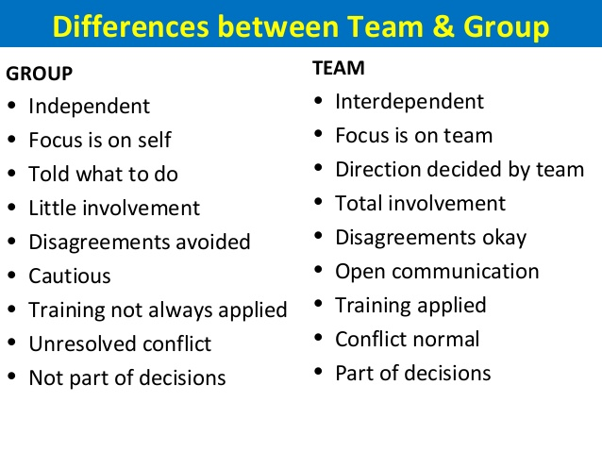
Image 1

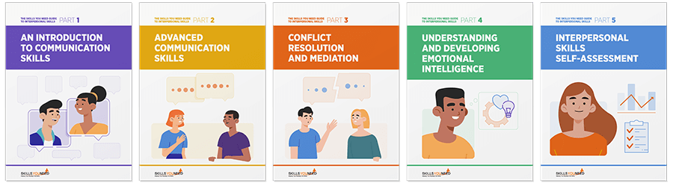
Image 2

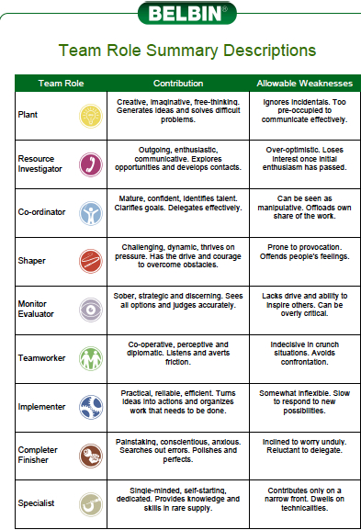
Image 3

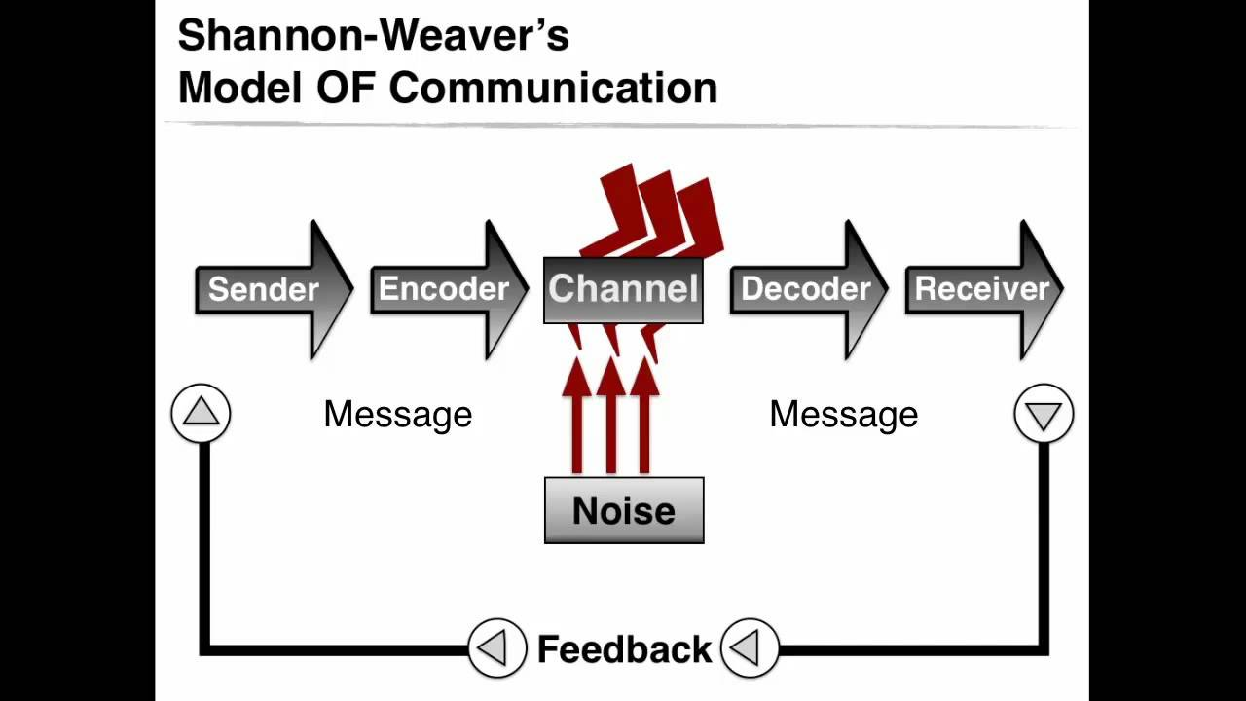
Image 4

