Assignment 2

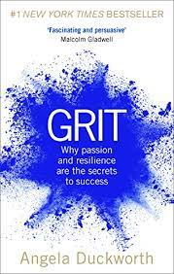

Student name: Alor Maxcarol Sochukwukamma

Student ID: 2027493

Moodle: BMSW4003

Assignment Section: Task 3

Lecturer Name Ngozi Ibeji

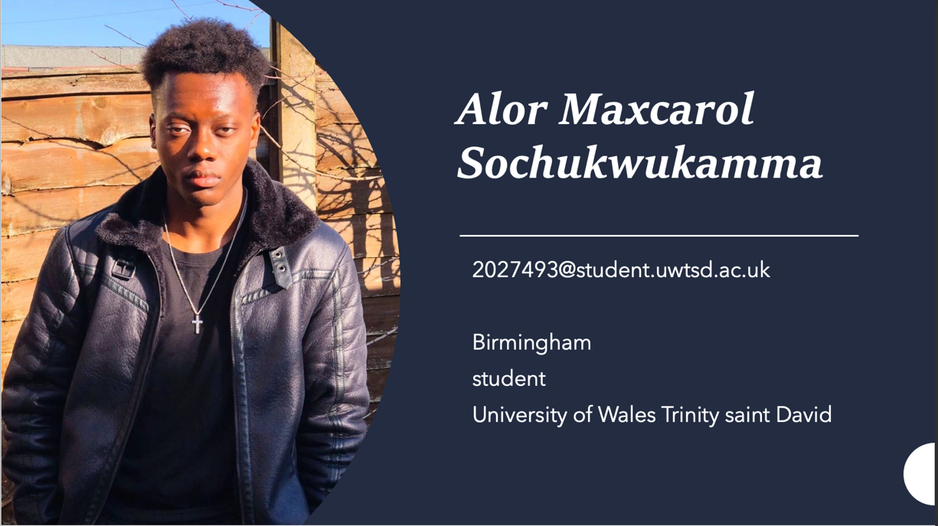

INTRODUCTION



The aim of this report to BBC NEWS is give greater understanding from Angela Duckworth research.

Duckworth gave a TED Talk in 2013, explaining how courage - that is, perseverance and passion for long-term goals - can be essential to succeed. (Anderson; Francisco 2019)
Angela Duckworth, a professor at the University of Pennsylvania, taught math for the seventh grade at several New York schools, she realised that her best performing students were not her most intelligent students, nor the good looks, not physical health nor IQ, but the most successful ones were the ones who had more grit.
After reaching this conclusion, she decided to quit teaching high school and become a research psychologist so that she could understand better what the importance of fundamental skills like resilience and perseverance play in achievement. (Anderson; Francisco 2019)
Duckworth analysed children and adults in different realities and situations, including g West Point military cadets, national spelling competitors and new teachers in difficult schools. In each of the situations she and her team asked themselves about the same: “Who is successful here and why?”.
In these different cases, one aspect stood out among the others as an indicator of success: Grit.
Grit is the virtue that allows someone to work hard towards their goal and stay focused, not for a short period of time but for the long term.

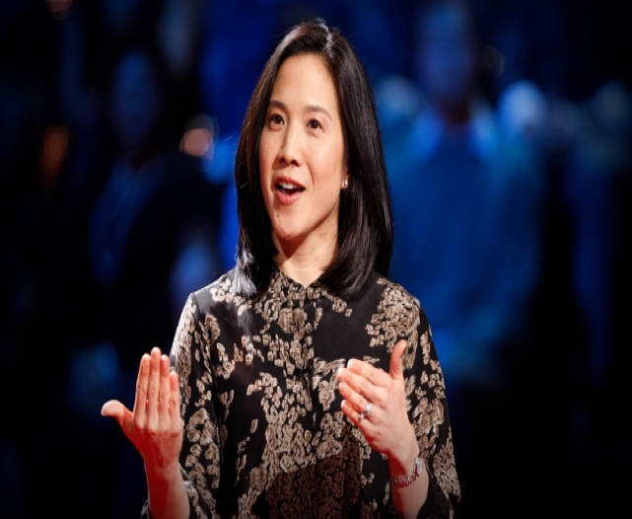
Did Angela Passed the CRAAP test?
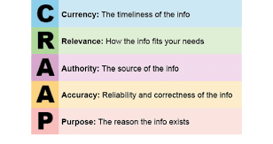
The craap test is to verify the veracity of the information provided. CRAAP is an agronomy for Currency, Relevant, Authority, Accuracy, Purpose.

With the large amount of fake news on the internet it is really difficult to distinguished the real information from the fake ones. But with the CRAAP test it is possible to identify the true news and avoid getting in contact with fake ones.

Information literacy is one of the most important skills to learn if you want to navigate today's complex information ecology, flourish as a lifelong learner, and make informed decisions as a citizen. Today's information environment, which is rife with misinformation, fake news, misleading data, propaganda, and other forms of manipulation, makes it difficult to construct fair worldviews and make accurate judgments and decisions. (Liu, 2021)

Angela Duckworth passed the CRAAP TEST because she was current, credible, and relevant. Her material was timely, usable, and timely. Angela's research answers a question that many people have: "how to be successful at school and in life," important content that benefits both adults and children, information presented in a clear and understandable manner for all audiences, she was Authorities, the talk was published by TED, TED Conferences LLC is an American media organisation that broadcasts online lectures for free sharing under the slogan "ideas worth spreading." (TED;2011,2018) Richard Saul Wurman created TED, which he co-founded with Harry Marks in February 1984 as a conference and has been hosted yearly since 1990.

Duckworth possesses the necessary qualifications to speak about the lecture's topic because she has professionally assumed the role of teacher, allowing her to directly deal with and analyse students on a cognitive and behavioural level, and all of the information provided can be verified by ourselves personally applying Duckworth's essential advice in our lives.

Concerning accuracy, there is no doubt that the content is reliable and true; the language used conveys emotion, and the voice is placed correctly so that the conveyed information is comprehended and well received by the public.
Last but not least, the purpose, or goal, of this palaestra is to demonstrate that IQ is not the only factor that determines whether or not a student will succeed in school, from an objective standpoint with no quotes from the author's personal influencers.

DIKW

Data collection

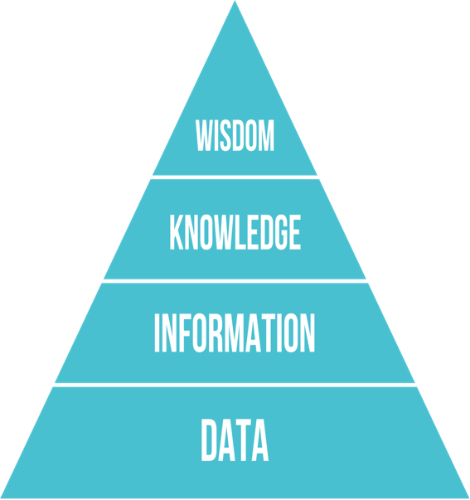
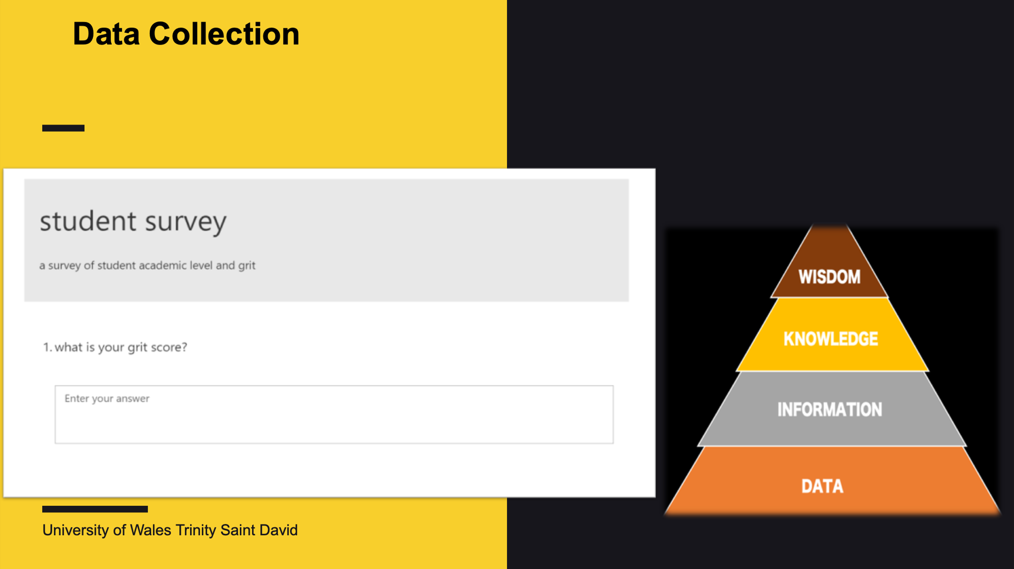

They are objects of observation, but only when they are employed are they relevant. The process is represented through data and information. Data and information serve a functional rather than a structural purpose. (rowley, 2006 )
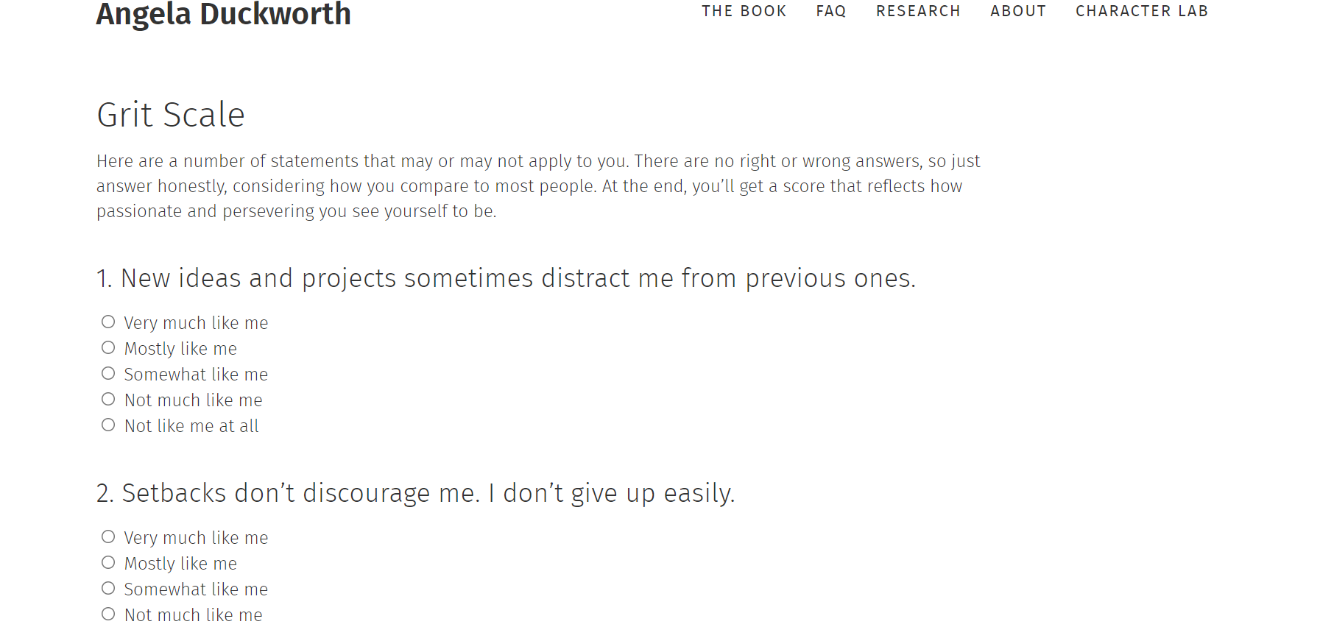
As illustrated in the image, Microsoft form is an important way for collecting data. With Microsoft form, anyone can have access, making the acquisition of needed data much easier.

- Data comes in a form of signs and signals, such as numbers, words or other signs that represent discrete facts about an objective reality. Data can be described with reference to objective metrics and thus can be verified and decisively proven to be correct or incorrect. Data is an organized string of symbols that represents empirical stimuli of perception. There’s no interpretation in data meaning that we can use automated computation to capture and process data. A collection of information in a raw or unstructured form, such as numbers or letters, is referred to as data.
- Data is a collection of facts in a raw or unorganized form such as numbers or characters. Data, on the other hand, can be meaningless without context. 12012012, for example, is just a series of digits with no apparent significance. However, if we consider it in the context of a date, we can quickly recognize the 12th of January, 2012. The numbers have greater meaning now that context and value have been added to them.
- In this approach, we've turned a random sequence of integers into a meaningful pattern. (Gabrovski, 2021)

Information

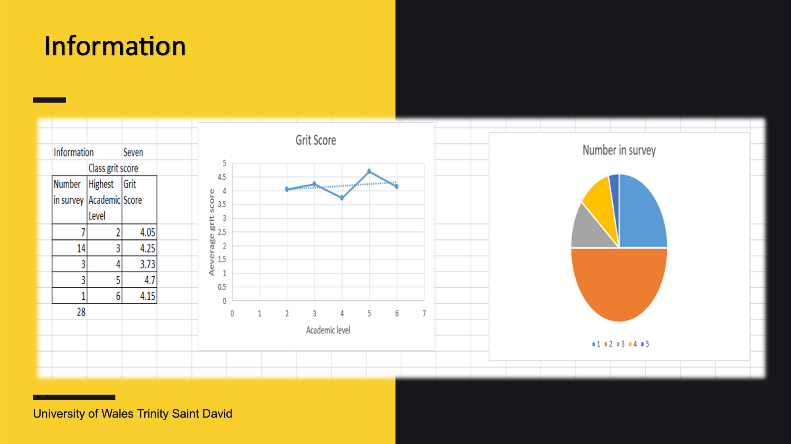

Information is embedded in descriptions, answers to questions introduced by words like who, what, when and how many. The data is archived, generated, and properly processed by the information’s systems.
Information systems books generally focus on the interconnection between data and information and their definition by unintentionally excluding the principles of model, structure, organization, meaning and feature value, cited below:

Information is the organization of data into descriptions it represents, sentences, equations questions The information's that we receive it can be used to answer interrogative questions such as who, what, where etc. We can extract relevant information from the data and improve its utility. (Gabrovski, 2021)
When it comes to the question of 'how,' however, this is what separates information from…….

Knowledge
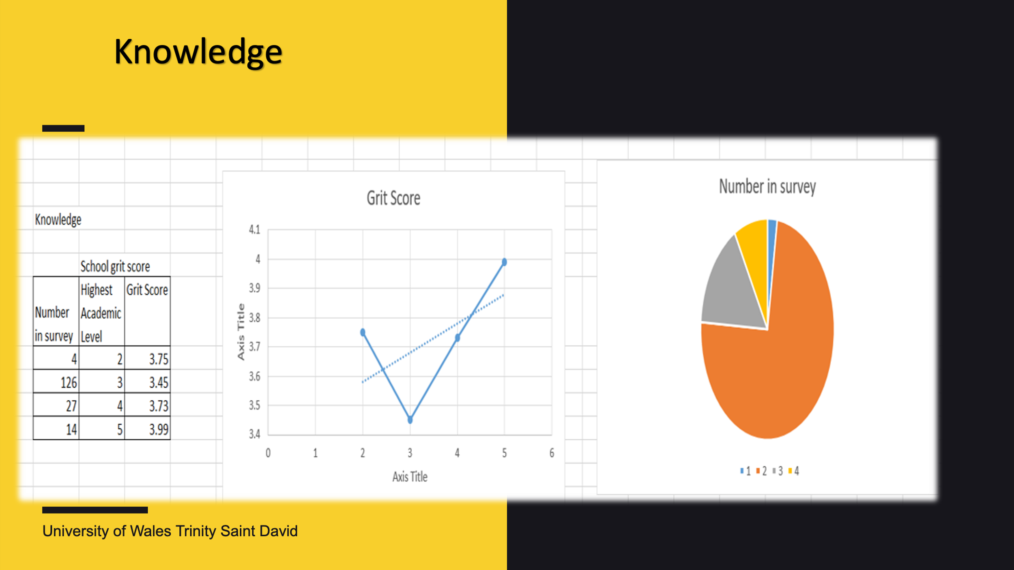

Knowledge is the synthesis of multiple sources of information over time to create conceptual frameworks, theories and sayings. Knowledge gives context through experience, values and insight. Once it turns into symbolic and objective knowledge is reduced to information. "How" is the information gained from the data relevant to our objectives? "How" are the pieces of this data linked together to add greater meaning and value? And, maybe most crucially, "how" can we use the information to accomplish our objective?
We turn information into knowledge when we learn how to utilise it to attain our objectives rather than just seeing it as a collection of facts. This knowledge is frequently a competitive advantage for businesses. We get deeper insights as we identify relationships that aren't clearly presented as information, moving us higher up the DIKW pyramid.
Knowledge is “know-how”, and it is what makes information become instructions. Knowledge can be achieved being transmitted by another individual who already have it, by instruction or derived from experience.

Speeches of definitions about knowledge go far beyond just data or information. In fact, several knowledge managements texts with explicit statements about the origin of knowledge, different interpretations and demonstrations, and discussions about the nature of knowledge. These discussions tend to be more difficult over time to disseminate the essence of knowledge.
About what to extract and what can be considered a definition related to data and information.

We can declare we've achieved the last – 'wisdom' – stage of the Knowledge Pyramid only when we apply the knowledge and insights gained from the information to make proactive decisions (Gabrovski, 2021)

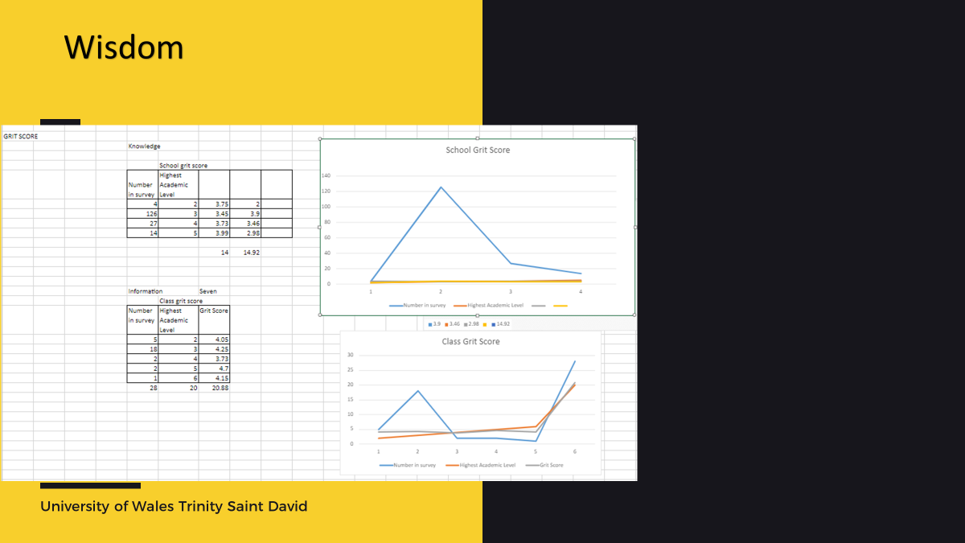
Wisdom is the ability to ensure effectiveness. Wisdom adds value, requiring the mind to form judgment from a critical standpoint, the ethical and aesthetic values involved are unique and strictly personal.
Only three of the books that attempt to define wisdom are of greater relevance over others, despite being at the apex of the pyramid. It is possible to dispute that these same books do not consider information and knowledge as a contribution to wisdom. Wisdom is a state of awareness, a paradigm or set of principles, it is the ultimate context and frame of reference. Wisdom is knowing of “why”, an evaluated understanding, acceptance and appreciation of why things are the way they are, it is seeing the whole. It involves knowing the right thing to do. For the better good. It requires a sense of what is right and wrong, ethical and unethical. Wisdom is at the summit of the DIKW pyramid, and we must answer questions like "why do something" and "what is best" to get there. Wisdom, in other terms, is knowledge put into practise.
If data and information are related with what we do now and what we hope to achieve in the future, knowledge and wisdom are associated with what we do now and what we want to achieve in the future. (Gabrovski, 2021)

This debate about the notion of wisdom in texts referred to above shows the limitation of discussions about the origin of wisdom and how it can be created in broader information systems, knowledge management and management literatures

Conclusion
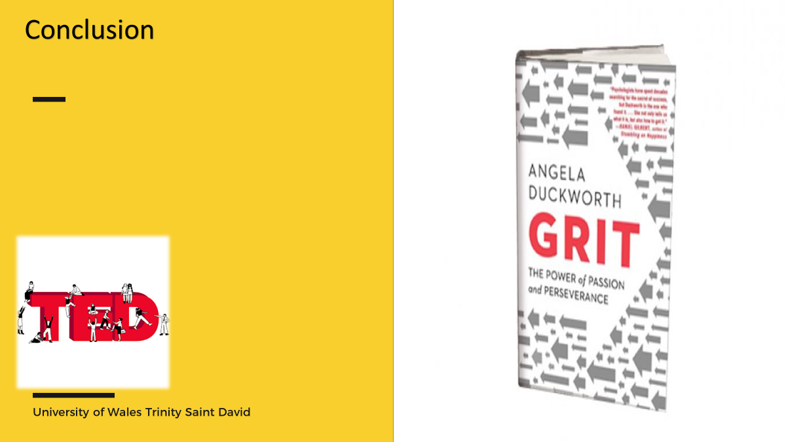
Angela Duckworth conducted study and discovered that IQ was not the only difference between pupils in both andragogy and pedagogy, and that while some courses were challenging, she was confident that if they tried hard enough, they could succeed.
This report can demonstrate how she passed the CRAAP TEST, demonstrating that her speech was credible and remained relevant to everyone, as well as providing explicit ideas regarding DIKW and CRAAP TEST.

A.K

What is the data, information, Knowledge, wisdom, DIKW Pyramid? (Gabrovski, 2021)
Expanding the CRAAP test with critical thinking and metacognition (Liu, 2021)

Bibliography
Gabrovski, N., 2021. ontotext. [Online]
Available at: https://www.ontotext.com/knowledgehub/fundamentals/dikw-pyramid/
Liu, G., 2021. Expanding the CRAAP test with critical thinking and metacognition. college & research libraries, Volume 82 , pp. 1-150 .
rowley, 2006 . dikw. Volume 34, pp. 1-50 .

