

Strategic Management (LCMB7003)

Strategic Analysis of (Marks & Spencer In Decline)

Student name: Rehan Farooqui
Student Number: 2223935
Lecturer: Dr Gladius Kulothungan
Word count:5000
Submission Date: 01/09/2023

Table of Contents
Introduction: 3
Background: 3
Mission and Objectives 3
Macro-Environment Analysis 5
PESTEL Analysis 5
Micro-Environment Analysis 6
Industry Life Cycle 6
Porter’s Five Forces Analysis 8
Internal Analysis 9
Strategic Resources and Capabilities 9
Value Chain Analysis 11
Primary Exercises 11
Secondary Activities 12
VRIO Analysis of Distinctive Resources and Capabilities 13
SWOT Analysis 15
Strategies to Sustain Competitive Advantage 17
Growth Strategies 18
Green Strategy and CSR 20
Conclusion 21
Recommendation 22
References 23

Introduction:
This report points to provide a comprehensive examination of Marks & Spencer (M&S), a noticeable UK-based company. Throughout the report, we'll dig into different perspectives of the company, shedding light on its foundation, monetary circumstances, working markets, and more. Our investigation will offer important bits of knowledge into M&S's current position and potential future prospects, whereas considering its age, worker number, and by and large financial well-being.

Background:
Marks & Spencer, commonly known as M&S, holds a noteworthy nearness within the UK's retail scene. Established in 1884, the company boasts a wealthy history, making it one of the most seasoned and most set-up retailers in the nation. Over a long time, M&S has advanced and expanded, gaining an image for quality items and client service (marksandspencer, 2023).
With respect to its monetary circumstance, we'll investigate key money-related markers, such as income, profits, and obligations, to pick up a comprehensive understanding of M&S's monetary solidness. Moreover, an investigation of the company's age will offer important experiences into how it has adjusted and withstood the challenges of an ever-changing retail market.
Besides, we'll look at the number of workers working at M&S and highlight their part in the company's operations. Understanding the measure and structure of the workforce will give us an important setting for assessing M&S's operational productivity and its capacity to meet client requests successfully.
Working markets will too be a crucial perspective of this report. We'll distinguish the different segments and geographies in which M&S works, laying out its competitive scene and potential zones for development. By assessing the company's current showcase nearness, we will gauge its versatility and potential to grow into new regions (Britannica, 2023).
In conclusion, this report will offer a comprehensive investigation of M&S UK, covering its foundation, money-related circumstance, worker count, and working markets. The bits of knowledge determined from this examination will give a clear understanding of M&S's current position and its prospects for maintained development and victory within the energetic retail industry.

Mission and Objectives
Marks & Spencer's mission is to be the driving retailer within the UK, offering high-quality, feasible items and uncommon client encounters. The company endeavors to make esteem for its partners, counting clients, workers, providers, and shareholders, whereas too contributing emphatically to the communities in which it works.
Goals of M&S UK:
• Customer-Centric Excellence: M&S is devoted to understanding and assembling the advancing needs and inclinations of its clients. The company points to providing extraordinary items, administrations, and shopping encounters that surpass client desires, cultivating long-term dependability and fulfillment (MSA, 2023).
• Product Quality and Sustainability: M&S is committed to giving items that are morally sourced, environmentally friendly, and of the most noteworthy quality. The company effectively looks to decrease its environmental impression, advance maintainable practices all throughout its supply chain, and offer a different range of items that adjust with capable utilization.
• Innovation and Adaptability: M&S recognizes the significance of remaining ahead in a fast-paced retail industry. It endeavors to cultivate a culture of advancement, persistently progressing its products, processes, and technologies to stay significant and competitive within the market (marksandspencer, 2023).
• Employee Engagement and Development: The company values its employees and points to form a strong and comprehensive work environment. M&S looks to draw in, hold, and create skilled people, enabling them to contribute their best to the organization's victory.
• Financial Performance: Whereas M&S centers on its social and environmental obligations, it also strives for sustainable financial development. The company points to realizing beneficial come about, producing shareholder esteem, and keeping up monetary steadiness to support its long-term commerce goals.
• Community and Social Responsibility: M&S takes its part as a mindful corporate citizen truly. It endeavors to emphatically affect the communities in which it works through charitable activities, supporting nearby causes, and advancing social well-being.
• Digital Transformation: M&S recognizes the noteworthiness of digital innovation in present-day retail. The company points to grasping digital change, improving its online nearness, e-commerce capabilities, and omnichannel techniques to meet the changing inclinations of consumers.

Macro-Environment Analysis

PESTEL Analysis
PESTEL investigation is a key instrument utilized by businesses to evaluate and comprehend the effect of six outside components: Political, Economic, Social, Technological, Environmental, and Legal. This system helps in decision-making and methodology development by distinguishing potential openings and threats within the broader business environment.
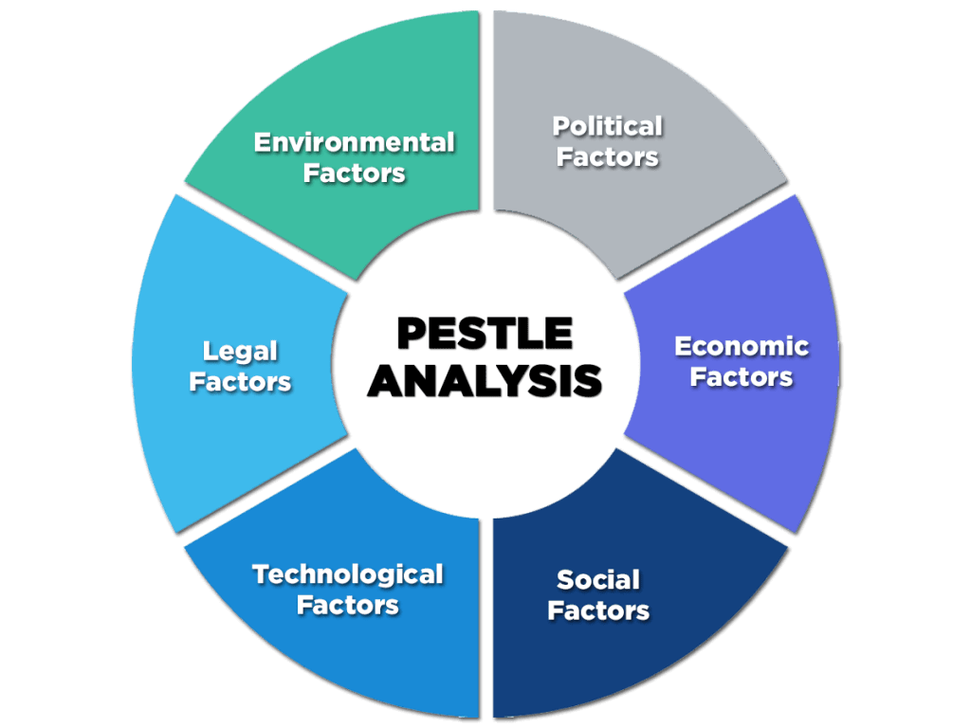
Figure 1: PESTLE ANALYSIS
Source: (Gandhi, 2020)
i. Political components: These allude to the influence of government arrangements and controls on the business environment. For Marks & Spencer, political variables may incorporate exchange arrangements, tax assessment laws, labor laws, and government steadiness within the nations where it works. Changes in these variables can affect the company's operations, supply chain, and fetched structure (BUSH, 2019).
ii. Economic components: Economic conditions such as economic development, expansion rates, trade rates, and buyer investing patterns can altogether influence a retail company like Marks & Spencer. Amid periods of financial downturn, buyer investing may diminish, affecting the company's deals and service.
iii. Social factors: These components include statistic patterns, social impacts, and societal states of mind that influence shopper behavior. Marks & Spencer must adjust its items and promote methodologies to meet changing consumer preferences, ways of life, and societal values (thestrategystory, 2023).
iv. Technological components: The retail industry is intensely impacted by innovative progressions. Marks & Spencer must consider the effect of e-commerce, digital promoting, information analytics, and supply chain automation to remain competitive and meet customer desires.
v. Environmental variables: Expanding mindfulness of natural issues and maintainability concerns may require Marks & Spencer to execute eco-friendly practices in its operations, item offerings, and supply chain.
vi. Legal components: Lawful components include compliance with laws and directions particular to the retail industry, counting labor laws, customer assurance laws, intellectual property rights, and item security standards (Farooq, 2023).

Micro-Environment Analysis

Industry Life Cycle
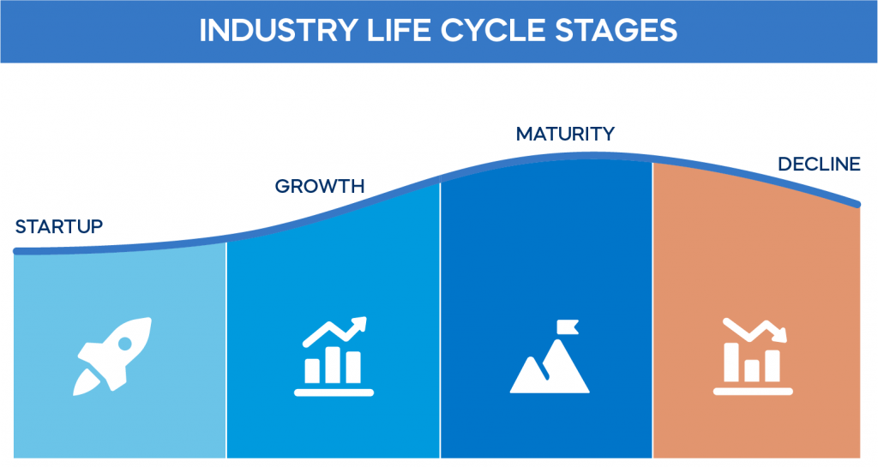
Figure 2: INDUSTRY LIFE CYCLE
Source: (Kitov, 2023)
Introduction Stage:
Marks & Spencer (M&S) was established in 1884, which places it within the introduction stage of the industry life cycle. Amid this stage, M&S was building up itself as a little market player with a center on giving quality items to its clients. The retail industry was in its nascent stages, and M&S was pioneering the concept of advertising a wide range of items under one roof.
Growth Stage:
M&S experienced noteworthy growth in the mid-20th century. The company extended its item offerings, gained notoriety, and became a family title within the UK. The growth stage was characterized by the opening of unused stores, enhancement of item lines, and an expanding client base. M&S was able to capitalize on a rising request for quality products, setting up itself as a trusted brand (Macrae, 2014).
Maturity Phase:
As the retail industry developed, M&S kept on developing and set its position within the showcase. Amid this stage, the company delighted in a period of steadiness and dominance. M&S became known for its accentuation on quality, client benefit, and solid brand personality. The maturity phase was checked by a wide distribution network, a faithful client base, and a solid presence within the UK retail scene.
Decline Stage and Adaptation:
For a long time, M&S confronted challenges and changes in buyer behavior. The rise of online shopping and changing inclinations posed a risk to the company's conventional brick-and-mortar model. This signaled a potential decay stage, where M&S had to adjust to the evolving retail environment. The decrease was not severe, but it provoked the requirement for vital alterations.
Revitalization and Potential Growth:
M&S recognized they have to be adjusted and set out on endeavors to revitalize its business. This stage includes embracing modern procedures to reignite development and cater to changing consumer requests. M&S contributed to digital change, patched up its item offerings, and grasped supportability activities. By doing so, the company pointed to position itself for potential development and relevance within the advanced retail scene.
It's vital to note that the industry life cycle isn't entirely linear, and diverse companies inside the same industry might encounter different stages differently. M&S's travel through the industry life cycle showcases its capacity to adjust and enhance to stay competitive in the face of changing market flow.

Porter’s Five Forces Analysis
Porter's Five Strengths examination is a key system created by Michael Porter. It evaluates industry competitiveness by looking at five key components: the threat of modern participants, bargaining control of providers, bargaining control of buyers, the threat of substitute items, and the intensity of competitive rivalry. This investigation helps businesses get their industry's flow and define effective techniques.
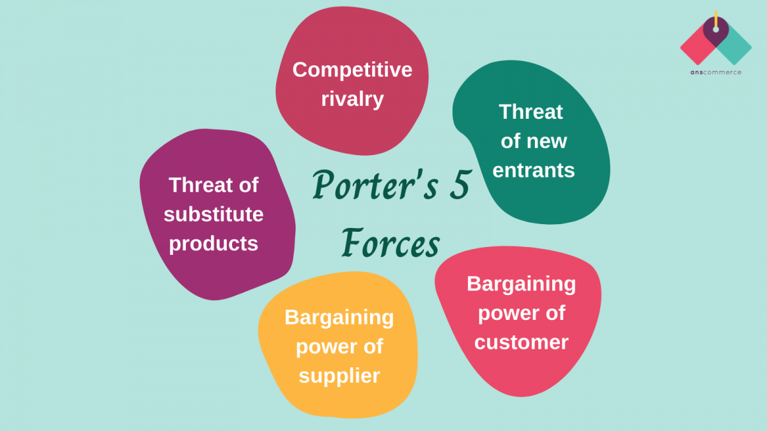
Figure 3: PORTER’S FIVE FORCES ANALYSIS
Source: (Pratyush, 2021)
Porter's Five Forces Analysis:
- The threat of new participants: Marks & Spencer faces potential competition from modern participants in the retail industry. The threat depends on obstructions to entry, such as high starting speculation necessities, brand devotion of existing clients, and economies of scale. In case entry boundaries are low, modern competitors may enter the showcase and heighten competition (Sarkar, 2023).
- Bargaining control of providers: Suppliers' capacity to impact the company's costs and supply chain effectiveness is critical. In case there are few elective providers or if providers have solid negotiating control, they can apply weight on Marks & Spencer to extend costs or influence item accessibility.
- Bargaining control of buyers: Customers' bargaining power is noteworthy within the retail industry, especially when there are numerous options accessible. Marks & Spencer must guarantee competitive estimating, high-quality items, and amazing client service to hold its client base (Murphy, 2018).
- Threat of substitutes: Marks & Spencer faces competition not as it were from coordinate competitors within the retail industry but moreover from substitutes. Substitutes are items or services that fulfill similar client needs. For occurrence, online shopping may be a substitute for in-store retail.
- Competitive competition: Marks & Spencer works in an exceedingly competitive retail showcase. The escalation of competition depends on the number of competitors, their estimate, and their techniques. The company must separate its items, offer special esteem suggestions, and keep up brand devotion to flourish in the midst of intense rivalry.
By conducting these external investigations, Marks & Spencer can superiorly get it the outside forces forming its industry and make educated key choices to remain competitive and accomplish its business targets.

Internal Analysis

Strategic Resources and Capabilities
A few of these key assets and capabilities are as follows:
i. Brand Recognition and Image: Marks & Spencer has set up a solid brand acknowledgment and image over a long time. The company is well-known for its commitment to quality and reliability, which resounds with a wide client base. The brand acknowledgment and positive image empower M&S to command premium costs for its items and cultivate client devotion (Hodgson, 2017).
ii. Existing Supply Chain Model: The company brags a well-established supply chain show that permits efficient sourcing, distribution, and stock administration. This streamlined supply chain empowers M&S to preserve a competitive advantage in terms of operational effectiveness, guaranteeing that items are readily accessible to clients and minimizing supply disturbances (GlobalData, 2022).
iii. Customer Devotion: Through its long-standing nearness within the market, M&S has developed a faithful client base. Clients frequently relate the brand with positive shopping encounters and high-quality items, cultivating rehash commerce and word-of-mouth proposals.
iv. Product Diversification: Marks & Spencer offers a different run of items, catering to different client fragments. This broad item portfolio permits the company to reach a wide client base and adjust to changing buyer inclinations, moderating the chance of depending intensely on a single item category (marksandspencer, 2023).
v. Experienced Workforce: The company benefits from an experienced and talented workforce. Marks & Spencer's workers have profound industry information, contributing to effective operations and predominant client service.
vi. Extensive Physical Store Organize: M&S has a broad network of physical stores in different areas. These brick-and-mortar stores give the company with a solid showcase presence and permeability.
vii. E-commerce Presence: Whereas the company confronted challenges in adjusting to online retail, it has made endeavors to set up an e-commerce nearness. The online stage empowers M&S to tap into the developing online buyer base and reach a broader gathering of people.
viii. Innovation in In-Store Technology: Marks & Spencer has contributed to in-store innovation to improve the shopping experience and bridge the crevice between physical and online offerings. Interactive displays, digital catalogs, and self-checkout booths are some of the innovative advancements the company has executed to engage clients and progress operational proficiency (Skeldon, 2023).
ix. Sustainability Initiatives: The company has illustrated a commitment to maintainability through different activities, such as eco-friendly item lines and moral sourcing hones. These supportability endeavors resonate with ecologically cognizant shoppers and contribute to the company's notoriety as a dependable retailer.
Thus, Marks & Spencer's key assets and capabilities, counting its solid brand acknowledgment, effective supply chain, steadfast client base, item enhancement, and commitment to development and supportability, play a noteworthy part in forming its competitive advantage. By leveraging these assets and ceaselessly creating its capabilities, M&S can explore challenges within the retail industry, keep up showcase relevance, and accomplish sustainable development in the long term.

Value Chain Analysis
Value Chain Investigation is a key instrument that assesses a company's activities, from raw material sourcing to item delivery, to recognize steps that make value and those that don't. Dividing processes into essential (specifically including value) and support (indirectly including value) activities, helps improve productivity, diminish costs, and improve competitive advantage.
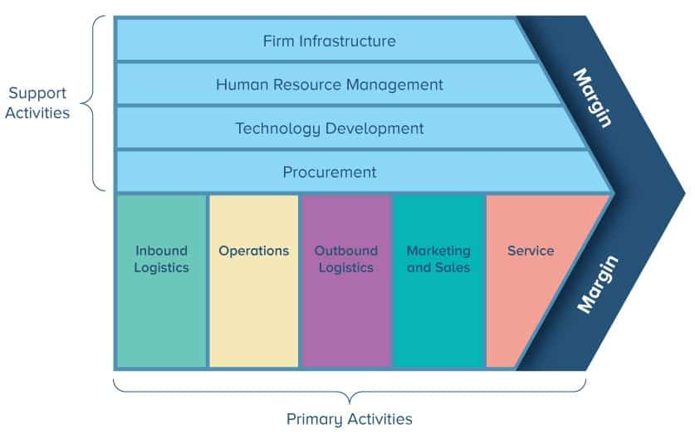
Figure 4: VALUE CHAIN ANALYSIS
Source: (Eby, 2023)
Value Chain Investigation may be a system utilized to recognize and analyze a company's essential and support exercises, making a difference to distinguish regions where esteem can be made and costs optimized. Marks & Spencer embraced a comprehensive Value Chain Investigation with a specific emphasis on the supply chain:

Primary Exercises
• Inbound Logistics: Marks & Spencer optimized its inbound coordination by setting up solid connections with providers and embracing just-in-time stock practices. This permitted the company to decrease stock holding costs and react rapidly to changing customer requests.
• Operations: The company centered on progressing operational effectiveness by contributing to progressed innovation and handling automation. This brought about quicker and more exact order fulfillment, improving client fulfillment (kasi, 2017).
• Outbound Logistics: Marks & Spencer progressed outbound logistics through key associations with solid conveyance companies. This guaranteed convenient conveyance of items to stores and clients, diminishing lead times and expanding responsiveness.
• Marketing and Sales: The company utilized its solid brand and notoriety to execute compelling promoting campaigns. By understanding client inclinations and patterns, Marks & Spencer created focused on deals techniques to boost sales and pull in new customers.
• Customer Service: Client service may be a significant viewpoint of Marks & Spencer's esteem chain. The company contributed to preparing its staff to provide remarkable client encounters, cultivating devotion and word-of-mouth promotion (Montgomery, 2023).

Secondary Activities
• Procurement: The company optimized its acquirement process to guarantee cost-effective sourcing of raw materials and finished items. By arranging favorable contracts with providers, Marks & Spencer picked up a competitive advantage in estimating.
• Human Resources: Marks & Spencer emphasized representative improvement and fulfillment to retain talented and persuaded staff. A competent workforce empowers effective operations and great client service.
• Mechanical Improvement: The company grasped technological progressions to improve different business forms, from supply chain management to client engagement. Contributing to innovation has empowered Marks & Spencer to remain ahead in a digitalized retail landscape.
• Firm Infrastructure: Successful administration and administration structures backed Marks & Spencer's esteem chain exercises. By keeping up a well-organized firm framework, the company guaranteed consistent coordination between diverse divisions (ARSALAN, 2022).

VRIO Analysis of Distinctive Resources and Capabilities
The VRIO system could be a key instrument utilized to evaluate a company's assets: whether they are Valuable, Rare, Inimitable, or Organized successfully. It helps decide a firm's competitive advantage potential.
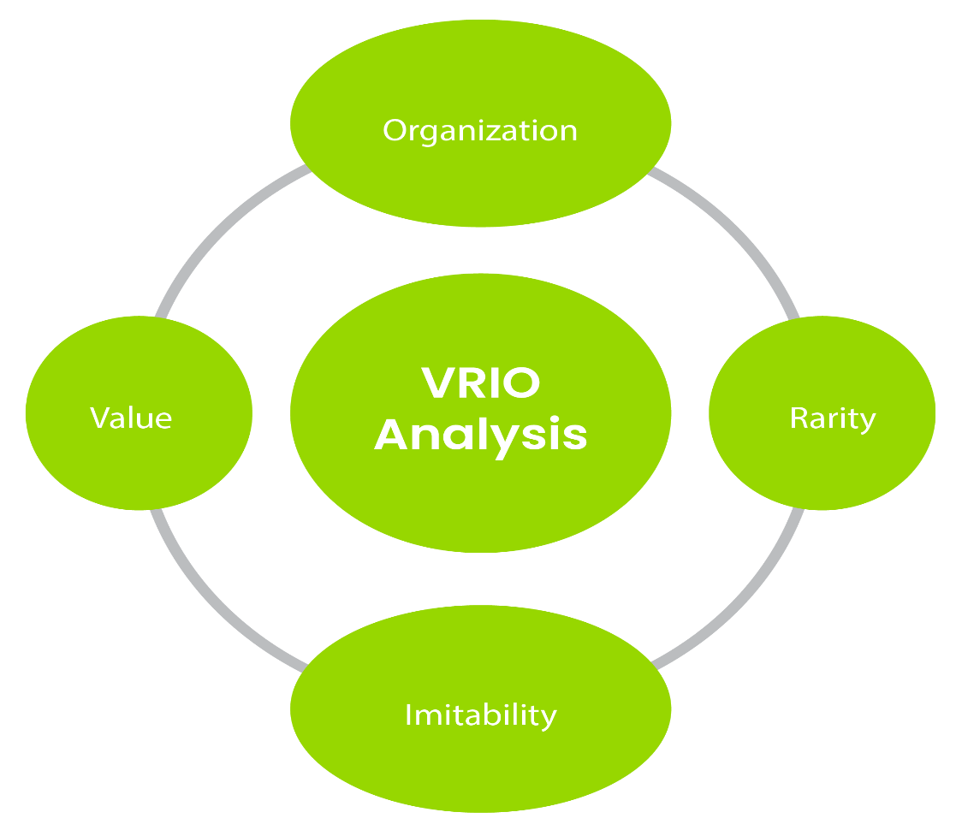
Figure 5: VRIO ANALYSIS
Source: (PALLISTER, 2022)

Resources/Capabilities | Distinctiveness | Rarity | Imitability | Organizational Support | Competitive Advantage
Brand Recognition and Reputation | Yes | Yes | Yes | Yes | Yes
Existing Supply Chain Model | Yes | Yes | Yes | Yes | Yes
Innovation in In-Store Technology | Yes | Yes | Yes | Yes | Yes

Explanation of VRIO Investigation:
1. Brand Recognition and Reputation:
Uniqueness: Marks & Spencer's solid brand acknowledgment and positive notoriety are distinctive assets that set the company separated from its competitors.
Rarity: The brand acknowledgment and notoriety of M&S are moderately uncommon within the retail industry, including to the company's competitive advantage.
Imitability: Building a solid brand like M&S isn't effortlessly imitable, making it a profitable and non-substitutable asset (Edwards, 2018).
Organizational Back: M&S viably leverages its brand acknowledgment in its showcasing techniques and customer-centric approach.
Competitive Advantage: Solid brand acknowledgment and positive notoriety contribute to client devotion and repeat business, providing M&S with a competitive advantage.
2. Existing Supply Chain Model:
Distinctiveness: Marks & Spencer's existing supply chain demonstrates may be a distinctive capability that upgrades its operational proficiency and cost control.
Rarity: Whereas supply chain models are not exceptional, M&S's specific model optimized for its needs is moderately uncommon within the retail industry.
Imitability: Imitating M&S's supply chain model would be challenging due to its complexity and integration with the company's operations.
Organizational Support: The company viably coordinates its supply chain demonstrated in its in general operations, supporting its competitive advantage (caseturbo, 2023).
Competitive Advantage: The productive supply chain model permits M&S to reply rapidly to showcase changes and keep up cost competitiveness, driving competitive advantage.
3. Innovation in In-Store Innovation:
Distinctiveness: Marks & Spencer's advancement in in-store innovation may be a distinctive capability that upgrades the shopping encounter for clients.
Rarity: Whereas in-store innovation selection is expanding, M&S's particular advancements are generally special compared to a few competitors.
Imitability: Duplicating M&S's particular in-store innovation developments would require noteworthy venture and exertion, making it challenging for competitors.
Organizational Back: The company viably joins in-store innovation into its retail technique to support its competitive advantage.
Competitive Advantage: The utilization of innovative in-store innovation upgrades client engagement and operational productivity, contributing to M&S's competitive advantage.
Thus, Marks & Spencer's distinctive assets and capabilities, counting its solid brand acknowledgment and notoriety, existing supply chain show, and advancement in in-store innovation, display uniqueness, rarity, and restricted imitability. These resources and capabilities back the company's competitive advantage, permitting M&S to distinguish itself and succeed within the competitive retail industry.

SWOT Analysis
SWOT investigation is a vital arranging instrument utilized by organizations to evaluate their inside qualities and shortcomings (S/W) and outside openings and threats (O/T). By assessing these components, businesses gain bits of knowledge about their competitive position, potential regions for change, and avenues for development. This examination guides decision-making, helps in strategy formulation, and enhances overall business execution by adjusting inside capabilities with outside market elements.
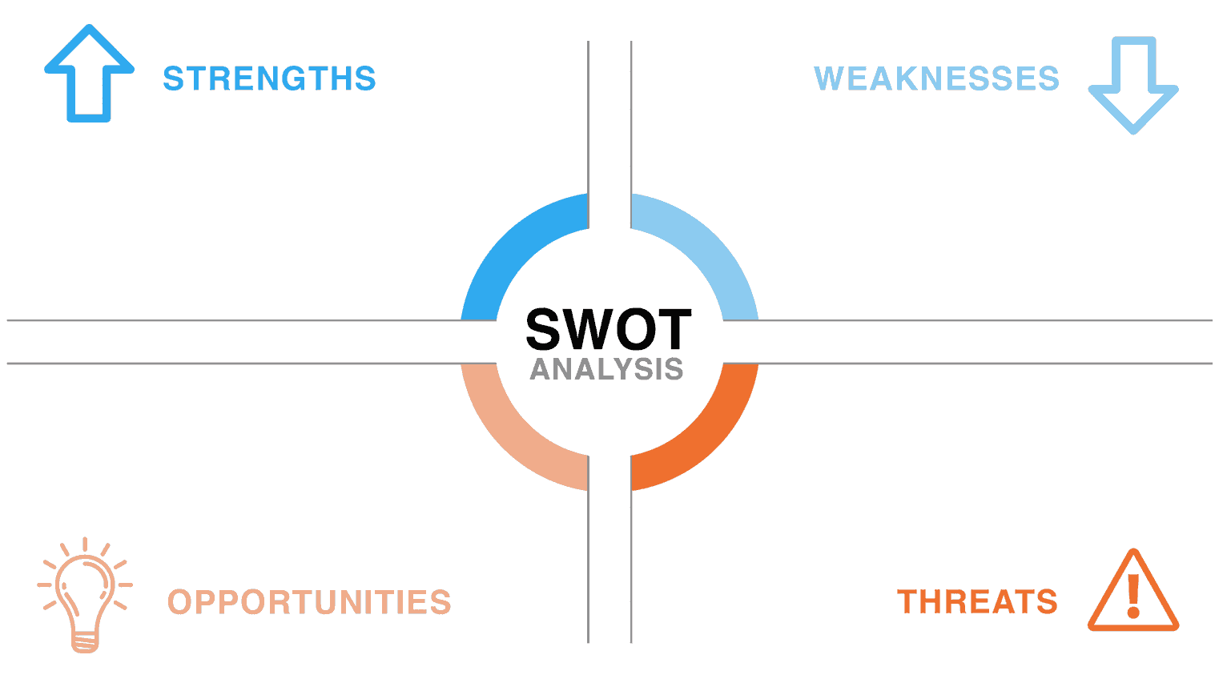
Figure 6: SWOT ANALYSIS
Source: (spiderstrategies, 2022)
Marks & Spencer's SWOT Examination uncovered a comprehensive understanding of the company's inner qualities and shortcomings, as well as outside openings and threats. Key discoveries from the SWOT Investigation are as takes after:
a. Strengths:
i. Brand Acknowledgment: Marks & Spencer's solid brand acknowledgment ingrains belief and devotion among clients, improving its market position (thestrategystory, 2023).
ii. Differentiated Item Range: The company offers a wide extend of items, catering to different client segments, subsequently extending its showcase reach.
iii. Worldwide Presence: Marks & Spencer's worldwide presence gives openings for development and broadening.
iv. Solid Supply Chain: The company's productive supply chain guarantees opportune and cost-effective item conveyance.
b. Weaknesses:
i. Obsolete Supply Chain Practices: A few of Marks & Spencer's supply chain practices may be obsolete, driving wasteful aspects and higher costs (MOMIN, 2022).
ii. Restricted Online Presence: Whereas the company contains a nearness in e-commerce, it must contribute more to digital promoting and online retail to tap into the developing online customer base.
c. Opportunities:
i. E-commerce Development: The expanding slant of online shopping gives an opportunity for Marks & Spencer to grow its online offerings and reach a broader client base.
ii. Worldwide Development: The company can investigate assisting development into rising markets with a developing middle class and request quality items (Bhasin, 2023).
iii. Feasible Practices: Developing shopper mindfulness approximately maintainability presents an opportunity for Marks & Spencer to embrace eco-friendly hones and draw in environmentally conscious clients.
d. Threats:
i. Strong Competition: The retail industry is profoundly competitive, and Marks & Spencer faces competition from both conventional retailers and online marketplaces.
ii. Economic Instabilities: Economic downturns and changes can affect buyer investing, influencing the company's deals and income.
iii. Changing Buyer Inclinations: Shifts in customer inclinations and trends may require the company to adjust its item offerings persistently (Shaw, 2023).
Consequently, the internal examination of Marks & Spencer through the Resource-Based View (RBV), Value Chain Examination, and SWOT Investigation has given important experiences into the company's qualities, shortcomings, openings, and threats. Leveraging its important brand, notoriety, and supply chain model, Marks & Spencer can upgrade its competitive advantage and stay versatile within the energetic retail scene. By tending to shortcomings such as obsolete supply chain hones and extending its online nearness, the company can capitalize on developing openings and relieve potential dangers. With a profound understanding of its internal capabilities and outside environment, Marks & Spencer is well-positioned to strategize viably and accomplish supported development within the exceedingly competitive retail industry.

Strategies to Sustain Competitive Advantage
To maintain its competitive advantage within the exceedingly competitive retail industry, Marks & Spencer (M&S) can actualize the taking after techniques, leveraging distinctive key examinations, counting Porter's Generic Technique:
1. Differentiation Strategy:
a. Upgraded Client Experience: M&S can proceed to distinguish itself through an uncommon shopping involvement, both in physical stores and online. The company can contribute to personalized client service, interactive shows, and consistent omnichannel shopping to make a special and important shopping journey for its clients (Butler, 2018).
b. Exclusive Item Offerings: By curating elite item lines and collaborations, M&S can offer special and premium items that are not effortlessly accessible somewhere else. This technique upgrades brand value and pulls in clients trying to find unmistakable things.
c. Sustainability Leadership: Building on its existing sustainability activities, M&S can position itself as a pioneer in feasible and moral practices. By advertising naturally local and morally sourced items, the company can offer to eco-conscious shoppers and pick up a competitive advantage.
2. Cost Administration Technique:
a. Operational Proficiency: M&S can advance and optimize its supply chain and store operations to decrease costs and progress generally proficiency. Executing just-in-time stock administration and improving coordination can offer assistance for the company to keep up with cost leadership (Green, 2022).
b. Private Label Expansion: Expanding its private name offerings can permit M&S to control generation costs and offer competitively estimated items, setting itself separated from competitors. Private names also give openings for item differentiation and higher benefit edges.
c. Innovation Adoption: Leveraging innovation to improve efficiency and streamline operations can contribute to cost savings. Automating certain forms, such as stock administration and arrange fulfillment, can lead to fetched efficiencies and support the cost leadership strategy.
3. Focus Technique:
a. Niche Showcase Targeting: M&S can recognize particular specialty markets or client fragments and tailor its items and promoting endeavors to meet their special needs. By centering on serving these unmistakable client bunches, the company can make solid client dependability and accomplish maintainable development (Vizard, 2019).
b. Geographic Development: The company can center on extending its presence in particular geographic locales where it incorporates a competitive advantage or undiscovered showcase openings. Concentrating assets in these zones can lead to a more profound showcase entrance and higher showcase share.
c. Category Administration: M&S can center on getting to be a pioneer in specific item categories or fragments, building notoriety for greatness and skill in those zones. This focus permits the company to distinguish itself and pull in clients looking for specialized items and services.
4. Blue Ocean Technique:
a. Modern Market Creation: M&S can investigate modern showcase openings and make inventive items or administrations that address neglected client needs. By venturing into undiscovered markets, the company can avoid direct competition and accomplish uncontested market space (Harvey, 2020).
b. Value Development: Emphasizing value advancement, M&S can simultaneously reduce costs and improve client esteem. By recognizing better approaches to convey value to customers, the company can separate itself from rivals and pull in a broader client base.
c. Customer-Centric Approach: Adjusting its procedure with client inclinations and yearnings, M&S can recognize modern regions of development and innovation. Understanding customers' advancing needs and wants can guide the company's esteem recommendation and business model.
Hence, by actualizing a combination of these techniques based on diverse vital investigations, such as Porter's Generic Procedure and Blue Ocean Methodology, Marks & Spencer can maintain its competitive advantage within the retail industry. By centering on separation, cost leadership, center, and blue ocean techniques, M&S can make a one-of-a-kind market position, upgrade client devotion, and drive economic development within the ever-changing retail scene. Nonstop adjustment and advancement are pivotal to keeping up and extending its competitive edge.

Growth Strategies
To drive development within the retail industry, Marks & Spencer (M&S) can receive different development techniques based on diverse vital investigations, counting the Ansoff Matrix, international techniques, and entry mode methodologies:
Ansoff Matrix:
a. Market Penetration:
Dependability Programs: M&S can present dependability programs to incentivize repeat buys and increment client maintenance. Advertising rewards, rebates, or exclusive advantages to loyal clients can improve brand devotion and drive income development.
Promotional Campaigns: The company can contribute in focused on special campaigns to draw in unused clients and increment deals. Viable promoting techniques can drive footfall to physical stores and boost online activity (Harvey, 2020).
b. Product Advancement:
Expansion of Item Lines: M&S can center on creating new item lines or growing existing ones to cater to rising customer patterns. Presenting inventive items in ranges such as economical design, well-being, wellness, or technology-driven attire can pull in modern client segments.
Private Label Extension: Extending the extent of private label items can grant M&S more control over overestimating, quality, and separation. Offering a different and select item portfolio can drive clients intrigued and increment showcase share (Montgomery, 2023).
c. Market Improvement:
Geographic Extension: M&S can investigate openings to extend its presence in modern geographic markets. Entering modern regions with similar shopper inclinations and demographics can offer assistance to the company tap into undiscovered client bases and accomplish development.
E-commerce Development: Centering on growing its e-commerce nearness, M&S can enter unused online markets and target universal clients. Receiving localized online procedures, including dialect and currency options, can encourage universal development.
International Methodologies:
a. Worldwide Standardization:
Standardized Items and Promoting: M&S can receive a worldwide standardization technique by advertising reliable items and promoting messages over universal markets. This approach permits the company to advantage of economies of scale and keep up a reliable brand picture.
Leveraging Brand Image: M&S can use its strong brand notoriety within the UK to draw in universal clients who esteem the company's quality and reliability (ivypanda, 2022),
b. Localization:
Fitting Items to Local Inclinations: In markets with unmistakable social inclinations, M&S can embrace a localization technique by customizing items and administrations to suit neighborhood tastes and inclinations.
Partnering with Nearby Retailers: Shaping organizations or joint wanders with nearby retailers can offer assistance to M&S to explore complex controls and pick up bits of knowledge about the nearby market. This approach can quicken the market section and set up a solid nearness in modern locales.
Entry Mode Techniques:
a. Joint Ventures:
Partnering with Local Retailers: Collaborating with built-up local retailers can give M&S with get to their conveyance systems, neighborhood ability, and client bits of knowledge.
Sharing Risks and Resources: Joint ventures and vital alliances permit M&S to share the risks and assets related to universal extension, making it a cost-effective and productive section mode (wordpress, 2023).
b. Franchising:
- Establishment Agreements: Embracing an establishment demonstrate can empower M&S to extend its impression quickly in modern markets whereas lessening capital venture and operational costs.
- Leveraging Local Franchisee Expertise: Working with experienced nearby franchisees encourage market entry, as they have information on local commerce practices and buyer inclinations.
Consequently, by utilizing a combination of development procedures based on diverse key investigations such as the Ansoff Framework, worldwide procedures, and section mode techniques, Marks & Spencer can accomplish economic development within the retail industry. Market penetration and item improvement can drive development in existing markets, whereas market improvement and universal extension can open unused avenues for revenue development. Leveraging worldwide standardization and localization procedures can optimize universal market sections, and considering section mode choices like joint ventures and diversifying can quicken development without overwhelming capital commitments. By receiving a well-planned and differentiated development approach, M&S can reinforce its market position and capture opportunities for victory within the competitive worldwide retail scene.

Green Strategy and CSR
Marks & Spencer recognizes the developing importance of maintainability and corporate social responsibility (CSR) within the business scene. As the retail industry faces expanding examination for its natural effect, the company must prioritize a green procedure and grasp CSR activities to adjust with the values of environmentally conscious buyers. By embracing maintainable hones and advancing moral production, Marks & Spencer cannot as it was relieve its natural footprint but moreover fortify its brand notoriety and pick up a competitive edge within the market.
One of the key components of Marks & Spencer's green procedure ought to be maintainable sourcing practices. The company can work closely with providers to guarantee that the raw materials utilized in its items are capably and morally sourced. By choosing economical materials, such as natural cotton and reused fabrics, Marks & Spencer can decrease its natural effect and offer to buyers who prioritize eco-friendly items (marksandspencer, 2023).
Another basic aspect of the green procedure is the decrease of carbon outflows all through its supply chain. Marks & Spencer can contribute to energy-efficient advances, such as solar panels and Led lighting, in its stores and dissemination centers. Furthermore, optimizing transportation and coordination can offer assistance to minimize the carbon impression related to item conveyance. By effectively tending to its carbon emanations, Marks & Spencer can illustrate its commitment to battling climate change and request buyers who back naturally responsible businesses.
Moral production practices are too basic for Marks & Spencer's CSR activities. The company ought to guarantee reasonable labor practices and secure working conditions for its workers and suppliers' specialists. Collaborating with factories and producers that follow high moral guidelines will exhibit the company's commitment to the well-being of laborers and human rights (Swallow, 2022).
Besides, Marks & Spencer can lock in in waste lessening and reusing efforts to contribute emphatically to a circular economy. Actualizing take-back and reusing programs for utilized clothing things can decrease material waste and advance a feasible fashion model. By empowering clients to reuse and repurpose items, the company can cultivate a culture of conscious consumption.
Locking in with local communities and supporting social causes is another crucial viewpoint of Marks & Spencer's CSR activities. The company can contribute to community improvement ventures, instructive programs, and activities that uplift underprivileged communities. By taking a dynamic part in social issues, Marks & Spencer can fortify its brand picture as a mindful corporate citizen and construct important associations with customers.

Conclusion
Marks & Spencer's supported competitive advantage requires a multi-faceted approach. The company ought to center on separation, online retail development, supply chain modernization, item line rearrangements, and universal development. Furthermore, receiving a green strategy and emphasizing CSR activities will upgrade its brand picture and request socially dependable customers.

Recommendation
1. Prioritize Differentiation: To make a one-of-a-kind brand picture and diminish reliance on rebates, Marks & Spencer ought to center on item advancement, elite collaborations, and personalized client encounters. By offering particular items and services, the company can draw in a loyal client base looking for esteem beyond price.
2. Invest in Online Retail: Marks & Spencer ought to proceed contributing to its online retail capabilities, counting user-friendly interfaces, mobile shopping apps, and proficient conveyance alternatives. A consistent omnichannel encounter will upgrade client convenience and devotion, driving development within the digital marketplace.
3. Modernize the Supply Chain: Updating the supply chain with progressed innovation, prescient analytics, and agile stock administration will empower Marks & Spencer to adjust rapidly to changing customer requests. Diminished lead times and improved effectiveness will deliver the company a competitive edge.
4. Simplify Item Lines: By streamlining item offerings and centering on center client inclinations, Marks & Spencer can progress stock administration and react quicker to fashion patterns. A leaner item line will upgrade operational productivity and boost client fulfillment.
5. Explore International Development: Marks & Spencer ought to conduct an exhaustive showcase investigation to distinguish potential markets with requests for its items. Entering new markets through joint ventures, franchising, or key organizations can drive development and differentiate the company's income streams.
6. Implement Supportability and CSR Activities: By receiving maintainable sourcing practices, lessening carbon emanations, and supporting moral generation, Marks & Spencer can pull in ecologically cognizant shoppers. Engaging in CSR activities, such as community improvement ventures, will reinforce the brand's notoriety as a socially dependable company.

References
ARSALAN, 2022. Strategic Analysis of Marks and Spencer. [Online]
Available at: https://academic-master.com/strategic-analysis-of-marks-and-spencer/
Bhasin, H., 2023. SWOT Analysis of Marks and Spencer (M&S) in 2023. [Online]
Available at: https://www.marketing91.com/swot-analysis-of-marks-spencer/
Britannica, 2023. Marks & Spencer PLC. [Online]
Available at: https://www.britannica.com/topic/Marks-and-Spencer-PLC
BUSH, T., 2019. Marks and Spencer PESTLE Analysis. [Online]
Available at: https://pestleanalysis.com/marks-and-spencer-pestle-analysis/
Butler, A., 2018. Marks Spencer Generic And Intensive Growth Strategies. [Online]
Available at: https://www.essay48.com/13854-Marks-Spencer-Porters-Generic-Strategies
caseturbo, 2023. Vrio Analysis of Marks And Spencer Ltd (A) (B) And (C) Case Help. [Online]
Available at: https://caseturbo.com/harvard-business-school/marks-and-spencer-ltd-(a)-(b)-and-(c)/vrio-analysis.php
Eby, K., 2023. Comprehensive Guide to Value Chain Analysis with Examples by Industry. [Online]
Available at: https://www.smartsheet.com/everything-you-need-to-know-about-value-chain-analysis
Edwards, Z., 2018. VRIO Analysis of Marks And Spencer Group Plc. [Online]
Available at: https://www.case48.com/vrio-analysis/9035-Marks-And-Spencer-Group-Plc
Farooq, U., 2023. PESTLE Analysis Of Marks And Spencer. [Online]
Available at: https://www.marketingtutor.net/pestle-analysis-of-marks-and-spencer/
Gandhi, R., 2020. Pestle Analysis: A Mechanism for Analysis of Businesses. [Online]
Available at: https://enterslice.com/learning/pestle-analysis-a-mechanism-for-analysis-of-businesses/
GlobalData, 2022. Marks & Spencer – Digital Transformation Strategies. [Online]
Available at: https://www.globaldata.com/store/report/marks-and-spencer-enterprise-tech-analysis/
Green, W., 2022. How M&S will save millions by 'taking control' of its supply chain. [Online]
Available at: https://www.cips.org/supply-management/news/2022/july/how-ms-will-save-millions-by-taking-control-of-its-supply-chain/
Harvey, M., 2020. Ansoff Matrix Of Marks And Spencer Group Plc. [Online]
Available at: https://www.essay48.com/9035-Marks-And-Spencer-Group-Plc-Ansoff-Matrix
Harvey, M., 2020. Blue Ocean Strategy Of Marks And Spencer Ltd A. [Online]
Available at: https://www.essay48.com/case/14602-Marks-and-Spencer-Ltd-A-Blue-Ocean-Strategy
Hodgson, S., 2017. It’s not just branding, it’s Marks & Spencer branding. [Online]
Available at: https://medium.com/@Stewart_Fabrik/its-not-just-branding-it-s-marks-spencer-branding-bcd3df9988cc
ivypanda, 2022. Marks & Spencer Company: Internationalisation Strategies Dissertation. [Online]
Available at: https://ivypanda.com/essays/marks-amp-spencer-company-internationalisation-strategies/
kasi, 2017. Value Chain Analysis of Mark & Spencer (M&S). [Online]
Available at: https://mba-tutorials.com/value-chain-analysis-of-mark-spencer-ms/
Kitov, I., 2023. The Industry Life Cycle Model Explained. [Online]
Available at: https://365financialanalyst.com/knowledge-hub/business-analysis-and-strategy/the-industry-life-cycle-model-explained-introduction-growth-maturity-decline/
Macrae, D., 2014. Marks & Spencer growth fuelled by product lifecycle management changes. [Online]
Available at: https://techmonitor.ai/technology/software/marks-spenser-growth-fuelled-by-product-lifecycle-management-changes-4293316
marksandspencer, 2023. Corporate Governance. [Online]
Available at: https://corporate.marksandspencer.com/about-us/corporate-governance
marksandspencer, 2023. Our History. [Online]
Available at: https://corporate.marksandspencer.com/about-us/our-history
marksandspencer, 2023. Reshaping. [Online]
Available at: https://corporate.marksandspencer.com/sites/marksandspencer/files/marks-spencer/investor/Annual%20Report%202023/M%26S_AR23_Strategic_report.pdf
marksandspencer, 2023. Sustainability at M&S. [Online]
Available at: https://corporate.marksandspencer.com/sustainability/sustainability-ms#:~:text=Our%20Group%20Sustainability%20Strategy&text=Whilst%20our%20environment%20goals%20focus,partnerships%2C%20and%20includes%20animal%20welfare.
MOMIN, A., 2022. Marks and Spencer SWOT Analysis: Strong Global Presence and eCommerce Opportunity. [Online]
Available at: https://pestleanalysis.com/marks-and-spencer-swot-analysis/
Montgomery, C. A., 2023. Marks and Spencer Ltd. (A) Ansoff Matrix / Product Market Grid Analysis & Solution/ MBA Resources. [Online]
Available at: https://embapro.com/frontpage/ansoffanalysis/14602-spencer-marks
Montgomery, C. A., 2023. Marks and Spencer Ltd. (A) Porter Value Chain Analysis & Solution/ MBA Resources. [Online]
Available at: https://embapro.com/frontpage/portervaluechainanalysis/14602-spencer-marks
MSA, 2023. Marks & Spencer Mission Statement Analysis. [Online]
Available at: https://mission-statement.com/marks-spencer/
Murphy, E., 2018. Marks Spencer Porter Five Forces Analysis. [Online]
Available at: https://www.essay48.com/term-paper/13854-Marks-Spencer-Porter-Five-Forces
PALLISTER, B., 2022. How to use the VRIO Framework in your product development projects. [Online]
Available at: https://innovolo-group.com/misc/how-to-use-the-vrio-framework/
Pratyush, 2021. How Porter’s Five Forces helps in E-commerce Business Analysis?. [Online]
Available at: https://www.anscommerce.com/blog/how-porters-five-forces-help-in-e-commerce-business-analysis/
Sarkar, I. K., 2023. Porter's Five of M&S. [Online]
Available at: https://www.scribd.com/document/441970414/Porter-s-five-of-M-S#
Shaw, A. A., 2023. SWOT Analysis of Marks and Spencer. [Online]
Available at: https://www.marketingtutor.net/swot-analysis-of-marks-and-spencer/
Skeldon, P., 2023. M&S pilots virtual try-on tech in two stores to digitally enhance physical experience. [Online]
Available at: https://internetretailing.net/ms-pilots-virtual-try-on-tech-in-two-stores-to-digitally-enhance-physical-experience/
spiderstrategies, 2022. Strength, Weakness, Opportunity, and Threat (SWOT) Analysis. [Online]
Available at: https://www.spiderstrategies.com/blog/swot-analysis-template/
Swallow, T., 2022. M&S promotes a sustainable supply chain through consumers. [Online]
Available at: https://sustainabilitymag.com/supply-chain-sustainability/mands-promotes-sustainable-supply-chain-through-consumers
thestrategystory, 2023. Marks and Spencer (M&S) PESTEL Analysis. [Online]
Available at: https://thestrategystory.com/blog/marks-and-spencer-ms-pestel-analysis/
thestrategystory, 2023. Marks and Spencer (M&S) SWOT Analysis. [Online]
Available at: https://thestrategystory.com/blog/marks-and-spencer-ms-swot-analysis/
Vizard, S., 2019. M&S boss: We must get back to being a value retailer. [Online]
Available at: https://www.marketingweek.com/ms-boss-we-must-get-back-to-being-a-value-retailer/
wordpress, 2023. Marks & Spencer the right strategy for India Entry. [Online]
Available at: https://dilipnaidu.wordpress.com/2010/08/05/marks-spencer-the-right-strategy-for-india-entry/

