ASSIGNMENT 2022

MANAGEMENT ECONOMICS

ASSESSMENT 1

Lecturer: Dr. Emad Elkhashen
Submitted by: Anna Silistraru (1917422)

Table of Contents
Introduction ……………………………………………………………………….3
Description of the business organisation …………………………………………3
Identifying demand and market equilibrium………………………………………4
Factors influencing the price elasticity of demand………………………………..7
Conclusion……………………………………………………………………….10
Reference List……………………………………………………………………11

Introduction

Business management plays a major role in planning and directing the interests of an organisation. By synchronizing planning and control processes, it helps to increase the company's importance in the market. The study is based on the IKEA Group company, where the demand and market balance of its manufactured products is expanded. This study also assesses the price elasticity of the product.

Description of the business organisation

Business overview
IKEA was founded in Sweden in 1943 by 17-year-old Ingvar Kamprad. IKEA operates 422 stores in more than 50 markets. Almost 70% of the stores are in Europe. The best countries for IKEA are Germany (15% of sales) and the US (14%). In 2018, there were 957 million visits to IKEA stores and 2.5 billion visits to the IKEA website. It offers around 9,500 products. The IKEA Group currently has nearly 208,000 employees. (Forbes, 2022) The company has effectively increased business growth year by year.
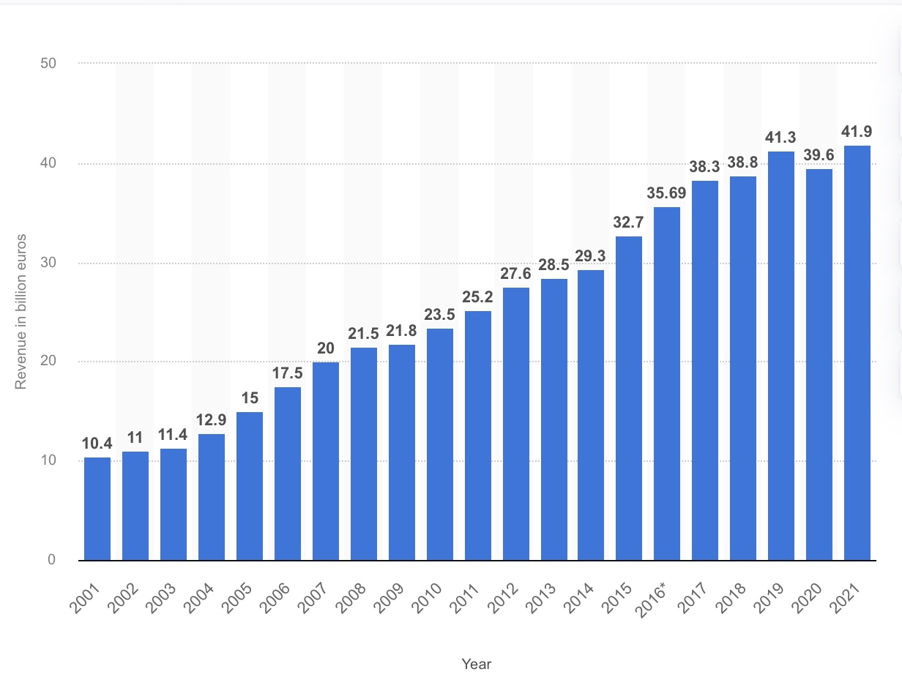
Figure 1: Annual revenue of the IKEA Group worldwide from 2001 to 2021
(Source: Satista.com, 2022)

Chosen product
The IKEA Group offers a wide range of furniture items that are beautifully designed, high-quality, durable and affordable enough for most people to buy. The main aim of IKEA Group was to design easy-to-manufacture and low-cost furniture, disassemble it in stores and display it in the showroom with detailed and clear instructions, with no sales staff required.

Reason for choosing this product
IKEA is running their business by using different types of business strategies to make its business more developed in the upcoming situation. (Burt et al., 2021)
The chosen company can achieve a higher level of success by maintaining its selling procedure. Offering the customers an attractive offer can increase their selling level and they will be able to supply sufficient products in the market according to the demand of their customers. Along with this, the company has earned a higher level of goodwill which is the most valuable thing for any kind of organisation to increase its profitability. For known company activities and business development style, the company has been chosen.

Identifying demand and market equilibrium

Nowadays, there is a higher level of competition in the marketplace and every organisation is running their business much more effectively, not facing any kind of problem in an upcoming situation just of the competition. (Arestav and Astrom, 2018) Identifying the market demand and market equilibrium is a major responsibility for every organisation and here are some points that describe it properly.

Price substitutes
Making substitutes for products can be a very useful strategic step to identify the market demand. In this case, the organisation has to be concerned with making more innovative products like beds with good quality and obviously, that should be attractive to the customer.
The price of substitute products has decreased and the quality of products has improved more.
Once the customer feels that the product has been made with high quality at a reasonable price, they will like to have that for a certain period.
According to many economists, making substitute products also helps to encourage employees to use their creative thoughts in their workplace. In this present case, it can be seen that they can be able to compete with other businesses with more efficiency and effectiveness.

Price complementation
The component product of the present organisation is a drawer, table bases, tables tops and more things.
The price of these component products has been decreased so they have been able to supply their products within a less amount.
Once the customer visits their stores and gets an offer with a reasonable price they will like to buy their product again and again. In this present case, the organisations are trying to make development in their organisational activities by making an attractive price for their products and services. During the last few years, it can be seen that the organisation is getting a higher level of profit by selling a large amount of furniture. Apart from this, it is true that customer satisfaction is a most important thing for every organisation so IKEA have to be more concerned on

Consumer income
The selling process or the level depends on the level of earning of the customer because the customer will like to buy more products once their earning level will be increased. At the same time, customers would like to have a product with a good price rate while their earning level is low.

Consumer preferences and tastes
The consumer will like to have a product by demanding more new products designed for the organisation. According to their choice and comfort once the organisation innovate more new product they will be able to increase their selling level because it is one of the other business strategies for increasing the earning level.
The market demand will be increased when the customers will find that there is a new and attractive product that is within an affordable price and they will like to buy that. Consequently, the market demand will be increased automatically which is the best opportunity to overcome further complexities that often arrives in the business field. According to Burt et al. (2021), equilibrium points also will meet at the time while the organisation will be able to supply their product according to the demand of their customer. After all of these, it can be said that organisations can be able to achieve a higher level of achievement and maintain their sustainability in the long run.
Expectations of price
Focusing on the consumer demand, choice, income level and expectation towards the products and the price rate, the organisation has decided to decrease the value of the products as much as possible for them.
Customer satisfaction is the major factor of a certain company and every organisation needs to take the necessary steps for this purpose. The present organisation is focusing greatly to increase their earning level and making their selling procedure improved by providing their customer with an attractive offer. (Arestav and Astrom, 2018) Consequently, the organisation will earn more goodwill and the demand for their product will be increased automatically which is very important for them.

Demographics

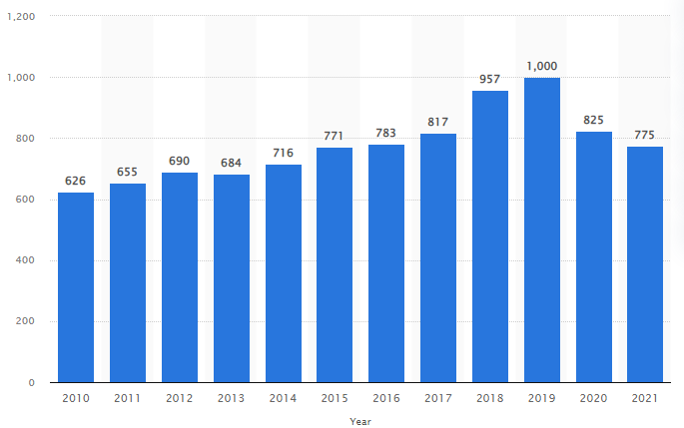
Figure 2: Number of visits to IKEA stores worldwide from 2010 to 2021
(Source: Satista.com, 2022)

The above graph describes the customer number and the position in properly making customer satisfaction of IKEA. According to the graph, it can be seen that the organisation has achieved a higher level of customers in the year 2018 and 2019 which has decreased significantly in the last two years from 825 million to 775 million.
Roughly IKEA Group has more than 775 million customers in this present situation and it is a huge number for any kind of business organisation. Along with this, the organisation is focusing on making more innovative models and products at a low price rate so they can be able to compete with other similar businesses with a great efficiency level and every organisation needs to be concerned about it.

Factors influencing the price elasticity of demand
a) Availability of Substitutes: - In economic and consumer theory, a substitute or interchangeable good is a product or service that consumers consider to be substantially identical or sufficiently similar to another product. (Hayes, 2022) As far as there exists a high range of substitute goods the demand will be more elastic
b) Luxury or Necessity Goods: - luxury items are recognized as the opposite of inferior or necessity goods. The goods that the company IKEA produces are high budgetary and luxurious, thus the customers of the company are high income budgetary.
c) Income spent buying the goods: - When consumer incomes increase, people have more money to spend. This means that demand for many goods and services will increase as consumers look to spend extra money. (BBC, 2022) They may buy upgraded versions of products they already own. In this case, IKEA expects to sell more of these luxury goods and services, which means it will make more products and potentially hire more people.
The income is directly related to the factor of consumer spending money, thus increase in income generates the ability of high spending money. A decrease in income rate will low grade the spending money on the product.
d) change in Price: - price changes create a specific change in the demand curve, which leads to changes in the quantity demanded. Price changes are directly related to the changes in demand as the proportion of the quantity demanded has been relatively changed.
Describing the fact how the main product of the company has been affected by the price elasticity of demand
Price elasticity affects a firm's ability to follow an increase in the price of a product; elastic goods are more sensitive because a slight increase in demand changes the demand for a product. IKEA's products are furniture and appear to be elastic goods. The reason for the flexible goods of furniture is a large number of substitutes. The more substitute goods the demand will become elastic, as there is also no need to pay off higher prices.
Substitution effect on luxury or necessary goods
The Substitution effect on the necessary goods, in general, may happen because of the relative change in the price of the substitute goods. The company IKEA is having an elastic product, therefore, it is having a huge range of competitors more likely American Woodmark. Thus changes in the price of competitive goods influence the demand for the product. Moreover, if the consumer finds the same product at a lower price thus it creates a Substitution effect on the necessary goods.

From the perspective of the customer the goods are luxury or necessary
As per the customer's point of view, IKEA products are necessary goods, and that is the reason the goods are elastic. The company's product segments are based on average income groups and do not produce high- or low-income products. Along with this, the proportion of the amount that the consumers spend in purchasing the product determines the phrase that the product is luxury or necessary for the consumer.
The factor that indicates the demand is elastic or inelastic
The factor that determines the approach of indicating the demand is the pricing segmentation of the product. As the product pricing segment of the IKEA business it has been recognised that the product is elastic (Han et al. 2022). Pricing level, type of product, level of income of the consumer, and most importantly the availability of the substitute products generate the factor affecting demand.
However, the inelastic mode of the product does not change even with the influence of demand or gain in consumer income. The price of inelastic goods always remains the same as these goods are considered luxurious goods (Serafimova et al. 2021). The inelastic goods are co politely different from the elastic goods. The substitutes of the inelastic goods are less or can be said not even close to the variant of elastic goods. In the case of elastic goods, the enlargement quantity in substitute goods enables the mode of discrimination in the demand for the product.
Purchasing the product determines the income power of the consumer
The purchasing power of the buyer evaluates the income power of the consumer, whether the income is high or low of the consumer. The income power of the consumer also derives from the fact of pricing of the goods, as the high price of goods will determine the downgrade in the sale (Elf, 2020). The decrease in the pricing of the product will increase the selling margin of the product. The income of the consumer also emphasizes the fact of influencing demand for the product. As high income generates a high mode of selling and low income of the customer will react on the opposite of high income.
The pricing policy that the business should implement in its business
The company IKEA should implement an economy pricing strategy and pricing for market penetration in its business.
Economy pricing strategy: - The economy pricing strategy help to lower the cost of the product by considering the low amount of investment in the production (Sala et al. 2020). Economy pricing permits the company to set the price of the final product as per the actual valuation of the production.
Pricing for market penetration:- The penetration pricing is implied by the business organisation to attract customers. A reasonable price helps to gain market penetration of the company. Customers are more affected if they can find the same quality product at a reasonable price. Hence, the economic pricing and penetration pricing are appropriate for the company IKEA.
The present organisation is trying to make more innovative typing by maintaining its pricing policies. In this case, they are trying to gather more investors for their company and make more innovative things to meet the market demand in the upcoming situation. Consequently, they will be able to reach a higher-level position in the marketplace to increase their profitability.

Conclusion

The entire report has described the topic related to the economical factors of IKEA and there it can be known how the present organisation is running their business activities by following different kinds of business strategies. Moreover, according to the graphs of the company, it can be known how the pricing policies are followed by the company and it can be known those are the positions of the company to achieve customer satisfaction.

Reference List
Arestav, A. and Astrom, S., 2018. Bridging the digital and physical worlds: The deployment of augmented reality in a retail setting–a case study on IKEA.
Burt, S., Dawson, J., Johansson, U. and Hultman, J., 2021. The changing marketing orientation within the business model of an international retailer–IKEA in China over 10 years. The International Review of Retail, Distribution and Consumer Research, 31(2), pp.229-255.
Elf, P., 2020. Supporting sustainable lifestyle change: an evaluation of IKEA's Live Lagom project (Doctoral dissertation, University of Surrey).
Han, D., Konietzko, J., Dijk, M. and Bocken, N., 2022. How do companies launch circular service business models in different countries?. Sustainable Production and Consumption.
Sala, C.M., Robles, E. and Kowaluk, G., 2020. Influence of adding offcuts and trims with a recycling approach on the properties of high-density fibrous composites. Polymers, 12(6),
Serafimova, M. and Stefanoska, B., 2021. OPERATIONS STRATEGY AND COMPETITIVENESS-CASE STUDY AND ANALYSIS. Yearbook-Faculty of Tourism and Business Logistics, 1(1), pp.31-38.
Forbes (2022) IKEA. [online] Available at: https://www.forbes.com/companies/ikea/ [Accessed 26 April 2022]
Statista (2022) Annual revenue of the IKEA Group worldwide from 2001 to 2021 (in billion euros). [online] Available at: https://www.statista.com/statistics/264433/annual-sales-of-ikea-worldwide/ [Accessed 27 April 2022]
Statista (2022)Number of visits to IKEA stores worldwide from 2010 to 2021. [online] Available at: https://www.statista.com/statistics/241828/number-of-visits-to-ikea-stores-worldwide/ [Accessed 27 April 2022]
Hayes, A. (2022) What Is a Substitute? [online] Available at: https://www.investopedia.com/terms/s/substitute.asp [Accessed 3 May 2022]
BBC (2022) The economy and business. [online] Available at: https://www.bbc.co.uk/bitesize/guides/zrwtmfr/revision/3 [Accessed 4 May 2022]

