
COMMUNITY ENGAGEMENT
LCBB4002
ASSESSMENT 1

UNIVERSITY OF WALES TRINITY SAINT DAVID
LECTURER: DR MOLLY JACK
STUDENT NAME AND ID: AMNA MASAUD 2113737
SUBMISSION DATE 3RD OF MAY 2022
WORD COUNT:2200

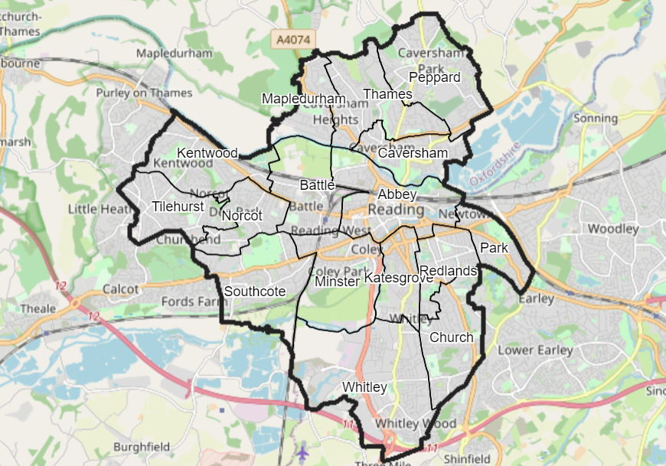
TABLE OF CONTENTS

TABLE OF FIGURES 2
INTRODUCTION 3
MAIN BODY 4
VISION 4
OBJECTIVES 5
BEST PRACTICES AND STANDARDS OF COMMUNITY ENGAGEMENT 5
STAKEHOLDERS’ ENGAGEMENT 5
SOCIAL MEDIA PLATFORMS 6
CORE COMMUNITY ISUUES 8
DEPRIVATION 8
CRIME 9
ENVIRONMENT 10
HEALTH, CULTURE AND WELLBEING 10
WAYS TO COMBAT THE CORE COMMUNITY ISSUES 10
SECURING READING’S ECONOMIC SUCCESS 10
ENSURING ACCESS TO HOUSING TO MEET COMMUNITY NEEDS 10
PROTECTING AND DEVELOPING THE LIVES OF CHILDREN AND ADULTS THAT ARE AT RISK 10
COMMUNITY ENGAGEMENT PRACTITIONER 11
CONCLUSION 11
RECOMMENDATIONS 11
REFERENCES 12

TABLE OF FIGURES

FIGURE NUMBER | DESCRIPTION | PAGE NUMBER
1 | Reading at a glance | 2
2 | Reading’s population in 2020 | 3
3 | Reading Council’s News platform | 6
4 | Reading’s Brand Portfolio | 6
5 | Reading’s multiple deprivation 2019 | 8

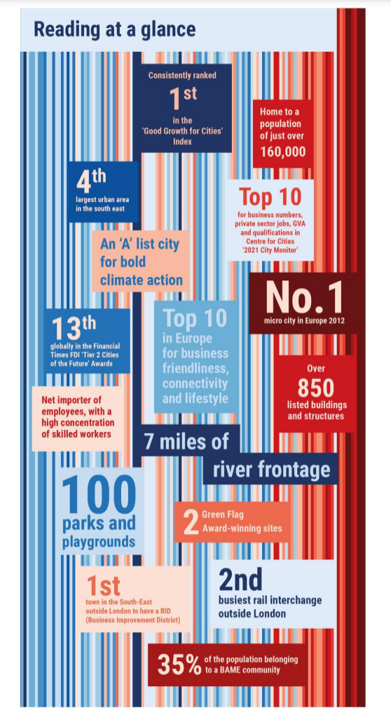
INTRODUCTION

Figure 1: Reading at a glance (Council, 2022)
According to Day (2006), community is a concept that has a complex and vague meaning, referring to the things that people have in common and tie them together providing a sense of belonging. It represents the base of society by bringing identification and solidarity in the community.
In the following report will be conducted an in-depth research and analysis of Reading’s community by identifying:
- the best practices and standards
- stakeholders’ relationships, strategies and participation
- core community issues
- ways to promote the community
The town represents the principal regional and commercial centre of the Thames Valley and a significant retail and leisure destination, having a population of 165,000 in 2020, as shown in Figure 2.
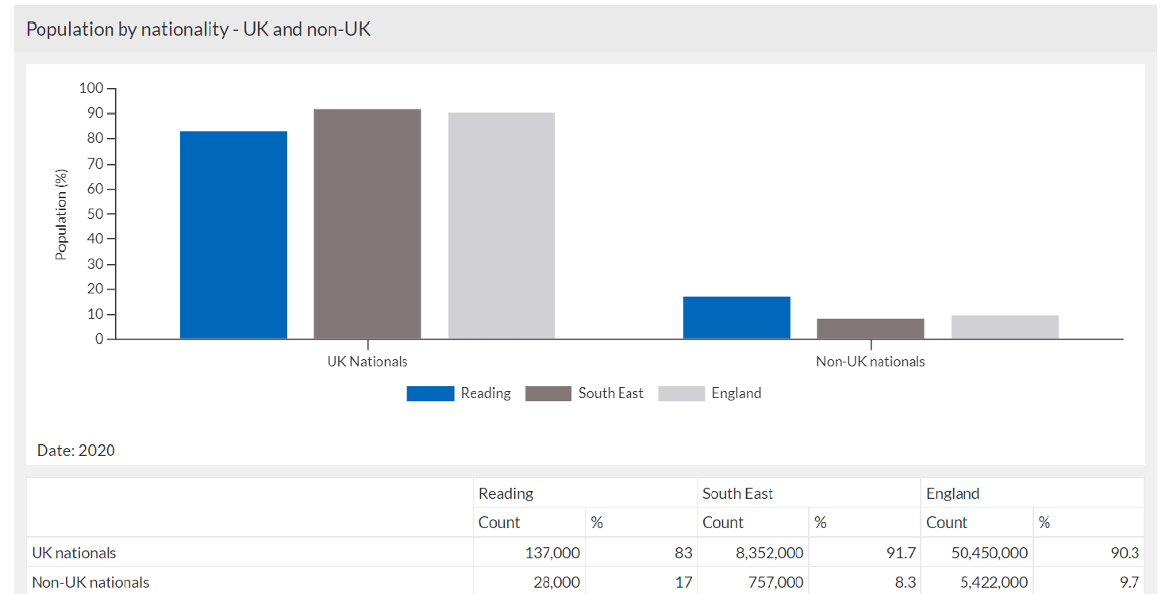

Figure 2: Reading’s population in 2020 (Council, 2022)
Reading represents a major transport interchange, having into proximity London and Heathrow Airport and has a significant percentage of high skilled working population, due to the well know University of Reading. However, all these benefits have brought problems like pressure on the communities, infrastructure and environment. The communities have been severely impacted in the last years by the increasing of living costs, crimes and deprivation. Reading Borough’s key outcomes are to improve the well-being of the residents and to address the needs of the ones requiring special attention.

MAIN BODY

VISION

The present vision of Reading is to realise its potential and ensure that everyone that works and lives in the town can acknowledge and take advantage of the benefits. To accomplish the vision, the Council’s work will be divided and focused on three main categories: healthy environment, inclusive economy and thriving communities.
By 2050, Reading is planning to be known as an economical and international borough. It foresees a place where carbon free lifestyle will be the standard and the innovative technology will develop an energetic and provable town, with a high life expectancy and fair opportunities for all the members of the community.

OBJECTIVES

The objectives of Reading are closely linked with the town’s desire to abolish the differences and improve the living standards of its residents:
- Strengthen the role of Reading by focusing on the development of employment, housing, facilities and services
- Improve the quality of life by creating inclusive and sustainable communities with access to education, employment, transport, healthcare
- Assuring that all the communities are sustainable and adapting to the climate change
- Offer cultural opportunities through multiculturalism, local heritage, leisure and arts
- Improve and develop transport systems, especially by sustainable modes: walking and cycling

BEST PRACTICES AND STANDARDS OF COMMUNITY ENGAGEMENT

Reading’s Council implemented a Community Involvement Guidance in 2012, that still applies, which is communicating the policies, practices, standards and is aiming to involve residents and customers:
Accessibility and choice: ensuring that the residents are informed, listened and involved regarding their needs. They can choose whether to be involved, how and to what extent taking into consideration the legal delimitations.
Timeliness: the individuals are involved and informed as early as possible in terms of community needs and expectations.
Inclusiveness and equity: all points of view are taken into consideration and diversity is valued under any circumstances. Opportunities are fairly accessible to everyone and youngsters’ and adults’ perspectives are treated in the same way.
Transparency and honesty: The borough provides transparency towards proposals, the process, outcomes, timeframes, limitations or requirements. The citizens are entitled to challenge any barrier that takes them apart from achieving the goals and to work collaboratively to find solutions.
Listening and respect: each contribution is valued, listened to and respected.
Accountability: proofs of individual involvement in the community are provided together with the outcomes.
Flexibility and evolution: a regular re-evaluation of Council’s involvement processes and methods will be taken. It will be modified in response to feedback or changing of circumstances.
Source: Council (2022)

STAKEHOLDERS’ ENGAGEMENT

Community engagement provides the best results when there is an evolving process and enables connections and confidence that will strengthen over time. Reading’s community engagement team are organising regularly Individual engagement events where are participating residents, the wider community and stakeholders to update them in terms of the progress made, gain feedback and understand any ongoing issues. The local key stakeholders are having a private preview as well with the project team to discuss the schemes implemented and the outcomes expected.
Reading has a third sector that is helping with the voluntary projects and consists of 1,000 separate organisations, linked with different projects. There have been put in place funding agreements (grants and/or contracts) with the members of the sector. During the COVID-19 pandemic, the community and voluntary sector worked together to implement the Reading Community Hub, where they have provided 7 days a week assistance for the people in need from the community. It was an outstanding project, with significant results, which will remain in Reading’s history forever.
After two years of pandemic, the Council established strong connections with the volunteers and both sides agreed to be involved in further projects that will make Reading’s community a better place to live.

Source: Rochester (2010); Council (2022)

SOCIAL MEDIA PLATFORMS

As Reading is a modern town and in a rapid and continuous development, the Council tries to stay in touch with its residents throughout a variety of channels that are relevant for the ‘era of technology’. Nowadays, social media represents a significant influence towards individuals believes and approaches, hence why, the local Council has a variety of platforms from where information can be gathered.
- Twitter

NAME: READING COUNCIL
- Facebook
- Instagram
- LinkedIn
- YouTube
- Nextdoor
The social media platforms are helping the residents to have a faster, easier and straight forward conversation with the officers, but as well keep them updated with the news and events from the local area (such as festivals, road closures, etc.). Trough these channels, the borough is able to evaluate its performance, the traffic and least engaging subjects.
Except the platforms mentioned above, Reading’s Council website has as well a news platform where all the recent events are presented, as shown in Figure 3.

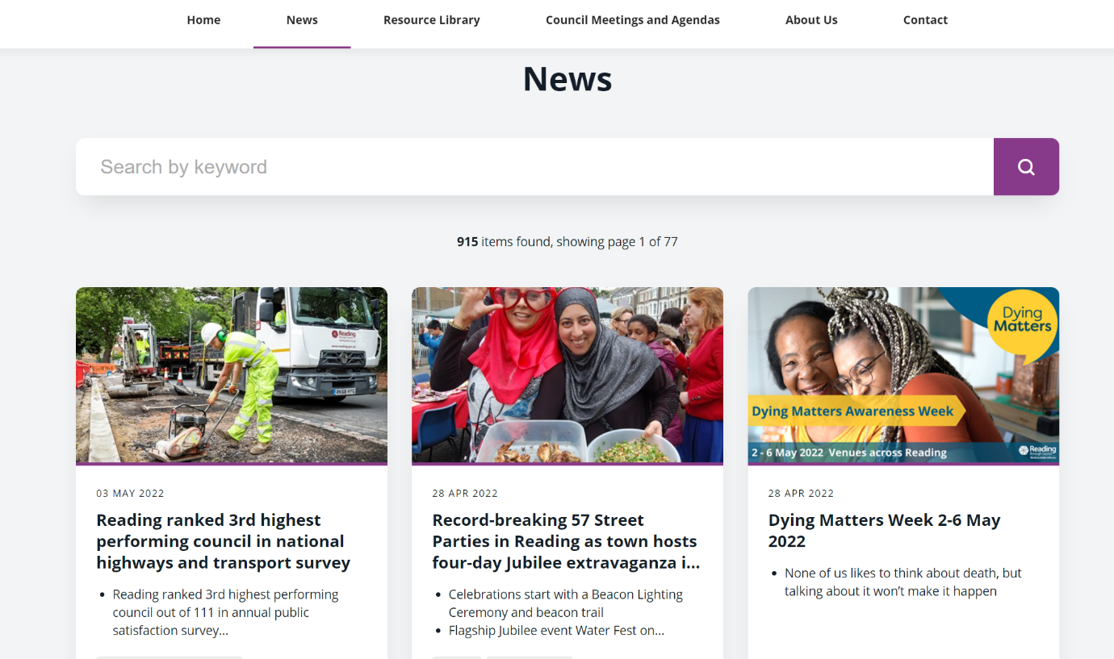
Figure 3: Reading Council’s News platform (Council, 2022)


Figure 4: Reading’s Brand Portfolio (Media, 2021)
The town is aiming to provide equal chances to the community adherents and created a Portfolio, called Media Pack(Figure 4), where local businesses are promoted and helped to reach a wider public in exchange of an amount of money. As Reading is one of the top five towns in England in terms of economies, the portfolio is accentuating its prestige, with the help of marketing team which manages to create eye-catching presentations for the businesses. It is delivered to over 70,000 households, twice a year.
Source: Council (2022); Media (2021)

CORE COMMUNITY ISUUES

According to Glichrist (2009), communities are having as well downsides and relationships are not always ‘universally beneficial’. The pregnant standards of community can destroy the identity and confidence of individuals over the time. Consequently, people will either start to obey or act against community’s goals. However, as much as Reading’s Council tries to satisfy communal needs, there are still core community issues concerning the wellbeing of the residents, such as:
- There is a significative amount of unqualified workers
- Facing significant congestion challenges that are directly impacting the residents
- The newly developed retail shops in Oxford and Bracknell represent a high competition and the shift towards online shopping are drastically impacting Reading’s economy
- The rising service costs and demand for people with special needs (individuals with impairments, endangered children and the enlarged number of elderly people over 75)

DEPRIVATION
Although Reading was in a continuous and rapid change, there is a discrepancy between the economic success and degree of benefits to local people, creating a significative gap between the most and least flourishing neighbourhoods. It is the 3rd most unequal town regarding the wealth and is 15% below the national level of poverty, as presented in Figure 5.
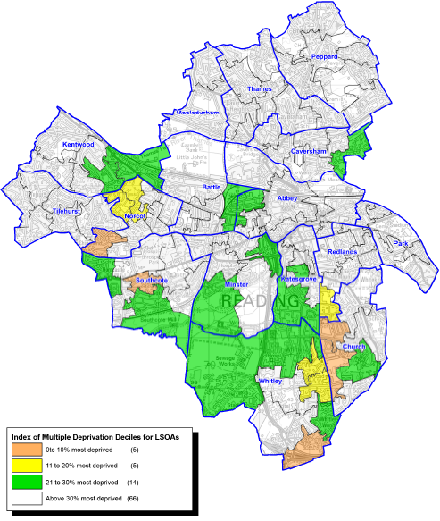
Figure 5: Reading’s multiple deprivation 2019 (Council, 2022)

CRIME
The fear of crime and crime have become extremely significant to Reading’s population, once the economy started to grow in the last years. However, the crime rate remained average, being reported 17,183 crimes in 2019-2020, having a 4.8 % increase compared with the previous year. In terms of personal theft and cycle theft it is above average and below average for the vehicle theft. Reading’s community Safety Partnership communicated its priorities: domestic violence, protecting vulnerable communities against hate and racism crime and adult exploitation.

ENVIRONMENT
Reading’s social wellbeing and economic welfare are directly connected to the quality of the environment. There are few ongoing issues in terms of the environment:
- increased level of fly-tipping
- low rate of recycling: 32%
- vandalization of the parks and open spaces
- play areas with low or inexistent access for children with disabilities
- pollution from traffic congestion

HEALTH, CULTURE AND WELLBEING
- deterioration of Council’s leisure facilities from Meadway, Rivermead and Palmer Park
- lack of health services to prevent obesity and addiction to drugs, smoking, alcohol
- low achievement of adult learners
- lack of investments to increase capacity in schools and building new ones

WAYS TO COMBAT THE CORE COMMUNITY ISSUES

Reading aims to contribute towards improving the global challenges, such as climate change. The Council admitted that is now in a climate emergency and will become a carbon free town by 2030.
However, except the climate crisis, the borrow has developed certain priority plans to tackle down the issues that the community is facing:

SECURING READING’S ECONOMIC SUCCESS
Reading’s goal is to become a well-recognised place of fair work and business and to have the highest economic prosperity per person in the Sout East part of England. To accomplish these goals the town will shift towards affluence, inward investment and efficiency by encouraging the growth of a skilled workforce, developing the infrastructure and initiating new and current business areas. The growth will be beneficial for disadvantaged people and communities.

ENSURING ACCESS TO HOUSING TO MEET COMMUNITY NEEDS
All the people from Reading’s community should have access to a home direct proportional with their financial situation. The borough wants to raise the quantity and quality of houses ready to use by building more buildings, improving the standard of private rented accommodation, assuring that are enough properties available at decent prices and decreasing the levels of homeless people.

PROTECTING AND DEVELOPING THE LIVES OF CHILDREN AND ADULTS THAT ARE AT RISK
To protect the vulnerable people of the community will be promoted independent living, controlled the increasing request for facilities, and establish tight connections with associates from the education, health and voluntary fields. Reading will protect each child and assure that lives in a safe environment and is under professional supervision.
Source: Council (2022)

COMMUNITY ENGAGEMENT PRACTITIONER

Community engagement contains a lot of uncertainty and is difficult to provide accurate reports and research. In a wider way, it involves discussing with the residents and obtain their feedback. To be a good practitioner is not enough just to listen and pass over the issues/ concerns of the community. A devoted practitioner will help, motivate and find ways to flourish relevant strategies to help the communities in need. He creates as well strong connections with the stakeholders, by addressing the most important challenges that they are facing and helping them to contribute to their community’s future. However, the environment plays a primordial role in the process, as every change that is facing will equally impact the community, stakeholders and practitioner. (Vazquez, 2020)

CONCLUSION
In conclusion, the concept of community will remain vague, subject to interpretation and will aim to abolish the core community issues for a brighter future. In the near future Reading’s Civic Society will play an important role in conserving borough’s beauty, representing one of the most influential and respected group that aims to protect town’s heritage. The 1,000 organisations that are members of the town, will help as well in the path towards development as are the leaders in creating organisations from different fields (non-profit, education) from which Reading can benefit. There is no clear model that is suitable to understand the contexts of community engagement approaches. However, it aims to reduce inequality, improve the quality of life and provide more for the groups that are at risk. A lot of factors need to be taking into consideration, especially the environment when the outcomes need to be maintained over the time.

RECOMMENDATIONS
A private group/platform only for residents will be an important recommendation as will help them to establish deeper connections between each other and discuss community issues without being afraid that the Council will act against them. It will be even more engaging if the community engagement practitioners will be taking part as some of the issues could be passed straight away to the relevant person.

REFERENCES

Community, p. (2014). Community planning toolkit. [Online] Available at: https://www.communityplanningtoolkit.org/sites/default/files/Engagement.pdf
[Accessed 1 05 2022].
Council, R. B. (2004-2022). Planning policies. [Online] Available at: https://www.reading.gov.uk/planning-and-building-control/planning-policy/ [Accessed 10 04 2022].
Council, R. B. (2022). Reading Observatory. [Online] Available at: https://reading.berkshireobservatory.co.uk/ [Accessed 20 04 2021].
Council, R. B. (2022). Reading Borough Council. [Online] Available at: https://www.reading.gov.uk/
[Accessed 15 04 2022].
Day, G. (2006). Community and everyday life. London: Routledge.
Gilchrist, A. (2009). The well-connected community [electronic resource] : a networking approach to community development. 2nd ed. Bristol: Policy Press.
Media, P. (2021). Reading the town with a big vision. [Online]
Available at: https://images.reading.gov.uk/2020/01/Reading_Borough_Council_Media_Pack.pdf
[Accessed 29 04 2022].
Rochester, C. (2010). Volunteering and Society in the 21st Century [electronic resource]. London: Imprint Palgrave Macmillan; Palgrave Macmillan UK.
Vazquez, L. (2020) ‘Review: The Heart of Community Engagement: Practitioner Stories From Across the Globe by Wilson, Patricia A’, Journal of planning education and research, p. 739456–. doi:10.1177/0739456X20916756.

