

University of Wales Trinity Saint David
School of Engineering

Connecting rod dynamic forces report

Gareth John England
Student ID – 1702839
BSC Automotive engineering

Contents.

Contents……………………………………………………………………………………………………………………………Page 2
List of figures…………………………………………………………………………………………………………………….Page 3
Introduction………………………………………………………………………………………………………………………Page 8
Literature Review/Research………………………………………………………………………………………………Page 8
Methodology…………………………………………………………………………………………………………………….Page 9
Analysis …………………………………………………………………………………………………………………………….Page 10
Conclusions……………………………………………………………………………………………………………………….Page 11
Recommendations for Further studies……………………………………………………………………..……….Page 11
References..……………………..……………………………………………………………………………………………….Page 11
Appendices ……………………………………………………………………………………………………………………….Page 12

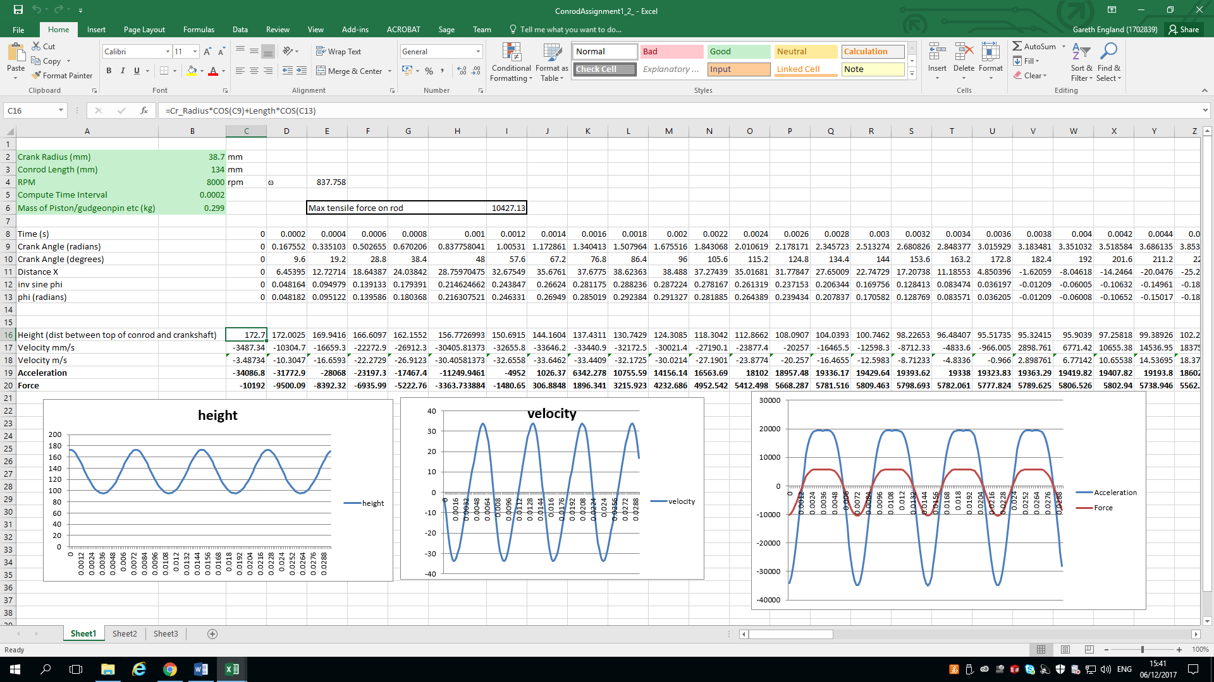
List of figures.
Figure 1

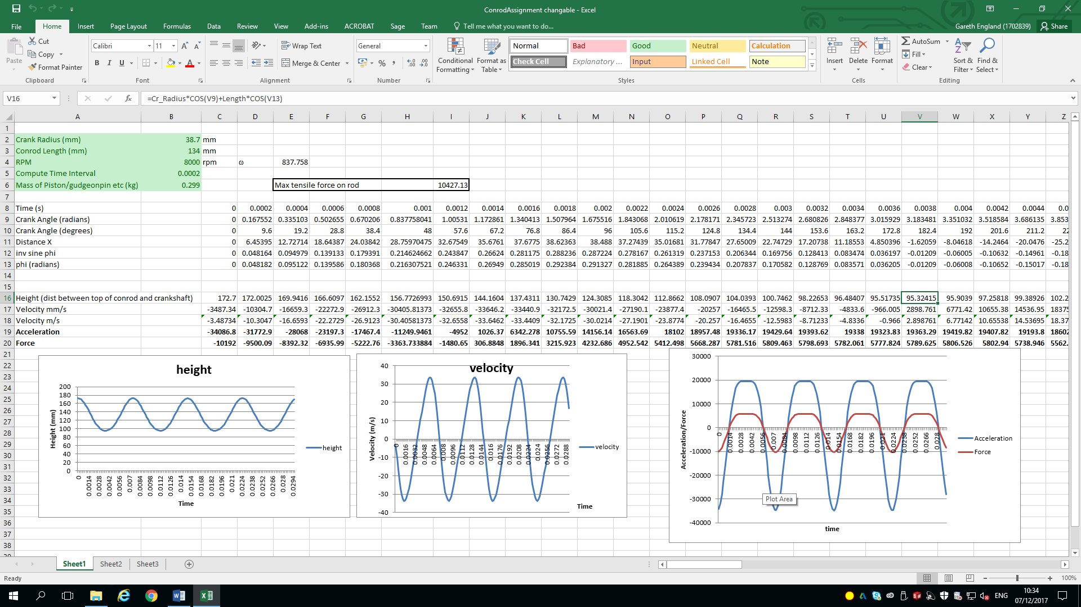
Figure 2

Figure 3

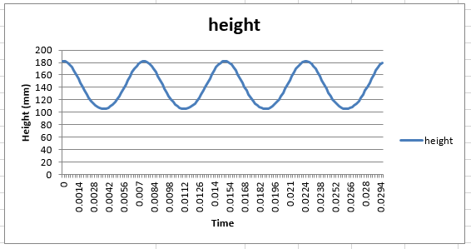
Figure 4

Figure 5
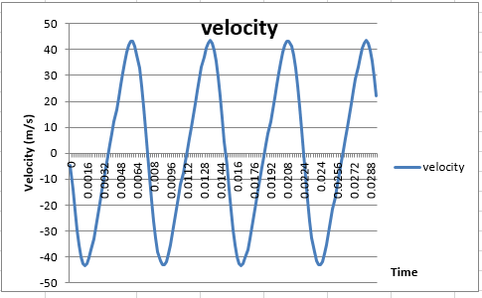
Figure 6

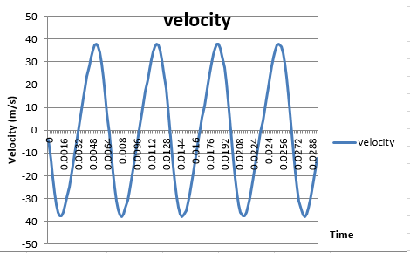
Figure 7

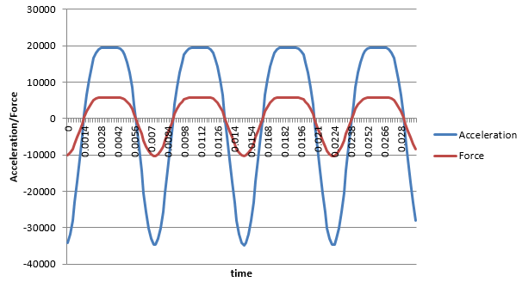
Figure 8

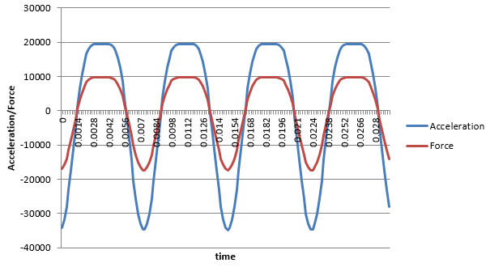
Figure 9

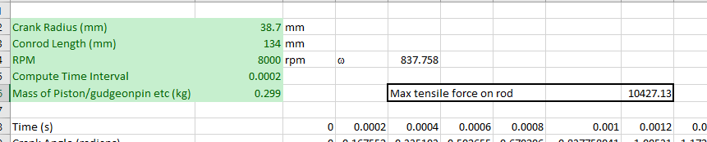
Figure 10

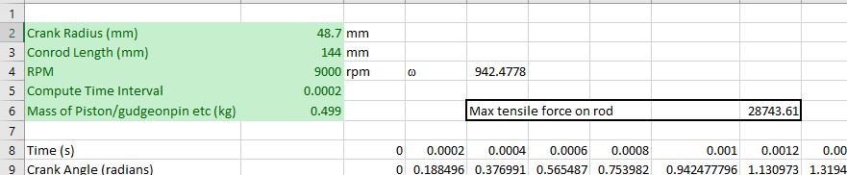
Figure 11

Introduction.
This is a report about connecting rods also known as conrods. Conrods are the pieces that connect the piston head to the crankshaft. This report will focus directly on the forces that conrods undergo and how they differ in relation to certain conditions such as the length of the conrod, mass of the piston, size of the crank radius and the revolutions per minute.
This data will be derived from values retrieved from a table and numerous graphs that will be produced in a Microsoft excel document. The baseline data will be that of research but to see how different conditions effect the conrods experimenting and changing some values are necessary.

To begin the engine chosen for research is a standard stock Honda b16a vtec engine. This engine was chosen because of its wide use and large popularity, hoping there would be extensive and easily available information about the engine. Not to mention it was the first Honda engine fitted with the renowned and innovative variable valve timing & lift electronic control (vtec) system.

Research/literature review.
Before starting this report it is prudent to have some background information about the engine to help with this study into conrods. It would also greatly help in understanding the graphs and how to analyse them. The research will be done primarily through the internet as it’s so accessible. Research into this engine has led to finding out that the engines compression ratio 10.2:1, its engine power is 160bhp, the engine torque is 112lb/f, it has cylinder bores that are 81mm and the engines where in production from 1988 to 2000 as stated in the article (Desjarlais, H. (2012), ‘Honda B16A 1st Gen 88-91 JDM Engine Specs’).

The Honda B16 series engine was one of the company’s most successful models in its modern series. The B16’s popularity was based around Honda’s decision to use the platform to showcase its evolving dual-overhead-camshaft and variable timing/lift electronic control technology as said by (Autos.com Editor. (2013), ‘A Brief History of Honda’s Two Most Successful Engines‘).

Research into this engine led to a service manual with a lot of useful information, most of which was irrelevant in helping understanding and analysing the graphs produced for this report because it was mostly service information such as, where to lift the vehicle (Honda civic) the engine or where to find the vehicle identification number in the engine bay. There is also useful information such as the height and warp tolerance as seen in appendix 1. (Honda motor co.,LTD (1990), ‘shop manual‘)

Methodology.
Before analysing the data and graphs research into the engine and its piston assembly, which includes the conrods the gudgeon pin and the piston head is needed. The research is needed to understand the size, mass and forces that will act upon the conrods.
The report uses a predetermined Microsoft excel program and inputted data from the earlier research to produce accurate graphs, from which values can be produced and analysed.
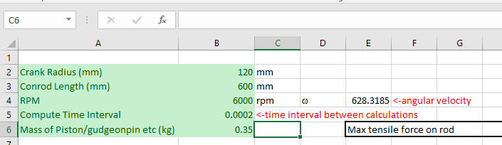
Using the research values will be entered into cells B2-B6. With these values entered the set formula and calculation will change to produce three graphs, from these three graphs we can then determine what is happening the height of the piston, what its velocity is and also its force and acceleration.
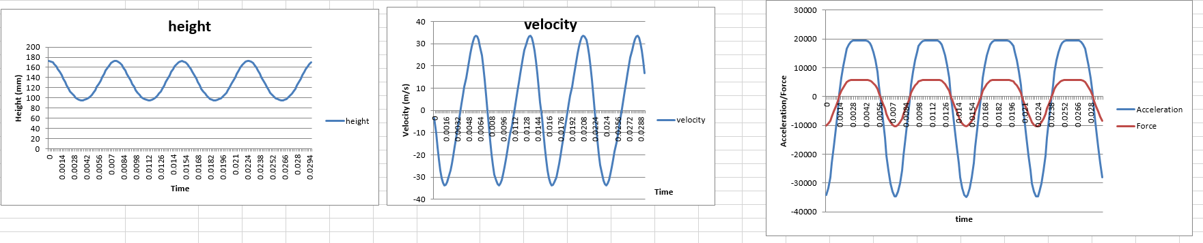
Next alter these values to different conditions and specifications, such as if the engine was at idle speed or the connecting rod was a different length etc. This will alter the graphs and from there, discuss and analyse the findings accordingly.

Analysis.

Graph 1 Height:

Starting with the baseline values figure one shows the height of the conrod at top dead centre (TDC). This condition would either mean the cylinder is on its compression or exhaust stroke. The overall height from the centre of the crankshaft to the top of the conrod is 172.7mm. This value is the length of the conrod (134mm) plus the crankshaft radius (38.7mm). the overall height can be seen in figure 1 under cell C16. This is the beginning point on the first graph labelled height.

Figure two shows the conrod at bottom dead centre (BDC), this means the cylinder will be on either its induction or ignition stroke. The height from the centre of the crankshaft to the top of the conrod is 95.3mm. This measurement is indicated in figure two in cell V16. this measurement is the size of the conrod (134mm) minus the size of the crankshaft radius(38.7mm).

Figure three is a graph showing the oscillations of height between top and bottom dead centre. The oscillations are regular as it goes through the multiple strokes. One engine cycle takes approximately fifteen milliseconds(0.015 seconds). Figure four is the same graph as figure three but the conrod length is increased in its size by 10mm (144mm). This graph shows that the oscillations between top and bottom dead centre are longer but take approximately the same time to complete a full cycle.

Graph 2 Velocity:

Figure five shows the velocity of the conrod under normal working conditions.
Figure six shows the velocity of the conrod when the crank radius is increased by 10mm(48.7mm).
Figure seven shows the velocity of the conrod when the engines maximum RPM has been increased to 9000 RPM.
The frequency is the same but the oscillations differ in length according to specific factors.

Graph 3 Force and Acceleration:

Figure eight shows the graph for force and acceleration under standard working conditions.
Figure nine shows the same graph with the piston and gudgeon pin weight increased by 0.2kg (0.499kg).
With the 0.2kg of added weight figure nine now shows that the acceleration will remain the same but the force at which the conrod is accelerating increases substantially.

Maximum tensile strength:
Figure ten shows the conrods normal standard working maximum tensile strength. Figure eleven shows the maximum value of tensile strength of the conrod if it was modified to be much larger and heavier. As shown by figure eleven the tensile strength has increased extensively.

Conclusion:
In conclusion to push an engine to reach higher velocities and have more acceleration with increased force and engine would have to be modified with larger and heavier piston/conrod assemblies. If the unmodified conrods reached the statistics that the modified conrods operate at then the tensile and compressive forces acting upon the conrods would make them stretch, distort and become brittle to the point that they would end up snapping and more than likely tear a hole in the side of the engine block.

Recommendations for further study:
Author: Mahle GmbH, Editor. (2016), ‘pistons and engine testing ‘ publisher: Springer Verlag

References
Desjarlais, H. (2012), ‘Honda B16A 1st Gen 88-91 JDM Engine Specs’, [Online]. Available: http://www.importinsider.net/2012/01/29/honda-b16a-1st-gen-88-91-jdm-engine-specs/, [Accessed Date – 2017, November, 25].

http: 1. (N/A), ‘B-Series Engine specifications PDF‘, [Online]. Available: http://www.jdmcars.com/tech/admin/bengine.pdf, [Accessed Date – 2017, November, 26].

http: 2. (N/A), ‘Honda B16 Engines‘, [Online]. Available: http://www.jdmspecengines.com/honda-engines/b-series/b16.html , [Accessed Date – 2017, November, 26].
Autos.com Editor. (2013), ‘A Brief History of Honda’s Two Most Successful Engines‘, [Online]. Available: http://www.autos.com/aftermarket-parts/honda-b16-engine, [Accessed Date – 2017, November, 26].

Honda motor co.,LTD (1990), ‘shop manual‘, [Online]. Available: http://www.carenthusiast.com/crxuk/VTEC_Supplement.pdf , [Accessed Date – 2017, November, 28].

Appendices:
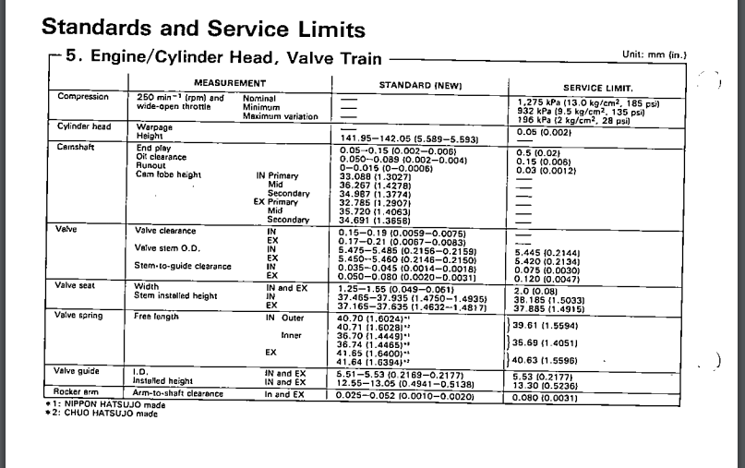
Appendix 1

