Programme: MSc Public Health and Social Care in Practice
Module: Quality Assurance and Service Improvements
Module code: LCHS7006
Assignment Title: Component 2 (Service Improvement Report)

Student name:Afshan Mirza
Student ID:2214807
Table of Contents
Introduction 1
Main Body 2
Recommendation 6
Conclusion 8
References 10

Introduction
Background and Overview
North Midlands Mental Health Trust is a national health service (NHS) which offers specialised mental health services throughout the community setting, both inpatient and outpatient. It offers mental health, crisis response and psychiatric care on a short and long-term basis within the high-pressure environment (NHS Employers, 2025). It works for managing emotional, psychological and physical distress of the patients, risk assessment, crisis management and so on.
Nonetheless, staff wellbeing is highly significant for delivering quality service under the NHS, making them more engaged, productive and delivering effective care. The high stress, lack of staff wellbeing and initiatives, reduces their performance, work-life balance and maximises their dissatisfaction and burnout. The selected case of improved staff wellbeing as well as reducing burnout demonstrates how a lack of staff wellbeing hampers mental health delivery and patient safety, and the significance of it to deliver quality care.
The problem mentioned in the case study.
As defined by Mental Health UK (2024), employee or staff burnout is a workplace syndrome caused by extreme physical, emotional or unmanaged workplace stress. The selected case no five discussed the public health issue of staff burnout due to a lack of staff wellbeing that occurred from the high-stress environment, emotional exhaustion and a lack of work-life balance. As per the NHS survey 2024, in North Midland Mental Health Trust, undergoing 46% staff burnout issue, and an absence rate of almost 6.8%, which is higher than the national average (NHS Employers, 2025). The employee turnover is rising devastatingly, which is enhancing employee disengagement and patient safety concerns, hampering service availability and quality.
The reason the case duty mentioned the problem is a quality concern.
The staff burnout issue is directly linked to quality concerns of healthcare as it impacts care quality, staff satisfaction, productivity and patient safety. As stated by Belicki and Woolcott (2022), tired staff are more prone to errors and mistakes. Therefore, higher stress can reduce the care quality by 20-60%, which creates a high risk for the patients. It reduces the concentration and productivity of employees and reduces empathy and the quality of outcomes. Moreover, enhance recruitment and training costs and minimise service affordability.
Report aims and objectives.
This service improvement report aims to analyse the selected case study and determine the root cause of the burnout issue within the North Midland Mental Health Trust. It will analyse the quality management theories applying Fishbone analysis, 5 whys, as well as the Donabedian Model. Finally, recommend evidence-based service improvement by implementing quality improvement tools, the PDSA cycle, lean methodology, and continuous improvement. Thus, outline a practical and easy implementation way to apply and sustain improvement and eradicate the employee burnout issue to maintain quality care and employee wellbeing.

Main Body
In terms of effectively addressing the employee burnout issue within the Mental Health Trust of North Midland, an informed and theory-based effective analysis needs to be done for empirical and data-driven analysis (Belicki and Woolcott, 2022). Employee burnout within the health and social care system is a multifaceted issue, and the key analytical models discussed below help to determine the key root cause of the problem to guide the best improvement and development approach.
Root Cause Analysis with Fishbone (Ishikawa) Diagram
The Fishbone Diagram is a structured framework that helps to assess and determine the underlying causes of any issue. The issue of burnout in the selected case study is also caused by many underlying reasons, which are determined below by applying the diagram.
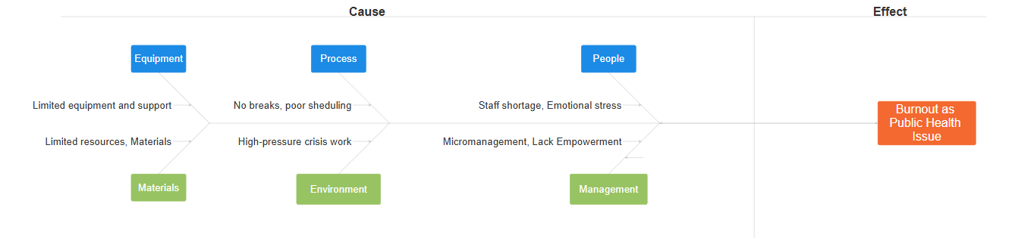
Figure 01: Fishbone (Ishikawa) Diagram.
Source: (Self-made).
People: The staff and healthcare professionals in a mental health organisation need to undergo various traumatic situations and deal with high-risk patients. This led them to nonstop as well as continuous emotional exhaustion and strain. However, with such a solution, if they had to work overtime, take on extra workload, and work under high pressure, this contributes to their compassion fatigue, emotional exhaustion and so on (NHS Employers, 2025). Moreover, the staff shortage issue and high demand for mental health services now a days creating workload pressures, reducing the work-life balance and quality time of the workers, which is enhancing emotional stress, exhaustion and burnout tendency within the employees.
Process: The employee burnout issue is also caused by poor scheduling, a lack of breaks, and holiday issues. These could give some stress relief, refresh the mind and ensure employee emotional and mental well-being (Kite, 2022). However, the healthcare organisations, including the NHS, are not sufficiently conscious to make structured breaks, scheduling and holiday opportunities. The policy and practice are also not consistent and practical. This creates failure while making meaningful outcomes.
Environment: Employee or staff burnout is a workplace syndrome caused by extreme physical, emotional or unmanaged workplace stress or a high-pressure work environment. The staff burnout in the North Midland Trust cause due to high pressure environment and workplace stress. The lack of staff wellbeing from the high-stress environment, emotional exhaustion and a lack of work-life balance occurred. As a result, the organization undergoing 46% staff burnout issue, and an absence rate of almost 6.8%, which is higher than the national average (NHS Employers, 2025).
Management and Leadership: Due to a lack of effective leadership and management in the Mental Health Trust, employee burnout is rising devastatingly, which is enhancing employee disengagement and patient safety concerns, hampering service availability and quality. The poor leaders and management are failing to empower employees, give adequate support and ensure engagement. They fail to establish effective communication, motivate and inspire the employees and engage them in the decision-making process. This reduces their trust and safety and enhances burnout.
Resources (Equipment and Materials): Lack mandatory materials, equipment, resources like staff, capital and infrastructure, also contributing to making a high-stress environment and work pressure (Ahad, 2024). The staff shortage is adding extra workloads, a lack of mechanisms, scheduling, infrastructure and technologies failing to manage the workload and requiring mandatory support. Thus, creating a higher burnout issue.
All in all, the Fishbone Diagram and analysis evidence, the burnout public health issue is embedded by multiple factors and causes under the environment, people, processes, management, and resources.
The 5 Whys Technique
The deep root cause analysis of the burnout issue can be done with the 5 Whys framework.
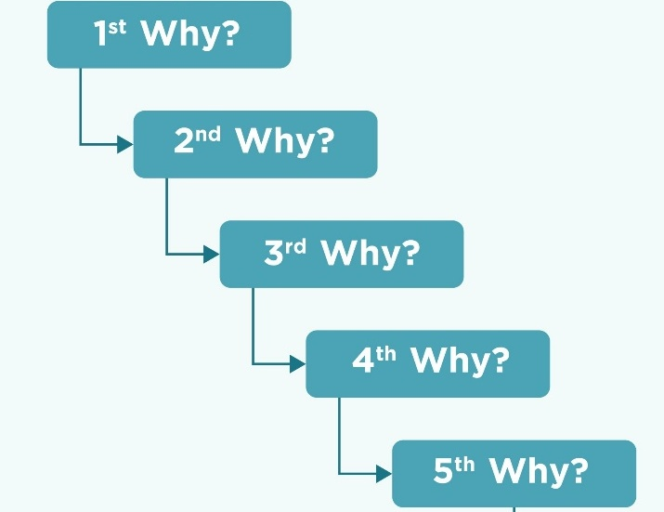
Figure 02: The Five Whys.
Source: (Hipe, 2024).
Why 1: The main burnout issue occurs due to excessive workload and a lack wellbeing policy cause emotional strain.
Why 2: The staff shortage and high demand for healthcare services maximise workload and pressurise the environment.
Why 3: The high workload and stress maximise burnout and contribute to high turnover, absenteeism, and extra workload.
Why 4: This makes an unsupportive and unsafe culture for the employees, and they feel job dissatisfaction.
Why 5: organisations fail to make a culture that prioritises the employees' wellbeing and crisis management, which ultimately contributes to the problem.
Elaboration: The root cause analysis ultimately detects that the main cause of the burnout issue is that organisations fail to create a culture that prioritises the employees' well-being and crisis management, which ultimately contributes to the problem. The outcome of the ineffective leadership and management in the Mental Health Trust, employee burnout is rising devastatingly, constructing a poor culture (Mental Health UK, 2024). The 1st 3 whys detected, excessive workload and lack wellbeing policy cause emotional strain, staff shortage, and high demand for healthcare services, which maximise workload and pressurise the environment. High workload and stress maximise burnout and contribute to high turnover, absenteeism, and extra workload. Thus, the overall situation works as a cycle and an interconnected process, which are not isolated factors. Thus, making a poor and vulnerable workplace culture, which persists in the burnout issue, enhances employee disengagement and patient safety concerns, hampering service availability and quality (Hipe, 2024).
Donabedian Model
The components of the Donabedian model are structure, process, and outcomes, and these components make a comprehensive framework which will help to evaluate the quality of care and underlying issues based on the selected case scenario:

Figure 03: Donabedian Model.
Source: (Self-made).
Structure: The traumatic situations, high-risk patients, high mental investment and high demand for service cause emotional exhaustion and strain on the mental health staff. With extra workload, high pressure, staff shortage issues reducing the work-life balance and quality time of the workers, which is enhancing emotional stress, exhaustion and burnout tendency within the employees (Creighton, 2023). Moreover, a poor workplace culture that does not prioritise the employees' wellbeing and crisis management ultimately contributes to the problem.
Process: The Holiday problems, inadequate scheduling, and a lack of breaks are further factors contributing to employee burnout. These could protect the emotional and mental well-being of employees and provide some stress reduction and mental refreshment. The poor leaders and management are failing to empower employees, give adequate support and ensure engagement. They fail to establish effective communication, motivate and inspire the employees and engage them in the decision-making process. This reduces their trust and safety and enhances burnout.
Nevertheless, the NHS and other healthcare institutions lack the awareness necessary to plan holidays, breaks, and schedules. Additionally, the practice and policy lack consistency and practicality. While producing significant results, this leads to failure (Kite, 2022).
Outcome: Extreme physical, emotional, or unmanaged job stress or a high-pressure work environment leads to employee or staff burnout. Stress at work and a high-pressure environment are the main causes of staff burnout at the North Midland Trust. There was a lack of work-life balance, emotional well-being, and low staff wellness due to the high-stress workplace. For this reason, 46% of employees in the company have burnout tendency suffer from mental health issues, and the absenteeism rate is about 6.8%, which is higher than the national average (Boyas and Wind, 2021).
SWOT analysis
A SWOT analysis has been conducted below to strategically determine the internal and external environment and available strengths, weaknesses, opportunities and threats:
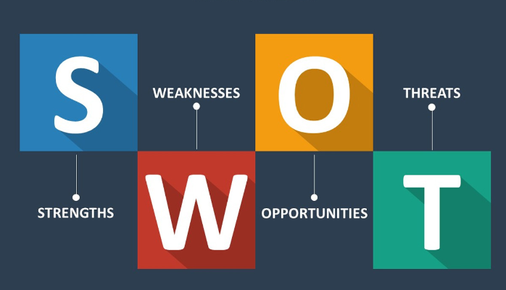
Figure 04: SWOT analysis.
Source: (Arabzad, 2022).
Strengths: The key strength in the case to solve the problem is the establishment of a well-being strategy group. It also detected the need for leadership awareness and recognition to solve the problem (Kumar, 2021). Moreover, a staff representative, an inclusive and innovative approach and an initiative for participative decision-making can make an effective workplace culture and solve the problems. Furthermore, a clear intention of the organisation to make a wellbeing culture with proactive measurement is another strength for solving the burnout issue.
Weaknesses: The burnout becomes persistent with a rate of 46%, where the absenteeism rate is also high. This evidence the systematic inefficiencies and interconnected challenges (Arabzad, 2022). The poor culture, lack of well-being initiatives, makes a gap between planning, policy, as well as practises. Moreover, the high demand for mental health services, as well as the rising staff shortage issue, adds more pressure and contributes to employee burnout.
Opportunities: Maximising the level of staffing using advanced tools and technologies can reduce stress and workload. This can also bring balance and can reduce exhaustion and a high-pressure environment. Moreover, making a wellbeing culture development and effective interventions and offering amendatory resources, IT infrastructure and leadership development can reduce administrative burden and maximise efficiency.
Threats: The situation is creating an enormous threat to patient safety and contributing to the enhancement of staff leaving. The tired staff are more prone to errors and mistakes, which creates a high risk for the patients (Kite, 2022). It reduces the concentration and productivity of employees and reduces empathy and the quality of outcomes. The staff burnout enhances work pressure, and this contributing maximization of staff leaving. Moreover, enhance recruitment and training costs and minimise service affordability.

Recommendation
Based on the root cause analysis above, the organisation should adopt the informed strategies recommended below:
North Midlands Mental Health Trust should do workload management with an effective staffing solution. Maximising the level of staffing using advanced tools and technologies can reduce stress and workload. This can also bring balance and can reduce exhaustion and a high-pressure environment (Boyas and Wind, 2021).
The organisation should focus on offering psychological support and change leadership for managing emotional stress, and should also do effective scheduling, break management and holiday planning for managing burnout and emotional exhaustion (Hiebert and Klatt, 2019).
The organisation should also be involved in making a well-being culture development and effective interventions, and offering amendatory resources, IT infrastructure and leadership development can reduce administrative burden and maximise efficiency.
Implementation frameworks – PDSA Cycle
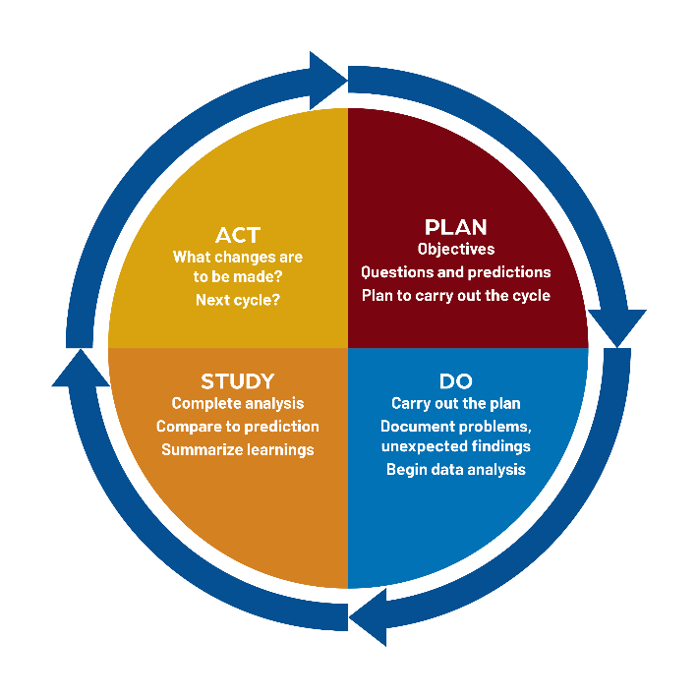
Figure 05: PDSA Cycle.
Source: (Curran and Bunyan, 2022).
The PDSA cycle can be applied effectively and successfully to implement the recommended strategies to solve the burnout issue based on root cause analysis. The framework supports the practical implement the solution and sustains the improvement:
Plan: The initial improvement planning of the burnout issue will involve determining the pilot areas, including determining and analysing root causes of burnout and absenteeism. Making an effective intervention to develop a crisis response team (Belicki and Woolcott, 2022). The intervention should be based on finding the root cause and empirical data, including leadership change, staffing, making protected breaks, holiday planning, offering psychological support and so on.
Do: After effective planning, the interventions have to be implemented by doing small-scale refinement and testing. For that, team check-ins for 15 minutes a week can offer development and refinement opportunities. Here, peer support and reflection will be practised, and guidance will be provided as needed. The employees and authorities also undergo training for promoting the initiatives and implementing them effectively (Curran and Bunyan, 2022).
Study: The interventions and initiatives will be studied and evaluated using qualitative as well as quantitative data. Mandatory surveys, personnel reviews, interviews, and observation were conducted to gather insight about the efficiency of the interventions and available areas of improvement. The key metrics which will be used to evaluate are the absenteeism rate, burnout rate, staff retention rate, patient care quality rate and so on.
Act: The interventions which evidence themselves as effective for the successful improvement of the burnout issue in the evaluation report will be finally implemented (Kite, 2022). The interventions will be broken into small strategies to make them easily implemented. Finally, the feedback loops will be welcome and promoted in terms of gaining insight about further upgrade plans and sustaining the improvement.
Lean Approach
The lean approach can be applied for effective application and sustainability of the improvement plan for the burnout issue. This can support reducing inefficiency, managing and removing unnecessary waste, and enhancing workflow and productivity.
The Lean-based improvement process works for reducing costs and inefficiencies, enhancing responsiveness and engagement, and enhancing performance and continuous improvement. Lean principles can be applied within specific interventions, like maximising the level of staffing using advanced tools and technologies, which can reduce stress and workload. By using digital tools and technologies, it can streamline the staffing process and reduce inefficiency (Nicoletti, 2021). This can also bring balance and can reduce exhaustion and a high-pressure environment. On the other hand, in the process of staff scheduling, holiday and break management, the administrative process can be improved by removing unnecessary scheduling, bottlenecks, and systematic errors. Moreover, by eliminating the redundant tasks, determining significant ones like leadership change, giving emotional support and so on, the unnecessary stress and workload can be managed with a lean approach. This ultimately can reduce burnout and enhance the efficiency of staff and patient care (Senthilkumar and Raffie, 2022).
Six Sigma
This method can be used for data-driven implementation and improving the quality of the improvement plan. It aims to enhance process quality based on statistical or data-driven analysis. It can be applied to gather insight about the efficiency of the interventions and available areas of improvement (Nicoletti, 2021). The approach can be used to evaluate the absenteeism rate, burnout rate, staff retention rate, patient care quality rate and so on. Thus, help to determine trends, patterns, and outcomes to determine areas of improvement, proactive management and improving efficiency, reducing error, waste and leading to higher quality and efficiency.

Conclusion
This report successfully analysed the burnout issue in the North Midland Mental Health Trust and service improvement report analysing a selected case study. It is evident that the staff burnout issue is directly linked to quality concerns of healthcare, as it impacts care quality, staff satisfaction, productivity and patient safety. Employee burnout within the health and social care system is a multifaceted issue, and the key analytical models discussed to determine the key root cause of the problem to guide the best improvement and development approach. Using the analytical root cause analysis theories, like Fishbone analysis, 5 whys, as well as the Donabedian Model, it effectively detected the root cause of the burnout issue. A SWOT analysis was also conducted for offering internal and external environmental insight and available strengths and opportunities for forming the right solution and intervention. Finally, form effective interventions and recommend them for improving the burnout issue. The recommendation emphasizes on in maximising the level of staffing using advanced tools and technologies can reduce stress and workload. offering psychological support and change leadership for managing emotional stress, and should also do effective scheduling, break making, a well-being culture development and effective interventions, and offering amendatory resources, IT infrastructure and leadership development can reduce administrative burden and maximise efficiency. The evidence-based service improvement recommendations implementation plan was also formed, and mandatory quality improvement tools, the PDSA cycle, lean methodology, and six Sigma are suggested in terms of effectively addressing the issue. Thus, the frameworks and approaches are practical and will help apply and sustain improvement and eradicate the employee burnout issue in the Mental Health Trust.

References
Arabzad, S. (2022). Improving Project Management Process in Municipality Based on SWOT Analysis. International Journal of Engineering and Technology, 4(5), pp.607–612.
Asq.org. (2024). What is a Fishbone Diagram? Ishikawa Cause & Effect Diagram | ASQ. [online] Available at: https://asq.org/quality-resources/fishbone?srsltid=AfmBOopay9Ijt4Jy_WuznmXDbKXVye3f56bnRpFAmJDxMhEvMMQeDXC_ [Accessed 29 Mar. 2026].
Belicki, K. and Woolcott, R. (2022). Employee and Patient Designed Study of Burnout and Job Satisfaction in a Chronic Care Hospital. Employee Assistance Quarterly, 12(1), pp.37–45.
Boyas, J. and Wind, L.H. (2021). Employment-based social capital, job stress, and employee burnout: A public child welfare employee structural model. Children and Youth Services Review, 32(3), pp.380–388.
Creighton, S. (2023). Avedis Donabedian: The creator of the Donabedian Model of Care. [online] blog.lifeqisystem.com. Available at: https://blog.lifeqisystem.com/avedis-donabedian.
Curran, E.T. and Bunyan, D. (2022). Using a PDSA cycle of improvement to increase preparedness for, and management of, norovirus in NHS Scotland. Journal of Hospital Infection, 82(2), pp.108–113.
Hiebert, M. and Klatt, B. (2019). The encyclopedia of leadership: a practical guide to popular leadership theories and techniques. New York; London: McGraw-Hill.
Hipe (2024). 5 Whys Analysis. [online] Performance Storyboard®. Available at: https://performance-storyboard.com/5-whys-analysis/ [Accessed 9 Nov. 2024].
Jerry (2024). What is a Fishbone Diagram? Ishikawa Cause & Effect Diagram | ASQ. [online] Asq.org. Available at: https://asq.org/quality-resources/fishbone?srsltid=AfmBOooSGFinDaAG0yFfh3b_iL5Rlb3_IpAC3pFw3FNqgdw9y4nsaxJo [Accessed 29 Mar. 2026].
Kite (2022). Principles underlying the development of clinical guidelines, clinical effectiveness and quality standards, and their application in health and social care | Health Knowledge. [online] www.healthknowledge.org.uk. Available at: https://www.healthknowledge.org.uk/content/principles-underlying-development-clinical-guidelines-clinical-effectiveness-and-quality [Accessed 15 Apr. 2022].
Kumar, P. (2021). A SWOT Analysis. Indian Journal of Applied Research, 3(7), pp.4–6.
Mental Health UK (2024). Burnout. [online] Mental Health UK. Available at: https://mentalhealth-uk.org/burnout/.
NHS Employers (2025). Beating burnout in the NHS | NHS Employers. [online] www.nhsemployers.org. Available at: https://www.nhsemployers.org/articles/beating-burnout-nhs.
Nicoletti, B. (2021). Lean Six Sigma and digitise procurement. International Journal of Lean Six Sigma, 4(2), pp.184–203.
Senthilkumar, Dr D. and Raffie, B.E. (2022). Six Sigma Single Sampling Variables Plan Indexed by Six Sigma AQL and Six Sigma AOQL. International Journal of Innovative Research in Engineering & Management, 3(6), pp.482–489.

