
University of Wales Saint David
Wales Institute of Science & Art

Kinetic Energy Recovery
Module code: ACHA5010
Module: Alternative Propulsion Systems
Lecturer: Mark Sandford

Name: Odysseas Androutsos
Student No: 2005263
Jan. 2023
Contents
1 Introduction 3
2 Literature review 3
3 Selection of vehicle and vehicle characteristics. 5
4 Calculations using the WLTP and analysis of results. 7
5 Selection of KERS 10
6 Conclusions 10
7 References 11
APPENDIX A 13

List of figures
Figure 1 – Mechanical (Flywheel Based) Kinetic Energy Recovery System 4
Figure 2 – Electrical Kinetic Energy Recovery System (Raj, 2014) 4
Figure 3 – Best-Selling Car Models in Europe in 2021 (Carlier, 2022) 5
Figure 4 – VW Golf 2021 (Arora, 2022) 6
Figure 5 – Tractive Forces 8
Figure 6 – Cumulative Tractive and braking Energy 9
Figure 7 – Cumulative Recovered energy per section 9
Figure 8 – Kinetic Energy returned to the wheels with KERS systems 10

List of Tables
Table 1– VW Golf 1.4 TSI eHybrid – Characteristics 7
Table 2 – WV Golf 1.4 TSI eHybrid Technical Data 14

Introduction
The pollution of the environment and the global warming are two major concerns of governments and scientists worldwide. The CO₂ emissions together with the depletion of the ozone layer are the main factors the contribute to the global warming and as a consequence to the climatic changes. In order this problem to be controlled it is necessary to reduce the CO₂ emissions and the air pollution. The use of renewable sources of energy, like solar power, wind energy, hydro energy or wave energy contribute positively in the reduction of the CO₂ emissions. The use of more efficient electric appliances and the use of LED light fittings contribute in the reduction of the power consumption and therefore in the reduction of the CO₂ emissions.
The vehicles and generally the Internal Combustion Engines (ICE) are a huge source of CO₂ emission. The production of more efficient engines and the introduction of Kinetic Energy Recovery Systems in the vehicles together with the Stop and Start strategy definitely contribute as well in the reduction of the CO₂ emission. (Mehrdad et al., 2018) This is an intermediate stage before the production of the ICE stops as per the EU directives and the whole production of cars is shifted to the solely production of electric cars.
The electric vehicles can get the energy required from the grid and since part of the energy from the grid is from renewable energy resources, the CO₂ emissions will be reduced considerably. Also, with the instruction of a KERS and Stop and Start strategy to the electric cars the CO₂ emission will be reduced even more.
It is evident from the above that the KERS and the Stop and Start strategy are systems that are used now and will be used in the production of the vehicles in the future as well. What type of KERS systems are available, what is their efficiency and how match energy can be recovered according the Worldwide Harmonised Light Vehicle Test Procedure (WLTP), these are parameters that will be investigated and discussed in this report.

Literature review
According to EU directives the CO₂ emission have to be reduces(EUR-Lex - 32019L1161 - EN - EUR-Lex, no date). The governments in order to force the vehicle manufacturers and the public towards this goal, imposed road taxes based on the CO₂ emissions of the vehicles their category. The higher the CO₂ emissions of a vehicle the higher the road tax is. This forces the buyers in buying vehicles with low CO₂ emissions and the vehicle manufactures to produce vehicles with low or zero CO₂ emissions.
The motor vehicle manufactures in order to archive this, they produce more efficient engines by capturing some of the thermodynamic energy the ICE produce using Exhaust recirculation system, using the 5th cylinder or using the Millar engine cycle or the heat recovery Rankine Cycle. (Sandford, 2022)
Another way of reducing the CO₂ emission is the introduction of the KERS system to the vehicles There are mainly two different types of KERS systems. (Raj, 2014)
- The Mechanical KERS system where the kinetic energy from the brakes is transferred with the use of a Continuously Variable Transmission (CVT) to the flywheel KERS where is stored. The CTV controls the transfer of the kinetic energy of the vehicle during braking to the flywheel KERS and connects the flywheel to the power train when is required. (see figure 1) The efficiency of this system is 70%. (Raj, 2014) 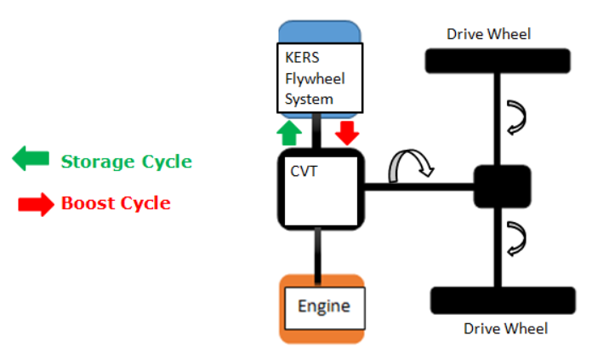
Figure 1 – Mechanical (Flywheel Based) Kinetic Energy Recovery System
(Raj, 2014)
- The Electrical KERS system, where during braking the kinetic energy of the vehicle is converted to electrical energy with the use of Motor/Generator Unit (MGU) is transferred to a storage unit i.e., Batteries. This action is controlled by the Power control Unit (PCU). When the energy which is stored in the batteries is need the PCU manages the transfer of this energy to gear box and then to the wheels through the MGU. (see figure 2) The efficiency of this system is 31%.(Raj, 2014)
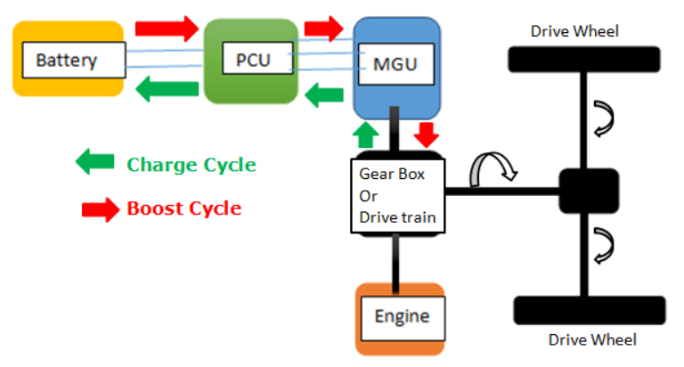
Figure 2 – Electrical Kinetic Energy Recovery System (Raj, 2014)
Both of these systems are used in the hybrid vehicles today.
With the use of the WLTP a suitable KERS system will be designed for a specific vehicle which was selected for this purposed. According to WLTP, the test procedure that will be followed depends on the classification of the vehicle. Based on WLTP (EU: Vehicle Definitions | Transport Policy, no date) there are three vehicle categories based in their power to weight ratio.
- Class 1 low power vehicle with P/W <=22 W/kg
- Class 2 Vehicle with 22< P/W <= 34 W/kg and
- Class 3 high power vehicles with P/W > 34 W/kg
Before proceeding the WLTP evaluation it was necessary to select a vehicle.

Selection of vehicle and vehicle characteristics.
The first step before applying the WLTP to a specific vehicle was to select the vehicle which will be assessed. Then based on its characteristics power and kerb weight its class was identified according on WLTP and then the test procedure was selected.
The selection of the vehicle was based on the number of sales of vehicles in Europe in 2021. Based on the statistics (Carlier, 2022), the vehicle with the highest sales was selected.
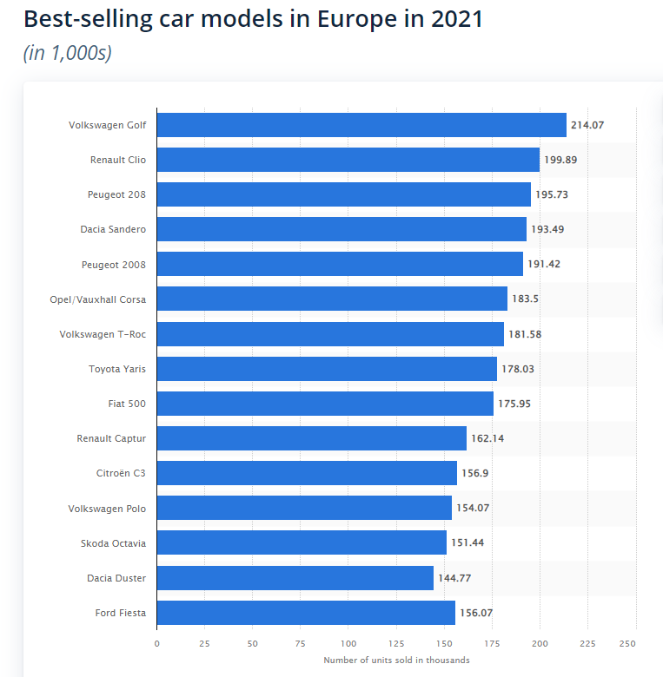
Figure 3 – Best-Selling Car Models in Europe in 2021 (Carlier, 2022)
The reason behind this is, if the KERS system is applied to as many vehicles as possible the global fuel consumption will be reduced and so the air pollution. As it can be seen from Figure 3 the vehicle with the highest sales in Europe in 2021 was VW Golf (see figure 4). It can also be seen also from figure 3, that other cars of the same or similar class have high sales as well. Therefore, the KERS system that will be design for the Golf can be the same for the other vehicles as wells. This will contribute in the reduction of the CO₂ emission even more and the production cost of this system will be even less due to the economies of scale.
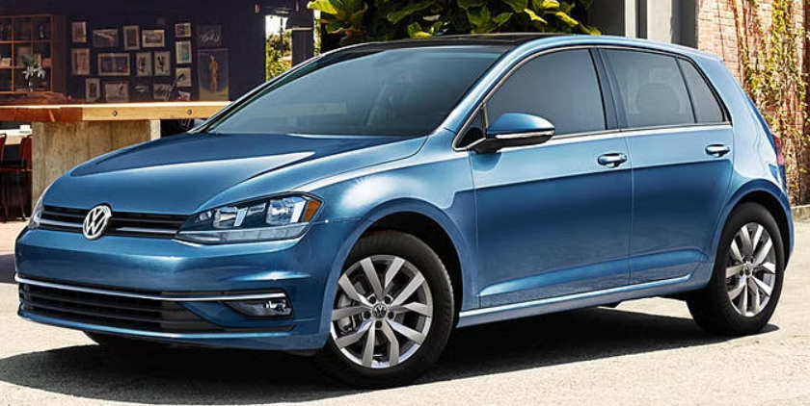
Figure 4 – VW Golf 2021 (Arora, 2022)
After selecting the vehicle, it was necessary to find the following vehicle characteristics in order to be used in the mathematical model for the WLTP.
- The Test mass of the vehicle
- The Rolling resistance coefficient of the vehicle
- The frontal area of the vehicle
- The coefficient of drag of the vehicle
The test mass of the vehicle was calculated based on the definition given by WLTP (EU: Vehicle Definitions | Transport Policy, no date) which is the following:
Test Mass = The actual Mass of the vehicle + 25 kg + 15% of the vehicle load for M category vehicles. Equation 1
After research the kerb weight of VW Golf 1.4 TSI eHybrid model was found to be 1517kg and the maximum load 503kg. (VOLKSWAGEN GOLF 1.4 TSI eHybrid Style 5dr DSG Technical Data | Motorparks, no date) (See Appendix A for more information) The vehicle category of this vehicle is M since is a passenger car. (EU: Vehicle Definitions | Transport Policy, no date). Considering the above and using Test mass equation above the Test mass of the vehicle was calculated to be 1645.45kg.
The rolling resistance coefficient of the vehicle was found to be 0.0065, the frontal area and the coefficient of drag were found to be 2.189m² and 0.281 respectively. (Aerodynamics and rolling resistance | Volkswagen Newsroom, no date)
The above vehicle characteristics are summarized in the table 1.

Table 1– VW Golf 1.4 TSI eHybrid – Characteristics
Vehicle Characteristics | Value
Test Mass (kg) | 1645.45
Rolling Resistance Coefficient | 0.0065
Frontal area (m2) | 2.189
Coefficient of Drag | 0.281

Calculations using the WLTP and analysis of results.
Using the spreadsheet that was provided with the vehicle velocities at every second for each vehicle class category according to WLTP, the acceleration of the vehicle at every second was calculated using the equation below. Where “a” is the acceleration, “dV” is the difference in velocity and “dt” is the time that took for the “dV” to occur.
a = $\frac{dV}{dt}$ Equation 2
Using the calculated values of the acceleration at every second the tractive force due to the acceleration was calculated for every second using the equation 3 below, where “F_{a}” is the tractive force due to the acceleration of the vehicle in N, “m” is the test mass of the vehicle in kg and “a” is the acceleration of the vehicle in m/s².
F_{a} = m a Equation 3
The tractive force due to the rolling resistance was calculated using equation 4 below where “F_{r}” is the tractive force due to the rolling resistance, “C_{r}“ is the rolling resistance coefficient (from table 1) “m” is the test mass in kg (from table 1) and “g” is the acceleration of gravity 9.81m/s². The rolling resistance was calculated for every second but because it does not depend from the velocity or the acceleration its value is constant except in the cases where the velocity is zero. This is because when the vehicle is not moving the rolling resistance does not get activated.
F_{r} = C_{r} m g Equation 4
The tractive force due to the drag was calculated using equation 5 where “F_{d}“ is the tractive force due to drag in N, “C_{d}“ is the drag coefficient, “A” is the frontal area of the vehicle in m² (From table 1), “p” is the density of the air at 25ºC and at 1 atmosphere air pressure (a value of 1.184kg/m³ was considered) and “V” is the speed of the vehicle in m/s.
F_{d} = C_{d} A p V² Equation 5
The total tractive force F_{t} was calculated by adding all the tractive forces as shown in Equation 6.
F_{t} = F_{a} + F_{r} + F_{d} Equation 6
The results of the tractive forces due to the acceleration, due to the rolling resistance, due to drag together with the total tracking force were calculated and are presented in graphical form in Figure 5. As it can be seen from this figure the tractive force due to the rolling resistance is positive and is constant except in the case where the vehicle is not moving. The tractive force due to the drag is always positive and it fluctuates depending on the speed of the vehicle and the tractive force due to the acceleration of the vehicle is positive when the vehicle accelerates and is negative when the vehicle decelerates. The total tractive force, more or less follows the pattern of the tractive for due to the acceleration because the tractive forces due to rolling resistance and due to drag are relatively small.
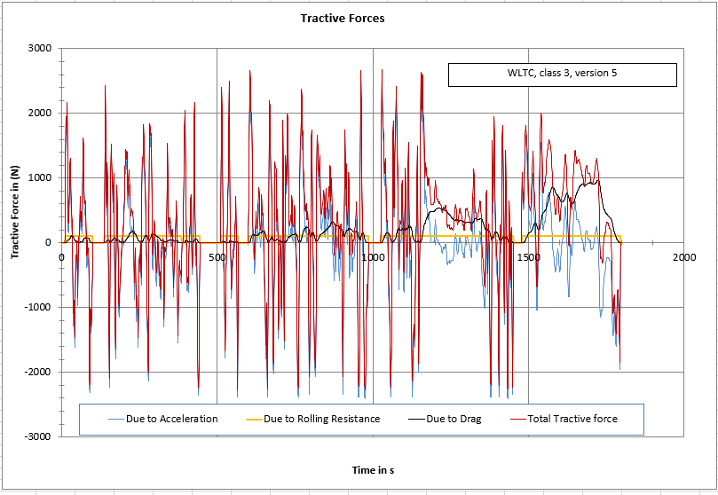
Figure 5 – Tractive Forces
The power required by the vehicles at each second in (w) was calculated by multiplying the total tractive force at each second in (N) with the corresponding velocity in (m/s) (see equation 7 below)
P = F_{t} V Equation 7
The cumulative energy required for the WLTP cycle was calculated by dividing the power the was calculated for every second during the WPLT motion by 1000 to make the Watts, KWs and then divided it again by 3600 to find the energy that was required for each second of the WLTP motion in KWhrs. The positive values were cumulatively added together in order to calculate the cumulative tractive energy and then the negative values were added together in order to calculated the cumulative brake energy that can be recovered with a KERS system. Figure 6 shows the results of these calculations.
As it can be seen from this figure the vehicle will consume 3.97kWhrs during the WLTP cycle and during this cycle 0.89kwhrs can be recovered during braking. From the calculation of the power, it was observed that the maximum power that is required in order the vehicle to pass the WLTP is 50.325kW and this is occurs at the 1567 sec though the test and the speed and the acceleration at this time are 31.58m/s and 0.47m/s² respectively. This power requirement is well below the maximum power of this vehicle which is 150kW.
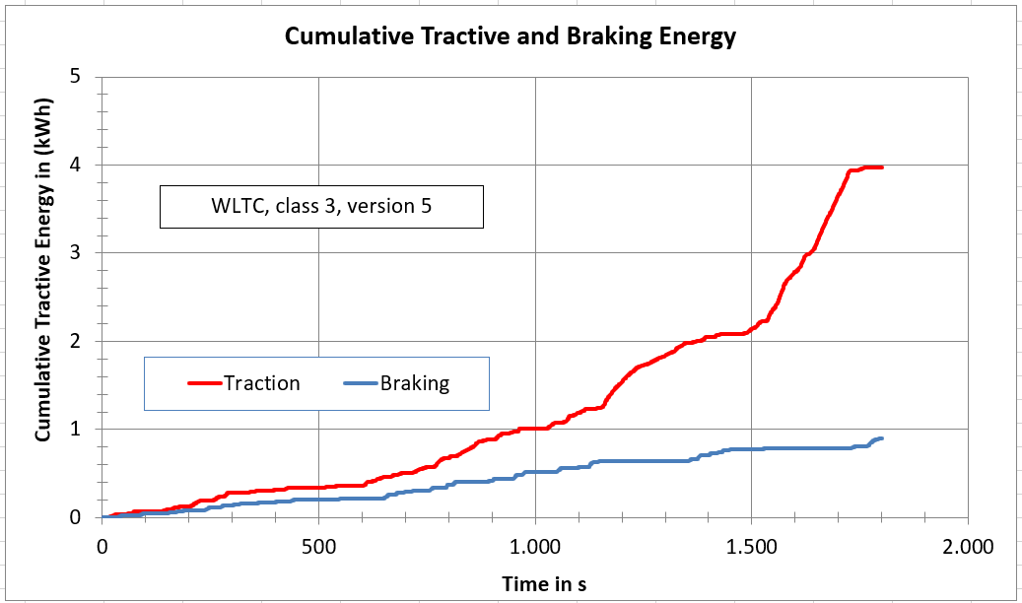
Figure 6 – Cumulative Tractive and braking Energy
Based on the assumption that the energy that can be recovered for each charging moment of the WLTP cycle will be used during the immediate after tractive period, the cumulative energy for each charging moments during the WLTP cycle were calculated and are presented in figure 7. As it can be seen from this figure the largest charging moment is towards the end of the WLTP cycle and the amount of cumulative energy is 0.084kWhr.
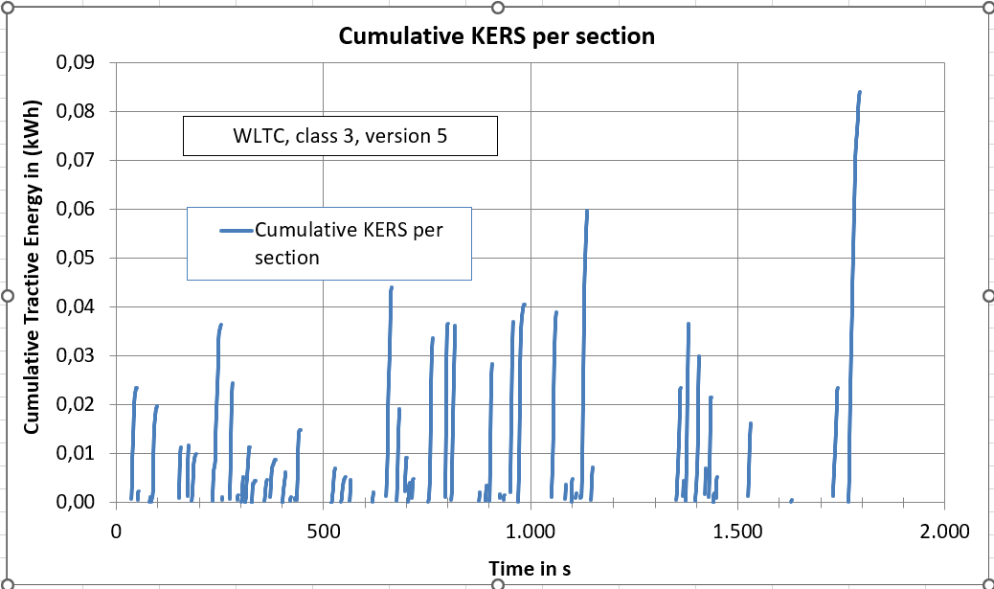
Figure 7 – Cumulative Recovered energy per section

Selection of KERS
As it previously mentioned there are mainly two KERS systems. The mechanical KERS with the flywheel which consists of the CVT and the flywheel KERS unit and the electrical KERS system which consists of motor/Generator, the power control unit, the batteries and the power train.
Considering that the maximum cumulative energy that can be recovered in a charging moment according to WLTP cycle, as is shown in Figure 7 is 0.084 kWhrs, it is more cost effective to select the mechanical KERS for this vehicle of 0.1kW capacity since the efficiency of this system is 70%.(Raj, 2014)
According to the specs of Golf 1.4Tsi eHybrid, the KERS system of this vehicle is equipped with 13kWhr Lithium ion battery and 80kW motor (The technical data of the new Golf hybrid models | Volkswagen Newsroom, no date) This is because this vehicle can be plug to the grid as well. The cost of this vehicle though is expected to be higher because of the large energy capacity of the battery and the large power of the electric motor.
If there was no need for a plug-in capability on this vehicle then a battery of about 0.1kWhr would have been sufficient as long as the required motors that will work with the battery of this energy capacity are available. In case the available motors are of higher power then a larger capacity of battery is required. The energy efficiency of this system though is 31%.(Raj, 2014)
Based on the efficiencies of the KERS mentioned above figure 8 was prepared which shows the Kinetic energy which will be returned to the wheels using the Mechanical and the Electrical KERS systems compared with the kinetic energy that was recovered during the WLTP cycle. As it can be seen from this figure the energy that will be returned to the wheels using a mechanical flywheel KERS system is more than double the energy which will be returned to the wheels using an electric KERS system.
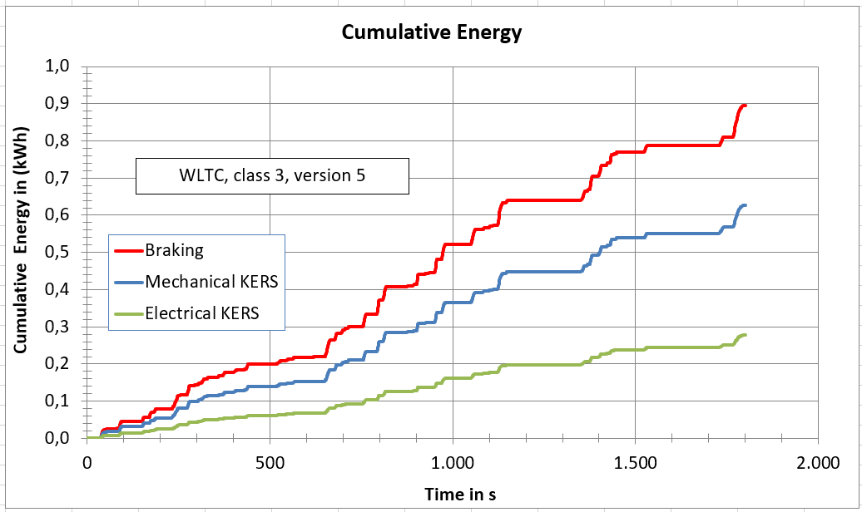
Figure 8 – Kinetic Energy returned to the wheels with KERS systems

Conclusions
The KERS system combined with the Stop and Start Strategy in a necessity in the future vehicles. This is because they contribute in the reduction of the fuel consumption and as a consequence in the reduction in the CO₂ emissions and in the reduction of the general pollution of the environment. Even though the mechanical KERS system with the flywheel is more efficient that the electrical KERS system with the battery (Raj, 2014) most of the vehicle manufacturers today produce vehicles with electrical KERS systems. The advantage of the electric KERS system is that by increasing the size of the battery, the vehicle can be charged as well from the grid reducing even more the CO₂ emissions since part of the energy from the grid is from renewable energy resources.
The advantage of the hybrid vehicles is that the do not required any infrastructure to operate since the ICE with which they are equipped can take the driver anywhere. The cost of these vehicle though is high because of the additional cost of the KERS with which they are equipped. It seems that the manufacture of hybrid vehicles is an intermediate point before the humanity shifts to the electric vehicles.
The electric vehicles are equipped only with motors and batteries and this will drive the cost of the vehicles down since there will not be a need for an ICE. It is important though to have the proper infrastructure with charging stations, that will be used to charge the electric vehicles as fast as possible. Also, the range the electric can travel is an issue at the moment but as the technology progresses it is believed that these issues will be sorted with high energy to weight density fast charged batteries. Definitely with the electric cars the global CO₂ emissions will reduced drastically since the electric cars will be charged from the grid.
Finally, from the driver’s point of view cars equipped with KERS system cost more than the cars with ICE only, they are silent especially when only the electric motors are in operation, especially at low speeds. The increase in the power and therefore in the acceleration is something that cannot go unnoticed since both the ICE and the electric motors can work together. Regarding the braking of the cars, speaking to people that drive vehicles with KERS they said that during braking the difference between the vehicles with KERS and the vehicle with only ICE is not something that can be noticed.

References
Aerodynamics and rolling resistance | Volkswagen Newsroom (no date). Available at: https://www.volkswagen-newsroom.com/en/international-driving-presentation-of-the-new-e-golf-2858/aerodynamics-and-rolling-resistance-2900 (Accessed: 9 January 2023).
Arora, U. (2022) 2021 Volkswagen Golf Engine, Horsepower, MPG and 0-60 | CarIndigo.com. Available at: https://www.carindigo.com/volkswagen/golf/performance (Accessed: 13 January 2023).
Carlier, M. (2022) Europe: best-selling car models | Statista. Available at: https://www.statista.com/statistics/1127929/best-selling-car-models-in-europe-by-units-sold/ (Accessed: 13 January 2023).
EU: Vehicle Definitions | Transport Policy (no date). Available at: https://www.transportpolicy.net/standard/eu-vehicle-definitions/ (Accessed: 13 January 2023).
EUR-Lex - 32019L1161 - EN - EUR-Lex (no date). Available at: https://eur-lex.europa.eu/eli/dir/2019/1161/oj (Accessed: 13 January 2023).
Mehrdad, E. et al. (2018) Modern Electric, Hybrid, Electric and Fuel Cell Vehecles. 3rd edn.
Raj (2014) KERS explained: how a mechanical Kinetic Energy Recovery System works · RaceFans. Available at: https://www.racefans.net/2009/01/11/kers-explained-how-a-mechanical-kinetic-energy-recovery-system-works/ (Accessed: 13 January 2023).
Sandford, M. (2022) ‘Alternative Propulsion Systems (Class Notes)’.
The technical data of the new Golf hybrid models | Volkswagen Newsroom (no date). Available at: https://www.volkswagen-newsroom.com/en/golf-etsi-golf-ehybrid-and-golf-gte-international-media-drive-6336/the-technical-data-of-the-new-golf-hybrid-models-6344 (Accessed: 15 January 2023).
VOLKSWAGEN GOLF 1.4 TSI eHybrid Style 5dr DSG Technical Data | Motorparks (no date). Available at: https://www.motorparks.co.uk/technical-data/volkswagen/golf/1.4-tsi-ehybrid-style-5dr-dsg?fbclid=IwAR2USWPBpn3fvUQiIuLibnjNLj_mvwf7cKCSNQVGfjMghJKEczJ0CNEk5Sg (Accessed: 14 January 2023).

APPENDIX A

Technical Data

Table 2 – WV Golf 1.4 TSI eHybrid Technical Data

(VOLKSWAGEN GOLF 1.4 TSI eHybrid Style 5dr DSG Technical Data | Motorparks, no date)

General
Alternative Fuel Qualifying: | True
Badge Engine CC: | 1.4
Badge Power: | 204
Based On ID: | N
Coin Description: | TSI
Coin Series: | Style
Generation Mark: | 8
Insurance Group 1 - 50 Effective January 07: | 24E
Man Corrosion Perforation Guarantee - Years: | 12
Manufacturers Paintwork Guarantee - Years: | 3
NCAP Adult Occupant Protection %: | 88
NCAP Child Occupant Protection %: | 87
NCAP Overall Rating - Effective February 09: | 5
NCAP Pedestrian Protection %: | 74
NCAP Safety Assist %: | 82
Service Interval Frequency - Months: | 12
Service Interval Mileage: | 9300
Standard manufacturers warranty - Mileage: | 60000
Standard manufacturers warranty - Years: | 3
Timing Belt Interval Frequency - Months: | N
Timing Belt Interval Mileage: | N
Vehicle Homologation Class: | M1

Electric Vehicle Data
Battery Capacity % guaranteed under warranty: | 70
Battery Capacity in kWh: | 13
Battery Charging Scenario 1 - Charge Time (Mins): | 300
Battery Charging Scenario 1 - Percentage Change: | 0-100
Battery Charging Scenario 1 - Power Supply - kW: | 2.3
Battery Charging Scenario 2 - Charge Time (Mins): | 220
Battery Charging Scenario 2 - Percentage Change: | 0-100
Battery Charging Scenario 2 - Power Supply - kW: | 3.6
Battery Charging Scenario 3 - Charge Time (Mins): | N
Battery Charging Scenario 3 - Percentage Change: | N
Battery Charging Scenario 3 - Power Supply - kW: | N
Battery Charging Scenario 4 - Charge Time (Mins): | N
Battery Charging Scenario 4 - Percentage Change: | N
Battery Charging Scenario 4 - Power Supply - kW: | N
Battery Type: | Lithium-ion
Charging Port Location: | Left Side Front
Coupler/Connector Type: | Type 2
Maximum Charging Rate - kW: | 3.6
Standard manufacturers Battery warranty - Mileage: | 100000
Standard manufacturers Battery warranty - Years: | 8
Usable Battery Capacity: | 10.4
WLTP - EC (kWh/100km) - Comb: | 14
WLTP - EC (miles/kWh) - Comb: | 4.4
WLTP - Equivalent AER (km) - Comb: | 69
WLTP - Equivalent AER (miles) - Comb: | 43

Emissions - ICE
CO2 (g/km): | 28
HC+NOx: | N
Particles: | N
Standard Euro Emissions: | EURO 6

Emissions - PHEV
WLTP - CO2 Weighted (g/km) - Comb: | 21
WLTP - CO2 Weighted (g/km) - Comb - TEH: | 26
WLTP - CO2 Weighted (g/km) - Comb - TEL: | 21

Engine and Drive Train
Camshaft: | DOHC
Catalytic Convertor: | True
CC: | 1395
Cylinder Layout: | IN-LINE
Cylinders: | 4
Engine Code: | CD14SY
Engine Layout: | FRONT TRANSVERSE
Fuel Delivery: | TURBO DIRECT INJECTION
Gears: | 6 SPEED
Number of Valves: | 16
Transmission: | SEMI-AUTO

Fuel Consumption - ICE
EC Combined (mpg): | N
EC Extra Urban (mpg): | N
EC Urban (mpg): | N

Fuel Consumption - PHEV
WLTP - FC Ch Sus (l/100km) - Comb: | 5.7
WLTP - FC Ch Sus (mpg) - Comb: | 49.6
WLTP - FC Weighted (l/100km) - Comb: | 0.9
WLTP - FC Weighted (l/100km) - Comb - TEH: | 1.2
WLTP - FC Weighted (l/100km) - Comb - TEL: | 0.9
WLTP - FC Weighted (mpg) - Comb: | 313.9
WLTP - FC Weighted (mpg) - Comb - TEH: | 235.4
WLTP - FC Weighted (mpg) - Comb - TEL: | 313.9

Performance
0 to 62 mph (secs): | 7.4
Engine Power - BHP: | 204
Engine Power - KW: | 150
Engine Power - PS: | True
Engine Torque - LBS.FT: | 184
Engine Torque - MKG: | 25.5
Engine Torque - NM: | 250
Engine Torque - RPM: | 1550
Top Speed: | 137

Test Cycles
Emissions Test Cycle: | WLTP
RDE Certification Level: | RDE 2

Tyres
Alloys?: | True
Tyre Size Front: | 205/55 R16
Tyre Size Rear: | 205/55 R16
Tyre Size Spare: | TYRE REPAIR KIT
Wheel Style: | SAN ANTONIO
Wheel Type: | 16" ALLOY

Vehicle Dimensions
Height: | 1474
Height (including roof rails): | N
Length: | 4284
Wheelbase: | 2629
Width: | 1789

Weight and Capacities
Fuel Tank Capacity (Litres): | 40
Gross Vehicle Weight: | 2020
Max. Loading Weight: | 503
Max. Towing Weight - Braked: | 1500
Max. Towing Weight - Unbraked: | 750
Minimum Kerbweight: | 1517
No. of Seats: | 5
Turning Circle - Kerb to Kerb: | 11.1

