Student Spring Gala 2023

A gala is defined as an entertainment based event with performances that is seen as a large party like setting (Cambridge dictionary, 2023). The student spring gala will follow this format being both orientated around an entertaining night for guests and a way of fundraising. This gala has an aim to be a relaxation for students before the begging of exam periods in Swansea University and placement and assignment due dates for the University Of Wales Trinity Saint Davids. This aim has been adapted into the regal and relaxing colour scheme of blue and gold. The use of a mix of bright blue and dark blue, the number one most liked colour globally, represents strength, serenity, dependability and peace ( Jill Morton, 2023). By adding in the mix of the colour gold, which represents wealth, generosity and success (About Colours, 2023) this gala’s theming aims to promote donations and serenity. The event aims to have a number of forms of entertainment, these include a DJ, a Live singer, professional photos and a live auction. The auction will take place to a number of sponsors, these sponsors have already been contacted and include Fiction, Plan B which are both local nightclubs, Peppermint and Coffi Glas which are both local restaurants, The Lc which is a leisure company and PSR Experiences which is a super car company. To complete the Gala there will be an after party at Fiction for all 100 guests, each guest with receive complimentary free entry, access to the VIP booths as well as a free drink.

On the 24th of March 2023 in the Dylan Thomas Centre, Swansea a Gala will be held from six thirty PM until midnight for a maximum total of 100 guest. These guest will be from a wide variety of different backgrounds and demographics such as ages, races and social statuses. Each of these 100 guests will purchase a ticket at the fee of £15 per person, this will cover a donation to the charity and any outgoing costs including £3.50 worth of canapés, an entry drink of lambrini costing £0.50 (Tesco, 2023) and thank you boxes including snacks and key rings. The tickets will be sold with a small booking fee through Fixr Events (Fixr, 2023).

Aims & Objectives
- The aim of the Gala is to raise over £500 for Swansea Mind through the funds raised in the auction and through the sale of tickets.
- Through raising awareness for the charity, it also allows important information to be administered on the subject of mental health (Swansea Mind, 2023).
- The Gala should have a positive financial impact on the local economy through using local companies, produce and staff.
- Utilising the colour scheme of the gala and therefore the concept of serenity and relaxation, a aim of the event is to create an environment for the students to relax and let loose.
- A legacy is created when an event is recreated for being memorable and unique, this Gala is the first of its kind and an aim is for it to be recreated and a legacy to be created. (Bladen, Kenall, Wilde, Abson, 2023)

Financial report
A budget has been created (appendices 1) for the Gala that consists of all the main financial concepts and the prices payed/ agreed for them. The following is a detailed summary for
Food and drink
The cost of food was initially budgeted at £700 for all of the guest. As the quote from the caterers at the venue was £5 per person, this was within the budget. As canapés have an average cost of £15 per person, the cost of £5 per person was very reasonable (Hargreaves, 2023). However, through the preparation of canapés elsewhere, it was possible to be cheaper, by negotiating with the venue the price for the canapés was then dropped to £3.50 per person. The £3.50 included one of each of the following per guest; mozzarella stick with a tomato purée, mini welsh sausages in a bbq sauce and beetroot falafels. Regarding welcome drinks, the venue agreed to waver corkage as it is a charity event held by students for students. Corkage is a fee payed y the attendee for serving their own drinks at the event (hargate hall, 2023). There where a number of low cost drinks available however it was still important, due to the luxurious feel of the event, that the drinks both looked and tasted good. The low cost, high quality drink that is decided upon is Strawberry Lambrini. The Lambrini costs a total of £3 per bottle, this is the equivalent of £0.50 per glass and therefore per person.
Venue
The Dylan Thomas Centre, Swansea is free to hire as a University Of Wales Trinity Saint Davids student. This is a major aspect of the budget and the lack of cost will have a major positive impact on the event. This venue consists of a large hall with chandeliers and large windows, creating an elegant appearance which is ideal for a gala (DylanThomas.com, 2023). The agreement with the venue included the use of the Vivian hall from 12 midday on the day of the event until midnight. Inside the venue a total of 10 circular tables, seating 10 people each with large white table cloths, 100 white chair covers and 100 champagne flutes are to be ready for the event. The venue being free allowed us to utilise finances in other areas of the gala. Despite not paying for the venue hire, the bar will be open with a total of 3 staff from the venue assigned to it from 6:30 pm until close. As well as this, a security guard will be provided for the event at an added cost of £128 . The security guards roles will include, searching bags if they are suspicious, checking ID’s on the door as the event is strictly over 18’s only and sweeping the building to ensure the safety of all the attendees and staff.
Decorations
The budget of £300 for the events decorations allows for all items that will be on display at the gala. The first item planned to purchase using Amazon for the Gala is a red carpet for the downstairs area of the venue, this costed £8 for a total of 9 meters in length. Using Shein, for a total of £15 an assortment of gold and pale blue jewels will be purchased to place on the tables (shein, 2023). To ensure an elegant portrayal, flowers will be used as the centre pieces for the tables, the flowers have been lent to the event at no cost. To place the flowers into, a total of 10 mason jars would be bought at Hobby Craft for £3 each. From hobby craft, ten 30 cm mirrors will also be purchased for a total of £60 or £6 each (Hobby Craft, 2023). As well as this a number of different coloured and patterned cards will be purchased to create auction lists and running orders for all guests.
DJ
As a discussion with the company, Crazy Characters, has resulted in the donation of a DJ for the night, on the condition that the equipment is pre set up, a total of £200 will be saved (Crazy Characters, 2023). Crazy Characters is a children’s entertainment and disco DJ company. They hold all necessary insurance and liability forms such as public liability(.
Singer
A local singer, who currently studies that the Dang Academy which is under the Urdang collection in London has offered to perform at the gala for the cost of her Train ticket ( The Dang, 2023). The train ticket at the would cost between £70 and £100 dependent on the date of purchase (Trainline, 2023). Katie Gear is a 19 year old performer who has been singing live since the age of three, due to the gala being for charity the lack of cost will create another positive impact on the event.
Staff
There will be a total of 11 staff members at the events. Not all of these staff members will be payed from the proceeds of the Gala. As the event is for charity, the two organisers/ managers will not be taking a wage from the event. Due to the corkage being wavered, the three members of staff on the bar will be being payed through the venue and therefore not out of the proceeds. The venue will also be paying the member of staff in the kitchen as the price has been reduced for the canapés resulting in the chef not being payed for. As previously mentioned, the security guard is an added cost of £128 as he would otherwise not be on duty that night. Finally the four members of staff who will be assisting with greeting, canapé’s, photography, welcome drinks and more will be payed £50 each for their 6 hours of work.
Boxes
The boxes cost a total of £40 to create 100 of them. This is due to a number of items being donated by a company named “Do Me A Favour” and Castle Howells. Do Me A Favour have donated a total of 100 recyclable boxes all with packing card included, 100 pink crystal Disney key rings and 100 laminated quotes. Castle Howells have donated a assorted total of 100 welsh cakes and toffee waffles (castle Howells, 2023). Purchased for the boxes where plain large chocolate eggs, popping candy, Easter themed Haribo’s and mini cream eggs.

Contingency plan
Problem | Contingency plan
Sound system crashing | The Vivian hall at the Dylan Thomas Centre has its own sound system that can quickly begin playing music
Guests arriving late | Doors open at 6:30 however no activities are planned until 8 pm to ensure optimal time for guests to arrive
Injuries | Multiple designated first aiders in close proximity to first aid kits
Radios failing | A WhatsApp group chat in case radios fail or run out of battery for anyone
Singer doesn’t show up | One member of staff is a singer and has a pre prepared set list in case of an emergency
No bids in the auction | A number of plants within the audience who are advised to attempt to drum up interest
Rush for entry | Two members of staff pre designated to entry and 1 available if needed
Security risk | Clearly announce the evacuation plan as there are multiple exits in case any are blocked
Disruptive guests | Have security be prepared to ask any guests to leave.
(Eventbrite, 2023)

Evaluation strategy
The success of this event will be evaluated in a number of different ways:
- The number of guests attending the Fiction After Party
- The money raised being more than the outgoings
- Positive feedback from the attendees
- A good level of interaction with the auction
- A large number of attendees on the dance floor during the DJ
- Social media posts from the attendees

Project planning
Date | Times | Notes
03/02/23 | 13:00- 15:00 | - Possible ideas-disco, gala, bake off  - Final decision - gala  - Title - Student Spring Gala 2023  - Possible dates- 24th or 25th of march  - Possible locations - Dylan thomas centre, st samlet, Morriston rugby club  - To do- contact Dylan Thomas centre about dates and conduct research
06/02/23 | 12:00 - 14:00 | - Both spoken to friends and have decided the 24th will have the larger turn out  - Sent an email to the Dylan thomas centre requesting the 24th  - Decide on a colour scheme of gold and blue, similar to UWTSD but also very formal  - Decide on a black tie theme with canapés  - Contact Swansea mind after choosing them as our charity
07/02/23 | 14:00 - 16:00 | - Had a response from the centre confirming the 24th  - Organise a meeting with Chloe parsons  - Look at marketing that Rhiannon’s worked on  - Contact DJ  - Contact singer  - Price tickets
10/02/23 | 12:00 - 13:00 | - Prepare for Chloe Parsons meeting through creating a plan of our Gala  - Debrief from the call with Mind Swansea
16/02/23 | 10:00 - 12:00 | - Debrief from the meeting with Chloe Parsons  - Fill in booking forms  - Contact a photographer  - Final edits to marketing ready for launch on the 17th of February
21/02/23 | 13:00 - 16:00 | - Discuss canapés reduced fee and agree to £3.50 per person  - Agree to the wavered corkage  - Discuss ticket sales
14/03/23 | 13:00 - 15:00 | - Confirm DJ  - Confirm singer  - Confirm all staff  - Confirm photographer  - Develop schedule for the day and recap on the sponsors
16/03/23 | 10:00 - 13:00 | - Prepare all gifts and information for the gala  - Purchase deco items  - Final ticketing push
21/03/23 | 13:00 - 14:00 | - Final confirmation with venue and final push
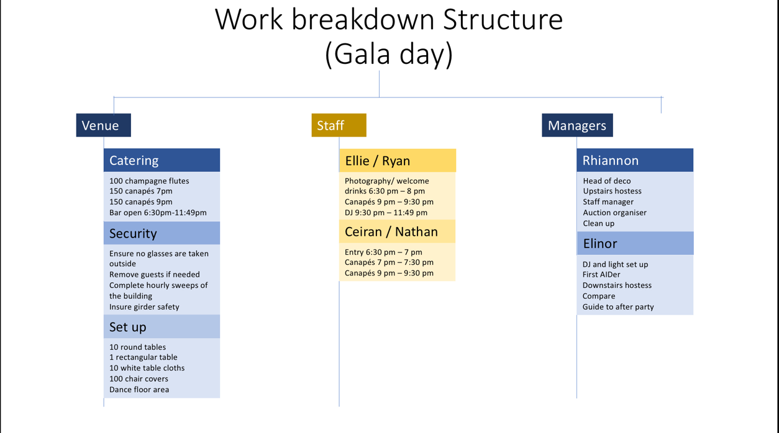
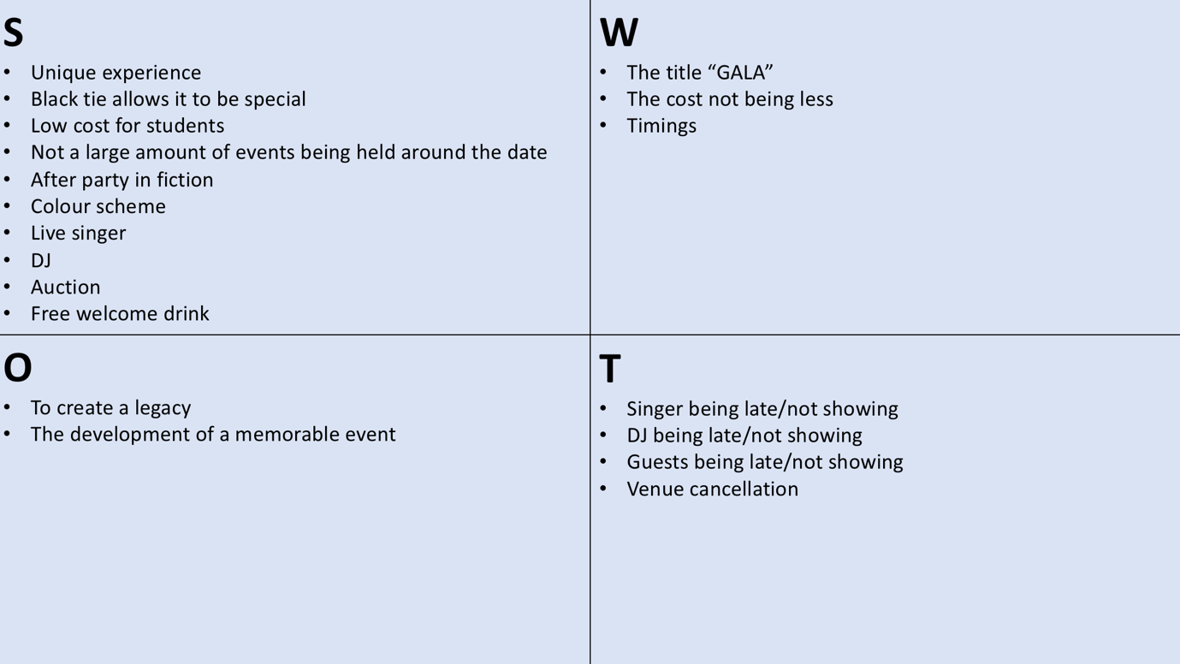
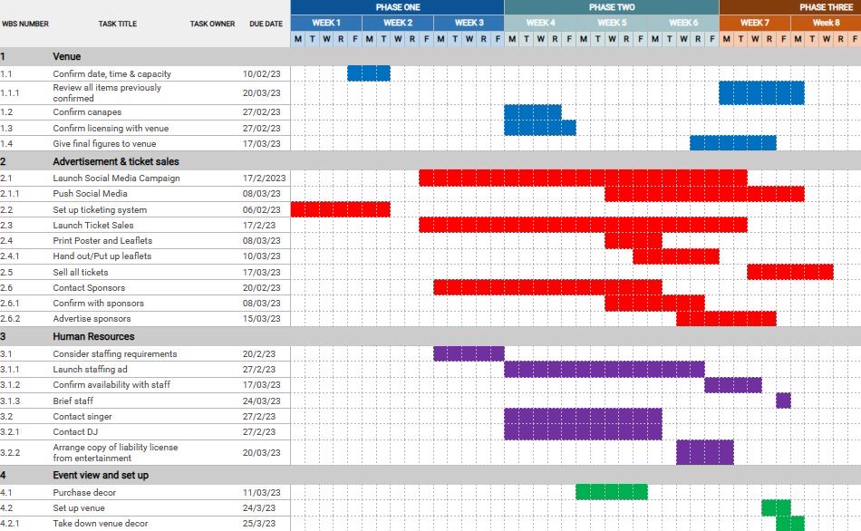
(NCBI, 2023)
(APM, 2023)

Appendices

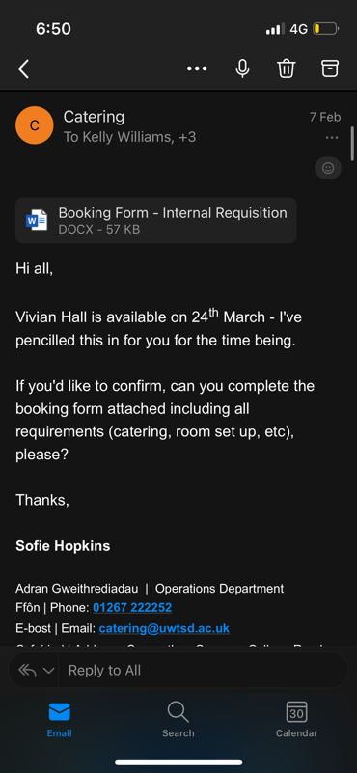
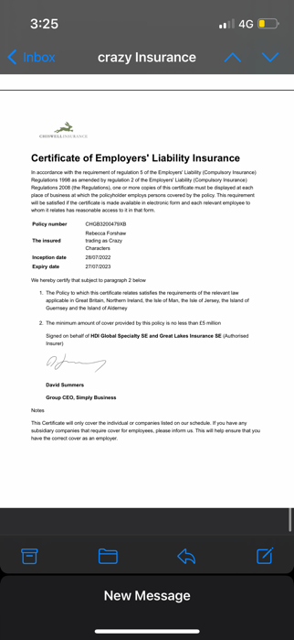
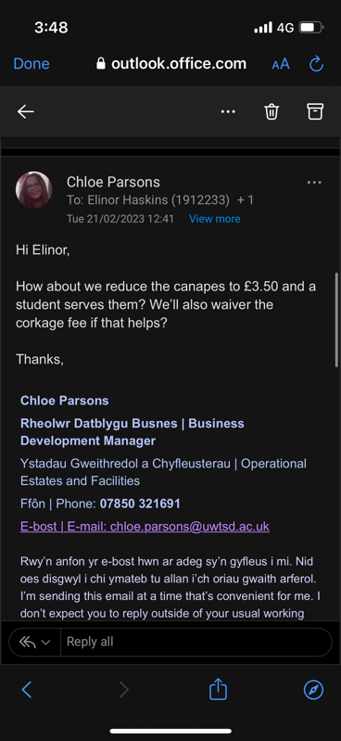
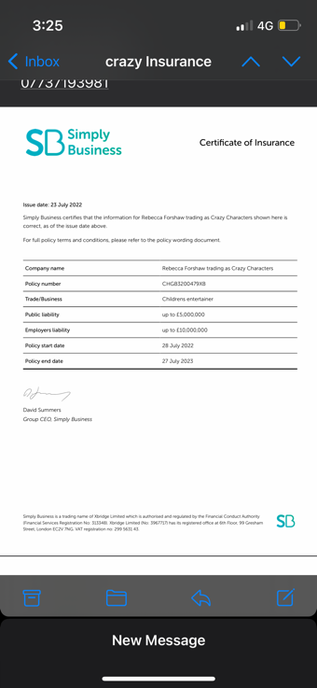
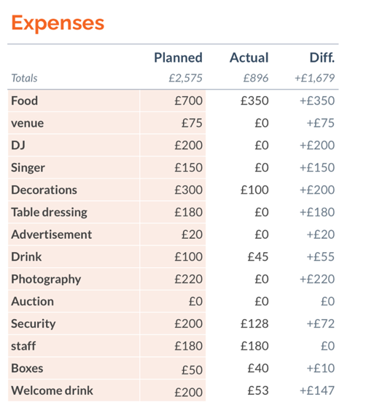
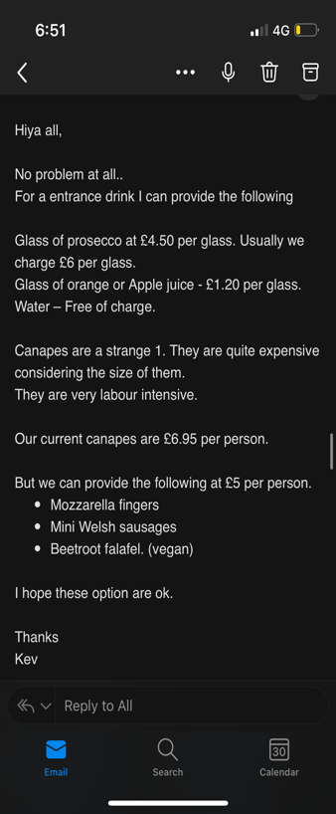
Appendices 1

Bibliography

GALA | English meaning - Cambridge Dictionary. 2023. GALA | English meaning - Cambridge Dictionary. [ONLINE] Available at: https://dictionary.cambridge.org/dictionary/english/gala. [Accessed 30 March 2023].

Jill Morton. 2023. Blue. [ONLINE] Available at: https://www.colormatters.com/the-meanings-of-colors/blue. [Accessed 30 March 2023].

About colors. 2023. Gold color - All about gold color meaning in one place - About colors. [ONLINE] Available at: https://www.about-colors.com/gold-color-meaning/. [Accessed 30 March 2023].

Tesco. 2023. Strawberry Lambrini. [ONLINE] Available at: https://www.tesco.com/groceries/en-GB/products/308845928 [Accessed 30 March 2023].

Bladen, C., Kennell, J., Wilde, N. and Abson, E., 2012. Events Management. Routledge.

Ian Hargreaves. 2023. How much does Event Catering Cost? [2021 Guide]. [ONLINE] Available at: https://www.fazecaterers.co.uk/how-much-does-event-catering-cost/. [Accessed 31 March 2023].

Hargate Hall. 2023. What is a Corkage Charge? And is it good value? - Hargate Hall. [ONLINE] Available at: https://www.hargate-hall.co.uk/what-is-a-corkage-charge/. [Accessed 31 March 2023].

Spring Sale 2023 | Women's & Men's Clothes, Shop Online Fashion | SHEIN UK. 2023. Spring Sale 2023 | Women's & Men's Clothes, Shop Online Fashion | SHEIN UK. [ONLINE] Available at: https://www.shein.co.uk/. [Accessed 31 March 2023].

Craft Ideas | Hobbycraft. 2023. Craft Ideas | Hobbycraft. [ONLINE] Available at: https://www.hobbycraft.co.uk/ideas/. [Accessed 31 March 2023].

Crazy Characters Swansea. 2023. Home - Crazy Characters Swansea. [ONLINE] Available at: https://crazycharacters.co.uk/. [Accessed 31 March 2023].

The Dang - Theatre & Dance Syllabus. 2023. The Dang - A Solange Urdang Collective. [ONLINE] Available at: https://thedang.com/. [Accessed 31 March 2023].

Trainline : Search, Compare & Buy Cheap Train Tickets. 2023. Trainline : Search, Compare & Buy Cheap Train Tickets. [ONLINE] Available at: https://www.thetrainline.com/book/results?origin=1f06fc66ccd7ea92ae4b0a550e4ddfd1&destination=f0bdaecbf8bf0a80e964800b9d89fa0a&outwardDate=2023-03-31T08%3A00%3A00&outwardDateType=departAfter&journeySearchType=single&passengers%5B%5D=1993-03-31&directSearch=false&splitSave=true&selectedOutward=W6X27Mlffr0%3D%3Abtx6IHsFyGk%3D. [Accessed 31 March 2023].

Castell Howell. 2023. Home - Castell Howell. [ONLINE] Available at: https://www.castellhowellfoods.co.uk/. [Accessed 31 March 2023].

Eventbrite Blog. 2023. How to Create an Event Contingency Plan - Eventbrite Blog. [ONLINE] Available at: https://www.eventbrite.co.uk/blog/create-event-contingency-plan-ds00/. [Accessed 31 March 2023].

FIXR. 2023. FIXR | Discover events. Book tickets. Create memories.. [ONLINE] Available at: https://fixr.co/. [Accessed 31 March 2023].

Mind Swansea - Mind - For better mental health. 2023. Mind Swansea - Mind - For better mental health. [ONLINE] Available at: https://www.swanseamind.org.uk/. [Accessed 31 March 2023].

www.ncbi.nlm.nih.gov. 2023. No page title. [ONLINE] Available at: https://www.ncbi.nlm.nih.gov/books/NBK537302/. [Accessed 31 March 2023].

DylanThomas.com. 2023. Dylan Thomas Centre - DylanThomas.com. [ONLINE] Available at: http://www.dylanthomas.com/. [Accessed 31 March 2023].

Simply business. 2023. Chiswell insurance. [ONLINE] Available as: https://www.simplybusiness.co.uk/insurance/insurers/chiswell/ . [Accessed 31 March 2023]

What Is a Gantt Chart? | Definition & Examples | APM. 2023. What Is a Gantt Chart? | Definition & Examples | APM. [ONLINE] Available at: https://www.apm.org.uk/resources/find-a-resource/gantt-chart/. [Accessed 31 March 2023].

