PROBLEM ANALYSIS AND SOLUTION DEVELOPMENT
Module Name: Analysing and Solving Problems
Module Code: ACCA4019 A2
Student Name: Eulalio Fernandes
Student ID: 2441942
Group: 1
Lecturer: Dr Fahad Ahmed

Contents
1. Introduction 3
2. Deconstruct the Problem 3
2.1 MoSCoW Technique Requirement 3
2.2 Variables Identification 5
3. Proposed Solution 5
3.1 Flowchart 5
3.2 Flowchart Explanation 6
4. Reflection and Justification 8
4.1 Abstract Thinking 8
4.2 Sub-dividing 8
4.3 Justification of Solution 9
4.4 Limitation 9
4.5 Assumption 10
5. Conclusion 10
References 11

Introduction

Efficient scheduling is a crucial element of successful group project administration in higher education. This paper addresses the challenges faced by students in coordinating group project meetings due to varying academic schedules, part-time jobs, and personal obligations. If an appropriate mutual time cannot be determined, meetings can be deferred, project tasks could be hindered, and the allocation of work may become imbalanced. The evaluation context necessitates an organised approach that determines appropriate meeting schedules, reduces timetable clashes, and guarantees that meetings take place prior to weekly project deadlines [1].
The problem can be considered a scheduling and constraint-satisfaction problem. A meeting time cannot be arbitrarily chosen based only on one student's convenience.The availability of each group member must be evaluated concurrently. Research on timetabling indicates that educational scheduling involves numerous limitations, and that automated or systematic methods can enhance the quality of scheduling choices. For instance, Mallari, San Juan, and Li formulated a multi-objective optimisation framework for university course scheduling, achieving an average enhancement of 9.45% compared to manually created timetables in their assessments [2].

Deconstruct the Problem

MoSCoW Technique Requirement
The MoSCoW approach delineates a system for classifying requirements as Must Have, Should Have, Could Have, and Won't Have at this juncture. Its purpose is to determine which requirements are vital and which may be lessened or delayed under constraints of time or finances. This is fitting for the existing dilemma since the group cannot reliably fulfilll all personal preferences while also complying with the weekly project timeline.

Table 1. MoSCoW requirements

Priority | Requirement | Justification
Must Have | A meeting must occur when all required group members are available. | A meeting that excludes a required member may create communication and workload problems.
Must Have | The selected meeting must occur before the weekly project deadline. | Missing the deadline would directly affect project progress.
Must Have | Existing university classes and employment commitments must not be violated. | These represent hard availability constraints.
Must Have | The system must identify whether a feasible common slot exists. | A scheduling process must provide a result or indicate that no feasible slot has been found.
Should Have | The meeting should preferably occur during a commonly preferred period. | Preferences improve convenience but are less important than the core constraints.
Should Have | The meeting duration should be consistent with the group's requirements. | Consistent duration makes planning easier.
Could Have | The system could provide alternative meeting times. | Alternatives are useful if the first choice becomes unavailable.
Could Have | A calendar notification could be generated. | Notifications would improve implementation but are not essential to solving the scheduling problem.
Won't Have this time | Individual preferences that conflict with all essential requirements will not be prioritised. | The solution must protect the project deadline and hard constraints.

The categorisation illustrates the notion that a Must Have is an essential criterion for delivering a feasible solution. In this situation, the limits of deadlines and availability take precedence over individual preferences. The method also offers adaptability as lesser-priority preferences may be relinquished if required.

Variables Identification
The scheduling problem can be represented using a number of variables. Identification of these variables allows the real-world problem to be converted into a logical model.
Table 2. Variables
Variable | Description
G | Set of group members
D | Set of available days
T | Set of possible time slots
A(g,d,t) | Availability of member g
C(g,d,t) | Academic conflict
W(g,d,t) | Work conflict
P(g,d,t) | Personal commitment conflict
M(d,t) | Proposed meeting decision
L | Weekly project deadline
R | Required meeting duration
S(d,t) | Scheduling score

A binary format may be utilised for indicating availability. For instance, an availability value of 1 may signify that a member is present, whereas a value of 0 may denote that the member is absent. A candidate meeting time should only be deemed viable when all necessary participants possess an availability score of 1 and there are no significant conflicts.
The issue can consequently be divided into rigid constraints and flexible constraints. Rigid limitations are stipulations that must not be breached, including a predetermined university course, a professional obligation, or the project timeline. Soft limitations denote inclinations, such as a favoured day or a chosen hour. This differentiation aligns with university scheduling studies, wherein rigid conflicts must be addressed while other preferences serve to evaluate the quality of various alternatives [2], [4].

3. Proposed Solution

3.1 Flowchart
The proposed solution uses a constraint-based scheduling process. The flowchart should be recreated in draw.io, Microsoft Visio or PowerPoint and embedded into the final Word document.
Figure 1. Proposed group meeting scheduling flow
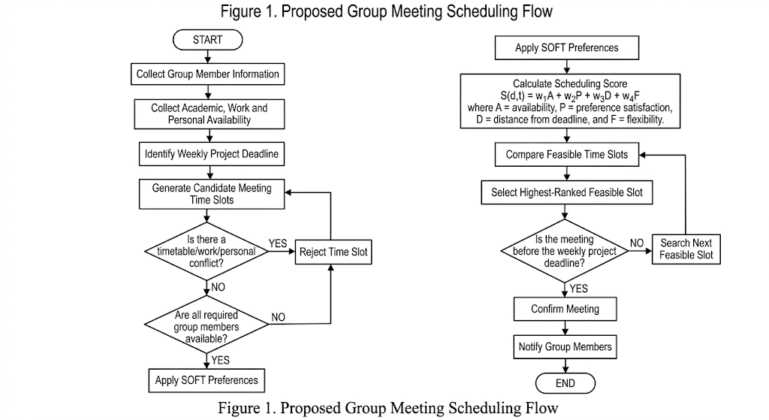

3.2 Flowchart Explanation
“First, group members' academic, work and personal availability is collected to identify feasible meeting periods.”
The weekly project deadline is then identified because the meeting must occur early enough to support completion of the required tasks.
Hard constraints, including university classes, work schedules and compulsory commitments, are checked first. Any slot containing a hard conflict is rejected.” This aligns with constraint-oriented methodologies in educational scheduling, where events are assigned while concurrently adhering to limitations [4].
The availability of all required members is then checked. A slot is rejected if a required member cannot attend.
A scheduling score can be calculated as:
S(d,t) = w₁A + w₂P + w₃D + w₄F
where:
- A = number or proportion of members available;
- P = preference satisfaction;
- D = distance from the project deadline;
- F = flexibility or quality of the candidate slot;
- w₁–w₄ = weights assigned to the criteria.
The primary tenet is that stringent limitations are evaluated initially. A significant preference score should never lead to the neglect of mandatory classes or work obligations.
The deadline element can also serve to safeguard project advancement. A time slot positioned just prior to the deadline may be theoretically viable but practically ineffective due to the inadequate time left for the duties designated in the meeting. As a result, prior viable meetings may be prioritised more significantly when the objective is to organise or allocate weekly tasks.
This methodology embodies contemporary studies in university scheduling. Mallari, San Juan, and Li employed a multi-objective mixed-integer linear programming model that incorporated both hard and soft constraints, achieving an average enhancement of 9.45% compared to several manually created timetables in their assessment [2]. Algethami and Laesanklang likewise structured university course scheduling with resource constraints and showcased the application of mathematical modelling to derive viable timetable solutions [4]. These investigations endorse the notion of distinguishing obligatory limitations from preferences and enhancing the quality of viable options.
Once the viable slots have been prioritised, the top-ranked slot is chosen. The chosen meeting must subsequently be verified against the weekly cutoff. If it fails to meet the deadline requirement, the subsequent viable option must be assessed. If no slot meets the criteria, the system must indicate that no completely viable solution has been found. The team may thereafter reevaluate a lesser priority criterion, such meeting length or preferred timing, instead of passively disregarding a rigid constraint.
The finalised meeting must be conveyed to all participants. A calendar invitation or group alert may serve as a functional implementation feature. The procedure ought to be reiterated weekly as availability and project timelines may fluctuate.
This resolution consequently fulfils the three primary aims of the evaluation. Initially, appropriate meeting times are determined by assessing the availability of all participants. Secondly, scheduling conflicts are minimised by considering academic and work-related issues as strict limitations. Third, the timeline is integrated into the selection procedure to ensure that meetings are not arranged beyond the moment they remain beneficial.

4. Reflection and Justification

4.1 Abstract Thinking
Abstract thinking was used by reducing a complicated real-world situation to a smaller set of relevant elements. The original scenario contains personal commitments, university timetables, employment, deadlines, preferences and group communication. Instead of attempting to represent every detail, the problem was represented using members, days, time slots, availability, constraints and deadlines.
This abstraction makes the problem easier to analyse because irrelevant information can be removed while the factors that directly influence scheduling are retained. Systems-thinking research has identified systems thinking as an important capability for understanding complex problems and decision-making [6]. The same principle is applicable here because each student's availability affects the feasibility of the group-level solution.
The abstraction also makes the proposed solution transferable. The same logic could be applied to different group sizes, different meeting durations and different weekly deadlines without redesigning the entire problem.

4.2 Sub-dividing
Sub-dividing was used to break the overall problem into smaller stages:
- Collect availability.
- Identify the deadline.
- Generate possible slots.
- Remove hard conflicts.
- Check group availability.
- Rank remaining options.
- Select a suitable slot.
- Confirm and communicate the meeting.
This breakdown diminishes cognitive intricacy and facilitates the identification of errors. For instance, if an improper meeting is chosen, the corresponding step can be analysed to ascertain whether the mistake sprang from insufficient availability data, a faulty restriction, or an unsuitable preference score.
Sub-division is especially suitable due to the presence of numerous interrelated limitations in scheduling issues. Investigations into university scheduling have characterised these issues as intricate optimisation challenges encompassing various constraints and goals [7]. Dividing the issue into smaller phases offers a pragmatic approach to handling complexity without necessitating an advanced method right once.

4.3 Justification of Solution
The suggested constraint-oriented method was chosen due to the issue's inherent focus on identifying a period that concurrently meets multiple criteria. A mere majority vote would be inadequate when the favoured timing of the majority may clash with the mandatory availability of another participant.
The suggested method further offers clarity. Each declined slot can be linked to a particular rationale, such a scheduling problem, professional obligation, or inability to meet the deadline.
An further benefit is scalability. For a limited cohort, the procedure can be executed utilising a spreadsheet. For more extensive systems, the identical conceptual framework might be expanded into constraint programming or mathematical optimisation. Studies have indicated the effectiveness of constraint-based reasoning in the realm of educational schedule formulation [4], however contemporary research has revealed that optimisation models can enhance timetable quality in contrast to manual methods [2].
The rationale for the solution is thus validated as it is rational, clear, comparatively easy to execute, and amenable to expansion. It specifically tackles the criteria outlined in the evaluation instead of addressing a broader university scheduling issue.

4.4 Limitation
Numerous constraints must be acknowledged. Initially, the evaluation context lacks concrete scheduling documentation for each student. Consequently, the suggested solution has been formulated as a universal model instead of being tested against the actual timetable of a particular group.
Secondly, students could furnish incomplete or erroneous availability details. The algorithm is capable of generating a dependable outcome just when the input data is trustworthy. Thirdly, unforeseen circumstances may arise subsequent to the arrangement of a meeting, like alterations to work schedules or academic events.
A further constraint pertains to the evaluation system. Preference weights are subjective, and various students may prioritise certain time frames over others. If unsuitable weights are chosen, the prioritisation of viable slots may fail to reflect the group's genuine preferences.
Ultimately, the suggested approach is tailored for a comparatively minor issue. A comprehensive scheduling system for the institution would include far greater variables and constraints, necessitating more sophisticated optimisation methods. Studies indicate that university scheduling can encompass extensive and intricate combinations of rigid and flexible requirements [2], [7].

4.5 Assumption
Several assumptions have been made. It is assumed that each group member provides accurate availability information. It is also assumed that academic classes and confirmed employment commitments are treated as hard constraints. It is assumed that the group has access to a shared scheduling mechanism, such as a spreadsheet or calendar.
It is further assumed that a meeting duration can be agreed in advance and that meetings are required on a weekly basis. The model assumes that a meeting involving all required members is preferable to a meeting involving only some members.
No numerical student timetable data has been invented because none is provided in the assessment scenario. Instead, the variables and decision rules have been designed so that real group data can be inserted during implementation. This maintains the distinction between evidence-based research and illustrative assumptions.

5. Conclusion
The issue of group meetings has been examined as a limited scheduling dilemma that encompasses academic schedules, work obligations, individual availability, and weekly project due dates. The MoSCoW method was employed to differentiate critical needs from desires. The essential factors were recognised, encompassing group participants, time intervals, accessibility, conflicts, meeting length, and deadlines.
A scheduling approach based on constraints was subsequently suggested. Candidate meeting times are created and evaluated against strict requirements prior to taking into account more flexible preferences. Viable time slots are evaluated based on a scheduling score, thereafter the top-ranked appropriate meeting is chosen and verified against the project deadline.
The primary constraint is that the evaluation context lacks genuine student availability information. As a result, the suggested model has not been demonstrated as an empirical evaluation of a specific cohort of students. Rather, it offers a universal, rational, and adaptable approach that allows for the incorporation of actual schedule data. The suggested strategy meets the necessary goals by emphasising attainable shared meeting times, minimising scheduling disputes, and safeguarding weekly project deadlines.

References
[1] University assessment brief, “ACCA4019 Analysing and Solving Problems: Assessment Component 2 – Written Assessment,” 2026.
[2] C. B. Mallari, J. L. San Juan, and R. Li, “The university coursework timetabling problem: An optimization approach to synchronizing course calendars,” Computers & Industrial Engineering, vol. 184, Art. no. 109561, 2023, doi: 10.1016/j.cie.2023.109561.
[3] Agile Business Consortium, “What is MoSCoW prioritization?” 2026. [Online]. Available: https://www.agilebusiness.org/resource/what-is-moscow-prioritization/
[4] H. Algethami and W. Laesanklang, “A mathematical model for course timetabling problem with faculty-course assignment constraints,” IEEE Access, vol. 9, pp. 111666–111682, 2021, doi: 10.1109/ACCESS.2021.3103495.
[5] H. Algethami and W. Laesanklang, “A mathematical model for course timetabling problem with faculty-course assignment constraints,” IEEE Access, vol. 9, pp. 111666–111682, 2021, doi: 10.1109/ACCESS.2021.3103495
[6] S. Elsawah, A. T. L. Ho, and M. J. Ryan, “Teaching systems thinking in higher education,” INFORMS Transactions on Education, vol. 22, no. 2, pp. 66–102, 2022, doi: 10.1287/ited.2021.0248.
[7] A. Bashab et al., “Optimization techniques in university timetabling problem: Constraints, methodologies, benchmarks, and open issues,” Computers, Materials & Continua, vol. 74, no. 3, pp. 6461–6484, 2023, doi: 10.32604/cmc.2023.034051.
[8] IEEE Author Center, “IEEE Reference Guide,” IEEE, 2025.

