University of Wales Trinity Saint David

BSC in Automotive Engineering
Turbo Charger Analysis
Powertrain Design and Efficiency
Stephen Hutchings
P148299
1.0 Abstract

Supercharging with turbochargers is a forced induction process which can improve the power and torque characteristics of an engine (Miller, 2008). This report will investigate the principles of turbocharging and analyse the factors which have an effect on volumetric efficiency. From a range of research it was found that turbocharging can improve the overall efficiency of an engine and increase volumetric efficiency of a naturally aspirated engine. A strip down of a 1.6 4 cylinder turbo was also completed in order to gain a better understanding of turbocharging principles. In addition to this, a design of a turbocharger installation for a V8 spark ignition four stroke engine which has a bore of 95mm and a stroke of 80mm was devised. Also, a range of calculations which included compressor efficiency and intercooler efficiency and the study of several compressor maps were performed in order to select a suitable compressor for the design. It was found that the turbocharger compressor was 77% efficient at maximum efficiency. The installation considerations were also summarised.

Contents Page
- Abstract…………………………………………………………Page 1

- Contents Page…………………………………………………Page 2

- List of figures…………………………………………………..Page 3

- Introduction……………………………………………………Page 4

- Literature Review……………………………………………..Pages 5 - 9

- Methodology……………………………………………………Pages 9 - 11

- Results and Analysis………………………………………...Pages 12 - 19

- Conclusion …………………………………………………Pages 19-20

- Reference List……………………………………………..Pages 21-22

- Appendices…………………………………………….Pages 23-24

List of figures

- Figure 1 – Diagram of turbo charger
- Figure 2 – Graph of turbo charger torque
- Figure 3 – Diagram of air and exhaust gases from atmosphere to tailpipe
- Figure 4 – Compressor section
- Figure 5 – Full turbo assembly image
- Figure 6 – Waste gate actuator removal
- Figure 7 – V-flange clamp removal
- Figure 8 – Oil pipe removal
- Figure 9 Compressor housing bolts removal
- Figure 10 – Compressor impeller detached
- Figure 11 – Compressor map characteristics
- Figure 12 – Compressor map 4 with 77% efficiency
- Figure 13 – Intercooler operation diagram
- Figure 14 – Air to water intercooler operation

Turbocharging

- Introduction
According to Hartman (2007) “turbocharging causes a rise in the air density by increasing the pressure at which the cylinder is filled with air during the intake stroke”. From research it can be seen that turbocharging increases the power levels of a vehicle (Miller 2008). Therefore, it can be said that turbocharging could potentially improve a vehicles overall performance. In addition, Hiller and Coombs (2004) state that turbocharging is an efficient way of “producing high power output along with excellent fuel economy”. This implies that turbocharging improves fuel efficiency without compromising on power. Literature shows that turbocharging is not a new concept and it dates back 1915 when the first turbocharger was patented by Alfred Buchi (Wagoner 2012). In addition to this, turbocharging is used in boats, trains and automotive vehicles (Baines 2005), suggesting that turbocharging is an effective way of sourcing more mechanical power. In present day, turbocharging appears to be more popular in diesel vehicles in comparison to petrol vehicles, however, Hiller and Coombs (2004) believe that modern day petrol engines which are fuel-injected can be fitted with a turbo. However, Nunney (2007) argues that petrol engines have warmer exhaust gases than diesel engines and the higher temperature puts strain on the turbocharger. Turbochargers can be used in forced induction systems, according to Dorries (2004) “forced induction systems pressurise the air intake manifold to force more air in when the valve opens”. This suggests that the amount of air forced into the engine has an effect on the amount of power produced by the engine. This is supported by Miller (2008) who states that the air pressure forced in increases the volumetric efficiency at higher speeds which then subsequently increases horsepower. The aim of this report is to investigate the principles of turbocharging and analyse the factors which have an effect on volumetric efficiency. An in-depth insight of these principles will be given in the as well as the documentation of the strip-down of a turbo. Also, the basic design of a turbocharger installation for a V8 spark ignition four stroke engine will be provided along with the selection of a suitable compressor, installation considerations will also be discussed.

- Literature Review
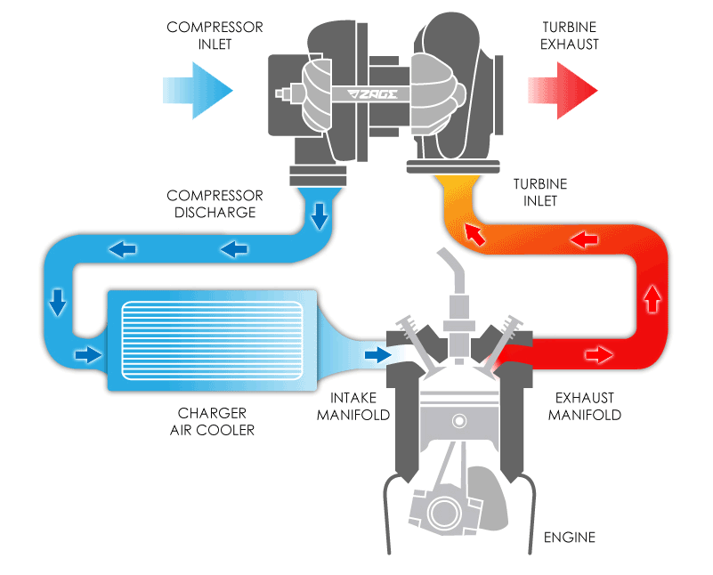
As mentioned briefly in the introduction, there are several merits of supercharging with a turbo charger. The main advantage of turbocharging is that it enhances the engines power output (Davis 2001; Kluczyk 2010; Stone 2012), this is done by using exhaust gas to run a turbine which then operates an air compressor that pushes a mixture of oxygen and air into the cylinders (Kluczyk, 2012) As more oxygen is received by the cylinders, this allows each cylinder to burn more fuel and subsequently produce more power (See figure 1 for diagram of how a turbo charger works). In addition to this, vehicle emissions are reduced as turbocharging uses gases produced by the vehicles exhaust system (Hiller and Coombes 2004). Therefore, the overall efficiency of the vehicle is improved. However, Stone (2012) argues that improvement in efficiency depends on the “efficiency and matching of the turbo charger or super charger”, suggesting that the efficiency is not automatically improved just by fitting a vehicle with a turbocharger. Also, there appears to be several drawbacks in turbocharging a vehicle. One of the main limitations of turbo charging is turbo lag; which refers to a delayed throttle response (Nunney, 2007). Therefore, this prevents the engine from operating smoothly. Another disadvantage of turbo charging is a turbo charger can be costly to install and repair (Hiller and Coombes, 2004). Furthermore, a vehicle with a turbocharger could need more maintenance in comparison to one without, as Wagoner (2012) states that turbo chargers are more demanding on engine oil. Therefore, it is clear that increased engine performance will come at a cost to the vehicle owner.
Figure 1: Diagram of turbo charger Turbo Dynamics (2014)
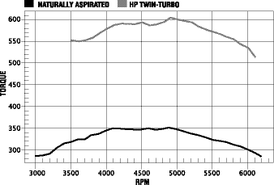
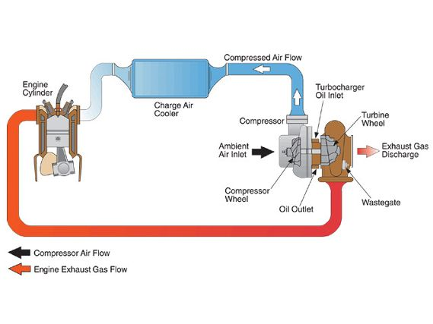
However, according to the Crolla et al (2015) “the benefits of turbo-charging diesel engines are so overwhelming that there are no significant naturally aspirated diesel engines”. When comparing the performance of a vehicle with a turbocharger in comparison to one with a naturally aspirated engine there are several differences which suggest that vehicles with turbochargers are overall more efficient. According to Reif (2014) an engine which is turbo charged has better torque characteristics across the speed range, this can be seen in figure 2 where the torque curve produced by a turbo-charged engine is much greater than that of a naturally aspirated engine. The reason for this is because more power is produced from combustion due to the increased intake of oxygen (Kluczyk, 2012) and this power is used to generate torque. This has an effect on fuel efficiency of a turbo charged engine as more force is available at lower speed. To add to this further, Crolla et al (2015) suggests that differences in compression ratios and the high throttling losses of aspirated engines mean that they are less fuel efficient than turbo-charged vehicles. Also, Reif (2014) believes that “lower fuel consumption is achievable by reducing engine swept volume”. As the volume is lower, exhaust gas emission rates are improved and less frictional and thermal energy is lost making the turbo-charged engine more economically and environmentally efficient than the naturally aspirated engine.
Figure 2: Graph of torque Holdener (2004)
Figure 3: air and exhaust gases from atmosphere to tailpipe Steamspeed (2015)
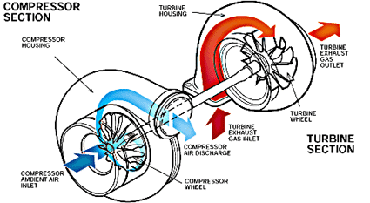
As mentioned previously, exhaust gases are used to drive a turbo. According to Bowen (2008) the turbocharger works like an air pump which is known as a centrifugal compressor. This suggests that unlike a naturally aspirated engine, the air entering a turbo charged engine is compressed before fuel injection takes place (see figure 3 for diagram of how air and exhaust gases flow through turbo from atmosphere to tailpipe). The flow of the air and exhaust gasses are guided through the turbine wheel and the exhaust gases are sucked from the atmosphere and through the turbine housing (Wagoner, 2012). Bowen (2008) adds to this further and suggests that kinetic energy and speed brings the air molecules closer together which turns the turbine wheel, gas is then exited through an exhaust outlet area. In addition to this, the turbine drives a compressor wheel which draws air into the compressor housing in order to compress it (Kluckzk, 2010). Following this, the compressed air is forced into the engine and more fuel is burnt (Brown, 2012). This suggests that this process allows more power to be produced. However, according to Bowen (2008) friction causes the air to heat up whilst it is compressing it and therefore means that the air exiting the compressor is hotter than the ambient air entering the compressor. Subsequently, this could mean that the effectiveness of the turbocharger could be reduced. Nevertheless, Wagoner (2012) suggests that the temperature of the air can be reduced before it enters the cylinders by using an intercooler. Therefore, this ensures that the effectiveness of the turbocharger is not compromised. In addition to this, the pressure of the airflow is greater when it has exited the compressor, this is so that air is forced into the cylinders, an illustration of this is given in figure 4, where the blue represents ambient air and the red represents compressed airflow. Finally, exhaust gases which have not been used in the process exit through the tailpipe via the waste-gate valve (Stone, 2012). In addition to this, the waste-gate is also operated at higher RPMs in order to prevent the turbine from over-spooling (Miller, 2008). This therefore ensures that no damage is caused to the engine and helps to ensure that the engine reaches its full horsepower potential.
Figure 4: Compressor section
TurboSmart (no date)
When considering the horsepower and RPMs of an engine, volumetric efficiency (VE) is an important factor to be taken into account (Hartman, 2008). According to Miller (2008) “an engine’s VE is a comparison of an engine’s calculated or theoretical, volumetric flow rate or air, versus its actual capability”. To add to this further, Ejvavec and Thompson (2014) describes VE as the “engines ability to fill it’s cylinders with air and fuel”. This suggests that VE refers to the amount of air an engine can absorb and consequently the amount of power an engine can produce. Furthermore, Rajput (2010) defines VE as “the ratio of actual volume of gas drawn into the compressor on each stroke to the piston displacement”. From research it can be seen that there are several factors which have an effect on an engine’s VE. According to Pesic et al (2013) the intake and exhaust system’s design and dimensions can have an effect on VE. To add to this, as the intake and exhaust system controls the direction, density and the flow of air (Pogorevec and Kegl, 2005). Therefore, both systems need to be designed so that the correct air/fuel ratio is achieved during the combustion process. Also, the shape of the combustion chamber is said to have an effect on VE, Hiller and Coombes (2004) believe that a hemispherical combustion chamber increases VE as it has a small surface area which reduces heat loss to a minimum
It can also be seen that back pressure affects VE, Vangelder (2012) states that build-up of pressure in the exhaust system obstructs the outward flow of exhaust gases. Therefore this may prevent the gas flow. Wagoner (2012) adds to this and believes that issues with the catalytic converter can cause back pressure, this suggests that the breakdown on vehicle parts can have an effect on VE. Futhermore, Hartman (2007) states that back pressure minimises the amount of fresh air flowing into the engine as it causes exhaust gases to go backwards into the combustion chamber. This could reduce the VE and subsequently have an effect on the engines performance.
Vangelder (2017) considers that forced induction increased VE as it “increases the air pressure in the intake manifold above atmospheric pressure”. For that reason, this enhances the engine output by increasing the quantity of air-fuel mixture that a cylinder burns. Therefore, it can be said that forced induction installation to a naturally aspirated engine will improve the engine’s VE. It has already been established in this report that a turbocharger is a forced induction system which increases the engine and that a compressor is used to drive the air into the engine (Bowen, 2008). Consequently, it can be said that the efficiency of the compressor is a factor that impacts on VE. According to Reddy et al (2013) compressor efficiency measures the compressors ability to pump air without overly heating the temperature. This suggests that if the air is too hot this could have an adverse effect on the compressed air which is forced into the engine and subsequently affect the way that fuel is burnt. Tamporial and Jancirani (2004) support this and state that too much of a rise in temperature will decrease the air density ratio. This will therefore reduce the engine output and will mean that engine performance is comprised. Therefore, the suitability of a compressor is an aspect that needs to be considered when designing a turbo charger installation later on in this report.

- Methodology
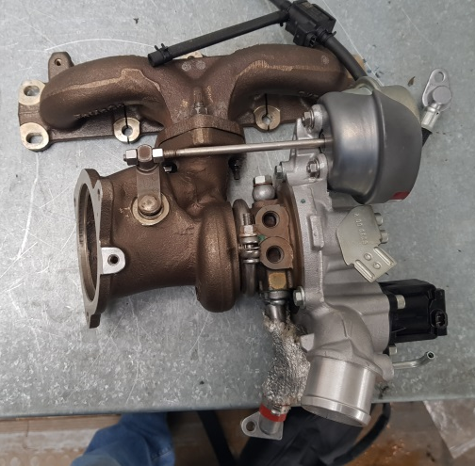
In order to perform a basic design of a turbo charger installation for a V8 spark ignition four stroke engine which has a bore of 95mm and a stroke of 80mm and to gain a better understanding of the components of a turbo, a turbo was stripped down in a workshop. The documentation of the procedure will be given in this section.
The turbo used to strip down was a Ford 1.6 four cylinder (see figure 5 for image of complete turbo), similar to that of a Ford Focus engine. According to Hosier (2013) four cylinder turbo units are low in weight but offer high power, meaning that it is likely to be fuel efficient without compromising on power.
Figure 5: Full turbo assembly
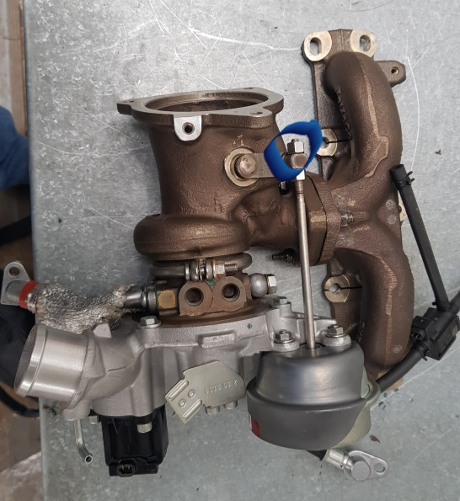
The turbo which was attached to the manifold was placed on a table in the workshop. According to Veneer (2015) the turbo manifold is made up of a series of pipes that “collect existing exhaust gases which can then be challenged into the merge collector.” The manifold attached to the turbo being stripped down was a single scroll manifold and a flange is needed to attach the manifold and turbo together. When using a single scroll manifold the exhaust gases leave through a single exit flange which is bolted on to the turbo (Bowen, 2008). The manifold was removed as part of the strip down.

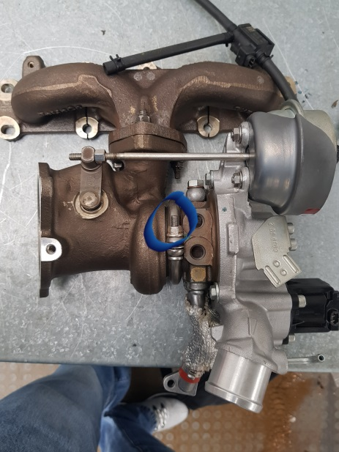
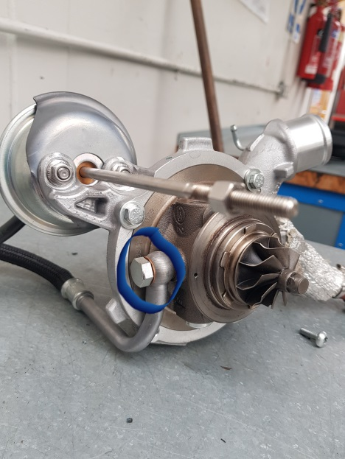
To start 1x10mm nut which was attached to waste gate actuator was removed, this was threaded with a jam nut (as shown in figure 6 circled in blue). Almost all turbos are fitted with a waste gate actuator and the role of this component is to control the operation of the waste gate valve in order to prevent the turbo from getting too hot in temperature (Miller, 2008). Following this, the v-band flange clamp which connected the waste gate housing to the turbo housing was removed by removing a 1x10mm nut (see figure 7 for image of this circled in blue). According to Chilton (1996) it is important to “take note of the positions of the coned discs springs and washers” when removing the flange nuts which attach the turbo and manifold together. This is to ensure that parts are fitted together correctly during re-assembly.
Figure 6: Waste gate actuator nut

After this, the oil return pipe was removed by using 1x6mm Hex key and the seals were replaced (see figure 8 circled in blue). As the turbo-shaft is pressure lubricated an oil feed pump and oil return pump is needed to feed oil from the engine oil filter mounting and return oil to the sump (Jex, 2007). The oil feed pipe was detached by removing 1x15mm banjo bolt, which allows for fuel transfer (Hartman,2008). The metric copper washer was then replaced.
Figure 7: V-flange clamp

Figure 8: oil pipe removed

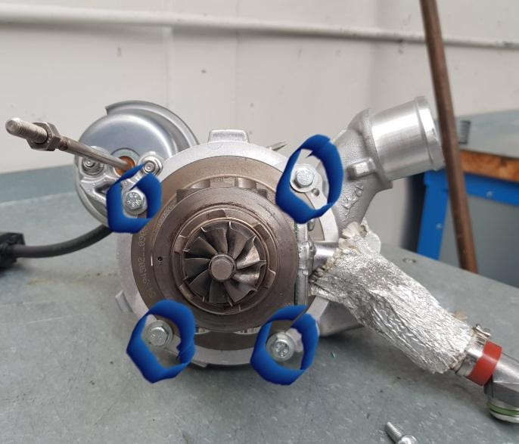
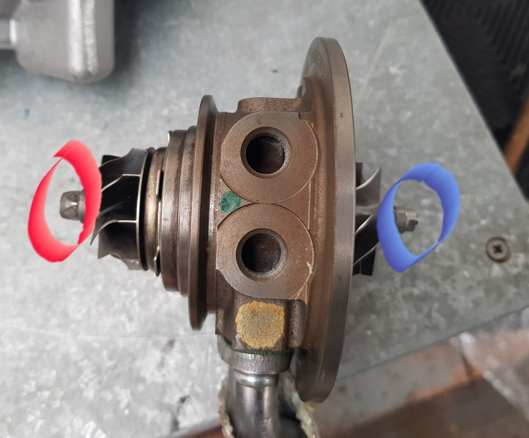
Next, 4x13mm compressor housing bolts were removed, these were attached to the top (x2) and bottom (x2) of the housing (see figure 9). The compressor housing houses the compressor wheel and is a volute shape. According to CDX automotive (2015) the compressor wheel and housing shape determines the volume of air which is supplied to the engine. After this, the compressor wheel/impeller was detached from the turbine shaft (see figure 10) by removing a 1x9 mm (red circle) socket on the hot side of the shaft and a 1x 6mm nut (blue circle ) which was a left handed thread on the impeller side of the shaft. As it was a left handed thread it needed to be moved clockwise to loosen instead of anticlockwise. Following this the oil seals were replaced and lubricated journal bearings, which are designed to support radial load (Das, 2008) were checked for any debris or wear. Miller (2008) states that as journal bearings are made out of softer material, they will typically show signs of wear before any other components. Therefore, checking these would be a good indicator for any wear/damage likely to take place to the turbocharger.
Figure 9: Compressor housing bolts

Figure 10: compressor impeller detached
After the turbo had been stripped down it was then re-assembled (see figure 6 again for full assembly). This procedure occurred in reverse order to the strip down. It was important to remember that the oil seal split had to face towards the oil flow in when putting shaft through housing. According to Bowen (2008) the sound of a click indicates that the seal had been fitted correctly.

Following the strip down of a turbo, the design of a turbo charger installation took place. According to Miller (2008) several design considerations and variables which relate to air flow need to be taken into account in order to design a highly effective turbo charger system. As the compressor has an influence on engine output (Bowen, 2008; Crolla et al 2015) the selection of a suitable compressor will be justified and supported via calculations and compressor maps. This can be seen in the next section.

4.0 Results and Analysis

A basic design of a turbocharger installation for a V8 spark ignition four stroke engine which has a bore of 95mm and a stroke of 80mm was performed. The engine has a rev limit of 9500 rpm. In naturally aspirated form, it had a volumetric efficiency of 85%. In this section several calculations will be given and then matched to compressor maps. The purpose of this is to best match the needs and the performance targets of the engine (Crolla et al, 2015). Also, the turbo is desired to run the turbocharged engine with 12 psi of boost pressure.
According to Hartman (2007), the calculations process needs to start with the engine airflow requirements. The volumetric flow rate calculation for a naturally aspirated engine is given below; where V= volumetric flow rate (m³/s), v= total engine displacement (m³), n_{v} = volumetric efficiency (0.85) and N = engine speed (rpm).
$$V= \frac{v x n_{v} x N}{2 x 60}$$

Therefore, the equation used for this turbo installation would be:

$V= \frac{4.536x{10}^{-3} x0.85x 9500}{2 x 60}$ = 0.305 m³/s
=646.295cfm

However, for a turbocharged vehicle the pressure ratio needs to be taken into account as this demonstrates how much atmospheric pressure in a system is increased by turbo (Bell, 1997). In addition to this, the flow rate needs to increase in line with the pressure ratio as this allows desired increased performance to be achieved (Davis, 2001). The calculation for pressure ratio is:
$$Pressure ratio=\frac{Atmosphere+boost}{Atmosphere}$$

Atmosphere is equal to 14.7 psi at sea level, also boost is the term used for intake manifold pressure (Pettit, 2004). Therefore, the equation used for the turbo installation was:
$$PR=\frac{14.7+12}{14.7}=\frac{26.7}{14.7} =1.816326531$$
As a result of this calculation the intake pressure will be 1.82 bar above atmosphere (14.7 at sea level). This equation demonstrates that if there is less pressure at the inlet of the compressor then the boost pressure will also be less, also higher pressure at the inlet signifies a higher boost at the outlet (Pettit, 2004). Pressure ratio was then used in the calculation for airflow requirements for a turbocharged engine, the calculation is show below:
$$V_{t }=PR x \frac{v x n_{v} x N}{2 x 60}$$

It is important to note that several turbo datasheets use imperial units (Hartman, 2007) therefore, the volumetric flow rate (v) would be in cubic feet per minute (cfm) so 1 m³/s would equal 2119 cfm. The calculation for the turbo installation was:

$$V_{t }=1.816326531 x646.295=1173.883 cfm$$

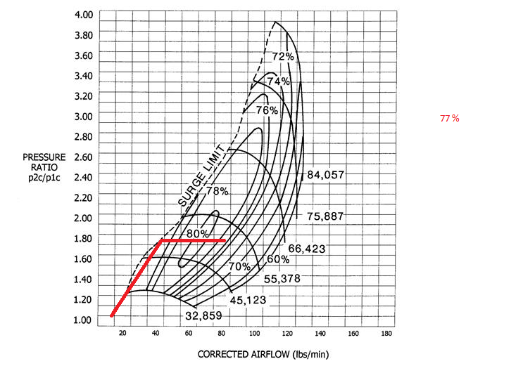
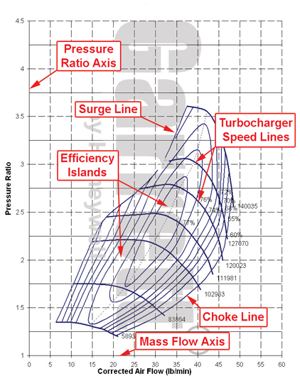
Following the completion of the above equations, data was plotted on compressor maps to establish the most suitable compressor for the installation. A compressor map illustrates the performance characteristics of a particular compressor (see figure 14 for characteristics on compressor map), these include speed, efficiency, mass flow range and boost pressure capability (Hartmann, 2007). The previous calculation was converted from cfm to lbs/min in order to plot the data on the compression maps (1173.883 x 0.07 = 82.172 lbs/min). Lines were drawn onto the compressor maps in order to determine the most suitable compressor, the lines were plotted at maximum airflow at PR = 82.172, 50% max air flow at PR = 41.086 and max airflow at 20% PR = 16.4344 (See appendix 1 for compressor maps with boost lines). From this it was established that compressor number 4 was the most suitable compressor to use (see figure 15 for image of this map). It was found that this was most suitable compressor because it was 77% efficient and the other compressor maps were out of range, therefore they are not compatible with the calculations.
Figure 12: Compressor map 4
Figure 11: Compressor map characteristics Honeywell Garrett (no date)
After the suitable compressor was chosen, the compressor outlet temperature was calculated, this was done in order to work out the compressor efficiency. According to Wagoner (2012) is “a compressor is less than a 100% efficient and the loss of heat during compression causes additional outlet air temperature to rise”. Therefore more of a rise in outlet air temperature means that more heat is lost meaning that the compressor is less efficient. The calculation used to work out the compressor outlet temperature is show below where$T_{in}$ = the inlet temperature in kelvin:
$$T_{out }= {PR}^{0.28 }x T_{in}$$
Therefore:
$$T_{out }= {1.816326531}^{0.28 }x 300=354.565 k (81.565 degrees celcius)$$

Furthermore, compressor efficiency was then calculated, according to Raven and Erikson (2011) the efficiency of super chargers decrease as the outlet temperature gets higher, for that reason the compressor efficiency needed to be calculated. In addition to this, the efficiency is determined by measuring the temperature and pressure totals at the compressor inlet and outlet (Nguyen-Schafer, 2015). Compressor efficiency is calculated below, where $n_{c}$ = Compressor efficiency:
$$n_{c }= \frac{ \left({PR}^{0.28}x T_{in}\right)-T_{in}}{Actual temp rise}$$
Therefore:

$ATR= \frac{ \left({1.816326531}^{0.28}x300\right)-300}{0.78}$= 70 degrees Celsius

Compressor efficiency = $\frac{ \left({1.816326531}^{0.28}x300\right)-300}{69.955}$= 0.78 x100 78% efficiency

From the compressor map (see figure 16) it can be seen that the turbo 78% efficient It was important to calculate the range of efficiencies as the airflow rate changes and means that the turbo operates during several efficiencies (Hartmann, 2007). From the map it can be seen than the turbo is less efficient at maximum load (68%) in comparison to maximum efficiency (77%).
Also, actual temperature rise can be calculated using the inlet temperature and compressor efficiency, this was needed to plot the efficiency of the compressor at maximum load conditions and maximum efficiency:
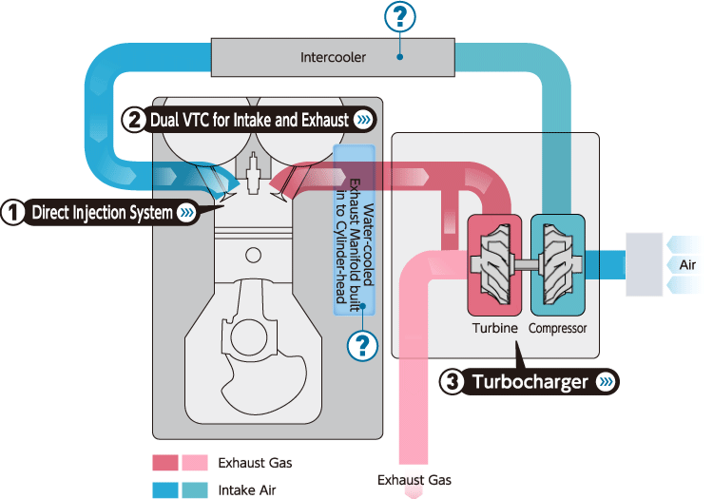
$Acutal temperature rise= \frac{ \left({PR}^{0.28}x T_{in}\right)-T_{in}}{n_{c}}$

Therefore:
Maximum load conditions: $actual temperature rise= \frac{ \left({PR}^{0.28}x T_{in}\right)-T_{in}}{n_{c}}$
$\frac{ATR= \left({1.816326531}^{0.28}x300\right)-300}{0.66}$ =82.67 degrees Celsius
Maximum efficiency conditions:
$\frac{ATR= \left({1.816326531}^{0.28}x300\right)-300}{0.78}$ =69.95 degrees Celsius
Figure 13: Intercooler operation Turbochargers (no, date)

These calculations indicate that the actual temperature rise is higher at maximum load conditions in comparison to maximum efficiency conditions; this result is expected as the compressor is less efficient during this stage (Bowen, 2008) and this could be cause by a rise in temperature. However, the rise in temperature can be decreased by using an intercooler (Hartman, 2011). See figure 17 for diagram of how intercooler operates. From the diagram it can be seen that the intercooler reduces the temperature of the intake air after compression and before it enters the engine. According to Miller (2008) the intercooler ensures that the air/fuel ratio is operating at a safe temperature. Therefore, this could mean that the engine reliability is increased.

The intercooler must be efficient to ensure that it operates effectively. Intercooler efficiency can be observed in several ways which include looking at heat capacity, pressure drop and heat transfer ability (Bowen, 2008). The intercooler has an efficiency rating which is defined by the quantity of heat eliminated by the intercooler to the sum of heat added by the turbo (McClurg, 2005). The calculation for intercooler efficiency is displayed below; where $n_{i}$= intercooler efficiency, $T_{co}$= compressor outlet temperature, $T_{io}$=intercooler outlet temperature and $T_{a}$ = ambient (inlet) temperature: $$n_{i }= \frac{ T_{co}-T_{io}}{T_{co}-T_{a}}$$
In order to work out the above equation the intercooler outlet temperature ( $T_{io})$ first needed to be determined. This equation is shown below, it was assumed that the ambient temperature was 27 degrees Celsius (300 kelvin) and the intercooler efficiency was 60% (0.60):
$T_{io}=$$T_{co}-n_{i }(T_{co}- T_{a}$) = 354.565 – 0.6(354.565-300) = 321.826 (48.826 celsius)

The calculation for intercooler efficiency for this study was:
$n_{i }= \frac{ 354.565-321.826}{354.565-300}$ = 0.6 x 100 = 60%
As the intercooler efficiency was 0.60 is demonstrated that the intercooler was 60% efficient. Raven and Erikson (2011) suggest that the intercooler needs to be at least 70% for the engine to show any difference. As the intercooler efficiency in this report was 60% this suggests that the intercooler was not as efficient as it could be.
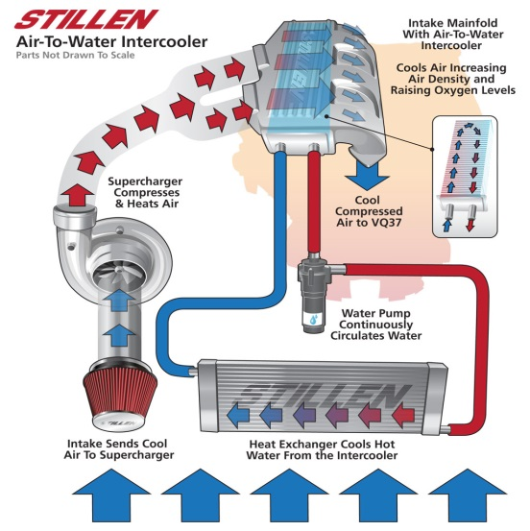
In addition, it appears that there are several ways that the intercooler design can influence the intercooler’s efficiency. Also, there are several different types of intercooler design which essentially operate in the same way, these being air to air intercooler and air to water intercooler. An air to air intercooler uses air to cool whereas an air to water uses water to cool air. According to research, the air to water intercooler can potentially be much more efficient than an air to air intercooler; also it is smaller than the air to air intercooler (Hartman, 2007; Bowen, 2008; Crola et al, 2015). Therefore, it appears that the fitting of an air to water intercooler would be more beneficial in this turbo installation. A diagram of an air to water cooler is included in figure 18.
Figure 14: Air to water intercooler
Turbo Basics (no date)

To work out the size of the intercooler that needed to be fitted the flow rate and the internal flow area was taken into consideration, the flow area was calculated by multiplying the flow rate (cfm) by the internal flow area.
$\frac{∆Y}{∆X}$ = $\frac{600}{31}$= 19.355x therefore: $\frac{1173}{19.355}$ = x = 60.604 square inch

This means that the size of the intercooler required for this turbo was 60.604 square inch.
voluAccording to Miller (2008) a well-designed intercooler achieves better density recovery. Also, density recovery is dependent on the intercoolers size and its efficiency (Hiereth and Prenninger, 2007). Therefore, it was seen that density recovery is as important as the performance of the intercooler. In order to work out the density recovery the equation below was used; where $T_{co}$= compressor outlet temperature (in kelvin) , $T_{io}$=intercooler outlet temperature (in kelvin)

$$DR= \frac{ T_{co}}{T_{io}}-1$$

Therefore:

$DR= \frac{ 354.565}{321.826}-1$ = 1.105162923
Meaning that there was a proportional increase of 1.1 in charge density. This was then multiplied by a 100 in order to calculate the percentage increase which was 110% however, as this is impossible this suggests that this calculation needs to be revisited.

As the turbo installation will take place on a naturally aspirated engine there are several installation considerations that need to be made which are related to the engine. Firstly Dinesh (2006) considers that the inlet and outlet exhaust manifolds would need to be fabricated in order to fit the specific application. As the exhaust inlet and outlet manifolds play a significant role in the control of the turbo this suggests that this must be done correctly in order for the system to work properly. It appears that it is easier to complete this process on a single turbo rather than a twin turbo as a twin turbo requires the plumbing of two air outlets (Petris, 2014). In addition to this the camshaft specification needs to be established as cam timing has an effect on cylinder pressure which can have an effect on torque and could cause detonation (Reid, 2004). Therefore, if the camshaft application is too high or low this could influence the overall performance of a turbo. According to Dinesh (2006) the specification should be of “mid duration and overlap”.

Installation considerations that relate to the associated components also need to be taken into account. The fuel system is another part of the vehicle that needs to be changed in order to meet the conditions of the turbocharger. According to Diesh (2006) “the injectors, fuel pump, pressure and mapping of the ignition system would also need to be modified”. Failure to modify the above may result in the turbo charger not working properly. This could mean that the design of the turbo charger installation could be flawed if other installation considerations are not taken into account.

5.0 Conclusion
To conclude it can be seen from this report that turbocharging has the ability to significantly increase the power of a vehicle (Hartman, 2007; Miller, 2008). In addition to this, it has been established that there are several merits to supercharging with a turbocharger, these include enhancement of engine’s power output, improved torque characteristics and increased fuel efficiency (Kluczyk, 2012; Wagoner, 2012; Crolla et al 2015). Furthermore, it has also been found that forced induction is a factor which can improve the volumetric efficiency of a naturally aspirated engine. However, it was recognised that the compression of air can potentially reduce the effectiveness of a turbo charger and for that reason compressor efficiency and the fitting of an intercooler is an important factor to consider when installing a turbocharger. Also, the strip down of a turbo in this report illustrated the importance of a turbo being assembled properly as incorrect strip down and assembly could cause damage to the turbo charger. The results in this report demonstrated that a suitable compressor which is efficient needs to be installed to ensure that a turbocharger performs to its full potential; the compressor in this report was 77% efficient. In addition, the results have shown that the design of the intercooler and the intercoolers efficiency also contribute towards the overall performance of a turbocharger. Furthermore, it has been established that there are several installation considerations that could impact on the turbo’s performance. In summary it appears that turbochargers can potentially improve an engines power and torque characteristics, however the installation of a turbo charger is quite a complex process and there are several factors that need to be considered to ensure that the turbo charger enables the engine to achieve its full potential.

6.0 Reference List

Baines, N. (2005) Fundamentals of Turbocharging. Concepts inc: London
Bell, C. (1997) Maximum Boost: designing, testing and installing turbochargers. London: Robert Bentley
Bowen, R. (2008) How to Build Max-Performance Mitsubishi 4G63t Engines. CarTech: China
CDX Automotive (2015) Fundamentals of heavy/medium duty diesel engines. Burlington: Jones and Bartlett
Chilton (2003) Chilton’s auto repair manual. Clifton Park: Delmar Learning
Clurg, B. (2005) How to build turbocharged and super charged Small-block Fords. China: Cartech
Das, M. (2008) fluid mechanics and turbo machines. Dehli: PHI Learning
Davis, E. (2001) Supercharging, Turbocharging and Nitrous Oxide Performance. Motorbooks: Minneapolis
Dinesh, A. (2016) Conversion of Naturally aspirated Diesel engine to turbocharged engine for improving the performance for Genset applications.
Journal of Chemical and Pharmaceutical Sciences, issue 5, pp 17 -22
Dorries, E. (2004) TechOne: Automotive Engine Repair. Cengage Learning: Clifton Park
Erjavec, J. and Thompson, R. (2014) Automotive Technology, a Systems Approach. Cengage Learning: Clifton Park
Hartman, J. (2008) Turbocharging Performance Handbook. Motorbooks : Minneapolis
Hiereth, H. and Prenniger, P. (2007) Charging the internal Combustion engine. Springer: Germany
Hiller, V. and Coombes, A. (2004) Hillier's Fundamentals of Motor Vehicle Technology. Nelson Thornes: Cheltenham
Hosier, R. (2013) How to modify BMW series 3. Dorset: Veloce Publishing
Kluczyk, B. (2012) How to Supercharge and Turbocharge GM LS-Series Engines. CarTech: China
Miller, J. (2008) Turbo: Real World High-Performance Turbocharger Systems. CarTech: China
Nguyen-Schafer, H. (2015) Rotor dynamics of Automobile Turbochargers. Springer: Germany
Pesic, R., Davinic, A., Petkovic, S. and Milordovic, D. (2013) Aspects of volumetric efficiency measurement for reciprocating engines. Journal of Thermal Science, 17(1) pp35-48
Pettitt, J. (2004) Sport Compact turbos and blowers. Cartech: China
Raven, G. and Erikson, H. (2011) Water-cooled performance handbook. MBI Publication: Minneapolis
Reddy, S., Pandurangadu, V. and Hussain, A. (2013)
Effect of Turbo charging On Volumetric Efficiency in an Insulated Di Diesel Engine For Improved Performance. International Journal of Modern Engineering Research. Vol 3(2). pp-674-677
Reif, K. (2014) Gasoline Engine Management: Systems and Components. Springer: Germany
Vemeer, R. (2015) Turbo Manifolds. (online) available from: http://www.themotorhood.com/themotorhood/2015/7/31/heres-our-guide-to-knowing-your-turbo-manifolds [last accessed 07/05/2018]

Stone, R. (2012) Introduction to Internal Combustion Engines. Palgrave: Hampshire
Wagoner, R. (2012) Turbocharging Normally Aspirated Engines on a Budget. Lulu Enterprise: London

7.0 Appendices
Appendix a – Compressor maps

Map 1

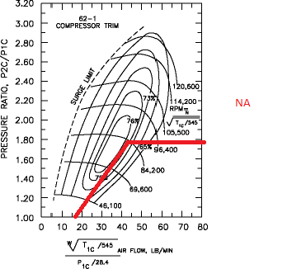
Map 2

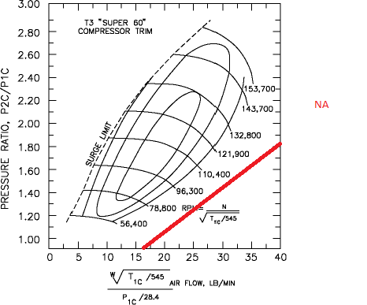

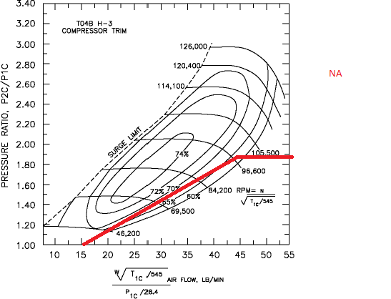

Map 3

Map 4

