Modern Movement Exemplar - Lee Harries (1700012)
Modernism ‘became the single most important new style or philosophy of architecture and design of the 20th century.’ (RIBA Architecture, 2017) The movement was said to be a response to increasing industrialisation and a changing social climate. Mies Van Der Rohe’s famous quote ‘Less is more’ (Phiadon, 2014) succinctly defines modernism as the movement embraced minimalism. Ornament became obsolete with clean lines, simple geometries and functional open spaces rapidly becoming clear aesthetic characteristics. (RIBA Architecture, 2017) The Schroder House and Villa Savoye are two iconic buildings that are inextricably linked to the modernism movement. For this body of work, a comparison between the two shall be made.
Historical Background
The Schroder House (Figure 1) was erected at the end of a suburban street in Utrecht during 1924. (Curtis, 1996, p.157) Designed by architect Gerrit Rietveld, ‘the Schroder House stands out dramatically from its sober brick neighbours.’ (Curtis, 1996, p.157) The abstract family home, which is the only building that fully encompasses the principles of De Stijl, was commissioned by Truus Schröder-Schradera to be a ‘veritable manifesto for how an independent modern woman should live her life.’ (The Art Story, 2019) The home completely defied conformity in architecture at the time. De Stijl, a design movement founded in 1917, focused on the notions of ‘ideal’ geometric forms along with strong influences from cubist paintings. (Wikipedia, 2019) A signature palette of white, black and primary colours was formed, exhibited both the façade and interior of the Schroder House. (Rietveld Schröderhuis, 2019)
Villa Savoye (Figure 2), located in Poissy, was designed by architect Le Corbusier. (Curtis, 1996, P.276) Completed in 1931, the home was at the forefront of cutting-edge design as it embraced new technologies. Corbusier famously states, ‘the house is a machine for living in.’ (Archdaily, 2018) The ‘floating’ home clearly adopts this mentality. Villa Savoye is the only structure to encompass Corbusier’s five points of architecture, those being; Pilotis, roof garden, free floorplan, horizontal windows and the free façade. (Les Couleurs, 2018) Le Corbusier created the five points of a new architecture to deal with the problem of mass housing. His idea was to mass produce the modern home, thus being ‘serviceable like the modern car.’ (Geocities, 2003)
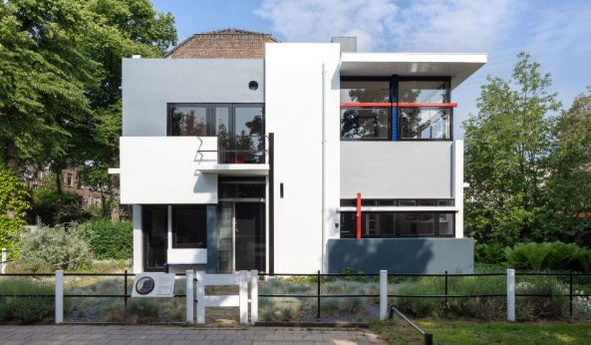
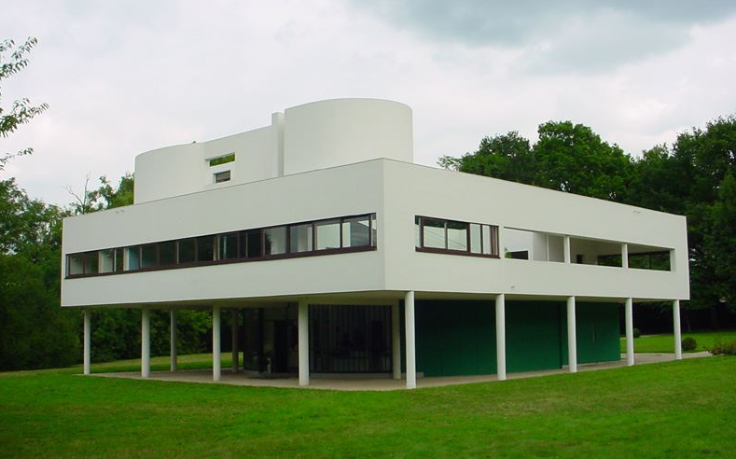
Figure 1 (Left) – The Schroder House (Deezeen, 2018)

Figure 2 (Right) – Villa Savoye (Wikipedia, 2019)
Plan and section
When looking at the technicalities of the Schroder House in terms of plans and section, it is clear to see the intricacy and complexity of design. The floorplans of the home (appendix 1) clearly show that specific rooms are not noted on any of the spaces, suggesting the spaces are more areas of activity rather than designated rooms. On the first floor of the Schroder House, partitions are used instead of walls and can be ‘removed altogether to give an entirely free plan.’ (Curtis, 1996, p.158) It is said that Mrs. Schroder gave three criteria about the rooms for her children, stating that the bed should be able to fit in two differing positions, each room should have a water supply and drainage and finally all bedrooms should have a door for direct access to the outside. (Archdaily, 2010) It is evident that these criteria formed prominent aspects of the home’s design. The section (Appendix 1) clearly outlines the layout of Rietveld’s Schroder House, allowing a larger understanding of how the spaces would function.
Villa Savoye, despite appearing aesthetically more simplistic also has a high level of intricacy to its floorplans. The plan of the Villa Savoye is nearly square, one of the simple geometries Le Corbusier admired. The atmosphere of the ground floor as depicted by Curtis (1996, p.278) is ‘clinical.’ It is largely comprised of pilotis, giving the illusion that the house is floating. These pilotis are positioned as such to allow car access around the structure, particularly to give an entry point to the garage. (Appendix 2) Within the habitable space of the ground floor is the entryway as well as the butler and maid’s quarters. The entryway sits within a grand curved wall of glass that floods the ground floor’s structure with natural light. A ramp and staircase grant entry to the home itself. Looking at the ramp in section, it is evident that it acts like a backbone for the dynamic of the house. The centrally located ramp meanders over every floor, inviting you to explore and take advantage of every useable space there is. (Appendix 2) The first floor is comprised of the living quarters, made up of three bedrooms, four bathrooms, office, master suite, kitchen and formal living room. Some of the spaces are attached to the roof terrace. The curved Solarium veers away from simple geometry seen in the rest of the house. Located at the top of the Villa Savoye is the solarium, which can be accessed via ramp or spiral staircase. The departure from straight lines gives the building added interest and provides an almost nautical touch. (Appendix 2) It is clear to see that both floorplans revolve around the function and use of the building, each catering to the needs and wants of the client.
Materials and light
Both buildings embraced new and innovative technologies when it came to materiality. The use of reinforced concrete, steel and large expanses of glass provided a new way of construction.
The Schroder House, with its intricate planar design was constructed out of Dutch brick and wood, material choices common for the time. Despite being designed for concrete only the foundation and balconies utilised reinforced concrete. (The Rietveld-Schroder House, 2012) Lintels and columns were made from Steel I-beams that were eventually painted over. The sliding partition walls of the first floor consisted of layered cork sealed by beaverboard. (The Rietveld-Schroder House, 2012) The signature De Stijl palette can be seen in the guide railings on the ceiling and floor, window mullions, balcony railings and attached struts, clearly depicting the planes they are on. (The Rietveld-Schroder House, 2012) Rietveld designed the windows of the home to open at a 90-degree angle to the wall to ‘preserve the strict design standards about intersecting planes.’ (Archdaily, 2010) The primary colour palette is seen internally to define space usage. Despite open spaces being prevalent, the internal spaces and colour choices are ‘finely chosen and immensely restful.’ (Nuttgens, 1997, p.276) This is aided with ample levels of natural light entering the internal spaces through the carefully positioned windows. The internal makeup, matched with the furniture designed for the home by Rietveld created a ‘highly dynamic and interactive environment to live in.’ (The Rietveld-Schroder House, 2012)
Le Corbusier introduced industrial materials when constructing the Villa Savoye. Steel, glass and reinforced concrete were used as he wanted ‘a shift away from what he saw as impractical materials and methods of the time.’ (The Conversation, 2014) The main structure of the Villa Savoye is comprised of pre-fabricated reinforced concrete and masonry units. Approaching this build with pre-fabrication was ahead of the times and was certainly an exciting new prospect for buildings going forward. The white plaster allows unification of the house and provides a simple yet pleasing façade to cover the pre-fabricated components. The white provides connotations of purity and cleanliness, leading to an impression that this building is superlative. The plaster also eliminates any distractions, allowing a greater appreciation for the key design features. Le Corbusier clearly wanted to highlight the signature five points of his new architecture within the design.
Idea and theories underpinning the design
Rietveld’s vision was to create a home that fully encompassed the aspects of the Destijl movement. A ‘cubist construction of smooth planes at right angles’ (Nuttgens, 1997, p.273), anchored and defined by primary colours. The collaborative work with Truus Schröder-Schradera conveyed the new sense of life desired by Schröder after the loss of her husband. The house provided an environment that exuded positive energy, imbuing a sense of freedom. Rietveld’s article from 1932, titled “New functionalism in Dutch Architecture” eludes to his viewpoints on architecture and the way it should be practised. He references the influence De stijl plays for artist, sculpture and architect. He states, ‘the materials and their forms still belonged to sculpture, that the light-reflecting surfaces of walls were the painter’s domain; the architect was left with nothing but empty space.’ (Modernist Architecture, 2010) He insists that ‘Architecture becomes an environment and nothing more’ (Modernist Architecture, 2010), resulting in a building no longer being a lone entity, rather being in an ‘active relationship to human beings.’ (Modernist Architecture, 2010) The direct links to both art and sculpture, met with Rietveld’s ideology, succinctly defines the nature and aesthetic of the Schroder House. The balance of design and functionality are managed along a fine line, crossing paths to allow an immersive yet seemingly tranquil space. It is evident that this approach was pioneering as the emphasis was no longer only on the building but people’s relationship to it.
Le Corbusier had a more purist approach to architecture. With his consistent inspiration from machinery, it is a crucial part of the concept Villa Savoye that the ‘observer is not standing in one fixed place, but is moving around.’ (Nuttgens, 1997, p.268) Art of the period seemingly had the same characteristics. It is theorised that elements such as the solarium in the Villa Savoye take reference from Le Corbusier’s earlier purist paintings as the shape resembles the outlines of a guitar. The introduction of the five points of architecture allowed Corbusier to dictate his architectural technique; Villa savoye being the prime example of the methodology. The home gave ‘poetic expression to his world view’ (Curtis, 1996, p.285) and was the outcome of ‘a radical quest, a returning to roots, a rethinking of the fundamentals of art.’ (Curtis, 1996, p.285) Corbusier’s want to repave the path of architecture was strong and his methods are still renowned today.
Conclusion
Ballantyne clearly argues that (2002, p.2) ‘architecture is part of the art of living’ and is most fortuitous when giving ‘expression to the life that inhabits it.’ Both architects tried to express this throughout their designs, with Reitveld being more successful. It is undeniable that both embraced new technologies and challenged the norm. The construction methods used in these homes can still prevalently be seen today and has left these buildings being timeless classics. Despite differences, both convey the approach and viewpoint of the architects.

Appendix 1
Floorplans and section of Schroder House. Floorplans Available at: http://art-now-and-then.blogspot.com/2014/01/rietveld-schroder-house.html
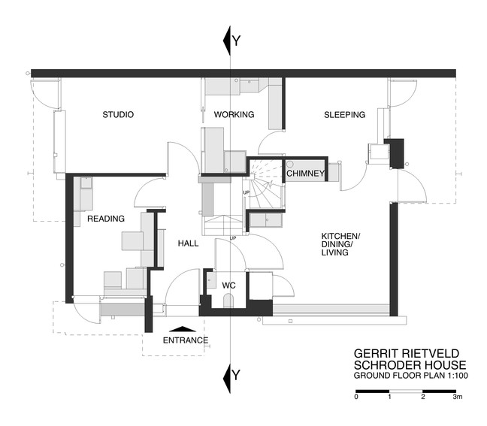
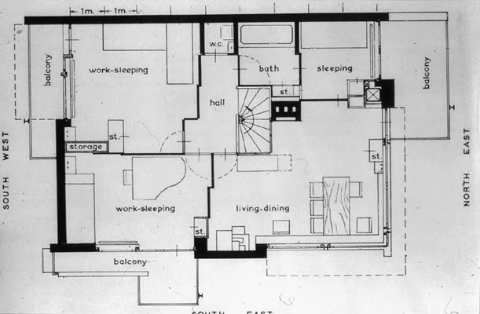

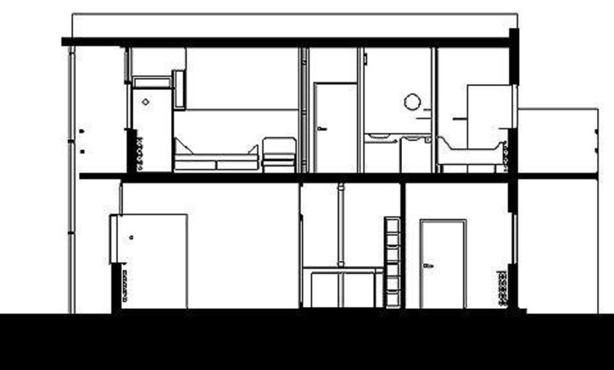

Section Available at: https://www.archdaily.com/99698/ad-classics-rietveld-schroder-house-gerrit-rietveld

Appendix 2
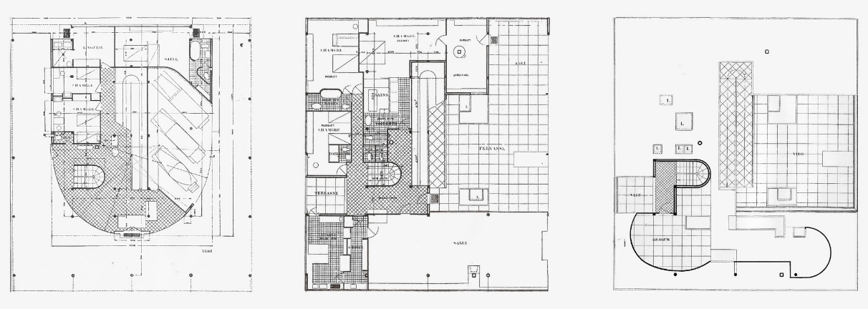
Villa Savoye Floorplans and section. Floorplans Available at: https://www.khanacademy.org/humanities/ap-art-history/later-europe-and-americas/modernity-ap/a/corbusier-savoye

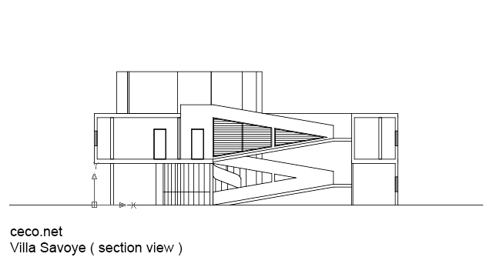
Section Available at: https://ceco.net/autocad-blocks/architecture/section-view/autocad-drawing-villa-savoye-le-corbusier-section-view-dwg-dxf-275

Bibliography
Books
Ballantyne, A. (2002) What is Architecture? London: Routledge
Curtis, W.I.R. (1996) Modern Architecture Since 1900. 3rd Ed. London: Phiadon Press Ltd.
Nuttgens, P. (1997) The Story of Architecture. 2nd Ed. London: Phiadon Press Ltd.
Websites
Archdaily (2010) AD Classics: Rietveld Schroder House / Gerrit Rietveld. Available at: https://www.archdaily.com/99698/ad-classics-rietveld-schroder-house-gerrit-rietveld (Accessed: April 13th 2019)
Archdaily (2018) Spotlight: Le Corbusier. Available at: https://www.archdaily.com/434972/happy-birthday-le-corbusier-2 (Accessed: April 11th 2019)
Deezeen (2018) Stijn Poelstra photographs Mondrian-esque elements of the Rietveld Schröder House. Available at: https://www.dezeen.com/2018/08/29/stijn-poelstra-photographs-mondrian-rietveld-schroder-house-architecture/ (Accessed: April 11th 2019)
Geocities (2003) Le Corbusier's Five Points of Architecture. [PDF] Available at: http://abl.gtu.edu.tr/hebe/AblDrive/73746022/w/Storage/987_2011_1_310_73746022/Downloads/5-points-of-arch.pdf (Accessed: April 11th 2019)
Les Couleurs (2018) Le Corbusier´s five points of a new architecture. Available at: https://www.lescouleurs.ch/en/journal/posts/the-five-points-of-a-new-architecture/ (Accessed: April 11th 2019)
Modernist Architecture (2010) Gerrit Rietveld’s “New Functionalism in Dutch Architecture”. Available at: https://modernistarchitecture.wordpress.com/2010/10/20/gerrit-rietveld-%E2%80%9Cnew-functionalism-in-dutch-architecture%E2%80%9D-1932/ (Accessed: April 15th 2019)
Phiadon (2104) What did Mies van der Rohe mean by less is more? Available at: https://uk.phaidon.com/agenda/architecture/articles/2014/april/02/what-did-mies-van-der-rohe-mean-by-less-is-more/ (Accessed: April 11th 2019)
RIBA Architecture (2017) Modernism in Architecture. Available at: https://www.architecture.com/explore-architecture/modernism (Accessed: April 11th 2019)
Rietveld Schröderhuis (2019) Rietveld’s Schröder House. Available at: https://www.rietveldschroderhuis.nl/en (Accessed: April 11th 2019)
The Art Story (2019) Important Art and Artists of De Stijl. Available at: https://www.theartstory.org/movement-de-stijl-artworks.htm#pnt_5 (Accessed: April 11th 2019)
The Conversation (2014) Sublime design: Le Corbusier’s Villa Savoye. Available at: https://theconversation.com/sublime-design-le-corbusiers-villa-savoye-26625 (Accessed: April 13th 2019)
The Rietveld-Schroder House (2012) An Architectural Case Study of the Most Famous House of the De Stijl Movement, Designed by Gerrit Rietveld. Available at: http://rietveldschroderhouse.blogspot.com/2012/12/normal-0-false-false-false-en-ca-zh-cn.html (Accessed: April 13th 2019)
Wikipedia (2019) De Stijl. Available at: https://en.wikipedia.org/wiki/De_Stijl (Accessed: April 11th 2019)
Wikipedia (2019) Villa Savoye. Available at: https://en.wikipedia.org/wiki/Villa_Savoye (Accessed: April 11th 2019)

