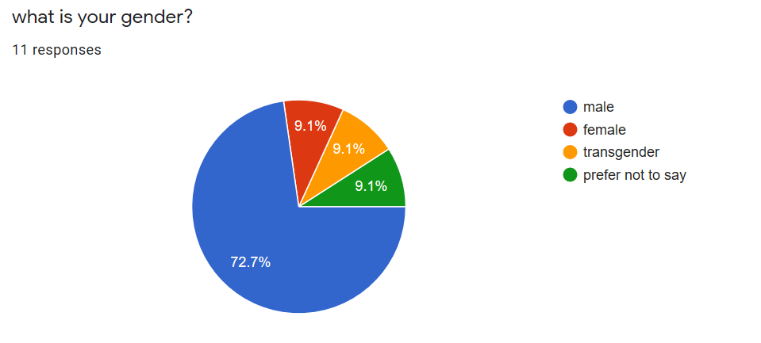This chart has shown me the clear indications that’s about 72% of respondents are male. This shows that we must work hard on the other gender to who did not respond to our survey. We will be working hard on our market research and target the other genders lime the female and the transgenders. We will use all the possible means available to us to convince them. For the female we will used the most benefit of the saffron in women and gave them the reason they should used saffron. We will used door to door marketing strategy for the other genders if possible. We will used women platform such as women gatherings to advertise the product, give out examples of the product. Since we know who our target market is after the chart review, we will go all out to attract me of the female transgender’s and those who have not prefer to say a word.

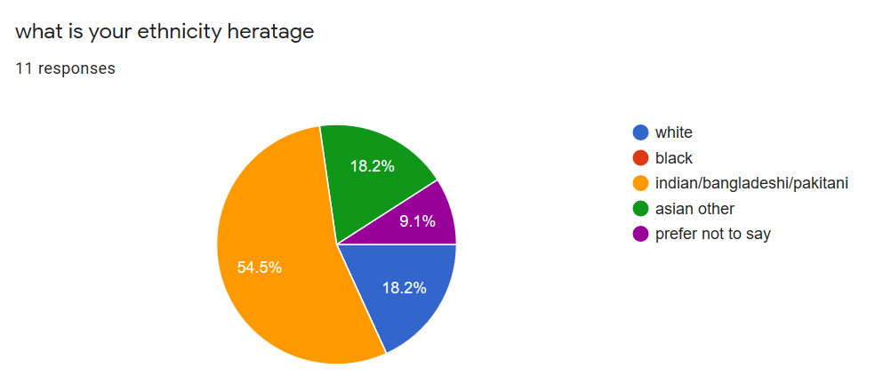
Our market survey shows over 54% of our market is Indian/Bangladeshis/Pakistani who will form the base of our market. The remaining 18.2% who are white,9.1% prefer not to say ,18.2%white another 18.2% also black and the rest Asian. With the reaming target ethnic, we will be making a huge marketing campaign towards each of this by inviting them our trade fares. We will try convincing them to make a trail of our product, explaining the health benefit of the product, gave them a bonus when ever they are able convince two people to try the product. With this strategy we will be able to target our other ethnic minorities to gain their confidence about the product.

Part 2 website
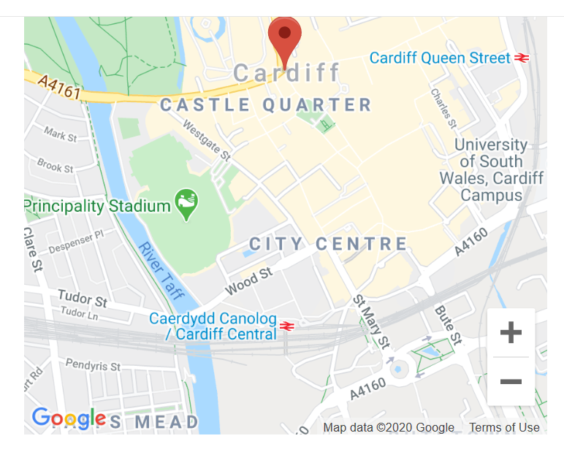
The reason of putting the map on the website, it makes people to easily located were exactly the business is located. People do not have newspapers and phone books like they had before. Nowadays people, particularly the younger generation, depends on their GPS, smartphones, and other web-based devices to locate nearly everything. We live in a digital world which makes it very easy now to find things. Google Maps is an excellent tool which no business can ignore. So, list the exact address and details of your business today itself on Google Maps and enable your prospective customers to get the exact directions to where you exactly are instead of relying on scribbled instructions or a map. Once listed at these location service websites, your business is ultimately open for the business reach to the common public. These are the very reason we put map on our business webpage. This will have a huge advantage for us as we will reach the wider customer both locally and international which will boost the business very well.
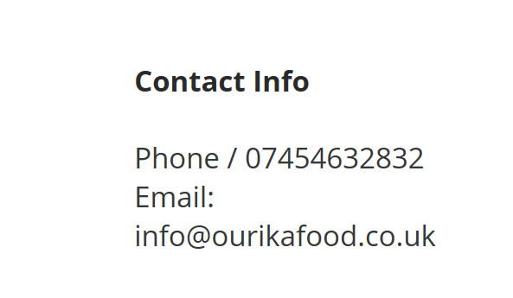 There are a few things that internet users are now looking at to make sure that the website they are using is genuine. One of these things is the contact the reason why you provide your contact details – to help reassure visitors that you’re a legitimate business. There are also a chance people will decide to go with another company who has their contact information in an easy to find place on their site. It provides different methods of contact for potential customers and is very easy to find. This essentially gives potential clients the option of calling, driving to your store and a form for them to email your company instantly. There are exceptions, it's possible that you would rather not have walk-in traffic at your company and in such case would not be needing to go. Having a website without contact information is just a waste of a resource.

