The Recall of Faces after a Distraction Task
(1520 words)

Abstract
When looking at the issue of face recognition, there is question into whether those of a specific race recognize own race faces better than other races. A group of white participants (students) aged 18-60 took part in a task where they were asked to look at 12 images of black and white faces and then recall the amount of each face they remembered from part one, when combined with random other faces. The results showed that those of a white ethnicity recalled more black faces compared to white faces and thus contradicts previous research of own-race bias and how those of a specific race will remember faces of their own race better.

Introduction
The topic that will be discussed and presented will concern the recall of facial recognition within different ethnic groups. There have been many studies which look at the relationship between these two aspects and from looking at different articles, it is clear to see that there is a higher recall in faces from a person of the same race. When looking at an article on face-race bias analysis by Meissner and Brigham (2001) it is clear to see that the information of the own race bias can be seen as a reliable source across different races but there is little information on the variables that may hinder the effect. The idea of the bias can be linked into a case of the “Quincy Five” in 1971 and there are issues with the own race bias when relating to eyewitnesses saying they recognised five black people and linked them to a crime. Therefore, research into the recall of faces must help provide knowledge on the subject. Within this article, looking at 39 research studies with roughly 5,000 participants the results had shown a "mirror effect" where own-race faces had a higher amount of success in recalls. Suggesting that those of a white race would be able to recognise more white faces clearly than black faces.
The article “An Investigation of the Contact Hypothesis of the Own-race Bias in Face Recognition” (Chiroro & Valentine, 1995), looks at own-race bias. They used a contact hypothesis to test whether black Africans, white Africans and white Britons who had contact, little contact or no contact to the opposite race would recall more of their own race faces or other ethnicities. The results concluded that there was a higher accuracy of recall of own-race faces and there were also a smaller amount of own-face race bias among those who had high contact with the other race compared to those who had little or no contact with the other race. This therefore supports the idea of those of a specific ethnicity will remember more faces related to their own race.
Additionally, research by Malpass and Kravitz (1969) support the research by looking at the Recognition of faces of own and other races. They showed a group of multi-racial students (20 black and 20 white) 20 images of both black and white males and asked the participants to recall the faces they recognized. From this study they found that the participants were found to have higher visual recall for faces of own race. However, they also found that when those of a black ethnicity had experience with those of a white race it had no connection to the accuracy of recognition. Meaning that having contact with other races has no link to accuracy of the recall.
From looking at the literature provided it is clear to see that an own race bias is present when recalling faces of different ethnic groups. White races are seen to remember more white faces and those of a black race recalling black faces. From the results gathered from the different studies which have been discussed, the hypothesis which will be tested throughout the report will be a directional hypothesis, that white faces will have more recalls than black faces. This due to all of the participants taking part in the study being of a white race.

Method
The participants used were recruited by means of opportunity sampling as a class of single honours Psychology students and Counselling and Psychology students used. There were 29 students used altogether (7 Male, 22 Female) the aged ranged between 18 – 60 (M =27.31, SD =10.81). All 29 participants were of a white ethnicity.
The design used was an experimental design with the participants being within subjects meaning that the same group took part in both conditions and the experiment was conducted in a group setting. The test that was used during this study was a paired samples to test to find the significance of the results. When looking at the variables of the study the independent variable was the ethnicity of the faces and there were two conditions in which these images were shown – black faces and white faces. The dependent variable was how many faces were recognised in the second part of the task. The dependent variable can be defined by how many faces recalled.
A PowerPoint presentation was used to create the study, this includes 12 faces shown in part 1 of the study which were shown individually for 2 seconds at a time. The images contained 6 black faces and 6 white faces. For the second task 6 faces were displayed on a single page for 12 seconds and repeated for 6 pages (36 faces altogether). With the second task there were 18 black faces and 18 white faces presented. A recall sheet was created to collect demographic and there was a space given to record responses.
The first step carried out was the participants were given a consent form to sign and agree to the study (See Appendix A). They were then instructed to watch a screen and additional instructions were presented in the PowerPoint presentation. Instructions were then given to tell the participants that they had to be silent during the process to allow for full concentration on the task and allow equal opportunity for the group. A countdown was then started from 3 to 1 which proceeded to show the first image and the presentation of the 12 initial faces followed. There was then a distraction given through means of a lecturer giving information for 1 minute. Instructions followed for the group to take part in part 2 of the study, additional instructions were given to see how many faces they could recall from the initial 12 images. At the end of the study a debrief was given through a screen so everyone in the group could see (See Appendix B).

Results
A within samples t-test (See Appendix C) was conducted to assess the difference in participants recall of black and white faces after a period of distraction. Results show that the recall from participants for black faces was significantly lower (M = 3.34m, SD = 2.42) compared to the recall of white faces (M = 2.67, SD = 1.97); t (28) =3.13, p <.05. When looking at the significance level of the test, it is clear to see that the data is significant as 3.13 is larger than the value in the t distribution table. The hypothesis for this study was that participants would recall more white faces, so this must be rejected.
Discussion
When looking at the study carried out, it can be seen the original hypothesis must be rejected as more black faces were recalled. When looking at the results obtained in relation to the literature discussed on own-race bias, there is no correlation within the results found so therefore the results are contradicting. In the articles by Meissner and Brigham (2001), Chiroro & Valentine (1995) and Malpass and Kravitz (1969) all three of these articles support that people of the same race will recognise faces of their own ethnicity more accurately and quickly than those of a different race. Even though previous studies include different experiments to find which faces would be remembered the most, the study carried out by Malpass and Kravitz (1969) was similar to this and the results produced in this report are the opposite to those found in the previous study. Meaning that the results cannot be supported.
There are also many limitations which can be seen in the study including the setting of the study as it was carried out as a group meaning that there will be an issue of individual differences. So, it could be replicated but carried out in a lab individually. Additionally, there was a limited number of participants used, 7 males and 22 females which means it limits the ability to generalise to a wider population, so a larger sample should be used to allow this. Also, only one ethnic group was used so to allow for wider research additional ethnic groups should be used to also help with generalising. With relation to the materials, a debrief sheet could be useful to the participant as they are able to keep a record of it instead of projecting it onto a screen, so they can view it once. With the images used in the study it can be seen that when combining 6 images onto one slide they can be small and may hinder the participant from getting specific details as it was projected to group on a screen. Therefore, by making the images larger may help but also by conducting the study on an individual basis may also allow the participant to get a better view.
With relation to the research problem, more studies need to be conducted in order to gain a better understanding of face recognition between different races. Other steps to proceed to may include using different races such as Asian, American Indian or native Hawaiian and ethnicities including Hispanic to allow for a wider variety of people to generalise findings too.

References
Chiroro, P., & Valentine, T. (1995). An Investigation of the Contact Hypothesis of the Own-race Bias in Face Recognition. The Quarterly Journal Of Experimental Psychology Section A, 48(4), 879-894. http://dx.doi.org/10.1080/14640749508401421
Malpass, R., & Kravitz, J. (1969). Recognition for faces of own and other race. Journal Of Personality And Social Psychology, 13(4). http://dx.doi.org/10.1037/h0028434
Meissner, C., & Brigham, J. (2001). Thirty years of investigating the own-race bias in memory for faces: A meta-analytic review. Psychology, Public Policy, And Law, 7(1), 3-35. http://dx.doi.org/10.1037//1076-8971.7.1.3
Appendix
Appendix A)
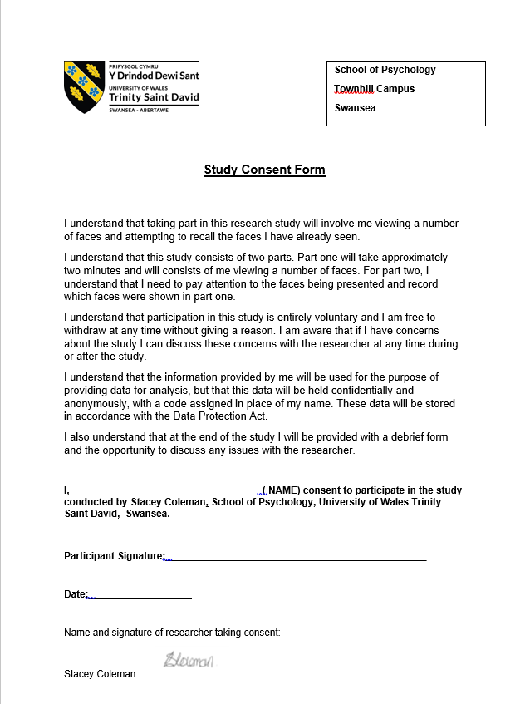

Appendix B)
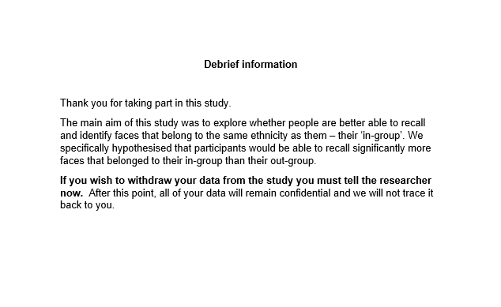
Appendix C)


