George Valentin Priboi

2029732
Lecturer : Tarila Zoufa LCBB4000

An Academic Report on

Effective Communication in Teams

Table of Contents
1. Introduction 3
2. What is effective communication? 3
3. The importance of effective communication in teams 4
4. Ways to develop effective communication among the team members 5
5. Conclusion 6
Reference list 7

1. Introduction
In recent times, the significance of effective communication regarding organizational performance has been realized by almost all organizations irrespective of their types and sizes worldwide. Therefore, Bhatti and Ahsan (2021) have enunciated that leaders and managers play a crucial role in facilitating effective communication in the teams that remain significant in improving individual and organizational performance. However, while surveying 400 companies from the UK or US, an important issue that has been identified is the communication barrier, which results in loss of productivity (Kashyap, 2021). During this pandemic period, when all the activities need to be conducted through virtual platforms, effective communication has become more crucial. Thus, in this report, a detailed discussion will be made on the process of effective communication, its importance and ways to facilitate effective communication in teams.

2. What is effective communication?
While defining effective communication, da Silva Nogueira and Rodrigues (2015) have asserted that it is a process of interaction between two individuals or among the group members with the aim to deliver, receive and comprehend the message accurately. Thus, it is a strategic process of sharing information among the team members that focuses on what the speaker wishes to deliver, what he says and how the receivers interpret it. Moreover, effective communication is based on 7C's or popularly known as seven principles of communication developed by Scott M. Cutlip and Allen H. Center that incorporates correct, clear, concise, complete, considerate, concrete and courteous (No, 2021).
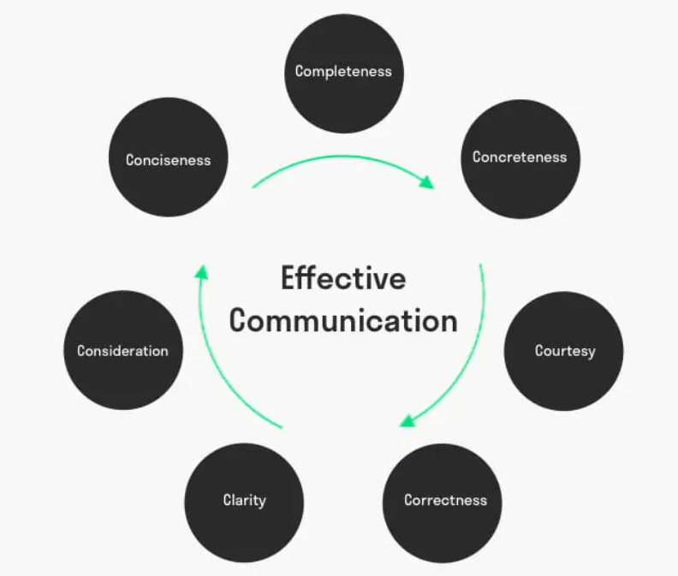
Figure 1: Seven principles of effective communication
(Source: toolshero, 2021)
Thus, effective communication aims to make the audience understand the delivered message correctly based on these principles. Therefore, it is necessary to keep the message simple, straightforward, and easy to understand. Also, it is essential to bring conciseness while delivering a message, and here, the message must be kept short and accurate (Banerjee, 2016). Moreover, for effective communication, it must be ensured that all the shared information is correct and valid, as well as it remains free from any technical, factual or grammatical errors. Along with this, shared messages must be complete to remain effective; otherwise, ambiguity, vagueness and assumptions will occur. Before delivering a message, the speakers need to consider the receivers' background, knowledge or expertise level, viewpoints etc., so that the communication does not develop any ineffectiveness (Soyinka, 2020). Lastly, it is essential to remain courteous, respectful, and polite to other members during communication as arguments or ill-temper can increase conflicts and make the process ineffective.

3. The importance of effective communication in teams
As opined by Muszynska et al. (2015), effective communication is the critical factor in building up a strong camaraderie by enhancing mutual understanding, trust and respect. Therefore, it is vital to reduce the appearance of misunderstanding among the teams and also brings more clarity regarding the contribution of each member. Thus, through effective communication, proper recognition and appreciation can be provided among the members and make them feel valued. Also, effective communication remains significant to foster a healthy workplace culture where members can work collaboratively and independently by sharing relevant skills, knowledge, and information and building up an ambience of trust. Thus, practising such communication is essential to develop positive employee relations, morale and motivation through which higher productivity and better performance can be ensured.
Similarly, DuBois et al. (2015) have interpreted that effective communication is essential to provide a safe working environment to the team members without any threats regarding their physical and mental health. Thus, in a working culture, where effective communication has been fostered by the leaders, sharing ideas, feelings, and thoughts becomes more convenient and fluent, leading to better innovation and creativity. In the study of Myers and Chou (2016), the authors have proclaimed that in a context where multiple individuals work together, it is very sure to occur conflicts when it comes to a difference of opinion. In such scenarios, the value of effective communication gets doubled as here; it works as an efficient tool to resolve conflicts by addressing the underlying issues among the members and turns the entire process into something unique and creative.
In addition to this, effective communication is also necessary to develop positive team spirit among the members that usually raises their desire and willingness to work together towards a common goal and achieve success. Also, Cumin et al. (2017) have identified the importance of effective communications in teams to develop self-esteem among every individual, keep them engaged with each other and the entire process through proper recognition and empowerment. However, it is also undeniably essential to deliver instruction to the team members and guide them in the appropriate direction to achieve established goals and objectives. At the same time, members receive a proper image regarding what is expected from them and how they should meet such expectations. Thus, to build up strong teams, provide higher satisfaction to the members, keep the members efficient and motivated, attain continuous improvement regarding individual and group performance and above all, to achieve significant success, it is essential to facilitate effective communication among the team members.

4. Ways to develop effective communication among the team members
To make effective communication, first, it is required to have definite planning. Marlow et al. (2017), in this context, have asserted that communication can never be effective if it's just focused on passing information to others; instead, the speaker needs to clarify and explain the ideas and thoughts well to make it more effective and appealing to the audiences. Thus, here, primary planning is required to identify the ways through which information will be explained and delivered to the receivers. At the same time, communication can only be effective when all the members listen to others actively. Therefore, the proper development of the active listening skill of all the team members is highly significant to facilitate effective communication within the team. Contrary to this, Salas et al. (2015) have suggested that the leader or manager of a group must identify one or two strategic techniques that suit the capability of every member. Communicating through such methods will bring more effectiveness in understanding the shared messages and responsiveness among the members.
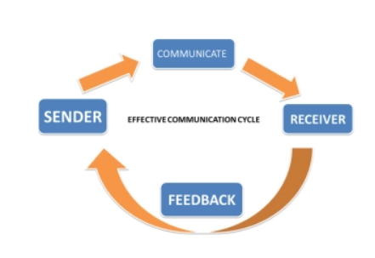
Figure 2: Effective communication cycle
(Source: maryanncqu.wordpress, 2015)
Moreover, while having verbal or non-verbal communication, the focus must be given to delivering a precise, accurate and relevant message to the members to accomplish the purpose of communication and count it as an efficient one. At the same time, team-building activities must be developed that will help the members communicate more with each other, even for personal discussion. Therefore, a strong sense of mutual understanding and trust can be acquired through which further professional communication can become more effective. Iorhen (2019) emphasizes more on developing two-way feedback as an effective mode of communication as it not only offers scope to the leaders and managers to offer feedback regarding team performance but also every individual receives the opportunity to express their opinions and point of views. Thus, by following all these ways, effective communication can be fostered among the team members that will help increase individual and team productivity, efficacy, efficiency, and performance.

5. Conclusion
Thus, from the entire discussion, it has been identified that effective communication is undeniably important for every team to drive better performance, attain progress and achieve significant success. However, leaders and managers often find it challenging to make communications effective, resulting in demotivation, lack of interest, less productivity, and poor performance. Therefore, the identified strategies are beneficial to overcome communication barriers among the team members and transform communication into an effective one.

Reference list
Banerjee, A., 2016. Modern Trends and Practices of E-Marketing: An Overview. OSR Journal of Business and Management (IOSR-JBM), Special Issue-AETM, 16, p.16.
Bhatti, M.W. and Ahsan, A., 2021. Effective communication among globally distributed software development teams: Development of an “effective communication” scale. In Research Anthology on Recent Trends, Tools, and Implications of Computer Programming (pp. 2014-2039). IGI Global.
Communication in Professional Contexts with Mary Ann. 2015. The importance of effective communication. [online] Available at: <https://maryanncqu.wordpress.com/2015/04/12/the-importance-of-effective-communication/> [Accessed 9 June 2021].
Cumin, D., Skilton, C. and Weller, J., 2017. Information transfer in multidisciplinary operating room teams: a simulation-based observational study. BMJ quality & safety, 26(3), pp.209-216.
da Silva Nogueira, J.W. and Rodrigues, M.C.S., 2015. Effective communication in teamwork in health: a challenge for patient safety. Cogitare Enferm, 20(3), pp.630-634.
DuBois, M., Koch, J., Hanlon, J., Nyatuga, B. and Kerr, N., 2015. Leadership styles of effective project managers: Techniques and traits to lead high performance teams. Journal of Economic Development, Management, IT, Finance & Marketing, 7(1).
Iorhen, P.T., 2019. Strategies For Developing High Performing Work Teams (HPWTS) In Modern Organizations. Economic Research, 3(2), pp.16-25.
Kashyap, S., 2021. Here’s How Effective Communication is in the Hands of 73% of Professionals. [online] ProofHub. Available at: <https://www.proofhub.com/articles/effective-communication> [Accessed 9 June 2021].
Marlow, S.L., Lacerenza, C.N. and Salas, E., 2017. Communication in virtual teams: A conceptual framework and research agenda. Human Resource Management Review, 27(4), pp.575-589.
Muszynska, K., Dermol, K., Trunk, V., Ðakovic, A. and Smrkolj, G., 2015, May. Communication management in project teams–practices and patterns. In Joint International Conference (pp. 1359-1566).
Myers, K. and Chou, C.L., 2016. Collaborative and bidirectional feedback between students and clinical preceptors: Promoting effective communication skills on health care teams. Journal of midwifery & women's health, 61(S1), pp.22-27.
No, P., 2021. Effective Communication as a Tool for Achieving Organizational Goals and Objectives. Journal of Economics, Finance And Management Studies, p.265.
Salas, E., Shuffler, M.L., Thayer, A.L., Bedwell, W.L. and Lazzara, E.H., 2015. Understanding and improving teamwork in organizations: A scientifically based practical guide. Human resource management, 54(4), pp.599-622.
Soyinka, V.I., 2020. A study on the effectiveness of communication patterns on employee performance in Iroko Television, Nigeria (Doctoral dissertation, Dublin Business School).
Toolshero. 2021. What are 7 C’s of Communication? Explanation + tips | toolshero. [online] Available at: <https://www.toolshero.com/communication-skills/7cs-of-communication/> [Accessed 9 June 2021].

