3/24/2025
University of Wales Trinity Saint David
London campus
E-Portfolio Link: https://sites.google.com/view/pedroclaudio27portfolio?usp=sharing
Module Name: Learning In the Digital Era
Module Code: ACCA 4025

Student Name: Pedro Claudio Martinez Almanzar
Student ID: 2510674
Group: 4

Lecturer’s Name: Dipo Dunsin

LDE Assignment 1
E-Portfolio
Table of Contents
Introduction 2
Main Body 2
Task 1: Essential Academic and Employment Skills for the future career Path 2
Task 1 (a): Report on Essential Academic and Employment Skills 2
Task 1 (b): Evaluation of Task 1 (a) based on Similarity report 2
Task 2: Collaborative Mind Map and Individual Poster 2
Mind Map (Collaborative) 2
Poster (Individual) 2
Task 3: Virtual Collaboration and RefWorks 2
Report on Virtual Collaboration 2
Step-by-step process of using RefWorks with visuals 2
Task 4: E-Portfolio Creation and Evaluation 2
Task 4 (a): E-Portfolio Creation 2
Task 4 (b): Illustrative Review of E-Portfolio tool Selection 2
Conclusion 2
References 2
Task 1 References: 2
Task 3 References: 2

Introduction
The final module assessment performed in the Learning in the Digital Era (ACCA4025) is the present portfolio. It demonstrates the process and use of the fundamental digital, academic, and professional competencies. The work is based on four major tasks and reflects active work with main skills that are necessary in higher education and a future career in the field of computing. They include: critical summary of essential skills; collaborative and personal discovery of teamwork; technical and focused demonstration of a virtual collaboration using an automated referencing tool, and the building of this reflective e-portfolio. The portfolio as an artefact is a summative artefact and also a pragmatic demonstration of digital literacy that is the core of the intended learning outcomes of the module. IEEE referencing standards have been used throughout the work in order to support research and every deliverable has been created with the focus on clarity, accessibility, and professionalism in the digital setting.

Task 1: Essential Academic and Employment Skills for the future career Path

Task 1 (a): Report on Essential Academic and Employment Skills
In the modern digital economy, the academic and professional skills that are fundamental are essential elements in order to become successful [1]. Within computing, the core capabilities, as digital literacy, critical thinking, and successful communication, form the arsenal that one needs to sail and innovate effectively in the sphere.
Digital literacy does not simply mean a level of knowledge about simple use of software [2]. It includes the ability to critically evaluate information received on online platforms, use specialised development and teamwork tools and keeping up with the rapidly changing technological world. It is one of the core competencies required of computing professionals and makes it easy to undertake effective research, ethical practices in code writing, and lifelong learning. Similarly, critical reasoning is also crucial. It consists of the logical analysis of complex issues, debugging of computer programs, testing of the efficiency of algorithms, and contingent decision-making when it comes to system architecture and data interpretation [3]. This method of analysis creates the distinction between an experienced and a novice programmer.
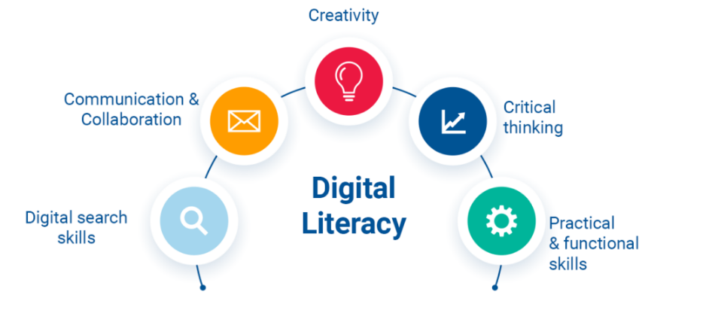
Figure 1: Digital Literacy
Besides, excellent written and oral communication is essential. It is due to the capacity to build code in a transparent way, creating technical reports, discussing the ways to provide solutions to non-technical audience, and collaboration in Agile teams that technical tasks are aligned with the business goal and user needs. These competencies are directly applicable in the case of software development career [4]. It allows exploiting an integrated development environment (IDE) with and without the version control system (Git) and cloud deployment through digital literacy. The process of professional communication ensures success in the involvement in team projects, understandable development of user documentation, and competent contribution at each of the life cycles of the software development.

Task 1 (b): Evaluation of Task 1 (a) based on Similarity report
My Turnitin similarity score is 22%. It falls into acceptable range but shows a dependence on common definitions and phrasing from my sources. I will emphases on paraphrasing of technical ideas and enhance the synthesis of my evaluation to decrease matched text in order to bring improvement. According to Generic Assessment Criteria, I would award this work 58%. It shows a satisfactory to best understanding of skills with clear implementation to computing and applying the references. There is coherence in structure but expression’s originality could be empowered to attain higher band.

Task 2: Collaborative Mind Map and Individual Poster

Mind Map (Collaborative)
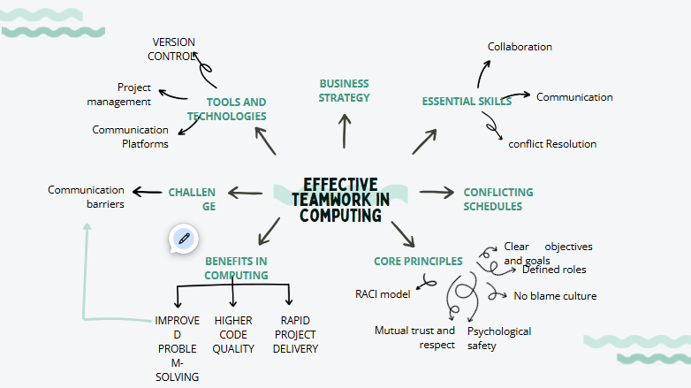

Poster (Individual)
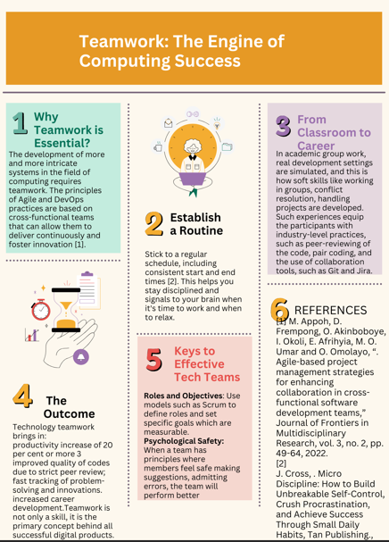

Task 3: Virtual Collaboration and RefWorks

Report on Virtual Collaboration
In modern computer work, virtual collaboration forms a part and parcel, especially since distributed teams and remote work systems have become popular. One of the key parts of this paradigm is asynchronous communication. The implementation of information exchange systematically without any expectation of an immediate response [1]. As compared to synchronous modalities like video conferencing, asynchronous tools, like Slack, Microsoft Teams (channels), and project-management systems like Jira support contribution by participants in different time zones at the pace of individual members.

The approach has great benefits to the software development. It avoids overloading of meetings, maintains a written history of decisions and rationale behind them, and allows more thoughtful and considered input [2]. Supplier in London As an example, a software developer in a more local office in London can put in a code-review request at the end of the day, and a counterpart in a different region such as India can answer at the start of their day, thus creating a development cycle known as follow-the-sun. This process is repeated thereby increasing productive working time and pushing project schedules.
However, the effectiveness of the asynchronous collaboration process depends upon the disciplined practice. To prevent misunderstandings, it is necessary to have a system of clear communication protocols, extensive documentation, and the strict adoption of threaded comments and channel organization. The tool usage is to be utilized selectively: complex conversations are to be carried out in the form of threaded comments, and quick clarifying messages are more likely to be performed in the vein of direct messaging [3]. The effectiveness of such a model depends on how a team is composed of the norms to ensure the responsiveness and clarity, thus turning possible delays into the chances of reflection and thoughtful work [4]. Computing professionals, these practices are a requirement or even a mandatory competency and a requirement to be involved in and lead in the global technology undertakings.

Step-by-step process of using RefWorks with visuals
I managed to handle the references in managing this summary using the IEEE format I needed to follow the rules and used RefWorks, which is a cloud-based reference manager.
Creating a New Reference: To create a New Reference in my RefWorks account, I entered the column after placing a log-in and then I clicked the option of adding a new reference and chose the reference. I selected the type of resource which is a Journal Article [2] and typed in the metadata manually; authors, title, journal name, volume, issue, page numbers, and DOI.
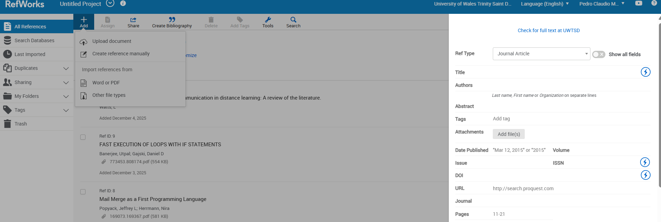
Figure 2: Creating a New Reference
Creating the Citation: I was able to use the Cite While You Write add-on in Microsoft word within my draught. I had the cursor in the place that I required the in-text citation to be and then I called up the RefWorks toolbar, typed the reference and clicked on the insert button. This would automatically insert the proper in-text citation number, e.g. [2]
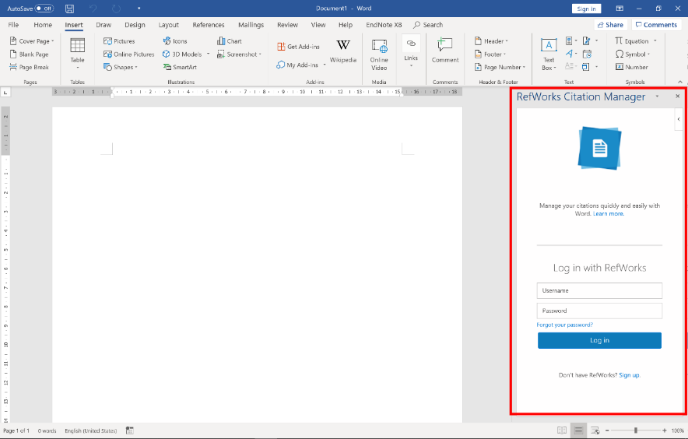
Figure 3: Creating the Citation
z

Producing the Bibliography: When all the citations were in place, I placed my cursor at the end of the document. With the help of the RefWorks toolbar, I chose Bibliography, IEEE loop of output style and then I pressed Create Bibliography. RefWorks automatically created a formatted reference list that was correctly formatted and listed
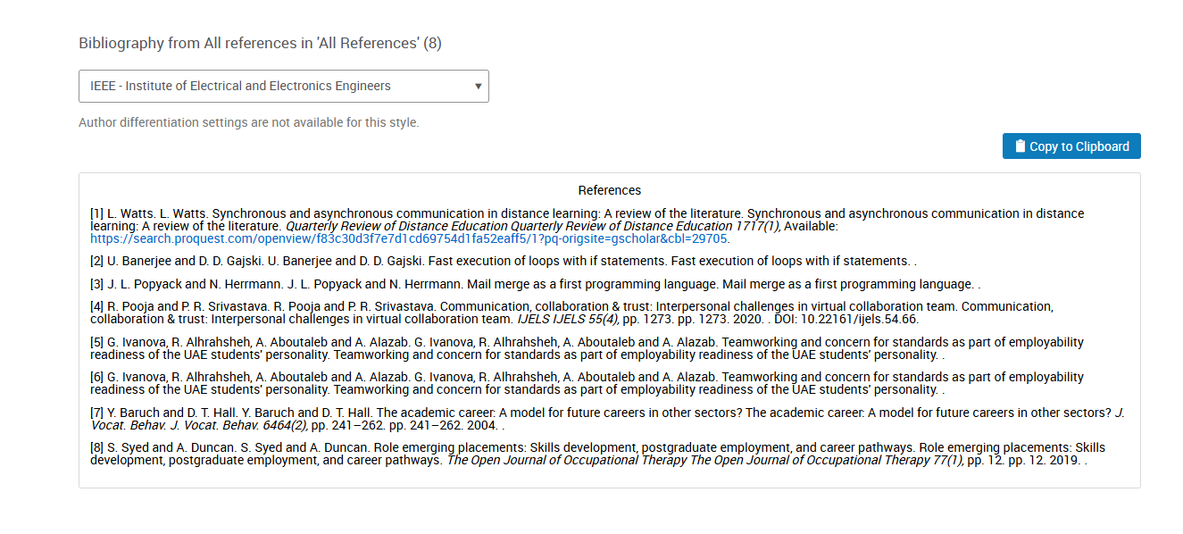
Figure 4: Producing the Bibliography
RefWorks have simplified the reference listing procedure, maintained uniformity and saved a lot of time used in formatting referenced materials manually thus providing me with time to concentrate on the studies of my research.

Task 4: E-Portfolio Creation and Evaluation

Task 4 (a): E-Portfolio Creation
Tool Selected: Google Sites
Main Justification of the Choice: I chose Google Sites because it is user-friendly, it is free and easy to use, and it is directly compatible with the main digital tools that I will work with during this module and overall studies. Google Sites provides a good opportunity to practice cloud-based development platform as a computing student, and a simple approach to structuring the webpage and content management without being that complex as full-scale development.
Key Advantages Experienced
- Quick To build: The visual editor allowed building a multi-page site with a complete layout in less than two hours.
- Trustworthy Integration: The possibility to embed the materials of Google Drive (Docs, Slides, Jamboard) was seriously smooth, so all content underpinning various files is synchronised and available.
- Intrinsic Responsiveness: The created site will automatically be responsive to desktop, tablet, and mobile displays, and that is a decisive aspect of the current web development and user-accessibility.
- Centralised Management: The use of my institutional Google account enabled single-sign-ons to all the assets hence simplifying the process of file management and permission controls.
Screenshot Documentation
I have taken a clear screenshot on each page of my e -portfolio as needed. The Word document submission that goes with this portfolio link will show these pictures hence giving verifiable completion evidence to any access problems in the event of access problems.
Not only did this exercise meet the assessment requirement but also enabled me to improve my practice of developing a professional online presence; a competence that has direct applicability in my career as a future computer use.

Conclusion
This portfolio is a good record of the learning and learning application of basic competencies in the digital-era. Together, the assignments can be used to understand a sequence moving on from an awareness of essential academic and employability competencies to the practice of these competencies via teamwork, research management, and online creation. Developing the e-portfolio has helped in consolidating learning and this shows that one has a talent towards using technology to organise, present and reflect upon work professionally. The given body of work does not only meet the assessment standards; it also creates a substantial body of skills that includes critical thinking, good communication, and technical expertise, which is directly portable to higher academic education and professional computing career. The experience highlights the importance of lifelong and dynamic digital practice that allows an individual to think, learn, and adjust to a constantly changing environment in order to attain personal and professional growth in the rapidly changing technological context.

References

Task 1 References:
[1] J. Biggs, C. Tang and G. Kennedy, “Teaching for quality learning at university 5e.,” McGraw-hill education (UK)., 2022.
[2] Y. Noh, “A study on the effect of digital literacy on information use behavior.,” Journal of librarianship and information science,, vol. 49, no. 1, pp. 26-56, 2017.
[3] R. Kitchin, “Thinking critically about and researching algorithms.,” The social power of algorithms, pp. 14-29, 2019.
[4] N. Assyne, H. Ghanbari and M. Pulkkinen, “The essential competencies of software professionals: A unified competence framework,” Information and Software Technology, p. 151, 2022.

Task 3 References:
[1] N. Mansour. N. Mansour. Students’ and facilitators’ experiences with synchronous and asynchronous online dialogic discussions and e-facilitation in understanding the nature of science. Students’ and facilitators’ experiences with synchronous and asynchronous online dialogic discussions and e-facilitation in understanding the nature of science. Education and Information Technologies Education and Information Technologies 2929(12), pp. 15965–15997. pp. 15965–15997. 2024. .
[2] M. Brennan. M. Brennan. No title. No title. The use of Asynchronous Discussion to Support Collaborative Learning in an Online Programme The use of Asynchronous Discussion to Support Collaborative Learning in an Online Programme 2021. .
[3] J. Kiesewetter, I. Hege, M. Sailer, E. Bauer, C. Schulz, M. Platz and M. Adler. J. Kiesewetter, I. Hege, M. Sailer, E. Bauer, C. Schulz, M. Platz and M. Adler. Implementing remote collaboration in a virtual patient platform: Usability study. Implementing remote collaboration in a virtual patient platform: Usability study. JMIR Medical Education JMIR Medical Education 88(3), pp. e24306. pp. e24306. 2022. .
[4] H. Singh, G. Cascini and C. McComb. H. Singh, G. Cascini and C. McComb. Virtual and face-to-face team collaboration comparison through an agent-based simulation. Virtual and face-to-face team collaboration comparison through an agent-based simulation. Journal of Mechanical Design Journal of Mechanical Design 144144(7), pp. 071706. pp. 071706. 2022. .

