Worksheet 3

Network Operating Systems ACCA5023
Neil O’Mahoney 0351709
Part Time Cyber Security Networks

Stuff goes here

Task 1

Understanding NTFS and Share Permissions
Figure 1 - Screenshot of Admin account typing text into file and allowing it to be saved.
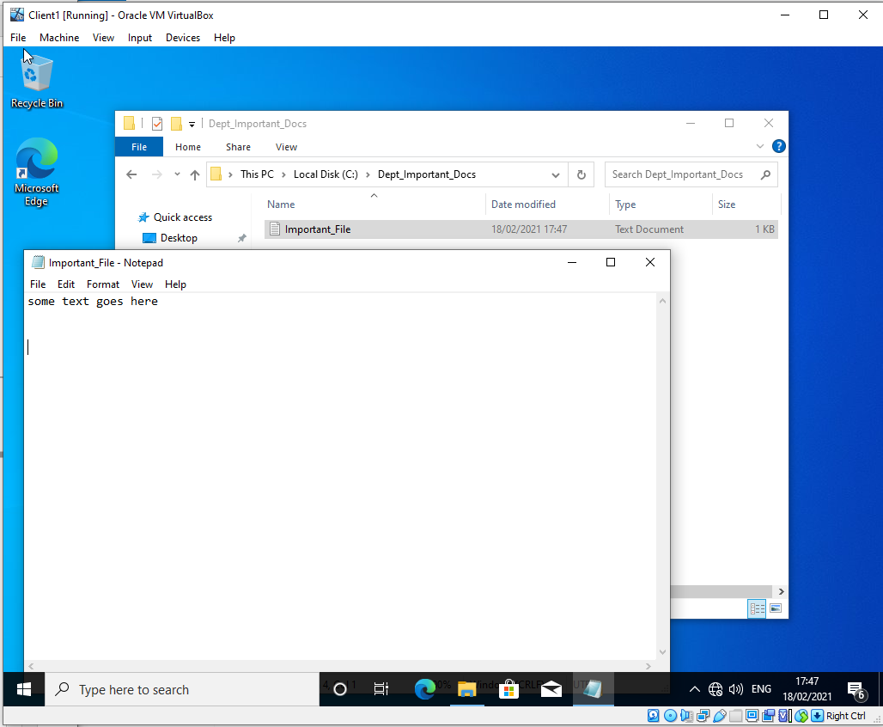
Figure 2 - Screenshot of Non-Admin Account modifying folder - this is not allowed as the permission for modify has not been ticked only read, execute and list.
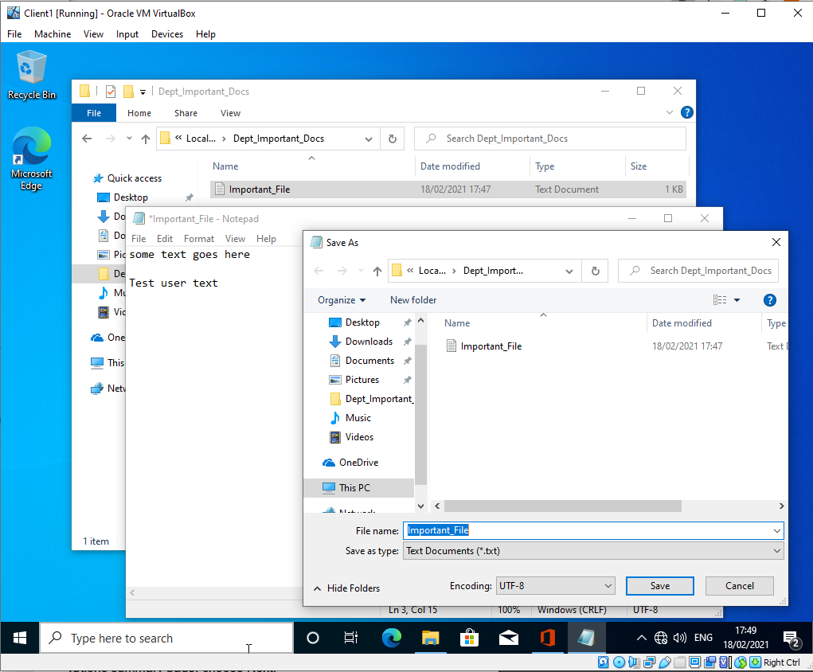
Figure 3 – permissions demonstrating what the test user has received. No permissions are inherited either.

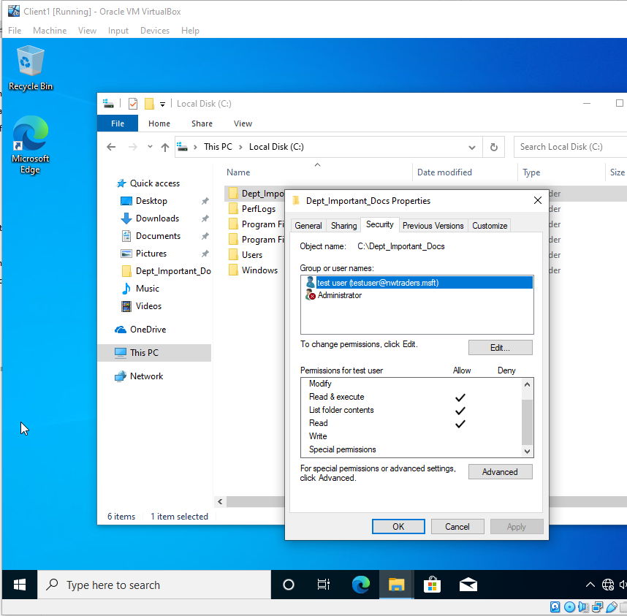

Share Permissions
Figure 4 – new SMB share has been created on Server 1

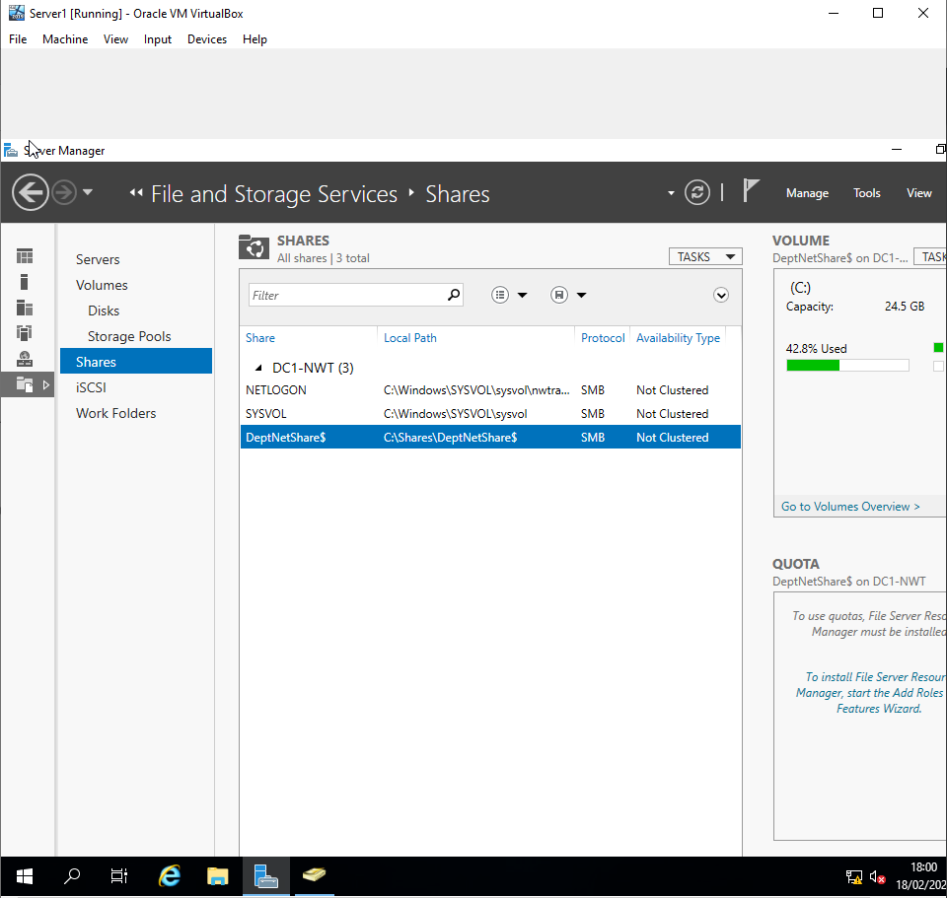

Accessing the file share/ server over the network
Figure 5 – Client machine with user account logged on displaying the file share as z:\ the \\DeptNetShares$ SMB serve share;
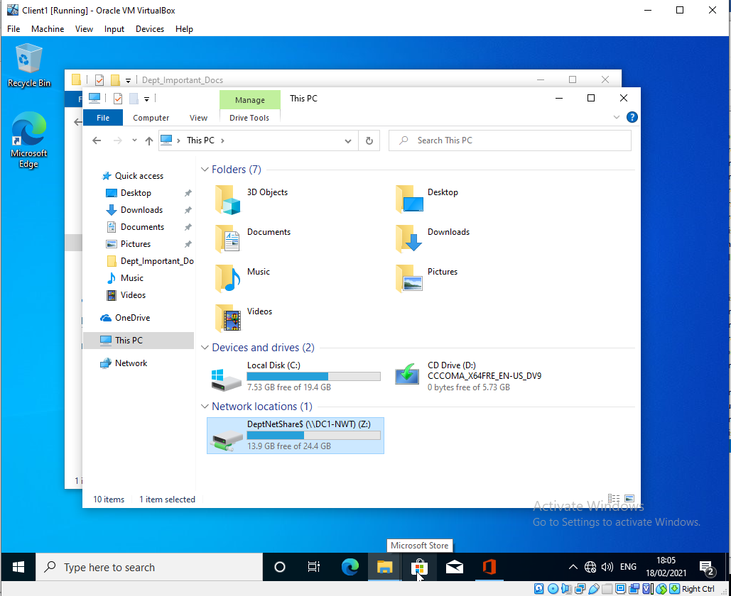

Task 2

Utilising Group Policy Management Console to better facilitate network object management.
Figure 7 – Having ‘gpupdate /force’ on the client machine with the ‘Testuser2’ account and searching for ‘Control Panel’
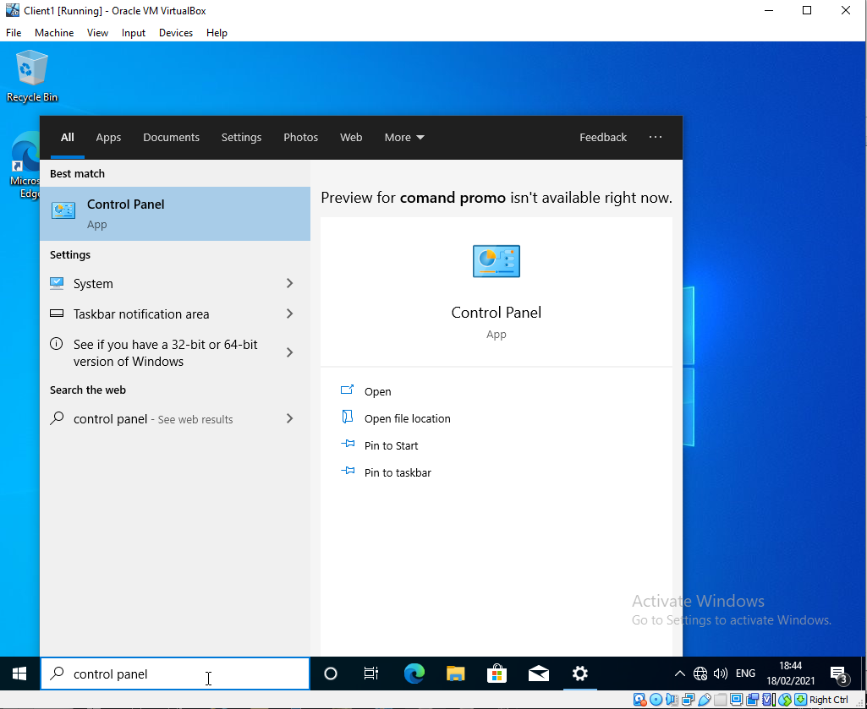
Figure 7 – Evidence screenshot control panel inaccessible to ‘testuser2’ account in group policy object denying it access. Initially didn’t work, added the policy into the ‘Link an Existing GPO’ – Screenshot now validated.

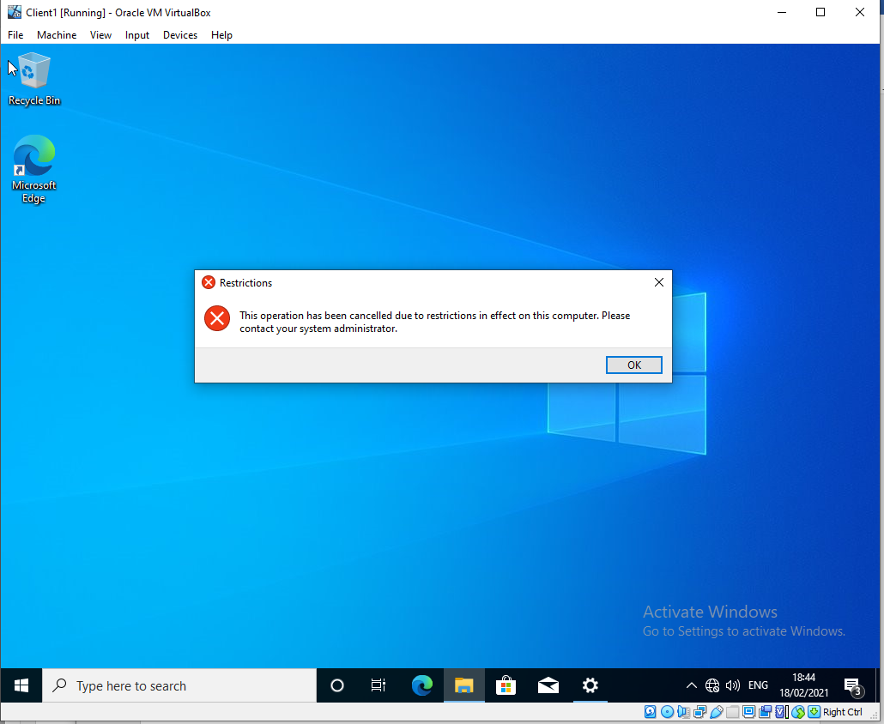
GPO 2 Removing Access to the Command Prompt
Figure 8 – ‘gpupdate /force’ applied to server and client machine, logged in with client account command prompt is searched for in the toolbar.
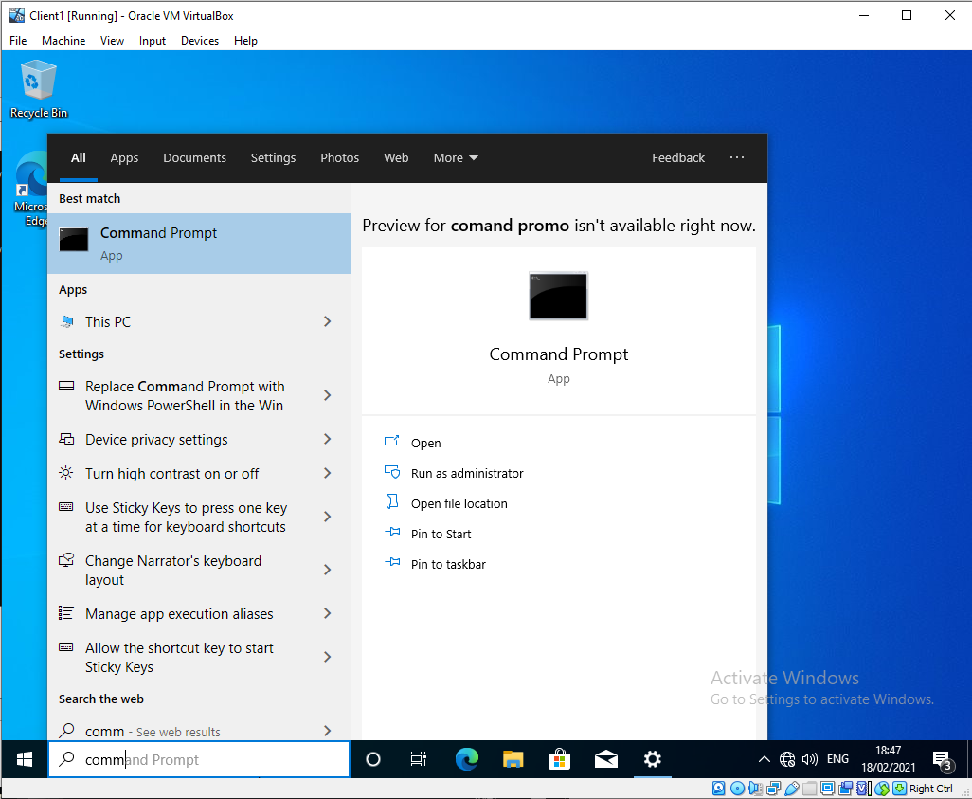
Figure 9 – validated screenshot of command prompt being disabled by administrator, slightly different to the control panel screen.
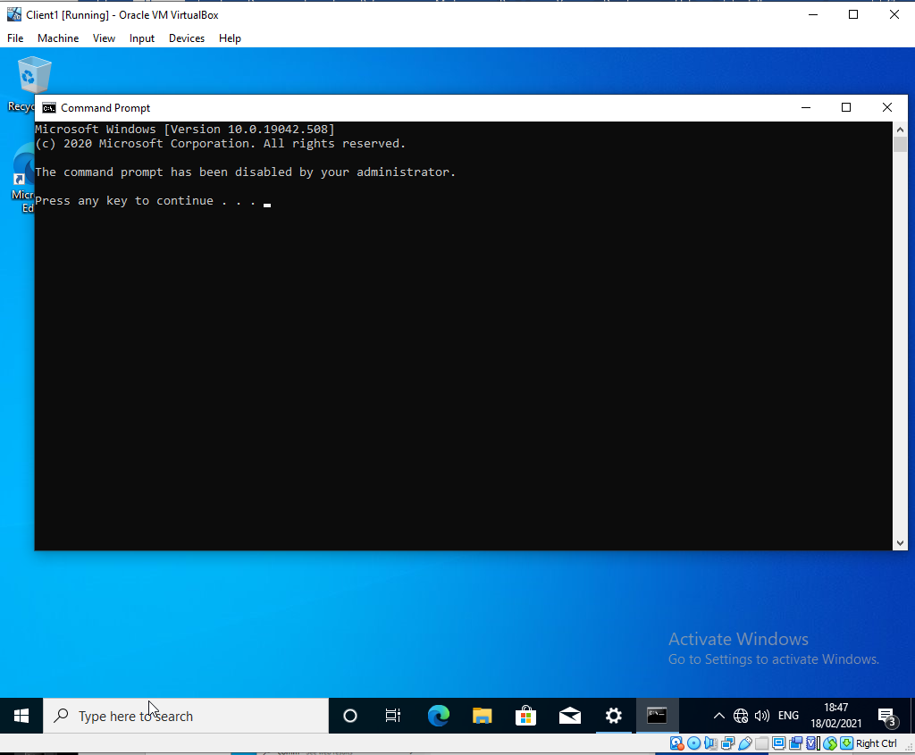

GPO 3: Restricting Access to Removable Media Drives.
Figure 10 – As shown below initially it said application was not found but still displayed information the device via explorer. At this point the student was not happy that the policy had installed correctly. GPUPDATE /Force was applied again but again, Student was able to access the CD ROM.
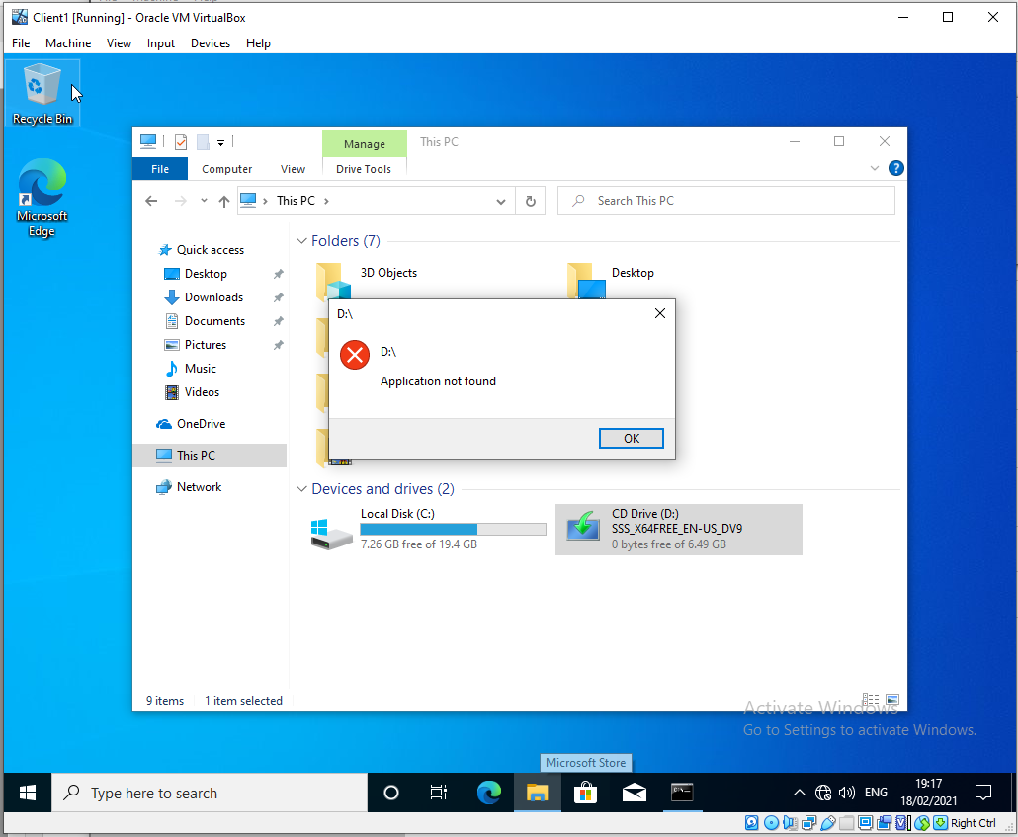
Figure 11 – After rebooting the client machine and logging in again the Testuser2 account was able to view that CD ROM drive was now blocked. The policy appears not to have correctly applied via GPUPDATE /FORCE.

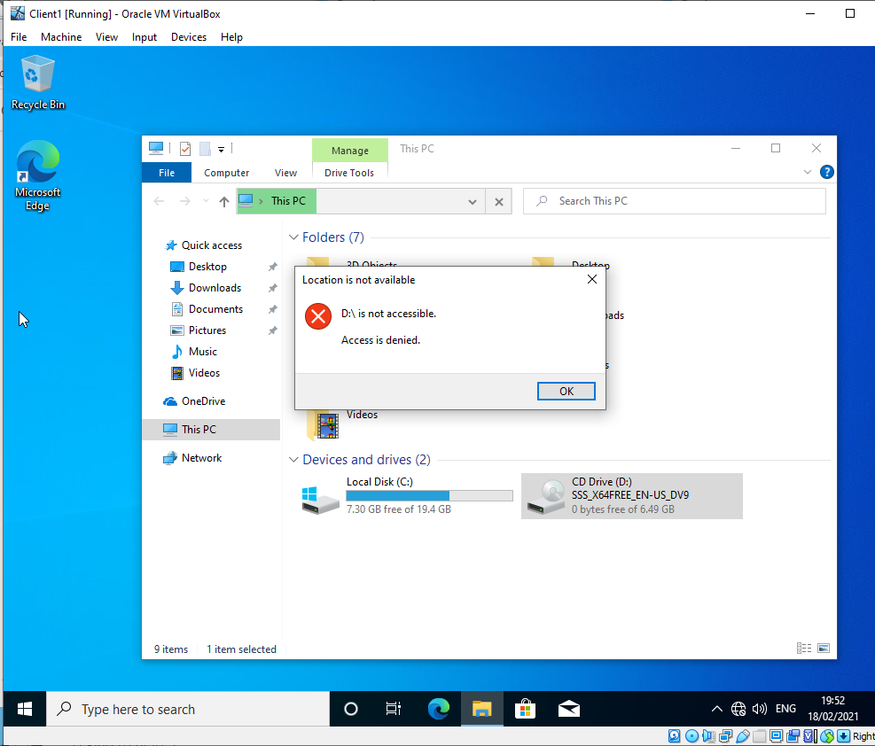

GPO 4: Restricting Software Installs

GPO 5: Enforcing Password Policy in the ‘nwtraders.msft’ domain
Figure 13 – test creating a new user smaller than the minimum requirements for the users password.

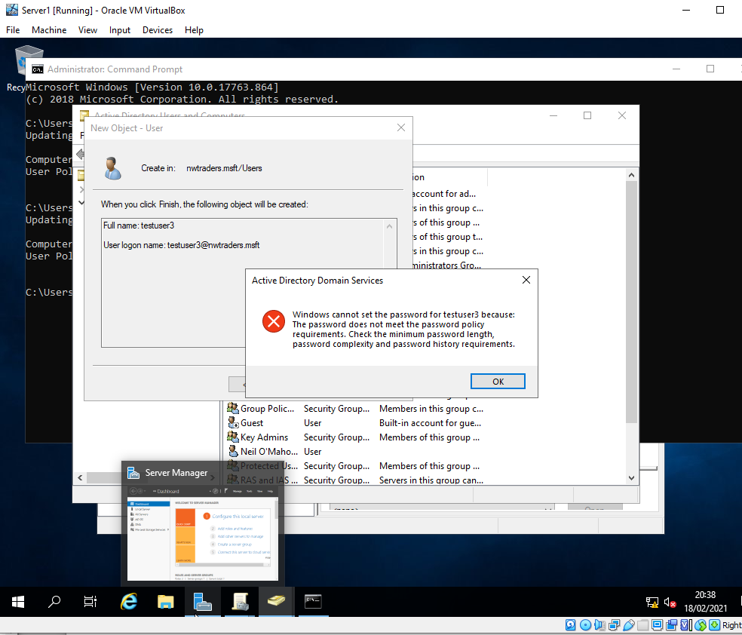

3 a) Explain the main differences between local permissions and file shares.
Local permissions: encompassing New Technology File System as well as File Allocation Table and FAT32, local permissions are used to control access stored in local permissions. The permissions are granted to the user account regardless of the location of the logon.
There are two types of local permissions; basic and advanced. Basic allows you to: full control, modify, read and Execute, read and write. Advanced permissions allows you to traverse folder, list folder, read attributes, create files, create folder, write attributes, delete subfolders and files, delete read, change and take ownership permissions. These permissions can also be inherited, allowed or denied.
File shares is a share of a folder over a network. It is not attached to the local logon of the account. The share applies to the folders and the files within the share.
Permissions of file shares cannot be as granularly controlled as local permissions, there is a read, change and full control option that can be applied. This can either be set as allow or deny.
Similarities both sets of permissions and shares are designed to do the same; prevent unauthorised access.

3 b) Describe the role of Group Policy Management in the network environment, you can use example policies in your answer.

Group Policy management is a centralised method of controlling computer and user accounts, in windows this is in an Active Directory (AD) Environment.
Policies define what the user or computer can do within the system. Anything from access to the control panel or denying access to the start button. Allowing or denying access to known and/ or unknown users on a network share is known as Objects or Group Policy Objects (GPO).
GPM achieves centralisation by distributing its GPO’s via AD or perhaps another 3rd part distribution method, belonging to the same domain. This is periodically refreshed (on Domain Controllers this is every 5 minutes) and also on start or reboot of the device. It can also be manually pulled by an allowed user on a device by using the ‘gpupdate /force’ via command prompt.
Order of processing is as follows: Local (local computer policy), Site (policies within AD), Domain (Domain wide policies – multi domains are processed in administrative order) and Organisational Unit (logically linked groups – all printers, users in same dept. etc – processed in administrative order). To display this simply type in ‘gpresult’ in command prompt.
Inheriting policies is passed from parent object to child object. An example of this would be an OU within an OU. It can be allowed or denied. If a higher level account has a policy against it that is blocked by a lower level policy the policy is still processed. Preferences can be setup where there are clashes of policy and the value given to the group policy will take over.
To apply specific policies to specific models or types of computer Windows has Windows Management Instrumentation (WMI) making the process easier to identify such devices.
Where a device is misconfigured or has been tampered with or in any way denied access to read the group policy settings a lower setting can be forcibly applied or random values.

3 c) Give some examples of sound ‘password’ principles in modern network environments.
Passwords are usually used in conjunction with a logon to confirm the identity of a user who is trying to access a system. It can be in the form of words, letters special characters or a mix of the three.
There are certain guides that can assist a user to increase the complexity of their password, by not making it a known word, increasing the length and using a more complex password will increase the difficulty to perspective hackers.
Bill Gates predicted the death of the password around 2003.
According to peters.com there are 5 core principles when selecting a password.
1 passwords should be unique, per system there should only be one password. Reusing passwords for multiple systems decreases the effectiveness of them if they are hacked and increases the risk should a breach occur.

Passwords should be difficult to guess cyber criminals don’t have time to waste trying to crack or guess passwords to systems, it is far easier to purchase these online. By using a known password protection checker system it can guide users to create long and difficult passwords whilst shutting down more commonly used ones.
Passwords should be too complex to memorize there is a direct correlation between difficult passwords, their complexity and uniqueness. Ideally over 8 characters, a mix of letters, numbers, upper and lower case as well as special characters should be used.
Passwords should be well managed. Using a password manager to remember all the complex passwords contained would be ideal. It can be manipulated so that policies about the complexity can be adhered to. A good password manager will store the password in an encrypted manner, this will increase the difficulty should the device become compromised.
Passwords should have a password – Multifactor authentication (MFA) is another layer of security that should be considered so even if a password is correctly guessed then if location differs from a usual sign in location MFA will send a text or email etc to a backup account to secondary verify the users account.

