Module: Hotel Placement Research Project
BMIH6008
Student Name: Lulzim Mendzici
Student ID: 2128512
Research Topic - The case of hotel placements within the hospitality industry: A case study of Rossington Hall.

AI Acknowledgement
I acknowledge that I have not utilised any AI tool for the completion of the work. The project has been completely done by my side conducting proper research based on the topic. Authentic sources have been for data collection which ensures the credibility and authenticity of this work.

Abstract
The research work has discussed the effectiveness of hotel placements in developing professional abilities and skill acquisition. Further, this has explained the aims and objectives along with the advantages and disadvantages. Besides, this research has highlighted the literature review in which the challenges and its understanding have been delivered. The methodology of this work along with conclusions and some suitable measures will also be interpreted here.

Table of Contents
Chapter One: Introduction 7
1.1 Introduction 7
1.2 Aims and Objectives 7
1.3 Research Questions 8
1.4 Project Background 9
1.5 Project Scope and Structure 9
Chapter Two: Literature Review 10
2.1 Introduction 10
2.2 The effect of hotel placements on skill acquisition and professional development 10
2.3 Perception of Participants and Employers Regarding Advantages and disadvantages of hotel Placements 12
2.4 The significance of hotel placements in augmenting employability 13
2.5 Best practices that can develop the effectiveness of functionality of hotel placement programmes 14
2.6 The alignment between acquiring academic knowledge and industry practice in hotel placements 15
2.7 Literature Gap 16
2.8 Summary 17
Chapter Three: Research Methods 18
3.1 Introduction 18
3.2 Research Onion 18
3.3 Research Philosophy 19
3.4 Research Approach 19
3.5 Research Design 19
3.6 Research Method 19
3.7 Data Collection Tools and Analysis 20
3.8 Sampling Technique 20
3.9 Time Horizon 20
3.10 Ethical Considerations 20
3.11 Summary 21
Chapter Four: Case Study Hotel Overview and Findings 22
Chapter Five: Discussion 36
5.1 Primary Survey 36
5.2 Primary Interview 45
5.3 Discussion 51
Chapter Six: Conclusion and Recommendations 53
6.1 Conclusion 53
6.2 Recommendations 54
References 58
Appendices 71
Appendix One: Gantt Chart 71
Appendix Two: Survey and Interview Questionnaire 73
Appendix Three: Interview Transcript 77
Appendix Four: List of Figures 80

Chapter One: Introduction

1.1 Introduction
Hotel placements play a significant role in the hospitality sector by bridging the gap between traditional knowledge acquirement and real-world professional experience. They help trainees develop industry-specific skills, apply classroom apprehension in real-world settings, and enable students to build healthy relationships with professionals. Besides, this also includes the development of key abilities like interaction, critical thinking, decision-making, problem-solving and adaptability (BBC, 2025). The aims and objectives of this work are based on the context of the effectiveness of hotel placements and that will be formed along with research questions. Accurate methods will be followed in this will bring an expected outcomes and that will be interpreted in the findings part. Some possible recommendations will also be narrated here which will deliver ways of further improvements.

1.2 Aims and Objectives
Aims
To investigate the impact of hotel placements on the professional development and skill acquisition of individuals within the hospitality industry.
To examine the benefits and challenges associated with hotel placements from the perspectives of both participants and employers.
To assess the role of hotel placements in enhancing employability and bridging the gap between academic learning and industry practice.
To provide recommendations for improving the effectiveness of the hotel placement programs in the hospitality sector.
Objectives
To explore the impact of hotel placements on professional development and skill acquisition.
To assess the perceived benefits and challenges of hotel placements from both participant and employer perspectives.
To evaluate the role of hotel placements in enhancing employability.
To identify best practices for improving the effectiveness of hotel placement programs.
To investigate the alignment between academic learning and industry practice in hotel placements.

1.3 Research Questions
How do hotel placements contribute to the professional development and skill acquisition of individuals within the hospitality industry?
What are the perceived benefits and challenges of hotel placements from both the participant’s and employer’s perspectives, and how do these impact employability outcomes?

1.4 Project Background
The hospitality sector is a customer-driven industry that fosters frequent changes within this department. Many of the students are accomplishing their degrees so that they can find suitable jobs for themselves in this dynamic landscape. Hotel placements help them to bridge the gap between what they have learnt during the courses and practical experiences (Dominioni, 2023). This is effective and sometimes disadvantageous in skill acquisition and professional development of individuals and employers. Rossington Hall, one of the renowned hotels in the UK is facing different problems regarding this matter that affects their services. Although this research work aims to provide some suggestive measures that can help this organisation to manage their difficulties.

1.5 Project Scope and Structure
The project has emphasised on the influence of hotel placements on obtaining specific skills and professional improvements. This will discuss the benefits of this kind of program that is arranged by Rossington Hall. Besides, it will explain the different problems that the individuals have faced while attending them. Some suitable solutions will also be narrated that can guide this organisation to organise more efficacious programmes in the future days so that they can maintain their operations and competitiveness.

Chapter Two: Literature Review

2.1 Introduction
According to Mauer and Venecek (2022), the literature review is an inclusive summary and critical analysis of the research works, scholarly articles, and approaches that exist in the academic context and are related to specific topics. Main purposes behind their conduction are delivering context, identifying gaps, establishing theoretical frameworks, and synthesising information. This particular work focuses on both the positive and negative impacts of hotel placements in the hospitality sector and their effect on developing professional abilities. Therefore, here the influence, advantages and disadvantages of hotel placements in developing employability skills will be described. This will further illustrate their effectiveness in bridging the gap between bookish knowledge and practical implementation or real-world experiences along with some solutions that can dissolve the issues.

2.2 The effect of hotel placements on skill acquisition and professional development
As per the words of Zopiatis et al. (2021), hotel placement plays a remarkable role in shaping the minds, knowledge, efficiency, and career trajectories of students and employers in the hospitality industry. These programmes deliver hands-on experiences which enable people to bridge the gap between theoretical knowledge and practical application.
Impact on Professional Development
As coined by Caspersen and Smeby (2021), placements help in making a transition from academic to industry by elevating confidence levels and preparing students for long-term employment. This is also effective in establishing sectoral connections because these initiatives lead to job offers, assistance, and future growth. As brought forward by Yarberry and Sims (2021), the experience of the world helps individuals to perceive information about professional expectations, the demands of services within this landscape, and workplace culture.
Influence on Skill Acquisition
As opined by Johnson et al. (2021), students and participants of these kinds of initiatives gain further and concrete information about areas like handling the front office, food and beverage services, customer relations, housekeeping and others. Exposure to real-world situations and landscapes guides people in this department in problem-solving and refining their multi-tasking abilities. According to Mwita et al. (2023), hotel placement programmes also provide a thorough comprehension of hotel operations, compliance with health and safety standards, and acquired technical knowledge and efficacy. This fosters the effectiveness of student's and other participant’s readiness for accomplishing full-time roles.

2.3 Perception of Participants and Employers Regarding Advantages and disadvantages of hotel Placements
As opined by Reichenberger and Raymond (2021), hotel placements serve as a bridge between bookish knowledge and real-world practice, delivering a hands-on experience to individuals and students regarding the advantages and benefits of it.
Perception of Participants
As coined by Park and Jones (2021), participants gain real-world experience in hotel operations and including customer services, management of food and beverages, and housekeeping. Besides, they learn about certain essential things like professional behaviour, ethics that are maintained in the workplace and teamwork. These help them in career preparedness and apart from that, this reinforces classroom learning by applying the effective concepts in real-world scenarios in the hospitality landscape. As brough forward by Meidute-Kavaliauskiene et al. (2021), there are some disadvantages to this kind of programme, for example, participants may experience high workloads while attending these initiatives and that can lead to burnout. Besides, some students feel placements are not properly guided or do not align with their career goals.
Perception of Employers
According to Young and Keech (2022), placement allows hotels to assist employees and help them to identify future needs or trends in this sector so that they can mould their skills in a way that can easily align with those changes. Students and trainees can get new energy and updated information from their academic learning and that they can implement in their jobs and reduce workload pressure. Besides, hotel placement programmes support student development and that can elevate the reputation of hotels. This makes them to establish effective ties with educational institutions so that they can directly select and get top talents for their firms. As coined by Goh and Baum (2021), despite of all the positive impacts, this cannot be denied that it is a time-consuming procedure which may slow down the operations of business. Placements are temporary and that can affect organisations regarding staff allocation which impacts the consistency of their services.

2.4 The significance of hotel placements in augmenting employability
According to Ladkin et al. (2023), hotel placements play a vital role in elevating the employability of individuals and students seeking careers in the hospitality department. The significance of these initiatives is described in the following-
Developing industry knowledge and practical skills
According to Fleming et al. (2021), while facing real situations participants improve their technical efficacies in areas like desk operations, customer service, food and beverage management, and housekeeping. Working in frequently transforming landscapes enhances their decision-making skills which guide them to handle work pressure and balance their personal and professional life.
Enhancing employment opportunities
As brought forward by Nikolić and Trajković (2022), m,any hotels are there who arrange placement or recruitment programmes and offer full-time jobs for top talents even if they are pursuing degrees or trainees. These kinds of initiatives guide them on how to face real-world situations effectively and this practical experience makes candidates more attractive to employees in this sector.
Bridging the gap between academic information and industry needs
According to Montaudon-Tomas et al. (2021), placement motivates and allows students to implement their classroom knowledge in real-world scenarios which actually enhances learning effectiveness. This allows them to gain insights into various aspects like industry trends, operational procedures, and standards of services. By collecting this information, they get more prepared for full-time roles and responsibilities. They get exposure to professional scenarios which help the learners or individuals to adjust to work ethics and industry demands.

2.5 Best practices that can develop the effectiveness of functionality of hotel placement programmes
The effectiveness of hotel placement programmes relies on both educational organisations and industry partners. Because it is them who implement best practices that confirm meaningful learning experiences, development of abilities and foster career growth.
Formulation of clear learning objectives and training structures
As opined by Greere (2023), hotels should set clear and lucid requirements on the competencies and skills of students and should select those who have those efficiencies. They can also allow trainees to take on real responsibilities rather than performing menial duties. By allowing access to every department the hospitality sector helps students and trainees to get well-rounded experiences.
Implement effective mentorship and guidance
As coined by Gannon et al. (2021), this sector can recruit those supervisors who can guide, support, and train students throughout their placement. When the guide is knowledgeable enough about how to handle pupils, they first try to foster a healthy workplace culture where trainees ask questions and solve their queries.
Ensure a balance between learning and work
According to Park and Jones (2021), interns should learn from the experiences they have faced while dealing with the real-world landscape. This enables them with ways to manage their personal and professional life. By managing work hours students can get stay encouraged and gain a positive impression of the department.

2.6 The alignment between acquiring academic knowledge and industry practice in hotel placements
Hotel placements serve as an impactful bridge between theoretical learning in academic organisations and practical applications in real hospitality settings. The alignment between these two ensures that students are efficient in the workforce while meeting the demands of the sector.
Role of academic knowledge in hotel placements
As per the words of Giousmpasoglou and Marinakou (2021), there are different departments in hotels and those are operated by different supervisors, for example, those who studied hotel operations and management are known to handle the tasks of front office, housekeeping, and revenue management. People who acquire knowledge about customer service and communication have improved interpersonal skills. These abilities involve guest management strategies, conflict resolution and many more.
Practical industry application during hotel placements
According Varra et al. (2021), applying the bookish or classroom knowledge in daily hotel functions such as restaurant service, housekeeping, front desk management and coordination. Besides, the hotel placement programme provides scope to handle guest complaints, manage service disruptions, and dealing unexpected barriers.

2.7 Literature Gap
Despite all the positive impacts of hotel placement on the abilities of students and trainees, few gaps are seen in this context and they highlight areas where existing studies may be lacking. These are formed due to different reasons like limited focus on specific skills, inconsistent methodologies for assessing the impact of hotel placement initiatives and others.

2.8 Summary
This literature shed light on the significance of hotel placements in bridging classroom knowledge and industry practice. Successful placement demands structured training, suitable mentorship, continual feedback, and strong collaboration between educational organisations and hotel employers. By addressing gaps in curricula and delivering apprehensive learning advantages, these initiatives can remarkably enhance students’ employability and career readiness in the hospitality industry.

Chapter Three: Research Methods

3.1 Introduction
This section will highlight the strategies followed by the researcher for the development of the project. Also, the tools for data collection will be demonstrated in this context along with the method and strategies.

3.2 Research Onion

Figure: Saunders’ Research Onion
Source: (Phair, 2021)
This is one of the most reliable and authentic frameworks that helps aspirants in constructing a project work effectively. With its multiple layers, it supports in completing all the tasks effectively which makes the work more effective (Phair, 2021).

3.3 Research Philosophy
The basic knowledge and the existing information relevant to the topic is called the research philosophy. In this scenario, the pragmatism has been followed by the investigator over positivism and interpretivism. This has supported in gathering of real-time information relevant to the topic and the above objectives (Lewis, 2025).

3.4 Research Approach
The approach for research referred to the techniques used by the aspirants for completing a project based on different topics. This time, the guide has taken the abductive one as the work has been based on both quantitative and qualitative details. The data from different sources has made the work more authentic and effective (BBC, 2025).

3.5 Research Design
The overall structure of the project based on different research topics is called the design of the work. Descriptive has been chosen design in this context over the exploratory and conclusive ones which has guided the investigator in gathering sufficient details. This has made the work authentic and efficient which has supported in understanding the impact of placement within Rossington Hall (Dontigney, 2025).

3.6 Research Method
The method consists of different designs and approaches which also highlight the chosen tool for data collection (Walliman, 2021). In this context, the aspirant has selected the mixed method as the information has been collected from a primary survey and interview with the use of Google Forms (BBC, 2025).

3.7 Data Collection Tools and Analysis
Primary qualitative and quantitative, both types of information have been collected in this context which has elevated the efficiency of the work. This has also supported in gathering sufficient details based on the current topic (Lohrey, 2025).

3.8 Sampling Technique
Sampling refers to the strategy in which a set of audiences is selected by the researcher for gathering information. Purposive sampling has been taken by the investigator in this context and questionnaires have been developed for interview and survey. Some respondents have been selected from the workforce of Rossington Hall for gathering efficient information effectively (Jensen, 2025).

3.9 Time Horizon
The word time horizon refers to the time for the development of the project with the completion of all the procedures. A cross-sectional time horizon has been chosen in this context over the longitudinal one which has ensured the construction of the work without any delays (Lohrey, 2025).

3.10 Ethical Considerations
All types of ethical aspects have been followed in this context and the Data Protection Act has been maintained for encrypting the information of the respondents. Proper acknowledgement has been given to the original authors and the citations have been taken from authentic sources (BBC, 2025).

3.11 Summary
The chosen method and the strategy have been highlighted in this context and the Research Onion model has been used in this scenario. Primary quantitative and qualitative information has been collected with the help of surveys and interviews with the workforce of Rossington Hall.

Chapter Four: Case Study Hotel Overview and Findings
Overview of Rossington Hall
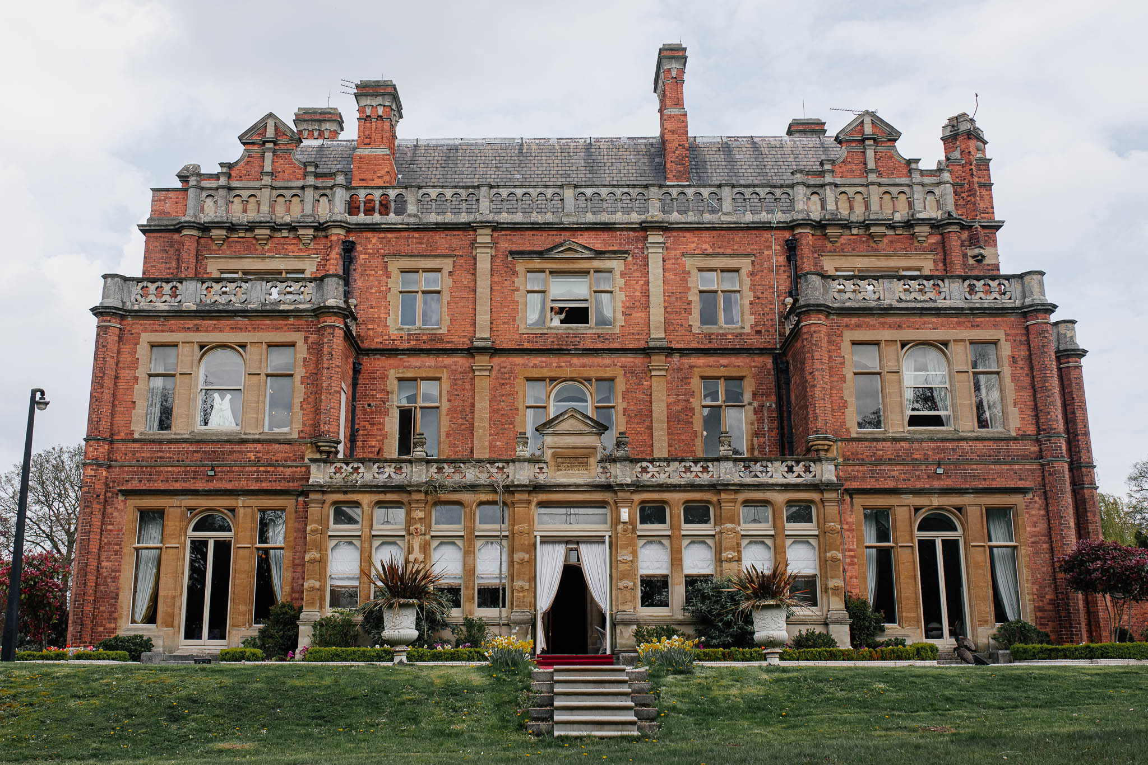
Figure: Rossington Hall
Source: (Rossingtonhall, 2025)
Analysis
Rossington Hall is considered a small-sized historic mansion which is popular for its cultural heritage and stunning elegance. This hotel is located near Doncaster, South Yorkshire. This particular hotel mansion provides customers with a diverse range of services, especially focusing on weddings, events, luxurious dining and many others. People are also allowed to conduct their business meetings and events in this mansion as well. With respect to that, Rossington Hall was established in the 18th century with eye-captivating architecture and opulent interiors. It has further been renovated in the 19th century with intense artistic visuals and sophistication.
Location
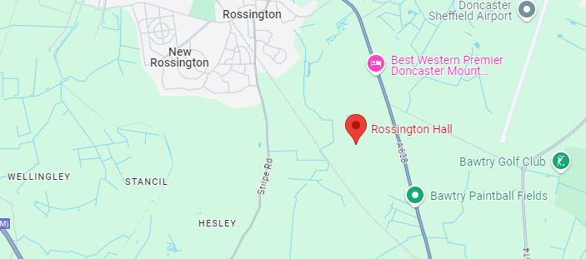
Figure: Location of Rossington Hall
Source: (Visitdoncaster, 2025)
Analysis
A highly popular and accessible location has been acquired by Rossington Hall which is located in Doncaster, Great North Road, South Yorkshire, England. The main attraction of this location is Doncaster city centre which is highly accessible for tourists with diverse facilities and amenities. Concerning this, various transportation options are linked in Rossington Hall, making it more convenient for people. For this, this hotel has become attractive and acceptable to customers, unifying a range of services. Apart from this, the proximity of this hotel to the airport is also considerable which facilitates convenience and reachability for international visitors as well.
Staffing
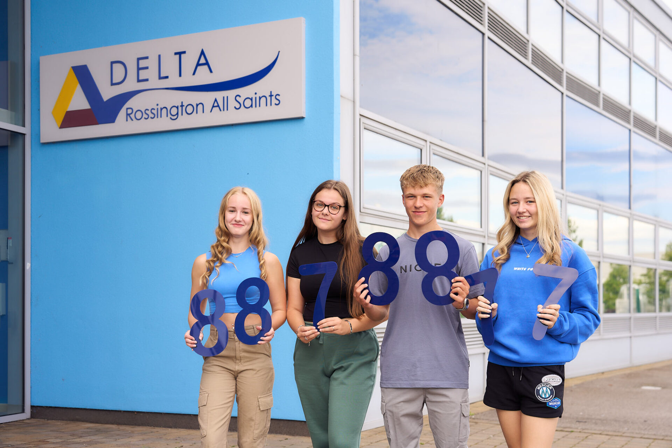
Figure: Staff at Rossington Hall
Source: (Venuescanner, 2025)
Analysis
A highly dedicated and skilled workforce is employed in Rossington Hall which is intensely committed to delivering an optimum guest experience. One of the prime aims of employees of the hotel is to aid customers in fulfilling their core needs and demands that can positively influence their buying behaviour and repeat booking. With respect to that, various types of staff are present in the hotel workplace in order to stimulate the service experience and facilitate the delivery system. There are workers such as event planners and coordinators, culinary team, managerial staff and others. The entire workforce is distributed with individual tasks and responsibilities to optimise the gusset services and their overall experience (Michael and Fotiadis, 2022).
Branches
Currently, being a small-sized historic hotel mansion in the United Kingdom, Rossington Hall does not have multiple branches and operates solely. This particular hotel has positioned itself in the UK hospitality industry as a single and luxurious place to arrange various types of events like weddings, corporate gatherings and many others. As it does not have other branches in the country, Rossington Hall is established as a single and private entity in the legal form. The single operations of the hotel ensure its service ranges to enhance the experience of visitors and expedite repeat bookings (Historichouses, 2025).
Turnover
The operational system of Rossington Hotel is very limited in public forums, due to which the financial information like annual revenue and turnover is not spread publicly. It is established in the UK as a private entity that does not share its internal information. Nevertheless, some industry reports disclose its revenue production in the country as well. In recent years, the organisation has accumulated approximately 1.5 million British pounds which ensures its consistent growth in the UK hospitality sector (Pomanda, 2025). Apart from this, more details of Rossington Hall are not disclosed in the reports for being a private company.
SWOT Analysis of Rossington Hall
Strengths | Weaknesses
High accessibility  Rossington Hall is located in a highly accessible place in South Yorkshire, England. Due to this reason, the hotel facilitates transportation for both local and international guests. This helps people conveniently access the facilities and amenities provided by the organisation (Puyt et al., 2023).  Inclusive service range  The hotel mansion provides customers with a wide range of services to acquire their attention and expedite the scope of repeat bookings. With respect to that, various types of event planning facilities, dining experiences and inclusive cuisine help the hotel differentiate its offerings from key competitors (Beerli-Palacio et al., 2020).  Historic reputation  Rossington Hall holds a strong market position in the UK hospitality sector through its historic and prestigious reputation. This hotel is considered a Grade II-listed Victorian mansion which contains robust elegance and an attractive atmosphere while decorating any kind of event or wedding ceremony (Periañez-Cristobal et al., 2020). | Seasonal demand  The organisation faces degrowth in its profitability and revenue generation due to the volatility in seasonal demands and wedding events. Sometimes, the seasons of weddings and events are very limited in the hospitality industry. During this time, the demand for hotel services is diminished in off-peak seasons (Phumchusri and Ungtrakul, 2020).  Limited occupancy capacity  Ensuring the room capacity in hotels is important to attain and acquire a range of customers. With respect to that, the poor capacity of occupancy within Rossington Hall is one of its weaknesses. The organisation is unable to accommodate numerous people at a time due to the low room capacity (Denton and Sandstrom, 2021).  High operational costs  Being a historic and heritage property, the maintenance charges and operational expenses are comparatively high in Rossington Hall. A high investment is required within this hotel to preserve the utmost culture and historic charms (Cloudbeds, 2025).
Opportunities | Threats
Market expansion  Rossington Hall may grab the opportunity to expand its market and services to luxurious alternatives which are related to retreats. Currently, the demand and need for spa services are highly growing in the country which may enhance the profitability customer base of the hotel (Provotorina et al., 2020).  Exclusive loyalty programmes for better customer acquisition  The organisation can also introduce attractive loyalty programmes in the industry to acquire a wide range of customers. This will also aid the hotel in encouraging repeat booking and maintaining a cohesive customer relationship as well (Kwiatek et al., 2020).  Strengthening digital presence  Nowadays, the growing demand for digital experiences and promotion is considerable in the hospitality market. Focusing on that, the organisation can embrace various types of digital advertisement methods such as social media, influencer promotion, SEO and others to strengthen its online presence in the market (Susilo and Santos, 2023). | Intense competitive pressure  The hospitality market in the United Kingdom is highly competitive which can create immense pressure for Rossington Hall. Various hotel organisations se5rve both national and international customers with unique offerings and facilities which is challenging for the hotel (Tyler et al., 2020).  Economic volatility  Currently, due to several external and internal factors, the operational expenses in the hotel sector are still increasing. Due to this reason, Rossington Hall can face challenges in coping with economic uncertainty and limited spending of customers (Ozdemir et al., 2022).  Changing preferences of consumers  The preferences, demands and expectations of visitors are rapidly changing in the UK hospitality market. Consequently, the organisation can face a severe decline in customer acquisition if it does not embrace ongoing trends and digital solutions related to customer satisfaction (Masiero et al., 2020).

PEST Analysis
Political Factors
Various political circumstances have different influences on the business of Rossington Hall in the United Kingdom. Understanding the regulatory framework and policies is important for businesses to standardise their services with high market visibility and reach. First of all, currently, the United Kingdom has a political stability of 0.51 points in the year 2023 in accordance with the country’s index (Theglobaleconomy, 2025). This helps the operations of Rossington Hall enrich its business planning with long-term vision and investment preparation. Apart from that, changing immigration policies in the UK after Brexit have restricted tourism activities which also affects the departmental roles and responsibilities within the organisation. Due to this, the price range of goods related to the hotel has also increased which stimulates the profitability of the business (Keith, 2024).
Economic Factors
There are several economic aspects present in the United Kingdom which has direct impacts on the business operations of Rossington Hall. It is important to analyse and assess the economic trends in the country to influence the spending of customers across the nation. With respect to that, the inflation rate of the country is highly volatile which strongly affects the business expenses and consumer spending in relation to Rossington Hall. presently, the inflation rate of the United Kingdom is 2.5 % as of December 2024 (Clark, 2025). This is a slight decrease from the previous month when it reached 2.6 %. However, in comparison to other countries, the inflation rate is high in the UK which leads the hotel to experience high expenses. Due to the volatile economic condition in the UK, people are also likely to limit their expenditure in premium hospitality services which negatively influences the business profitability of Rossington Hall (Statista, 2025).
Social Factors
The event and wedding trends are still evolving in the United Kingdom with advanced facilities and decorations. People are more likely to enjoy very concise and intimate events with peaceful atmosphere. This is one of the popular insights into the trendy features of weddings which should be considered by the hotel organisation (Taiwo, 2023). Focusing on this, Rossington Hall allows people to enjoy their special moments very concisely with inclusive guest service and optimum experience. In addition to this, the business also offers people various types of discounted packages to gain their attention as well. On the other hand, the concerns of sustainability is also in demand which compelled the hotel to embrace various types of initiatives such as saving energy, minimise the consumption of water and others (Revnomix, 2025).
Technological Factors
The enhancement of technology is one of the significant drivers of the growth and success of hospitality brands in the United Kingdom. With respect to that, individuals are contemporarily intensely attached to digital platforms such as Facebook, Instagram, YouTube and others to find out their preferred accommodation options (Dimitrios et al., 2023). Consequently, through the utilisation of digital marketing tools such as Search Engine Optimisation, social media, influencer marketing and others, the hotel business aims to accelerate its service visibility. Furthermore, embracing Augmented Reality and virtual tours can also be effective for the business in terms of enhancing guest experience both before and after the booking (Bretos et al., 2024).
Competitor Analysis
Rossington Hall | The Mansion House | Cedar Court Hotel
One of the most significant aspects of Rossington Hall is its historic charms and heritage. This organisation provides people with a diverse range of services such as wedding events, corporate meetings and many others. During these events, various types of cuisines and fine dining are also provided to people within Rossington Hall. this organisation aims to create a tailored experience for customers during the period of accommodation and other events. However, the few numbers of rooms are a significant downfall of the organisation that may affect its customer acquisition ratio. In addition to that, the fluctuating booking demand also hampers its profitability as well (Coolstays, 2025). | The Mansion House is another popular event-organising mansion in the United Kingdom, especially, in Doncaster. This particular hotel also offers customers numerous event programming facilities with exclusive dining services. With respect to that, this organisation is located very near the town centre which has made it very convenient and accessible to people while making bookings and reaching the house. Especially, business persons and other visitors are the gainers of the comprehensive accessibility of the mansion. On the other side, this hotel is unable to provide customers with exclusive services and experiences like Rossington Hall as well (Thecityofldn, 2025). | Cedar Court Hotel is a large hotel organisation which is considered a modern and advanced business in the country. This specific hotel business provides customers with various types of contemporary services which contain different facilities and features. Both the leisure guests and corporate persons are highly facilitated through the services provided in this place. More significantly, Cedar Court Hotel also offers customers budget-friendly options while making bookings for personal or business events. Consequently, it has the ability to reach and attract a diverse customer range. Nevertheless, the lack of historical charm and cultural elegance, this business is limited from the aspect of customer acquisition compared to Rossington Hall (Cedarcourthotels, 2025).

Netnography
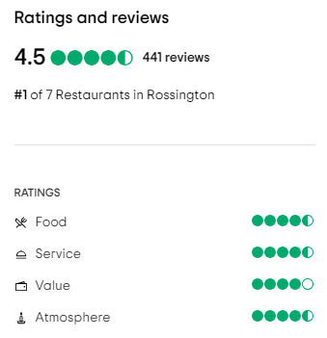
Figure: Reviews of Rossington Hall
Source: (Tripadvisor, 2025)
Analysis
Various positive feedback and reviews have been received by Rossington Hall in online forums. The above demonstration is the reflection of the service ratings towards the facilities and attractions of the hotel. According to the rating ratio, customers have provided 4.5 ratings for its cuisines and dining services. For overall customer service within the organisation, people have also provided 4.5 ratings. In accordance with customers, the food and customer service are highly considerable within the hotel which creates elegance and repeat purchases. The atmosphere of the organisation is also positive within the hotel as well. However, there are some areas present that require more improvements such as the creation of value and overall pricing of services.
Reflective Account
During the analysis of the information related to Rossington Hall, I have gained several insights and understanding into the clear services of the hotel. I understood that the hotel is positioned in the UK market as a historic and luxurious hospitality brand which caters to a diverse range of customers with numerous offerings. The sentimental connection of the hotel has been reflected through the demonstration of public reviews and feedback. Here, I have found that most of the reviews of people were positive. However, several aspects have also been addressed that necessitate more concentration for further enhancement. In order to gain a significant competitive edge, the organisation needs to differentiate its offerings from key competitors such as Cedar Court Hotel and The Mansion House.

Chapter Five: Discussion

5.1 Primary Survey
Figure 1
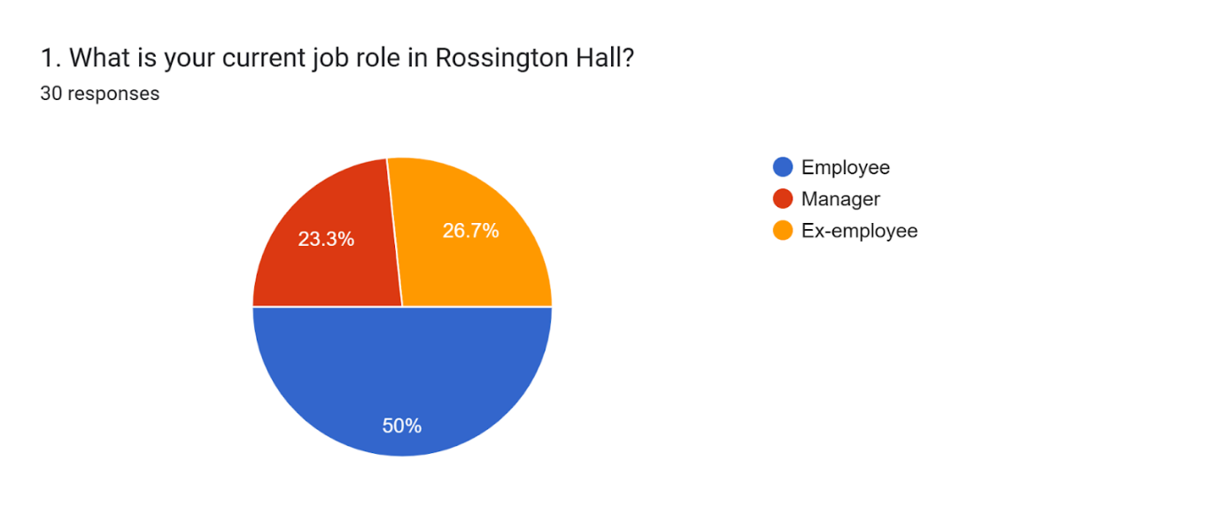
(Source: Google Forms, 2025)
Analysis
As per the above graph, 50% of the respondents are currently working at Rossington Hall which has guided in understanding the scenario more effectively. Also, 26.7% of them are the ex-employees who have sufficient experience working in this company. 23.3% of people are the managers who have highlighted the internal scenario and the challenges associated with the hotel placement activities. The participants in this context have helped in gathering the necessary information about the company and its overall operations significantly.
Figure 2
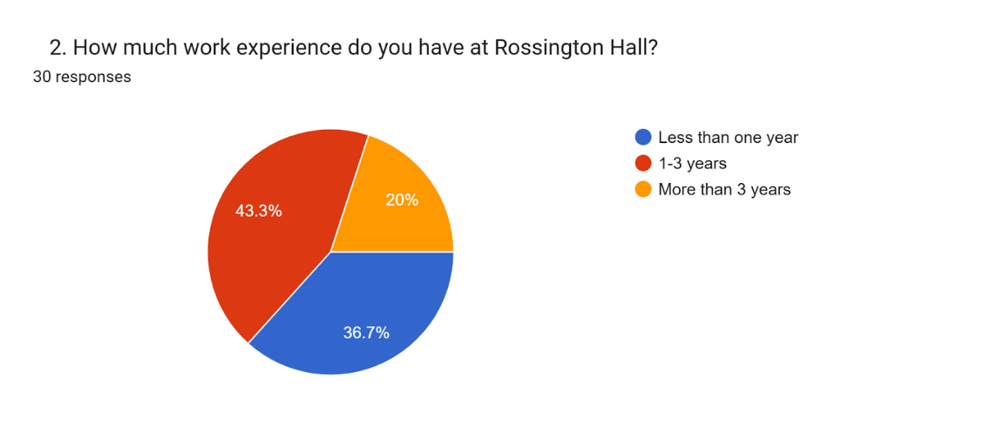
(Source: Google Forms, 2025)
Analysis
The above graph has highlighted that 43.3% of people from the whole participants have an experience between 1 to 3 years. Also, there are some respondents more specifically 20% of them who have been working in this firm for more than 3 years. The rest of the audience such as 36.7% have an experience of less than one year and are mostly the new employees. This has highlighted that the survey has been taken from the people who have mostly worked for more than 1 year.
Figure 3
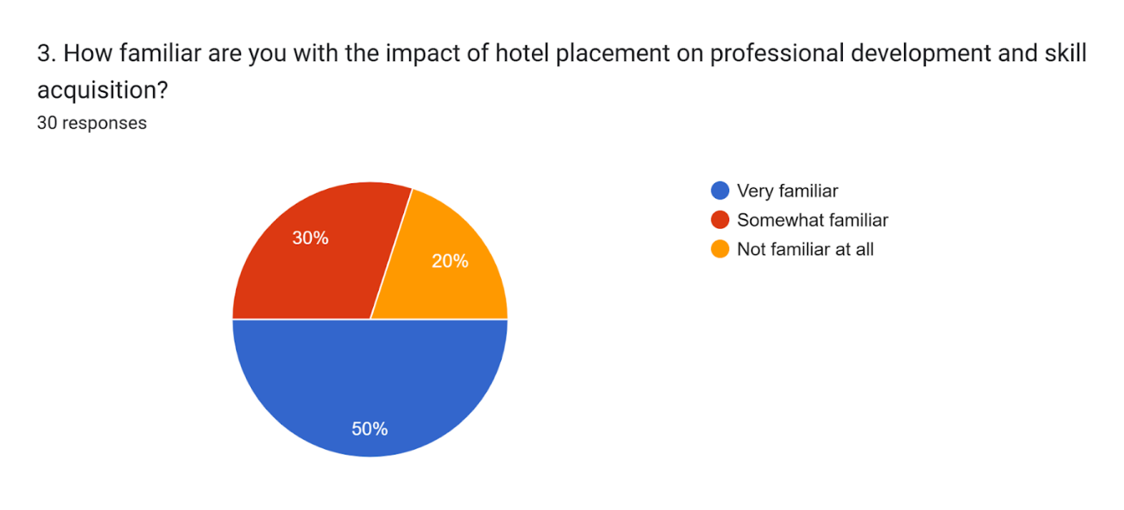
(Source: Google Forms, 2025)
Analysis
50% of people have been very familiar with the impact of hotel placement on professional development and skill acquisition. This has also demonstrated that these types of practices have been positively worked within the organisation and have negotiated the gap in the abilities of their workers. On the other hand, it has uplifted the overall performance of the company and has guided in achieving its goals. 30% of the total audience have responded that they are not very familiar with the hotel placements. The rest of the participants such as 20% are not aware of this type of practice within the company as they are very new to the business.
Figure 4
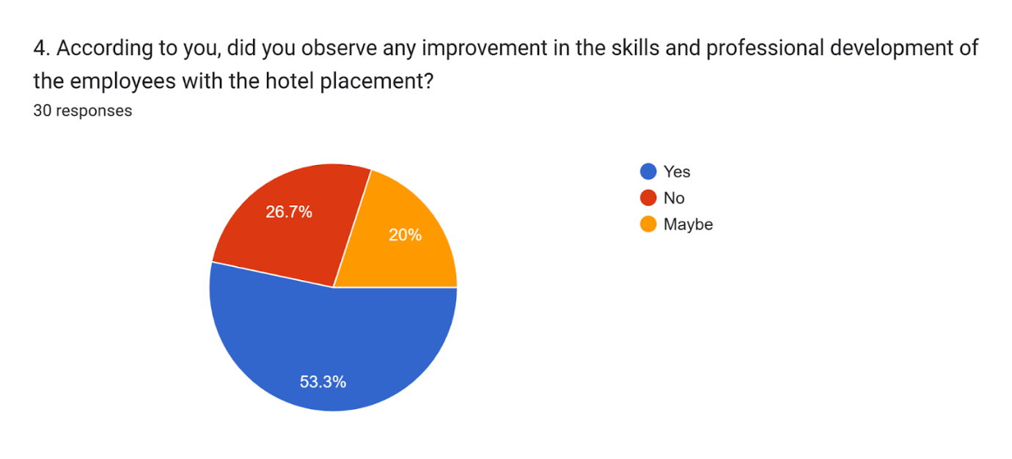
(Source: Google Forms, 2025)
Analysis
53.3% of people have highlighted that they have observed an upliftment in overall skills and professional abilities due to the practices within the hotel placement. This has enhanced the overall capabilities of the individuals which has improved the performance of the workers. The quality of guest services has been increased with the hotel placement. However, 26.7% of respondents have stated that there has been no improvement in the overall skills of the employees with such exercises. 20% of people have not been aware of such activities as they are very new to Rossington Hall.
Figure 5
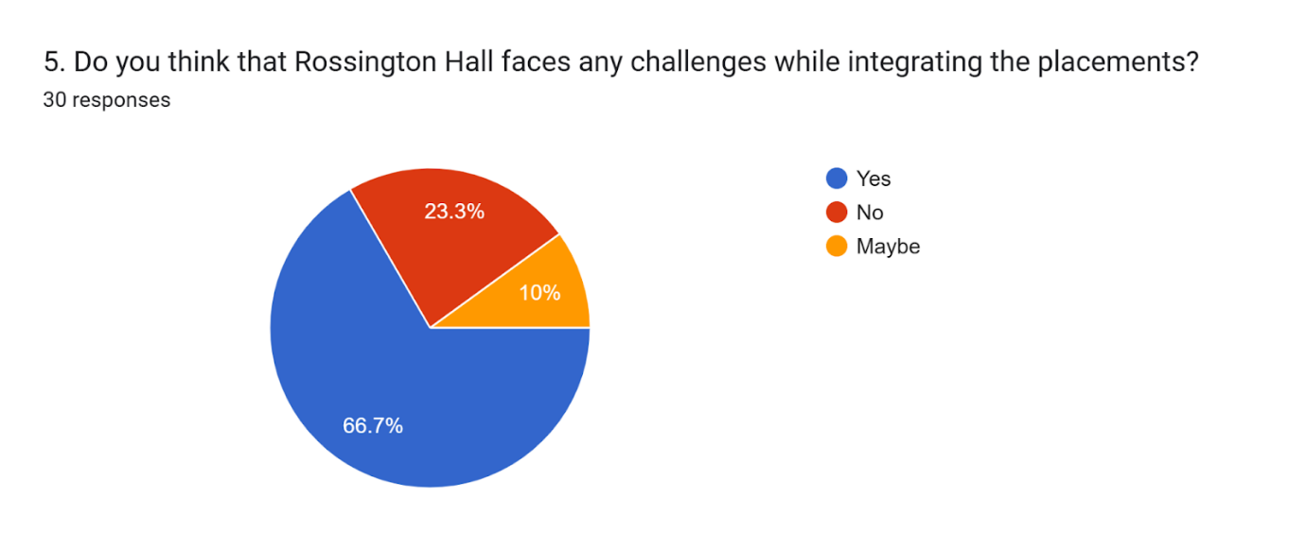
(Source: Google Forms, 2025)
Analysis
As per the above graph, 66.7% of people have portrayed that the company has faced several issues within the hotel placement activities. This has somehow affected its brand image among the guests and decreased the equality of its services in different measures. 23.3% of people have highlighted that there are no issues for which Rossington Hall has suffered during the hotel placement. However, 10% of the total participants are unaware of the fact as they are newly employed by the firm. This has highlighted that the majority of the respondents have ensured that, the business has faced significant problems due to such activities.
Figure 6
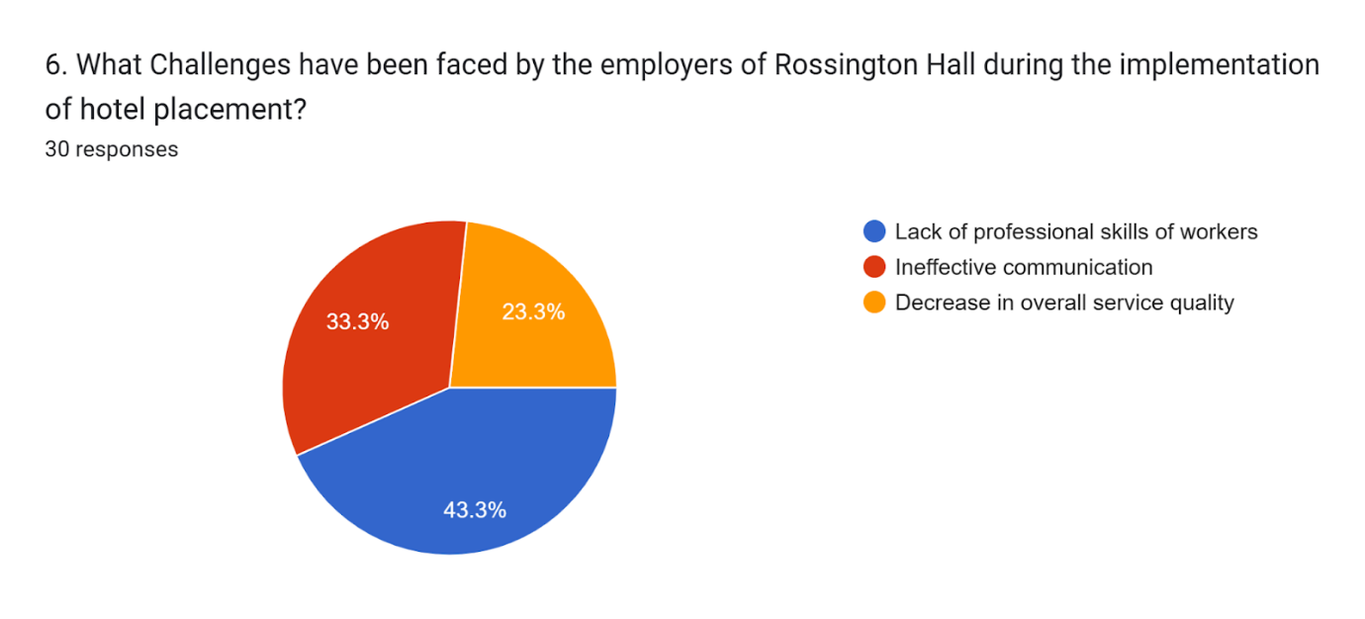
(Source: Google Forms, 2025)
Analysis
43.3% of people have highlighted that Rossington Hall has faced several issues due to the lack of professional skills among the employees. This has decreased the overall efficiency of the company and has restricted it from gaining a competitive edge in the current market. The satisfaction rate of the guests has been also reduced due to such problems. Due to the lack of ineffective communication between the management and employees the organisation has failed to provide satisfactory services to their guests which has driven them in facing financial losses. The rest of the participants such as 23.3% of people have ensured that it has decreased the overall quality of its offerings which has resulted in a major decrease in customer engagement.
Figure 7
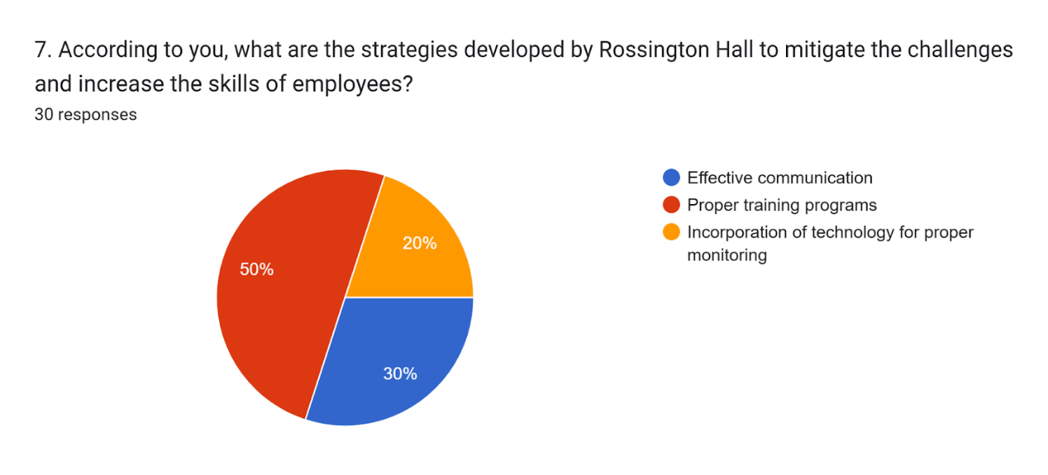
(Source: Google Forms, 2025)
Analysis
As per the response of 50% of people, Rossington Hall has incorporated innovative and advanced training programs within the organisation for mitigating the challenges faced during the placement. This has guided the firm in increasing their overall productivity and ensuring better quality work proceedings. Also, 30% have stated that some effective measures have been taken by Rossington Hall for elevating the communication between the workers and the management. This has supported them in mitigating several significant issues within the business. However, 20% of the total participants have highlighted that the company has introduced different innovative technologies within their infrastructure for uplifting the skill set of the staff and monitoring their overall performances.
Figure 8
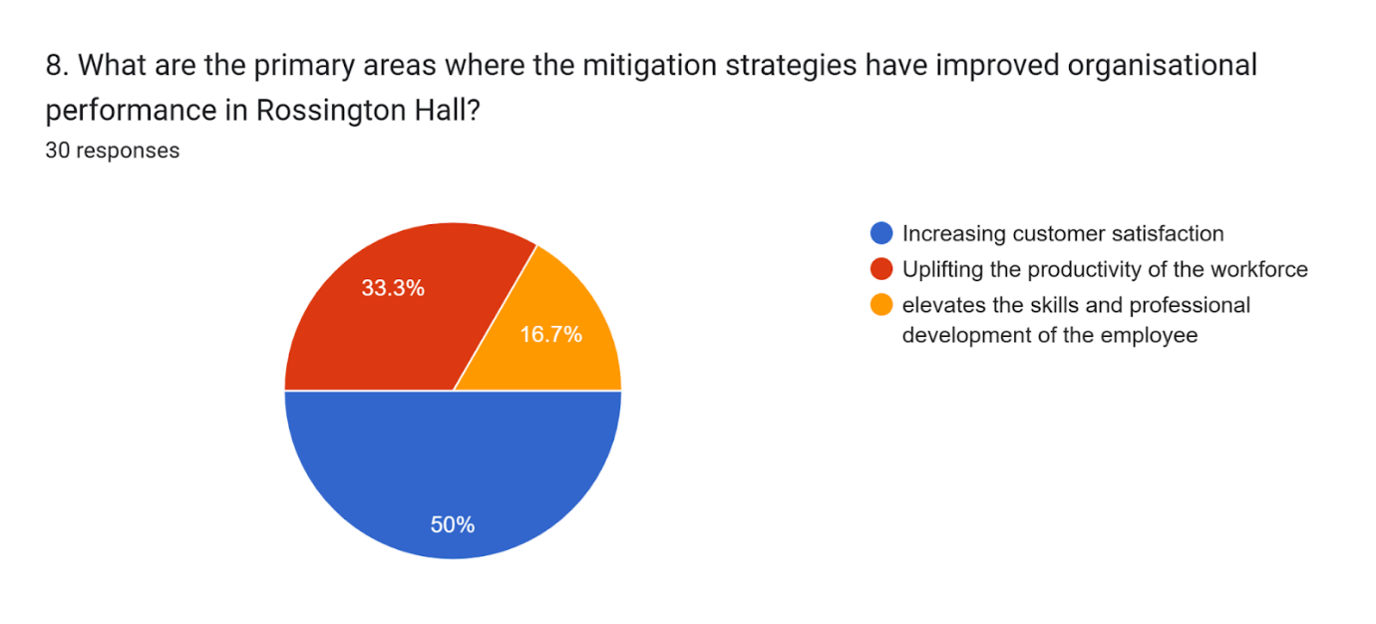
(Source: Google Forms, 2025)
Analysis
In the above graph, 50% of the total participants portrayed that the development of mitigation strategies has guided Rossington Hall in increasing the rate of customer satisfaction. The implementation of innovative and advanced technologies and proper training programs have uplifted the overall abilities of their workers. This has supported the firm in delivering better facilities to the guests as per their preferences. However, 33.3% of people have ensured that the mitigation strategies have uplifted the overall productivity of Rossington Hall. This has guided the organisation in reaching its future goals or objectives efficiently. Also, 16.7% of participants have stated that these practices have elevated the overall abilities of the employees and have ensured better professional development.
Figure 9
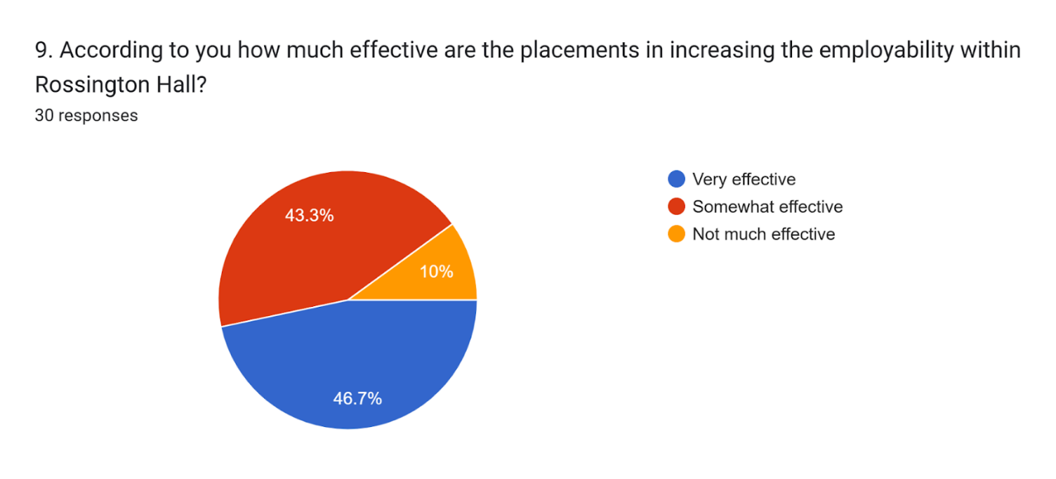
(Source: Google Forms, 2025)
Analysis
As per the response of 46.7% of people, the placements within Rossington Hall have been very helpful for the employees in improving their skills. Employability has been also increased within such activities which have ensured better performance of the company. It has also driven the firm in gaining a competitive edge in the current market. 43.3% of people have ensured that the placements have been effective in improving the overall performance of the organisation. The rest of the audience such as 10% have highlighted that such exercises have not been effective as the employability has not increased in the recent times.
Figure 10
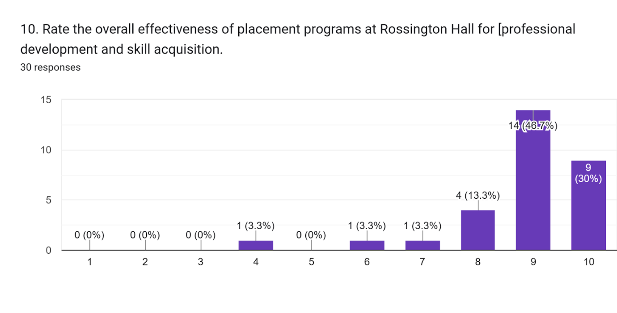
(Source: Google Forms, 2025)
Analysis
The above graph highlights that the hotel placement within Rossington Hall has been very effective for professional career building and uplifting the overall skills of the workers. That is why 30% of people have rated it 10 whereas 46.7% or the majority of the audience have given a rating of 9. This has illustrated the efficiency of such programs initiated by Rossington Hall and it has also increased the overall performance of the organisation. 13.3% of participants have rated 8 however 3.3% of people repeatedly provided a rating of 4, 6, and 7 respectively. The majority of people have ensured the effectiveness of the hotel placement activities which has on the other hand supported the firm in gaining a competitive edge in the current market.

5.2 Primary Interview
Figure 1
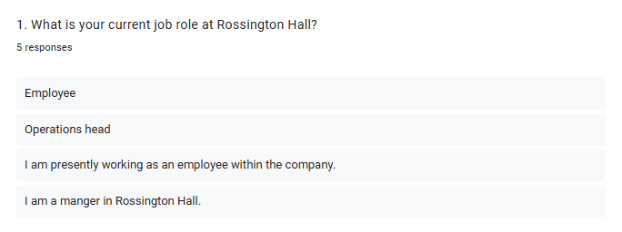
(Source: Google Forms, 2025)
Analysis
The above interview has been conducted within the workforce of Rossington Hall and people from respective departments have been gathered in this context. 3 of them are employees while the rest of the participants are managers and operation heads. These respondents have been targeted as they can illustrate the scenario effectively. Also, the benefits and challenges have been analysed significantly with the interview. There are people from different designations which has helped in understanding the perspectives of both employee and employer. This has elevated the efficiency of the work and the findings have become more enriched.
Figure 2
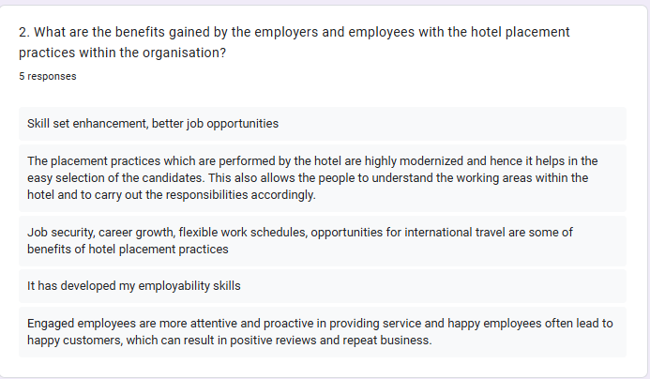
(Source: Google Forms, 2025)
Analysis
The placement-related activities have benefited both the employer and the employees effectively in different measures. This has uplifted the performance of the firm which has supported Rossington Hall in delivering better services to their guests. The satisfaction rate of the consumers has increased which has uplifted the engagement of people from diverse locations. Moreover, this type of program has enriched the skills of their staff which can provide several opportunities to them in their future proceedings. The gap in abilities has been mitigated with the proper and advanced training programs within the company. This has uplifted the performance of the organisation which has guided them in reaching their future goals or objectives significantly.
Figure 3
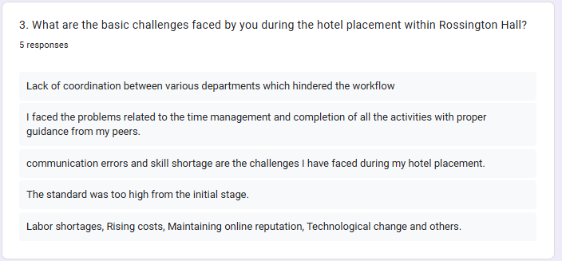
(Source: Google Forms, 2025)
Analysis
As per the above graph, there have been different types of challenges faced by the management and the employees during the placement within Rossington Hall. This has on the other hand hindered the workflow balance and decreased the productivity of the workforce. The satisfaction rate of the customers has been reduced due to the lack of efficiency in the overall facilities. Skill gap of employees has been one of the biggest challenges which has created several challenges for the management to reach their goals. This has also decreased brand reputation among the people from the diverse location which has restricted the firm from engaging more consumers. The staff have faced several challenges due to the incorporation of advanced technology within the infrastructure. Moreover, the skill shortage has been a major problem which has restricted the workers from executing all the work effectively. The communication error has been seen in the placement which has raised several problems in the work proceedings.
Figure 4
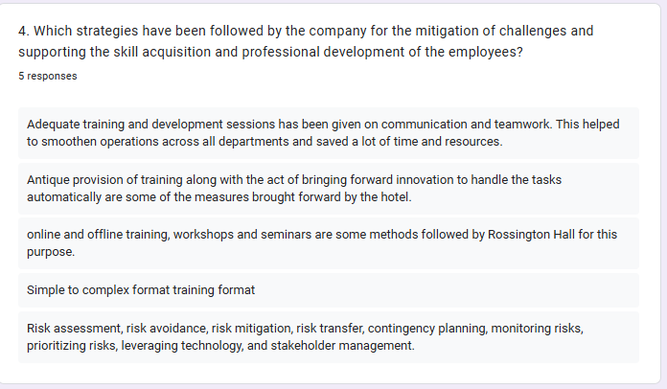
(Source: Google Forms, 2025)
Analysis
As per the above graph, Rossington Hall has initiated different innovative tools within the infrastructure for enhancing the skills of their employees. This has improved the overall performance of the brand and has uplifted the productivity of the workforce. The company has been able to reach its future goals or objectives and the satisfaction rate of the staff has also improved. Rossington Hall has incorporated different innovative tools within the infrastructure for mitigating the gaps in abilities. Moreover, it has supported them in delivering training offline and online which has improved the performance of the workers. This has also assisted the company in providing satisfactory services to the guests which has elevated the engagement of staff within the business.
Figure 5
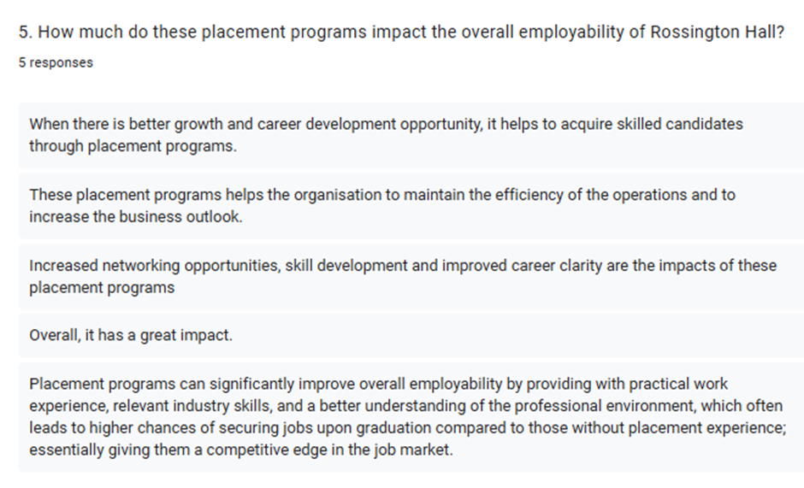
(Source: Google Forms, 2025)
Analysis
The working experience of the employees within Rossington Hall has been significant during the time of placement. This has improved the overall performance of the workers and has ensured the mitigation of skills gaps in the staff. Moreover, it has guided the organisation in reaching their future goals or objectives which has also uplifted the engagement of customers. The workers have got some efficient chances in the future proceedings after completing the placement. These programs have also guided Rossington Hall in uplifting their reputation among the people from diverse locations. The engagement of people has been enhanced with such practices and the skill gaps have been mitigated by the firm effectively.

5.3 Discussion
The above findings have highlighted the response of people from the workforce of Rossington Hall. It has been stated that the company has ensured the mitigation of skill gaps with the placement practices within the organisation. This has improved their overall service and the guest satisfaction rate has increased significantly. However, Rossington Hall has faced several challenges during these activities due to the diverse preferences of individuals and the lack of professional skills among the workers. This has decreased the effectiveness of the organisation and has restricted in delivery of satisfactory services to the guests. The engagement has also reduced due to such problems which has guided the company from facing some financial losses. This has on the other hand uplifted the satisfaction rate of the customers which has provided a significant competitive edge to the firm. The brand has incorporated different types of new and innovative technologies within the infrastructure for improving its overall performance. These have guided them in providing proper training to their staff in offline and online platforms. The skills gaps have been mitigated successfully by the side of Rossington Hall with the utilisation of this strategy. Also, the firm has relentlessly monitored the performance of its workers with such tools. This has given the company operational efficiency and has driven them in reaching their future goals or objectives.

Chapter Six: Conclusion and Recommendations

6.1 Conclusion
Analysing a hotel’s placement services is important to understand the way customers can be acquired as well as gain a significant competitive advantage. With respect to that, the above-discussed project intended to disclose the service demonstration as well as probable challenges and opportunities. A comprehensive discussion on Rossington Hall has been produced in this report to understand the diverse perspectives of staff and others. With respect to that, a detailed literature review has been elaborated in this research project. This has contained broader aspects to justify the aims and objectives of the study and answer relevant questions. While demonstrating the literature review, this study has shed light on the impacts of effective hotel placement in terms of skill development. Potential advantages and drawbacks of this have also been analysed along with its significance, best practices and antialignment. Based on relevant gaps, suitable methods for the further conduction of the research have been determined. Focusing on a mixed method, both the qualitative interview and quantitative survey have been conducted to derive more structured results. Furthermore, a comprehensive case study regarding Rossington Hall has been elaborated, containing its internal information, SWOT analysis, PEST analysis and competitor analysis. Moreover, considering the key findings of the analysis, some effective ways have been recommended to the organisation to enhance its hospitality practices and strengthen employability.

6.2 Recommendations
The owners of Rossington Hall can implement certain suggestive measures that can help them to solve their problems regarding the lack of employability skills among their staff members. Besides, by incorporating solutions the firm can be able to solve the communication error in their placement programme that can create various problems in their work procedures (Úbeda-García et al., 2021).
Structured training programmes
Rossington Hall can organise regular training programmes by emphasising on main employability skills, like teamwork, customer service, time management, problem-solving, and communication. This will help the employees to enhance their employability or interpersonal skills (BBC, 2025). Besides, they can provide relevant workshops that are tailored to various roles within the hotel and the focus of these initiatives should be on soft and technological skills that are essential for the hospitality sector. The organisation can pair new staff with experienced supervisors who can train them in improving employability abilities besides helping them integrate into the workplace culture (Forbes, 2021).
Improved communication channels
The renowned hotel of the UK, Rossington Hall can establish clear communication protocols for its employees to follow, confirming consistency in how messages are delivered. This can include certain things like setting expectations for responses, formalising written communication and ensuring regular check-ins (Serra, 2022). Besides, they can schedule regular one-to-one or group meetings where the workmen of the company can receive feedback, participate in discussing challenges and offer suggestions to solve them. This will be effective in recognising communication gaps early and making a platform for continuous development (Donate et al., 2022). Apart from that, they can implement tools like Microsoft Teams and Slack to enhance interaction across various groups of their brand. This can allow for the sharing of significant information efficiently, particularly in a large hotel environment like Rossington Hall (Forbes, 2023).
Enhanced placement programmes
Before any placement begins, this organisation can provide a comprehensive induction to employees which includes information about the goals of the firm, their vision, mission, and the role of workmen. Besides, this will also include how to interact within the hotel setting (Dempsey, 2023). When the staff members clearly know about their roles and responsibilities the formation of any kind of misunderstanding gets reduced. They know what their workplace expects from them and this makes them to mould their abilities in a way that can bring positive outcomes in their love as well as in the organisation they are working in (McKinsey, 2022).
Training for improving soft skills for communication
Rossington Hall can provide training to their workforce regarding interpersonal communication and conflict resolution (Koechling et al., 2023). The reason behind this initiative is to ensure that all the workmen understand how to communicate effectively under pressure. This is especially significant in the hospitality industry, where client's expectations can be in utmost important (BBC, 2025). They can conduct team-building exercises that promote collaboration and interaction among staff members. This can be effective in breaking down silos, encourage cross-departmental communication, and improve overall efficacy (BBC, 2025).
Evaluation of recruitment procedure
This hotel can revise the recruitment process to prioritise soft skills like adaptability, interactions and emotional intelligence. They can also leverage interview techniques such as behavioural interviews to examine how candidates control diversified work scenarios and customer interactions. Apart from that, this brand clearly delivers expectations regarding interaction, professionalism, and professional abilities to new recruits during the hiring procedure to ensure alignment from the start (Garcea, 2023). Moreover, by developing the entire firing procedure this firm will be able to employ top talents in their brand that can help them to align their skills with organisational goals. This will help the hotel to maintain its productivity, profitability and popularity in this agile sector (Tanković et al., 2021).
By applying the above-mentioned solutions Rossington Hall can address both the skills gap and communication errors within their employees. This ultimately enhances the effectiveness of their placement programs and confirms better outcomes for both the guests and staff members (Ramos-Monge et al., 2023).

References
BBC, (2025). Careers in hospitality. [Online] Available at: https://www.bbc.co.uk/bitesize/guides/zb6njhv/revision/1 [Accessed 28 January 2025].
BBC, (2025). Conducting research - methodology. [Online] Available at: https://www.bbc.co.uk/bitesize/guides/z9rn3k7/revision/3 [Accessed 02 February 2025].
BBC, (2025). Data Protection Act. [Online] Available at: https://www.bbc.co.uk/bitesize/guides/z9nk87h/revision/4 [Accessed 02 February 2025].
BBC, (2025). Interpersonal skills and professional qualities. [Online] Available at: https://www.bbc.co.uk/bitesize/guides/zvb9scw/revision/1 [Accessed 03 Februray 2025].
BBC, (2025). Research methods. [Online] Available at: https://www.bbc.co.uk/bitesize/guides/zrv247h/revision/3 [Accessed 02 February 2025].
BBC, (2025). Training and development. [Online] Available at: https://www.bbc.co.uk/bitesize/guides/zhmqjhv/revision/1 [Accessed 03 February 2025].
Beerli-Palacio, A., Martín-Santana, J.D. and Román-Montoya, C., (2020). Complementary services at hotels in accordance with their pricing strategy and the price sensitivity of tourists. International Journal of Hospitality Management, 87, p.102458.
Bretos, M.A., Ibáñez-Sánchez, S. and Orús, C., (2024). Applying virtual reality and augmented reality to the tourism experience: a comparative literature review. Spanish Journal of Marketing-ESIC, 28(3), pp.287-309.
Caspersen, J. and Smeby, J.C., (2021). Placement training and learning outcomes in social work education. Studies in Higher Education, 46(12), pp.2650-2663.
Cedarcourthotels, (2025). Cedar Court Hotel Harrogate. [Online] Available at: https://cedarcourthotels.co.uk/hotels/harrogate/ [Accessed 01 February 2025].
Clark, D., (2025). Inflation rate for the Consumer Price Index (CPI) in the United Kingdom from January 2000 to December 2024. [Online] Available at: https://www.statista.com/statistics/306648/inflation-rate-consumer-price-index-cpi-united-kingdom-uk/#:~:text=The%20UK%20inflation%20rate%20was,11.1%20percent%20in%20October%202022 [Accessed 01 February 2025].
Cloudbeds, (2025). How hotel operating costs affect the bottom line. [Online] Available at: https://www.cloudbeds.com/articles/how-hotel-operating-costs-affect-the-bottom-line/ [Accessed 01 February 2025].
Coolstays, (2025). Rossington Hall. [Online] Available at: https://www.coolstays.com/property/rossington-hall/26873 [Accessed 01 February 2025].
Dempsey, J., (2023). Hospitality sector 'anxious' over summer staffing. [Online] Available at: https://www.bbc.com/news/business-66021588 [Accessed 03 February 2025].
Denton, G. and Sandstrom, J., (2021). The Influence of Occupancy Change on Hotel Market Equilibrium. Cornell Hospitality Quarterly, 62(4), pp.426-437.
Dimitrios, B., Ioannis, R., Angelos, N. and Nikolaos, T., (2023). Digital marketing: The case of digital marketing strategies on luxurious hotels. Procedia Computer Science, 219, pp.688-696.
Dominioni, F., (2023). 5 Trends Driving The Hospitality Industry And What They Mean For Property Management. [Online] Available at: https://www.forbes.com/councils/forbesbusinessdevelopmentcouncil/2023/04/12/5-trends-driving-the-hospitality-industry-and-what-they-mean-for-property-management/ [Accessed 28 January 2025].
Donate, M.J., González-Mohíno, M., Appio, F.P. and Bernhard, F., (2022). Dealing with knowledge hiding to improve innovation capabilities in the hotel industry: The unconventional role of knowledge-oriented leadership. Journal of Business Research, 144, pp.572-586.
Dontigney, E., (2025). Types of Business Research Methods. [Online] Available at: https://smallbusiness.chron.com/types-business-research-methods-57582.html [Accessed 02 February 2025].
Fleming, J., Rowe, A.D. and Jackson, D., (2021). Employers as educators: the role of work placement supervisors in facilitating the transfer of skills and knowledge. Journal of Education and Work, 34(5-6), pp.705-721.
Forbes, (2021). Employability Skills. [Online] Available at: https://www.forbes.com/councils/forbeshumanresourcescouncil/2021/10/22/help-employees-continually-develop-their-skills-with-these-16-strategies/ [Accessed 03 February 2025].
Forbes, (2023). 6 Steps To Improve Communication With Employees. [Online] Available at: https://www.forbes.com/sites/drsamanthamadhosingh/2023/11/07/6-steps-to-improve-communication-with-employees/ [Accessed 03 Februray 2025].
Gannon, J., Clayton, D. and Klenert, A., (2021). Mentoring Initiatives as Talent Management Innovations. In Talent Management Innovations in the International Hospitality Industry (pp. 99-125). Emerald Publishing Limited.
Garcea, N., (2023). Skills-Based Hiring Can Help You Hire Better Candidates Faster. [Online] Available at: https://www.forbes.com/councils/forbesbusinesscouncil/2023/02/27/skills-based-hiring-can-help-you-hire-better-candidates-faster/ [Accessed 03 Februray 2025].
Giousmpasoglou, C. and Marinakou, E., (2021). Hotel internships and student satisfaction as key determinant to career intention. Journal of Tourism Research, 25, pp.42-67.
Goh, E. and Baum, T., (2021). Job perceptions of Generation Z hotel employees towards working in Covid-19 quarantine hotels: the role of meaningful work. International Journal of Contemporary Hospitality Management, 33(5), pp.1688-1710.
Greere, A., (2023). Training for quality assurance in higher education: practical insights for effective design and successful delivery. Quality in Higher Education, 29(2), pp.165-191.
Historichouses, (2025). Rossington Hall. [Online] Available at: https://www.historichouses.org/house/rossington-hall/stays/ [Accessed 31 January 2025].
Jensen, K., (2025). How Is Sampling Important to Business?. [Online] Available at: https://smallbusiness.chron.com/sampling-important-business-80416.html [Accessed 02 February 2025].
Johnson, R.D., Stone, D.L. and Lukaszewski, K.M., (2021). The benefits of eHRM and AI for talent acquisition. Journal of Tourism Futures, 7(1), pp.40-52.
Keith, (2024). PESTEL Analysis For Hotel Industry. [Online] Available at: https://pestelanalysis.education/pestel-analysis-for-hotel-industry/ [Accessed 01 February 2025].
Koechling, A., Wehner, M.C. and Warkocz, J., (2023). Can I show my skills? Affective responses to artificial intelligence in the recruitment process. Review of Managerial Science, 17(6), pp.2109-2138.
Kwiatek, P., Morgan, Z. and Thanasi-Boçe, M., (2020). The role of relationship quality and loyalty programs in building customer loyalty. Journal of Business & Industrial Marketing, 35(11), pp.1645-1657.
Ladkin, A., Mooney, S., Solnet, D., Baum, T., Robinson, R. and Yan, H., (2023). A review of research into tourism work and employment: Launching the Annals of Tourism Research curated collection on tourism work and employment. Annals of Tourism Research, 100, p.103554.
Lewis, J., (2025). How to Apply Moral Philosophy to Business Ethics. [Online] Available at: https://smallbusiness.chron.com/apply-moral-philosophy-business-ethics-33340.html [Accessed 02 February 2025].
Lohrey, J., (2025). Cross-Section Design of a Business Research Method. [Online] Available at: https://smallbusiness.chron.com/crosssection-design-business-research-method-81863.html [Accessed 02 February 2025].
Lohrey, J., (2025). Management Tools Used in Data Collection. [Online] Available at: https://smallbusiness.chron.com/management-tools-used-data-collection-79051.html [Accessed 02 February 2025].
Masiero, L., Viglia, G. and Nieto-Garcia, M., (2020). Strategic consumer behavior in online hotel booking. Annals of Tourism Research, 83, p.102947.
Mauer, B. and Venecek, J., (2022). Writing the literature review. Strategies for Conducting Literary Research, 2e.
McKinsey, (2022). Taking a skills-based approach to building the future workforce. [Online] Available at: https://www.mckinsey.com/capabilities/people-and-organizational-performance/our-insights/taking-a-skills-based-approach-to-building-the-future-workforce [Accessed 03 Februray 2025].
Meidute-Kavaliauskiene, I., Çiğdem, Ş., Yıldız, B. and Davidavicius, S., (2021). The effect of perceptions on service robot usage intention: a survey study in the service sector. Sustainability, 13(17), p.9655.
Michael, N. and Fotiadis, A., (2022). Employee turnover: The hotel industry perspective. Journal of Tourism, Heritage & Services Marketing, 8(1), pp.38-47.
Montaudon-Tomas, C.M., Yañez-Moneda, A.L. and Pinto-López, I.N., (2021). FUTURE EMPLOYMENT TRENDS IN THE HOSPITALITY AND TOURISM SECTOR–CLOSING THE GAP THROUGH HIGHER EDUCATION PROGRAMS. In ICERI2021 Proceedings (pp. 8468-8475). IATED.
Mwita, K., Kinunda, S., Obwolo, S. and Mwilongo, N., (2023). Soft skills development in higher education institutions: Students’ perceived role of universities and students’ self-initiatives in bridging the soft skills gap. International Journal of Research in Business and Social Science (2147-4478), 12(3), pp.505-513.
Nikolić, I.J. and Trajković, M.S., (2022). Fostering the development of future tourism and hospitality professionals' employability skills through the use of podcasting technology. BizInfo (Blace) Journal of Economics, Management and Informatics, 13(2), pp.21-28.
Ozdemir, O., Han, W. and Dalbor, M., (2022). Economic policy uncertainty and hotel occupancy: the mediating effect of consumer sentiment. Journal of Hospitality and Tourism Insights, 5(2), pp.253-273.
Park, M. and Jones, T., (2021). Going virtual: The impact of COVID-19 on internships in tourism, events, and hospitality education. Journal of Hospitality & Tourism Education, 33(3), pp.176-193.
Periañez-Cristobal, R., Luengo, P. and Calvo-Mora, A., (2020). The heritage character and service quality in urban defensive structures renovated as hotels. Journal of Heritage Tourism, 15(1), pp.44-59.
Phair, D., (2021). Saunders’ Research Onion. [Online] Available at: https://gradcoach.com/saunders-research-onion/ [Accessed 02 February 2025].
Phumchusri, N. and Ungtrakul, P., (2020). Hotel daily demand forecasting for high-frequency and complex seasonality data: a case study in Thailand. Journal of Revenue and Pricing Management, 19(1), pp.8-25.
Pomanda, (2025). rossington hall limited. [Online] Available at: https://pomanda.com/company/07359556/rossington-hall-limited [Accessed 31 January 2025].
Provotorina, V., Kazmina, L., Petrenko, A. and Makarenko, V., (2020), September. Development of the hotel business as a component of the regional tourism industry. In International Scientific Conference on Architecture and Construction (pp. 20-32). Singapore: Springer Nature Singapore.
Puyt, R.W., Lie, F.B. and Wilderom, C.P., (2023). The origins of SWOT analysis. Long Range Planning, 56(3), p.102304.
Ramos-Monge, E., Fox, P. and Garcia-Piquer, A., (2023). Addressing soft skill gaps in the digital employment market: the case of Spanish students in a technology-based university. Education+ Training, 65(6/7), pp.923-938.
Reichenberger, I. and Raymond, E.M., (2021). Students’ perceptions of tertiary tourism education and careers during the Covid-19 pandemic. Journal of Teaching in Travel & Tourism, 21(4), pp.380-402.
Revnomix, (2025). Ultimate Guide to Sustainability in the Hospitality Industry. [Online]Available at: https://revnomix.com/ultimate-guide-to-sustainability-in-the-hospitality-industry/ [Accessed 01 February 2025].
Rossingtonhall, (2025). About Us. [Online] Available at: https://rossingtonhall.co.uk/about-us/ [Accessed 31 January 2025].
Serra, J., (2022). Communication: The Key To Improving Employee Satisfaction And Engagement. [Online] Available at: https://www.forbes.com/councils/forbesagencycouncil/2022/10/04/communication-the-key-to-improving-employee-satisfaction-and-engagement/ [Accessed 03 February 2025].
Statista, (2025). Consumer spending on accommodation in the United Kingdom from 2005 to 2023. [Online] Available at: https://www.statista.com/statistics/476659/accommodation-consumer-spending-in-the-united-kingdom-uk-since-2005/#:~:text=Consumer%20expenditure%20on%20accommodation%20in%20the%20UK%202005%2D2023&text=Based%20on%20figures%20going%20back,billion%20British%20 [Accessed 01\ February 2025].
Susilo, D. and Santos, M.C.K., (2023). Digital marketing communication sustainable hotel practice of accor group in social media. International Journal of Economic, Business, Accounting, Agriculture Management and Sharia Administration (IJEBAS), 3(3), pp.730-743.
Taiwo, I., (2023). How changing consumer preferences might impact hotels. [Online] Available at: https://www.hospitalityinvestor.com/esg/how-changing-consumer-preferences-might-impact-hotels [Accessed 01 February 2025].
Tanković, A.C., Kapeš, J. and Kraljić, V., (2021). Importance of soft skills and communication skills in tourism: Viewpoint from tourists and future tourism employees. Tourism in Southern and Eastern Europe..., 6 , pp.167-185.
Thecityofldn, (2025). Mansion House. [Online] Available at: https://www.thecityofldn.com/directory/mansion-house/ [Accessed 01 February 2025].
Theglobaleconomy, (2025). United Kingdom: Political stability. [Online] Available at: https://www.theglobaleconomy.com/United-Kingdom/wb_political_stability/ [Accessed 01 February 2025].
Tripadvisor, (2025). Rossington Hall. [Online] Available at: https://www.tripadvisor.co.uk/Restaurant_Review-g4597293-d3314860-Reviews-Rossington_Hall-Rossington_Doncaster_South_Yorkshire_England.html [Accessed 01 February 2025].
Tyler, B., Lahneman, B., Beukel, K., Cerrato, D., Minciullo, M., Spielmann, N. and Discua Cruz, A., (2020). SME managers’ perceptions of competitive pressure and the adoption of environmental practices in fragmented industries: a multi-country study in the wine industry. Organization & Environment, 33(3), pp.437-463.
Úbeda-García, M., Claver-Cortés, E., Marco-Lajara, B. and Zaragoza-Sáez, P., (2021). Corporate social responsibility and firm performance in the hotel industry. The mediating role of green human resource management and environmental outcomes. Journal of Business Research, 123, pp.57-69.
Varra, L., Scioni, M., Grassini, L. and Giusti, A., (2021). Job requirements in the hospitality industry: Technical or general skills? The dilemma for academic education. European Journal of Tourism Research, 29, pp.2915-2915.
Venuescanner, (2025). Rossington Hall Hotel. [Online] Available at: https://www.venuescanner.com/gb/venues/yorkshire/book/rossington-hall-hotel [Accessed 31 January 2025].
Visitdoncaster, (2025). Rossington Hall. [Online] Available at: https://www.visitdoncaster.com/stay/hotels/rossington-hall [Accessed 31 January 2025].
Walliman, N., (2021). Research methods: The basics. Routledge.
Yarberry, S. and Sims, C., (2021). The impact of COVID-19-prompted virtual/remote work environments on employees’ career development: Social learning theory, belongingness, and self-empowerment. Advances in Developing Human Resources, 23(3), pp.237-252.
Young, N. and Keech, J., (2022). Second chance hiring: Exploring consumer perception of employers who hire individuals with criminal histories. Management Decision, 60(9), pp.2389-2408.
Zopiatis, A., Papadopoulos, C. and Theofanous, Y., (2021). A systematic review of literature on hospitality internships. Journal of Hospitality, Leisure, Sport & Tourism Education, 28, p.100309.

Appendices

Appendix One: Gantt Chart
Features | 1st week | 2nd week | 3rd week | 4th week | 5th week | 6th week | 7th week | 8th week | 9th week | 10th week | 11th week | 12th week | 13th week | 14th week | 15th week
Choosing research topic
Picking up the aim
Setting the objectives
Literature Review
Selecting the appropriate methodology
Findings and Analysis
Resources
Discussion
Improvements
Conclusion
Submission

Appendix Two: Survey and Interview Questionnaire
Survey questions
1. What is your current job role in Rossington Hall?
Employee
Manager
Ex-employee
2. How much work experience do you have at Rossington Hall?
Less than one year
1-3 years
More than 3 years
3. How familiar are you with the impact of hotel placement on professional development and skill acquisition?
Very familiar
Somewhat familiar
Not familiar at all
4. According to you, did you observe any improvement in the skills and professional development of the employees with the hotel placement?
Yes
No
Maybe
5. Do you think that Rossington Hall faces any challenges while integrating the placements?
Yes
No
Maybe
6. What Challenges have been faced by the employers of Rossington Hall during the implementation of hotel placement?
Lack of professional skills of workers
Ineffective communication
Decrease in overall service quality
7. According to you, what are the strategies developed by Rossington Hall to mitigate the challenges and increase the skills of employees?
Effective communication
Proper training programs
Incorporation of technology for proper monitoring
8. What are the primary areas where the mitigation strategies have improved organisational performance in Rossington Hall?
Increasing customer satisfaction
Uplifting the productivity of the workforce
elevates the skills and professional development of the employees
9. According to you how much effective are the placements in increasing the employability within Rossington Hall?
Very effective
Somewhat effective
Not much effective
10. Rate the overall effectiveness of placement programs at Rossington Hall for professional development and skill acquisition.
1 2 3 4 5 6 7 8 9 10

Interview questions
1. What is your current job role at Rossington Hall?
2. What are the benefits gained by the employers and employees with the hotel placement practices within the organisation?
3. What are the basic challenges faced by you during the hotel placement within Rossington Hall?
4. Which strategies have been followed by the company for the mitigation of challenges and supporting the skill acquisition and professional development of the employees?
5. How much do these placement programs impact the overall employability of Rossington Hall?

Appendix Three: Interview Transcript

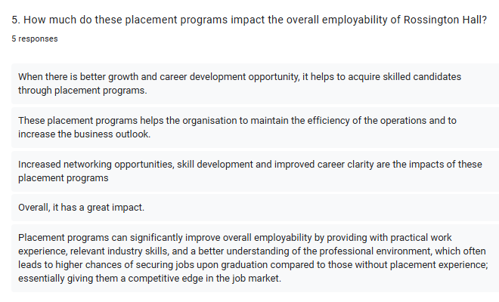

Appendix Four: List of Figures

