

Programme: BSc Health and Social Care
Module: Changemakers: Creativity and Value Creation
Module Code: BMHP5014
Assignment Title: Component 2: Written Assignment (Report)

Student Name: Nirmala Budhathoki
Student ID: 2409861
Lecturer: Parese Ahmed
Submission deadline: 31/07/2027

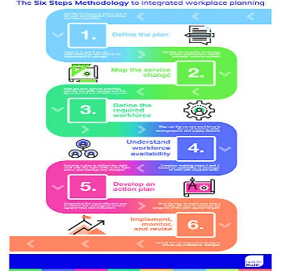

Technology integration combines AI driven burnout prediction systems, staff wellbeing mobile applications, real time workload dashboards, smart rota optimisation and advanced data analytics for early intervention (The Health Foundation, 2023). These tools identify early physiological and behavioural indicators of stress, enabling proactive workforce management across NHS services. Staff self-reporting apps enhance psychological safety and encourage timely occupational health engagement (ICO, 2024). Predictive analytics improve staffing decisions, reduce human error and strengthen patient safety outcomes. Workforce intelligence systems also enable system wide monitoring of pressure points across departments, supporting evidence-based planning and resilience (UK GMC, 2026).
AI DRIVEN STAFF MIND STAGE
Implementation will occur across NHS hospitals, GP surgeries and community care services to ensure system wide coverage of workforce wellbeing intervention. Delivery responsibility will sit with NHS Trust leadership HR departments and occupational health teams coordinating operational governance and accountability (The Health Foundation, 2023). Integration into existing NHS digital staff systems will enable real time monitoring of workload pressures and early identification of burnout risk (NIHR Evidence, 2025). Mandatory wellbeing check ins combined with automated escalation pathways will support timely intervention for high-risk staff reducing patient safety incidents. Phased rollout from pilot sites to regional expansion and finally national adoption will ensure safe scalable implementation across the NHS system. Overall, this structured approach improves safety efficiency and staff wellbeing outcomes across services nationally.
DIGITAL WORKFORCE SAFETY OPERATION FRAMEWORK
NHS Workforce Wellbeing and Patient Safety Artificial Intelligence (AI) Support System is an integrated digital strategy using real-time monitoring, predictive analytics, and staff wellbeing tools to reduce burnout, improve clinical decision-making, and enhance overall patient safety and service quality across NHS settings.
INNOVATION OVERVIEW
EFFECTIVE LEADERSHIP BEHAVIOURS ENHANCE TEAM ENGAGEMENT, IMPROVE COLLABORATION, AND SUPPORT INNOVATION WITHIN HEALTHCARE SETTINGS AND ORGANISATIONS
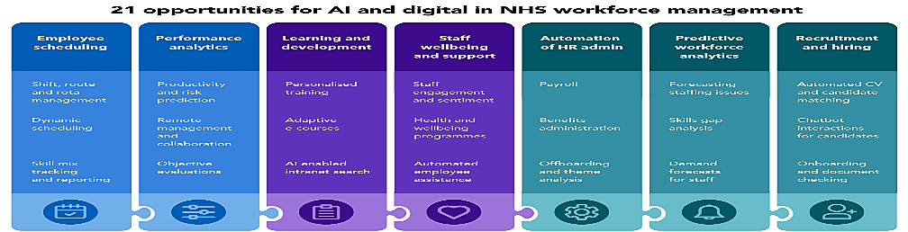

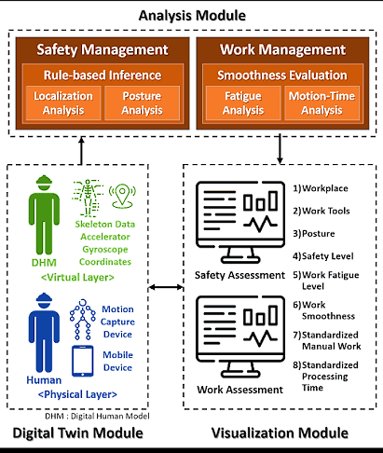

Workforce burnout is a recognised occupational syndrome involving emotional exhaustion, reduced motivation and impaired professional functioning, and within NHS, the sustained staffing shortages, rising patient demand and increasing workload intensity have significantly accelerated burnout among healthcare professionals, weakening overall service efficiency and care quality (WHO, 2024). NHS workforce data highlights high levels of work-related stress, absenteeism and staff turnover, all of which directly disrupt continuity of care and patient safety (NHS England 2025). Burnout has been strongly associated with increased clinical errors, reduced attention to detail and declining job performance, placing patients at higher risk during treatment episodes which further indicates that sustained workforce pressure contributes to deteriorating organisational performance and service ratings across healthcare settings (The King's Fund 2025). Collectively, these factors demonstrate that burnout is not only a staff wellbeing issue but a critical patient safety and system performance challenge across the NHS today.
SILENT CRISIS: WORKFORCE BURNOUT HARMING NHS
SAFETY

STRATEGIC NHS INTEGRATION TIMELINE
Dissemination will use NHS staff training sessions, intranet campaigns and leadership workshops to ensure awareness and uptake. Collaboration with Royal Colleges and unions will strengthen credibility, while the “Healthy Staff, Safe Care” campaign and integration into induction programmes will embed the innovation into everyday NHS workforce practice nationally.
NHS ENGAGEMENT ADOPTION
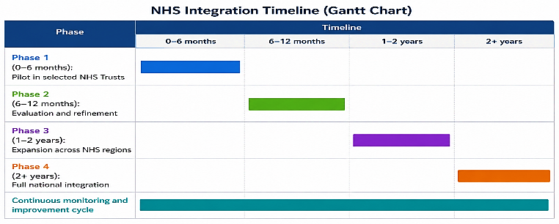
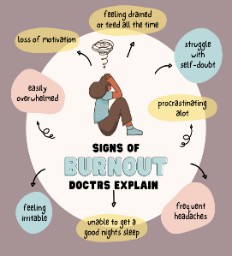

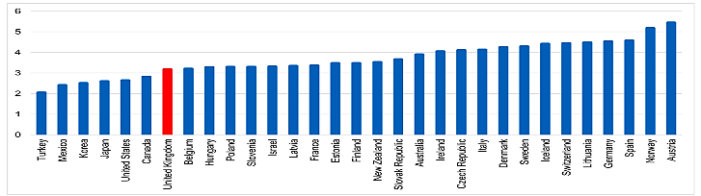
Development of the proposed innovation must comply with NHS digital governance frameworks ensuring safe, effective and transparent use of health technologies across clinical settings (NHS England 2025). Data processing and monitoring systems must adhere strictly to GDPR requirements to safeguard confidentiality, ensure lawful processing and protect sensitive workforce information (ICO, 2024).
ETHICAL POWER FOR NHS SYSTEMS
Regulatory alignment with Care Quality Commission standards is essential to maintain patient safety, service quality and organisational accountability across NHS Trusts (CQC, 2025). In addition, compliance with the Health and Safety at Work Act 1974 reinforces organisational duty to protect staff wellbeing (British Safety Council, 2025). Ethical considerations include informed staff consent, and robust data privacy protection to prevent surveillance culture (Aboalnass et al., 2024).
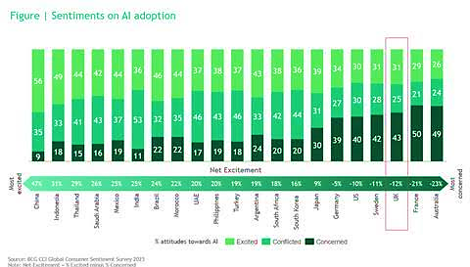
NHS nurses’ doctors and allied health professionals represent the primary workforce targeted due to high burnout exposure workload pressure within acute and community care settings (NHS England 2025). Secondary stakeholders include patients’ users and NHS trust management responsible for commissioning safe efficient care delivery systems (CQC, 2025). Reducing burnout among staff improves job satisfaction retention psychological wellbeing contributing to safer working environments staff stability (Alqahtani et al., 2023). Patient outcomes benefit through fewer clinical errors enhanced continuity of care improved decision making under reduced workforce strain conditions (UK GMC, 2026). This collectively strengthens NHS workforce sustainability improves service resilience and supports long term public health system performance nationally.
SILENT CRISIS: WORKFORCE BURNOUT HARMING NHS
SAFETY

This innovation addresses workforce burnout through AI driven monitoring, digital wellbeing tools and structured NHS implementation strategies. It improves staff wellbeing, enhances patient safety by reducing clinical errors and strengthens overall service quality. It supports a resilient, efficient and sustainable NHS workforce for long term healthcare delivery improvement.
CONCLUDING STATEMENT

Pitch

Workforce Burnout Intelligence Within NHS Transformation
I propose an NHS Workforce Burnout Prevention and Patient Safety Intelligence System to tackle the growing problem of staff burnout and its direct impact on patient safety and service quality within the NHS. According to the World Health Organisation (WHO 2024), burnout is an occupational phenomenon characterised by chronic workplace stress that is not effectively managed. In the NHS, pressures of workload, staff shortages and emotional workload have led to an increase in psychological deficient performance, and an increase in clinical error. I created this innovation because of the increasing concerns highlighted in staff retention and wellbeing reports, which focus on how poor staff wellbeing negatively impacts system efficiency and patient outcomes (The King's Fund 2025). My solution combines digital monitoring, AI-driven workload analysis and structured wellbeing interventions for a proactive approach to workforce sustainability and patient safety, rather than reactive.
I suggest that the system consists of three linkages: AI predictive analytics, real-time workforce monitoring dashboards, and a staff wellbeing digital application. The predictive analytics model can be used to help identify early signs of burnout risk by analysing patterns in workforce data before patients are put at risk (NIHR Evidence 2025). The dashboard enables NHS managers to gain up-to-the-minute information on staffing issues, workload, and alerts about risks, to make quick operational choices. The wellbeing app allows staff to record their own stress levels without others knowing and provides them with customisable occupational health support to reinforce the early intervention process. Digital health technologies can alleviate workforce pressures and enhance the efficiency of care delivery, as they are integrated into clinical systems, with evidence demonstrating this (NIHR Evidence 2025). Additionally, the successful implementation of the project relies on the involvement of leaders in this change, as having effective leadership structures helps drive improved wellbeing and contributes to organisational performance (The Health Foundation, 2023). A proactive approach to workforce wellbeing, with a continuous monitoring and support approach rather than a retrospective one.
The innovation is particularly relevant as the NHS suffers from longstanding and growing issues of staff burnout affecting patient care, quality, and sustainability in the system. Burnout has been linked to emotional exhaustion and diminished clinical efficiency, which can result in patient outcomes that are lower than usual and an increased risk of errors (Aboalnass et al., 2024). The system is being directed at frontline healthcare workers such as nurses, doctors, and allied health staff to minimise psychological stress and increase job satisfaction and retention. Better staff wellbeing results in better protection of patients and less absenteeism, better continuity of care for patients. Patients gain by having fewer clinical errors, more standardised treatment processes, and increased trust in health care facilities. This innovation will help achieve sustainability of the NHS at the system-level by minimising turnover costs and increasing workforce stability in the long-term. It is also in line with a national agenda to improve staff wellbeing and retention rates in health services to help the NHS meet rising demand and ensure high-quality care is provided.
I suggest a staged approach to implementation with initial testing in a small number of NHS Trusts to test the effectiveness of the system and to ensure that there are some opportunities to refine the way the system works. Engagement with NHS leadership teams, human resource teams, occupational health, and digital transformation teams will ensure that the design of the new system is aligned with existing systems within the NHS. The testing phase will be about checking usability, engagement, and impact of the tasks on the staff workload. The system will then be rolled out regionally, to other NHS organisations, and trained through a structured training programme for managers and clinical staff. A nationwide implementation phase will then put the system into the normal governance arrangements of the NHS workforce. Secure digital infrastructure, AI analytics ability, and existing NHS electronic staff records are key resources needed. Regulatory compliance must be achieved, such as GDPR, compliance with data protection and legal processing of employee data (ICO 2024). Staff wellbeing protection also requires that the health and safety requirements of the Health and Safety at Work Act are complied with (British Safety Council 2025). Ongoing evaluation and feedback from stakeholders will inform ongoing improvements during implementation.
This innovation brings considerable benefits as it tackles the underlying causes of staff burnout, enhances the safety of NHS patients, and boosts service resilience. The system integrates AI-powered monitoring and digital wellbeing tools, helping to identify risk at an early stage, minimising unnecessary clinical errors, and enhancing the quality of care. There is evidence that the integrated workforce wellbeing approaches have a positive impact on retention and organisational performance in healthcare systems (Alqahtani et al 2023). The innovation will be feasible as it will fit with the existing NHS digital infrastructure and is complementary to the current strategies which are in place to improve the workforce. But there are some potential challenges, such as employee resistance to digital tracking and privacy and implementation issues with data. These challenges can be overcome with communication, good governance, and a progressive roll-out with leadership buy-in. Building trust and acceptance will be further strengthened by working with professional bodies and regulatory organisations. The system is scalable and is not limited to use in Hospital's but could be extended to community health services and even to other healthcare systems around the world with high workforce and low patient satisfaction levels. This innovation contributes to long-term transformation of healthcare delivery and to making staff wellbeing a key part of patient safety and system effectiveness.
This innovation must be prioritised for immediate implementation in any NHS workforce transformation programmes to facilitate improvements to staff wellbeing and patient safety outcomes in a timely manner. Immediate investment will alleviate the financial strain of staff turnover, sickness absence and clinical mistakes in the long term and enhance organisational resilience. I also suggest a national steering group to provide overarching governance for implementation, track outcomes, and enable ongoing development. This will ensure consistency with NHS strategic goals and facilitate sustainable integration of digital workforce wellbeing systems in all settings of care nationally. ￼￼

References
Aboalnass, F. M., Alguthamy, W. H., Al-Hussein, A. A. N., Al-Mazargah, A. N. M., Al-Harisi, I. S. I., Alotaibi, S. S. H., ... and Alharbi, M. F. (2024). Health And Safety in Health Care Settings: Review on Protection of Patients and Healthcare Workers. Cultura: International Journal of Philosophy of Culture and Axiology, 21(3s), 285-306.
Alqahtani, H. M. H., Alharbi, A. S., Alherz, S. S., Alqasir, M. A. A., Alsufayan, M. F., Aldosari, A. O., ... and Alzubidi, A. H. A. (2023). Optimizing workforce well-being and retention in integrated health systems: a multidisciplinary approach to combating burnout. International Journal of Health Sciences, 7(S1), 3881-3907.
British Safety Council (2025). The Health and Safety at Work Act Explained. [online] British Safety Council. Available at: https://www.britsafe.org/training-and-learning/informational-resources/the-health-and-safety-at-work-act-explained [Accessed 13 Jun. 2026].
CQC (2025). Partnerships and communities - Care Quality Commission. [online] www.cqc.org.uk. Available at: https://www.cqc.org.uk/guidance-regulation-nhs-key-question-well-led-partnerships [Accessed 13 Jun. 2026].
ICO (2024). Lawful basis for sharing personal data. [online] ico.org.uk. Available at: https://ico.org.uk/for-organisations/uk-gdpr-guidance-and-resources/data-sharing/data-sharing-a-code-of-practice/lawful-basis-for-sharing-personal-data/ [Accessed 13 Jun. 2026].
NHS England (2025). Staff leaving the NHS among lowest in over a decade. [online] England.nhs.uk. Available at: https://www.england.nhs.uk/2025/03/staff-leaving-the-nhs-among-lowest-in-over-a-decade/ [Accessed 13 Jun. 2026].
NIHR Evidence (2025). Digital technology in healthcare: reducing staff pressures. [online] NIHR Evidence. Available at: https://evidence.nihr.ac.uk/collection/digital-technology-in-the-nhs-reducing-staff-pressures-improving-care/ [Accessed 13 Jun. 2026].
The Health Foundation (2023). Strengthening NHS Management and Leadership. [online] The Health Foundation. Available at: https://www.health.org.uk/reports-and-analysis/briefings/strengthening-nhs-management-and-leadership [Accessed 13 Jun. 2026].
The King’s Fund. (2025). Securing the NHS workforce for the future: our recommendations for action. [online] Available at: https://www.kingsfund.org.uk/insight-and-analysis/long-reads/securing-nhs-workforce-future-recommendations-action [Accessed 13 Jun. 2026].
UK GMC (2026). Caring for doctors Caring for patients. [online] Available at: https://www.gmc-uk.org/cdn/documents/caring-for-doctors-caring-for-patients_pdf-80706341.pdf [Accessed 13 Jun. 2026].
WHO (2024). Burn-out an ‘occupational phenomenon’: International classification of diseases. [online] World Health Organization. Available at: https://www.who.int/news/item/28-05-2019-burn-out-an-occupational-phenomenon-international-classification-of-diseases [Accessed 13 Jun. 2026].

