PROBLEM SOLVING AND DECISION MAKING

  - MANAGEMENT REPORT
  - MODULE CODE: BMSK4004

Executive Summary
National Health Service (NHS) is the public-oriented service of the govt in every hospital of the UK. The free of charge facility for maximum diseases and a little charge for some diseases have made it a trustworthy service of the govt in hospitals. With more than 69 providers in different corners of the country, NHS is servicing people with social care, healthcare, consultancy and more. Recently, due to changes in the economy, social needs, and govt policies, NHS is undergoing shortage of funding. Moreover, hospitals are unable to provide free services due to a deficit of budget. In such case, even with the high demand for services, NHS is falling from its reputation. To solve this, NHS needs to make efficient financial planning, track performance of hospitals and local communities and serve online service to reduce cost. Moreover, focus on social care and vaccines for children rather than treatment policy can help it to cope up with the current situation.

Table of Contents
Introduction : Current situation of NHS 4
PESTEL Analysis 8
Political factors 8
Economic factors 9
Social factors 10
Technological factors 11
Environmental factors 11
Legal factors 12
Options to resolve problems 12
Improvement of financial plans 12
Utilizing sources of financial support 13
Recruiting experts from countries 14
Supplementary social care 15
Evaluation of options 17
Financial planning 17
Use of financial sources improving costs 18
Recruiting staffs 20
Social care project 20
A&E services 21
Conclusion & Reccomendation 23
Recommendation for implementing the option 23
References 24

INTRODUCTION: Current situation of NHS
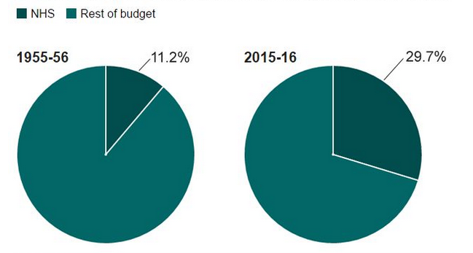
As the most sustainable achievement after the world war, the establishment of National Health Service (NHS) is considered bringing benefits to the society. Starting the journey from 1948 with the hands of Clement Atlee’s Labour govt, NHS is providing healthcare services to every UK citizen regardless of their wealth (Nhs.uk, 2018). Except for some fees for a prescription, optical and dental services, all the services of NHS have been free to all. As a result, the UK govt has to allot more than 29.7% of their budget for NHS which has led it a bone of contention to different political parties (Ferile, 2017). But serving more than 64.3 million people in the UK and 54.3 million people in England alone have made it one of the sustained organizations in the UK (Ferile, 2017). Therefore, the organization is operating for 70 years in the UK.

Figure: Allocation of budget in NHS in the UK (BBCNews, 2018)
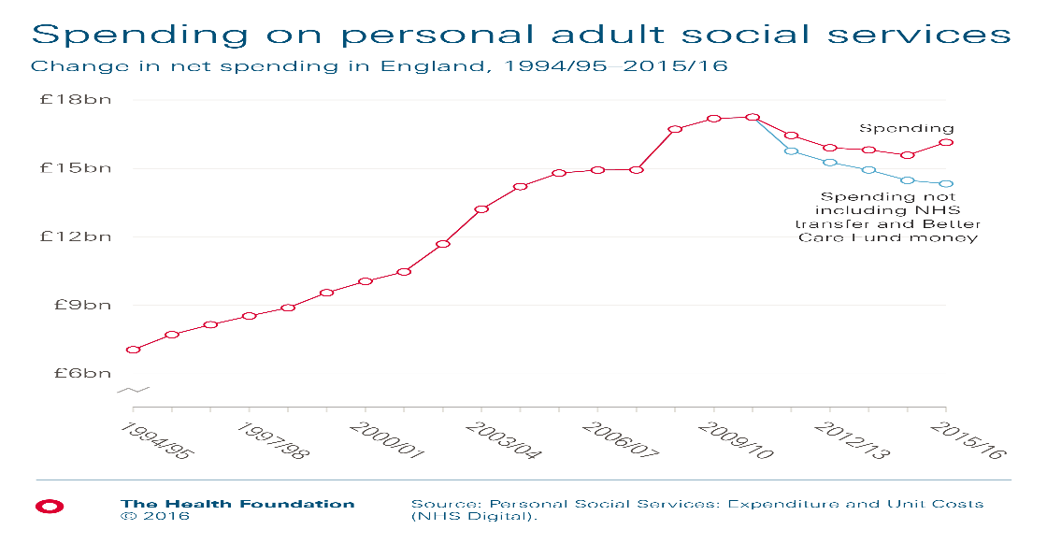
NHS has been responsible to provide free healthcare services even to poor people. For various diseases like; asthma, diabetes, measles and more, NHS provides treatment to all ages of people. Moreover, under its continuing service, NHS provides medical care what an individual institution cannot do. For the complex health needs, around 12.4% people in the UK take the care from NHS in in their own homes or registered care homes (Ferile, 2017). NHS continuing care program serves to adults only but young children can take it if they are undergoing disability, accident or so. Therefore, for the adults in the UK, more than £15 billion is being spent in 2016 which indicates the popularity of this program (BBCNews, 2018). Apart from that, for health-related social care, people can seek from NHS through the local authority. Especially, adults in their older time seek such healthcare under some conditions applied by the local authority. Furthermore, connecting different hospitals, dentists, care homes, consultants and more, NHS provides needs near to people. The advisory panel also helps to deal with depression, mental needs and provides urgent medical help at any corner in the UK (Nhs.uk, 2018). Therefore, more than 64 million people in the UK take NHS services before going to other places for medical need.

Figure: Spending on adult services (White, 2017)
From 2010, the cost of NHS services is increasing tremendously. Around 67.4% people under NHS care are adults taking continuing care services of NHS (White, 2017). Moreover, people are taking their social care through NHS. Therefore, the cost of medical care is the highest among the elder people. NHS only focuses on treatment of diseases. Therefore, people over 30-years old are the main customers of NHS services. But these elder people alone are not responsible for increasing cost of NHS. Rising costs and wages in peoples’ lives has increased the NHS cost by £3 billion from 2015 to 2016 (BBCNews, 2018). Moreover, new technology with expanded treatment, increasing immigrants and others have increased the cost by £2 billion in 2016. Even with the 29% of the budget allotted for NHS, the organization is burdened by heavy costs which are affecting its services nowadays.

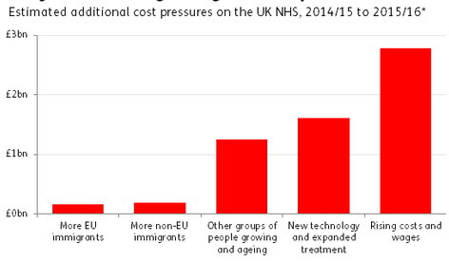
Figure: Reasons for increasing cost of NHS (nuffieldtrust.org.uk, 2018)

The most popular services of NHS are its Accident and Emergency service (A&E) which provides health treatment for the instant situation (Nhs.uk, 2018). The target of the service is to provide instant treatment to relieve within 4-hours. But for some years, this target is being missed. Due to lack of technology and proper spending in medical service have increased the amount of time needed. Moreover, the target is to treat 95% of patients within 4-hours. But the rate is below 90% from 2016 (White, 2017). The increasing population also is increasing the cost of NHS services in social care but not in emergency care. Therefore, patients are now losing their trusts on NHS for emergency services. As a result, currently, NHS is undergoing a pressure from increasing patient services along with managing the allotted funds effectively.
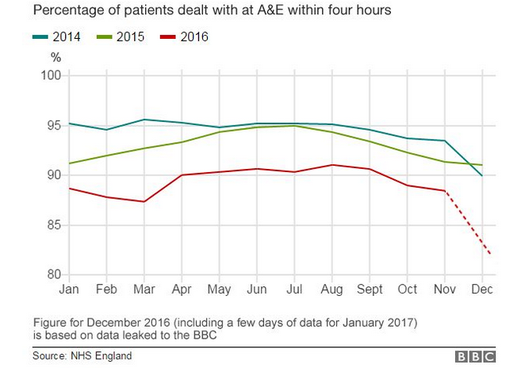
Figure: Decreasing patients service in NHS A&E service (BBCNews, 2018)

PESTEL Analysis
PESTEL analysis will help to derive the pressure from the external environment on NHS. This includes;

Political factors
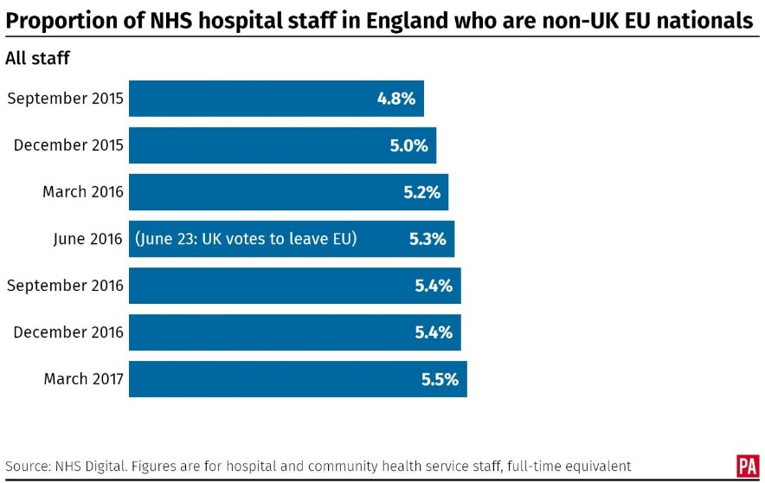
Politically, the UK is quite a stable country. The ruling parties have created a stable environment in the UK for industries to expand. In 2016, the Brexit had increased the costs of companies by 17% due to turmoil in share market and depreciation of exchange rate (Kauders, 2017). But, in 2017, the local election of the UK has decreased the pressure on foreign companies affected by Brexit. But the winning of conservative party has put the healthcare system in the UK under pressure as they have been voting against NHS for a long time. The current tax rate of 20% paid by the individuals in the UK which has been untouched from 2015 (Kauders, 2017). But the govt is deciding to change the tax rate by increasing it by 10% as NHS tax for providing better healthcare to people. Such increase can help NHS by providing it more funds and to deal with the shortage of its employees. Apart from that, the Brexit has opened an opportunity for NHS. Through EC’s free trade agreement with the US and non-EU countries have increased the trade by 12% in the UK (White, 2017). Trade with countries like; Bangladesh, India, and others can reduce the costs for medicines for NHS. Moreover, the lack of staff needs can be mitigated through this agreement. Already staff number from non-EU countries has increased by 5.5% in 2017 from 5.2% in 2016 in NHS which is positive for the organization.

Figure: Increase in staffs after Brexit in NHS (White, 2017)

Economic factors
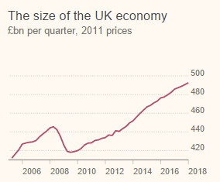
Among all the G-7 countries, the UK is the fastest growing country at 1.8% rate. The economy size has increased to £500 billion from 2016 to 2017 (ukeconomy.com, 2018). On the other hand, GDP per head has increased to £7400 in 2018. Therefore, people have a higher earning capacity in the UK and have a high amount of disposable income in hand. As a result, people can contribute better to NHS funding along with claiming better healthcare service from NHS. Along with that, the higher income level of the country can allot more amount for NHS (Ferile, 2017). In that way, even with high level of cost, NHS can fund itself to provide better service. But, the inflation rate of the UK has dropped to 3% from 3.1% in 2017 (ukeconomy.com, 2018). As a result, the wages of healthcare staffs will decrease eventually making them lose interest from NHS. Moreover, such decrease will reduce the people’s expenditure in social care under NHS, making it slow in its operations. Therefore, the economic change can affect NHS from its funding to the cost structure.

Figure: Economy size of the UK (ukeconomy.com, 2018)

Social factors
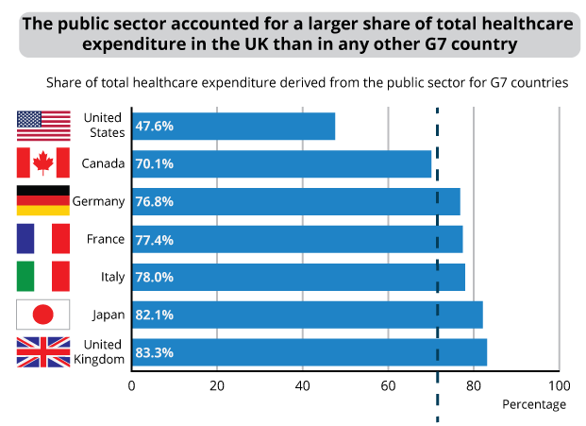
In the UK, people use to expend a lot on healthcare facilities. Aging rate is high in the UK and 17% people of the country are aged over 65 years. Most of this elderly people claim for social care within which around 37.5% people seek for healthcare facilities first of all (Kauders, 2017). Therefore, through elderly care system, the expenditure on healthcare in the UK has increased by 3.1%. Among all the G-7 countries, the UK has the highest expenditure on healthcare with 83.3% of the spending of the public sector (nuffieldtrust.org.uk, 2018). Moreover, people of different ages are now depended most on public healthcare. For different vaccines for the infants, around 72% families take services of NHS (Jafri, n.d.). For emergency services and for different diseases, people need to seek healthcare from near points. As a result, the NHS care points help through emergency services and expert doctors. Poor people who cannot access to private healthcare can also get their needed help from NHS. Therefore, the demand for NHS services is increasing day-by-day. But the increasing cost of NHS services for emergency and continuing services are costing a lot for young people as well. Recently, lack of staffs and new technologies are depriving almost 3% of complex patients of needed services. So, NHS is losing its image to serve better among people.
Figure: Spending on healthcare in the UK (Ferile, 2017)

Technological factors
The UK is one of the technology-based countries from where many innovative ideas come in. around 11% of world’s innovation comes from the UK researchers (Kauders, 2017). Therefore, the govt has employed separate funding for research and innovation in here. NHS employs its experts in National Institute of Health Research (NIHR) for developing better servicing (Nhs.uk, 2018). The organization applies state-of-the-art data analytics to explore health trends in countries along with pinpointing most needed treatment of people. The organization mainly focuses on dementia and different mental health problems and develops different solutions for them. Moreover, in NHS points, people can seek medical help through online, calling at 111 and can get immediate help (Campling, 2017). To serve even in distant areas, NHS Digital App also is helpful to connect to NHS. With the use of 16 Global Digital Exemplars, around 80% of the services has been made digitized. New 33 innovations, 13 Genomic Medicine Centres and 22000 employees have exemplified the research and innovation facilities of the NHS (Nhs.uk, 2018).

Environmental factors
In the UK, govt has imposed strict regulations to control the effect of industries on the environment. Environmental Law-1972 has imposed that organizations need to manage ecological balance within them (Nhs.uk, 2018). Moreover, reducing the impact on the environment has been necessary to maintain the brand image in the UK. In NHS, this issue has got tremendous attention. To meet greenhouse gas target, NHS has created “route map” in all of its care points (Nhs.uk, 2018). Air conditions are water-powered, doctors are instructed for using correct bins, flower classes for ulcer patients and more are helping to mitigate carbon emission. Moreover, in Nottinghamshire, using the local amenities, the Kings Mill hospital has developed £4 million energy project to reduce carbon emission (Jafri, n.d.). As a result, the produced energy is supplying 40% energy needs in winter. The hospital meals are becoming vegetarian and are sourced from local firms. Along with that, hospitals are recycling rubbishes and installing green roofs in new buildings. In that way, NHS is reducing carbon emission by 10% as targeted (Ferile, 2017).

Legal factors
Organizations are strict to follow equity pay act-1970, race relation act-1976 and more in the UK to protect employees and stakeholders. Health and Social Care Act- 2012 has assured equality in health services (Nhs.uk, 2018). Moreover, Social Value Act- 2012 considers economic, social and environmental wellbeing for the rendered services. Therefore, NHS, as a public service provider is taking actions benefitting social determinants of health like; employment, housing and more. Moreover, irrespective of wealth or money, NHS is servicing people of all income and all ages for AtoZ diseases (White, 2017). Moreover, as being a public health service, NHS is having a suitable legal facility in the UK.

Options to resolve problems
Basically, from the factors externally, NHS is suffering from the efficient use of its funds, increasing costs for adults and lack of ability to serve for demanded services (Jafri, n.d.). From the economic and social overview, the need for changing the situation has been necessary with proper actions. The possible options can be;

Improvement of financial plans
As being a collection of hospitals in different corners of the country, the performance of hospitals needs to be analyzed to meet up the efficient use of funds. From 2013, NHS is facing a deficit in its funds’ uses even if it had enough allotment from the govt budget. More than 13% of the budget is allotted for healthcare through NHS by the UK govt even the spending is reducing by 2.6% every year (BBCNews, 2018). In 2013, the deficit budget was £91 million whereas it was £2447 million deficit in 2015 (nuffieldtrust.org.uk, 2018). Such huge deficit is reducing the capacity of different hospitals to treat patients with proper treatment and to deliver emergency services in time. Royal Free NHS Foundation Trust and Gloucestershire Hospitals NHS Foundation Trust have planned for only £11 million of deficit whereas it increased to £32 million of the deficit which hampered their continuing program (BBCNews, 2018). Therefore, it has been a necessity to develop an effective financial plan for managing such deficits.

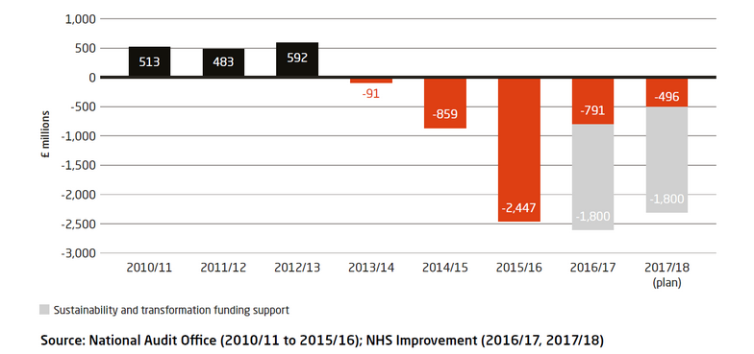

Figure: Deficit of funds of NHS (BBCNews, 2018)

Utilizing sources of financial support
Apart from the Sustainability and Transformation Fund money, NHS is depended on other sources for funding. Interest-bearing loans and supports of rich also contribute to the funds of providers. Still, many providers are using their reserves to meet up the costs of hospitals. 19 of 69 providers take loans at high-interest rate whereas 29 of them run down of their reserve (Wood, 2016). As a result, the proper utilization of funds is not taking place in hospitals. Within £1.8 billion of funds, 10 hospitals have used the funds but have delayed payment or canceled them (Campling, 2017). So, the acceptance of many hospitals is decreasing and services are becoming quite costly in many hospitals. Therefore, more efficient sources are needed to be developed to make financial supports utilized.

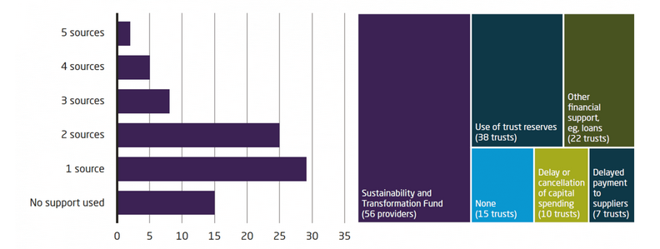
Figure: Capital sources for NHS (Wood, 2016)

Recruiting experts from countries
One of the most demanded services of the NHS is its A&E service which serves immediate medical aid within 4-hours of time (Nhs.uk, 2018). The target of this program is to serve around 95% of the patients of such cases within 4-hours so that people can rely on immediate services. But in recent years, this service is falling significantly. Doctors having the experience to take immediate decisions and to treat such accidents effectively are lacking in NHS. Only 80-82% of patients are treated within the targeted time for this lack of doctors (Wood, 2016). As a result, hospitals are lacking services offered and people are moving their back to such. Since 2010, more than 4000 mental beds are being vacant and the number of staffs is reduced to 22000 only (Nhs.uk, 2018). GP services are also in the perilous situation due to the training of new doctors. Such shortage of needed doctors has made the vacancy rate and rural practice closure 3.5% higher than before. Staff numbers in hospitals for different wards are also decreasing to 75% compared to 89% in 2010 (Davies, 2016). According to BMA study on 900 doctors, 67% doctors have seen that emergency services have worsened more in 2017 whereas 71% have experienced the servicing in primary and GP care has worsened due to staff shortages (Campling, 2017). In 2017, the clinical staff number in GP services has declined to only 43000. As a result, it has become necessary to recruit staffs to mitigate the shortage in healthcare.

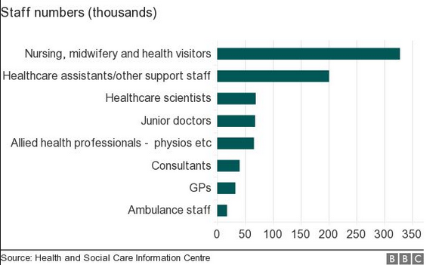

Figure: Decrease in staff number in NHS (Davies, 2016)

Supplementary social care
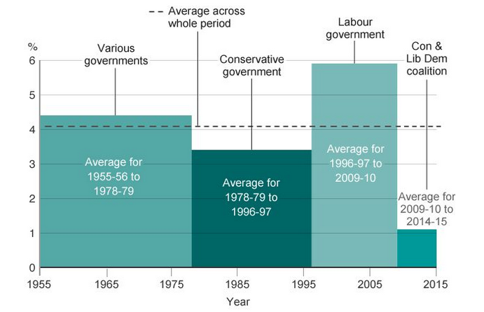
The govt allows a certain percentage of the budget for NHS every year. But the spending of the govt for healthcare is decreasing each year. From 1978 to 1997, the spending for healthcare was 4.2% on average of GDP under the conservative govt (Dixon, 2017). On the other hand, under labor govt in 2005, the spending rose higher to 5.7% increasing the care for adults. But in 2015, it lowered to all time low at 1.3% leading adult healthcare in danger (Dixon, 2017). As a result, the social care for adults has become quite costly to bear.
Figure: Average spending on health by govt (BBCNews, 2018)
Adult people above 65-years old are the beneficiaries of social care. They claim for such service according to their income level and state arranges for this. But this social care service in the UK has become paralyzed. Social care funding has reduced to £4.4 billion instead of £13 billion (Campling, 2017). Therefore, people now have to bear the higher cost of their social care by themselves. Funding for this social care is needed immediately to reduce the cost of adults. For this, the social care plan should be effective in the UK.
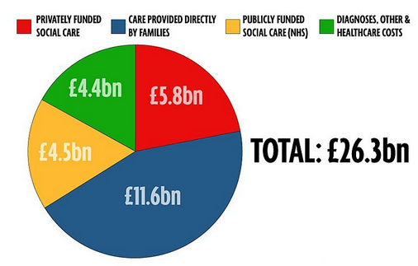

Figure: Funding for social care (Dixon, 2017)

Evaluation of options
The options above can reduce the financial problem of NHS along with its efficiency in the healthcare industry if applied. Most importantly, NHS needs to improve its effectiveness with proper planning. The analysis says that,

Financial planning
NHS, even with a high allotment of the budget cannot occupy the effective use of its funds. Among 72% healthcare service providers, the allotment provides a deficit budget (Davies, 2016). Even in remote areas, more than 15 hospitals have undergone to a severe deficit in the budget for which they couldn’t provide free services along with emergency services. This is causing a mismanagement within NHS. To solve this, proper financial planning is necessary.
Apart from 29% of the budget, additional £1.6 billion has been announced for NHS funding (Jafri, n.d.). For A&E funding, additional £570 million will be available as well. In this case, NHS needs to a lot 25% of its funding for regular services. Moreover, 25% should be for most demanded A&E services. In that way, the demanded services of the organization will be available and efficient (Kauders, 2017). NHS funding should also consider the existing budget and surplus of its providers. Such as; Aspen Healthcare in 2017 has experienced a deficit of £3 million whereas celesio has a surplus of £0.5 million (Davies, 2016). This analysis will help to discover the real needs in areas and to allot funds effectively. Moreover, the needs of services in areas is needed to be analysed as well. This will help to curve the amount allotment for specific services in specific areas. Such as; for providers in London, allotment for A&E and regular services should be 2% higher than Hampshire for its comparatively higher demand (Davies, 2016). On the other hand, in Devon and Wales, hospitals focus more on continuing service and social care. Therefore, hospitals in these remote areas should be allotted 2.5% higher for social care (Dixon, 2017). Moreover, screening in daily or weekly basis of all the providers can track the funding and use of NHS. In that way, any deficit can be minimized by transferring funds and by shifting experts from place to place.
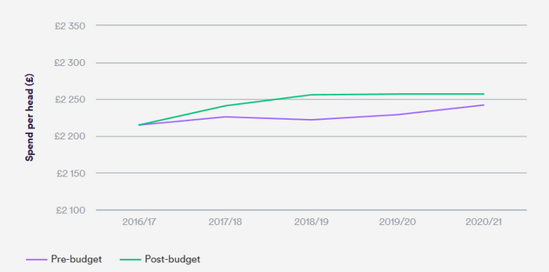
Figure: Spend per head in NHS under financial planning (Dixon, 2017)

Use of financial sources improving costs
For meeting up the NHS funding, govt may start NHS tax on people by 2019 but this is still under analysis. So, to meet up the current funding needs, more sources of funds are needed. Around 76% of existing funds are from tax paid by people, 19% from national income and 5% from user charges (Dixon, 2017). Companies arrange for private insurance for healthcare and people pay 11% out-of-pocket to meet up healthcare costs (Campling, 2017). Therefore, NHS funding mostly depends on tax and if that becomes lower, NHS funding becomes lower too.
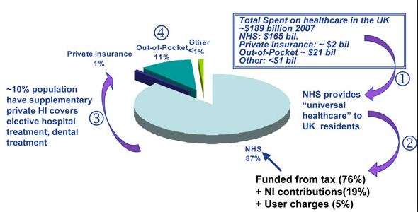

Figure: Funding of NHS (Dixon, 2017)

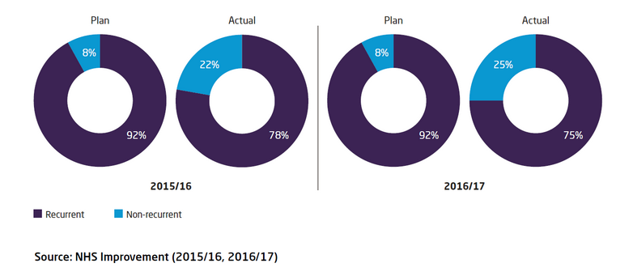
Hospitals take loans from different sources at a high-interest rate of 8% from different banks to fund deficits (White, 2017). But NHS can fund these through its credit union by creating an account for loan providers. People can access this credit union by providing £1000 to £100000 at 7% rate with a free of all charges benefit (Devaney, 2017). In this way, NHS can take loans from people by providing a promise to pay within time along with free of charges benefit program. Being a public organization, such loans can be typical for NHS but it can occupy it against a promised service for future. Moreover, gifts from sponsors by making beneficiaries alumni for NHS can help to cope up the current fund need. Many companies like; pharmaceuticals, sponsor different service programs in hospitals to advertise them. these companies can be alumni for NHS and can sponsor its providers.

Figure: Cost improvement success in NHS (Devaney, 2017)
Apart from using sources, NHS can improve its cost structure and can save as its reserve. In 2017, providers delivered £3.1 billion of savings improving costs (Dixon, 2017). In maximum hospitals rather than borrowing, saving costs can be helpful to create the further fund. For this, NHS can contract with its medicine suppliers overseas like developing countries to reduce the cost of medicines. Moreover, focusing on vaccines for children rather than treatment can reduce the cost by 3.6% each year with lower children diseases (Devaney, 2017). Moreover, eProcurement, online services can reduce the costs by reducing service charges of the NHS. Redesigning mental health services with online consultation, shifting expert doctors from one place to another can help to reduce the vacant beds which can be utilized for general services.

Recruiting staffs
Apart from using local staffs, NHS can recruit from overseas. Immigrants with proper training can be helpful to serve NHS with commitment (Wood, 2016). Moreover, the cost becomes 7% lower for immigrant staffs. Furthermore, part-time jobs arrangement for additional staffs can help to minimize the staff shortage (Jafri, n.d.). Shifting expert staffs like doctors from place to place can meet up the current demand of staffs.

Social care project
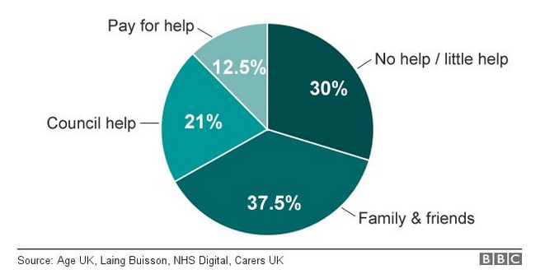
Fewer older people in the UK get services from NHS care through social care. 12.5% of older people get help after paying for the services. on the other hand, 37.5% people get help when their families pay for them (Davies, 2016). the council can help only 21% through social care and almost 30% remain deprived of social care. Therefore, amendments are needed in social care service.

Figure: Aged people under social care (BBCNews, 2018)

As the cost of social care is increasing, an efficient social care plan should be developed. Aging of people has increased to 14% for which new social care plan should start from the career of e person (KMIETOWICZ, 2017). Citizens can contribute 14% of their income for social care under a separate fund by govt named as “Adult care” which will bear their cost in old age. Moreover, various insurance options starting from £10 per month can be introduced to insure for complex diseases by the govt (KMIETOWICZ, 2017). Furthermore, 25% of NHS fund should be allotted for social care which will help to provide care for poor people on old age (Ferile, 2017). In that way, social care can be available at low price in every NHS care point leading to funding saving.
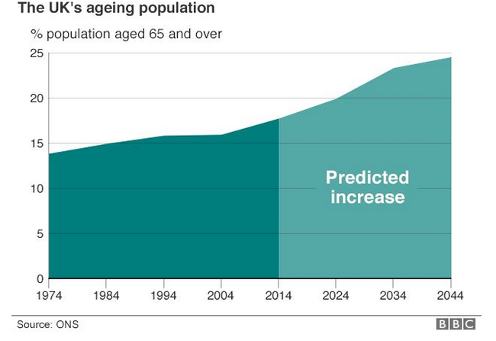

Figure: Increase in aging in the UK (Ferile, 2017)

A&E services
The demand for A&E services is the highest in the UK. The accident rate is higher in city areas by 2.17% compared to rural areas (Ferile, 2017). Moreover, the emergency needs are the highest with frequent calls in 111 in the UK. Therefore, this service is needed to be available more to people.
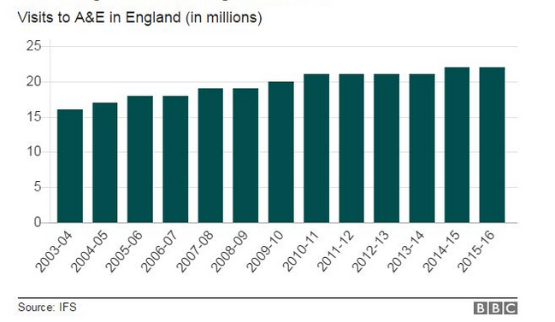
Figure: A&E demand in the UK (Devaney, 2017)
To improve this service, connection to local communities is necessary. NHS should encourage people to take care outside hospitals. Moreover, local cares should be integrated to improve quality of A&E services. Vacant 4000 mental care beds can be utilized to treat emergency cares (Devaney, 2017). Therefore, an integration can increase the cost improvement effectively.

Conclusion & Reccomendation
This report has explained about the current crisis regarding the funding needs and service crisis within NHS. Only a single option cannot be effective to meet the crisis within NHS. It needs to develop a model incorporating two of the options. NHS needs to develop an efficient financial planning along with proper controlling and should improve its cost structure. This can help to meet up the funding needs by saving from the costs and utilizing the allotted funds in the best way. With the allotted fund from govt and other sources, a plan should be occupied to allot funds to all providers. Reduction of deficiency can be achieved through tracking performance of care points every specific time period. Moreover, savings from cost improvement through utilizing vacant beds, shifting experts in places, providing a separate fund to social care and more can contribute to the efficient plan.

Recommendation for implementing the option
To implement the efficient planning with cost improvement, NHS needs to analyze its fund deficits in hospitals. 25% of the fund should be allotted to social care along with 25% in regular services. Staffs wages should be increased by 7% by giving ranking to experts to become a part of NHS. Funds can be collected from credit union, social care reserve and sponsors as well. With this fund, hospitals should be distributed amounts for their services and must be tracked from time to time to see their performances. Moreover, to improve cost and to save from it, NHS needs to allot for social care, shift expert staffs, encourage people to take online and local community services and contract to overseas or local companies for low-cost supplies. In that way, within next 6 years, NHS can develop its services and can create its own funds from its redesigning.

References
BBCNews. (2018). 10 charts that show why the NHS is in trouble. [online] Available at: http://www.bbc.com/news/health-38887694 [Accessed 1 Mar. 2018].
Campling, P. (2017). Intelligent Kindness: professional healthcare and the future of the UK NHS.European Journal for Person Centered Healthcare, 2(2), p.235.
Davies, P. (2016). The NHS in the UK. 3rd ed. London: NHS Confederation.
Devaney, A. (2017). Learning resource needs of UK NHS support staff. Health Information & Libraries Journal, 22(4), pp.253-261.
Dixon, J. (2017). Making the NHS and social care system sustainable. BMJ, p.j1826.
Ferlie, E. (2017). A New Mode of Organizing in Health Care? UK Cancer Services and Governmentality. Journal of Healthcare Management, 56(4), pp.283-284.
Jafri, T. (2017). Designing better medicines delivery in the UK National Health Services (NHS).Australasian Medical Journal, pp.121-128.
Kauders, D. (2017). Understanding Brexit Options. 3rd ed. Sparkling Books Limited.
Kmietowicz, Z. (2017). Financial strains must not jeopardise work of volunteers in NHS and social care. BMJ, 346(mar13 2), pp.f1595-f1595.
Nhs.uk. (2018). NHS Choices Home Page. [online] Available at: https://www.nhs.uk/pages/home.aspx [Accessed 1 Mar. 2018].
nuffieldtrust.org.uk. (2018). The facts: EU immigration and pressure on the NHS. [online] Available at: https://www.nuffieldtrust.org.uk/resource/the-facts-eu-immigration-and-pressure-on-the-nhs [Accessed 1 Mar. 2018].
ukeconomy.com. (2018). 44 charts that explain the UK economy. [online] Available at: https://ig.ft.com/sites/numbers/economies/uk [Accessed 1 Mar. 2018].
White, J. (2017). New challenges set for the NHS (UK). Leadership in Health Services, 23(4).
Wood, K. (2016). Introductory guide to NHS finance in the UK. 5th ed. Bristol: Healthcare Financial Management Association.

